

FURNITURE UPHOLSTERER

KM15 COVER MAKING AND COVERING METHODS FOR UPHOLSTERED FURNITURE PROTOTYPES AND REPAIRS

ASSESSMENT GUIDE

Cover Making and Covering Methods for Upholstered Furniture Prototypes and Repairs

Module # | KM-15
NQF Level | 4
Notional hours | 150
Credit(s) | 15
Curriculum Code | 683401000
SAQA QUAL ID | 103199
Qualification Title | Occupational Certificate: Furniture Upholsterer NQF Level 4, Credits 549

TABLE OF CONTENTS

ASSESSMENT REQUIREMENTS 5
KM-15-KT01: Covering techniques for prototypes (60%) 6
Internal Summative Assessment 9
KM-15-KT02: Repairs to upholstery furniture (40%) 11
Formative assessment 11
Summative assessment 13
Model Answers 16

ASSESSMENT REQUIREMENTS

Integrated Formative Assessment:
The skills development provider will use the curriculum to guide them on the stipulated internal assessment criteria and weighting. They will also apply the scope of practical skills and applied knowledge as stipulated by the internal assessment criteria. This formative assessment leads to entrance into the integrated external summative assessment.

Integrated Summative Assessment:

External Integrated Summative Assessment (EISA):
An external integrated summative assessment, conducted through the relevant QCTO Assessment Quality partner is required for the issuing of this qualification. The external integrated summative assessment will focus on the exit level outcomes and associated assessment criteria. The external assessment model requires that the external assessment will be conducted through a combination of a written assessment and practical task at an accredited trade test centre. The written examination will be concluded at an accredited trade test centre and marked by registered assessors. Practical tasks will also be assessed by registered assessors. The combination of the written and practical assessment will be conducted over a period of two working days.

KM-15-KT01: Covering techniques for prototypes (60%)

# Integrated Formative Assessment

Multiple Choice Questions (MCQs)

1. IAC0101: Which of the following is NOT a type of upholstery cover?
- A) Leather
- B) Velvet
- C) Plastic
- D) Hardwood
- Model Answer: D) Hardwood

2. IAC0102: What is crucial when analyzing cover components in terms of design specifications?
- A) Color only
- B) Texture only
- C) Both color and texture
- D) The price of the materials
- Model Answer: C) Both color and texture

3. IAC0103: Which item is not typically considered a consumable in upholstery?
- A) Foam
- B) Thread
- C) Nails
- D) Sandpaper
- Model Answer: D) Sandpaper

4. IAC0104: What is the primary goal of covering frame components in the correct order?
- A) To save time
- B) To minimize cost
- C) To achieve the desired visual effect
- D) To ensure durability only
- Model Answer: C) To achieve the desired visual effect

True/False Questions

5. IAC0105: Stretching and pulling methods are not necessary for a proper upholstery fit.
- True
- False
- Model Answer: False

6. IAC0106: Slip stitching is a method that should be invisible on the final upholstered product.
- True
- False
- Model Answer: True

7. IAC0107: A quality inspection only needs to be done once at the end of the upholstery process.
- True
- False
- Model Answer: False

Short Answer Questions

8. IAC0101: Explain the difference between natural and synthetic upholstery covers.
- Model Answer: Natural upholstery covers are made from materials that occur in nature, such as cotton, leather, and wool. They tend to be more breathable and comfortable but may require more care. Synthetic covers, like polyester and nylon, are man-made and generally offer greater durability and stain resistance, often at a lower cost.

9. IAC0102: How do cover components relate to design specifications?
- Model Answer: Cover components must match design specifications in terms of color, texture, weight, and durability to ensure the final product meets the intended aesthetic and functional requirements. Mismatched components can lead to an unsatisfactory appearance and performance.

10. IAC0103: Discuss the importance of accurately determining the types and quantities of consumables for an upholstery project.
- Model Answer: Accurately determining the types and quantities of consumables is crucial for ensuring the project can be completed without unnecessary interruptions or waste. Overestimating can lead to excess cost, while underestimating can result in project delays and inconsistency in quality if additional materials differ from the original batch.

11. IAC0104: Evaluate the importance of the correct order of covering frame components.
- Model Answer: Covering frame components in the correct order is vital for achieving the desired visual effect and ensuring structural integrity. Incorrect order can lead to issues with fit, appearance, and comfort, and may even necessitate redoing work, thereby increasing time and cost.

12. IAC0105: Why are fitting, aligning, stretching, pulling, shaping, pleating, and folding techniques critical in upholstery?

- Model Answer: These techniques are critical as they ensure the cover fits snugly and attractively over the furniture, enhancing both aesthetics and comfort. Proper execution of these techniques can significantly impact the final look and durability of the upholstered piece.

13. IAC0106: How do back tacking and stapling contribute to the effectiveness of upholstery?

- Model Answer: Back tacking and stapling are methods used to secure the upholstery fabric to the frame. They provide a firm hold, ensuring the fabric stays in place, maintains tension, and contributes to the overall durability and appearance of the finished piece.

14. IAC0107: Describe the role of quality inspections in identifying faults and flaws in upholstery.

- Model Answer: Quality inspections are critical in identifying faults and flaws such as uneven seams, material defects, and poor technique execution. They ensure that each piece meets the set standards for quality and uniformity, leading to customer satisfaction and maintaining the manufacturer's reputation.

Internal Summative Assessment

# Case Study: Restoring a Vintage Chesterfield Sofa

Background:
You are an experienced upholsterer tasked with restoring a vintage Chesterfield sofa. The client wants the sofa to retain its classic look but with a more durable and modern fabric. The frame of the sofa is sturdy, but the springs, padding, and cover show significant wear and tear. The client has also requested the use of eco-friendly materials wherever possible.

IAC0101: Types of upholstery covers identified and explained.

- Model Answer: For the Chesterfield sofa, traditional leather is a classic choice known for its durability and aging grace. However, considering the client's request for modern and durable fabric, a high-quality microfiber or polyester blend could be used as they are stain-resistant and have a similar texture to leather. For an eco-friendly option, recycled or organic fabrics could also be considered.

IAC0102: Cover components analysed in terms of design specifications.

- Model Answer: The original Chesterfield design features deep buttoning, a quilted design, and rolled arms. The cover components, therefore, must include durable buttons and appropriate fabric that can hold the deep button tufts and withstand the tension without tearing.

IAC0103: Types, dimensions, quantity, and quality of consumables and decorative finishing items required discussed.

- Model Answer: High-quality threading for stitching, durable buttons for tufting, and eco-friendly foam for padding are required. The dimensions and quantity will depend on the sofa's size, but an estimate can be made based on its length, width, and buttoning pattern. For decorative finishing, brass nailhead trim could be added to highlight the sofa's classic lines.

IAC0104: Methods of covering prepared frame/components evaluated.

- Model Answer: The frame should first be covered with a layer of padding, followed by the eco-friendly foam. The fabric should then be draped over the frame, starting from the centre of the sofa and moving outwards to ensure even tension. This order helps achieve the desired plush look synonymous with Chesterfield sofas.

IAC0105: Methods of fitting, aligning, stretching, pulling, shaping, pleating, and folding evaluated.
- Model Answer: The fabric should be aligned with the sofa's shape, ensuring that the pattern matches at all seams. The fabric will need to be stretched and pulled tightly to avoid wrinkles and ensure it fits snugly against the padding. Pleating and folding techniques will be particularly important around the arms and buttoning areas to maintain the classic Chesterfield look.

IAC0106: Methods of back tacking, stapling, and slip stitching evaluated.

- Model Answer: Back tacking and stapling should be used on the underside and back of the sofa where it's not visible to secure the fabric. Slip stitching may be used for areas that need a more subtle finish, especially around the arms and any cushion edges, to ensure that stitches are not visible but still hold the fabric firmly.

IAC0107: Principles of quality inspections evaluated.

- Model Answer: Quality inspections should focus on the uniformity of button placement, the symmetry of the tufting, and the firmness of the padding. Inspectors should also check for any material defects in the fabric, ensuring there are no faults or flaws, and that the stitching is strong and even throughout.

This case study provides a comprehensive scenario to assess the upholsterer's understanding and application of various techniques and standards in a real-world context, ensuring they are prepared to deliver high-quality work that meets both aesthetic and functional criteria.

KM-15-KT02: Repairs to upholstery furniture (40%)

Formative assessment

Formative Assessment: Furniture Upholstery Repair

Instructions: Please answer the following questions based on your knowledge of furniture upholstery repair.

Section 1: Multiple Choice Questions

1. IAC0201: What is one common cause of damage to upholstered furniture?
- A) Sunlight exposure
- B) Vacuuming
- C) Temperature changes
- D) Regular cleaning
- Answer: A) Sunlight exposure

2. IAC0202: When justifying repair costs for upholstery, which factor should be considered?
- A) The colour of the fabric
- B) The location of the furniture
- C) The type and quality of materials used
- D) The age of the upholstery professional
- Answer: C) The type and quality of materials used

Section 2: True/False Questions

3. IAC0203: True or False: Organisational constraints play a role in determining the quality requirements for upholstery repair.
- Answer: True

4. IAC0204: True or False: Preparation requirements for different types of repair should be analysed to ensure efficient and cost-effective repairs.
- Answer: True

Section 3: Short Answer Questions

5. IAC0201: Explain two different types of damage that can occur to upholstered furniture.
- Answer: Examples of different types of damage could include wear and tear of fabric due to regular use or structural damage from accidents.

6. IAC0202: Justify why using high-quality materials in upholstery repair may lead to higher repair costs.
- Answer: High-quality materials often come at a higher cost but can result in more durable and visually appealing repairs, which justifies the increased repair cost.

7. IAC0203: Provide an example of an organizational constraint that can impact upholstery repair procedures and policies.
- Answer: An organizational constraint could be a limited budget, which may affect the choice of materials or the extent of repairs that can be undertaken.

8. IAC0204: What are some preparation requirements that an upholsterer should consider when repairing a piece of furniture with extensive structural damage?
- Answer: Preparation requirements may include assessing the extent of damage, sourcing appropriate replacement parts, and planning the repair process.

This integrated formative assessment covers the specified assessment criteria and provides model answers to help learners evaluate their understanding of furniture upholstery repair concepts.

Summative assessment

Case Study: Upholstery Repair for "The Antique Armchair"

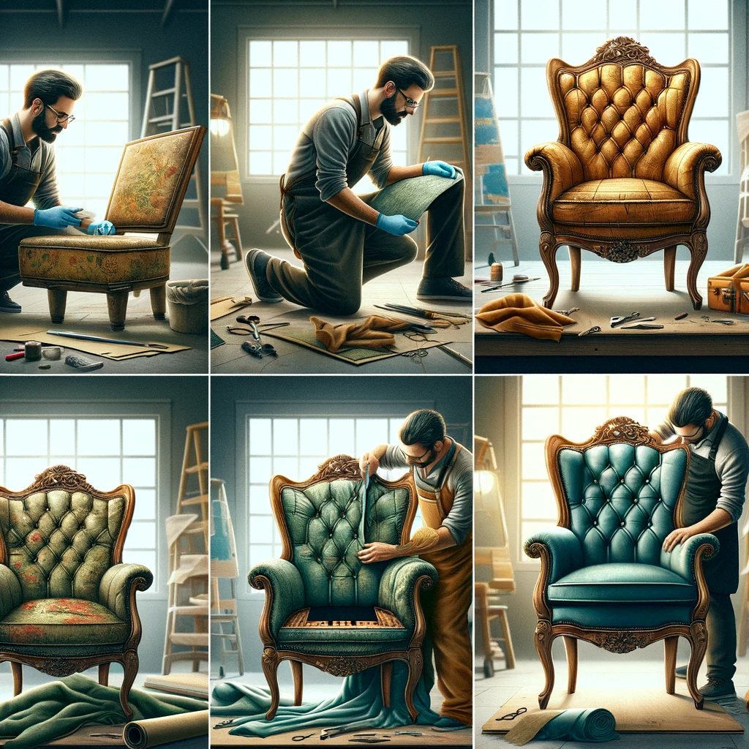

Background:

You are a professional furniture upholsterer working at a reputable restoration company. A client, Ms. Smith, has brought in a cherished antique armchair that requires restoration. The armchair holds sentimental value to Ms. Smith, and she wants it to be restored to its former glory. You are tasked with assessing, planning, and executing the restoration of "The Antique Armchair."

Integrated Assessment Criteria:

- IAC0201: Identify and describe the causes and different types of damage that "The Antique Armchair" has sustained.
- IAC0202: Justify the repair methods you propose for each type of damage and provide a breakdown of the repair costs.
- IAC0203: Consider and justify any organizational constraints, quality requirements, and repair procedures and policies that may impact the restoration project.
- IAC0204: Analyse and outline the preparation requirements for repairing the different types of damage identified.

Task 1: Identifying Damage (IAC0201)

- Describe the various types of damage you observe on "The Antique Armchair" and provide the likely causes for each type.
- Explain how identifying these types of damage is crucial for planning the restoration.

Task 2: Repair Methods and Cost Justification (IAC0202)

- Propose specific repair methods for each type of damage identified in Task 1.
- Break down the estimated repair costs for each repair method you propose and justify the costs.

Task 3: Organisational Constraints and Quality Requirements (IAC0203)

- Identify any potential organisational constraints that may affect the restoration project.
- Explain how adhering to quality requirements and repair procedures and policies is essential to meet the client's expectations.

Task 4: Preparation Requirements (IAC0204)

- Analyse the preparation requirements necessary for executing the repair methods proposed in Task 2.
- Provide a detailed plan for preparing "The Antique Armchair" before starting the restoration work.

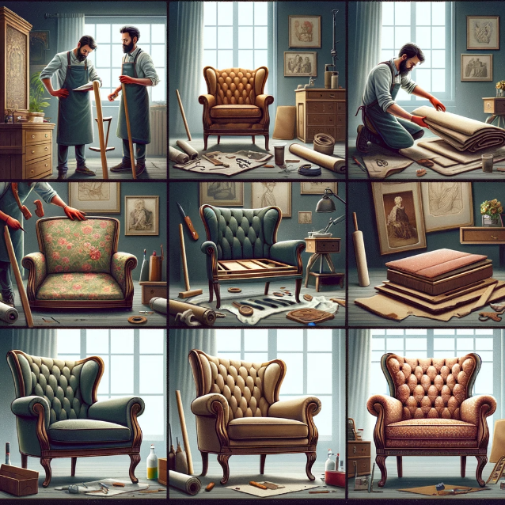

A series of images depicting the restoration of an antique armchair by a professional furniture upholsterer. The first image shows the upholsterer examining the worn-out chair in a well-lit workshop, noting the areas that require attention. The second image illustrates the chair disassembled with care, showcasing the old fabric, padding, and frame. The third image is of the upholsterer choosing new fabric and materials that match the armchair's original style and quality. The fourth image depicts the reupholstering process, with the upholsterer skilfully attaching the new fabric. The final image presents the beautifully restored antique armchair, looking as splendid as it did when it was new, ready to be returned to Ms. Smith.

Model Answers

Note: Model answers will vary based on the specific details provided in the case study.

Task 1: Identifying Damage (IAC0201)

- Types of Damage: The armchair has sustained upholstery fabric tears, wood frame cracks, and missing decorative elements.
- Causes of Damage: Fabric tears are likely due to wear and tear, wood frame cracks may result from age and humidity changes, and missing decorative elements might be due to past accidents.
- Importance: Identifying these types of damage helps us assess the scope of work and plan appropriate repairs.

Task 2: Repair Methods and Cost Justification (IAC0202)

- Repair Methods: Fabric tears will require patching and stitching, wood frame cracks will be repaired through re-gluing and clamping, and missing decorative elements will be recreated.
- Cost Justification: Patching and stitching fabric: R500, Wood frame repair: R1000, Decorative element recreation: R750.
- Justification: Costs are based on materials, labour, and expertise required for each repair method.

Task 3: Organizational Constraints and Quality Requirements (IAC0203)

- Constraints: Limited budget and client's timeline constraints.
- Quality Requirements: Adherence to industry-standard restoration techniques and client's desire for authenticity.

Task 4: Preparation Requirements (IAC0204)

- Preparation:
- Fabric tears: Gather matching upholstery fabric, upholstery thread, and needles.
- Wood frame cracks: Acquire wood glue, clamps, and sandpaper.
- Decorative elements: Source appropriate moulding materials and carving tools.
- Preparation Plan: Ensure all required materials and tools are available before starting the restoration process.

This case study provides the basis for a summative assessment that assesses learners' understanding and application of the integrated assessment criteria related to upholstery repair.

