

FURNITURE UPHOLSTERER

KM15 COVER MAKING AND COVERING METHODS FOR UPHOLSTERED FURNITURE PROTOTYPES AND REPAIRS

ASSESSMENTS

Cover Making and Covering Methods for Upholstered Furniture Prototypes and Repairs

Module # | KM-15
NQF Level | 4
Notional hours | 150
Credit(s) | 15
Curriculum Code | 683401000
SAQA QUAL ID | 103199
Qualification Title | Occupational Certificate: Furniture Upholsterer NQF Level 4, Credits 549

LEARNER CONTACT INFORMATION:

Name
Contact Address
Telephone (H)
Telephone (W)
Cellular

TABLE OF CONTENTS

ASSESSMENT REQUIREMENTS 4
KM-15-KT01: Covering techniques for prototypes (60%) 5
Internal Summative Assessment 7
KM-15-KT02: Repairs to upholstery furniture (40%) 8
Formative assessment 9
Summative assessment 9

ASSESSMENT REQUIREMENTS

Integrated Formative Assessment:
The skills development provider will use the curriculum to guide them on the stipulated internal assessment criteria and weighting. They will also apply the scope of practical skills and applied knowledge as stipulated by the internal assessment criteria. This formative assessment leads to entrance into the integrated external summative assessment.

Integrated Summative Assessment:

External Integrated Summative Assessment (EISA):
An external integrated summative assessment, conducted through the relevant QCTO Assessment Quality partner is required for the issuing of this qualification. The external integrated summative assessment will focus on the exit level outcomes and associated assessment criteria. The external assessment model requires that the external assessment will be conducted through a combination of a written assessment and practical task at an accredited trade test centre. The written examination will be concluded at an accredited trade test centre and marked by registered assessors. Practical tasks will also be assessed by registered assessors. The combination of the written and practical assessment will be conducted over a period of two working days.

KM-15-KT01: Covering techniques for prototypes (60%)

# Integrated Formative Assessment

Multiple Choice Questions (MCQs)

1. IAC0101: Which of the following is NOT a type of upholstery cover?
- A) Leather
- B) Velvet
- C) Plastic
- D) Hardwood

2. IAC0102: What is crucial when analyzing cover components in terms of design specifications?
- A) Color only
- B) Texture only
- C) Both color and texture
- D) The price of the materials

3. IAC0103: Which item is not typically considered a consumable in upholstery?
- A) Foam
- B) Thread
- C) Nails
- D) Sandpaper

4. IAC0104: What is the primary goal of covering frame components in the correct order?
- A) To save time
- B) To minimize cost
- C) To achieve the desired visual effect
- D) To ensure durability only

True/False Questions

5. IAC0105: Stretching and pulling methods are not necessary for a proper upholstery fit.
- True
- False

6. IAC0106: Slip stitching is a method that should be invisible on the final upholstered product.
- True
- False

7. IAC0107: A quality inspection only needs to be done once at the end of the upholstery process.
- True
- False

Short Answer Questions

8. IAC0101: Explain the difference between natural and synthetic upholstery covers.

9. IAC0102: How do cover components relate to design specifications?

10. IAC0103: Discuss the importance of accurately determining the types and quantities of consumables for an upholstery project.

11. IAC0104: Evaluate the importance of the correct order of covering frame components.

12. IAC0105: Why are fitting, aligning, stretching, pulling, shaping, pleating, and folding techniques critical in upholstery?

13. IAC0106: How do back tacking and stapling contribute to the effectiveness of upholstery?

14. IAC0107: Describe the role of quality inspections in identifying faults and flaws in upholstery.

Internal Summative Assessment

# Case Study: Restoring a Vintage Chesterfield Sofa

Background:
You are an experienced upholsterer tasked with restoring a vintage Chesterfield sofa. The client wants the sofa to retain its classic look but with a more durable and modern fabric. The frame of the sofa is sturdy, but the springs, padding, and cover show significant wear and tear. The client has also requested the use of eco-friendly materials wherever possible.

IAC0101: Types of upholstery covers identified and explained.

IAC0102: Cover components analysed in terms of design specifications.

IAC0103: Types, dimensions, quantity, and quality of consumables and decorative finishing items required discussed.

IAC0104: Methods of covering prepared frame/components evaluated.

IAC0105: Methods of fitting, aligning, stretching, pulling, shaping, pleating, and folding evaluated.

IAC0106: Methods of back tacking, stapling, and slip stitching evaluated.

IAC0107: Principles of quality inspections evaluated.

KM-15-KT02: Repairs to upholstery furniture (40%)

Formative assessment

Formative Assessment: Furniture Upholstery Repair

Instructions: Please answer the following questions based on your knowledge of furniture upholstery repair.

Section 1: Multiple Choice Questions

1. IAC0201: What is one common cause of damage to upholstered furniture?
- A) Sunlight exposure
- B) Vacuuming
- C) Temperature changes
- D) Regular cleaning

2. IAC0202: When justifying repair costs for upholstery, which factor should be considered?
- A) The colour of the fabric
- B) The location of the furniture
- C) The type and quality of materials used
- D) The age of the upholstery professional

Section 2: True/False Questions

3. IAC0203: True or False: Organisational constraints play a role in determining the quality requirements for upholstery repair.

4. IAC0204: True or False: Preparation requirements for different types of repair should be analysed to ensure efficient and cost-effective repairs.

Section 3: Short Answer Questions

5. IAC0201: Explain two different types of damage that can occur to upholstered furniture.

6. IAC0202: Justify why using high-quality materials in upholstery repair may lead to higher repair costs.

7. IAC0203: Provide an example of an organizational constraint that can impact upholstery repair procedures and policies.

8. IAC0204: What are some preparation requirements that an upholsterer should consider when repairing a piece of furniture with extensive structural damage?

Summative assessment

Case Study: Upholstery Repair for "The Antique Armchair"

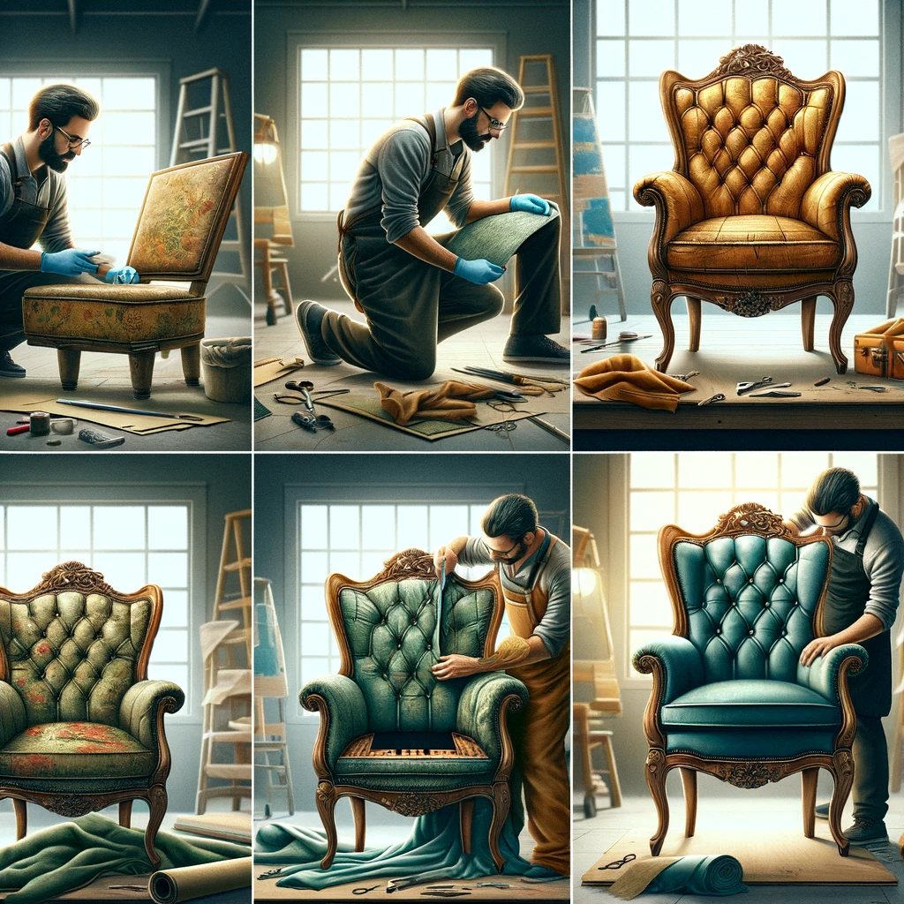

Background:

You are a professional furniture upholsterer working at a reputable restoration company. A client, Ms. Smith, has brought in a cherished antique armchair that requires restoration. The armchair holds sentimental value to Ms. Smith, and she wants it to be restored to its former glory. You are tasked with assessing, planning, and executing the restoration of "The Antique Armchair."

Integrated Assessment Criteria:

- IAC0201: Identify and describe the causes and different types of damage that "The Antique Armchair" has sustained.
- IAC0202: Justify the repair methods you propose for each type of damage and provide a breakdown of the repair costs.
- IAC0203: Consider and justify any organizational constraints, quality requirements, and repair procedures and policies that may impact the restoration project.
- IAC0204: Analyse and outline the preparation requirements for repairing the different types of damage identified.

Task 1: Identifying Damage (IAC0201)

- Describe the various types of damage you observe on "The Antique Armchair" and provide the likely causes for each type.
- Explain how identifying these types of damage is crucial for planning the restoration.

Task 2: Repair Methods and Cost Justification (IAC0202)

- Propose specific repair methods for each type of damage identified in Task 1.
- Break down the estimated repair costs for each repair method you propose and justify the costs.

Task 3: Organisational Constraints and Quality Requirements (IAC0203)

- Identify any potential organisational constraints that may affect the restoration project.
- Explain how adhering to quality requirements and repair procedures and policies is essential to meet the client's expectations.

Task 4: Preparation Requirements (IAC0204)

- Analyse the preparation requirements necessary for executing the repair methods proposed in Task 2.
- Provide a detailed plan for preparing "The Antique Armchair" before starting the restoration work.

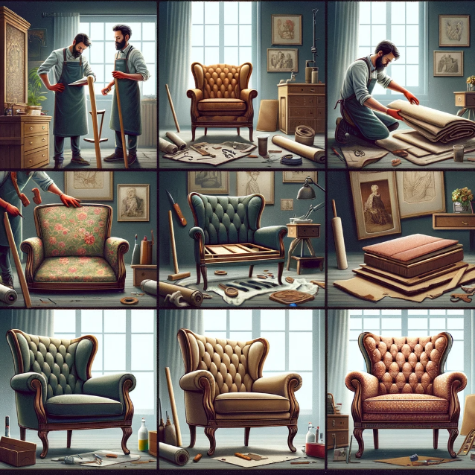

A series of images depicting the restoration of an antique armchair by a professional furniture upholsterer. The first image shows the upholsterer examining the worn-out chair in a well-lit workshop, noting the areas that require attention. The second image illustrates the chair disassembled with care, showcasing the old fabric, padding, and frame. The third image is of the upholsterer choosing new fabric and materials that match the armchair's original style and quality. The fourth image depicts the reupholstering process, with the upholsterer skilfully attaching the new fabric. The final image presents the beautifully restored antique armchair, looking as splendid as it did when it was new, ready to be returned to Ms. Smith.

