

UPHOLSTERERY FRAME PREPARER

KM02 UPHOLSTERED FURNITURE FRAME PREPARATION

LEARNER GUIDE

TABLE OF CONTENTS

KM-02-KT01: Specifications for upholstered furniture (10%) 3
KM-02-KT02: Upholstery raw materials and consumables types and characteristics (15%) 11
KM-02-KT03: Raw materials and consumables used in the frame padding process (5%) 51
KM-02-KT04: Use of chemicals: adhesives and solvents (5%) 61
KM-02-KT05: Upholstery tools and equipment (10%) 80
KM-02-KT08: Frame preparation: knocking-on principles (5%) 167
KM-02-KT09: Knocker on techniques (15%) 177
KM-02-KT10: Foaming-up or padding-up principles (10%) 191
KM-02-KT11: Foaming-up or padding-up techniques (10%) 203
KM-02-KT12: Joints and bracings of the frame (5%) 216

KM-02-KT01: Specifications for upholstered furniture (10%)

Learning Outcome
At the end of this section, learners should cover:
KT0101 Function of product specifications and standards in the manufacturing process.
KT0102 Types of product specifications including sketches, technical drawings, samples, prototypes, cutting lists and job cards, and their uses.
KT0103 Principles and concepts of interpreting specifications and workplace instructions to determine the type, quality, sizes and quantities of raw materials and consumables for the frame preparation process.
KT0104 Frame and upholstery components construction and parts identification.
KT0105 Compliance and non-compliance.
KT0106 Consequences of prepared frames and covered furniture not meeting specified standards.

KT0101 Function of product specifications and standards in the manufacturing process.
Product specifications and standards serve as the backbone of the entire upholstered furniture manufacturing process. Their primary function is to provide a detailed roadmap that guides upholsterers through the design, construction, and finishing stages. These specifications establish the quality benchmarks, safety standards, and aesthetic requirements that must be met to ensure a successful outcome. Upholsterers rely on product specifications to understand the unique characteristics and attributes expected in the final product, allowing them to create items that are not only visually appealing but also functional and durable.

KT0102 Types of product specifications including sketches, technical drawings, samples, prototypes, cutting lists and job cards, and their uses.
In the upholstery industry, various types of product specifications play distinct roles in shaping the manufacturing process.

Sketches:
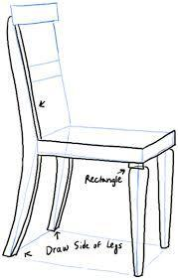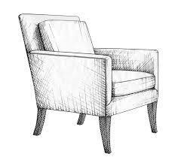
These visual representations offer a preliminary view of the upholstered item, helping upholsterers grasp the overall design and aesthetics.

Technical Drawings:
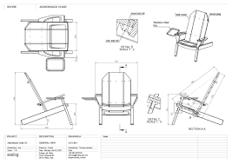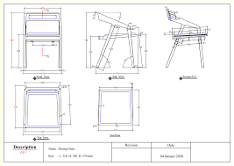
More detailed than sketches, technical drawings provide precise engineering information. This includes isometric, oblique, and orthographic views, projections, sectional views, component parts, dimensioning, scaling, line structures, and geometry. For instance, isometric views convey three-dimensional aspects, while orthographic views provide detailed projections.

Samples and Prototypes:
Actual physical representations that allow upholsterers to assess the tactile qualities, comfort, and visual appeal of the final product.

Cutting Lists and Job Cards:

These documents outline the materials needed, dimensions, and assembly instructions. Cutting lists specify the quantity and size of each material, while job cards detail the step-by-step process of construction.

Understanding these types of specifications empowers upholsterers to navigate the diverse requirements of different projects efficiently.

KT0103 Principles and concepts of interpreting specifications and workplace instructions to determine the type, quality, sizes and quantities of raw materials and consumables for the frame preparation process.

Interpreting specifications is a skill that involves understanding the principles and concepts embedded in industry and workplace standards.

This includes:
Raw Material Standards:
Upholsterers must grasp the specifications related to the quality and characteristics of materials, ensuring that the chosen raw materials align with the intended use and design requirements.

Drawing Standards:

Knowledge of drawing standards involves understanding the symbols, abbreviations, and conventions used in technical drawings. This ensures accurate interpretation and execution of design elements.

Engineering Symbols:

Mastery of symbols used in engineering drawings is essential for correctly identifying and implementing various components and features.

Abbreviations and Conventions:

Upholsterers need to be familiar with common abbreviations and conventions used in specifications, ensuring clear communication and adherence to standards.

KT0104 Frame and upholstery components construction and parts identification.

Understanding the construction of frames and upholstery components is crucial for accurate assembly. This involves identifying various joints, bracings, and individual parts. For instance, recognizing the difference between mortise and tenon joints, understanding the purpose of corner blocks, and identifying specific components like arms, legs, and rails are vital skills. Upholsterers must be proficient in part identification to ensure precise assembly according to specifications.

KT0105 Compliance and non-compliance.

Compliance in upholstery refers to the strict adherence to specified standards and requirements outlined in product specifications. Upholsterers must follow these guidelines meticulously to achieve the desired quality, safety, and functionality of the final product.

Example of Compliance:

Ensuring that the frame dimensions match the technical drawings precisely, using materials that meet specified standards, and following recommended construction techniques.
Non-compliance, on the other hand, introduces the risk of deviating from these standards, leading to potential defects, compromised structural integrity, and diminished customer satisfaction.

Example of Non-Compliance:

Ignoring recommended construction methods, using substandard materials, or deviating from specified dimensions.

KT0106 Consequences of prepared frames and covered furniture not meeting specified standards.
The consequences of prepared frames and covered furniture not meeting specified product standards are significant and multifaceted.

Quality Implications:

Non-compliance can result in suboptimal structural integrity, reduced comfort, and compromised durability.

Customer Satisfaction:

Non-compliant products may fail to meet customer expectations, leading to dissatisfaction and potential returns.

Safety Hazards:

Non-compliance may pose safety hazards, underscoring the critical importance of adhering to specified standards in the upholstery process.

Evaluating the consequences of non-compliance highlights the imperative nature of adherence to established standards in the upholstery process.

Formative assessment

IAC0101 Various types of product specifications used in the upholstery industry are compared and differentiated.
IAC0102 Various aspects of basic sketches and engineering drawings such as isometric, oblique and orthographic views and projections, sectional views, component parts, dimensioning, scaling, line structures and geometry, drawing labelling, curves and radiuses are identified and each function explained.
IAC0103 Aspects included in industry and workplace product specification concepts such as raw material standards, drawing standards, engineering symbols, abbreviations and conventions are identified.
IAC0104 The concepts of compliance and non-compliance is explained.
IAC0105 The consequences for the upholstery process of prepared and covered frames not meeting the specified product standard are evaluated

(Weight 10%)

KM-02-KT02: Upholstery raw materials and consumables types and characteristics (15%)

Learning Outcome
At the end of this section, learners should cover:

KT0201 Furniture raw materials with reference to natural (hard woods, soft woods, bamboo, cane and veneers) and engineered / composite materials.
KT0202 Location and procurement of raw materials and consumables.
KT0203 Raw frames and consumables supplied by frame making department.
KT0204 Types and gauges of various springs needed for the knocker-on process, including coil springs and zig-zag springs.
KT0205 Types, sizes, quantity and quality of consumables including clips, nails, staples, edge rolls, twine and cord needed for the springing up process.
KT0206 Types of webbing needed for the knocker on process, including manmade elastic and rubber webbing, and those made from natural fibres like jute webbing and hessian.
KT0207 Density, thickness and types of foam required for the foaming up process.
KT0208 Types of padding for covering coil springs.
KT0209 Consumables required for the foaming up process, including profile jigs and templates.
KT0210 Fabrics used for covering webbing, springs, foam and padding including calico, hessian, polypropylene, Dacron and flock.
KT0211 Labels, codes and the coding system and traceability.
KT0212 Principles and concepts of safe materials handling and storage methods.
KT0213 Identify raw materials used in furniture making and explain the characteristics of each.

KT0201 Furniture raw materials with reference to natural (hard woods, soft woods, bamboo, cane and veneers) and engineered / composite materials.
Furniture raw materials encompass a variety of options, each with distinct characteristics.

Understanding these materials is crucial for effective upholstery:

Natural Materials:
Hardwoods:


Distinguished by their density and durability, hardwoods like oak and cherry are ideal for framing due to their strength.

Softwoods:
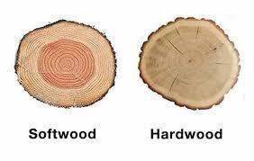
Pine and cedar, being softer and more pliable, are often used for less structural elements or intricate designs.

Bamboo and Cane:
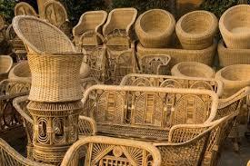
These materials bring a unique aesthetic to furniture, offering flexibility and visual appeal.

Veneers:

Thin layers of wood veneer add a decorative finish to furniture.

Engineered/Composite Materials:
Plywood:
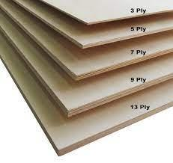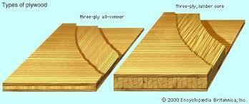
Layers of wood glued together create a stable and versatile material.

Particleboard:
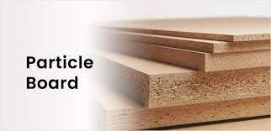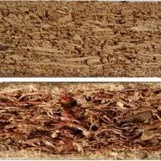
Compressed wood particles result in an economical yet stable material.

MDF (Medium-Density Fibreboard):
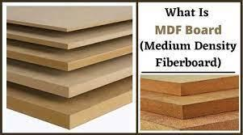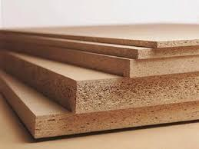
Comprising wood fibres and resin, MDF provides a smooth surface for upholstery.

KT0202 Location and procurement of raw materials and consumables.
Efficient procurement involves strategic sourcing and understanding market trends.

Key considerations include:
Cost:
Balancing quality with cost-effectiveness.

Quality:
Ensuring materials meet required standards.

Sustainability:
Opting for environmentally friendly options when possible.

Building relationships with reliable suppliers and staying informed about market dynamics are critical aspects of effective procurement.

KT0203 Raw frames and consumables supplied by frame making department.
Collaboration between the upholstery and frame making departments is integral to a smooth workflow. Raw frames and essential consumables must align with design specifications to ensure seamless integration. Effective communication is key to achieving this coordination.

KT0204 Types and gauges of various springs needed for the knocker-on process, including coil springs and zig-zag springs.

Coil Springs:
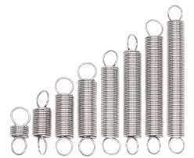
Coil springs are a fundamental component in upholstery, offering a balance of resilience and support. Their specific characteristics and variations in gauge play a crucial role in determining the overall comfort and firmness of the seat.

Functionality:
Coil springs work by compressing and expanding, responding to the weight and movement of the person sitting on the furniture. This dynamic responsiveness contributes to the overall comfort of the upholstered item.

Gauge Variations:
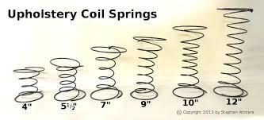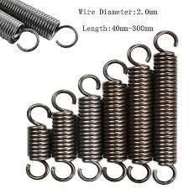
The gauge of a coil spring refers to the thickness of the wire used in its construction. In the knocker-on process, where springs are affixed to the frame, the selection of the appropriate gauge is paramount. Different gauges provide varying levels of firmness, and the choice depends on the intended use and design specifications.

Higher Gauge (Thinner Wire):
Offers a softer feel, suitable for areas where a plush and luxurious sensation is desired, such as the back cushions.

Lower Gauge (Thicker Wire):
Provides firmer support, making it ideal for seat cushions in areas where more robust and durable seating is required.

Placement:
Understanding the intended function of each part of the furniture helps in strategic placement of coil springs. For example, the backrest may benefit from a softer gauge to enhance comfort, while the seat cushion might require a firmer gauge for better support.

Zig-Zag Springs:
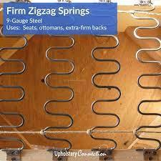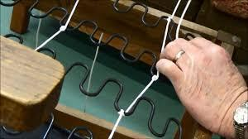
Zig-zag springs, also known as sinuous or serpentine springs, are another essential element in upholstery, particularly in the knocker-on process. These springs are characterized by their S-shaped or zig-zag design, forming a continuous and responsive support system.

Functionality:
Zig-zag springs distribute weight evenly across the seat, providing consistent support and preventing sagging over time. They are commonly used in the seats of sofas and chairs.

Gauge Variations:
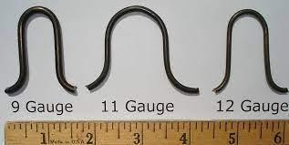
Similar to coil springs, zig-zag springs come in different gauges, allowing customization of the level of support provided. The gauge selection depends on factors such as the intended use of the furniture and the desired level of firmness.

Lighter Gauge:

Offers a softer feel, suitable for applications where a more relaxed and cushioned seating experience is preferred.

Heavier Gauge:
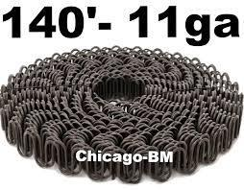
Provides firmer support, making it suitable for seats that require additional durability and resilience.

Continuous Support System:
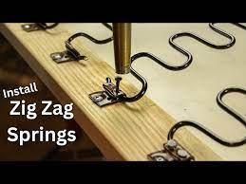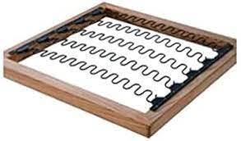
Zig-zag springs, when properly installed and secured during the knocker-on process, create a continuous support system across the seat. This system ensures that weight is distributed evenly, enhancing the longevity and comfort of the upholstered furniture.
Customization:
The ability to customize the level of support by selecting the appropriate gauge of zig-zag springs allows upholsterers to tailor furniture to meet specific design and comfort requirements.

Considerations for Upholsterers:
Application Expertise:
Upholsterers must possess a deep understanding of the application of both coil springs and zig-zag springs. This involves considering factors such as the furniture type, user preferences, and design specifications.

Integration with Frame:
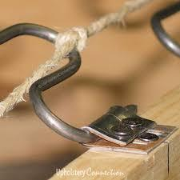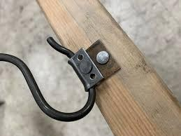
Proper integration of springs with the furniture frame during the knocker-on process is critical for ensuring stability and longevity. Upholsterers need to secure springs securely, preventing displacement or uneven support.

Compliance with Standards:
Upholsterers must adhere to industry standards and specifications during the knocker-on process to ensure that the finished product meets quality and safety requirements.
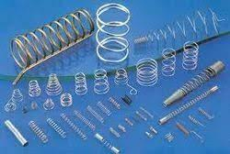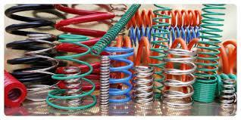
By comprehensively understanding the types and gauges of springs used in the knocker-on process, upholsterers can expertly select and integrate these components to achieve optimal comfort.

KT0205 Types, sizes, quantity and quality of consumables including clips, nails, staples, edge rolls, twine and cord needed for the springing up process.
The springing-up process in upholstery involves securing springs and other foundational elements to the frame to create a supportive and comfortable seating structure. Several consumables are essential for this process, each playing a specific role in ensuring the longevity, stability, and comfort of the upholstered furniture.

Clips:
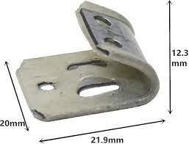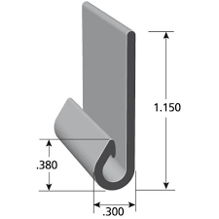

Purpose:
Clips are used to secure individual springs to the frame, preventing movement and ensuring consistent support.

Types:
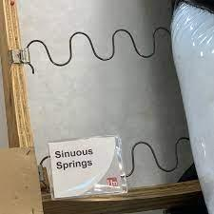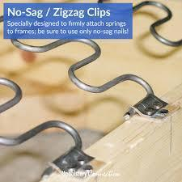
Various types of clips, such as sinuous spring clips or coil spring clips, are available to accommodate different spring designs.

Sizes:
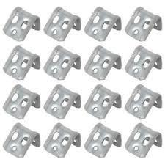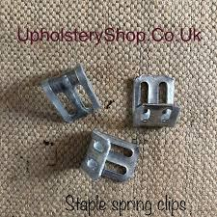
Clips come in different sizes, and the choice depends on the diameter and type of springs being used.

Quantity:
The quantity of clips needed is determined by the number of springs and the desired level of support.

Quality:
High-quality clips are essential to withstand the tension and pressure exerted on them over time.

Nails:
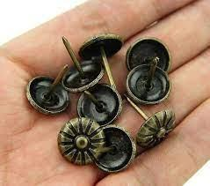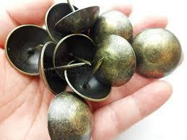
Purpose:
Nails are commonly used to attach webbing, burlap, and other foundation materials to the frame.

Types:
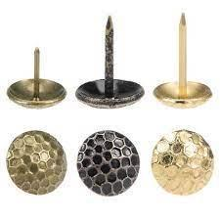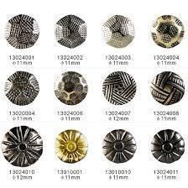
Different types of upholstery nails, including decorative and functional varieties, are available.

Sizes:
The size of nails depends on the material being secured and the desired aesthetic.

Quantity:
The quantity of nails is determined by the surface area to be covered and the type of material being attached.

Quality:
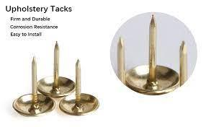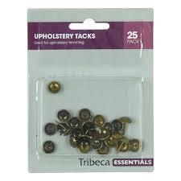
Durable and corrosion-resistant nails are crucial to maintain the structural integrity of the upholstery.

Staples:
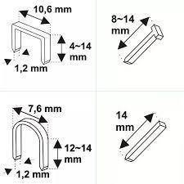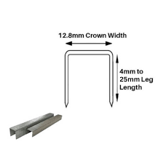
Purpose:
Staples are versatile fasteners used for securing various materials, including fabric, webbing, and padding.

Types:
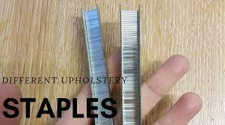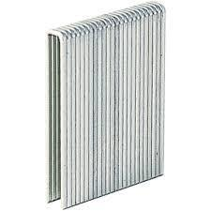
Different types of staples, such as flat or crown staples, are chosen based on the application.

Sizes:
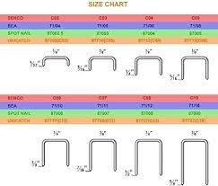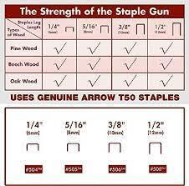
Staple sizes vary, and the selection depends on the thickness of the materials being fastened.

Quantity:
The quantity of staples is influenced by the surface area and the layers of materials being secured.

Quality:
High-quality staples are necessary to ensure a secure and lasting attachment.

Edge Rolls:
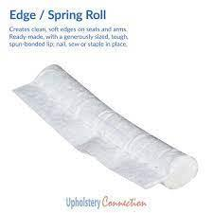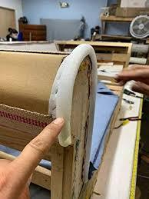
Purpose:
Edge rolls, also known as roll or wire edge, provide shape and contour to the edges of the furniture, enhancing comfort and aesthetics.

Types:
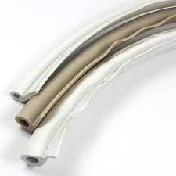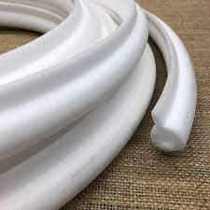
Different types of edge rolls, such as wire or rubberized edge rolls, are available based on the desired effect.

Sizes:
Edge rolls come in various sizes to accommodate different furniture designs and styles.

Quantity:
The quantity needed is determined by the length and complexity of the edges to be padded.

Quality:
Durable and resilient edge rolls are crucial to maintaining the shape and appearance of the upholstered edges.

Twine and Cord:
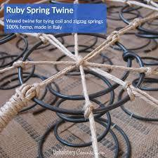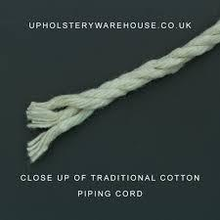
Purpose:
Twine and cord are used for tying springs together, creating a unified and stable support system.

Types:
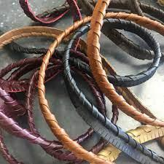
Natural and synthetic twines and cords are available, each offering specific advantages.

Sizes:
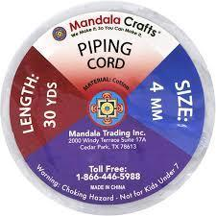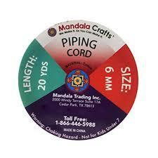
The size of twine and cord is chosen based on the type and gauge of the springs being tied.

Quantity:
The quantity needed depends on the number of springs and the preferred tying method.

Quality:
Strong and durable twine and cord are essential to withstand tension and provide long-lasting support.

Considerations for Upholsterers:
Matching Consumables to Materials:
Upholsterers must match the type, size, and quantity of consumables to the specific materials being used, considering factors like fabric thickness, spring type, and frame structure.

Precision and Consistency:
Achieving precise and consistent attachment of springs and foundation materials is crucial for the overall quality of the upholstered piece. Upholsterers need to maintain a high level of precision in placing and securing consumables.

Adherence to Standards:
Upholsterers should follow industry standards and best practices to ensure that the springing-up process meets quality and safety requirements. This involves using the right consumables in the correct manner.
Quality Control:
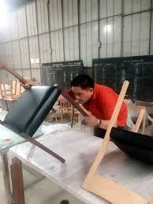
Regular quality checks should be conducted during the springing-up process to identify and address any issues promptly. This includes checking the tightness of clips, the secure attachment of nails and staples, and the proper positioning of edge rolls.

Efficient Use of Materials:
Upholsterers should optimize the use of consumables to minimize waste and enhance cost-effectiveness. This involves strategic planning and organization during the springing-up process.

By comprehensively understanding the types, sizes, quantity, and quality of consumables for the springing-up process, upholsterers can contribute to the creation of durable, comfortable, and aesthetically pleasing upholstered furniture.

KT0206 Types of webbing needed for the knocker on process, including manmade elastic and rubber webbing, and those made from natural fibres like jute webbing and hessian.

Manmade Elastic and Rubber Webbing:
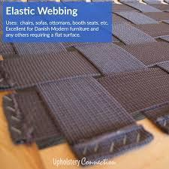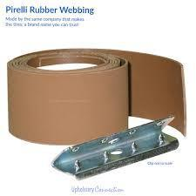
Purpose:
Adds elasticity to the upholstery, providing enhanced comfort and flexibility.

Examples:
Elastic Webbing:
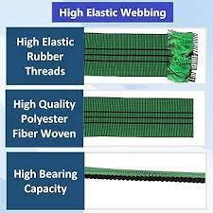
Made from stretchable materials like rubber or latex, offering dynamic support.

Rubber Webbing:
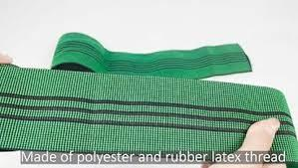
Utilizes rubber strands for durability and flexibility.

Application:
Suitable for areas that require a responsive and resilient foundation, ensuring a comfortable and supportive sitting experience.

Considerations:
Choosing the appropriate type and tension of elastic or rubber webbing based on the specific design and user preferences.

Natural Fibres like Jute Webbing and Hessian:
Purpose:
Known for their strength and stability, offering a robust foundation for upholstery.

Examples:
Jute Webbing:
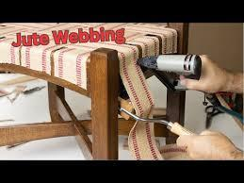
Woven from natural jute fibres, providing sturdy support.

Hessian (Burlap):

Coarse fabric made from hemp or jute, offering durability.

Application:
Ideal for creating a solid base for seating areas, especially in traditional or rustic furniture designs.

Considerations:
Assessing the weave density and thickness to match the intended level of support and the overall design aesthetics.

KT0207 Density, thickness and types of foam required for the foaming up process.
Foam Density:
Impact on Support:
Higher density contributes to firmer support and increased durability.

Variations:
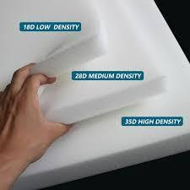
High-Density Foam:

Suitable for heavy-duty use and areas requiring robust support.

Low-Density Foam:

Offers softer support, ideal for areas prioritizing comfort over firmness.

Selection Criteria:
Determining the desired level of support and the application of the upholstered piece.

Thickness:
Influence on Feel and Appearance:
Thicker foam provides a plush feel and a fuller appearance.

Variations:
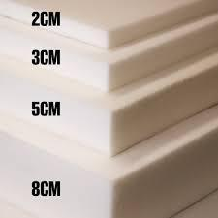
Thin Foam Layers:

Used for subtle padding or detailing.

Thick Foam Layers:

Employed for luxurious comfort and a more substantial look.

Application:
Choosing thickness based on the design, comfort requirements, and visual aesthetics.
Types:
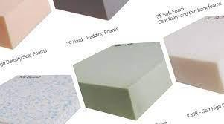

Diverse Foam Options:

Different foam types cater to various comfort preferences.

Examples:
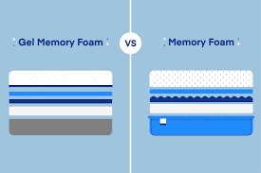

Memory Foam:
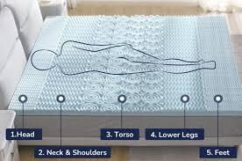
Conforms to body shape, offering personalized comfort.
Polyurethane Foam:
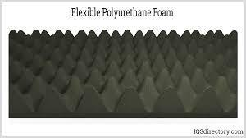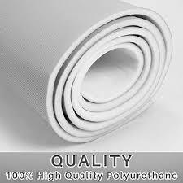
Versatile and commonly used for various upholstery applications.
Application:
Selecting foam types based on the desired feel, durability, and the specific needs of the furniture piece.
KT0208 Types of padding for covering coil springs.

Dacron:
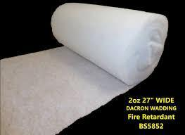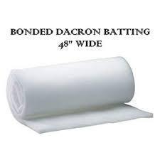
Purpose:
Adds loft and cushioning to the surface, enhancing comfort.

Application:
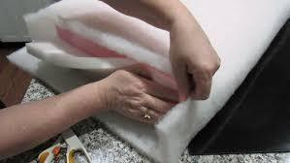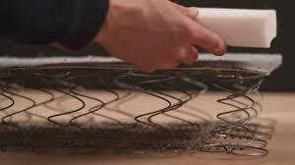
Wrapping coil springs with Dacron prevents them from directly impacting the fabric, ensuring a smoother appearance.

Considerations:
Balancing the thickness of Dacron to achieve the desired level of cushioning without compromising the overall aesthetics.

Flock:
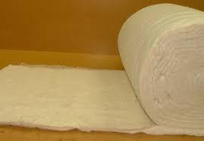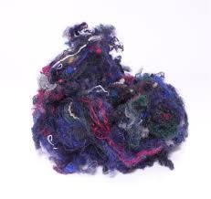
Purpose:
Provides a soft, luxurious feel to the upholstery.

Application:
Used as a top layer for added comfort, especially in high-end furniture pieces.

Considerations:
Selecting the appropriate flock material based on texture, colour, and the desired tactile experience.

KT0209 Consumables required for the foaming up process, including profile jigs and templates.
Profile Jigs and Templates:
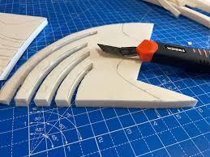
Definition:
Profile jigs and templates are tools designed to shape foam accurately according to predetermined patterns and specifications.

Purpose:
These consumables serve as guides for achieving specific contours and dimensions in the foam, ensuring consistency across upholstered pieces.

Foam Adhesives:
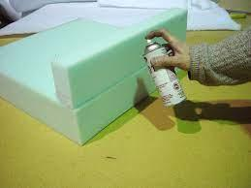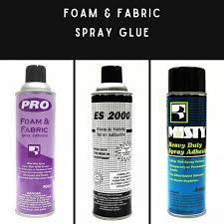
Definition:
Adhesives specifically formulated for bonding foam pieces together during the shaping process.

Purpose:
Ensures a secure and durable connection between different foam sections, maintaining the desired shape and structure.

Cutting Tools (Utility Knives, Electric Cutters):
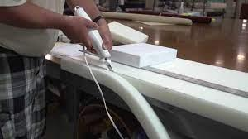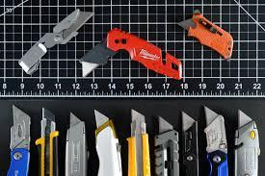
Definition:
Various cutting tools used to trim and shape foam according to the templates.

Purpose:
Enables precise cutting, creating smooth edges and accurate profiles for the foam pieces.

Measuring Instruments (Rulers, Tape Measures):
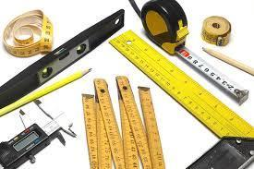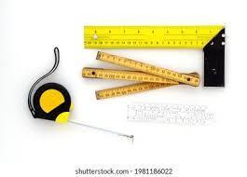
Definition:
Standard measuring tools used to verify and maintain accurate dimensions as per the design.

Purpose:
Ensures the foam pieces conform to specified measurements, preventing inaccuracies in the final upholstered product.

Safety Equipment (Gloves, Goggles):
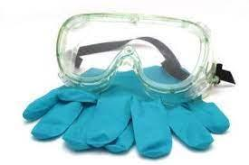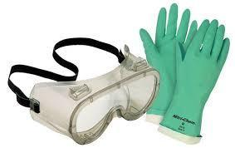
Definition:
Personal protective equipment (PPE) designed to ensure the safety of the upholsterer during the foaming-up process.

Purpose:
Protects against potential hazards such as adhesive exposure, sharp tools, and dust generated during cutting.
Cleaning Supplies (Brushes, Wipes):

Definition:
Materials used to clean excess adhesives and debris from tools and work surfaces.

Purpose:
Maintains a clean and efficient working environment, preventing the accumulation of residues that could affect the quality of the foaming-up process.

Storage Containers:
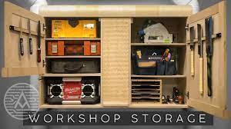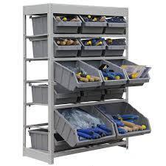

Definition:
Containers for storing and organizing different foam pieces and consumables.

Purpose:
Facilitates an organized workspace, ensuring easy access to materials and minimizing the risk of misplacement or damage.

Waste Disposal Bags:
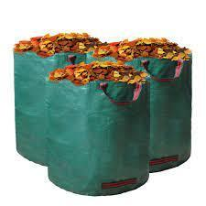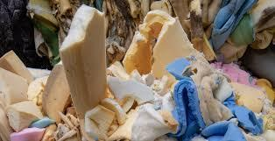
Definition:
Bags designated for the proper disposal of waste materials generated during the foaming-up process.

Purpose:
Supports eco-friendly practices by promoting responsible waste disposal.

By employing these consumables thoughtfully, upholsterers can enhance the precision, efficiency, and safety of the foaming-up process, contributing to the overall quality of the upholstered furniture.

KT0210 Fabrics used for covering webbing, springs, foam and padding including calico, hessian, polypropylene, Dacron and flock.

Base Fabrics (Calico, Hessian, Polypropylene):
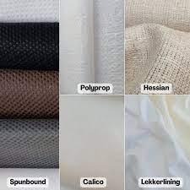

Purpose:
Provide structural support and a foundation for the upholstery layers.

Application:
Used as the initial layer to cover the frame and foundation materials.

Considerations:
Assessing the durability and compatibility of base fabrics with other upholstery components.

Additional Layers (Dacron, Cambric, Flock):
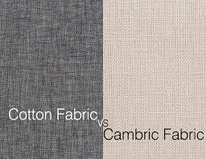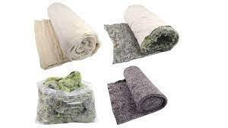

Purpose:
Enhance comfort, aesthetics, and overall upholstery performance.

Application:
Layered above the base fabrics to provide additional padding, softness, and a finished appearance.

Considerations:
Coordinating the selection of additional layers to achieve the desired look, feel, and performance.
This understanding of webbing, foam, padding, and other consumables ensures that upholsterers can make informed choices, contributing to the quality, comfort, and longevity of upholstered furniture.

KT0211 Labels, codes and the coding system and traceability.
Labels:

Definition:

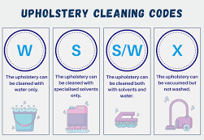
Labels in upholstery contain essential information about the materials, providing details such as composition, care instructions, and origin.

Purpose:
Enables traceability and ensures that materials are used correctly based on specifications and industry standards.

Codes and Coding System:

Definition:
Codes are alphanumeric or symbolic representations assigned to materials, helping in inventory management and tracking.

Purpose:
Facilitates efficient organization, quick identification, and easy retrieval of materials during the upholstery process.
KT0212 Principles and concepts of safe materials handling and storage methods.

Handling:
Principles:
Proper Lifting Techniques:


Upholsterers are trained in lifting heavy materials using techniques that minimize the risk of injury.

Equipment Usage:
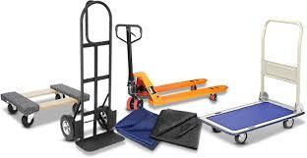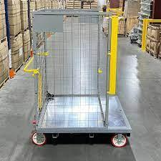
The use of appropriate tools and equipment, like dollies and carts, to transport materials safely.

Purpose:
Prevents injuries and ensures the physical well-being of workers, promoting a safe working environment.

Storage:
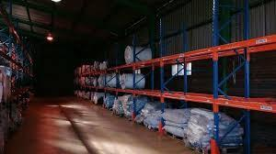

Principles:
Climate Considerations:
Materials are stored in environments that prevent degradation due to temperature and humidity.

Protection:

Materials are protected from dust, pests, and other potential damage factors.

Organisation:
A systematic arrangement of materials for easy access and inventory management.

Purpose:
Preserves the quality of materials, minimizes waste, and facilitates efficient material retrieval.

KT0213 Identify raw materials used in furniture making and explain the characteristics of each.
Hardwoods:
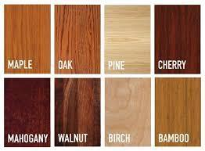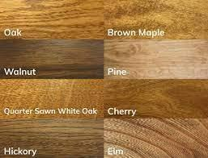
Characteristics:
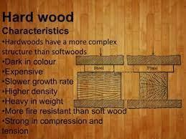
Durable and Resistant:

Hardwoods like oak and maple are known for their durability and resistance to wear.

Distinctive Grain Patterns:
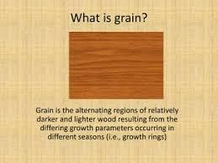
Each hardwood species has a unique grain pattern, contributing to aesthetic appeal.

Uses:
Commonly used for structural components requiring strength and durability.

Softwoods:
Characteristics:
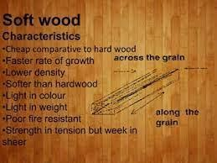

Lighter and Porous:

Softwoods like pine are lighter in weight and more porous than hardwoods.

Uses:
Suitable for various applications, including decorative elements and less load-bearing components.

Bamboo and Cane:


Characteristics:
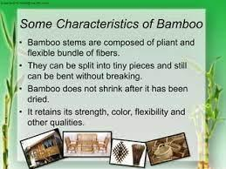

Lightweight and Flexible:
Bamboo and cane are lightweight materials with inherent flexibility.

Uses:
Add visual appeal in decorative elements, often used for chair backs and sides.

Veneers:


Characteristics:
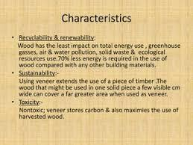

Thin Layers:

Veneers are thin slices of wood applied to a base material.

Uses:
Used for decorative surfaces, providing the appearance of solid wood at a lower cost.

By understanding and applying the principles and concepts outlined in these topics, furniture upholsterers can ensure the proper handling, storage, and identification of raw materials, contributing to the overall quality and durability of the upholstered products.

Formative assessment

IAC0201 The use of specifications and workplace instructions to determine the type, quality, sizes and quantities of raw materials and consumables for the frame preparation process is reasoned.
IAC0202 Various types of frames and their raw materials and type of foundation materials to be used for each component are identified.
IAC0203 Types and gauges of various springs needed for the knocker-on process are identified including coil springs and zig-zag springs.
IAC0204 Types, sizes, quantity and quality of consumables such as clips, nails, staples, edge rolls, twine and cord needed for the springing up process are identified.
IAC0205 Differences between the types of webbing needed for the knocker on process, such as manmade elastic and rubber webbing, and natural fibres like jute webbing are evaluated.
IAC0206 Types, sizes, quantity and quality of consumables such as clips, tacks, and staples needed for the webbing up process are identified.
IAC0207 Methods for identifying density and thickness of various types of foam required for the foaming up process are described.
IAC0208 Consumables required for the foaming up process are listed.
IAC0209 Raw materials required for the padding and covering of coil springs are listed.
IAC0210 Fabrics used for covering webbing, springs, foam and padding including calico, hessian (burlap), polypropylene, Dacron, cambric and flock are listed.
IAC0211 Principles and concepts of safe materials handling and storage methods are reasoned.

(Weight 15%)

KM-02-KT03: Raw materials and consumables used in the frame padding process (5%)

Learning Outcome
At the end of this section, learners should cover:

KT0301 Fabric types, characteristics and uses, safe handling and storage (such as coir, kapok, wadding).
KT0302 Man-made fiber and cloths, characteristics and uses, safe handling and storage (foam).
KT0303 Padding materials and foam characteristics and uses.
KT0304 Safe handling and storage of raw materials.

KT0301 Fabric types, characteristics and uses, safe handling and storage (such as coir, kapok, wadding).

Examples of Natural Materials:
Coir:

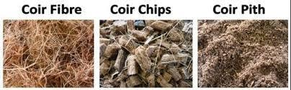
Characteristics:

Natural fibre extracted from coconut husks, known for its durability and resilience.

Uses:
Commonly used as padding material in seats and backs for its firm support.

Safe Handling and Storage:
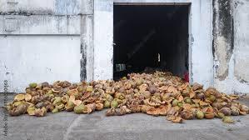
Coir should be stored in dry conditions to prevent mould growth, and handling should be done with gloves to avoid skin irritation.

Kapok:
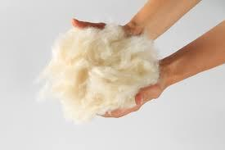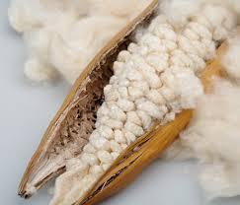
Characteristics:

Lightweight and buoyant natural fibre obtained from the seed hairs of kapok trees.

Uses:
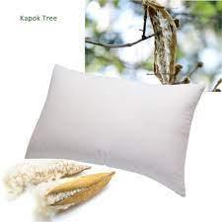
Ideal for providing a soft and fluffy feel in cushions and pillows.

Safe Handling and Storage:
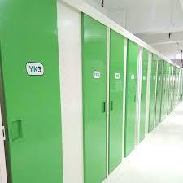
https://encrypted-tbn0.gstatic.com/images?q=tbn:ANd9GcRNkCY6BSxUsmc3KJXEfH7DlOQdwBLAashu4A&usqp=CAU
https://encrypted-tbn0.gstatic.com/images?q=tbn:ANd9GcTnyjcytMJH-frx7qYYt6D2zmjeaxBKJ3YjGw&usqp=CAU
Kapok requires careful handling due to its fine fibres, and storage should be in a well-ventilated area to prevent moisture retention.

Wadding:
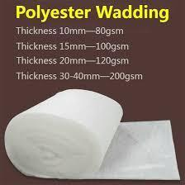
Characteristics:
Soft and pliable material often made from cotton or other fibres, offering loft and comfort.

Uses:

Wadding is commonly used as a layer of padding to add softness and loft in cushions and upholstery.

Safe Handling and Storage:
Wadding should be handled gently to maintain its loft, and storage should be in a dry environment to prevent compression.

By incorporating information about wadding, learners gain a more comprehensive understanding of natural materials used in upholstery, meeting the assessment criteria effectively.

KT0302 Man-made fibre and cloths, characteristics and uses, safe handling and storage (foam).

Examples of Man-made Materials:
Foam:
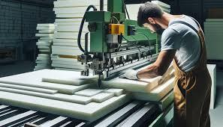

Characteristics:
Versatile padding material with various densities, providing customizable support.

Uses:
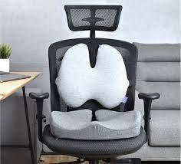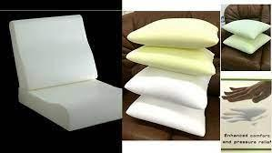
Commonly used in seat cushions and backs to enhance comfort and resilience.

Safe Handling and Storage:
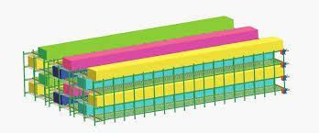
Foam should be handled with care to prevent tearing, and storage should be in a dry and cool environment to maintain its properties.

Characteristics:

Soft and fluffy synthetic fibre, known for its loft and insulating properties.

Uses:
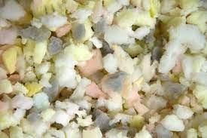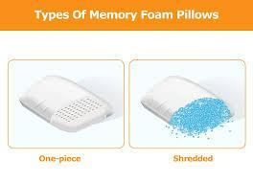
Frequently used as filling for cushions and pillows to add a plush feel.

Safe Handling and Storage:
Gentle handling is important to preserve the fibre’s loftiness.
Storage in a clean and dry space to prevent clumping and maintain its volume.

Polypropylene Fabric:
Characteristics:

Synthetic fabric known for its durability, resistance to moisture, and quick-drying properties.

Uses:
Commonly used for upholstery in outdoor furniture due to its weather-resistant features.

Safe Handling and Storage:
Can be handled with standard care, and storage should be in a cool, dry place.
Resistant to mildew, reducing the risk of damage during storage.

KT0303 Padding materials and foam characteristics and uses.

Examples of Padding Materials:
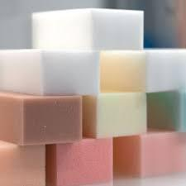
Natural Padding:
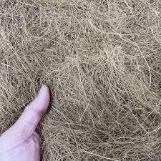
Characteristics:
Include coir, kapok, and wadding, offering different levels of firmness and support.

Uses:
Coir for firm support, kapok for a softer feel, and wadding for added loft in cushions.

Foam Characteristics:
Varying densities of foam cater to different comfort preferences, with high-density foam offering firmer support and low-density foam providing a softer feel.

Uses:
Foam is utilized in various upholstery applications, from seating to mattresses.
KT0304 Safe handling and storage of raw materials.
General Principles:
Handling:

Importance:
Proper handling prevents damage to materials and ensures the safety of workers.

Examples:
Using gloves when handling coir and kapok due to potential skin irritation.

Storage:
Importance:
Appropriate storage conditions preserve material integrity.

Examples:
Storing foam in a climate-controlled environment to prevent deterioration.

By understanding the characteristics, uses, and safe handling/storage practices for natural and man-made padding materials, furniture upholsterers can ensure the quality and longevity of upholstered products. This knowledge aligns with the assessment criteria, enabling learners to identify and evaluate different raw materials effectively.

Formative assessment

IAC0301 Types of natural raw materials used as padding for upholstered furniture are identified and the respective uses and characteristics are evaluated.
IAC0302 Types of man-made raw materials used as padding for upholstered furniture are identified and the respective uses and characteristics are evaluated.
IAC0303 The importance of safe handling and storage of raw materials is justified.

(Weight 5%)

KM-02-KT04: Use of chemicals: adhesives and solvents (5%)

Learning Outcome
At the end of this section, learners should cover:

KT0401 Chemical types, characteristics, properties and purpose.
KT0402 Types of solvents characteristics, properties and purpose.
KT0403 Application equipment, tools and dispensers.
KT0404 Measuring and application techniques and procedures.
KT0405 Preparation and application techniques.
KT0406 Safety hazards and risks.

KT0401 Chemical types, characteristics, properties and purpose.
Adhesives:

Characteristics:
Varying formulations such as water-based, solvent-based, or hot melt.
Adhesive strength, curing time, and flexibility are key characteristics.

Purpose:

Bonding different materials like fabric to foam or wood to create a cohesive structure.

Flame Retardants:
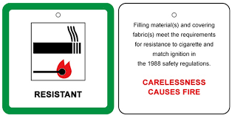
Characteristics:

Formulated to inhibit the spread of flames on upholstery materials.

Purpose:

Enhancing the fire safety of upholstered items.

Antimicrobial Agents:

Characteristics:
Designed to inhibit the growth of bacteria and mould.

Purpose:

Preventing microbial-related issues in upholstery, especially in humid environments.
KT0402 Types of solvents characteristics, properties and purpose.
Mineral Spirits:
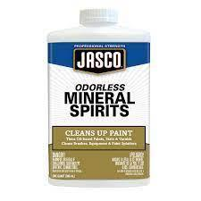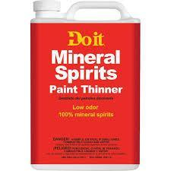
Characteristics:

Petroleum-based solvent effective for cleaning and thinning.

Purpose:

Diluting adhesives, cleaning tools, and preparing surfaces for bonding.

Acetone:
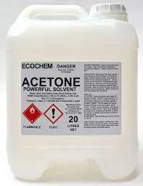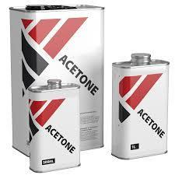

Characteristics:

Fast-evaporating solvent with strong cleaning properties.

Purpose:

Removing adhesives, cleaning surfaces, and preparing materials for finishing.
KT0403 Application equipment, tools and dispensers.

Spray Guns:

Application Equipment:
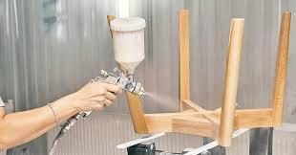

Devices for Controlled Application:
Spray guns are essential devices employed in upholstery processes for applying adhesives and solvents. These tools are designed to ensure a controlled and even distribution of chemicals onto various surfaces.

Precision and Control:
Spray guns provide a level of precision and control that is crucial in upholstery work. They allow the upholsterer to target specific areas or cover larger surfaces evenly, depending on the requirements of the task.

Efficient Coverage:
The design of spray guns facilitates efficient coverage of materials, ensuring that adhesives or solvents are applied uniformly. This is particularly important for achieving strong and consistent bonds in the upholstery assembly.

Tools and Dispensers:
Nozzles:
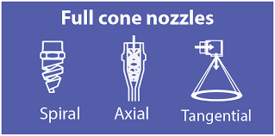
Nozzles are attachments or components of spray guns that play a crucial role in shaping and directing the spray pattern. Different types of nozzles can be used to achieve variations in spray width, ensuring adaptability to the specific needs of the task.

Containers:
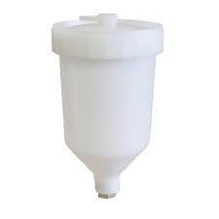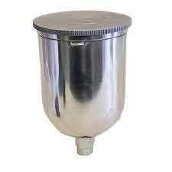
Containers, often referred to as reservoirs or cups, are integral parts of spray guns that hold the chemicals to be dispensed. These containers are designed to accommodate the specific chemical formulations used in upholstery, and they vary in size based on the volume needed for a particular job.

Designed for Specific Chemical Formulations:
Tools and dispensers associated with spray guns are engineered to match the characteristics of the chemicals used in upholstery. For instance, the materials and design of nozzles and containers are selected to be compatible with the viscosity and properties of adhesives and solvents.

Ensuring Compatibility:
The selection of the appropriate tools and dispensers is critical to ensure that the spray gun functions optimally with the chosen chemicals. This compatibility enhances the efficiency of the application process and contributes to the quality of the upholstery work.

Maintenance:
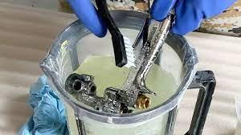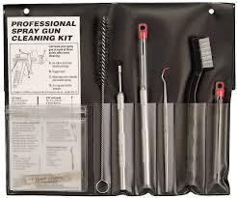
Upholsterers must maintain and clean the tools and dispensers regularly to prevent any residue build-up that might affect the performance of the spray gun. Proper care extends the lifespan of the equipment and ensures consistent application over time.
By using spray guns, along with the associated tools and dispensers, upholsterers can achieve precise, efficient, and consistent application of adhesives and solvents, meeting the specific requirements of different upholstery tasks. The careful selection and maintenance of these tools contribute to the overall quality of the upholstered products.

KT0404 Measuring and application techniques and procedures.
Proper Mixing:
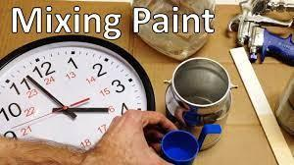

Techniques:
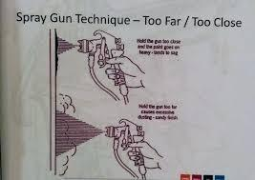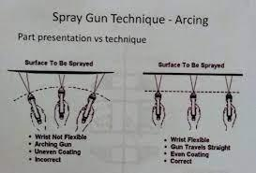

Following Recommended Ratios:
Upholstery chemicals, including adhesives, often come in components that need to be mixed in specific ratios. Upholsterers must adhere to the recommended ratios provided by the manufacturers. This involves precise measurement to achieve the desired chemical composition.

Accurate Measurement:

Measuring techniques involve using appropriate tools, such as graduated containers or scales, to ensure accuracy in the quantity of each component. Upholsterers should be adept at measuring the chemicals to the required precision.

Procedures:
Ensuring Thorough Blending:

The effectiveness of adhesives and other chemicals is heavily dependent on thorough mixing. Upholsterers must follow procedures that guarantee a complete blend of components. This might involve stirring, shaking, or using mechanical mixers to achieve homogeneity in the chemical mixture.

Optimal Performance:
Proper mixing is crucial for the optimal performance of adhesives and solvents. A well-blended mixture ensures that the chemicals function as intended, providing the necessary bonding strength and other desired properties.

Application Sequencing:
Techniques:
Applying Adhesives Before Assembly:
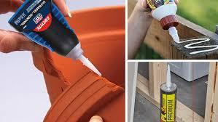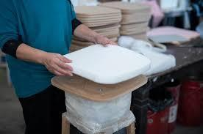
Upholsterers often apply adhesives to surfaces before assembling various upholstery components. This technique allows for a uniform distribution of the adhesive and facilitates better bonding between the materials.

Procedures:
Sequencing for Strong Bonds:


The sequence of application is critical to achieving strong and durable bonds. Upholsterers follow procedures that dictate the order in which chemicals are applied during the upholstery process. This might involve applying adhesives to specific components at strategic points in the assembly process to ensure optimal bonding.
For instance, applying adhesive to a foam cushion before attaching fabric ensures that the bond is formed effectively, contributing to the longevity and quality of the upholstered piece.
By mastering proper measuring techniques and following precise application procedures, upholsterers can enhance the efficacy of chemicals used in the upholstery process. This attention to detail in mixing and sequencing contributes to the overall quality, durability, and performance of upholstered furniture.

KT0405 Preparation and application techniques.
Surface Preparation:
Techniques:

Cleaning and Sanding:
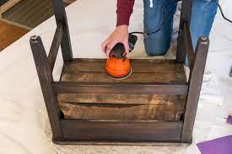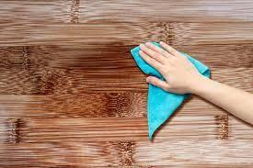
Before applying adhesives or solvents, the surfaces must be clean and, in some cases, roughened to ensure proper adhesion. Techniques involve thorough cleaning to remove dust, dirt, or residues, and sanding to create a suitable surface for bonding.

Surface Priming:
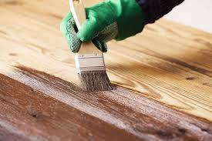
In certain applications, especially with particular materials, priming may be necessary. Techniques for priming involve applying a preparatory coat to enhance the adhesion of subsequent layers.

Procedures:
Adhering to Manufacturer Guidelines:
Upholsterers should strictly follow the guidelines provided by chemical manufacturers regarding surface preparation. Procedures may include specific cleaning agents, sanding grits, or primers recommended for compatibility with the chosen chemicals.

Application Techniques:
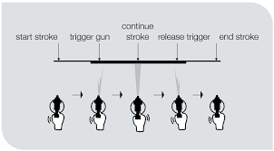
Spraying:
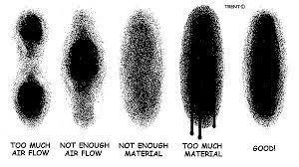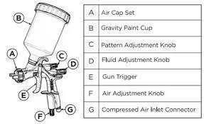
Applying adhesives and solvents often involves spraying for an even and controlled distribution. This technique requires skill in adjusting spray nozzles and controlling the application pressure to achieve the desired coverage.

Brushing/Rolling:
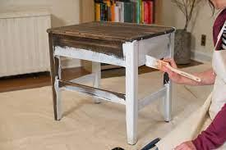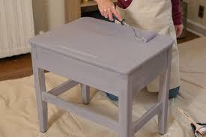
Depending on the nature of the chemicals and the specific requirements of the upholstery project, brushing or rolling may be employed. These techniques allow for precision in applying chemicals to targeted areas.

Procedures:
Uniform Application:
Upholsterers must follow procedures to ensure uniform application of chemicals. This involves maintaining consistent pressure and coverage, whether through spraying, brushing, or rolling.

Drying Time Observance:
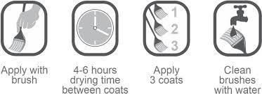

Following recommended drying times is crucial to the success of the application. Upholsterers should adhere to specified procedures for allowing sufficient drying time between coats or before assembling upholstered components.
By mastering surface preparation and application techniques, and adhering to precise procedures, upholsterers can achieve optimal results in the use of chemicals. These steps contribute to the longevity, aesthetics, and quality of upholstered furniture.
KT0406 Safety hazards and risks.

Types of Chemical Hazards:
Inhalation Hazards:
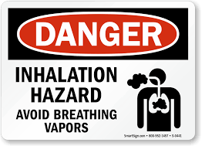
Chemical Fumes:

Inhalation of fumes from adhesives and solvents can lead to respiratory issues. Proper ventilation is crucial to mitigate this hazard.

Volatile Organic Compounds (VOCs):

Some chemicals release VOCs during application, posing inhalation risks. Upholsterers should be aware of the VOC content in the products used.

Skin Contact Hazards:

Chemical Burns:
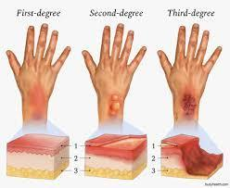
Direct contact with certain adhesives or solvents may cause skin irritation or chemical burns. Upholsterers must use appropriate protective gear to prevent skin exposure.

Allergic Reactions:

Some individuals may be allergic to specific chemicals. Upholsterers should be aware of potential allergens and take necessary precautions.

Eye Hazards:


Chemical Splashes:

Mishandling of chemicals can result in eye exposure, leading to irritation or more severe injuries. Protective eyewear is essential during chemical application.

Characteristics and Properties:
Flammability:

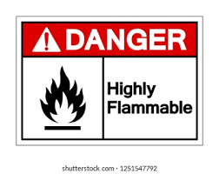
Highly Flammable Products:
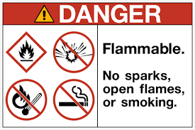
Some adhesives and solvents are highly flammable. Upholsterers need to be cautious around potential ignition sources.

Toxicity:
Toxic Chemicals:

Understanding the toxicity of chemicals is crucial. Upholsterers should be informed about the potential health effects and adhere to safety guidelines.

Purpose of Safety Procedures:
Personal Protective Equipment (PPE):

Usage and Care:

Upholsterers must be trained in selecting, using, and maintaining PPE, including gloves, goggles, and masks.

Handling Spillages, Waste, and Effluent:
Spill Response Procedures:

In the event of spills, proper clean-up procedures should be followed to prevent environmental contamination and exposure.

Standard Operating Procedures:

Adherence to SOPs:
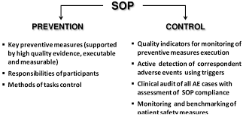

Upholsterers must follow established SOPs for handling chemicals, ensuring a standardized and safe approach in the workshop.
By being aware of the hazards, understanding the characteristics of chemicals, and following safety procedures, upholsterers can create a secure working environment and reduce the risks associated with chemical use in upholstery processes.

Formative assessment

IAC0401 The various types of chemicals used in upholstery processes are named.
IAC0402 Characteristics and properties of the chemicals used in upholstery processes are described.
IAC0403 The purpose of each of these chemicals used in the process is explained.
IAC0404 Various types of solvents used in upholstery processes are listed.
IAC0405 Characteristics and properties of these solvents are explained.
IAC0406 The purpose of each solvent used in the process is explained.
IAC0407 The application techniques and sequence used for chemicals and solvents are described.
IAC0408 Safety procedures, hazards and risks associated with handling of chemicals and solvents are described.
IAC0409 Standard operating procedures dealing with spillages, waste and effluent are explained.
IAC0410 Types, usage and care of personal protective equipment used in textile wet product preparation processes are described.

(Weight 5%)

KM-02-KT05: Upholstery tools and equipment (10%)

Learning Outcome
At the end of this section, learners should cover:

KT0501 Upholstery hand tools for the knocker on springing, webbing and foaming processes: operation, components and parts, uses, safe storage and handling.
KT0502 Pneumatic tools, settings and operation of, components and parts, relationship between parts, uses, safe storage and handling, supply systems for knocker on springing, webbing and foaming processes.
KT0503 Upholstery electric portable power tools for the knocker on springing, webbing and foaming processes: settings and operation of, components and parts, uses, safe storage and handling.
KT0504 Upholstery frame preparation equipment.
KT0505 Spraying equipment for adhesive application and foaming up workstations.
KT0506 Personal protective equipment and materials handling equipment.
KT0507 Tools and equipment maintenance, fault finding and standard operating procedures.
KT0508 Safety measures and mechanisms.

KT0501 Upholstery hand tools for the knocker on springing, webbing and foaming processes: operation, components and parts, uses, safe storage and handling.
Operation:
Knocker-On Springing:
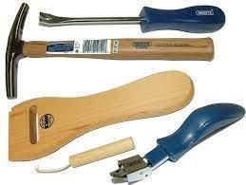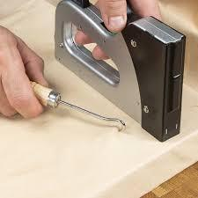
Hand tools like tack hammers, webbing stretchers, and staple guns are used to secure springs and webbing to the frame.
Precision and control are essential for effective knocker-on processes.

Webbing and Foaming:
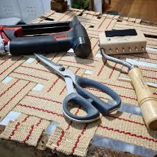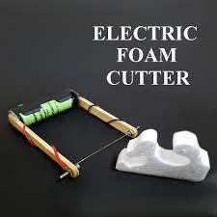
Hand tools, such as shears and foam cutters, aid in cutting and shaping materials for webbing and foaming.
Skillful operation ensures accurate and efficient work.

Components and Parts:
Tack Hammer:
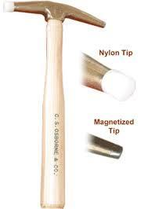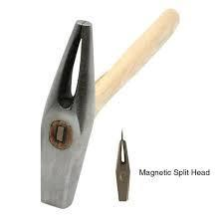
Components include a handle and a striking head.
The head may have a magnetic surface to hold tacks during application.

Webbing Stretcher:
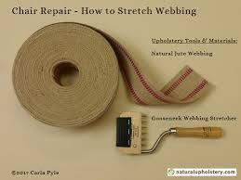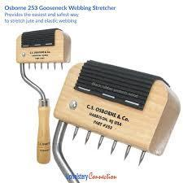
Typically consists of a handle and jaws for stretching and securing webbing.
Adjustments may be available for different webbing tensions.

Staple Gun:
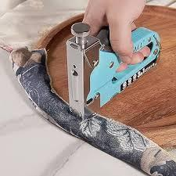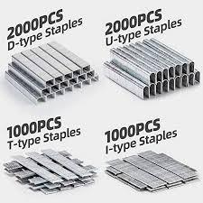
Components include a trigger, magazine, and nose for staple insertion.
Different staple sizes can be accommodated based on the model.

Uses:
Tack Hammer:
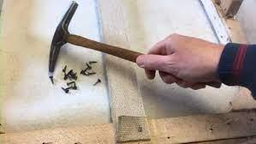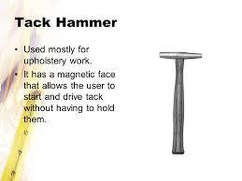
Securing fabric and materials to the frame.
Tacking springs in place during the knocker-on process.

Webbing Stretcher:
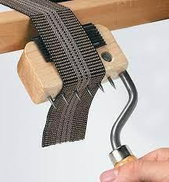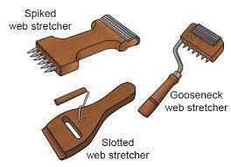
Stretching and securing webbing evenly across the frame.
Ensuring proper tension for a comfortable seat.

Staple Gun:
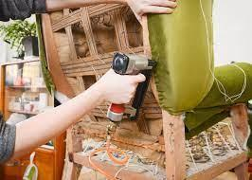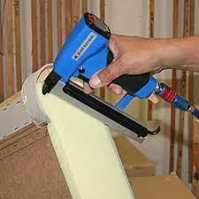
Fixing materials like fabric and foam to the frame.
Essential for attaching components securely.

Safe Storage and Handling:

Storage:
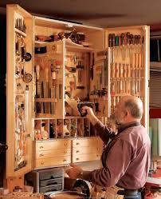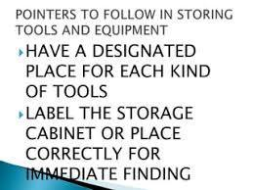

Tools should be stored in a designated area to prevent damage and ensure easy access.
Magnetic surfaces on tack hammers should be kept clean.

Handling:
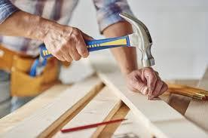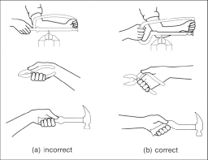
Proper gripping techniques to avoid strain.
Regular checks for wear and tear.

KT0502 Pneumatic tools, settings and operation of, components and parts, relationship between parts, uses, safe storage and handling, supply systems for knocker on springing, webbing and foaming processes.

Settings and Operation:
Adjusting Pressure:

Understanding and adjusting air pressure for optimal tool performance.
Higher pressure for heavy-duty tasks, lower pressure for delicate materials.

Operation:
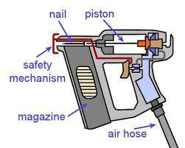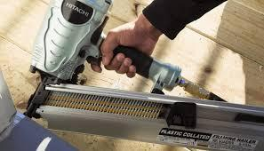
Trigger control for precise staple or nail placement.
Sequential or bump firing modes depending on the application.

Components and Parts:
Pneumatic Stapler:
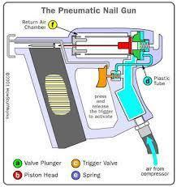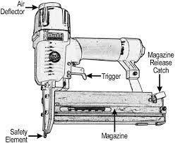
Components include a magazine, nose, trigger, and air inlet.
Magazine capacity varies based on the model.

Pneumatic Nailer:
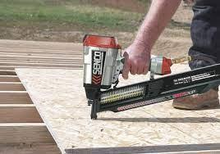
Similar components to a stapler but designed for nails.
Sequential or contact firing modes available.

Relationship Between Parts:
Air Inlet to Trigger:
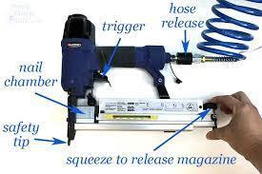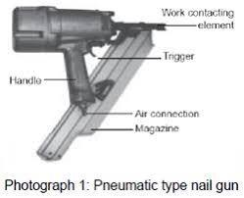
Air flows from the compressor to the trigger mechanism.
Trigger controls the release of air for tool operation.

Magazine to Nose:
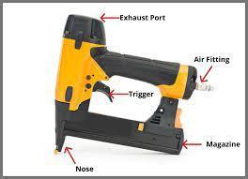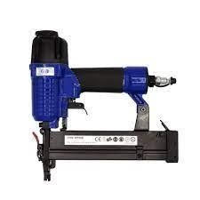
Magazine feeds staples or nails to the nose for firing.
Proper loading ensures smooth operation.

Uses:
Pneumatic Stapler:
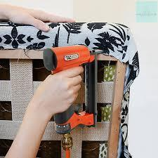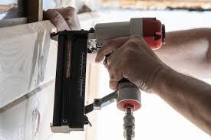
Rapid and efficient stapling of fabric and materials to the frame.
Ideal for large-scale upholstery projects.

Pneumatic Nailer:
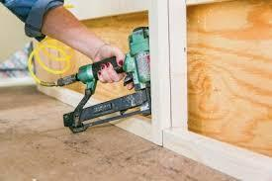
Securing frame components using nails.
Useful for attaching hard-to-reach areas.

Safe Storage and Handling:
Storage:
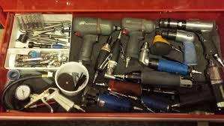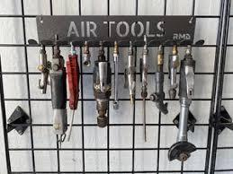
Pneumatic tools should be stored in a dry and clean environment.
Regular checks for air leaks and worn parts.

Handling:
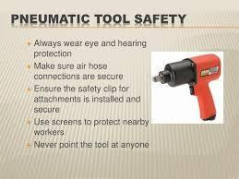
Safe handling involves understanding the tool's kickback.
Following guidelines for proper grip and trigger control.

KT0503 Upholstery electric portable power tools for the knocker on springing, webbing and foaming processes: settings and operation of, components and parts, uses, safe storage and handling.

Settings and Operation:
Speed and Depth Adjustment:
Understanding and adjusting speed and depth for different materials.
Higher speeds for cutting, lower speeds for precision.

Operation:
Trigger control for the activation of the tool.
Understanding the direction of blade rotation for accurate cutting.

Components and Parts:
Electric Staple Gun:
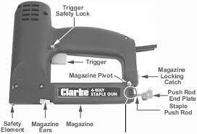
Components include a trigger, magazine, and nose.
Compatible with various staple sizes.

Electric Foam Cutter:
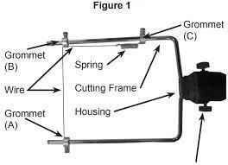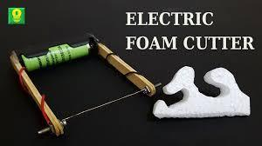
Components include a handle, trigger, and cutting blade.
Blade options for different foam densities.

Uses:
Electric Staple Gun:
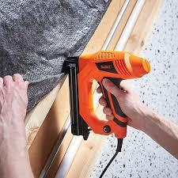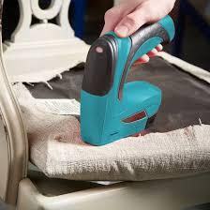
Quick and precise stapling of materials to the frame.
Suitable for both large-scale and intricate upholstery work.

Electric Foam Cutter:
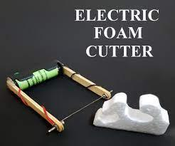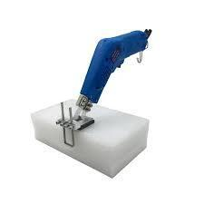
Efficient shaping and cutting of foam.
Ideal for creating custom foam shapes.

Safe Storage and Handling:
Storage:
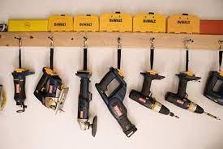
Electric tools should be stored in a dry and secure location.
Protective cases for blades and accessories.

Handling:
Proper handling includes a firm grip and controlled movements.
Regular checks for wear on blades and electrical components.

KT0504 Upholstery frame preparation equipment.
Purpose and Components:
Frame Glue Applicator:
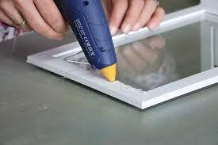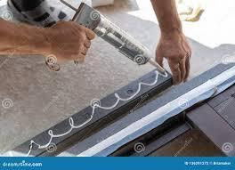
Purpose:
Applying adhesive for joining frame components.

Components:
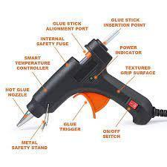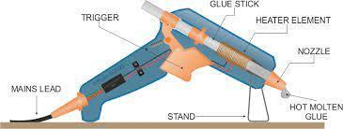
Reservoir for glue, applicator nozzle, trigger mechanism.

Frame Joint Connector:
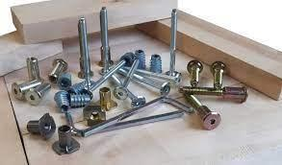
Purpose:
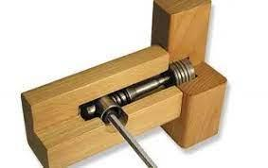
Joining frame elements securely.

Components:
Connector pieces, screws, and tools for assembly.

Frame Staple Gun:
Purpose:
Securing joints and frame components.
Components:
Trigger, magazine, and nose for staple insertion.

Uses:
Frame Glue Applicator:
Applying glue evenly along joint surfaces.
Ensuring a strong bond between frame elements.

Frame Joint Connector:
Joining frame components for structural integrity.
Essential for constructing sturdy furniture frames.

Frame Staple Gun:
Securing joints with staples for additional strength.
Versatile tool for various frame assembly tasks.

Safe Storage and Handling:
Storage:
Glue applicators and staple guns should be stored in a clean and dry environment.
Regular checks for clogs and proper functioning.

2. Handling:
Adhering to safety guidelines for handling glue applicators.
Proper grip and trigger control for staple guns.

KT0505 Spraying equipment for adhesive application and foaming up workstations.

Types and Components:
Spray Gun for Adhesive:

Types:
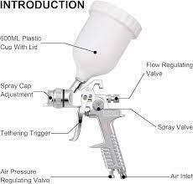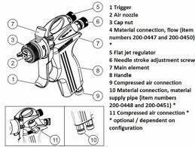

HVLP (High Volume Low Pressure) and airless spray guns.
Components:
Nozzle, trigger, paint container, and air supply.

Foam Spray Gun:
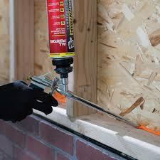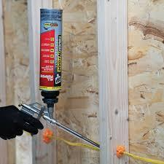
Types:
PU foam spray guns for precise foam application.

Components:
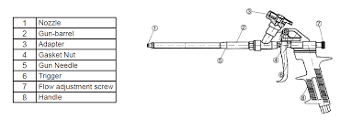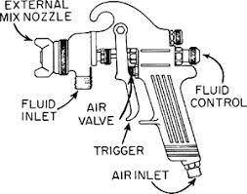
Trigger, nozzle, and foam canister.

Uses:
Spray Gun for Adhesive:
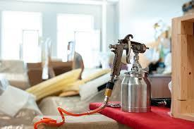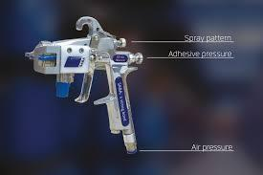
Applying adhesive evenly on large surfaces.
Suitable for various upholstery projects.

Foam Spray Gun:
Controlled application of foam for padding.
Ensures uniform foam distribution.

Safe Storage and Handling:
Storage:
Spray guns should be stored with proper care to prevent nozzle clogs.
Foam spray canisters stored in a cool and dry place.

Handling:
Adhering to safety guidelines for handling spray guns.
Regular cleaning to prevent residue buildup.

KT0506 Personal protective equipment and materials handling equipment.
Types and Usage:
Personal Protective Equipment (PPE):

Types:

Safety glasses, gloves, ear protection, and masks.

Usage:
Protection against dust, chemicals, and noise.

Materials Handling Equipment:
Types:
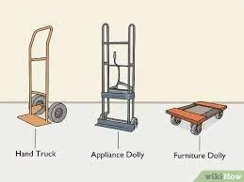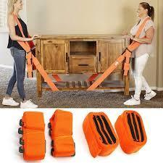
Dollies, hand trucks, and lifting straps.

Usage:
Safely transporting heavy materials and furniture.

Care and Usage:
PPE:

Regular inspection for wear and tear.
Proper fitting and usage based on the task.
Materials Handling Equipment:
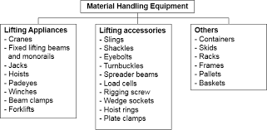
Regular maintenance checks for wheels and straps.
Adhering to weight capacity guidelines.

KT0507 Tools and equipment maintenance, fault finding and standard operating procedures.
Maintenance Procedures:
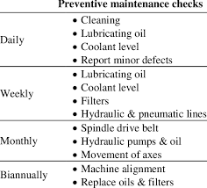
Hand Tools:
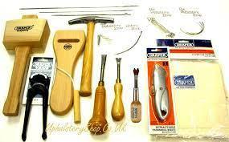
Components:
Handles, blades, and moving parts.

Maintenance:
Regular cleaning, lubrication, and blade sharpening.
Inspection for wear and tear.

Pneumatic Power Tools:
Components:
Air hoses, triggers, and moving parts.

Maintenance:
Lubricating moving parts.
Regular checks for air leaks.

Electric Power Tools:
Components:
Cords, switches, and moving parts.

Maintenance:
Checking for frayed cords.
Lubricating moving parts.

Fault Finding:
Hand Tools:
Identifying loose handles or misaligned components.
Addressing issues related to worn-out parts.

Pneumatic Power Tools:
Diagnosing air pressure irregularities.
Identifying trigger malfunctions.

Electric Power Tools:
Checking for power supply issues.
Diagnosing motor or switch problems.

Standard Operating Procedures:
Hand Tools:
Demonstrating correct usage techniques.
Following proper sequences in frame preparation.

Pneumatic Power Tools:
Adhering to safety guidelines for air pressure.
Demonstrating correct handling during operation.

Electric Power Tools:
Following manufacturer's instructions for usage.
Demonstrating proper handling to avoid electrical hazards.

KT0508 Safety measures and mechanisms.
Safety Measures:
Hand Tools:
Proper usage techniques to prevent injuries.
Ensuring tools are in good condition before use.

Pneumatic Power Tools:
Wearing appropriate PPE during operation.
Regular checks for air pressure stability.

Electric Power Tools:
Adhering to electrical safety guidelines.
Avoiding the use of damaged tools.

Safety Mechanisms:
Hand Tools:
Ergonomic designs to reduce strain.
Safety locks for certain tools.

Pneumatic Power Tools:
Trigger locks for controlled operation.
Safety valves for air pressure regulation.

Electric Power Tools:
Overload protection mechanisms.
Insulated handles for electrical safety.

Upholstery Frame Preparation Equipment:
Proper use of cutting and shaping tools.
Ensuring stability during equipment operation.

Spraying Equipment for Adhesive Application and Foaming Up Workstations:
Proper ventilation to minimize inhalation risks.
Regular inspection and maintenance of spray nozzles.
Personal Protective Equipment (PPE) and Materials Handling Equipment:
Correct fitting and usage of PPE like gloves and safety goggles.
Training on the proper use of materials handling equipment to prevent strain.
Understanding and implementing these safety measures and mechanisms are crucial for maintaining a secure working environment in the upholstery field. Regular training, adherence to guidelines, and routine equipment checks contribute to a safer workplace for all involved. Upholsterers should prioritize safety at every step of the process, from tool usage to materials handling and equipment operation.

Formative assessment

IAC0501 Hand tools used by the frame preparing department are identified and their purposes are explained.
IAC0502 Parts of the hand tools are identified.
IAC0503 Maintenance procedures for each tool explained.
IAC0504 The consequences of not handling, cleaning and maintaining hand tools correctly are assessed.
IAC0505 Pneumatic power tools used in the frame preparing department are identified and their purposes explained.
IAC0506 Parts and safety mechanisms of the pneumatic power tools are identified and the maintenance procedures for each tool is explained.
IAC0507 The consequences of not handling, cleaning and maintaining pneumatic power tools correctly are assessed.
IAC0508 Electric power tools used in the frame preparation department are identified and respective purpose is explained.
IAC0509 Parts and safety mechanisms of the electric power tools are identified and maintenance procedures for each tool is assessed.
IAC0510 Consequences of not handling, cleaning and maintaining electric power tools correctly is evaluated.
IAC0511 The identification, selection and loading staples, nails, bits and other consumables into the relevant power tool are explained.
IAC0512 The consequences of not cleaning the spray equipment and spray booth thoroughly after use are assessed.

Definition:
Precision refers to the level of detail and exactness in measurements, while consistency involves maintaining uniformity throughout the process.

Application:
Upholsterers must consistently apply precise measurement techniques to every component of the frame, ensuring uniformity in dimensions.

Reference Points and Benchmarks:
Definition:
Establishing reference points and benchmarks provides a standardized framework for measurements.

Application:
Use identifiable reference points on the frame or template to measure and mark key locations consistently, reducing the likelihood of errors.

Double-Checking and Verifying:
Definition:
Double-checking involves reviewing measurements for accuracy, and verifying ensures that measurements align with specifications.

Application:
Upholsterers should routinely double-check their measurements against established standards and verify that the dimensions meet the project requirements.

Use of Appropriate Tools:
Definition:
Selecting and using the right measuring tools for specific tasks.

Application:
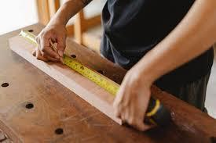
Upholsterers need to choose tools such as steel tape measures, squares, or templates that are appropriate for the type of measurement required, ensuring accuracy.

Consideration of Tolerances:
Definition:
Tolerances represent acceptable variations in measurements that still meet quality standards.

Application:
Upholsterers should be aware of tolerance levels and work within these limits to achieve measurements that fall within acceptable ranges.

Clear Documentation:
Definition:
Documenting measurements in a clear and organized manner.

Application:
Accurate records of measurements, including notations for critical points, help maintain consistency and provide a reference for future stages of the upholstery process.

Adherence to Design Specifications:
Definition:
Following the design specifications precisely.

Application:
Upholsterers must adhere to the provided design specifications, ensuring that the frame's dimensions align with the intended design and functionality.

Awareness of Environmental Factors:
Definition:
Considering factors such as temperature and humidity that can impact measurements.

Application:
Upholsterers should be aware of environmental conditions that may affect the materials or measuring tools, making adjustments as needed to account for these factors.

By adhering to these principles, upholsterers can maintain a high level of accuracy in measurements, resulting in well-crafted and functional upholstered furniture.

KT0602 Units of measurement and measuring tools and equipment required for the frame preparation process.
Length:

Units:

Inches, feet, centimetres, meters.

Tools:

Steel tape measure, cloth tape measure, rulers, yardsticks.

Area:
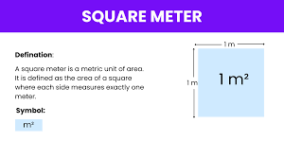
Square inches, square feet, square centimetres, square meters.

Tools:
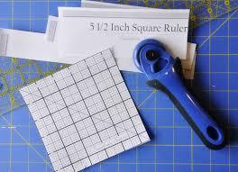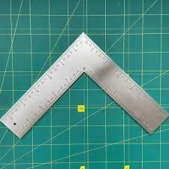
Square rulers, templates.

Volume:
Units:
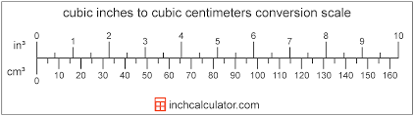
Cubic inches, cubic feet, cubic centimetres, cubic meters.

Tools:
Templates, measuring containers.

Angle:
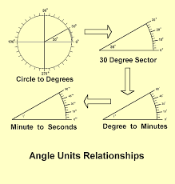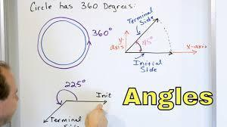
Units:
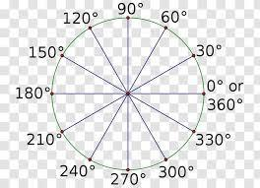
Degrees.

Tools:
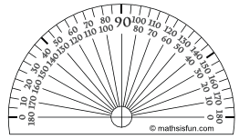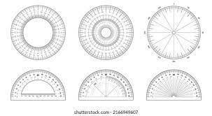
Protractors.

Pressure:
Units:
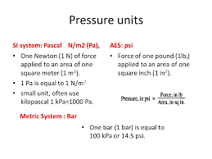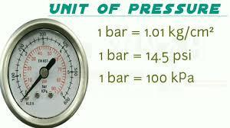
Pounds per square inch (psi), kilopascals (kPa).

Tools:
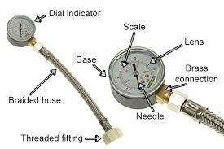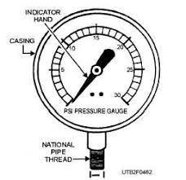
Pressure gauges.

Deflection:
Units:
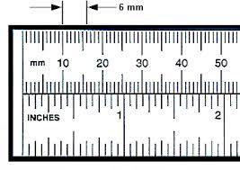
Inches, millimetres.

Tools:
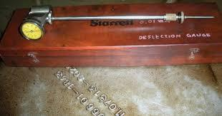
Deflection gauges.

Quantity:
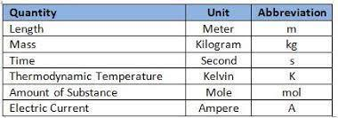
Units:
Unit count.

Tools:
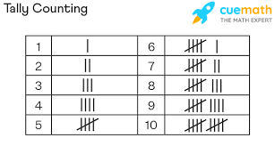
Counting tools, such as counters or tally sheets.

Measuring Tools and Equipment:
Steel Tape Measure:
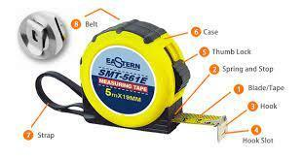
Purpose:
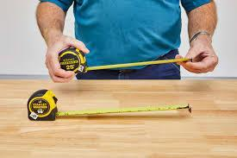
Measure length in a flexible format.

Components:
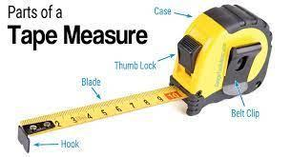
Tape, housing, locking mechanism.

Uses:
Taking linear measurements.
Cloth Tape Measure:

Purpose:
Measure length in a flexible, non-metallic form.

Components:
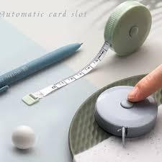
Fabric tape, housing.

Uses:
Measuring fabric and other soft materials.

Rulers and Yardsticks:
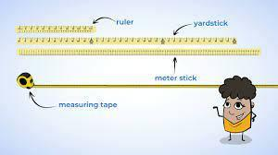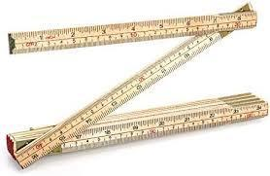
Purpose:
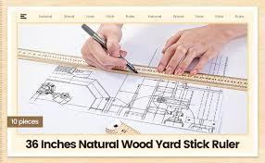
Measure length in a rigid format.

Components:
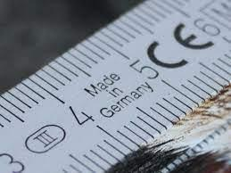
Graduated markings.

Uses:
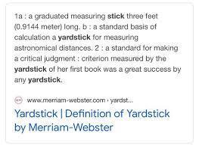
Providing straight measurements.

Square Rulers:
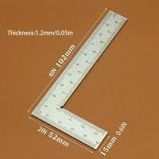
Purpose:
Measure and mark right angles.

Components:
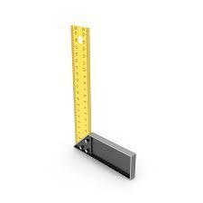
Ruler with a perpendicular edge.

Uses:
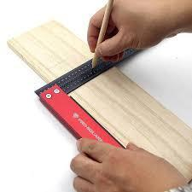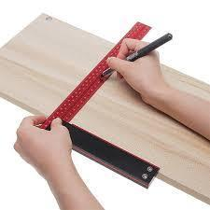
Ensuring square corners.
Templates:
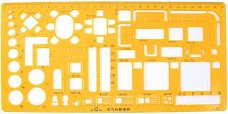
Purpose:
Guide for shaping or tracing specific forms.

Components:
Outline of a shape.
Uses:
Transferring patterns or shapes.

Protractors:
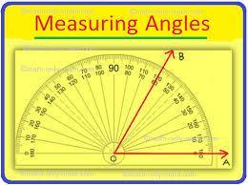
Purpose:
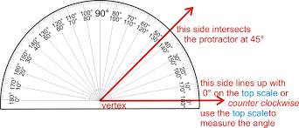
Measure and draw angles.

Components:
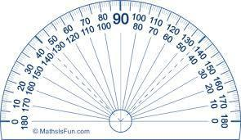
Circular tool with degree markings.

Uses:

Checking and setting angles.

Pressure Gauges:

Purpose:
Measure the pressure of gases or liquids.

Components:
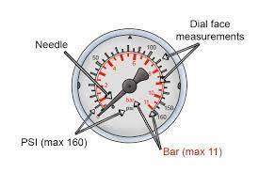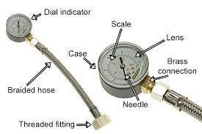
Gauge face, needle, scale.

Uses:
Checking air pressure in pneumatic systems.

Deflection Gauges:
Purpose:
Measure the amount of bending or sagging.

Components:
Gauge with a reference point.

Uses:
Assessing the deflection of springs or components.

Counting Tools:
Purpose:

Track the quantity of items.

Components:
Counter or tally sheet.

Uses:
Counting individual components or materials.

These tools and units are essential for accurate measurements during the frame preparation process in upholstery, ensuring precision and adherence to design specifications.

KT0603 Measuring techniques.

Direct Measurement:
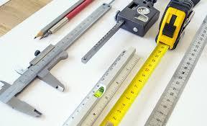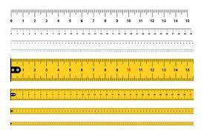
Description:
Taking measurements directly using tools like tape measures or rulers.

Application:
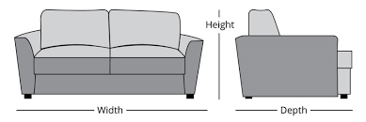
Measuring the length, width, or height of furniture components.

Indirect Measurement:
Description:
Deriving measurements using other known dimensions or properties.

Application:
Calculating the height of a frame by measuring the length of a connected component.

Angular Measurement:
Description:
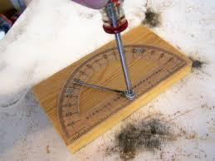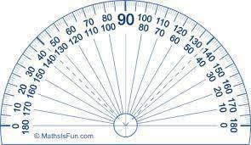
Measuring angles using tools like protractors.

Application:
Ensuring the correct alignment of components, such as the angle between joints.

Volumetric Measurement:
Description:
Determining the volume of a three-dimensional space.

Application:
Calculating the amount of foam needed for a specific cushion.

Deflection Measurement:
Description:
Assessing the amount of bending or sagging in a material.

Application:
Checking the deflection of springs to ensure proper support.

Counting Techniques:
Description:
Counting individual units or components.

Application:
Determining the quantity of fasteners or other small items needed.

Template Measurement:
Description:
Using templates to transfer shapes or patterns.

Application:
Tracing and cutting fabric or materials based on predefined patterns.

Comparative Measurement:
Description:
Comparing measurements against a standard or reference.
Verifying that multiple components are consistent in size.

Linear Measurement:
Description:
Measuring in a straight line from one point to another.

Application:
Checking the length of upholstery fabric or trim.

Area Measurement:
Description:
Determining the size of a surface in square units.

Application:
Calculating the fabric needed to cover a specific area.

Volume Measurement:
Description:
Measuring the space occupied by a three-dimensional object.

Application:
Ensuring the correct amount of filling material for cushions.

Tolerance Measurement:
Description:
Setting acceptable limits for variations in measurements.

Application:
Ensuring that components meet specified tolerances for quality.

Understanding and applying these measuring techniques are crucial for achieving accuracy and precision in upholstery, resulting in well-crafted and consistent furniture pieces.

KT0604 Calculations and angles.

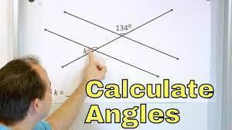

Calculations Involving Dimensions:
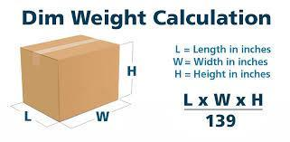
Explanation:
Upholsterers often need to perform calculations related to the dimensions of furniture components. This includes determining the length, width, height, or thickness of materials.

Definition:
Dimensional calculations involve numeric operations (addition, subtraction, multiplication, division) to derive specific measurements.
Example:
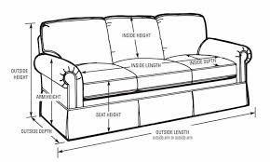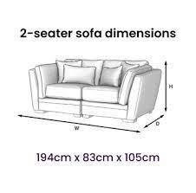
Calculating the total length of fabric needed for covering a sofa, considering its dimensions and any allowances for seams.

Spacing Calculations:
Explanation:
Proper spacing is essential in upholstery to achieve a balanced and aesthetically pleasing look. This involves calculating the distance between components.

Definition:
Spacing calculations ensure that items like buttons, stitches, or decorative elements are evenly distributed.

Example:
Determining the equal spacing between tufted buttons on a headboard.

Quantities Calculation:
Explanation:
Upholsterers need to calculate the quantity of materials required for a project, such as the number of springs, nails, or fabric yards.

Definition:
Quantities calculation involves determining the needed amount of various components based on project specifications.

Example:
Calculating the number of springs needed for a specific piece of furniture based on design requirements.

Volume and Air Pressure Calculation:
Explanation:
In the foaming process, calculating the volume of foam required or determining the appropriate air pressure for pneumatic tools is crucial.

Definition:
Volume and air pressure calculations involve mathematical operations to ensure accurate material application.

Example:
Calculating the volume of foam needed for a cushion or adjusting the air pressure on a staple gun for optimal performance.

Step-by-Step Guide for Calculations and Angles:
Define the Objective:
Clearly understand the purpose of the calculation, whether it is determining material quantities, spacing, or adjusting tool settings.

Gather Necessary Information:
Collect all relevant measurements and specifications needed for the calculation. This may include dimensions, spacing requirements, or recommended air pressure levels.

Choose Appropriate Units:
Ensure consistency in units throughout the calculation. Convert measurements to a common unit if necessary.

Perform Calculations:
Use appropriate mathematical operations (addition, subtraction, multiplication, division) based on the type of calculation needed.

Check and Double-Check:
Verify your calculations to avoid errors. Double-checking ensures accuracy and minimizes mistakes.

Consider Tolerances:
If applicable, take into account acceptable tolerances for variations. This is crucial for maintaining quality standards.

Apply Results:
Implement the calculated values in your upholstery process, whether it is cutting materials, spacing elements, or adjusting tool settings.
Understanding these calculation principles and following the step-by-step guide helps upholsterers make precise and informed decisions, contributing to the overall quality of the finished product.

KT0605 Calculating allowances.
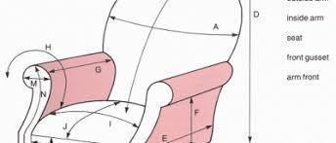
In the context of upholstery and furniture manufacturing, an "allowance" refers to an additional measurement or dimension intentionally added to the actual size or dimension of a component. This extra space is included to account for variations, ensure a proper fit, and accommodate potential changes during the manufacturing process. Allowances are typically added during the cutting and assembling stages of upholstery.

There are different types of allowances used in upholstery, including:

Seam Allowance:
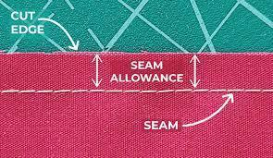
Explanation:
The additional fabric added around the edges of a fabric piece to allow for sewing seams.

Example:
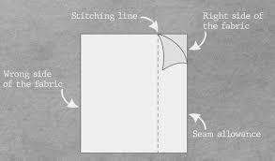
When cutting fabric pieces for upholstery, an extra inch or so may be added around each side to account for seams.

Pattern Allowance:
Explanation:

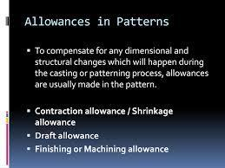
Additional material added to a pattern to allow for adjustments, align patterns correctly, or accommodate variations in the upholstery process.

Example:
When using a pattern for cutting fabric, extra material might be added to ensure precise alignment or to account for variations in the foam or padding.

Padding Allowance:
Explanation:
Extra padding or filling material added to account for compression and settling over time.

Example:
When adding foam or batting to a cushion, an allowance might be considered to ensure that the cushion maintains its desired fullness over the long term.

Fit Allowance:
Explanation:
Additional space added to ensure that components fit together correctly during assembly.

Example:
When constructing a frame or attaching upholstered components, allowances may be added to avoid tight fits that could lead to difficulties during assembly.

The purpose of allowances is to provide flexibility and account for variables in the manufacturing process, contributing to the overall quality and precision of the final upholstered product. It allows for adjustments and ensures that the components come together seamlessly, even if there are minor variations or changes during the production process.

KT0606 Problem solving.
Problem-solving is a crucial skill in the upholstery frame preparation process. It involves addressing challenges that may arise during the various stages of frame preparation.

Here is a comprehensive guide on problem-solving in upholstery:

Identification of Issues:
Definition:
Problem-solving begins with the identification of issues or challenges in the frame preparation process.

Examples:
Issues could include uneven frame construction, incorrect measurements, or defects in materials.

Root Cause Analysis:
Definition:
Once an issue is identified, a thorough analysis is conducted to determine its root cause.

Examples:
If a frame is uneven, the root cause could be a misalignment in the initial frame construction.

Collaborative Problem-Solving:
Definition:
Upholstery is often a collaborative process. Problem-solving may involve input from various team members, including frame preparers, upholsterers, and quality control.

Examples:
Team members collaborate to address issues related to material defects or incorrect specifications.

Application of Corrective Measures:
Definition:
After identifying the root cause, corrective measures are applied to resolve the issue.

Examples:
Adjustments to the frame construction or re-measuring and re-cutting materials to correct dimensions.
Documentation of Solutions:
Definition:
Successful problem-solving is documented for future reference. This includes detailing the issue, the root cause, and the corrective actions taken.

Examples:
Creating a record of issues and solutions to inform training programs or improve standard operating procedures.

Continuous Improvement:
Definition:
Problem-solving contributes to continuous improvement in the upholstery process. It involves learning from challenges and implementing changes to prevent similar issues in the future.

Examples:
Updating training materials based on common issues or refining measurement techniques to reduce errors.

Preventive Measures:
Definition:
Problem-solving extends to implementing preventive measures to minimize the occurrence of issues.

Examples:
Regular maintenance of tools and equipment to prevent malfunctions during the frame preparation process.
Team Training and Development:
Definition:

Building a problem-solving culture involves training and developing team members to handle challenges effectively.

Examples:
Conducting workshops on effective communication and collaboration to enhance the problem-solving capabilities of the team.

In summary, problem-solving in upholstery frame preparation is a dynamic process that involves identifying, analysing, and addressing issues collaboratively. Successful problem-solving contributes to the overall quality and efficiency of the upholstery manufacturing process.

Formative assessment

IAC0601 Various units, conversions and terminology for measurements, including quantity, deflection, and compressed air volume and pressure are explained and applied.
IAC0602 Calculations required during the upholstery process are explained and applied.
IAC0603 Measuring tools such as steel tape measure, cloth tape measure, squares, steel rules, vernier calliper, templates and patterns, and pressure gauges and their parts are identified and their functions analysed.
IAC0604 Calculations involving dimensions, spacing, quantities, volume, and air pressure using consistent units and conversions and appropriate mathematical operation are completed, recorded and checked.
IAC0605 Consequences of inaccurate measurements on the upholstery process and the output of the department are assessed.

(Weight 5%)

KM-02-KT07: Upholstered furniture manufacturing processes (5%)

Learning Outcome:
At the end of this section, learners should cover:

KT0701 Upholstered furniture manufacturing process from raw frame to finished product.
KT0702 Process flow and productivity
KT0703 Operations in the process flow: knocker on operations, foaming up operations, padding sprung foundations and frames and covering operations.
KT0704 Routing sheets.
KT0705 Cutting lists.
KT0706 Product specifications.
KT0707 Finishing aids.

KT0701 Upholstered furniture manufacturing process from raw frame to finished product.

The manufacturing process of upholstered furniture involves a series of meticulously planned and executed steps.

Here is an overview of the journey from a raw frame to a finished product:

Frame Preparation:
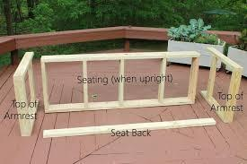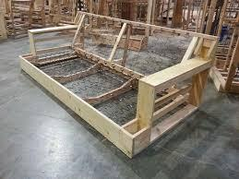
Description:
The process initiates with frame preparation, involving the assembly and construction of the basic structure.

Implications of Design and Construction Faults:
Design and construction faults at this stage can significantly impact the final product's stability and aesthetics.

Knocker-On Operations:
Description:
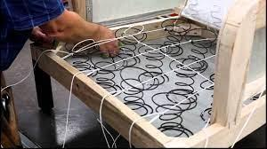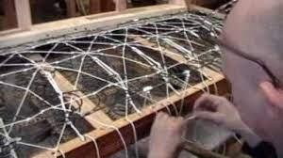
Knocker-on operations involve the attachment of essential components such as springs and webbing to the frame.

Implications of Faults:
Any faults in this stage can result in uneven support and discomfort in the finished product.

Foaming Up Operations:
Description:
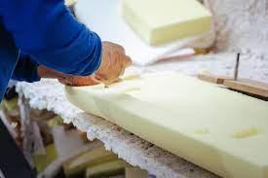
Foaming up operations include the application of foam padding, contributing to the product's comfort and appearance.

Implications of Faults:
Inadequate or uneven foaming can lead to discomfort and affect the overall aesthetics.

Padding Sprung Foundations and Frames:
Description:
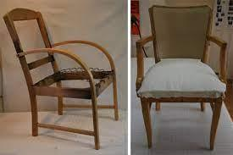
This step involves adding additional padding and support to sprung foundations and frames.

Implications of Faults:
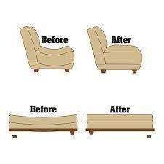
Faults can lead to uneven padding, affecting the product's comfort and longevity.

Covering Operations:
Description:
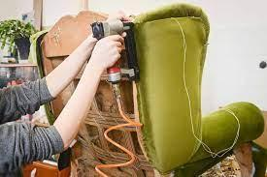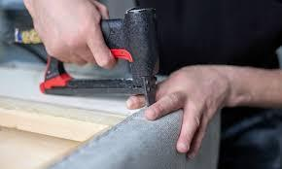
Covering operations encompass the application of fabric or upholstery material to the prepared frame.

Implications of Faults:
Faults in covering operations can result in a poorly finished appearance and compromise the overall quality.

KT0702 Process flow and productivity.

Understanding the process flow and productivity is essential for efficient manufacturing:

Process Flow Overview:


Brief Outline:
An overview of the entire process flow, emphasizing the sequential nature of operations.

Productivity Considerations:

Importance:
Highlighting the significance of productivity in meeting production targets and maintaining high-quality standards.

Enhancement Methods:
Discussion on various methods employed to enhance productivity, such as optimized workflows and efficient resource allocation.
KT0703 Operations in the process flow: knocker on operations, foaming up operations, padding sprung foundations and frames and covering operations.

Machining Operations:
Description:
Machining involves precision cutting and shaping of raw materials to create components for the furniture frame.

Importance:
Accurate machining is critical for ensuring the components fit seamlessly during assembly, contributing to the overall stability and aesthetics of the finished product.

Potential Faults:
Errors in machining can result in ill-fitting components, compromising structural integrity and visual appeal.

Assembling Operations:
Description:
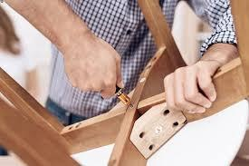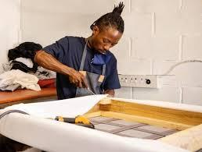
Assembling operations focus on putting together the various machined components to form the furniture frame.

Importance:
Proper assembly is essential for structural stability and functionality of the furniture piece.

Potential Faults:
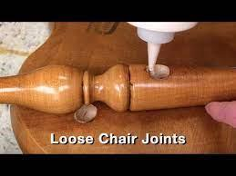
Incorrect assembly can lead to weak joints, affecting the overall strength of the frame.

Finishing Operations:
Description:
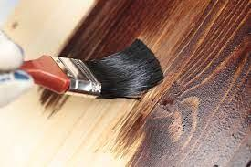
Finishing operations involve applying coatings, stains, or paints to enhance the aesthetics of the furniture.

Importance:
Finishing adds a protective layer, enhances the appearance, and contributes to the durability of the product.

Potential Faults:
Inadequate or uneven finishing can result in a subpar appearance and reduced product lifespan.

Knocker-On Operations:
Description:
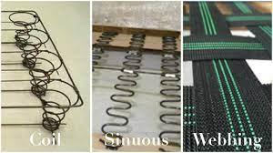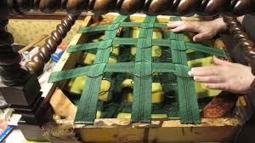
Knocker-on operations include attaching essential components such as springs and webbing to the frame.

Importance:
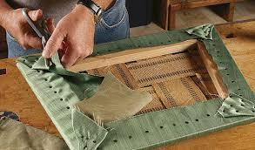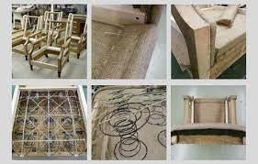
Proper knocker-on operations ensure even support and comfort in the final product.

Potential Faults:
Faults in this stage can lead to uneven support and discomfort for the end user.

Foaming Up Operations:
Description:
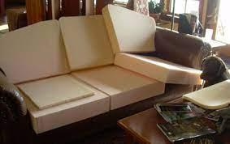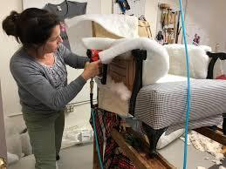
Foaming up operations involve the application of foam padding to the frame.

Importance:
Even and proper foaming contributes to the comfort and aesthetics of the upholstered furniture.

Potential Faults:
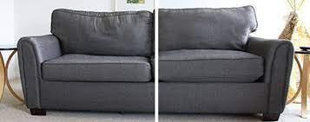
Inadequate foaming can result in uneven surfaces and reduced comfort.

Padding Sprung Foundations and Frames:
Description:
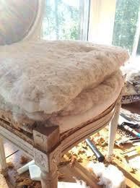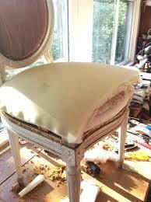
Additional padding is added to provide support and comfort to sprung foundations and frames.

Importance:
Proper padding ensures that the furniture piece meets comfort standards and is resilient.

Potential Faults:
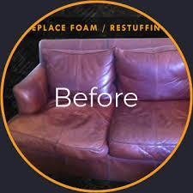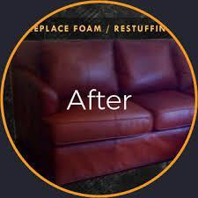
Inadequate padding can lead to discomfort and a diminished lifespan for the product.

Covering Operations:
Description:
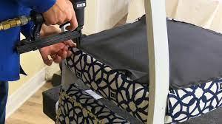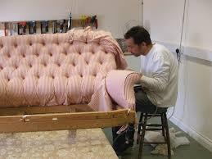
Covering operations involve applying fabric or upholstery material to the prepared frame.

Importance:
Proper covering contributes to the final appearance, texture, and overall quality of the upholstered furniture.

Potential Faults:
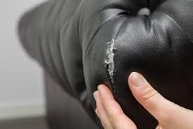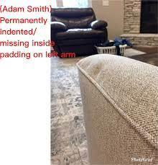
Faults in covering can result in a poorly finished appearance and compromised durability.

By understanding and reviewing each operation in the process flow, learners gain insights into the sequential steps that contribute to the creation of a high-quality upholstered furniture piece. This knowledge is essential for meeting the specified assessment criteria and ensuring successful furniture manufacturing.

KT0704 Routing sheets.
Definition and Purpose:
Routing Sheet Definition:
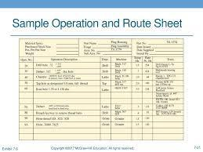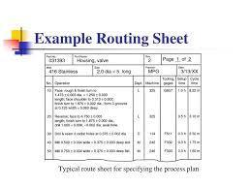
A routing sheet is a detailed document that outlines the systematic process and specific instructions for manufacturing a particular upholstered furniture item.

Purpose:
The primary purpose of a routing sheet is to guide workers through the manufacturing process, ensuring consistency, accuracy, and adherence to specified standards.

Content and Components:
Component Details:
The routing sheet includes a comprehensive list of components needed for the furniture item, specifying materials, dimensions, and quantities.

Assembly Steps:
It provides a sequential breakdown of the assembly process, specifying the order in which different components are added to the frame.

Job Instructions:
Specific instructions related to each step, such as tools to be used, techniques to be applied, and quality standards to be met, are outlined.

Workstation Guidance:
Assigning Workstations:
The routing sheet may allocate specific tasks to different workstations or departments within the manufacturing facility.

Flow of Work:
It ensures a smooth flow of work by indicating the logical progression of the furniture item through various stages of production.

Time and Resource Allocation:
Time Estimates:
Routing sheets may include time estimates for each step, helping in production planning and scheduling.

Resource Allocation:
It specifies the allocation of resources, including labour, tools, and machinery, for each stage of the manufacturing process.

Quality Control Checks:
Quality Standards:
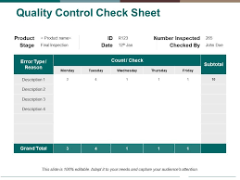
The routing sheet highlights quality control checkpoints, indicating where and how quality checks should be conducted.

Acceptance Criteria:
It specifies the criteria that each component or assembly must meet to pass quality control inspections.

Communication Tool:
Interdepartmental Communication:
Routing sheets serve as a communication tool between different departments involved in the manufacturing process.

Feedback Mechanism:
They provide a mechanism for feedback and continuous improvement as workers can annotate the sheet with observations and suggestions.
Documentation and Record Keeping:
Documentation:
Routing sheets serve as part of the documentation process, ensuring that the manufacturing process is well-documented for future reference.
Record Keeping:
They contribute to record-keeping efforts by preserving a record of the manufacturing instructions followed for each product.

Flexibility and Adaptability:
Updates and Revisions:
Routing sheets can be updated and revised to accommodate design changes, process improvements, or new quality standards.

Adaptability:
They allow for adaptability to changing production requirements and continuous optimization of the manufacturing process.

Understanding routing sheets is crucial for workers to follow standardized procedures, maintain consistency, and produce high-quality upholstered furniture that meets design and quality specifications. This knowledge is vital for meeting the specified assessment criteria related to the understanding of manufacturing processes and documentation.

KT0705 Cutting lists.
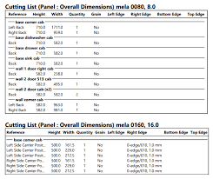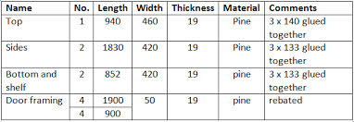
Cutting lists are essential documents in the upholstery manufacturing process, providing detailed instructions for cutting and preparing materials needed for constructing upholstered furniture. These lists streamline the production workflow and help optimize material usage.

Let us explore the key components and considerations related to cutting lists:

Bill of Materials:
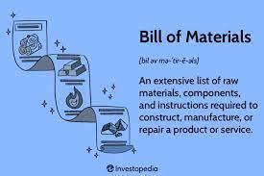

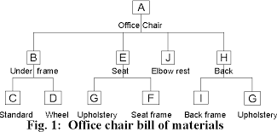

Comprehensive Material Breakdown:
A cutting list includes a detailed breakdown of all materials required for a specific furniture item, including fabric, foam, wood, and other components.

Component Specifications:
Dimensions:
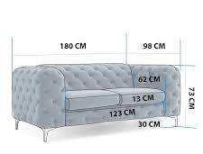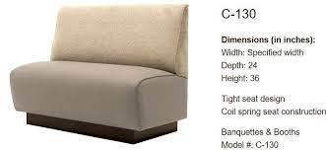
Provides precise measurements for each component, including length, width, and thickness. This ensures accurate cutting and assembly.

Identification:
Assigns unique identifiers or codes to each component for easy reference and traceability throughout the manufacturing process.

Material Optimization:
Layout Diagrams:
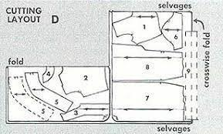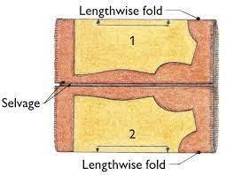
Often includes graphical representations or diagrams showing how components should be laid out on raw materials to minimize waste and optimize material usage.
Nesting Instructions:
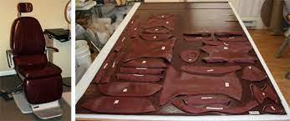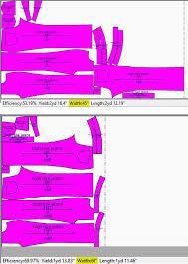
Offers guidance on how to nest components efficiently on larger material sheets to reduce scrap and enhance cost-effectiveness.

Cutting Instructions:
Cutting Patterns:
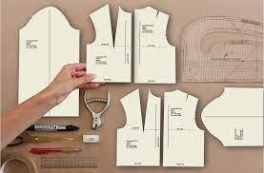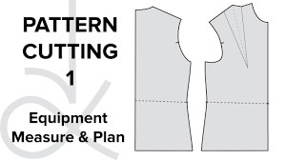
Specifies cutting patterns for each component, indicating the shape and orientation of cuts to achieve the desired dimensions.

Cutting Tools:
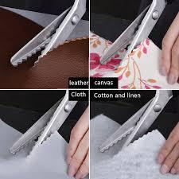
Recommends the types of cutting tools or equipment to be used for different materials, considering factors like blade types and cutting techniques.

Material Identification:
Marking Guidelines:
Provides instructions for marking or labelling cut components to aid in the assembly process. This may include part numbers, fabric patterns, or other relevant details.

Grain Direction:
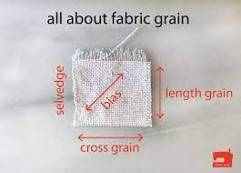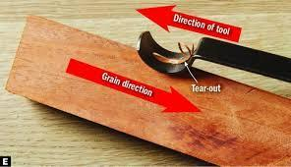
Indicates the direction of the grain for materials like wood or fabric, ensuring proper alignment during assembly.

Quality Control:
Inspection Points:
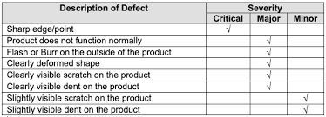
Specifies checkpoints for quality control during the cutting process, ensuring that components meet specified dimensions and quality standards.

Rejection Criteria:

Outlines criteria for identifying and rejecting components that do not meet quality standards.

Version Control and Revisions:
Document Control:
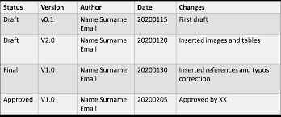
Includes version numbers or revision dates to track changes to the cutting list, ensuring that the latest version is used in production.

Change Management:
Describes procedures for implementing and communicating changes to the cutting list to relevant stakeholders.

Integration with Other Documents:
Alignment with Product Specifications:
Cutting lists should align with the broader product specifications, ensuring consistency and adherence to design and quality standards.

Coordinated with Routing Sheets:
Coordinates with routing sheets to ensure seamless integration into the overall manufacturing process.

Understanding and effectively using cutting lists are critical skills for upholsterers and production teams. These documents facilitate efficient material handling, reduce waste, and contribute to the overall success of the manufacturing process.
KT0706 Product specifications.
Product specifications are detailed descriptions outlining the requirements and characteristics of the final upholstered furniture product. These specifications serve as a comprehensive guide for manufacturing, ensuring consistency, quality, and adherence to design and performance standards.

Let us delve into the key aspects of product specifications:

Components of Product Specifications:
Design Details:

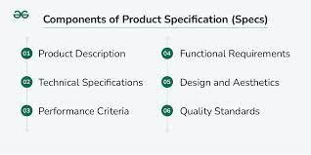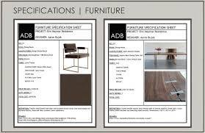
Specifies the visual and structural design elements of the furniture, including dimensions, shapes, and any decorative features.

Materials:
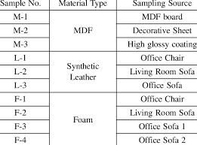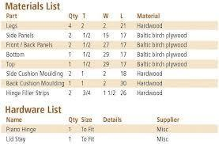
Clearly defines the types and quality of materials to be used, such as wood types, fabrics, foams, springs, and any other components.

Construction Methods:
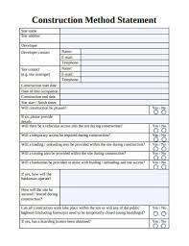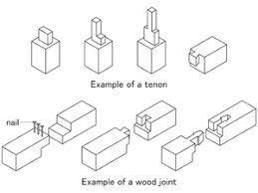
Outlines the specific techniques and methods to be employed during the manufacturing process, ensuring consistency in assembly and construction.

Finish Requirements:
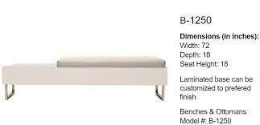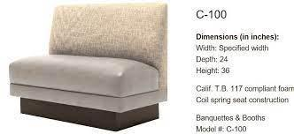
Describes the desired finish, colour, and texture for both wooden and upholstered surfaces.

Standards and Regulations:
Compliance:
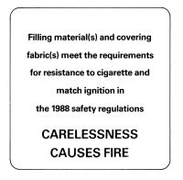
Product specifications often include references to industry standards, safety regulations, and quality control requirements that the final product must meet.

Performance Standards:
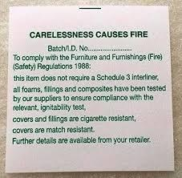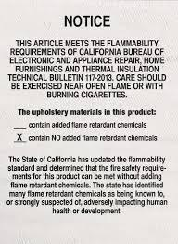
Specifies any specific performance criteria, such as load-bearing capacity, durability, and safety standards.

Sizes and Dimensions:
Overall Dimensions:
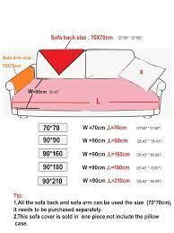
Provides precise measurements for the final product, including height, width, depth, and any other relevant dimensions.

Component Sizes:
Specifies dimensions for individual components to ensure proper fit and assembly.

Testing and Quality Control:
Testing Protocols:
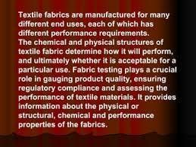
Outlines any testing procedures or quality control measures that must be undertaken to ensure the product meets specified standards.

Acceptance Criteria:
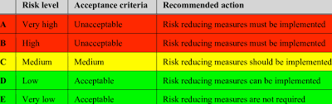
Clearly defines the criteria for accepting or rejecting a finished product based on quality, functionality, and appearance.

Traceability and Documentation:
Identification:
Specifies methods for labelling or marking components to facilitate traceability during the manufacturing process.

Documentation:

Calls for the creation and maintenance of documentation, including production records, inspection reports, and compliance certificates.

Revisions and Updates:
Version Control:
Product specifications may have version numbers or dates to track revisions, ensuring that the latest version is always used in production.

Change Management:
Describes procedures for implementing changes to product specifications and communicating these changes to relevant stakeholders.
Communication with Stakeholders:
Supplier Requirements:
If applicable, product specifications may include requirements for materials supplied by external vendors, specifying quality, quantity, and delivery terms.

Client Expectations:
Aligns with the expectations and preferences of the end customer, ensuring that the final product meets or exceeds their requirements.

Understanding product specifications is vital for all individuals involved in the manufacturing process, from design and procurement to assembly and quality control. This knowledge ensures that the final upholstered furniture product aligns with the specified design and performance criteria.

KT0707 Finishing aids.
In the context of upholstered furniture manufacturing, finishing aids play a crucial role in enhancing the final appearance, durability, and overall quality of the product.

Let us explore various aspects related to finishing aids:

Definition and Purpose:
Definition:
Finishing aids are additional materials, tools, or substances used in the final stages of furniture production to improve aesthetics, functionality, or protection.

Purpose:
The primary purpose of finishing aids is to refine the appearance, ensure product durability, and add specific features to the upholstered furniture.

Types of Finishing Aids:
Polishes and Sealants:
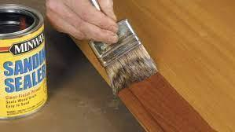
Finishing aids may include polishes and sealants applied to wooden components, providing a protective layer, enhancing the wood's natural beauty, and preventing damage.

Stain and Dye Products:
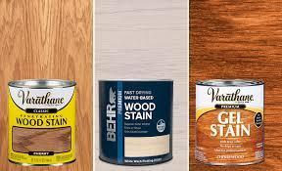
These aids are used to colour wood or other materials, allowing for customization and achieving desired aesthetic effects.

Protective Coatings:
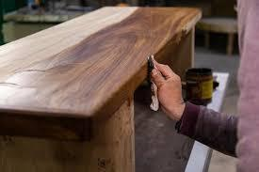
Clear coatings or protective films are applied to surfaces to safeguard against scratches, stains, and wear, contributing to the longevity of the furniture.

Decorative Elements:
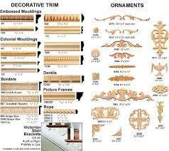
Finishing aids can encompass decorative elements such as appliques, trims, or hardware that are added to enhance the overall design.

Fabric Treatments:

For upholstered portions, fabric treatments like stain repellents or flame retardants may be applied to improve performance and safety.

C3Assembly Tools:
Tools used in the final assembly, such as specialized screws or connectors, can also be considered finishing aids.

Application Techniques:
Spraying:
Some finishing aids, like protective coatings, may be applied using spray equipment to ensure even and efficient coverage.

Hand Application:
Others, such as polishes or decorative elements, may be applied by hand for precision and control.

Quality Control and Inspection:
Standards Compliance:
Finishing aids should comply with industry standards and specifications, ensuring that the final product meets quality requirements.

Visual Inspection:
The application of finishing aids often involves a visual inspection to verify that the desired aesthetic and functional outcomes are achieved.

Documentation and Record Keeping:
Usage Records:
Manufacturers may keep records of the types and quantities of finishing aids used for each product, contributing to traceability and quality control.

Safety Data Sheets (SDS):
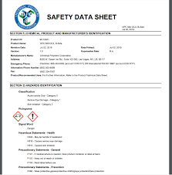
Detailed information about finishing aids, including safety considerations, should be documented in SDS for employee safety and regulatory compliance.

Environmental Considerations:

Eco-friendly Options:
Manufacturers may consider environmentally friendly finishing aids to align with sustainability goals and reduce the environmental impact of the production process.

Waste Management:
Proper disposal or recycling of containers and materials used for finishing aids is essential to minimize environmental impact.
Understanding finishing aids is essential for workers involved in the final stages of furniture production. It ensures that the finishing touches contribute to the overall quality, functionality, and aesthetic appeal of upholstered furniture. This knowledge aligns with the assessment criteria related to understanding finishing aids and their impact on the manufacturing process.

Formative assessment

IAC0701 Workshop processes of producing upholstered items from raw frame to finished product and the implications of design and construction faults on the final product are analysed.
IAC0702 The process of furniture manufacture is briefly outlined.
IAC0703 The operations in furniture manufacture such as machining, assembling and finishing operations are reviewed.
IAC0704 The finishing processes of furniture is outlined.
IAC0705 The importance of productivity and methods to enhance productivity are discussed.
IAC0706 The role of the routing sheet is described.
IAC0707 Job card information such as component sizes and details, shoulder-to-shoulder size and chemicals to use is explained.
IAC0708 Product specifications are understood and their impact on the manufacturing process is discussed in terms of the process flow and methods that will be used.

(Weight 5%)

KM-02-KT08: Frame preparation: knocking-on principles (5%)

Learning Outcome
At the end of this section, learners should cover:

KT0801 Stretch, tension and deflection of webbing and springs.
KT0802 Spacing of tacks, nails and staples.
KT0803 Spacing of webbing.
KT0804 Correct sizes of nails and staples.
KT0805 Positioning of the staples, nails, tacks.
KT0806 Keeping the working edge clean for the next operation.

KT0801 Stretch, tension and deflection of webbing and springs.
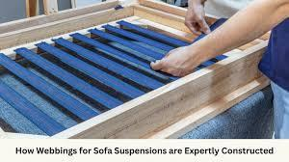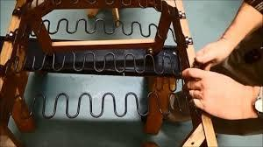
Understanding the principles of stretch, tension, and deflection is crucial in frame preparation for upholstered furniture.

These principles directly impact the comfort, durability, and overall quality of the final product:
Stretch of Webbing:
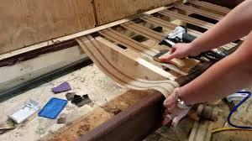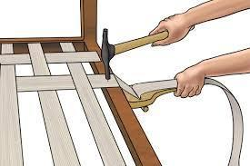
Purpose:
Webbing provides support and flexibility to the furniture frame.
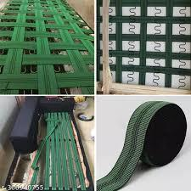

Principle:
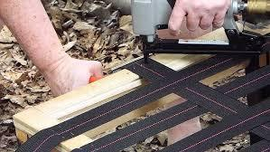
Proper stretching of webbing ensures optimal support for the springs and cushions.

Technique:
Upholsterers must apply the right amount of tension to achieve the desired level of support without compromising comfort.

Tension of Springs:
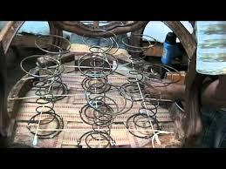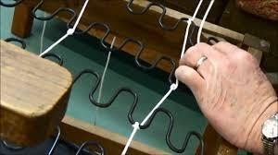
Function:
Springs contribute to the resilience and comfort of the upholstered furniture.

Principle:
Tension in springs needs to be carefully calibrated for the desired level of bounce and support.

Considerations:
Different furniture designs and applications may require varying levels of spring tension.

Deflection of Webbing and Springs:
Definition:
Deflection refers to the displacement or movement of webbing and springs when subjected to pressure.

Balancing Act:
Upholsterers must balance deflection to ensure optimal comfort without causing excessive wear on materials.
KT0802 Spacing of tacks, nails and staples.

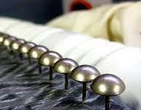
Proper spacing of fasteners is essential for secure and durable frame preparation.

The spacing principles vary based on the type of fastener and the specific application:

Tacks and Nails:
Spacing Guidelines:
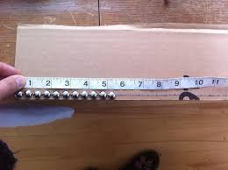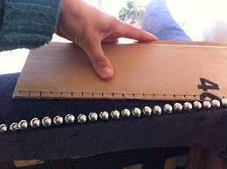
Upholsterers follow guidelines for spacing tacks and nails to ensure even and secure attachment of fabric to the frame.

Impact on Appearance:
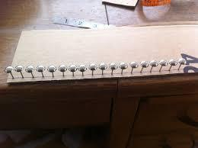
Proper spacing contributes to a neat and professional appearance of the upholstery.

Staples:
Consistent Placement:
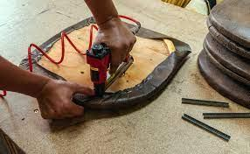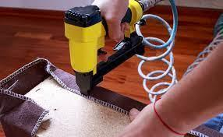
Staples are spaced evenly to distribute tension and prevent uneven pulling of the fabric.

Efficiency Considerations:
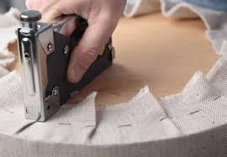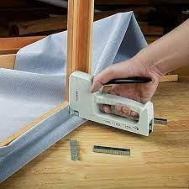
Upholsterers balance spacing for efficiency and aesthetics, ensuring a clean and uniform finish.
KT0803 Spacing of webbing.
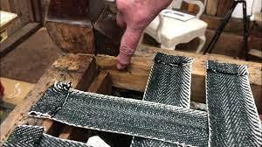

The spacing of webbing is critical for achieving uniform support and preventing sagging in upholstered furniture:

Uniform Distribution:
Equal Spacing:
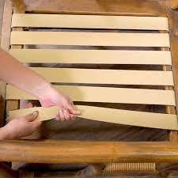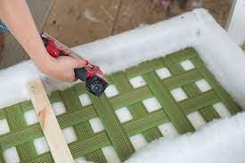
Webbing should be evenly spaced to distribute tension and provide consistent support across the entire seating area.

Preventing Sags:
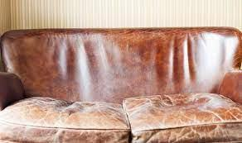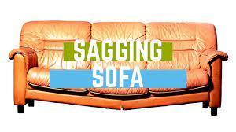
Proper spacing minimizes the risk of sagging or uneven wear over time.
KT0804 Correct sizes of nails and staples.

Selecting the right sizes of nails and staples is essential for effective frame preparation:

Matching Sizes:
Compatibility:
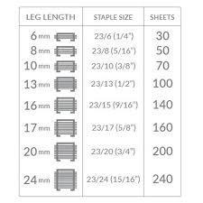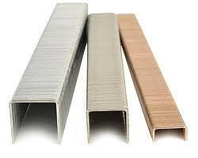
Nails and staples should be chosen based on the thickness and material of the frame components.

Secure Fastening:
Using correct sizes ensures a secure and durable connection between frame elements.

KT0805 Positioning of the staples, nails, tacks.

Precise positioning of fasteners contributes to the structural integrity and aesthetics of the upholstered frame:

Strategic Placement:
Balancing Act:
Upholsterers strategically position staples, nails, and tacks to balance tension, achieve a uniform appearance, and enhance overall durability.

Avoiding Weak Points:
Proper positioning helps prevent the creation of weak points in the frame.

KT0806 Keeping the working edge clean for the next operation.

Maintaining a clean working edge is essential for the efficiency and quality of subsequent operations in frame preparation:

Efficiency and Precision:
Preventing Interference:
A clean working edge reduces the risk of interference with subsequent operations, ensuring precision in each step.

Professional Finish:
Upholsterers prioritize a tidy working edge for a professional and polished final product.

Formative assessment

IAC0801 Frame preparation principles are identified and the effect thereof on quality end-product is analysed.

(Weight 5%)

KM-02-KT09: Knocker on techniques (15%)

Learning Outcome
At the end of this section, learners should cover:

KT0901 Tacking.
KT0902 Stapling.
KT0903 Nailing.
KT0904 Rasping.
KT0905 Stretching.
KT0906 Tensioning.
KT0907 Interlacing.
KT0908 Removing of staples and nails.
KT0909 Web pattern.
KT0910 Cut to size and curl the end of zig-zag spring.
KT0911 Sequence of tasks â“ from left to right or other way round.
KT0912 Standing in the correct position and apply correct posture.

KT0901 Tacking.
Tacking is a fundamental knocker-on technique involving the use of small, sharp nails to attach various upholstery materials to the frame:
Selection and Measurement:
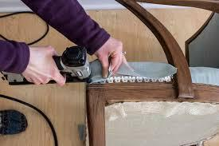
Choosing the right tacks based on the material and frame requirements. Measuring ensures accurate placement.

Cutting and Edge Bending:
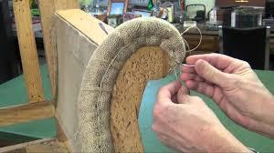
Trimming excess material and bending edges for a neat finish.

Spacing:
Ensuring even and appropriate spacing for secure attachment.

Tools:
Utilizing appropriate hand tools for precise tacking.

KT0902 Stapling.

Stapling is a widely used technique for attaching fabric and other materials to the frame:

Selection and Measurement:
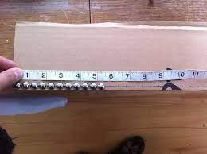
Choosing staples based on material and frame thickness. Measuring to determine accurate placement.

Cutting Allowances:
Trimming excess material and calculating allowances for precise stapling.

Spacing and Interweaving:
Ensuring consistent spacing and interweaving fabric for stability.

Hand and Power Tools:
Using both hand and power staplers depending on the task.

KT0903 Nailing.

Nailing involves the use of nails for securing different upholstery components to the frame:

Spacing:
Ensuring proper spacing for stability and uniformity.

Hand and Power Tools:
Selecting and using hand or power tools as appropriate.

Attachment to Webbing and Frame:
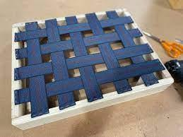
Nailing materials securely to both the webbing and frame.

KT0904 Rasping.
Rasping is a technique used to smooth and shape wooden components for a polished finish:
Smoothing Edges:
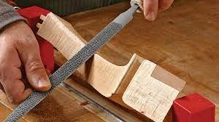
Using a rasp tool to smooth rough edges on wooden components.

Shaping:
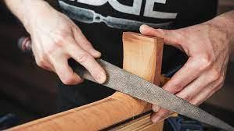
Achieving desired shapes for enhanced aesthetics.

Preventing Snags:
Ensuring that rasped edges will not snag or damage upholstery materials.
KT0905 Stretching.

Stretching is a crucial technique for achieving evenness and tautness in upholstery:

Appropriate Tension:
Applying the correct tension to fabric or materials to avoid sagging.

Even Distribution:
Ensuring equal stretching for a uniform appearance.

Tools and Equipment:
Using appropriate tools and equipment for effective stretching.

KT0906 Tensioning.
Tensioning involves creating and maintaining tension in materials for optimal support and appearance:
Balancing Act:
Achieving the right balance of tension for comfort and durability.

Consistency:
Maintaining consistent tension throughout the upholstery process.

Impact on End Product:
Understanding how tensioning affects the final appearance and feel.

KT0907 Interlacing.
Interlacing involves weaving materials together for added strength.
Proper Weaving:
Example:
Interweave materials securely.

Explanation:
Proper weaving enhances stability.

Ensuring Uniformity:
Example:
Achieve consistent interlacing.

Explanation:
Uniformity contributes to a polished look.

Application to Webbing:
Example:
Interlace materials securely to webbing.

Explanation:
Secure attachment to webbing ensures stability.

KT0908 Removing of staples and nails.
Removing Staples and Nails is essential for repair and refinishing.
Tools and Techniques:
Example:
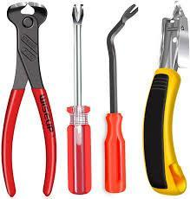
Use pliers and a staple remover.

Explanation:
Proper tools prevent damage to the frame.

Surface Preparation:
Example:
Ensure the frame is ready for the next upholstery stage.

Explanation:
Prepared surfaces enhance the quality of subsequent work.

KT0909 Web pattern. Web Patterns involve the arrangement of webbing for optimal support.
Identification:
Example:
Recognize different webbing patterns.

Explanation:
Identification aids in choosing appropriate patterns.

Selection:
Example:
Choose a pattern based on furniture type and support requirements.

Explanation:
Selection impacts the strength and comfort of the furniture.

KT0910 Cut to size and curl the end of zig-zag spring.
Preparing Zig-Zag Springs requires precise cutting and shaping.

Measuring and Cutting:
Example:
Measure accurately and cut to the required size.

Explanation:
Precision ensures proper fit and support.

Curling the End:
Example:
Shape the end for secure attachment and prevention of snagging.

Explanation:
Curling prevents fabric damage and ensures safety.

KT0911 Sequence of tasks from left to right or other way round.
Sequencing Tasks is crucial for a systematic workflow.
Logical Order:
Example:
Organize tasks logically for efficiency.

Explanation:
A logical order streamlines the upholstery process.

Efficiency Considerations:
Example:
Consider the most efficient order for the specific project.

Explanation:
Efficiency enhances productivity and reduces errors.

KT0912 Standing in the correct position and apply correct posture.
Maintaining Correct Posture and positioning enhance quality and efficiency in the knocker-on process.
Proper Alignment:
Example:
Stand aligned with the work area for optimal reach.

Explanation:
Correct alignment minimizes strain and supports precision.

Balanced Stance:
Example:
Distribute weight evenly for stability.

Explanation:
A balanced stance reduces the risk of accidents and fatigue.

Impact on Work Quality:
Example:
Understand how posture affects the quality of attachment.

Explanation:
Correct posture contributes to accurate and consistent work.

Formative assessment

IAC0901 Techniques of selecting, measuring, cutting, edge bending, spacing and using hand and power tools to attach zig zag springs securely to a frame with the correct tension.
IAC0902 Techniques of selecting, measuring, cutting allowances, spacing, interweaving and using hand and power tools to attach webbing securely to a frame.
IAC0903 Techniques of spacing and using hand and power tools to attach coil springs securely to a webbing and to the frame.
IAC0904 Identify the types of knots and clips used when securing coil springs and zig zag springs to each other and to the frame.
(Weight 15%)

KM-02-KT10: Foaming-up or padding-up principles (10%)

Learning Outcome
At the end of this section, learners should cover:

KT1001 Safety.
KT1002 Apply correct amount of glue for good bonding.
KT1003 Foam: correct densities, correct sizes, correct shapes or profile, the feel of the foam, good bonding.
KT1004 Correct positioning and appearance of the padding and foam.
KT1005 Centralized, according to the divisions of the couch.
KT1006 Stretch, tension and deflection of fabric.
KT1007 Spacing of tacks, nails and staples.
KT1008 Uniformity of a pair of arms and wings, pleating and folding and buttoning.
KT1009 Positioning of the cover and alignments.
KT1010 Pattern matching of fabric.
KT1011 Correct shaping edges and corners.

KT1001 Safety.

Importance:
Upholstery processes involve various tools and materials, making safety critical.

Detailed Explanation:

Safety measures include wearing appropriate personal protective equipment (PPE) such as gloves and goggles, proper use of tools, and adherence to safety guidelines. Understanding the potential risks and implementing precautions ensures a secure working environment.

KT1002 Apply correct amount of glue for good bonding.

Application:
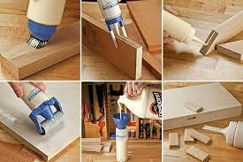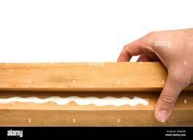
Achieving an effective bond requires precision in glue application.

Example:
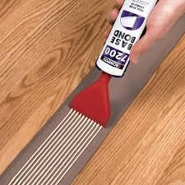
Using too much glue can lead to seepage, affecting the fabric's appearance, while too little may result in insufficient adhesion. The application process involves evenly spreading the glue to ensure uniform bonding.
KT1003 Foam: correct densities, correct sizes, correct shapes or profile, the feel of the foam, good bonding.

Density:
Foam density is a crucial consideration for comfort and longevity.

Example:
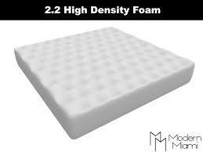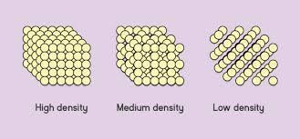
Higher density foams are suitable for areas with more prolonged use, such as seat cushions. Understanding the characteristics of different foams enables upholsterers to select the right material for each application.

KT1004 Correct positioning and appearance of the padding and foam.
Alignment:
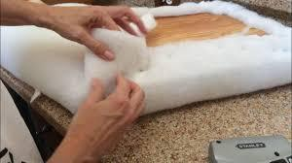
Proper alignment contributes to the aesthetics and functionality of the upholstery.

Example:
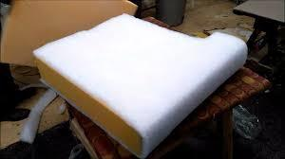
Ensuring that foam edges align with the frame enhances the overall appearance, and correctly positioning padding materials ensures optimal comfort and support.

KT1005 Centralized, according to the divisions of the couch.
Guideline:
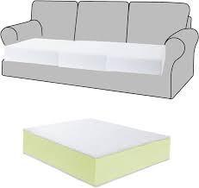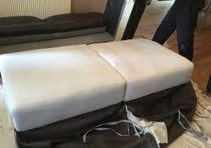
Distributing padding materials evenly based on couch divisions ensures balanced support.

Example:
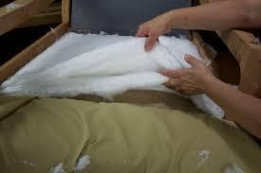
Dividing the couch into sections and applying padding uniformly prevents uneven wear and maintains consistent comfort across the entire piece.

KT1006 Stretch, tension and deflection of fabric.
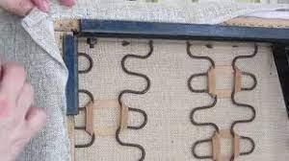
Considerations:
Understanding how fabric behaves in terms of stretch, tension, and deflection is crucial.

Example:
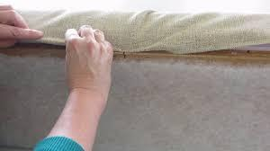
Allowing for stretch in areas with frequent use, such as seat cushions, ensures that the fabric maintains its integrity over time.

KT1007 Spacing of tacks, nails and staples.
Precision:

Maintaining accurate spacing when securing fabric enhances the final appearance.

Example:
Consistent spacing of tacks, nails, or staples contributes to a professional finish and prevents uneven tension in the fabric.

KT1008 Uniformity of a pair of arms and wings, pleating and folding and buttoning.
Craftsmanship:
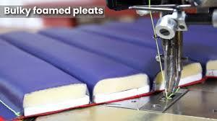
Achieving uniformity in pleating, folding, and buttoning is a mark of skilled craftsmanship.

Example:
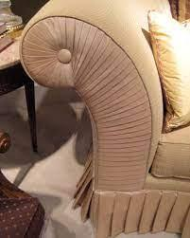
Ensuring consistent pleats and folds contributes to the overall aesthetics of the upholstery, showcasing the upholsterer's expertise.

KT1009 Positioning of the cover and alignments.
Accuracy:
Precise positioning of the cover and proper alignments contribute to a polished look.

Example:
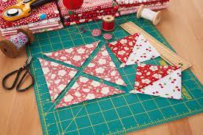
Aligning patterns or seams accurately ensures a cohesive appearance, enhancing the visual appeal of the finished piece.

KT1010 Pattern matching of fabric.
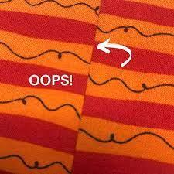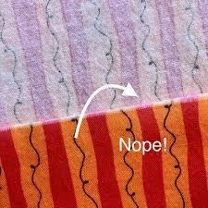
Skill:
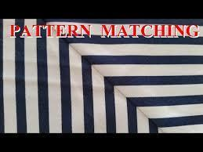
Mastering the art of pattern matching requires attention to detail.

Example:
Seamlessly aligning patterns across multiple pieces demonstrates a high level of skill and results in a cohesive and professional finish.

KT1011 Correct shaping edges and corners.
Technique:
Employing correct techniques for shaping edges and corners is essential.

Example:
Ensuring smooth and well-defined edges contributes to the durability and refined appearance of the upholstery.

Formative assessment

IAC1001 Foaming-up or padding-up principles are identified and described and the effect thereof on quality end-product is analysed.
(Weight 10%)

KM-02-KT11: Foaming-up or padding-up techniques (10%)

Learning Outcome

At the end of this section, learners should cover:
KT1101 Bonding foam to foam.
KT1102 Bonding foam to other substances.
KT1103 Shaping according to design or style.
KT1104 Templates and cutters.
KT1105 Building and shaping a profile with layers.
KT1106 Apply the sequence depending on the design.
KT1107 Tacking, sewing, tying and bonding to the sprung foundations and frame.

KT1101 Bonding foam to foam.


Technique:
Procedure:
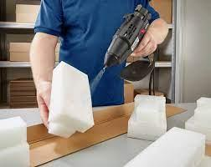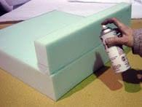
Apply a layer of foam adhesive evenly on the surface of one foam piece.

Pressing Together:
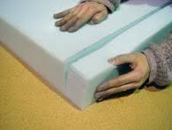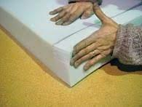
Join the adhesive-coated foam with another foam piece, ensuring uniform pressure for a secure bond.

Curing Time:
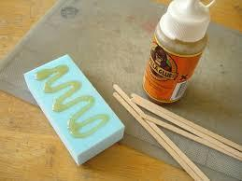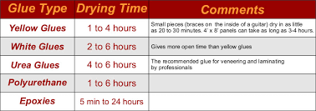
Allow sufficient time for the adhesive to cure and create a strong connection
Detailed Explanation:
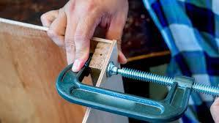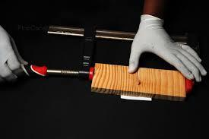

Applying adhesive evenly on foam surfaces and pressing them together, ensuring that the bonding process is uniform. This technique is crucial for constructing multi-layered padding with consistent adhesion.
.

KT1102 Bonding foam to other substances.
Application:
Applying adhesive to bond foam to various materials.

Technique:
Surface Preparation:
Ensure that both the foam and the substrate are clean and free of debris.

Adhesive Selection:
Choose an adhesive compatible with both the foam and the material it will bond to.

Application:
Apply adhesive to the foam and the substrate, following proper bonding guidelines.

Example:
Bonding foam to wood or other substrates using the appropriate adhesive. Understanding the compatibility between foam and different materials ensures a strong and lasting bond.

KT1103 Shaping according to design or style.
Technique
Using Tools:
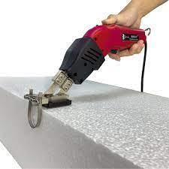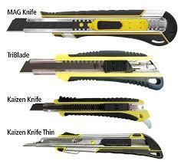
Employ various tools such as knives, electric cutters, or custom shaping tools.

Precision Cutting:
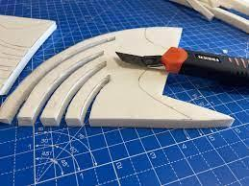
Cut the foam with precision, following design templates or patterns.

Sculpting:
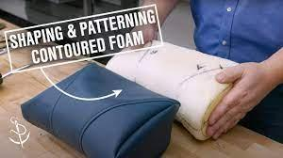
Sculpt the foam into desired shapes, paying attention to curves, angles, and contours

Skill:
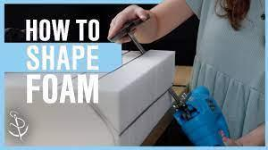
Shaping foam to match specific design or style requirements.

Example:
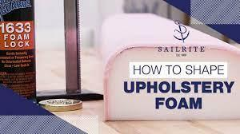
Sculpting foam to create curves, angles, or contours that align with the intended design. This technique requires precision to achieve the desired aesthetic and functional outcomes.

KT1104 Templates and cutters.
Tools:
Templates:
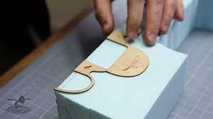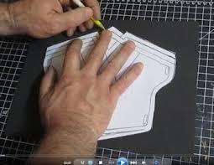
Utilize pre-designed templates or patterns to guide the cutting process.

Cutting Tools:
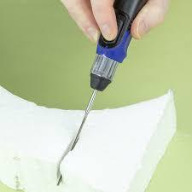
Select appropriate cutters such as knives, electric cutters, or specialty foam cutters.

Accuracy:
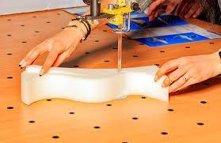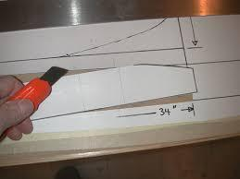
Ensure accurate cutting along the template lines for consistent and precise shapes.

Explanation:
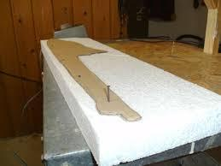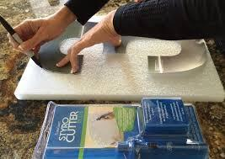
Templates serve as guides for cutting foam to specific shapes, while cutters ensure clean and accurate edges. This technique enhances efficiency and accuracy in achieving the desired foam shapes.

KT1105 Building and shaping a profile with layers.
Process:
Constructing and shaping a multi-layered profile for enhanced comfort and aesthetics.

Technique
Layering:
Strategically layer different densities and types of foam.

Bonding Layers:
Use bonding techniques (KT1101) to secure each layer.

Shaping:
Sculpt the layered foam to create a contoured profile, considering ergonomic and design requirements.

Example:
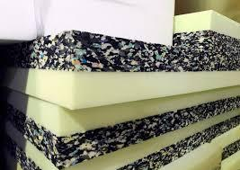
Layering different densities of foam strategically to create a contoured profile. Building up layers contributes to the overall comfort and appearance of the upholstered piece.

KT1106 Apply the sequence depending on the design.
Strategy:
Design Blueprint:
Refer to the design blueprint or specifications for the intended sequence.
Logical Order:
Apply foam layers or padding materials in a logical order that aligns with the overall design.

Consistency:
Maintain consistency in sequence application for uniform results.

Example:
Following a predetermined order in applying foam layers or padding materials to ensure that each element contributes to the overall design. Sequence adherence is essential for achieving a cohesive and well-structured result.

KT1107 Tacking, sewing, tying and bonding to the sprung foundations and frame.
Methods:
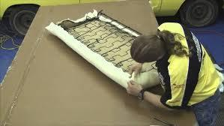
Various techniques for attaching foam and padding to the frame and springs.

Tacking:
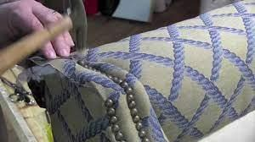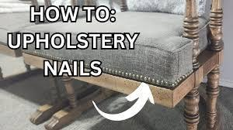
Use small nails to secure fabric or padding to the frame.

Sewing:
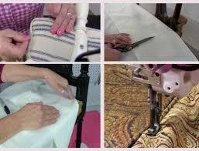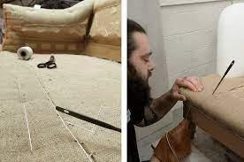
Stitch fabric securely to the frame or other materials.

Tying:
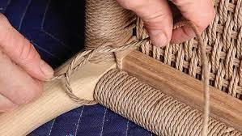
Fasten materials using twine or cords for added support.

Bonding:
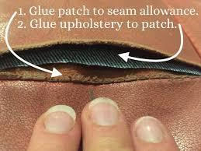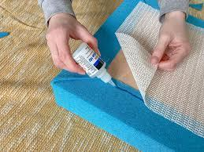
Apply adhesive to attach materials, ensuring a durable bond

Details:
Tacking involves securing fabric or padding with small nails, sewing involves stitching fabric securely, tying involves using twine or cords to fasten materials, and bonding involves adhesive applications. The choice of method depends on the specific requirements of the upholstery project.

Formative assessment

IAC1101 Techniques of padding and edge rolls when covering coil springs and arms.
IAC1102 Techniques of selecting specified densities of foam, applying adhesive to bond foam-to-foam and using templates and tools to construct and shape the foam and attach it to the frame over the springs and webbing.
IAC1103 Techniques of selecting specified padding / stuffing materials, applying and attaching it by means of tacking, sewing, tying and bonding to the sprung foundations and frame, and shaping it to meet specifications.
IAC1104 Techniques of measuring, cutting and attaching the specified fabric to cover the foam and paddings.
IAC1105 Importance of following workplace procedures handle and stack and store completed prepared frame for the next upholstery procedure and explain the types and consequences of damage to the product.
(Weight 10%)

KM-02-KT12: Joints and bracings of the frame (5%)

Learning Outcome
At the end of this section, learners should cover:

KT1201 Types.
KT1202 Uses.
KT1203 Requirements.
KT1204 Manufacturing.

KT1201 Types.
Types of Joints:
Mortise and Tenon Joints
Dovetail Joints
Lap Joints
Butt Joints
Mitre Joints
Tongue and Groove Joints

Types of Bracings:
Corner Braces
Gusset Plates
Cross Bracings
Strap Bracings

KT1202 Uses.
Joints:
Mortise and tenon joints provide strong connections for framing elements.
Dovetail joints enhance the aesthetics and strength of corner connections.
Lap joints are often used in tabletops and panels.

Bracings:
Corner braces reinforce the structural integrity of frame corners.
Gusset plates add stability to joints in various applications.
Cross bracings prevent lateral movement in structures.

KT1203 Requirements.
Common Requirements:
Strength:
Joints and bracings must provide the necessary structural strength.

Durability:
They should withstand the expected load and environmental conditions.

Aesthetics:
Considerations for visible joints, ensuring they align with the design.

KT1204 Manufacturing.
Manufacturing Processes:
Precision Cutting:
Using saws or other cutting tools to achieve accurate joint shapes.

Joinery Techniques:
Employing appropriate joinery methods for each type.

Fastening:
Securing joints and bracings using glue, screws, or other fasteners.

Finishing:
Sanding and polishing to achieve a smooth and visually appealing result.

Formative assessment

IAC1201 Various types of joints and bracings of the frame is described with reference to uses, requirements and manufacturing thereof.

(Weight 5%)

Provider Programme Accreditation Criteria:
Physical Requirements:
The provider must have lesson plans and structured learning material or provide learners with access to structured learning material that addresses all the topics in all the knowledge modules.
Human Resource Requirements:
Lecturer/learner ratio of 1:20.
Qualifications of lecturers: 5 years relevant experience or NQF 2 58227 with 2 years of experience.
Legal Requirements:
OHS compliant.
Exemptions
No exemptions, but the module can be achieved in full through a normal RPL process.

