

UPHOLSTERERY COVER FITTER

KM03 UPHOLSTERED FURNITURE BASIC COVER FITTING

LEARNER GUIDE

TABLE OF CONTENTS

INTRODUCTION TO THE MODULE 5
SECTION 1: KM-03-KT01: Specifications for upholstered furniture (10%) 7
INTRODUCTION 8
KT0101 Function of product specifications and standards in the manufacturing process. 10
KT0102 Types of product specifications including sketches, technical drawings, samples, prototypes, cutting lists and job cards, and their uses. 16
KT0103 Principles and concepts of interpreting specifications 30
(and workplace instructions to determine the type, quality, sizes and quantities of raw materials and consumables for the frame preparation process.) 30
KT0104 Frame and upholstery components construction and parts identification. 39
KT0105 Compliance and non-compliance. 76
KT0106 Consequences of prepared frames and covered furniture not meeting specified standards. 84
Internal Assessment Criteria 91
SECTION: 2 KM-03-KT02: Upholstery raw materials and consumables types and characteristics (20%) 92
Introduction 93
KT0203 Main upholstery material types 108
KT0204 Types, sizes, quantity and quality of consumables needed for cover fitting, finishing and trimming. 118
KT0205 Density, thickness and types of foam required for the foaming up process. 129
KT0206 Types of padding for covering coil springs. 132
KT0207 Consumables required for the foaming up process 137
KT0208 Using profile jigs and templates. 140
KT0209 Fabrics used for covering webbing, springs, foam and padding 142
KT0210 Types and gauges of various springs needed for the knocker-on process, including coil springs and zig-zag springs. 144
KT0211 Types, sizes, quantity and quality of consumables including clips, nails, staples, edge rolls, twine and cord needed for the springing up process. 147
KT0212 Types of webbing needed for the knocker on process, 149
KT0213 Labels, codes and the coding system and traceability. 151
KT0214 Principles and concepts of safe materials handling and storage methods. 156
FORMATIVE ASSESSMENT 162
SECTION: 3 KM-03-KT03: Use of chemicals: adhesives and solvents (10%) 165
INTRODUCTION 165
KT0301 Chemical types, characteristics, properties and purpose. 167
KT0302 Adhesives and solvents, characteristics and uses, flammable and hazardous, safe handling and storage. 168
KT0303 Application equipment, tools and dispensers. 169
KT0304 Measuring and mixing techniques and procedures. 171
KT0305 Preparation and application techniques. 173
KT0306 Safety hazards and risks 175
FORMATIVE ASSESSMENT 177
SECTION: 4 KM-03-KT04: Upholstery tools and equipment (10%) 178
INTRODUCTION 179
KT0401 Upholstery hand tools for the furniture covering processes: 181
KT0402 Pneumatic tools 186
KT0403 Upholstery electric portable power tools for the furniture covering processes: settings and operation of, components and parts, uses, safe storage and handling. 191
KT0404 Upholstery covering equipment. 192
KT0405 Personal protective equipment and materials handling equipment. 196
KT0406 Tools and equipment maintenance, fault finding and standard operating procedures. 198
KT0407 Safety measures and mechanisms. 211
FORMATIVE ASSESSMENT 213
SECTION:5 KM-03-KT05: Upholstery measuring tools techniques and calculations (10%) 214
INTRODUCTION 214
KT0501 Principles of accurate measurements during the frame preparation process. 216
KT0502 Units of measurement and measuring tools and equipment required for the frame preparation process. 224
KT0503 Measuring techniques. 230
KT0504 Calculations and angles. 241
KT0505 Calculating allowances. 248
KT0506 Problem solving 249
FORMATIVE ASSESSMENT 259
SECTION: 6 KM-03-KT06: Upholstered furniture manufacturing processes (10%) 260
INTRODUCTION 261
KT0601 Upholstered furniture manufacturing process from raw frame to finished product. 262
KT0602 Process flow and productivity. 264
KT0603 Operations in the process flow: knocker on operations, foaming up operations, padding sprung foundations and frames and covering operations. 266
KT0604 Routing sheets. 267
KT0605 Cutting lists. 268
KT0606 Product specifications. 269
KT0607 Finishing aids. 269
FORMATIVE ASSESSMENT 271
SECTION: 7 KM-03-KT07: Upholstery covering principles (10%) 272
INTRODUCTION 273
KT0701 Stretch, tension and deflection of fabric. 274
KT0702 Spacing of tacks, nails and staples. 275
KT0703 Uniformity of a pair of arms and wings, pleating and folding and buttoning. 277
KT0704 Positioning of the cover and alignments. 279
KT0705 Pattern matching (fabric). 280
KT0706 Principles and concepts of preparing and stacking covered frames for the next step in the production process. 281
FORMATIVE ASSESSMENT 281
SECTION: 8 KM-03-KT08: Upholstered furniture covering operations and techniques (20%) 282
INTRODUCTION 283
KT0801 Correct sequence and procedure 285
KT0802 Slip stitching with circular needle and piping slip stitching. 287
KT0804 Tufting 291
KT0805 Tacking, stapling, nailing. 293
KT0806 Pleating and folding fabric. 295
KT0807 Pulling, tensioning and stretching. 296
KT0808 Preventing tack ties. 297
KT0809 Shaping edges and corners by using hand skills. 298
KT0810 Measuring centralising the cover, spacing of buttons and studs, front borders of chairs. 300
KT0811 Attaching decorative trimmings. 301
KT0812 Cutting in of covers. 303
KT0813 Foam marking 305
FORMATIVE ASSESSMENT 307
Provider Programme Accreditation Criteria 308

INTRODUCTION TO THE MODULE

Knowledge Module 03, 'Upholstered Furniture Basic Cover Fitting', forms a fundamental part of the NQF Level 2 qualification in Upholstery. This module, encompassing 8 credits, is designed to impart a comprehensive understanding of the principles, techniques, and materials involved in upholstered furniture making.

The module covers a spectrum of topics, each weighted to signify its importance in the curriculum:

1. KM-03-KT01: Specifications for Upholstered Furniture (10%): This topic delves into the standards and specifications required for quality upholstered furniture, emphasising the importance of design and functionality.

2. KM-03-KT02: Upholstery Raw Materials and Consumables Types and Characteristics (20%): A detailed exploration of various materials and consumables used in upholstery, focusing on their properties and suitability for different furniture types.

3. KM-03-KT03: Use of Chemicals: Adhesives and Solvents (10%): This section educates about the chemicals involved in the upholstery process, particularly adhesives and solvents, highlighting their correct and safe usage.

4. KM-03-KT04: Upholstery Tools and Equipment (10%): An overview of the tools and equipment essential for upholstery, outlining their usage and maintenance.

5. KM-03-KT05: Upholstery Measurements, Measuring Tools, Techniques and Calculations (10%): This topic focuses on the precision and techniques required in measuring and calculating materials for upholstery.

6. KM-03-KT06: Upholstered Furniture Manufacturing Processes (10%): An insight into the manufacturing processes, from initial design to final product completion.

7. KM-03-KT07: Upholstery Covering Principles (10%): It covers the foundational principles behind upholstery covering, essential for quality craftsmanship.

8. KM-03-KT08: Upholstered Furniture Covering Operations and Techniques (20%): This detailed section deals with the practical aspects of covering upholstered furniture, including various techniques and operations.

This module aims to equip learners with the skills and knowledge to excel in the upholstery industry, particularly focusing on cover fitting, a skill critical to the aesthetic and functional aspects of upholstered furniture [[1](https://allqs.saqa.org.sa/showQualification.php?id=103187)], [[2](https://regqs.saqa.org.sa/viewQualification.php?id=103199)].

SECTION 1: KM-03-KT01: Specifications for upholstered furniture (10%)

Learning Outcome

At the end of this section, learners should cover:

- KT0101 Function of product specifications and standards in the manufacturing process.
- KT0102 Types of product specifications including sketches, technical drawings, samples, prototypes, cutting lists and job cards, and their uses.
- KT0103 Principles and concepts of interpreting specifications and workplace instructions to determine the type, quality, sizes and quantities of raw materials and consumables for the frame preparation process.
- KT0104 Frame and upholstery components construction and parts identification.
- KT0105 Compliance and non-compliance.
- KT0106 Consequences of prepared frames and covered furniture not meeting specified standards.

INTRODUCTION

The first Knowledge Topic, KM-03-KT01: Specifications for Upholstered Furniture, is crucial in understanding the standards and requirements that guide the production of quality upholstered furniture. This topic is designed to provide learners with a comprehensive understanding of the various elements that contribute to the manufacturing process, ensuring that the final product meets both industry standards and customer expectations.

The topic elements to be covered include:

1. KT0101: Function of Product Specifications and Standards in the Manufacturing Process: This element focuses on the role of specifications and standards in ensuring consistent quality and functionality in upholstered furniture manufacturing.

2. KT0102: Types of Product Specifications: It covers various forms of specifications such as sketches, technical drawings, samples, prototypes, cutting lists, and job cards, exploring their specific uses and importance in the production process.

3. KT0103: Interpreting Specifications and Workplace Instructions: This section deals with understanding and applying specifications and instructions to determine the appropriate materials and quantities required for frame preparation.

4. KT0104: Frame and Upholstery Components Construction and Parts Identification: Learners will be introduced to the different components involved in frame and upholstery construction, including identification and understanding of each part's role.

5. KT0105: Compliance and Non-Compliance: This element emphasises the importance of adhering to set standards and specifications, and the implications of non-compliance.

6. KT0106: Consequences of Non-Compliance: It addresses the potential repercussions of failing to meet specified standards in the preparation of frames and furniture covering.

Through this knowledge topic, learners will acquire the skills and understanding necessary to navigate the complex aspects of furniture manufacturing, ensuring that their work adheres to the highest standards of quality and craftsmanship as required in the upholstery industry
[[1](https://regqs.saqa.org.sa/viewQualification.php?id=103199)], [[2](https://allqs.saqa.org.sa/showQualification.php?id=103187)].

KT0101 Function of product specifications and standards in the manufacturing process.


The first knowledge topic element, KT0101, focuses on the function of product specifications and standards in the manufacturing process, a crucial aspect of the South African upholstery industry.

1. Importance of Product Specifications: Product specifications serve as a detailed blueprint for manufacturing. They outline critical aspects like dimensions, materials, and assembly instructions, ensuring that each piece of upholstered furniture meets the intended design and functionality.

- Defining Product Quality and Consistency: Product specifications serve as a detailed framework, outlining essential aspects like size, materials, and design features. They ensure every product remains consistent in quality and appearance, meeting both the manufacturer's standards and customer expectations. This is especially important in industries where uniformity, like in restaurant or bar furniture, is crucial for brand identity and customer experience

- Guiding the Manufacturing Process: Specifications act as a step-by-step guide for manufacturers, detailing each phase of the production process. This clarity helps in minimising errors, streamlining production, and enhancing efficiency.

- Facilitating Communication: Clear product specifications enable effective communication among different departments within a manufacturing company and between manufacturers and clients. This ensures everyone involved has a shared understanding of what the final product should be.

- Ensuring Compliance and Safety: Specifications often include compliance with industry standards and safety regulations. Adherence to these specifications is essential to avoid legal issues and ensure the safety and wellbeing of the end-users, particularly in environments like schools, hospitals, or public spaces.

- Supporting Customisation and Innovation: Detailed specifications allow for customisation while maintaining the integrity of the design. They also foster innovation by providing a foundation upon which new designs and improvements can be built.

In summary, product specifications are not just a list of instructions; they are a cornerstone of quality, efficiency, and innovation in manufacturing.

2. Role of Standards in Upholstery Manufacturing: Standards, often set by national and international bodies, provide benchmarks for quality, safety, and durability. In South Africa, organisations like the South African Bureau of Standards (SABS) play a vital role in developing these standards, which help maintain consistency and reliability in the manufacturing process

Ensuring Quality and Consistency: Standards provide a set of established criteria or benchmarks for quality and performance. This ensures that all products consistently meet the desired level of quality, essential in maintaining brand reputation and customer trust.

Safety and Compliance: In the upholstery manufacturing industry, adhering to safety standards is crucial. These standards often encompass aspects like flammability, durability, and structural integrity, ensuring the safety of both the end-users and the environment. Compliance with these standards is not optional but a regulatory requirement.

Guiding Best Practices: Standards serve as a guide for best practices in manufacturing, from the selection of materials to the final assembly processes. They often contain technical specifications and guidelines, which help manufacturers optimise their production process for efficiency and sustainability.

Facilitating Market Access: Compliance with standards, especially those recognised internationally, opens up broader market access. It ensures that products can be sold in different markets without facing compliance issues, which is vital for expanding business operations globally.

Enhancing Product Value: Adhering to high standards can also be a unique selling proposition, elevating a product's value in the eyes of consumers who are increasingly conscious of quality, safety, and environmental impact.

In summary, standards in upholstery manufacturing play a critical role in guiding the industry towards producing high-quality, safe, and sustainable products.

3. Compliance with Regulatory Requirements: Adherence to relevant standards is not just about quality assurance; it is also about compliance with legal and regulatory requirements. Products entering the South African market must meet these standards, impacting aspects like labelling, safety, and environmental impact.

- Adherence to Laws and Standards: The furniture industry is highly regulated, and manufacturers must comply with a range of laws and standards covering all aspects of their operations. These regulations are designed to ensure product safety, quality, and environmental responsibility.

- Safety and Health Compliance: In the upholstery industry, compliance often involves adhering to specific safety and health regulations. These can include regulations pertaining to the use of materials, flammability standards, and structural integrity of the furniture. Ensuring workplace safety and health compliance is also a key aspect, especially in areas like the wood and upholstery industry.

- Certification Labels: For products like upholstered furniture, manufacturers are required to have certification labels that indicate compliance with relevant regulatory requirements. These labels often include statements about meeting specific flammability standards or other safety criteria.
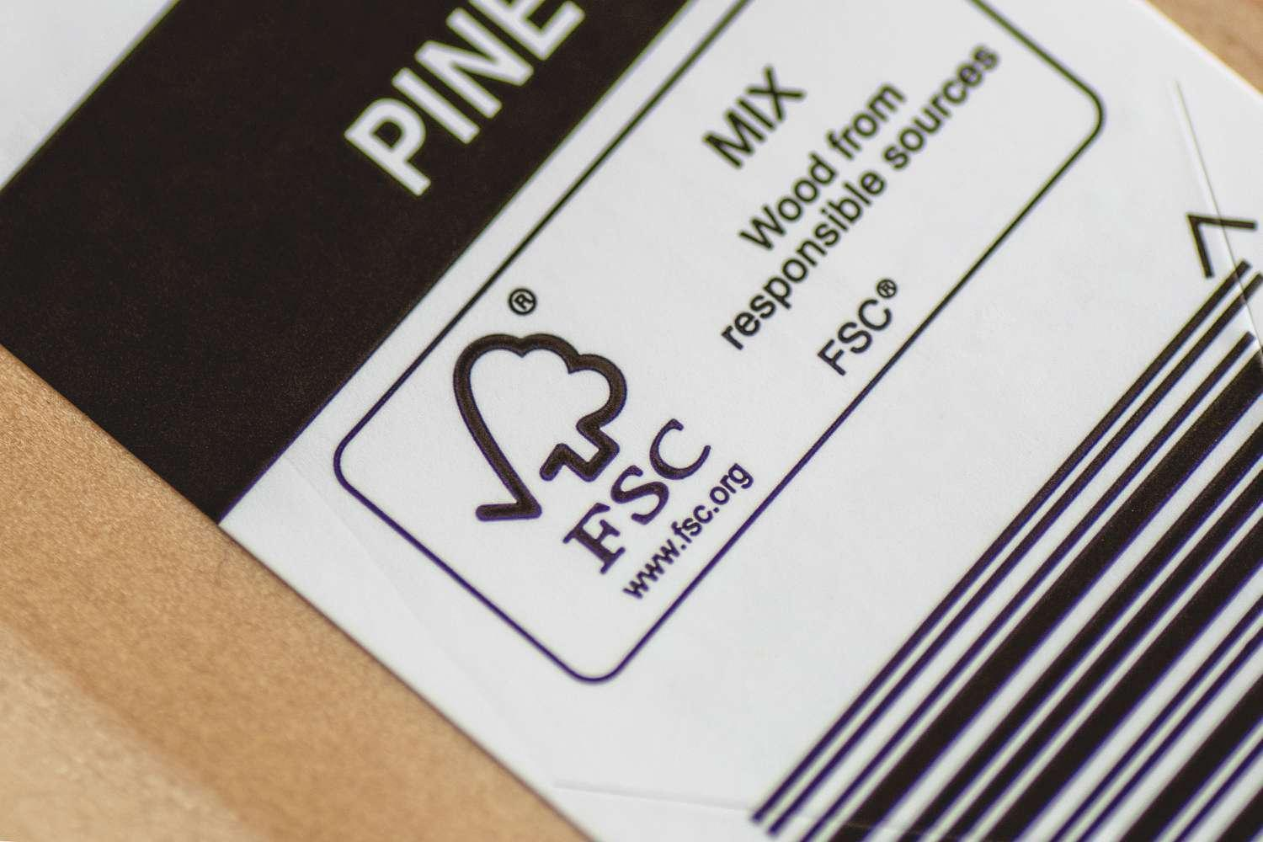

- Avoidance of Non-Compliance Consequences: Non-compliance can lead to various consequences, including failed safety tests, legal penalties, and a tarnished reputation. Inadequate material strength or improper construction are common reasons for failure in compliance testing

- Consumer Protection: Compliance also plays a significant role in protecting consumers. Furniture must meet specific standards for flammability and fire resistance, which are crucial for minimising risks such as fire accidents and property damage

Compliance with regulatory requirements not only ensures legal adherence but also enhances the credibility and safety profile of the products in the market.

4. Quality Control: Specifications and standards play a key role in quality control. They act as a reference point against which the finished product can be checked, ensuring that the upholstered furniture aligns with customer expectations and industry norms.

Quality Control (QC) in upholstery manufacturing is a critical process ensuring that furniture meets established standards of quality, safety, and customer satisfaction:

- Standard Adherence: QC involves verifying that the furniture adheres to the specified standards and guidelines, which could include material quality, strength, durability, and aesthetics. This is crucial in maintaining product integrity and market reputation.

- Inspection and Testing: Regular inspection and testing of both raw materials and finished products are integral to QC. This might involve checking the strength of materials, the safety of construction, and the precision of dimensions. Such practices help to identify and rectify defects before products reach the market.

- Process Monitoring: QC extends beyond just inspecting finished products; it also includes monitoring the manufacturing process. This ensures that each stage of production, from material selection to final assembly, adheres to predefined standards and procedures.

- Customer Satisfaction: Quality control is not only about meeting technical specifications; it is also about ensuring customer satisfaction. This includes aspects like comfort, design, and usability, which are vital in the furniture industry.

- Continual Improvement: QC is a continuous process, feeding back into product development and process improvement. This ongoing cycle helps in adapting to new standards, technologies, and customer preferences, thereby fostering innovation and growth in the industry.

Quality control is thus a multi-faceted approach, essential in delivering products that are safe, reliable, and aligned with customer expectations in the upholstery manufacturing industry.

Understanding the function of specifications and standards is fundamental for anyone involved in the upholstery manufacturing process, especially in ensuring that the products are competitive both in the local and international markets.

KT0102 Types of product specifications including sketches, technical drawings, samples, prototypes, cutting lists and job cards, and their uses.
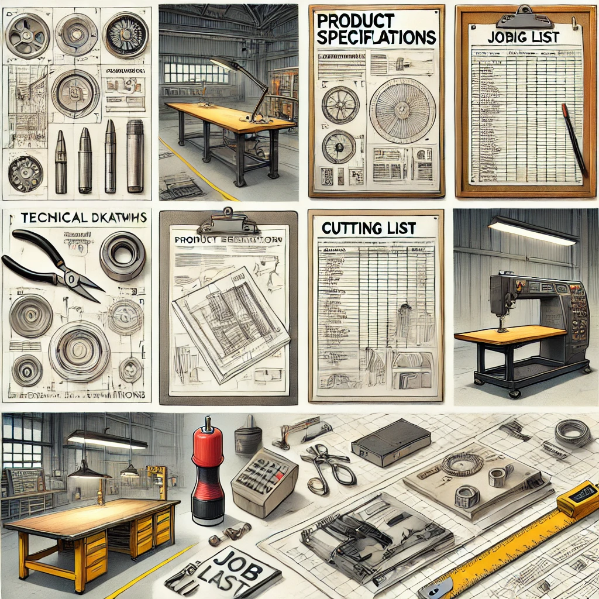

In the field of upholstery and furniture design, understanding the various types of product specifications is essential for the effective communication and execution of design ideas. Here are the key types and their uses:
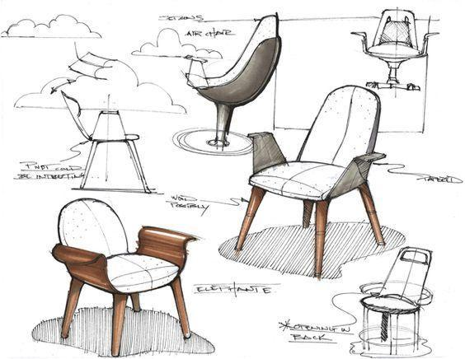

1. Sketches:


Sketches are the initial visual representations of a concept. They are quick, freehand drawings that capture the basic ideas and forms of the desired product. They are often used in the early stages of the design process to brainstorm and communicate preliminary ideas.

Sketches play a fundamental role in the initial stages of product design and development, particularly in the field of upholstery and furniture design:

1. Idea Visualisation: Sketches are the primary tool for visualising and communicating ideas. They provide a quick and effective way to translate a concept or idea from the designer’s mind onto paper, allowing for immediate exploration and iteration.

2. Flexibility and Creativity: Sketching offers a high degree of flexibility, enabling designers to experiment with different shapes, dimensions, and features without the constraints of technical accuracy. This freedom encourages creativity and innovation in design.

3. Feedback and Collaboration: Sketches serve as a means of communication between designers, manufacturers, and clients. They facilitate discussions and feedback, allowing for collaborative refinement of the design concept before moving on to more detailed and technical stages.

4. Cost-Effective: Being a low-cost and quick method, sketches are ideal for exploring multiple design options without incurring significant expenses or time commitment. This makes them an essential tool, especially in the early conceptual phase of product development.

5. Foundation for Further Development: Sketches often form the foundation for more detailed and technical product specifications, such as technical drawings and prototypes. They provide the initial reference point from which these more detailed and precise representations are developed.

In summary, sketches are invaluable in the early stages of furniture design, providing a versatile, collaborative, and cost-effective tool for visualising and refining design ideas.

2. Technical Drawings:

Technical drawings are precise and detailed representations of the final product. They include dimensions, materials, and construction details, providing a comprehensive guide for manufacturing. Technical drawings are essential for ensuring accuracy in the final product, and they serve as a reference throughout the production process.

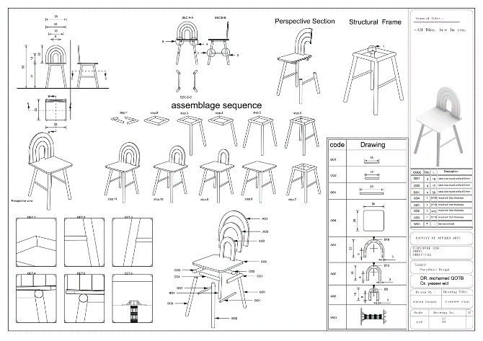

Technical drawings are a critical component in the furniture manufacturing process, especially in the context of bespoke or custom furniture, where precision and detail are paramount:

- Detailed Representation: Technical drawings provide a detailed and precise representation of the furniture piece. They include exact dimensions, materials, and assembly details, which are crucial for accurate fabrication.

- Communication Tool: These drawings serve as an essential communication tool between designers, manufacturers, and clients. They help in visualising the final product and ensure that all parties have a clear understanding of the design and specifications.

- Error Reduction: By providing precise specifications, technical drawings reduce the possibility of errors during the manufacturing process. They play a key role in quality control, ensuring that the final product aligns perfectly with the design intent.

- Efficiency and Cost-Effectiveness: Accurate technical drawings contribute to the efficiency of the manufacturing process. They help in optimising material use and reducing waste, thereby contributing to cost-effectiveness.

- Legal and Patent Documentation: In cases where a design is unique and needs to be patented, technical drawings can be used as part of the patent application process. They provide a legal document that describes the design in detail.

- Standard Compliance: Technical drawings ensure that the furniture design complies with industry standards and regulations, which might include ergonomic considerations, safety standards, and environmental regulations [[6](https://www.scandinavian.house/services/technical-drawings-furniture/)].

Technical drawings are thus indispensable in the furniture manufacturing process, providing accuracy, efficiency, and a bridge between conceptual design and physical reality.

3. Samples:
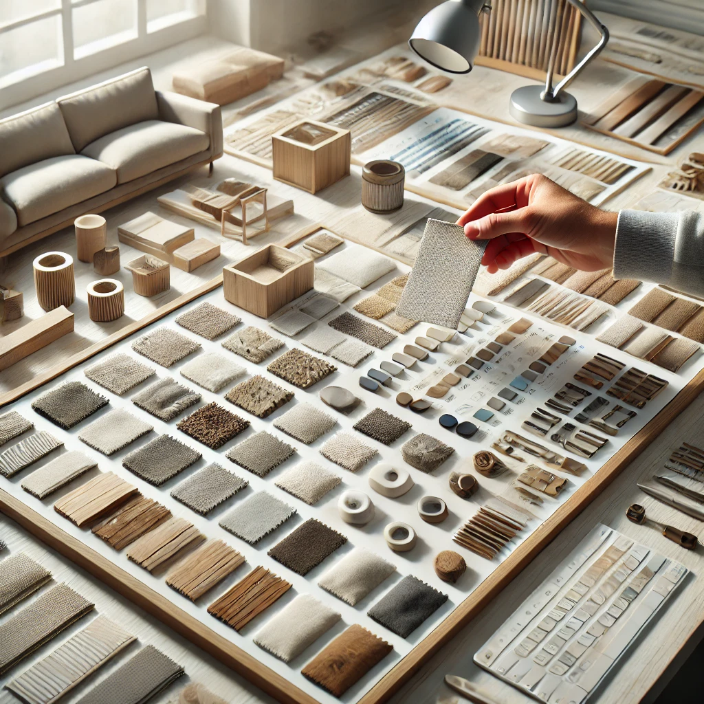
Samples are physical examples of materials or components that will be used in the final product. They are crucial for assessing texture, colour, and material quality, and they help in making decisions regarding material suitability and aesthetic appeal.

In the context of upholstery and furniture manufacturing, samples play a pivotal role in the design and production process:

- Material Assessment: Samples allow designers and manufacturers to physically assess the materials they plan to use. This includes evaluating the texture, weight, durability, and colour of fabrics, leathers, or other upholstery materials. It is crucial for ensuring that the chosen materials meet both aesthetic and functional requirements.

- Client Approval: For custom-made furniture, samples are often presented to clients for approval. This step is essential in ensuring client satisfaction with the material choices, especially in terms of feel and colour, which can be difficult to gauge accurately from pictures or descriptions alone.

- Quality Control: Samples serve as a benchmark for quality control throughout the manufacturing process. They help ensure consistency in production, particularly when matching colours or textures across different batches of material.

- Prototyping: In prototyping, samples of different materials can be used to create small sections of the furniture piece to test how various materials work together. This is particularly important for understanding the interplay of different textures and strengths in the final product.

- Supplier Evaluation: When sourcing materials from suppliers, samples are often requested to evaluate the supplier’s capability to meet the specified requirements for quality and consistency. This is crucial in maintaining high standards in the production chain.

In summary, samples are integral to the upholstery and furniture manufacturing process, assisting in material selection, client satisfaction, quality control, prototyping, and supplier evaluation.

4. Prototypes:
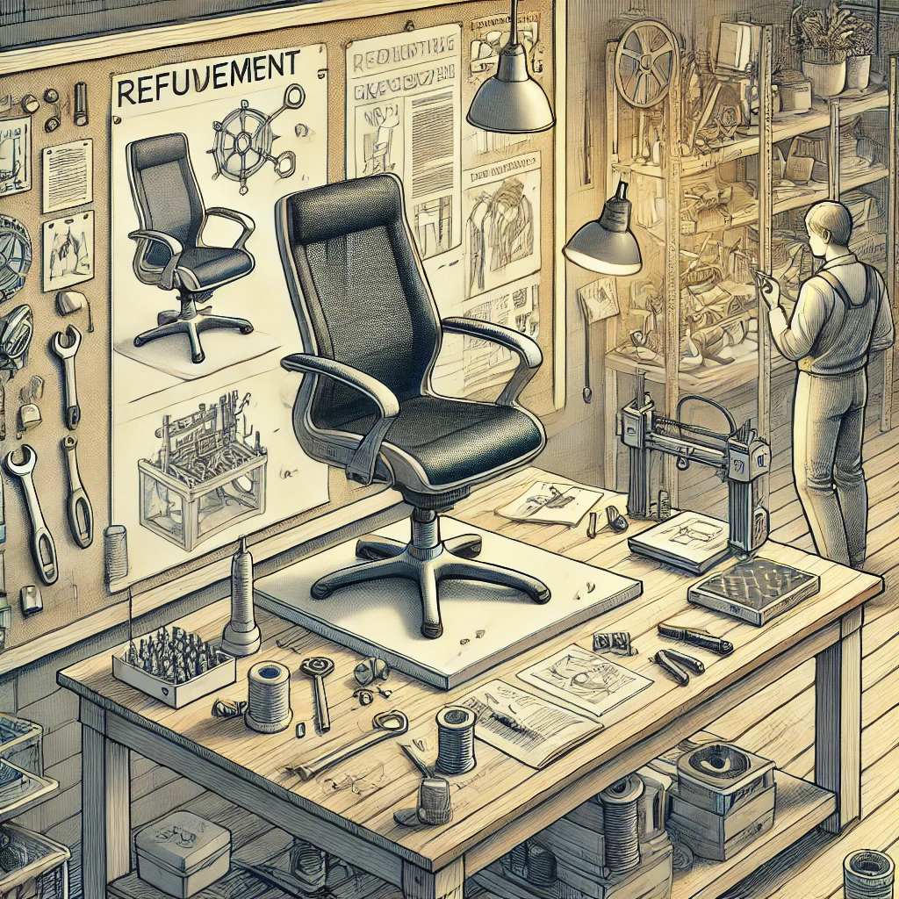
Prototypes are full-scale working models of the final product. They are used for testing the design in real-world conditions, identifying any issues with form, function, or manufacturability. Prototypes are invaluable for refining the design before mass production begins.

Prototyping in furniture manufacturing is a critical step in the design and development process, offering several key benefits:

1. Design Validation: Prototypes allow designers and manufacturers to validate and refine the design of a furniture piece. It provides a tangible model to assess aesthetics, functionality, and ergonomics, ensuring the design meets both aesthetic and practical requirements [[1](https://www.deskera.com/blog/designing-for-furniture-manufacturing/)].

2. Testing and Feedback: Prototyping offers an opportunity to test the product for various factors such as durability, comfort, and stability. Feedback can be gathered from potential users or clients to make improvements before the final production begins [[2](https://xo3d.co.uk/furniture-prototyping-can-help-you-succeed/)].

3. Error Identification and Correction: Through prototypes, potential issues in design, materials, or construction can be identified early in the process. This enables corrections to be made before mass production, saving time and resources [[3](https://www.upholsteryresource.com/node/261)].

4. Innovation and Experimentation: Prototyping provides a platform for experimenting with new materials, designs, or construction techniques. This can lead to innovative solutions and improvements in furniture design and functionality [[4](https://fibreguard.com/blog/digital-prototyping-the-future-of-sofa-design)].

5. Cost and Time Efficiency: By identifying and addressing issues during the prototyping stage, manufacturers can avoid costly errors in the mass production phase. Prototyping can streamline the production process, making it more efficient and cost-effective [[5](https://blog.twinbru.com/sitting-pretty-expand-your-furniture-prototyping-with-digital-fabric-twins)], [[6](https://cgifurniture.com/furniture-prototyping-5-benefits/)].

In conclusion, prototypes are an indispensable tool in furniture manufacturing, offering practical insights into the design and function of a product, aiding in innovation, and ensuring quality and customer satisfaction.

5. Cutting Lists:
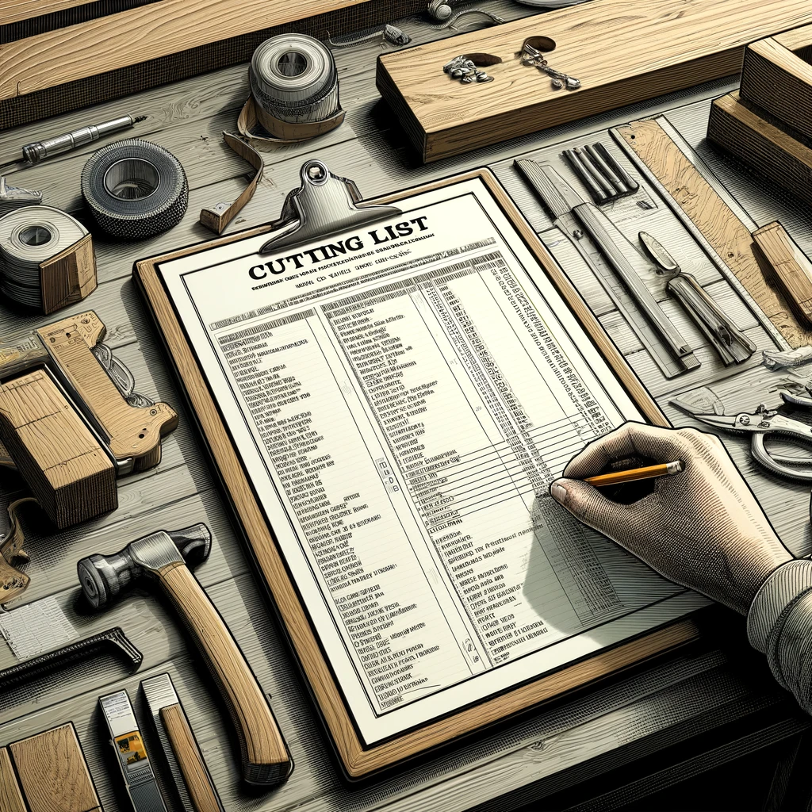

Cutting lists are detailed lists of parts, materials, and dimensions required for the manufacture of a piece of furniture. They ensure efficient use of materials and accurate cutting of components, crucial for the assembly of the product [[5](https://cuttinglistforkitchens.co.sa/)].

Cutting lists are a crucial element in the furniture manufacturing process, serving several important functions:

Material Organisation: A cutting list organises all the materials needed for a furniture project. It specifies the types and quantities of materials, such as wood, fabric, or metal, required for each part of the furniture piece.

Efficient Use of Resources: By detailing exact dimensions and quantities, cutting lists help in minimising waste. They ensure that materials are used efficiently, reducing excess and helping to control costs.

Accuracy in Manufacturing: Cutting lists provide precise measurements for each component of the furniture. This accuracy is vital for ensuring that all parts fit together correctly during assembly, leading to a higher quality finished product.

Time Management: They streamline the manufacturing process by providing a clear roadmap for cutting and preparing materials. This organisation helps in managing production timelines more effectively.

Cost Estimation and Budgeting: Cutting lists are used to estimate the amount of material needed, which aids in budgeting and cost control. They help manufacturers in quoting prices for custom furniture pieces.

Quality Control: By standardising the dimensions and quantities of materials, cutting lists contribute to consistency in production, which is key for maintaining quality standards across multiple units of the same design.

In summary, cutting lists are essential for efficient and accurate furniture manufacturing, contributing to better resource management, quality control, and overall production efficiency.

6. Job Cards:
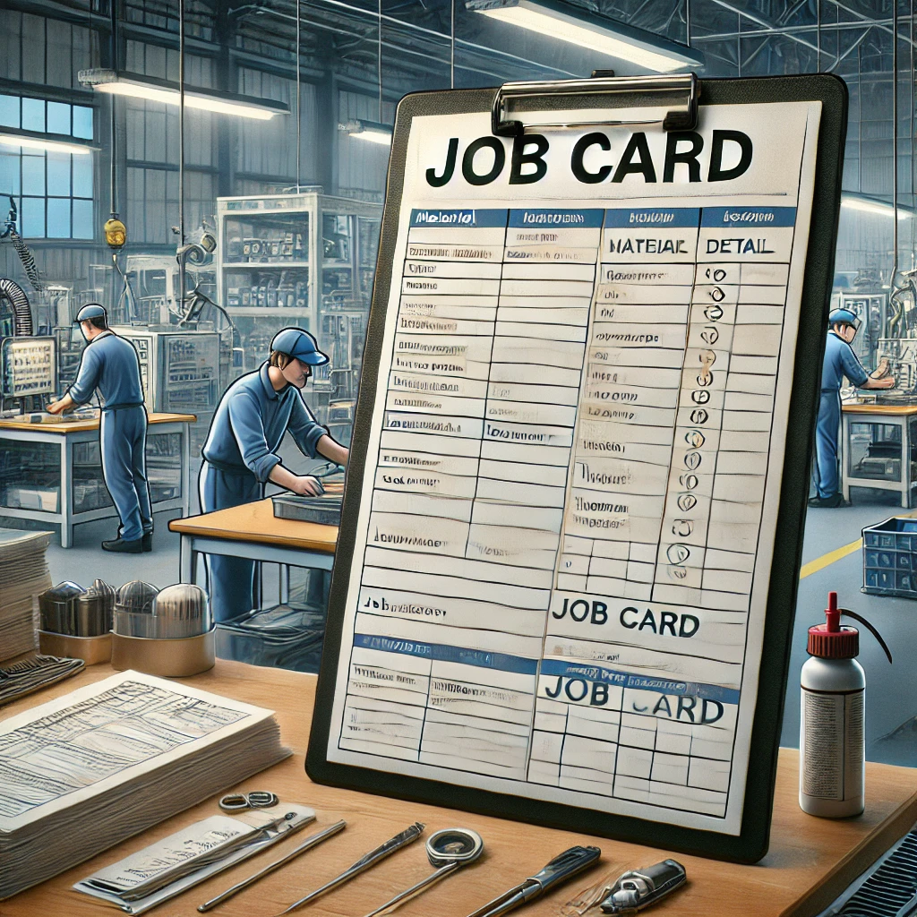
Job cards are documents used to manage and record the production process. They typically include information about the materials, equipment, and labour required for a job, as well as timelines and process steps. They are essential for tracking progress and ensuring that each stage of production is completed on schedule.
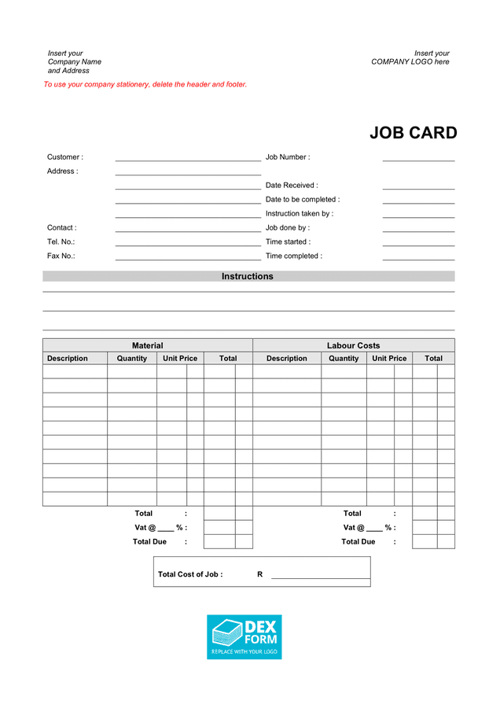
Job cards are an essential tool in furniture manufacturing and other industries, serving several important purposes:

Record Keeping and Task Assignment: Job cards are used to assign specific tasks or jobs to teams or individuals. They contain detailed information about what needs to be done, providing a clear directive for the work order.

Tracking Progress: They help in monitoring the progress of tasks or jobs. With job cards, supervisors and managers can keep track of where each task stands, which is vital for maintaining timelines and ensuring efficient workflow.

Quality Control: Job cards can include specifics about quality standards and checks, ensuring that each step of the manufacturing process meets the set criteria. This is crucial in maintaining the quality of the finished product.

Resource Allocation: They provide information on the resources required for a job, such as materials, tools, and manpower. This aids in efficient resource management and planning.

Customer and Order Details: In custom furniture manufacturing, job cards often include customer specifications and order details. This ensures that the final product aligns with the customer’s requirements and expectations.

Enhancing Operational Efficiency: By streamlining communication and coordination between different teams and departments, job cards enhance overall operational efficiency. They serve as a central source of information for the entire manufacturing process.

In summary, job cards are a critical component in managing and executing manufacturing processes effectively, ensuring that tasks are completed as per the requirements, on time, and with the desired quality.

Each of these types of product specifications plays a vital role in the furniture manufacturing process, helping to translate design concepts into tangible, high-quality products.

KT0103 Principles and concepts of interpreting specifications


(and workplace instructions to determine the type, quality, sizes and quantities of raw materials and consumables for the frame preparation process.)

KT0103 focuses on the principles and concepts essential for interpreting specifications and workplace instructions, particularly in relation to selecting raw materials and consumables for the frame preparation process in furniture manufacturing:

1. Understanding Specifications: It involves comprehending detailed documentation that outlines the type, quality, and dimensions of materials required. Specifications often include technical descriptions, material standards, and design requirements. The ability to accurately interpret these details is crucial for selecting appropriate materials.

Understanding specifications is a fundamental aspect of furniture manufacturing and involves comprehending the detailed requirements outlined for a product or service:

1. Definition and Purpose: Specifications are documented requirements that must be satisfied by a material, design, product, or service. They serve as a guide for production, ensuring that the final product meets desired standards of quality, functionality, and safety [[1](https://en.wikipedia.org/wiki/Specification_(technical_standard))].

2. Detailed Requirements: Specifications typically include detailed descriptions of materials, design dimensions, construction methods, and performance criteria. This detailed information is crucial for manufacturers to produce items that align with the intended design and function [[5](https://study.com/academy/lesson/writing-technical-specifications.html)].

3. Quality and Compliance: Specifications ensure that the products adhere to the required quality standards and comply with relevant industry regulations. They provide guidance on how goods should be designed, constructed, and manufactured [[3](https://info.library.okstate.edu/c.php?g=151802&p=998794)].

4. Communication Tool: They act as a communication tool between designers, manufacturers, and clients, ensuring that all parties have a shared understanding of what is to be produced. Specifications help in mitigating misunderstandings and discrepancies in the production process [[2](https://www.crowncommercial.gov.uk/news/how-to-write-a-specification-procurement-essentials)].

5. Planning and Research: A good specification is created through careful planning and research. It involves understanding the end-user's needs, market trends, and technological possibilities, thereby forming the basis of all offers and contracts [[6](https://www.procurementjourney.scot/route-3/develop-documents/specification)].

In summary, understanding specifications is critical for ensuring that the furniture manufacturing process is aligned with the required standards, meeting both the client's expectations and regulatory compliance.

2. Quality Assessment: This aspect covers evaluating the quality of materials as per the specifications. It includes understanding various grades, durability, and suitability of materials like wood, metal, or composites for the frame construction.

Quality Assessment (QA) is a crucial process in various sectors, including manufacturing and service industries, to ensure that products or services meet established standards:

1. Monitoring and Evaluation: QA involves continuous monitoring and evaluation of processes and outputs. It ensures that the project or product development adheres to predefined quality standards and meets the intended objectives [[2](https://www.coursesidekick.com/management/192246)].

2. Identifying Biases and Errors: An essential part of QA is identifying potential biases or errors that could affect the outcome. This proactive approach anticipates problems and allows for timely corrective actions [[3](https://ifis.libguides.com/systematic_reviews/evaluation-of-included-studies)].

3. Cost Analysis in QA: Involves evaluating which costs were considered in a study or project, assessing the resources used, and determining the efficiency of the expenditure. This aspect of QA ensures financial accountability and cost-effectiveness [[1](https://www.york.ac.uk/crd/SysRev/!SSL!/WebHelp/5_5_QUALITY_ASSESSMENT.htm)].

4. Strengthening Academic Integrity: In educational contexts, quality assessment design plays a role in upholding academic integrity. It involves ensuring that assessments are fair, transparent, and aligned with learning outcomes [[4](https://ltc.uow.edu.au/hub/article/assessment-design-to-strengthen-academic-integrity)].

5. Theoretical Basis of QA: QA methods are often grounded in quality theory, which provides a framework for assessing the effectiveness and efficiency of a process or product. This includes safety analyses and the overall quality of the output [[5](https://www.sciencedirect.com/topics/engineering/quality-assessment)].

In summary, quality assessment is a systematic process of evaluating whether a product or service meets specific quality standards, focusing on monitoring, error identification, cost-effectiveness, and integrity.

3. Size and Quantity Determination: Interpreting specifications to ascertain the correct sizes and quantities of materials is key. It involves calculations based on dimensions provided in the specifications to ensure adequate material is ordered without excess [[2](https://allqs.saqa.org.sa/showUnitStandard.php?id=14580)].

Size and Quantity Determination is a critical aspect in the manufacturing process, particularly in ensuring efficiency and cost-effectiveness:

1. Conformance to Specifications: The process involves ensuring that the sizes and quantities of raw materials and consumables conform to the specifications laid out in the design. This means adhering to the targets and tolerances determined by product designers to ensure quality [[1](https://knecnotes.co.ke/quality-and-quantity-determination/)].

2. Order Quantity and Lot Sizing: It Is closely related to determining the appropriate quantity of each product to be ordered or produced. This involves calculations that consider production capacity, demand, inventory costs, and the minimisation of waste [[2](https://www.planettogether.com/blog/lot-sising-and-order-quantity-determination-in-industrial-manufacturing-streamlining-processes-with-advanced-integration)].

3. Efficient Resource Use: Accurate size and quantity determination aid in the efficient use of resources. It ensures that there is enough material to meet production needs without excessive over ordering, which can lead to increased costs and storage issues [[3](https://help.sap.com/docs/SAP_ERP/af181e123e50445fbab04de3e910a867/eb48d953189a424de10000000a174cb4.html)].

4. Customer Needs and Product Specifications: This process may also involve analysing customer needs and determining product specifications accordingly. This helps in tailoring products to meet specific market demands or customer preferences [[4](https://www.sciencedirect.com/science/article/pii/S2212827122006692/pdf?md5=c17d4bf9d554d19cdfe4ae50bac81843&pid=1-s2.0-S2212827122006692-main.pdf)].

5. Economic Order Quantity (EOQ): The determination of size and quantity can be guided by models such as the Economic Order Quantity, which helps in calculating the ideal order quantity to minimise inventory costs and balance ordering and holding costs

In summary, size and quantity determination is integral to manufacturing, impacting resource efficiency, cost management, and the ability to meet specific customer and market needs.

- [Information mining of customers preferences for product specifications - ScienceDirect](https://www.sciencedirect.com/science/article/pii/S2212827122006692/pdf?md5=c17d4bf9d554d19cdfe4ae50bac81843&pid=1-s2.0-S2212827122006692-main.pdf)
- [Economic Order Quantity Model in Inventory Management - Investopedia](https://www.investopedia.com/ask/answers/052715/how-economic-order-quantity-model-used-inventory-management.asp)
- [Economic Order Quantity: What is EOQ + Formula - ShipBob](https://www.shipbob.com/blog/economic-order-quantity/)
4. Compliance with Standards: Ensuring that materials and consumables comply with relevant industry standards and regulations. This includes adherence to safety, environmental, and quality standards.

Compliance with standards is an integral part of any manufacturing process, including furniture production. It encompasses several key aspects:

1. Adherence to Legal and Regulatory Requirements: This involves ensuring that the manufacturing processes and the products themselves conform to the laws and regulations of the country. Such compliance instills confidence in the government's ability to uphold standards and in the quality of the products themselves [[3](https://www.agsa.co.sa/MediaRoom/Previouscolumns/tabid/237/ArticleID/122/Compliance-with-laws-and-regulations-in-government-will-fulfil-the-aspirations-of-citisens.aspx)].

2. Following Industry Standards: Compliance includes adhering to specific industry standards, which could relate to material quality, safety, environmental impact, and product durability. These standards are often set by industry bodies or standardisation organisations.

3. Quality Assurance: Compliance with standards ensures that products meet certain quality benchmarks, which is crucial for customer satisfaction and brand reputation. It involves regular quality checks and adherence to predefined quality criteria.

4. Ethical and Social Responsibility: It also involves ethical considerations, such as fair labor practices, environmentally sustainable production methods, and social responsibility. Compliance in this area enhances the company's public image and aligns with consumer expectations for ethical production [[1](https://www.gov.sa/document?search_query=regulations&amp%3Bfield_gcisdoc_doctype=All&amp%3Bfield_gcisdoc_subjects=512&amp%3Bstart_date=&amp%3Bend_date=&page=35)].

5. Operational Efficiency: By adhering to standards, manufacturing processes can be streamlined, reducing wastage and improving overall efficiency. This can lead to cost savings and better resource management.

6. Handling of Complaints and Feedback: Standards often outline procedures for handling customer complaints and feedback, ensuring that any issues with products are addressed promptly and effectively [[2](https://www.gov.sa/document?search_query=&field_gcisdoc_doctype=All&field_gcisdoc_subjects=531&start_date=&end_date=&page=2)].

In summary, compliance with standards is essential for legal adherence, quality assurance, ethical production, operational efficiency, and maintaining a positive corporate image.

5. Interpreting Workplace Instructions: This involves understanding instructions that may be specific to the workplace or the project. It includes following guidelines on material handling, storage, and preparation processes.

Interpreting workplace instructions is a critical skill in the manufacturing and service industries. This process involves several key steps:

1. Understanding the Content: It is essential to comprehend the content of the instructions, which can range from procedural guidelines to safety protocols. This involves reading and interpreting the documents accurately [[2](https://training.gov.au/Training/Details/MSFGN3001?releaseId=c7e6f100-33b0-486f-a299-3ecd2ddaa7c8)].

2. Safety and Productivity: Following instructions in the workplace is vital to ensure safety and increase productivity. Properly understanding instructions helps in minimising risks and avoiding errors in the workflow [[3](https://www.picomto.com/en/why-follow-clear-work-instructions/)].

3. Standardising Work Processes: Work instructions are used to standardise processes across the organisation. They ensure consistency in how tasks are performed, which is crucial for maintaining quality and efficiency [[4](https://safetyculture.com/topics/work-instruction/)].

4. Effective Task Completion: Understanding work instructions is key to completing tasks effectively. They provide the necessary information and steps needed to carry out specific jobs or procedures [[5](https://www.asumuta.com/resources/blog/the-importance-of-work-instructions-and-how-to-write-them/)].

5. Giving and Following Directions: Interpreting instructions also involves understanding the context and specifics provided. Clear instructions help in better understanding tasks and contribute to a more efficient work environment [[6](https://thinkx.net/blog/5-steps-to-giving-and-following-instructions-in-the-workplace)].

In summary, interpreting workplace instructions correctly is crucial for safety, productivity, standardisation of processes, and effective task execution.

6. Effective Communication: Effective interpretation also involves communicating any discrepancies or clarifications in the specifications with the design team or suppliers to ensure alignment with the project goals.

Effective communication is vital in any workplace for ensuring clarity, efficiency, and positive relationships. It involves several key aspects:

1. Clear Message Conveyance: Effective communication means delivering a message in such a way that the audience understands exactly what is intended. This clarity helps in minimising misunderstandings and errors in task execution [[1](https://www.knowledgehut.com/blog/project-management/effective-communication)].

2. Improving Relationships: Good communication skills are crucial for building and maintaining healthy working relationships. They help in avoiding conflicts and misunderstandings, fostering a collaborative work environment [[2](https://www.helpguide.org/articles/relationships-communication/effective-communication.htm)].

3. Active Listening: Being an effective communicator also means being a good listener. Active listening involves fully concentrating on what is being said rather than just passively hearing the message of the speaker [[3](https://www.masterclass.com/articles/how-to-improve-your-communication-skills)].

4. Overcoming Barriers: Identifying and overcoming barriers to communication, such as physical, emotional, or cultural barriers, is crucial. This ensures that the message is delivered and received as intended [[4](https://drexel.edu/graduatecollege/professional-development/blog/2018/July/6-barriers-to-effective-communication/)].

5. Ensuring Mutual Understanding: The goal of effective communication is to ensure that the message is understood as the communicator intended. This involves clear expression, appropriate tone, and confirming understanding [[5](https://courses.lumenlearning.com/suny-esc-communicationforprofessionals/chapter/characteristics-of-effective-professional-communication/)].

6. Exchanging Ideas and Data: It entails the exchange of ideas, thoughts, knowledge, and data in a way that the intended message is received and understood correctly. This is particularly important in task execution and decision-making processes [[6](https://www.coursera.org/articles/communication-effectiveness)].

In summary, effective communication is crucial for conveying clear messages, fostering relationships, active listening, overcoming barriers, ensuring understanding, and exchanging ideas in the workplace.

In summary, interpreting specifications and instructions accurately is vital for ensuring that the right materials and quantities are selected, which directly impacts the quality and efficiency of the frame preparation process in furniture manufacturing.

KT0104 Frame and upholstery components construction and parts identification.
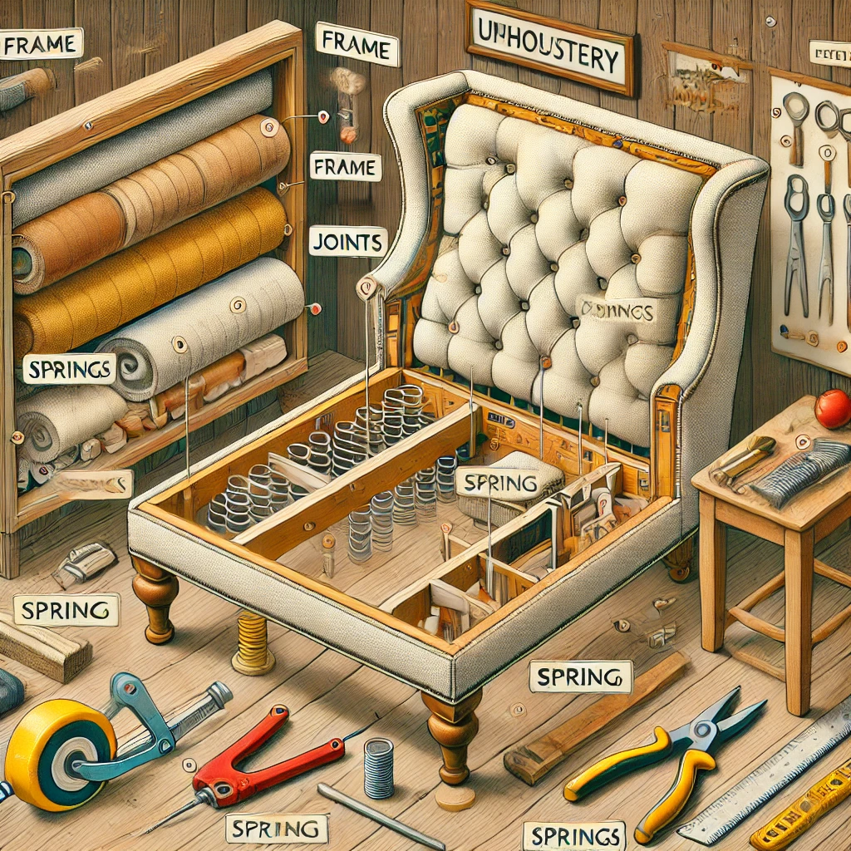

The theoretical content for KT0104, focusing on Frame and Upholstery Components Construction and Parts Identification, includes the following key topics:

1. Overview of Upholstery Frames: Understanding the types of frames used in upholstery. These can range from solid wood to metal frames, each offering different levels of durability and style.

1. Definition and Importance:
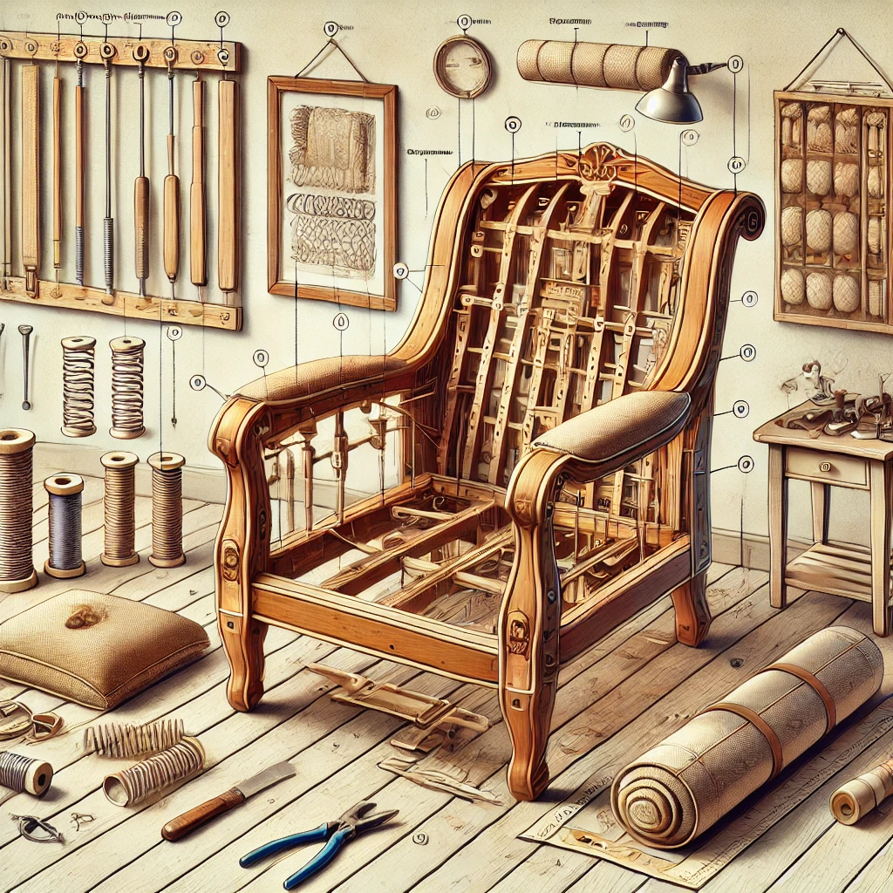
An upholstery frame in furniture making is the skeletal structure that provides the basic shape and structural support for upholstered furniture. The frame is fundamental as it forms the foundation upon which all other components, such as springs, padding, and fabric, are built [[1†source]].

2. Types of Frames:
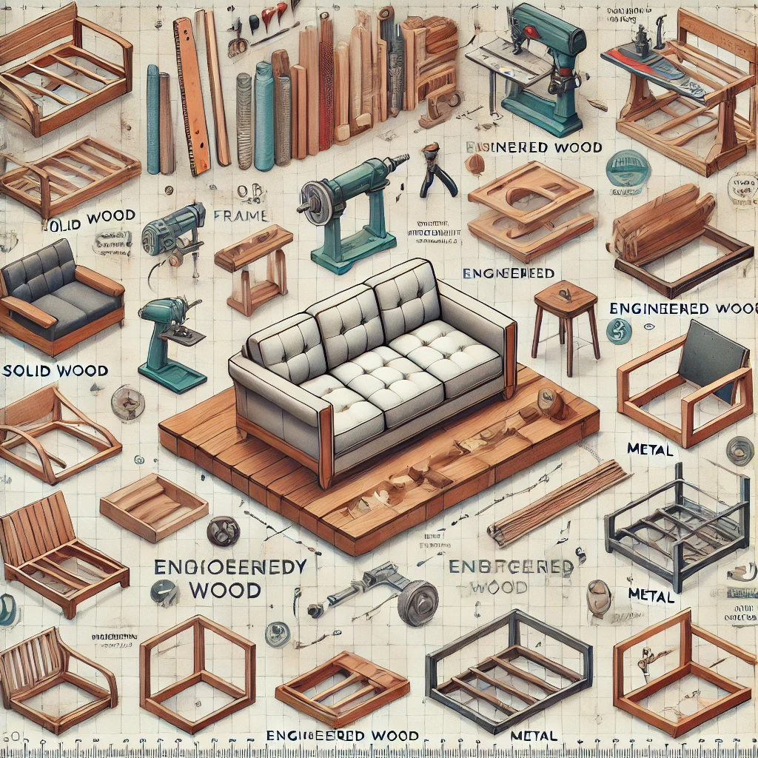
There are various types of frames used in upholstery, each suited for different styles and purposes. Common materials include solid wood, engineered wood, metal, and sometimes a combination of these. The choice of material impacts the durability, weight, and overall quality of the furniture piece [[4†source]].

3. Design and Functionality:
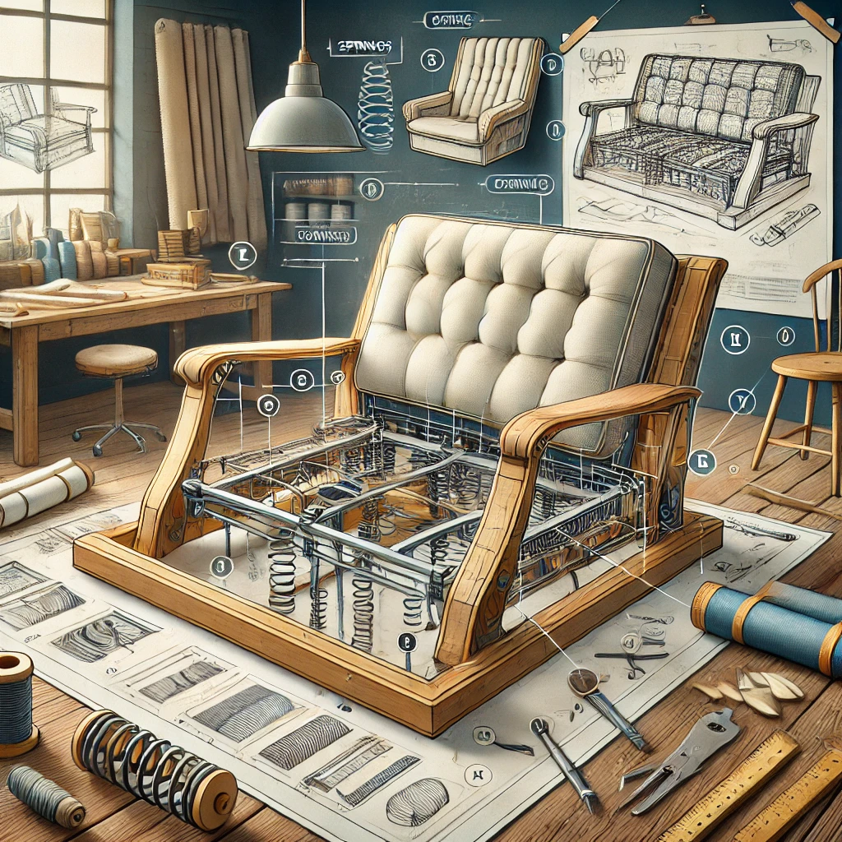
The frame's design not only determines the furniture's shape and style but also its functionality and comfort. Frames are designed to accommodate springs, cushions, and other components, contributing to the overall comfort and ergonomics of the furniture [[2†source]].

4. Construction Techniques:
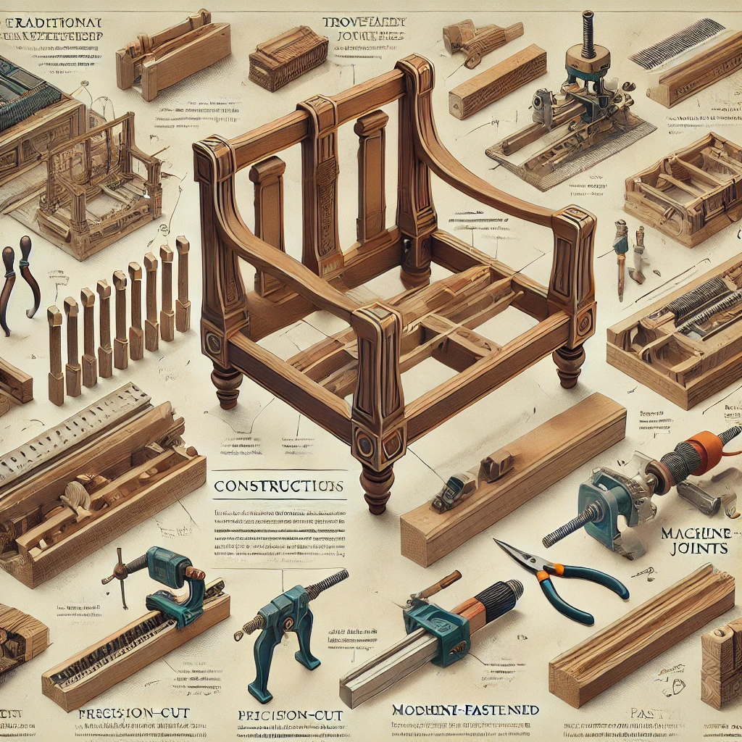
The craftsmanship in constructing a frame is crucial for longevity. Traditional joinery techniques, like dovetail or mortise and tenon, are often used for their strength and durability, while modern manufacturing might involve more mechanised methods [[5†source]].

5. Considerations for Frame Selection:
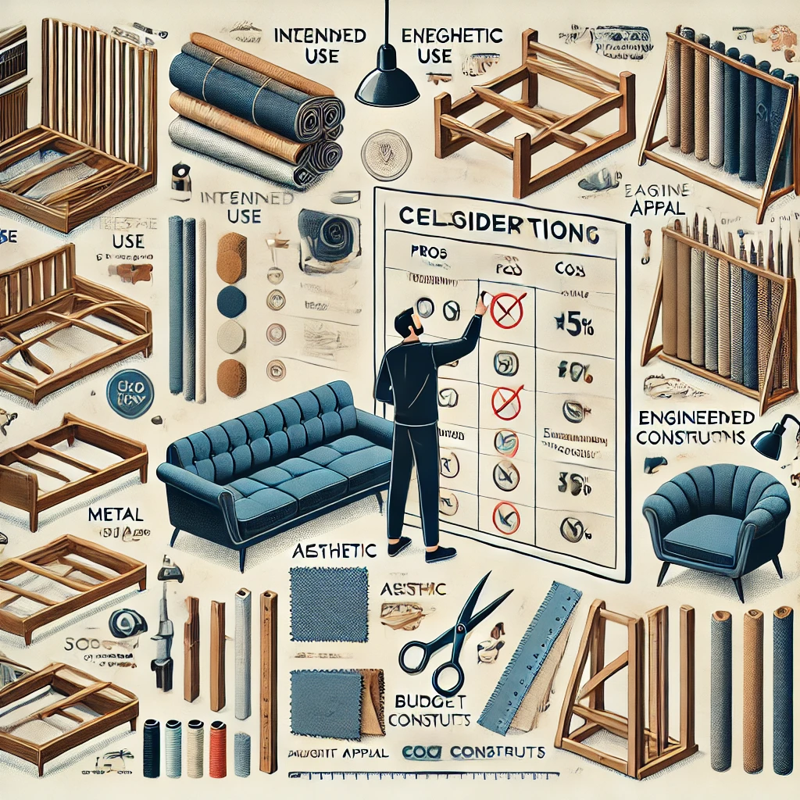
When selecting a frame for a piece of furniture, factors like the intended use of the furniture, the desired aesthetic, and the budget play significant roles. Higher quality frames usually translate into longer-lasting furniture [[5†source]].

6. Role in Upholstery:
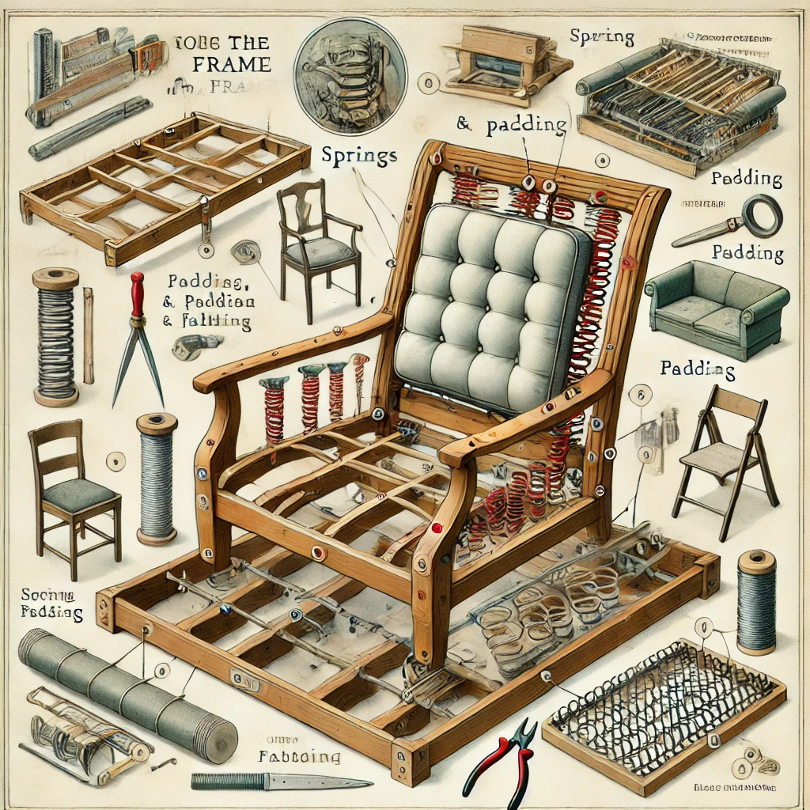
In the overall upholstery process, the frame is the first component to be considered. Its quality and construction significantly affect the final product's comfort, appearance, and lifespan [[1†source]].

2. Frame Construction Techniques:
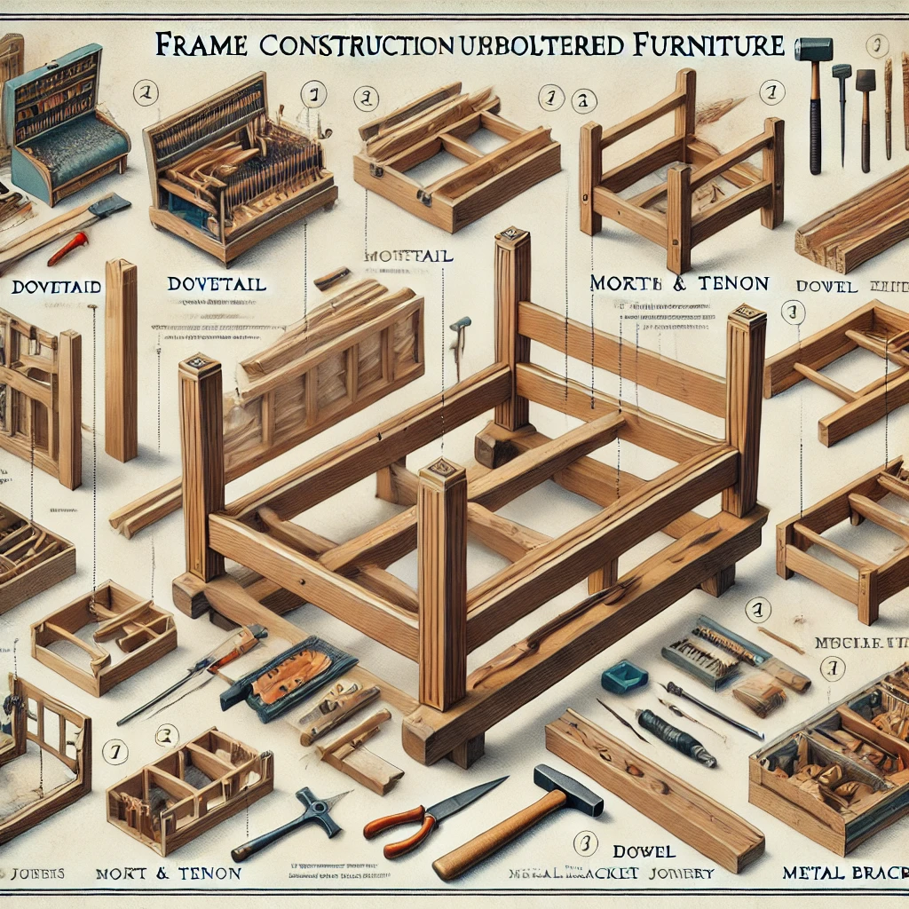
Discussing traditional joinery methods such as dovetails, mortise and tenon, alongside modern techniques like dowel or metal bracket joinery. Emphasis on the importance of a sturdy frame as the foundation of any upholstered furniture.

1. Traditional Joinery Methods:
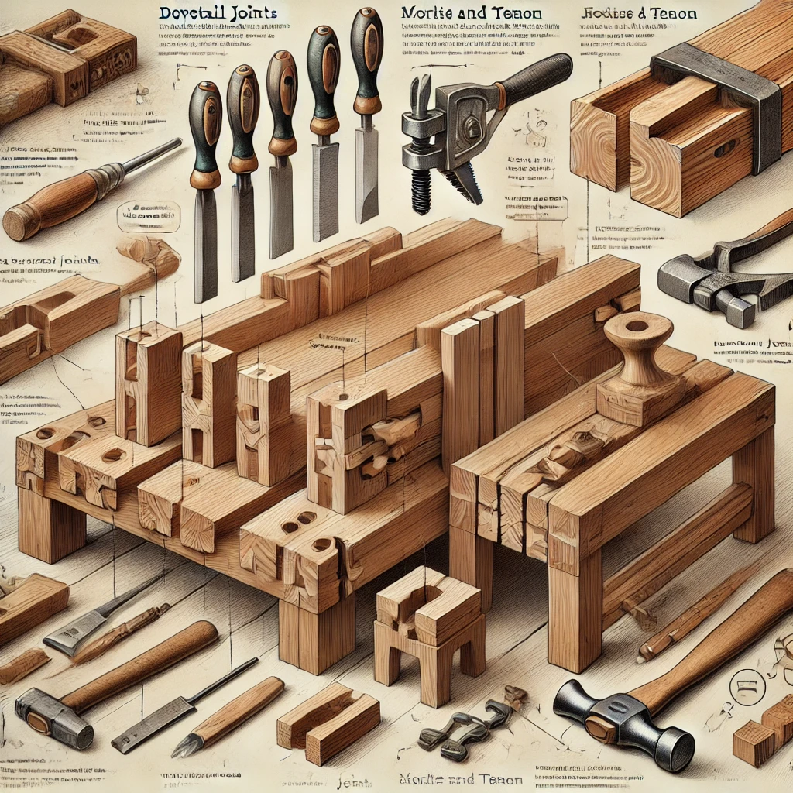
These include techniques like dovetail, mortise and tenon, and dovetail joints. These methods are known for their strength and durability, making them ideal for high-quality furniture that lasts long. They provide a strong bond between different parts of the frame without relying solely on adhesives or fasteners [[6†source]].

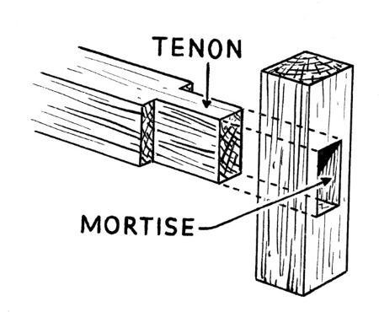

2. Dowel Joinery:
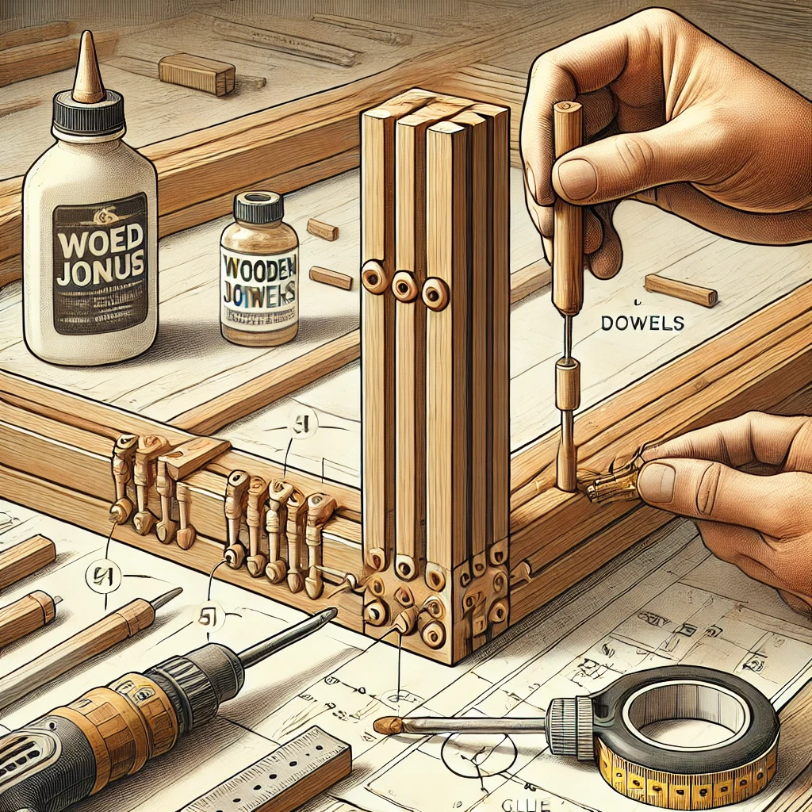

This involves the use of dowels – small wooden pins – to join different parts of the frame. This technique is simpler than traditional joinery but still offers a robust connection. Dowels are often used in combination with glue to strengthen the joint [[6†source]].

3. Metal Brackets and Screws:
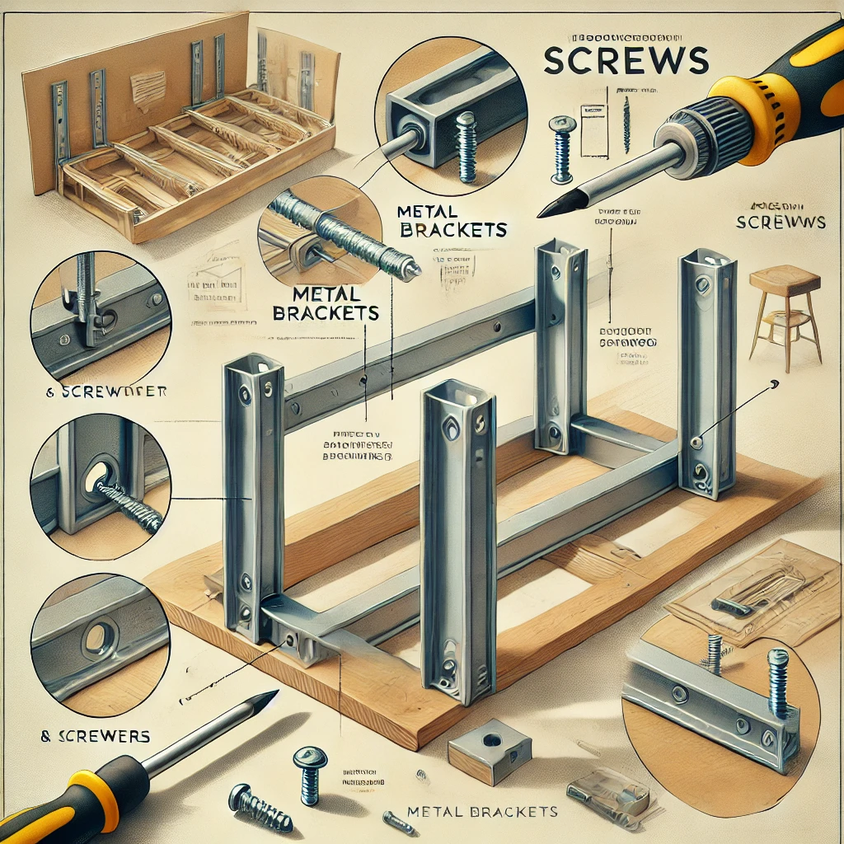 In some modern furniture, metal brackets and screws are used for joining frame components. This method is quicker and can be more cost-effective, making it a popular choice for budget-friendly furniture options [[4†source]].

4. Glue and Other Adhesives:
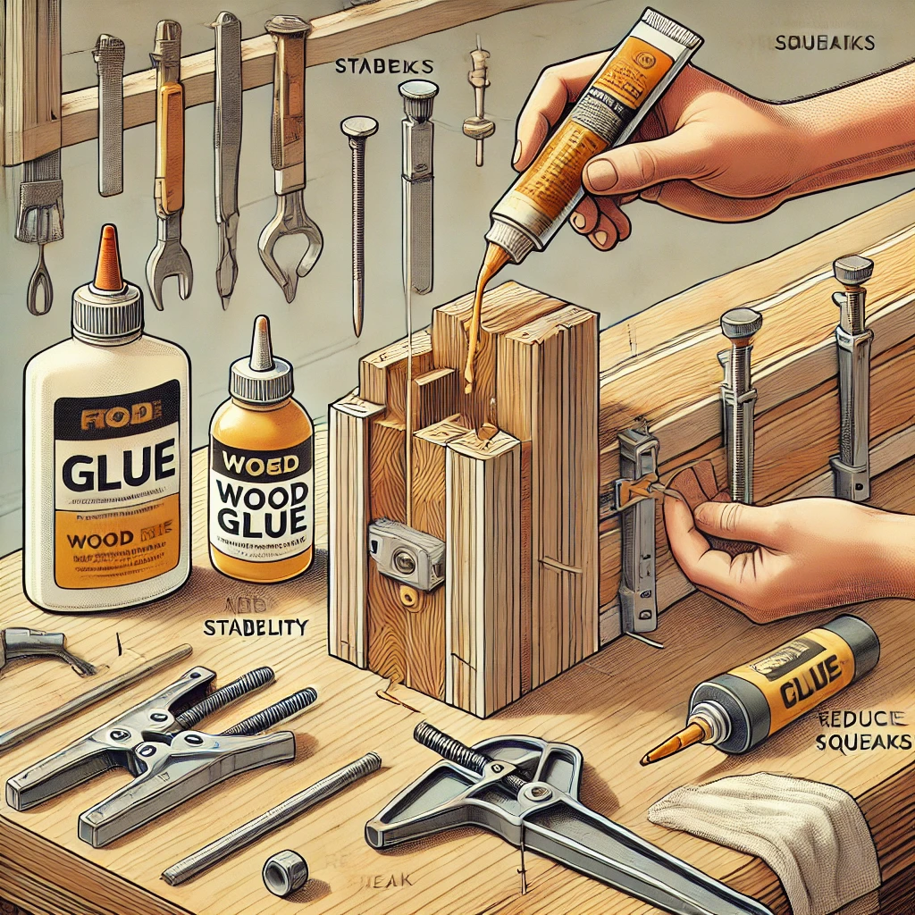
High-quality adhesives are often used in conjunction with other joinery techniques. They add an extra layer of stability to the joints and can help in reducing squeaks and movement in the furniture over time.

5. Corner Blocks:
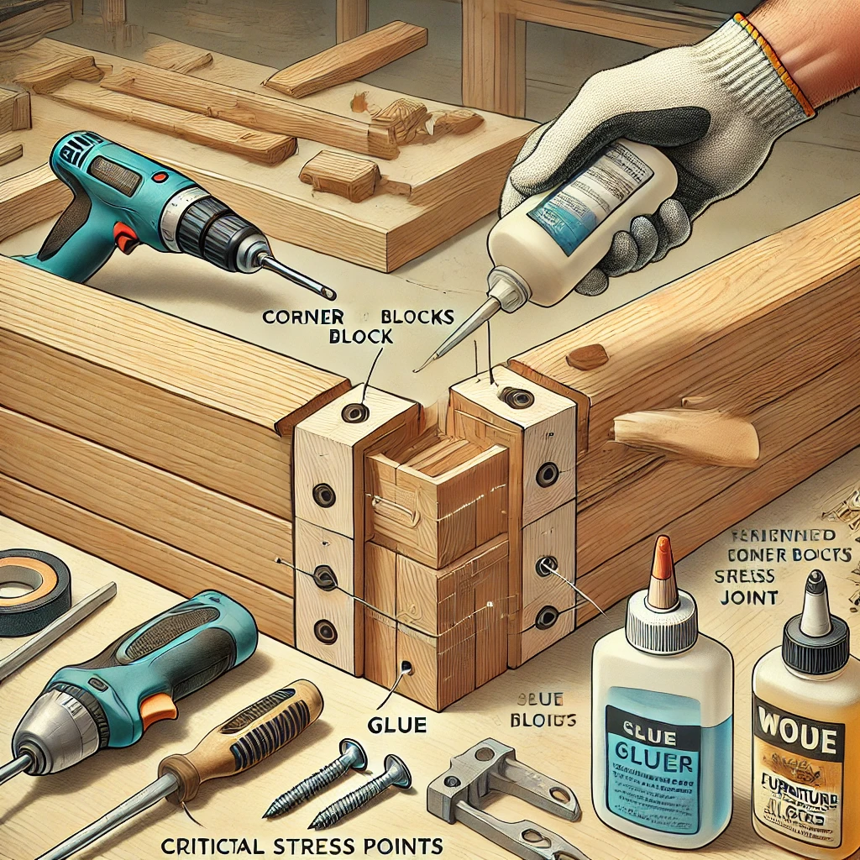
These are used to reinforce corners in furniture frames. They are typically glued and screwed into place, providing additional stability and strength to these critical stress points [[6†source]].

6. Use of Plywood and Engineered Wood:
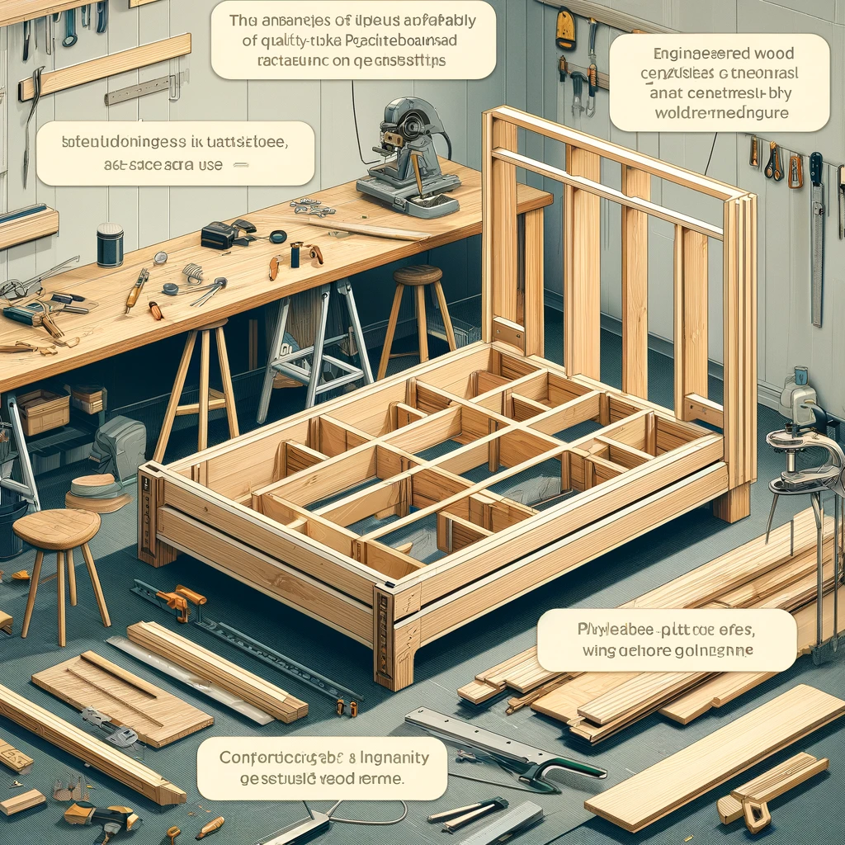
For some types of furniture, especially those designed to be more affordable, plywood or engineered wood is used. These materials can be easier to work with and more consistent in quality, but they may not offer the same longevity as solid wood frames [[4†source]].

7. Finite Element Method (FEM) in Design:

Advanced techniques like FEM are used in the design phase to predict the performance of different frame constructions under various conditions. This approach helps in optimising the frame design for both strength and efficiency [[3†source]].

3. Materials Used in Frame Making:
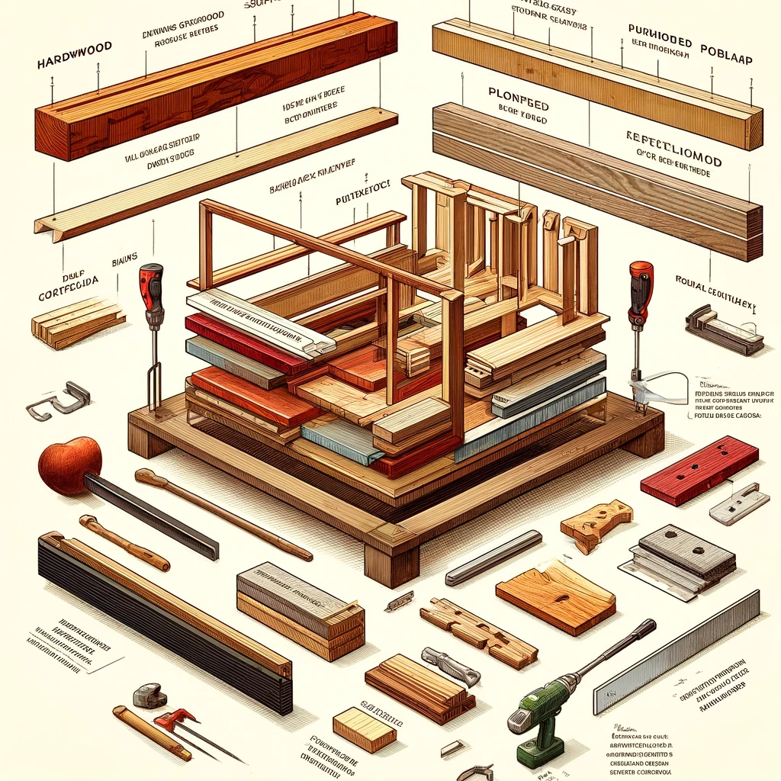
Exploring various materials like hardwood, softwood, plywood, and metal. The choice of material affects the furniture's longevity, weight, and cost.

1. Hardwood:
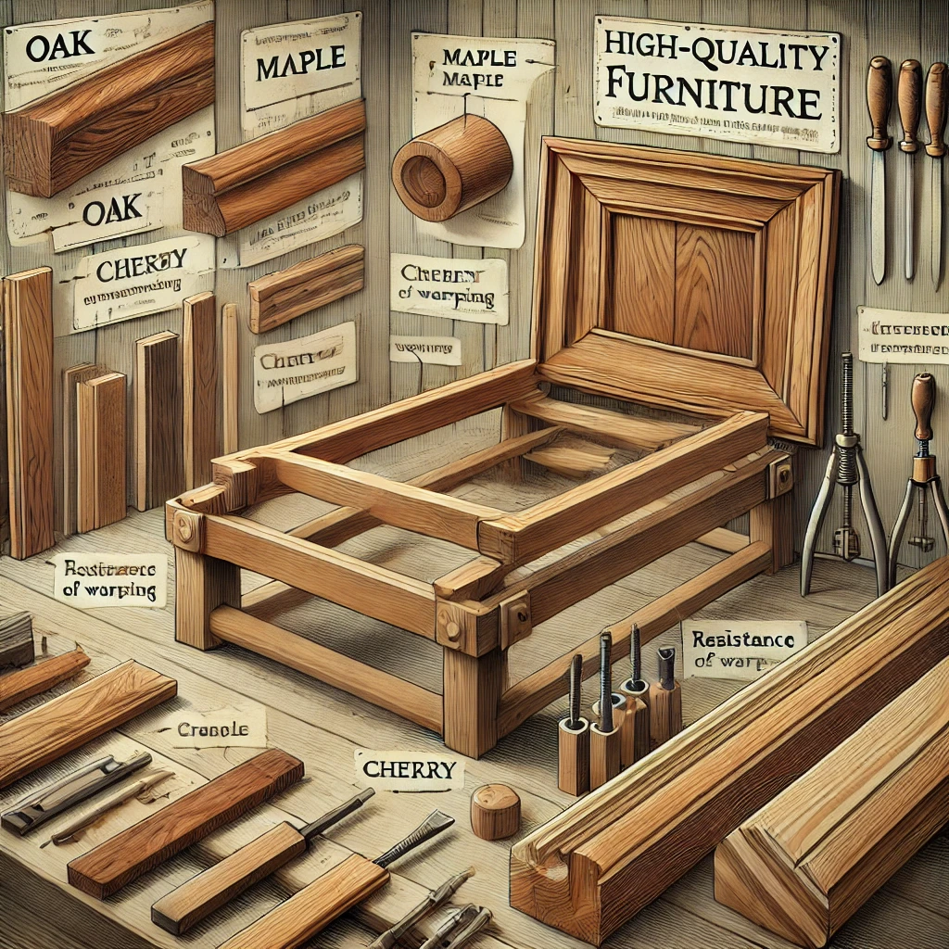
Widely used in high-quality furniture frames due to its durability, strength, and resistance to warping. Common hardwoods include oak, maple, and cherry. These woods can withstand the stress of weight and use over time.

2. Softwood:
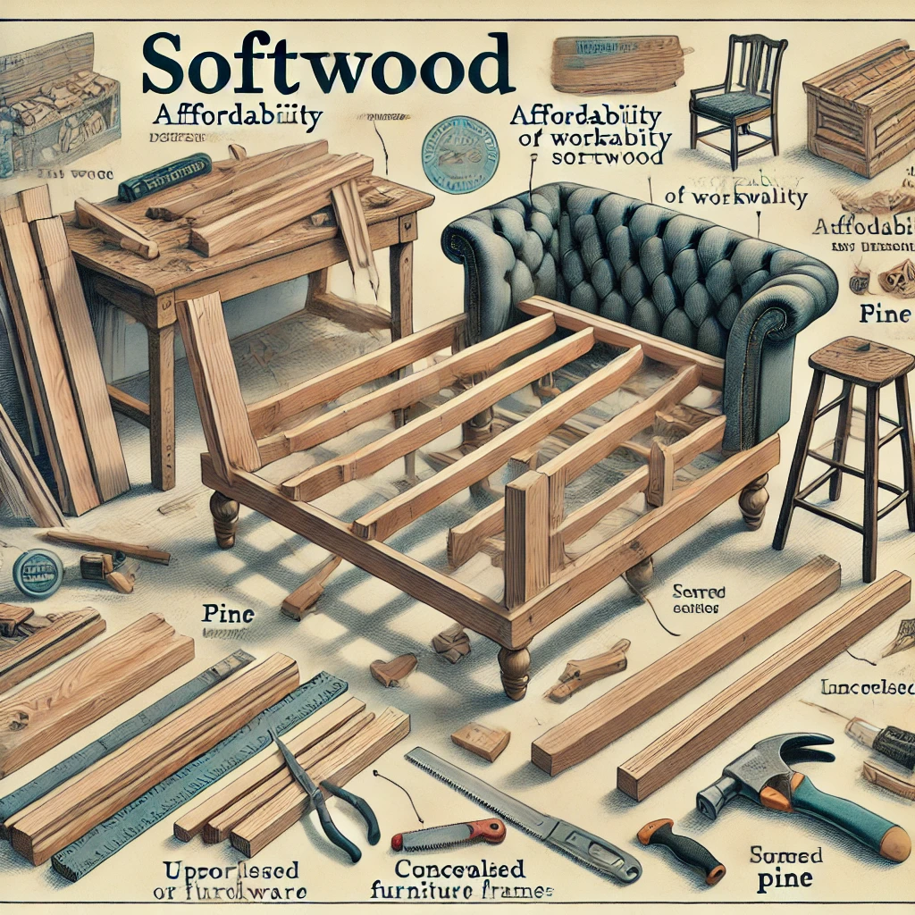
Softer than hardwoods and generally less expensive. Pine is a popular softwood choice for furniture frames, especially for pieces that will be upholstered or not exposed. It is easier to work with but not as durable as hardwood.

3. Engineered Wood:
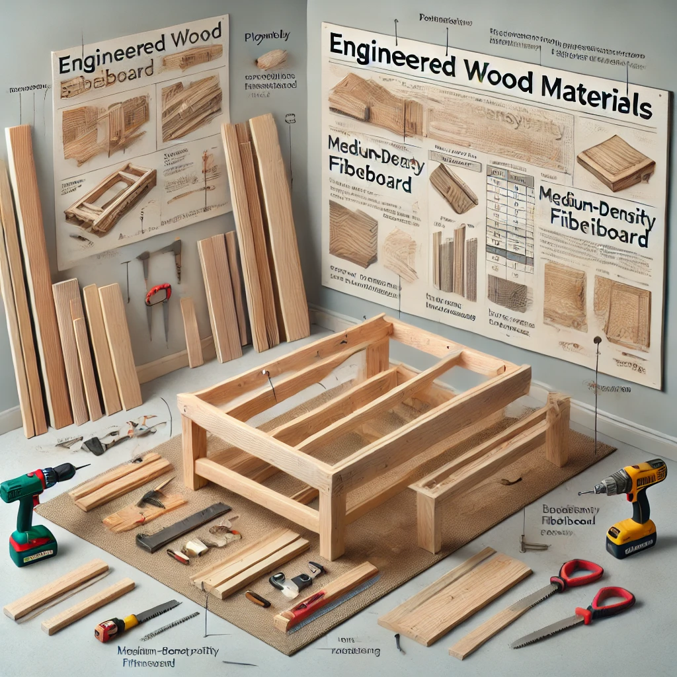
Such as plywood and medium-density fibreboard (MDF), are commonly used in modern furniture. These materials offer consistency in quality and are less prone to warping. They are often used in budget-friendly furniture options, though they may not have the same longevity as solid wood frames [[3†source]].

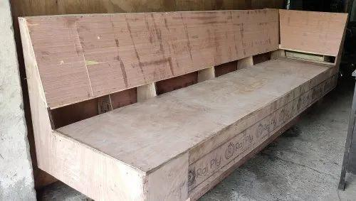
4. Metal:
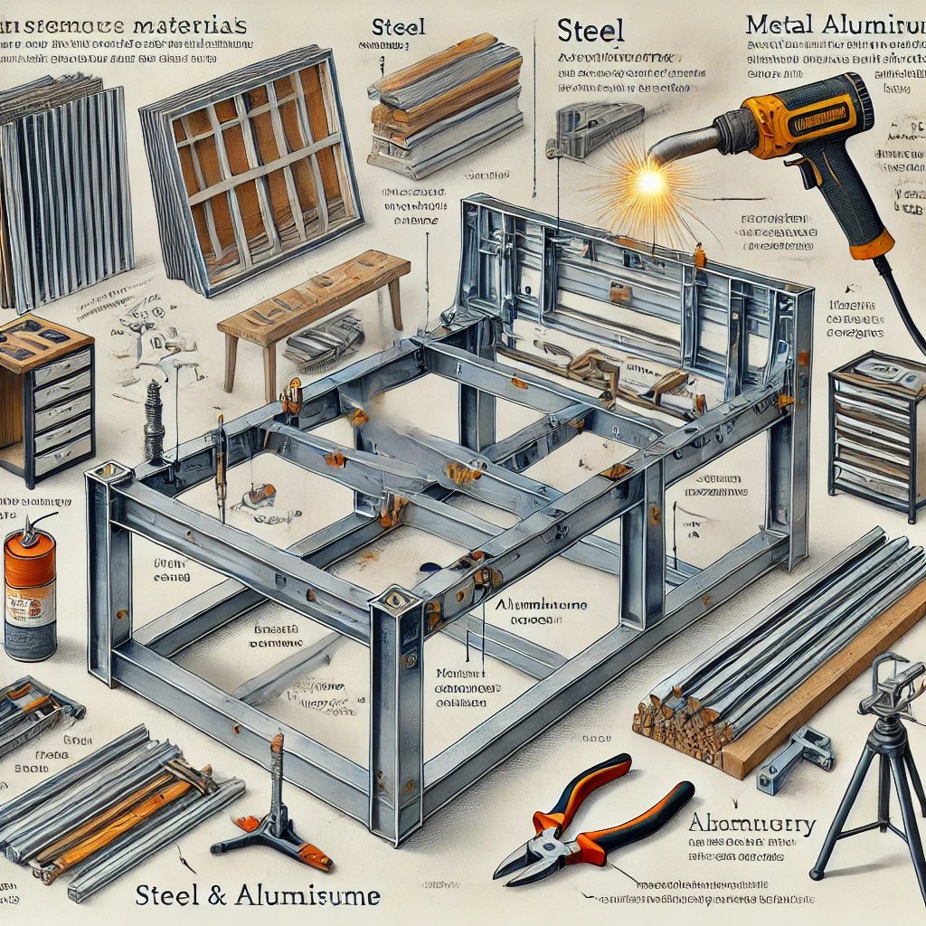

Frames made of metal, like steel or aluminium, are used for their strength and durability. They are especially common in modern and contemporary furniture designs. Metal frames can support a lot of weight and are often used in sofas and other large pieces of furniture.

5. Composite Materials:
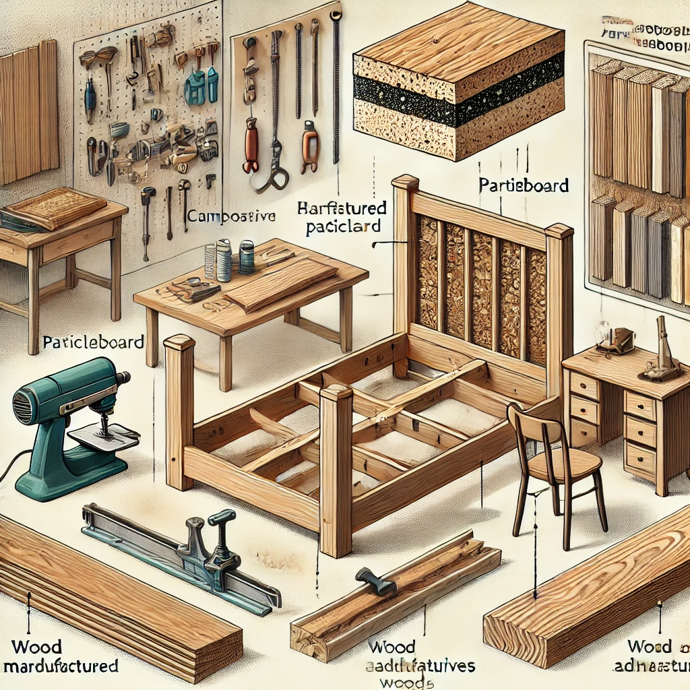
These include particleboard and other manufactured woods, which are made from wood particles and adhesives. They are more affordable than solid wood but are generally less durable and may not withstand heavy use over long periods.

Each of these materials has its own set of characteristics and is chosen based on the specific requirements of the furniture piece, including its design, intended use, and budget constraints.

4. Introduction to Upholstery Components:
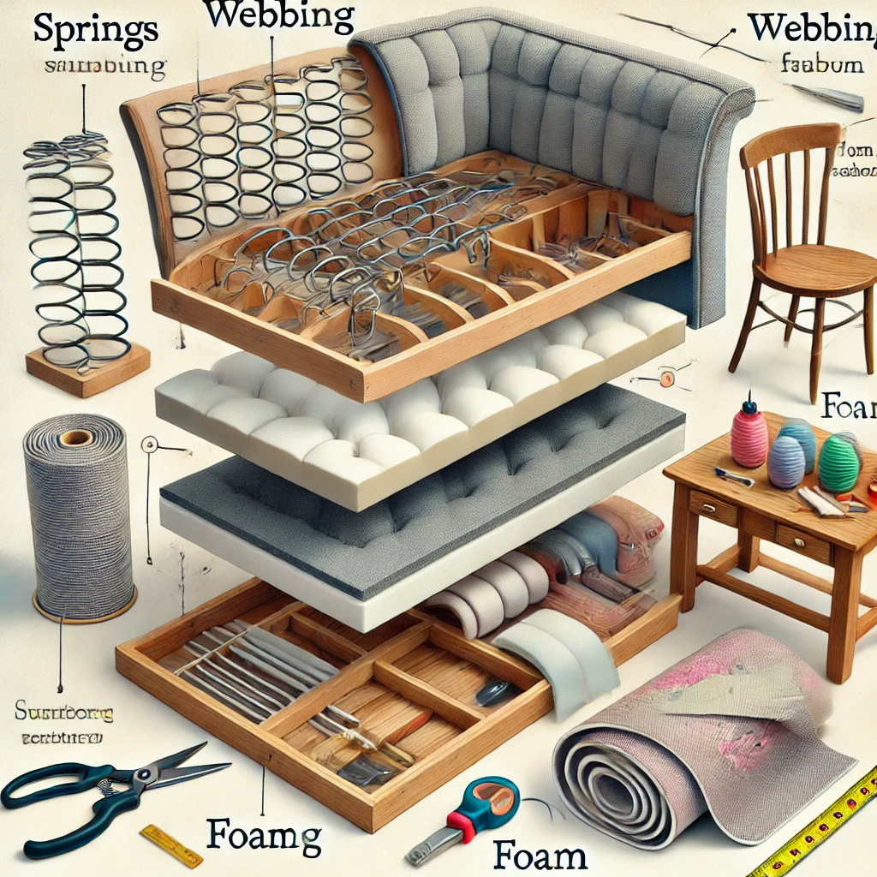
Outlining the components such as springs, webbing, foam, and fabric. Each component has a specific role in comfort and durability.

1. Fabric:
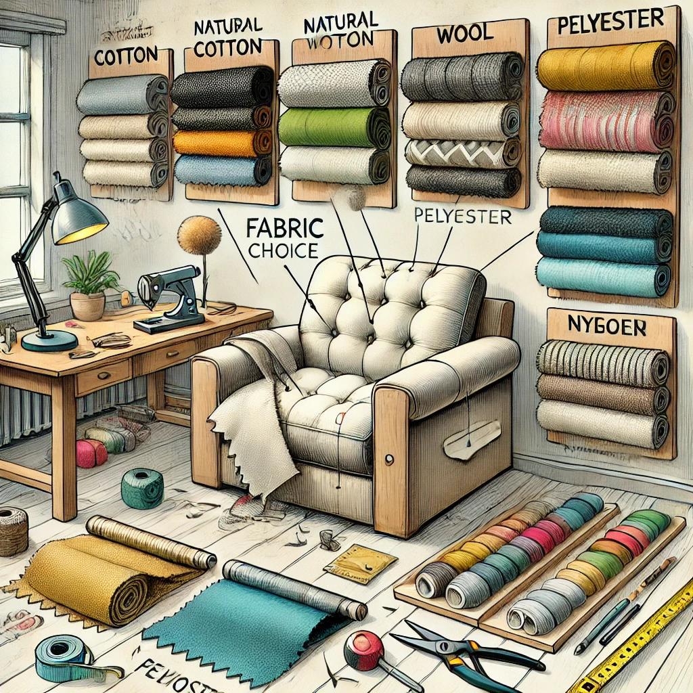
The visible outer covering of furniture, available in a vast array of materials, including natural fibres like cotton and wool, and synthetic fibres such as polyester and nylon. Fabric choice affects the look, feel, and durability of the upholstered item [[2†source]], [[3†source]].

2. Padding:
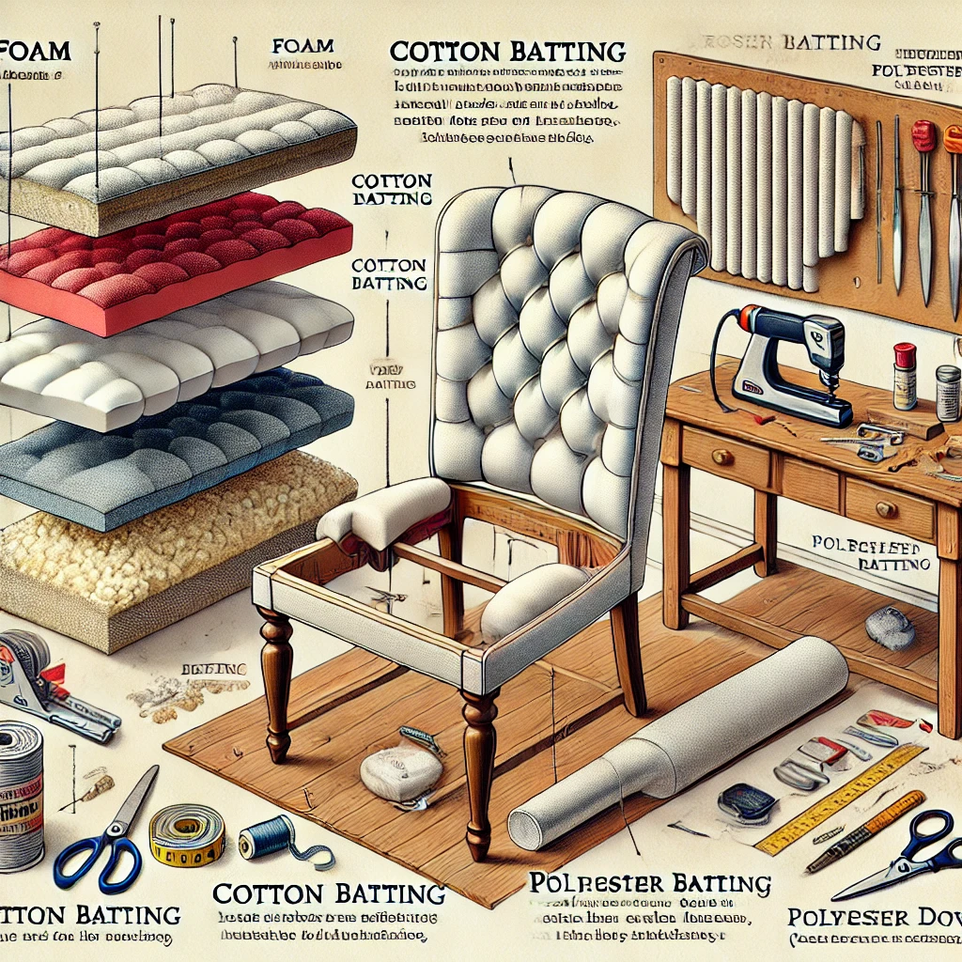
This layer provides comfort and shape to the upholstery. Materials commonly used for padding include foam, batting (cotton or polyester), and down. The type and density of padding material chosen can greatly influence the firmness and comfort of the furniture [[3†source]].

3. Webbing:
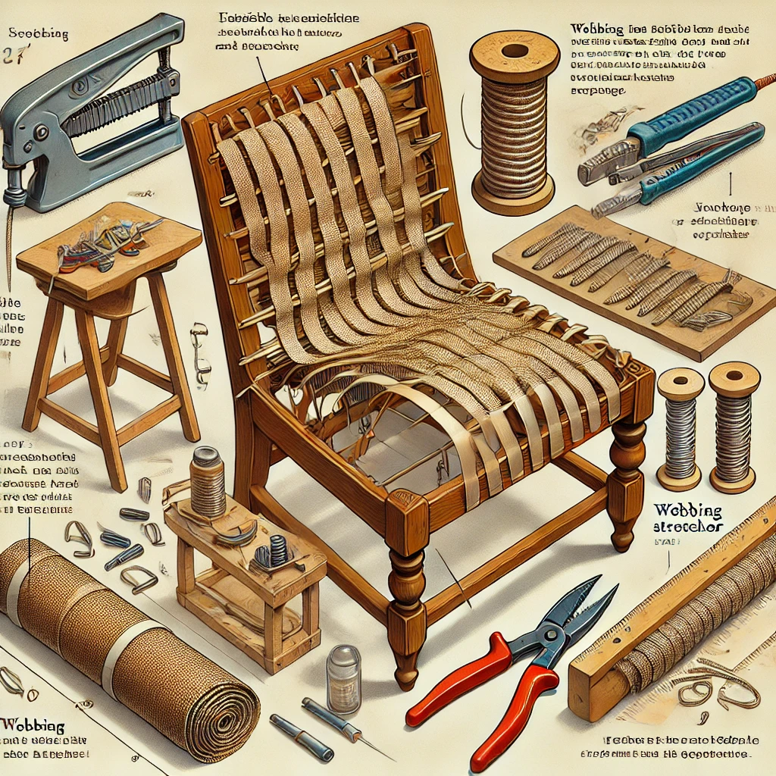
A strong, woven fabric strip used to support the cushioning on seats. It is typically made of jute or synthetic materials and offers a flexible foundation for the padding and springs [[3†source]].

4. Springs:
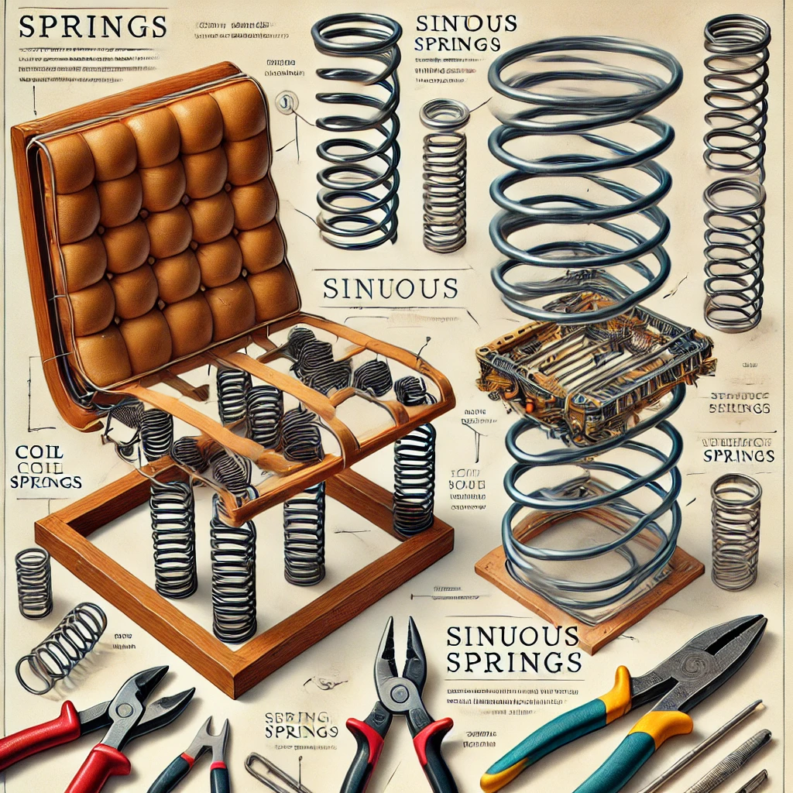
Springs are used in upholstery to provide support and resilience. The most common types are coil springs and sinuous (zigzag) springs. Coil springs are tied together for a traditional, bouncy feel, while sinuous springs offer a firmer, more modern support system [[3†source]], [[4†source]].

5. Frame:
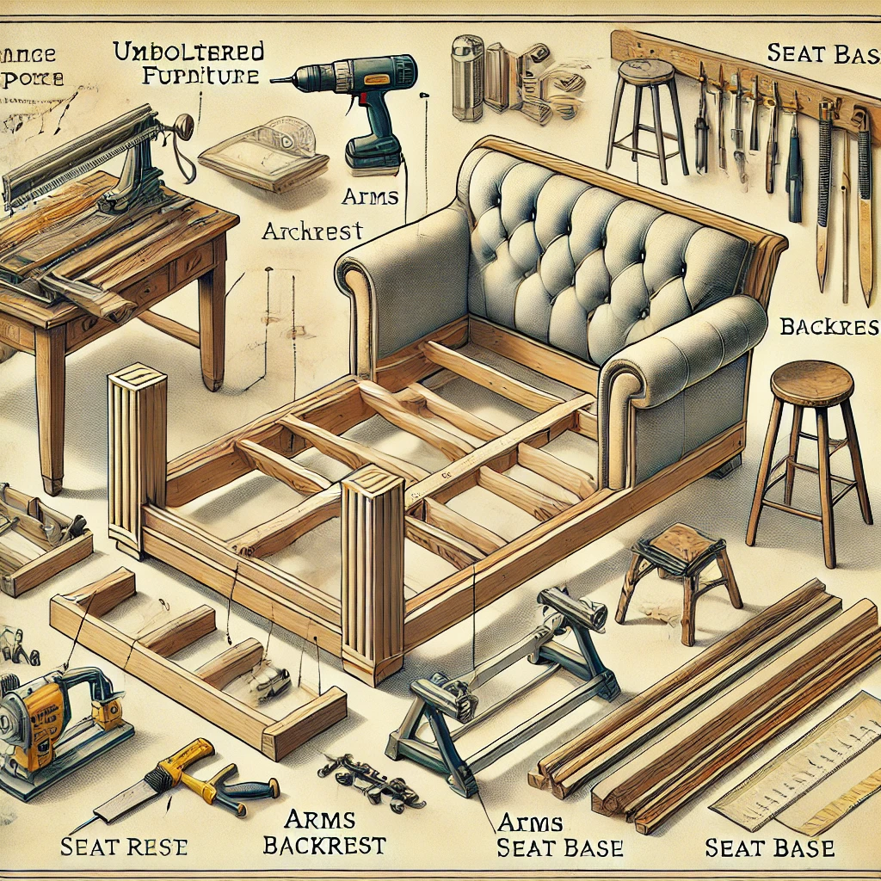
The skeleton of the furniture, typically made of wood, metal, or a combination of both. It provides the structural support and determines the basic shape of the upholstered item [[4†source]].

6. Support System:
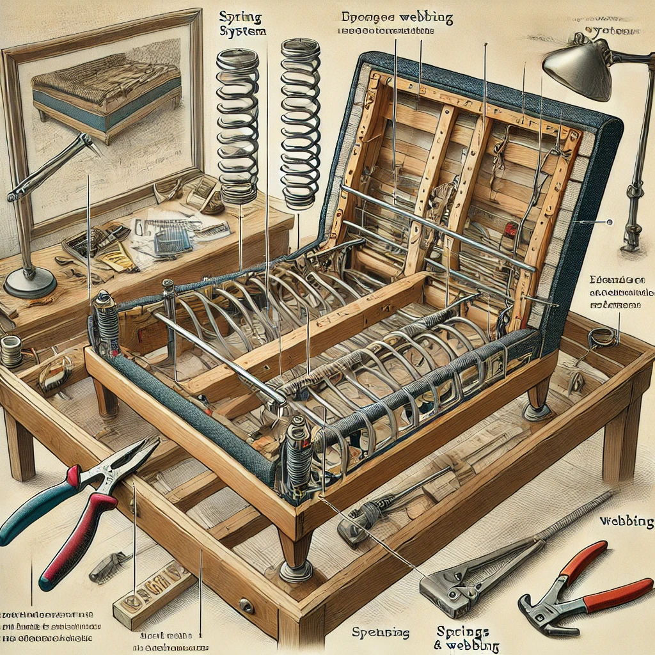
This refers to the structure that holds the springs and webbing, often part of the frame itself. It plays a crucial role in the durability and comfort of the furniture [[4†source]].

Each of these components plays a vital role in the overall functionality and aesthetic of upholstered furniture, contributing to its comfort, durability, and style.

5. Spring Systems:

Describing different types of springs like coil springs, serpentine springs, and webbing. Understanding their placement and tension is crucial for comfort and support.

1. Coil Springs:

Traditional and widely used, coil springs are known for their durability and comfort. They are individually tied and offer a bouncy, well-supported feel, making them ideal for high-quality furniture. Coil springs are often hand-tied in an eight-way system for superior comfort and support [[1†source]], [[2†source]].

2. Sinuous Springs:

Also known as zigzag springs, these are S-shaped and run from the front to the back of the seat frame. They offer firmer support compared to coil springs and are typically used in modern furniture due to their relatively lower cost and ease of installation. Sinuous springs are known for their durability and can provide a comfortable seating experience with less maintenance [[4†source]], [[6†source]].

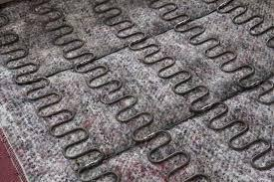

3. Pocket Springs:

These are smaller, individually wrapped coil springs that are used in the cushioning of sofas and chairs. Pocket springs work independently to conform to the body's shape, offering a more tailored support and comfort experience.

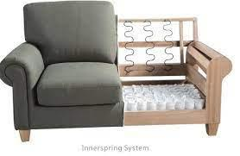
4. Webbing:

While not a spring system, webbing is sometimes used in place of springs in lower-cost furniture. Made of jute or synthetic materials, webbing provides a basic level of support but doesn’t offer the same comfort or longevity as spring systems.

Each type of spring system has its own advantages and is chosen based on factors like desired comfort level, durability, cost, and the overall style of the furniture piece.

6. Padding and Cushioning Materials:

Discussing the use of foam, batting, and other cushioning materials. Different materials offer varying levels of comfort, support, and durability.

1. Foam:

A common choice for modern upholstery, foam padding comes in various densities and firmness levels. It provides a consistent, durable cushioning that maintains its shape over time. High-density foam is preferred for seats due to its durability and comfort [[1†source]], [[5†source]].

2. Polyester Fiberfil:

Often used as a top layer over firmer padding materials for added plushness. It is lightweight, affordable, and provides a soft, cushioned feel. Fiberfil is also commonly used in throw pillows and back cushions [[3†source]].

3. Down and Feathers:

Traditionally used for a luxurious, soft feel. Down and feathers are often used in higher-end furniture, providing a unique, plush comfort that foam and fibrefill cannot replicate. However, they require more maintenance, as they tend to clump and need regular fluffing [[2†source]], [[6†source]].

4. Latex:

Offers a natural, eco-friendly padding option. It is durable, comfortable, and maintains its shape well. Latex is a good choice for those looking for an alternative to synthetic materials [[2†source]], [[6†source]].

5. Wool:

Another natural material, wool is known for its durability and natural flame-retardant properties. It provides a firm yet comfortable cushioning and is often used in combination with other materials [[6†source]].

6. Cotton and Cotton Batting:

Traditional padding material, offering a moderate level of comfort and support. It is less resilient than foam but provides a firmer, more traditional feel.

Each of these materials has unique properties and is chosen based on the desired comfort level, durability, cost, and the specific application in upholstery.

7. Fabrics and Coverings: Providing an overview of various upholstery fabrics like cotton, linen, leather, and synthetics. Factors like wear resistance, texture, and ease of cleaning are important considerations.

1. Cotton: A popular choice for upholstery due to its breathability, comfort, and versatility. Cotton fabric comes in a wide range of patterns and colours. It is durable but not as resistant to wear and tear as some synthetic fabrics [[1†source]].

2. Linen: Known for its elegant and refined appearance. Linen is a natural fibre that's typically used in formal and adult-only areas due to its susceptibility to wrinkling and staining [[1†source]].

3. Wool: A durable and sturdy fabric that's often blended with synthetic fibres to improve its resistance to wrinkling and soiling. Wool offers warmth and comfort, making it ideal for colder climates [[1†source]].

4. Leather: A high-end material noted for its durability and ease of cleaning. Leather ages well and can develop a unique patina over time. It is ideal for a sophisticated look and high-traffic areas [[1†source]].

5. Polyester and Acrylic: Synthetic fabrics that are often used for their durability and resistance to fading and staining. They are commonly blended with natural fibres to improve texture and durability [[1†source]].

6. Velvet: Velvet provides a luxurious look and feel. It is generally made from silk, cotton, or synthetic fibres and is best used in low-traffic areas due to its delicate nature.

7. Microfiber: A synthetic fabric that's known for its durability and stain resistance. Microfiber is soft to the touch and is a good option for households with children and pets.

Each of these fabrics offers different advantages in terms of aesthetics, durability, and maintenance, making them suitable for various applications in furniture upholstery.

8. Parts Identification and Terminology: Familiarising with common terms used in upholstery and furniture making. This includes parts like arms, backs, seats, legs, and their respective components.

1. Frame: The structural foundation of upholstered furniture. It is typically made of wood or metal and shapes the furniture piece.

2. Webbing: Elastic bands or strips of fabric that provide support and form the base for the springs and padding in the furniture.

3. Springs: Devices embedded in furniture to provide cushioning and support. Common types include coil springs and sinuous springs.

4. Padding: Materials such as foam, cotton, or polyester used to cushion and soften the feel of furniture. It is layered over the springs and under the fabric.

5. Fabric or Upholstery: The outermost layer of furniture, available in various materials like cotton, leather, or synthetic fabrics.

6. Arms: The side parts of chairs, sofas, or loveseats that provide support for the arms when seated.

7. Back: The rear vertical surface of a piece of furniture against which one leans.

8. Seat: The part of the furniture that one sits on. It typically includes webbing, springs, padding, and fabric.

9. Legs: The supports at the bottom of furniture that raise it off the ground.

10. Deck: The area under the cushions of a sofa or chair where the webbing and springs are located.

Understanding these terms helps in identifying different parts of furniture and in effectively communicating about furniture design and construction.

9. Tools and Equipment: Introducing tools used in frame construction and upholstery, from basic hand tools to advanced machinery.

1. Staple Gun: A critical tool for attaching fabric to furniture frames. Electric or pneumatic staple guns are preferred for their efficiency and ease of use [[1†source]].

2. Scissors: Heavy-duty scissors are essential for cutting fabric and other materials precisely.

3. Sewing Machine: Used for stitching fabric pieces together, especially for custom or detailed work.

4. Upholstery Needles: These come in various sizes and shapes, including curved needles for hand-stitching parts of the upholstery that the sewing machine can't reach [[2†source]].

5. Webbing Stretcher: A tool used to tightly stretch the webbing across the frame of the furniture for a firm base [[1†source]].

6. Hammer and Tack Lifter: Used for removing old staples and tacks, and for securing new ones in place.

7. Foam Cutter: For shaping and cutting foam padding to the desired size and shape.

8. Upholstery Regulator: A pointed tool used for adjusting and smoothing the padding and fabric.

9. Measuring Tape: Essential for accurate measurement of fabric, foam, and other materials.

10. Chalk or Fabric Marker: Used for marking measurements and cutting lines on the fabric.

These tools are essential for various stages of upholstery, from removing old materials to cutting and attaching new fabrics and padding.

10. Safety and Best Practices: Emphasising the importance of safety in the workshop, including the correct use of tools and handling of materials.
1. Adherence to Safety Standards: Ensuring all upholstered furniture meets strict safety standards, particularly concerning flammability and structural integrity. This includes using materials that are fire resistant and structurally sound [[2†source]].

2. Proper Training: Providing comprehensive training for staff in the use of tools, machinery, and materials. This includes understanding the proper handling and storage of potentially hazardous materials [[1†source]].

3. Workshop Safety: Maintaining a clean, organised, and well-ventilated workspace to minimise the risk of accidents and health hazards. This includes regular maintenance of equipment and proper disposal of waste materials [[1†source]].

4. Personal Protective Equipment (PPE): Utilising appropriate PPE such as gloves, safety glasses, and masks, especially when working with chemicals or operating machinery.

5. Ergonomic Practices: Implementing ergonomic practices to prevent strain and injury. This includes using adjustable workstations and encouraging regular breaks.

6. Quality Control: Regularly inspecting tools and equipment for wear and tear, and ensuring that all finished products meet quality and safety standards.

7. Sustainable and Safe Materials: Using renewable, recycled, and non-toxic materials whenever possible to reduce environmental impact and ensure safety for both workers and end-users [[6†source]].

8. Infection Control: Ensuring furniture is free of rips or tears to maintain cleanliness and reduce contamination risks, particularly important in healthcare settings [[5†source]].

These safety and best practices are essential in maintaining a safe working environment and producing high-quality, durable, and safe upholstered furniture.
11. Quality Control and Standards: Understanding quality standards in frame construction and upholstery, ensuring durability and customer satisfaction.

1. Material Quality Checks: Ensuring all materials used, such as fabric, foam, and springs, meet certain quality standards. This includes checking for durability, colour fastness, and resistance to wear and tear.

2. Construction Standards: Verifying that the furniture construction follows established industry standards. This involves assessing joinery, stability, and the overall strength of the frame and assembly.

3. Compliance with Safety Regulations: Adhering to national and international safety standards, particularly regarding flammability, structural integrity, and the use of non-toxic materials. This helps in preventing any potential hazards associated with the furniture [[2†source]].

4. Regular Inspection Protocols: Implementing a system of regular inspections during and after production to identify and correct any defects or inconsistencies.

5. Feedback Integration: Using customer feedback and warranty claims to identify areas for improvement and to ensure customer satisfaction.

6. Employee Training: Ensuring that all employees involved in production are well-trained in quality control practices and understand the importance of maintaining high standards.

7. Environmental Compliance: Upholding environmental standards, including the use of sustainable materials and practices that minimise waste and pollution.

8. Final Product Testing: Conducting tests on finished products to ensure they meet the desired quality, comfort, and durability standards.

By maintaining strict quality control and adhering to high standards, upholstery businesses can ensure their products are safe, durable, and of high quality.

12. Sustainability in Upholstery: Discussing eco-friendly practices in upholstery, including the use of sustainable materials and methods to minimise environmental impact.

1. Use of Eco-Friendly Materials: Choosing sustainable materials like organic cotton, linen, and wool, which require fewer natural resources for production. These materials are biodegradable and have a lower environmental impact [[2†source]].

2. Recycling and Upcycling: Implementing practices that involve recycling old furniture or using recycled materials in new upholstery projects. This reduces waste and the need for new resources, making the process more sustainable [[3†source]], [[5†source]].

3. Sourcing Ethically: Ensuring that materials are sourced from suppliers who practice ethical and sustainable farming and manufacturing processes. This includes fair labour practices and responsible land use.

4. Durability and Longevity: Creating high-quality, durable upholstery that lasts longer, reducing the need for frequent replacement and thus diminishing the overall environmental impact [[1†source]].

5. Reducing Chemical Use: Minimising the use of harmful chemicals in the production of upholstery fabrics and fillings. Opting for natural dyes and treatments which are less harmful to the environment.

6. Energy-Efficient Production: Employing energy-efficient machinery and practices in the production process to reduce the carbon footprint of upholstery manufacturing.

7. Sustainable Packaging: Using recyclable or biodegradable packaging materials for the transportation and delivery of upholstered furniture.

8. Awareness and Education: Educating customers and stakeholders about the importance of sustainable practices in upholstery and encouraging them to make eco-friendly choices.

By adopting these sustainable practices, the upholstery industry can significantly reduce its environmental impact while still providing high-quality, beautiful furniture.

KT0105 Compliance and non-compliance.

The theoretical content for KT0105, focusing on Compliance and Non-Compliance, includes the following key aspects:

1. Definition of Compliance: Compliance in a broad sense refers to the act of conforming to a rule, law, or set of guidelines. In the context of an organisation or institution, it means adhering to legal standards, ethical norms, and internal policies.

1. Adherence to Standards and Regulations: Compliance in the South African furniture upholstery industry involves conforming to various standards and regulations. This includes meeting specifications, policies, and laws related to manufacturing, safety, and quality of furniture products [[2†source]].

2. Occupational Health and Safety: Ensuring compliance with the Occupational Health and Safety Act is critical. This involves conducting regular Health and Safety Compliance Audits to verify adherence to safety protocols in the workplace, thereby protecting employees from potential health hazards [[1†source]].

3. Product Safety and Quality: Upholstered furniture must meet specific safety and quality standards. This includes aspects like the flammability of materials, durability, and performance of the furniture items. Testing services like those offered by SGS South Africa can confirm compliance to these regulations [[4†source]].

4. Labelling Requirements: For retail purposes, new upholstered furniture must have permanent labels securely attached, indicating compliance with relevant safety and quality standards. This is part of the responsibility of retailers in ensuring compliance [[5†source]].

5. Environmental Compliance: In addition to safety and quality, compliance also extends to environmental regulations, ensuring sustainable and environmentally friendly manufacturing practices.

Compliance in this industry is vital not only for legal adherence but also for ensuring the safety, quality, and environmental sustainability of furniture products.

2. Understanding Non-Compliance: Non-compliance is the failure to act in accordance with these rules, laws, or regulations. It can occur due to various reasons including lack of awareness, misunderstanding, or intentional disregard.

1. Definition of Non-Compliance: Non-compliance in the context of the furniture upholstery industry refers to the failure to adhere to established regulations, standards, and guidelines. This can include not following safety protocols, quality standards, and environmental regulations.

2. Reasons for Non-Compliance: Non-compliance may arise due to various reasons including lack of awareness, misunderstanding of regulations, financial constraints, or intentional avoidance of compliance measures.

3. Consequences of Non-Compliance: Non-compliance can lead to serious consequences such as legal penalties, financial losses, reputational damage, and safety hazards. According to the Occupational Health and Safety Act of South Africa, non-compliance could result in exclusion from tender processes, supplier databases, and legal action [[1†source]], [[2†source]].

4. Risk Assessment and Management: Identifying areas of potential non-compliance and implementing measures to mitigate these risks is crucial. Regular audits and reviews can help in maintaining compliance.

5. Importance of Compliance Culture: Fostering a culture of compliance within the organisation is essential. This involves training employees, clear communication of rules and standards, and encouraging a proactive approach towards compliance.

6. Learning from Non-Compliance: Understanding instances of non-compliance can provide valuable insights into operational weaknesses and areas for improvement, ultimately enhancing overall compliance in the organisation.

Understanding and addressing non-compliance is crucial for the sustainable operation and success of businesses in the furniture upholstery industry.

3. Theories Behind Compliance: Various theories explain why entities choose to comply or not. These include rational choice theory (where compliance is based on cost-benefit analysis), normative theory (compliance due to ethical or moral beliefs), and others that consider social, cultural, and psychological factors [[2†source]], [[4†source]].

1. Rational Choice Theory: Suggests that individuals and organisations weigh the costs and benefits before deciding to comply. Compliance is more likely when the benefits of adhering to regulations outweigh the potential costs of non-compliance.

2. Normative Theory: This theory posits that compliance is driven by normative beliefs and values. Individuals or organisations comply with regulations because they believe it is the right thing to do, based on ethical or moral standards.

3. Social Influence Theory: Compliance can be influenced by social factors, such as peer pressure, societal norms, and cultural expectations. Organisations might comply to maintain a positive reputation or because of industry standards set by peers.

4. Institutional Theory: This theory focuses on the influence of institutions and the regulatory environment. Compliance is seen as a response to formal rules, regulations, and procedures imposed by governing bodies or industry associations.

5. Resource-based View: Compliance is influenced by the resources available to an organisation, including financial resources, human capital, and technology. Organisations with more resources are generally better equipped to meet compliance requirements.

Each of these theories provides a different perspective on why organisations choose to comply or not comply with regulations, highlighting the complex and multifaceted nature of compliance.

4. Consequences of Non-Compliance: Non-compliance can lead to legal penalties, financial losses, reputational damage, and operational disruptions. It also impacts the trust and reliability of the organisation in the eyes of stakeholders [[3†source]].

1. Legal Penalties: Non-compliance with laws, such as the Occupational Health and Safety Act in South Africa, can lead to legal actions against the organisation. This can include fines and sanctions which can be financially burdensome [[1†source]].

2. Operational Disruptions: Non-compliance can lead to operational interruptions. For example, if a company fails to meet workplace safety standards, it may be required to halt operations until compliance is achieved, leading to a loss in productivity and revenue [[5†source]].

3. Reputational Damage: Non-compliance can harm a company's reputation, leading to a loss of trust among customers, suppliers, and investors. This can have long-term effects on business relationships and market position.

4. Increased Costs: Failure to comply can result in increased costs, including the cost of rectifying non-compliance issues, potential compensation to affected parties, and increased insurance premiums [[3†source]].

5. Exclusion from Business Opportunities: Non-compliance can lead to exclusion from tendering processes and supplier databases, limiting business opportunities and growth potential [[3†source]].

6. Workplace Safety Risks: Non-compliance in areas such as workplace safety can lead to increased risks of accidents and injuries, impacting the health and well-being of employees [[5†source]].

The consequences of non-compliance emphasize the importance of adhering to relevant laws, regulations, and standards to ensure the smooth, safe, and legal operation of a business.

5. Factors Influencing Compliance: Factors such as organisational culture, leadership, legal and regulatory environment, and individual attitudes play a significant role in determining the level of compliance.

1. Regulatory Environment: The complexity and clarity of regulations play a significant role. Clear, well-defined regulations are more likely to be followed compared to those that are complex and ambiguous.

2. Organisational Resources: Availability of resources such as financial, human, and technological resources influences an organisation's ability to comply. Adequate resources enable organisations to implement necessary compliance measures effectively.

3. Management Commitment: The attitude and commitment of top management towards compliance are crucial. A leadership that prioritises and values compliance sets a precedent for the entire organisation.

4. Employee Awareness and Training: The level of awareness and training provided to employees about compliance requirements significantly impacts adherence. Regular training and effective communication are key factors.

5. Industry Standards and Peer Influence: Standards set within an industry and the practices of peers can influence an organisation's compliance behavior. Companies often conform to industry norms to remain competitive.

6. Legal Enforcement and Penalties: The likelihood of detection and severity of penalties for non-compliance are strong motivators. Effective enforcement of regulations encourages organisations to comply.

7. Cultural Factors: Organisational culture, including values and ethics, can influence compliance. A culture that emphasizes integrity and ethical behaviour fosters a higher rate of compliance.

These factors collectively shape an organisation's approach to compliance, determining how regulations and standards are adhered to in practice.

6. Importance of Compliance in Upholding Standards: Compliance ensures that organisations operate within the bounds of legality and ethics, thus maintaining standards in service, safety, and operations.

1. Ensuring Safety and Health: Compliance with health and safety regulations, such as the Occupational Health and Safety Act in South Africa, is vital to ensure the safety and well-being of employees. This includes providing safe working conditions and appropriate equipment [[1†source]], [[6†source]].

2. Maintaining Quality: Adherence to compliance standards ensures that the products and services offered meet certain quality benchmarks. This is crucial in maintaining customer trust and satisfaction.

3. Legal Obligations: Compliance helps in avoiding legal repercussions, including fines and penalties that can arise from non-adherence to laws and regulations. This is essential for the legal integrity and financial health of the business [[2†source]].

4. Corporate Responsibility: Upholding compliance is a part of being a responsible corporate citizen. It reflects the organisation's commitment to ethical practices and societal norms [[3†source]].

5. Protecting Reputation: Non-compliance can damage an organisation's reputation, affecting customer loyalty and business prospects. Compliance helps in maintaining a positive public image [[2†source]].

6. Market Competitiveness: Compliance with industry standards and regulations is often a prerequisite for entering and remaining competitive in the market. It can be a differentiating factor in a crowded marketplace.

7. Risk Management: Compliance plays a key role in risk management strategies by identifying and mitigating potential risks associated with non-compliance.

The importance of compliance in upholding standards is fundamental to the successful and sustainable operation of any organisation, particularly in industries like wood and upholstery where safety and quality are paramount.

7. Strategies for Ensuring Compliance: This involves setting clear guidelines, providing adequate training and resources, regular audits and monitoring, and fostering a culture of integrity and accountability.

1. Regular Audits and Assessments: Conducting regular health and safety compliance audits to ensure adherence to all relevant legislation, particularly in workplaces that require handling of specialised equipment or materials [[1†source]].

2. Continuous Employee Training: Implementing ongoing training programs for employees to keep them informed about the latest compliance standards and practices.

3. Staying Informed about Regulations: Keeping abreast of changing regulations, market conditions, and user needs. This includes engaging in furniture testing and certification to confirm compliance with regulation, quality, safety, durability, and performance standards [[2†source]], [[3†source]].

4. Implementing Internal Policies: Developing and enforcing internal policies that align with regulatory requirements. This could include guidelines for workplace safety, ethical practices, and environmental sustainability.

5. Collaboration with Compliance Experts: Working with experts in compliance, such as legal advisors or specialised agencies, to ensure that all aspects of the business are compliant with national and international laws.

6. Technology Integration: Utilising technology to streamline compliance processes. This can include software for tracking regulatory changes, managing documentation, and automating compliance-related tasks.

7. Active Engagement in the Compliance Process: Encouraging a culture of active engagement in compliance matters within the organisation, where employees feel responsible and are encouraged to report non-compliance issues.

Implementing these strategies can significantly aid in maintaining compliance, thus ensuring the smooth operation and integrity of a business.

8. Compliance as Part of Self-care: In healthcare and personal settings, compliance is often seen as a part of self-care, where individuals follow prescribed guidelines for their well-being [[5†source]].

1. Integration into Personal Health Management: Compliance can be seen as an integral part of self-care, especially in healthcare settings. It involves individuals adhering to medical regimens, treatments, or lifestyle changes as recommended by healthcare professionals for their well-being [[1†source]], [[2†source]].

2. Proactive Health Approach: By complying with medical advice or therapeutic treatments, individuals take a proactive role in managing their health. This form of compliance is seen as an act of taking care of oneself rather than passively receiving care.

3. Empowerment and Responsibility: Compliance as self-care empowers individuals to take responsibility for their health. It involves making informed decisions about treatment options and actively participating in the healthcare process [[3†source]], [[4†source]].

4. Balancing Choices and Medical Advice: Self-care compliance recognises that individuals make choices about their health based on personal circumstances, beliefs, and values. It emphasizes the balance between following medical advice and personal autonomy [[2†source]].

5. Impact on Health Outcomes: Effective self-care compliance leads to better health outcomes, as individuals are more likely to follow through with treatments and preventive measures that are in their best interest [[4†source]], [[5†source]].

Compliance as part of self-care highlights the importance of individuals' active involvement in their health and wellness journey, underscoring the role of personal responsibility and informed decision-making in achieving positive health outcomes.

Understanding compliance and non-compliance is crucial in maintaining the integrity, reputation, and operational effectiveness of any organisation

KT0106 Consequences of prepared frames and covered furniture not meeting specified standards.

For KT0106, focusing on the consequences of prepared frames and covered furniture not meeting specified standards, the key points are:

1. Structural Instability: Frames that do not meet standards may lead to structural instability in furniture. This can result in furniture that is unsafe for use, posing risks of collapse or breakage under normal usage conditions.

1. Risk of Furniture Collapse: Furniture with structural instability due to substandard frame preparation or poor-quality materials poses a significant risk of collapse. This can lead to accidents, potentially causing injury to users.

2. Compromised Load-Bearing Capacity: Structural instability in furniture means it cannot reliably bear the intended weight. This can result in the furniture being unsafe for its intended use, like chairs that cannot support the weight of a person or shelves that buckle under load.

3. Shortened Lifespan of Furniture: Furniture that lacks structural integrity is likely to have a shorter lifespan. It will be more prone to damage from regular use, leading to premature wear and tear.

4. Increased Maintenance and Repair Costs: Structural instability often necessitates frequent repairs and maintenance, incurring additional costs for the owner and reducing the overall value of the furniture.

5. Safety Hazards: Beyond the risk of collapse, structurally unstable furniture can have protruding parts, uneven surfaces, or sharp edges, all of which pose safety hazards, especially in environments with children or elderly individuals.

6. Legal and Warranty Implications: Manufacturers and sellers of furniture with structural instability may face legal implications, including liability for injuries and warranty claims from dissatisfied customers.

Addressing structural instability is crucial in furniture design and manufacturing to ensure safety, functionality, and customer satisfaction.

2. Compromised Durability: Inadequate frame preparation or covering can significantly reduce the longevity of the furniture. Furniture that does not meet quality standards may degrade quickly, leading to early wear and tear.

1. Material Degradation: Furniture that doesn't meet specified standards often uses materials of lower quality. These materials can degrade faster under normal usage, leading to a reduced lifespan of the furniture.

2. Vulnerability to Damage: Compromised durability in furniture means it is more susceptible to damage from everyday wear and tear. For example, weak joints or poor-quality wood can easily break or warp.

3. Increased Repair Costs: Furniture with compromised durability requires more frequent repairs, increasing the overall cost of maintenance for the owner.

4. Reduced Resale Value: Furniture that lacks durability has a lower resale value. Potential buyers are less likely to invest in pieces that show signs of early wear or are known to be of poor quality.

5. Safety Risks: Durability issues can pose safety risks, particularly in furniture that bears weight or is used frequently, like chairs and tables. Weak structural components can fail, potentially causing injury.

6. Environmental Impact: Less durable furniture contributes to environmental waste. As these items need to be replaced more frequently, they contribute to increased consumption of resources and higher waste generation.

7. Customer Dissatisfaction: Products that fail to meet durability expectations lead to customer dissatisfaction, impacting brand reputation and customer loyalty.

Addressing durability issues is essential to ensure the safety, longevity, and satisfaction associated with furniture products.

3. Aesthetic Shortcomings: Furniture that fails to meet finishing standards can have aesthetic flaws. This includes uneven upholstery, visible defects in the frame, or misalignment of components, affecting the overall appearance.

1. Visual Imperfections: Furniture not meeting specified standards often exhibits visual flaws. This includes uneven finishes, misaligned joints, and visible defects in the material, detracting from the overall appearance.

2. Inconsistent Design Elements: Lack of adherence to design standards can result in inconsistencies in style, colour, and texture, leading to a piece that doesn't match the intended aesthetic or fails to integrate with existing decor.

3. Poor Craftsmanship: Aesthetic shortcomings often stem from poor craftsmanship. This includes sloppy work like uneven upholstery, visible glue or staples, and poorly executed joinery.

4. Reduced Appeal to Customers: Aesthetically compromised furniture is less appealing to consumers, impacting sales and marketability. Customers are less likely to purchase items that do not meet their visual expectations.

5. Impact on Brand Image: Consistently delivering products with aesthetic shortcomings can damage a brand's reputation for quality and design, affecting long-term customer loyalty and brand perception.

6. Diminished User Experience: Aesthetically flawed furniture can detract from the user's experience and satisfaction, as the visual appeal is a significant aspect of furniture selection for many consumers.

Addressing these aesthetic shortcomings is vital for maintaining quality, customer satisfaction, and brand reputation in the furniture industry.

4. Decreased Comfort: Poorly prepared frames and coverings can lead to uncomfortable furniture. Issues like uneven surfaces, inadequate support, and poor ergonomic design are common outcomes.

1. Ergonomic Issues: Furniture that does not meet specified standards may lack ergonomic design, leading to discomfort during use. This includes improper support for the back, neck, or limbs, and can result in physical strain over time.

2. Poor Quality Materials: The use of substandard materials in cushions, upholstery, or padding can lead to decreased comfort. This might manifest as overly hard or sagging seats, rough fabric textures, or insufficient cushioning.

3. Improper Sizing and Proportions: Furniture with dimensions that do not conform to standard ergonomic measurements can be uncomfortable for users. For instance, chairs with too high or too low seating can affect posture and comfort.

4. Lack of Stability: A lack of stability in furniture, such as wobbling tables or chairs, can cause discomfort and unease during use, as users may feel unsafe or unable to relax.

5. Temperature and Moisture Control: Furniture that doesn’t manage temperature well or absorbs moisture can create an uncomfortable sitting or sleeping environment, particularly in climates with extreme temperatures or high humidity.

6. Aesthetic Discomfort: Aesthetically unpleasing furniture can also contribute to a sense of discomfort, as the environment plays a significant role in overall comfort and satisfaction.

Addressing these factors is key to ensuring the comfort of furniture, which is a crucial aspect of user experience and satisfaction.

5. Increased Costs for Repairs and Replacements: Non-compliance with standards often leads to additional costs in repairs and replacements. This not only impacts the manufacturer but also the end-user.

1. Frequent Maintenance: Furniture not meeting standards often requires more frequent repairs due to issues like structural weaknesses or material failures. Regular maintenance incurs additional costs over time.

2. Higher Repair Expenses: The cost of repairing substandard furniture can be significant, especially if specialised parts or skills are needed. This includes costs for labour, replacement parts, and possibly transport for off-site repairs.

3. Shortened Replacement Cycles: When furniture is not durable or functional, it needs to be replaced more often. Frequent replacement cycles lead to higher long-term costs compared to investing in higher quality, longer-lasting items.

4. Impact on Warranty Claims: Furniture that doesn’t meet quality standards might lead to more warranty claims, adding to the manufacturer’s or seller's costs in terms of replacements, refunds, or repair services.

5. Total Cost of Ownership: The total cost of owning substandard furniture often exceeds the initial savings from purchasing cheaper, lower-quality items. Over time, the cumulative costs of repairs and replacements can surpass the cost of a more expensive but higher-quality alternative.

6. Opportunity Costs: There are also opportunity costs involved, as time and resources spent on fixing or replacing furniture could be used more productively elsewhere.

Understanding these factors is crucial for both manufacturers and consumers in evaluating the true cost of furniture over its lifespan.

6. Reputational Damage: Supplying substandard furniture can harm the reputation of the manufacturer or retailer, leading to a loss of customer trust and potential decrease in future sales.

1. Loss of Consumer Trust: When furniture does not meet quality standards, it can lead to a loss of trust among consumers. This can have a long-term impact on customer loyalty and brand preference [[1†source]], [[2†source]].

2. Negative Public Perception: Poor quality products can lead to negative public perception of a brand. This can be exacerbated by social media and online reviews, where one bad experience can be shared widely [[3†source]], [[4†source]].

3. Impact on Brand Value: Reputational damage can significantly impact the overall value of a brand. It can deter new customers and lead to a decline in sales and revenue [[2†source]], [[5†source]].

4. Difficulty in Attracting New Customers: A company known for substandard products will have a harder time attracting new customers. The negative reputation acts as a barrier to expanding the customer base [[4†source]], [[6†source]].

5. Challenges in Business Partnerships: Reputational damage can also affect a company's relationships with suppliers, distributors, and other business partners, who may be hesitant to associate with a brand known for poor quality [[2†source]], [[3†source]].

6. Reduced Market Competitiveness: In a competitive market, a damaged reputation can place a company at a significant disadvantage compared to competitors who maintain higher quality standards [[1†source]], [[5†source]].

Addressing and preventing reputational damage is crucial for maintaining a strong brand image and ensuring the sustainability of the business.

7. Legal and Compliance Issues: Non-compliance with furniture standards can result in legal repercussions, especially if it leads to consumer safety incidents. Manufacturers and retailers may face fines, penalties, or lawsuits.

1. Regulatory Non-Compliance: Furniture that doesn’t meet specified standards may violate regulatory requirements. This can lead to legal actions, fines, and sanctions from regulatory bodies [[1†source]], [[2†source]].

2. Consumer Protection Violations: Non-compliance with consumer protection laws can result in legal challenges. Customers may have grounds to file lawsuits for false advertising, breach of warranty, or selling unsafe products [[3†source]], [[4†source]].

3. Liability for Damages: If substandard furniture causes injury or property damage, the manufacturer or seller could be held liable. This includes personal injury lawsuits and compensation claims [[2†source]], [[4†source]].

4. Product Recalls: Legal and compliance issues may necessitate product recalls, which are costly and damage the brand's reputation. Recalls also involve logistical challenges in retrieving and replacing or refunding the recalled products [[1†source]], [[5†source]].

5. Impact on Business Operations: Dealing with legal and compliance issues can divert resources from normal business operations, impacting productivity and profitability [[3†source]], [[4†source]].

6. Increased Regulatory Scrutiny: Repeated compliance failures can result in increased scrutiny from regulatory bodies, leading to more inspections, audits, and tighter controls [[2†source]], [[5†source]].

Addressing legal and compliance issues is essential for maintaining business integrity, avoiding financial losses, and protecting the company's reputation.

8. Consumer Dissatisfaction and Returns: Substandard furniture often leads to customer dissatisfaction, resulting in increased returns, complaints, and negative reviews, which can further impact business.

1. Increased Return Rates: When furniture does not meet specified standards, it often leads to an increase in consumer returns. This not only affects the company's logistics and inventory management but also incurs additional shipping and handling costs [[2†source]], [[3†source]], [[4†source]].

2. Complaints Management: Handling consumer complaints becomes more challenging and resource-intensive. The process requires dedicated customer service teams to address issues and possibly negotiate solutions like replacements or refunds [[2†source]], [[3†source]], [[4†source]].

3. Impact on Customer Loyalty: Dissatisfied customers are less likely to make repeat purchases or recommend the brand to others. This can significantly impact customer loyalty and the company's long-term profitability [[1†source]], [[5†source]].

4. Pressure on Customer Service Resources: Increased complaints and returns place added pressure on customer service resources, potentially leading to delays in response times and further dissatisfaction among consumers [[2†source]], [[3†source]], [[4†source]].

5. Legal Obligations: In many jurisdictions, including South Africa, retailers and manufacturers are legally obligated to address consumer complaints and returns efficiently, especially in cases of defective or substandard products [[5†source]], [[6†source]].

6. Reputation Management: Managing the company’s reputation in the face of widespread consumer dissatisfaction is crucial. Poor handling of returns and complaints can lead to negative reviews and bad publicity, further harming the brand’s reputation [[1†source]], [[5†source]].

Addressing these issues effectively is essential for maintaining customer satisfaction and avoiding the negative impact on the business.

Understanding these consequences underscores the importance of adhering to specified standards in furniture making, ensuring safety, quality, and customer satisfaction.

Internal Assessment Criteria

  - IAC0101 Various types of product specifications used in the upholstery industry are compared and differentiated.
  - IAC0102 Various aspects of basic sketches and engineering drawings such as isometric, oblique and orthographic views and projections, sectional views, component parts, dimensioning, scaling, line structures and geometry, drawing labelling, curves and radiuses are identified and each function explained.
  - IAC0103 Aspects included in industry and workplace product specification concepts such as raw material standards, drawing standards, engineering symbols, abbreviations and conventions are identified.
  - IAC0104 The concepts of compliance and non-compliance is explained.
  - IAC0105 The consequences for the upholstery process of prepared and covered frames not meeting the specified product standard are evaluated
(Weight 10%)

SECTION: 2 KM-03-KT02: Upholstery raw materials and consumables types and characteristics (20%)
Learning Outcome
At the end of this section, learners should cover:

- KT0201 Furniture raw materials with reference to natural and manmade fabrics and finishings.
- KT0202 Location of raw materials and consumables.
- KT0203 Main upholstery material types (woven plain, woven patterned, printed cretonne, pile, knitted jersey, coated fabrics and animal skins).
- KT0204 Types, sizes, quantity and quality of consumables needed for cover fitting, finishing and trimming.
- KT0205 Density, thickness and types of foam required for the foaming up process.
- KT0206 Types of padding for covering coil springs.
- KT0207 Consumables required for the foaming up process, including adhesives and solvents, profile jigs and templates.
- KT0208 Using profile jigs and templates.
- KT0209 Fabrics used for covering webbing, springs, foam and padding including calico, hessian, polypropylene Dacron and flock.
- KT0210 Types and gauges of various springs needed for the knocker-on process, including coil springs and zig-zag springs.
- KT0211 Types, sizes, quantity and quality of consumables including clips, nails, staples, edge rolls, twine and cord needed for the springing up process.
- KT0212 Types of webbing needed for the knocker on process, including manmade elastic and rubber webbing, and those made from natural fibres like jute webbing and hessian.
- KT0213 Labels, codes and the coding system and traceability.
- KT0214 Principles and concepts of safe materials handling and storage methods.

Introduction

Upholstery is a skilled craft that involves the art of transforming furniture into comfortable and aesthetically pleasing pieces. Central to the upholstery process is a deep understanding of raw materials and consumables. In Knowledge Module KM-03-KT02, we delve into the essential knowledge and characteristics of these materials, which are fundamental to the upholstery industry.
Upholstery encompasses a wide range of materials, from fabrics and foam to springs and adhesives. The choice of these materials significantly impacts the quality, comfort, and durability of upholstered furniture. Moreover, understanding the characteristics, types, and appropriate applications of these materials is vital for upholstery professionals.
By the end of this module, learners will possess a solid foundation in upholstery materials and consumables, enabling them to create high-quality, comfortable, and visually appealing upholstered furniture. Whether you are an aspiring upholsterer or a seasoned professional, the knowledge gained here is invaluable for success in the upholstery industry. KT0202 Location of raw materials and consumables.
1. Furniture Raw Materials: We will explore the world of upholstery raw materials, focusing on both natural and manmade fabrics, as well as finishings. Understanding the properties and uses of different fabrics and finishings is essential for achieving desired aesthetics and functionality.
Furniture manufacturing relies on a diverse range of raw materials, each with its unique properties and characteristics. Understanding these materials is essential for creating durable and aesthetically pleasing furniture. Here, we explore the types of raw materials commonly used in furniture production:

Wood: Wood is perhaps the most traditional and versatile raw material for furniture making. It can be sourced from various tree species, each offering distinct grains, colours, and hardness. Common wood types include oak, pine, maple, cherry, and walnut. Wood is appreciated for its natural beauty and durability.



Metal: Metals like steel, aluminium, and iron are used for structural support and decorative elements in furniture. They provide strength and stability, making them ideal for chair frames, table legs, and hardware.

Upholstery Fabrics: Fabrics play a crucial role in upholstered furniture. Natural fabrics like cotton and linen offer comfort and breathability, while synthetic options like polyester and microfiber provide durability and stain resistance. The choice of fabric impacts the furniture's aesthetics and comfort.

Leather: Leather is a premium material known for its luxurious feel and durability. It is commonly used in sofas, chairs, and upholstery. Different types of leather, such as full-grain, top-grain, and bonded leather, offer varying levels of quality.

Glass: Glass is used for table tops and decorative elements. It adds a modern and elegant touch to furniture design. Tempered glass is preferred for safety reasons.

Plastic: Plastic materials, including polypropylene and polyethylene, are lightweight and durable. They are often used for outdoor furniture due to their weather resistance.

Veneer: Veneer is a thin layer of wood applied to furniture surfaces. It allows for intricate patterns and finishes while conserving natural wood resources.

Composite Materials: Engineered wood products like plywood, MDF (Medium-Density Fibreboard), and particleboard are used extensively in furniture manufacturing. They offer cost-effective alternatives to solid wood.



Foam and Padding: Foam materials, such as polyurethane foam, are used for cushioning in upholstered furniture. Different densities and thicknesses are chosen to provide the desired level of comfort.

Fasteners and Hardware: Nails, screws, hinges, and other hardware components are essential for assembling and reinforcing furniture pieces.

Understanding the characteristics of these raw materials is crucial for selecting the right materials for specific furniture designs and ensuring the longevity and quality of the finished products. Additionally, sustainability considerations have led to increased interest in eco-friendly materials and recycling practices in the furniture industry【1†source】【2†source】【3†source】【6†source】.

2. Location of Raw Materials: Knowing where to source raw materials and consumables is crucial for efficient production. We will discuss reliable sources and supply chain considerations.

The location of raw materials is a critical consideration in the furniture manufacturing process.

1. Proximity to Suppliers: Furniture manufacturers often establish their facilities near raw material suppliers. This proximity reduces transportation costs and lead times, ensuring a steady supply of materials. For example, a factory making wooden furniture might be located close to timber suppliers or forests.

2. Transportation Logistics: Efficient transportation is key. Manufacturers need to plan the logistics of transporting raw materials to their production facilities. This includes choosing appropriate modes of transportation (trucking, shipping, etc.) and optimising routes to minimise costs and environmental impact.

3. Global Sourcing: In today's globalised world, furniture manufacturers may source raw materials from various regions worldwide. This practice allows them to access a wide range of materials, from exotic woods to unique fabrics. However, it also introduces complexities related to international trade, customs, and tariffs.

4. Sustainability Considerations: Location can influence sustainability efforts. Manufacturers may opt for materials that are locally sourced to reduce their carbon footprint. They may also choose suppliers committed to sustainable and ethical practices.

5. Storage Facilities: Adequate storage facilities are essential for keeping raw materials safe from environmental factors like moisture, pests, and temperature fluctuations. Manufacturers need well-organised warehouses to store materials efficiently.

6. Inventory Management: Proper inventory management ensures that raw materials are readily available when needed for production. Manufacturers use inventory systems to track the quantity and quality of materials in stock.

7. Supplier Relationships: Building strong relationships with raw material suppliers is crucial. This includes negotiating favourable terms, quality control, and continuous communication to address any issues promptly.

8. Just-in-Time (JIT) Practices: Some manufacturers adopt JIT practices, where raw materials are delivered as needed, minimising the need for extensive storage space and reducing inventory costs.

9. Resilience Planning: Manufacturers must also consider the resilience of their supply chain. Disruptions due to natural disasters, political instability, or other factors can impact the availability of raw materials. Contingency plans help mitigate such risks.

In summary, the location of raw materials profoundly impacts furniture manufacturing. Manufacturers must strategically plan their sourcing and logistics to ensure a smooth production process and meet customer demands efficiently【1†source】【5†source】【6†source】

3. Upholstery Material Types: From woven plain fabrics to printed cretonne, we will dissect the main upholstery material types. This knowledge enables informed choices in upholstery design and construction.

Upholstery materials play a crucial role in furniture manufacturing, determining the comfort, aesthetics, and durability of the final product.

1. Natural Fabrics:
- Cotton: Cotton upholstery fabric is breathable, soft, and durable. It is a versatile choice suitable for a wide range of furniture styles.
- Linen: Linen is known for its natural texture and elegant appearance. It is often used for creating a timeless and sophisticated look in furniture.
- Wool: Wool upholstery offers warmth, resilience, and a luxurious feel. It is particularly favoured for its natural flame resistance.

2. Synthetic Fabrics:
- Polyester: Polyester upholstery fabric is durable, easy to clean, and resistant to wrinkles and fading. It is a practical choice for everyday furniture.
- Polypropylene: This synthetic fabric is known for its resistance to moisture, stains, and mildew. It is ideal for outdoor or high-traffic furniture.
- Acrylic: Acrylic fabrics mimic the look of natural fibres like wool and cotton. They are often used in outdoor settings due to their resistance to UV rays.

3. Leather:
- Leather upholstery exudes luxury and elegance. It is available in various grades and types, including full-grain, top-grain, and bonded leather, each with distinct characteristics.

4. Blends:
- Upholstery materials can also be blends of different fibres. For example, a cotton-polyester blend combines the durability of polyester with the softness of cotton.

5. Specialised Fabrics:
- Some specialised fabrics are designed for specific purposes. For instance, microfiber upholstery is known for its stain resistance, making it a popular choice for families with children or pets.

6. Velvet and Chenille:
- Velvet and chenille upholstery materials offer a plush and luxurious texture, making them suitable for upscale and cosy furniture.

7. Silk and Satin:
- Silk and satin upholstery fabrics are known for their smooth and shiny appearance. They are often used for accent pieces or high-end furniture.

8. Durability and Maintenance:
- When selecting upholstery materials, it is essential to consider factors like durability, ease of maintenance, and resistance to stains and wear, depending on the intended use of the furniture.

In summary, the choice of upholstery materials can significantly impact the look, feel, and longevity of furniture. Furniture manufacturers carefully select materials based on design aesthetics, comfort, and practicality, ensuring that the final product meets the desired quality standards【1†source】【3†source】【4†source】

4. Consumables: Learn about the types, sizes, quantities, and quality of consumables required for cover fitting, finishing, and trimming. Precise selection is key to achieving a polished final product.

Consumables in the context of furniture manufacturing refer to materials and items that are used during the production process but are not part of the final product.
1. Types of Consumables: Consumables encompass a wide range of items, including but not limited to staples, nails, clips, twine, cord, adhesives, solvents, edge rolls, and more. These are essential for various stages of furniture production.

2. Quantity and Quality: Manufacturers need to determine the types, sizes, quantities, and quality standards of consumables required for cover fitting, finishing, and trimming. The right quantity and quality ensure the durability and aesthetics of the final product.

3. Role in Production: Consumables play a crucial role in ensuring that different components of furniture are securely attached and finished. Staples, for example, are commonly used to fasten fabric or upholstery to the frame, while adhesives provide bonding for various materials.

4. Springing Up Process: Consumables are essential for the springing up process in upholstery. This includes the types of springs used, such as coil springs and zig-zag springs, and the associated consumables like clips, nails, and twine needed for securing and attaching springs to the frame.

5. Webbing and Padding: For the knocker-on process, which involves securing webbing and padding, manufacturers require specific types of webbing, including manmade elastic and rubber webbing, as well as those made from natural fibres like jute webbing and hessian. Consumables such as nails or staples are used to secure these components.

6. Labelling and Traceability: Consumables may also include labelling materials, codes, and a coding system to ensure traceability and quality control throughout the production process.=
7. Safety Considerations: Manufacturers must adhere to principles and concepts of safe materials handling and storage methods when dealing with consumables, particularly adhesives and solvents, which can pose safety risks.
8. Efficiency and Cost Control: Efficient management of consumables is crucial for cost control. Manufacturers need to minimise wastage and ensure that consumables are used effectively to avoid unnecessary expenses.

9. Environmental Impact: Sustainable practices in the selection and use of consumables can reduce the environmental impact of furniture manufacturing. Choosing eco-friendly adhesives or recyclable materials is becoming increasingly important.

In conclusion, consumables are indispensable in furniture manufacturing, as they contribute to the structural integrity, aesthetics, and overall quality of the final product. Proper management and selection of consumables are essential for efficient and sustainable production processes【1†source】【4†source】.

5. Foaming Up Process: Delve into the density, thickness, and types of foam needed for the foaming up process, a critical step in upholstery.
The foaming up process in upholstery refers to the method of building up layers of foam in furniture to provide comfort, support, and shape. This process typically involves the following steps:

1. Selection of Foam Types: Different types of foam are chosen based on their density and firmness. These can include high-density foam for support, softer foam for comfort, and memory foam for contouring.

2. Layering: The foam is layered to achieve the desired level of comfort and support. The base layer often consists of a firmer, high-density foam for support, while the top layers are softer for comfort.

3. Shaping: The foam layers are cut and shaped to fit the specific dimensions of the furniture piece. This might involve contouring the foam to match the design of the furniture.

4. Application of Batting: Batting is often applied over the foam. This thin layer of material, which can be made from cotton, wool, or polyester, helps smooth out the shape and adds additional softness.

5. Upholstery Cover: Finally, the upholstered piece is covered with the chosen fabric or leather, which is tightly fitted over the foam and batting layers.

This process is crucial for ensuring both the aesthetic appeal and the functional comfort of the upholstered furniture.

6. Padding for Coil Springs: Explore the various padding options used for covering coil springs, ensuring comfort and support.

Padding for coil springs in upholstery or vehicle suspension systems is an essential component designed to enhance comfort and durability. The main aspects of this padding include:
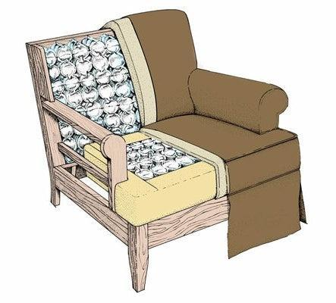
1. Material Selection: The padding material, often made from foam, rubber, or specialised fabrics, is chosen for its ability to absorb shock and reduce noise. The material must be durable enough to withstand repetitive compressions and expansions.

2. Design and Function: In upholstery, padding is placed over the coil springs to provide a cushioning layer, enhancing comfort and preventing the springs from poking through the fabric. In vehicle suspension systems, the padding, often referred to as a spring pad, sits between the coil spring and the seat, reducing metal-to-metal contact and dampening vibrations.

3. Size and Shape: The padding is tailored to fit the size and shape of the springs, ensuring effective coverage and function. In vehicle suspensions, the spring pad's design may include a centre hole to accommodate the spring's positioning.

4. Impact on Performance: Properly chosen and installed padding can significantly impact the comfort and longevity of furniture or the effectiveness of a vehicle's suspension system by providing an additional layer of shock absorption.

The role of padding in coil springs is crucial in both providing comfort in upholstered furniture and in enhancing the performance of vehicle suspension systems.

7. Foaming Up Process Consumables: Understand the consumables, including adhesives, solvents, profile jigs, and templates, necessary for the foaming up process.

The consumables involved in the foaming up process, particularly in industries like packaging or beverage production, play a significant role in achieving desired results. Key aspects of these consumables include:

1. Foaming Agents: These are substances used to create foam. In plastic foaming processes, conventional agents like HCFCs, HFCs, or hydrocarbons are common, though environmental concerns are leading to the adoption of more eco-friendly alternatives.

2. Solvent Control for Lab Evaporation: In laboratory settings, dealing with solvent bumping and foaming requires careful management. Techniques such as opening and closing the stop cock to minimise foaming are utilised.

3. Foam Control in Packaging: In packaging processes, especially for foamy products, techniques like bottom-up fill nozzles are employed to control the foam. This method helps in reducing foam creation during the filling process.

4. Foam Particles for Food Products: In the food industry, carbohydrate-free soluble foam particles containing proteins are used to create foaming compositions, enhancing the texture and appearance of the final product.

These consumables and techniques are vital in managing the foaming process across various industries, ensuring efficiency and quality in the final products.

8. Profile Jigs and Templates: Learn how to use profile jigs and templates effectively in upholstery work.

Profile jigs and templates are essential tools in woodworking and carpentry, designed to guide the cutting and shaping of materials to achieve precise and repeatable profiles. Their key aspects include:

1. Design and Purpose: Profile jigs and templates are specifically designed for creating consistent shapes and cuts. For instance, a radius jig helps in cutting circular shapes or curves with accuracy.

2. Material Construction: These jigs and templates are often made from durable materials like plywood, hardwood, or even 3D-printed plastics. The choice of material ensures longevity and precision in their application.

3. Variety and Customisation: They come in various designs for different purposes, such as corner radius sets for routers, which allow for creating precise rounded edges on wood. Some jigs are also customisable for specific tasks, like cutting openings for pipes and cables in wooden floors.

4. Application in Woodworking: Profile jigs and templates are crucial for complex woodworking tasks, offering precision and efficiency. They are used in conjunction with tools like routers to achieve the desired profiles on wood or other materials.

5. Enhancing Efficiency and Safety: By providing a guide for tools, these jigs and templates not only enhance the accuracy of work but also contribute to safer operations in woodworking, reducing the risk of errors and accidents.

Profile jigs and templates are invaluable for craftsmen, enabling them to achieve high-quality, consistent results in their woodworking projects.

9. Fabric Selection: Discover the fabrics used for covering webbing, springs, foam, and padding, including calico, hessian, polypropylene Dacron, and flock.

Fabric selection is a critical aspect in garment making, quilting, and various textile projects. It involves several key factors:

1. Purpose of the Garment or Project: The intended use of the garment or textile item significantly influences fabric choice. For instance, everyday wear requires durable and comfortable fabrics, while special occasion garments may call for more luxurious and delicate materials.

2. Fabric Type and Quality: Different fabrics, such as silk, cotton, wool, and synthetics, offer varied textures, weights, and drape qualities. The quality of the fabric also impacts its appearance, feel, and longevity.

3. Colour and Pattern: The colour and pattern of the fabric should complement the design of the garment or project. This includes considering how patterns align at seams and the overall aesthetic appeal.

4. Drape and Flow: The way fabric falls and moves is crucial for certain designs. Fabrics with good drape are essential for flowing garments, while stiffer fabrics are better for structured pieces.

5. Seasonality: Seasonal factors play a role in fabric selection. Lighter, breathable fabrics are suitable for summer, whereas heavier, warmer materials are preferred for winter garments.

6. Care Requirements: It iWis important to consider the care and maintenance of the fabric. Some fabrics may require special cleaning methods or may be more prone to wrinkling or fading.

Proper fabric selection ensures not only the aesthetic quality of the finished item but also its functionality and suitability for the intended purpose.

10. Spring Types: Explore the types and gauges of various springs needed for the knocker-on process, such as coil springs and zig-zag springs.

Spring types refer to the various kinds of mechanical springs used in different applications, from small devices to large industrial machinery. Key types include:

1. Compression Springs: These are perhaps the most common type of spring. They are designed to operate with a compressive load and are typically found in automotive suspensions, mechanical pencils, and many other applications.

2. Extension Springs: Extension springs absorb and store energy by resisting a pulling force. Typical uses include garage door mechanisms and trampolines.

3. Torsion Springs: These springs work via torsion or twisting motion. They are used in clothespins, clipboards, and even in the hinges of doors.

4. Coil Springs: Common in vehicle suspension systems, they are designed to absorb shock and maintain contact between the road and the wheels.

5. Leaf Springs: These are used mainly in the suspension systems of heavy vehicles like trucks and vans. They consist of several layers of metal bound together to act as a single unit.

6. Conical Springs: Shaped like a cone, they are used where regular compression springs might buckle. They are often found in battery contacts and push buttons.

7. Volute Springs: These are used in applications requiring large amounts of energy to be stored in a small space, such as in clocks and watches.

Each type of spring is designed for specific applications, taking into account factors like the required force, the space available, and the desired longevity of the spring.

11. Springing Up Consumables: Understand the types, sizes, quantities, and quality of consumables, including clips, nails, staples, edge rolls, twine, and cord, needed for the springing up process.

In the context of the furniture upholstery industry, "Springing Up Consumables" refers to various materials required during the "springing up" process, which is a crucial stage in furniture making where springs are installed and secured to provide support and comfort. Understanding the types, sizes, quantities, and quality of these consumables is essential for efficient and high-quality upholstery work.

1. Types:
- Clips, Nails, and Staples: Used for securing fabric and springs. They come in various types suited for different materials and thicknesses.
- Edge Rolls: Essential for creating clean, defined edges on furniture. They come in various materials like foam or fibre.
- Twine and Cord: Used for tying springs and securing upholstery layers.

2. Sizes:
- Clips, Nails, Staples: Sizes vary depending on the thickness of the material and the type of furniture. Heavier upholstery may require larger, more robust fasteners.
- Edge Rolls: Available in various thicknesses and widths to match different furniture designs.
- Twine and Cord: Thickness should be chosen based on the tension required and the type of springs used.

3. Quantities:
- Depends on the size of the furniture piece and the complexity of the design. Always estimate a little more than the calculated amount to account for any errors or adjustments.

4. Quality:
- High-quality materials ensure durability and longevity of the furniture. Choose rust-resistant nails and staples, sturdy twine, and durable edge rolls.

In summary, a thorough understanding of these consumables' characteristics is crucial for achieving the desired comfort, appearance, and durability in upholstered furniture.

12. Webbing Varieties: Learn about the types of webbing needed for the knocker-on process, including manmade elastic and rubber webbing, as well as natural fibre options like jute webbing and hessian

Webbing, used in a variety of applications from outdoor gear to upholstery, comes in different types, each suited for specific purposes. The key varieties include:

1. Nylon Webbing: Known for its strength and durability, nylon webbing is commonly used in outdoor gear such as backpacks and climbing harnesses. It has high tensile strength and is resistant to mildew and aging.

2. Polyester Webbing: Similar to nylon in strength, polyester webbing is more UV-resistant and doesn’t stretch as much. It is ideal for outdoor applications where exposure to sunlight is a factor, like in boat rigging and outdoor furniture.

3. Polypropylene Webbing: Lightweight and water-resistant, this type of webbing is often used in aquatic applications. It floats and is resistant to mildew, making it ideal for life jackets and water sports equipment.

4. Cotton Webbing: Known for its softness and comfort, cotton webbing is often used in apparel and bag straps. It is not as strong or durable as synthetic webbing but is preferred for its natural feel and aesthetic.

5. Seatbelt Webbing: Made from a very tightly woven polyester, seatbelt webbing is designed for safety and durability. It is used in automotive seat belts and heavy-duty harnesses.

6. Kevlar Webbing: Known for its high heat resistance, Kevlar webbing is used in fire safety equipment and applications requiring high tensile strength at elevated temperatures.

Each variety of webbing has unique properties that make it suitable for specific uses, balancing factors like strength, stretch, water resistance, and UV stability.

13. Labels, Codes, and Traceability: Gain insights into the importance of labelling, coding systems, and traceability in the upholstery industry.

Labels, codes, and traceability play a crucial role in various industries, ensuring the tracking and management of products from production to end-user. Here are their key aspects:

1. Labels: Labels are used to provide essential information about a product, such as its name, ingredients, manufacturer, and usage instructions. They can also include barcodes or QR codes for easier tracking and identification.

2. Codes: These are systems of symbols (like binary code) or words used to represent information in a compact and standardised format. In communications, codes replace information with an arbitrarily chosen symbol for efficiency and confidentiality.

3. Traceability: This refers to the ability to trace the history, application, or location of an entity by means of recorded identifications. In manufacturing, traceability is vital for tracking the movement and quality of products, often using labels and codes.

4. Operational Requirements: In ISO standards, for example, traceability and identification are essential for quality control, allowing companies to track batches of products, individual items, and raw materials through the production process.

5. Digital Tracking: With the advancement in digital technologies, labels and codes are increasingly being used in digital formats, enhancing the efficiency of tracking and traceability processes.

Labels, codes, and traceability systems ensure the quality, safety, and integrity of products, enabling businesses to monitor their supply chains and meet regulatory requirements.

14. Safe Materials Handling and Storage: Lastly, we will discuss the principles and concepts of safe materials handling and proper storage methods to ensure the well-being of workers and the integrity of materials. Safe materials handling and storage is essential in various work environments to prevent injuries and ensure operational efficiency. Key practices include:

1. Proper Training: Employees should receive training on safe handling practices, including the use of equipment and understanding the properties of different materials.

2. Use of Personal Protective Equipment (PPE): Workers must be equipped with appropriate PPE like gloves, safety glasses, and hard hats when handling materials.

3. Ergonomic Lifting Techniques: Encourage maintaining correct posture, avoiding bending over, and keeping lifts close to the body. Lifting should be done in a careful, deliberate manner.

4. Safe Stacking and Storage: Materials should be stacked securely to prevent sliding, falling, or collapse. This includes following guidelines for height limits and weight distribution.

5. Use of Lifelines and Safety Belts: In situations like working on stored materials in silos, hoppers, or tanks, employees should use safety equipment such as lifelines and belts.

6. Regular Maintenance of Equipment: Ensure that material handling equipment is regularly inspected and maintained for safety and reliability.

7. Clear Aisles and Workspaces: Keep aisles, passageways, and storage areas clear of obstruction to facilitate easy movement and reduce the risk of accidents.

Adhering to these safety protocols helps in reducing the risk of injuries and improving the efficiency of material handling and storage operations.

KT0203 Main upholstery material types
(woven plain, woven patterned, printed cretonne, pile, knitted jersey, coated fabrics and animal skins).

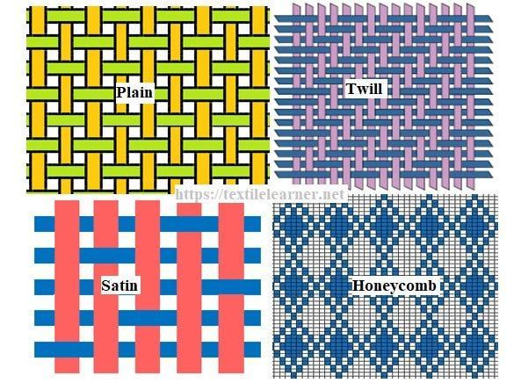

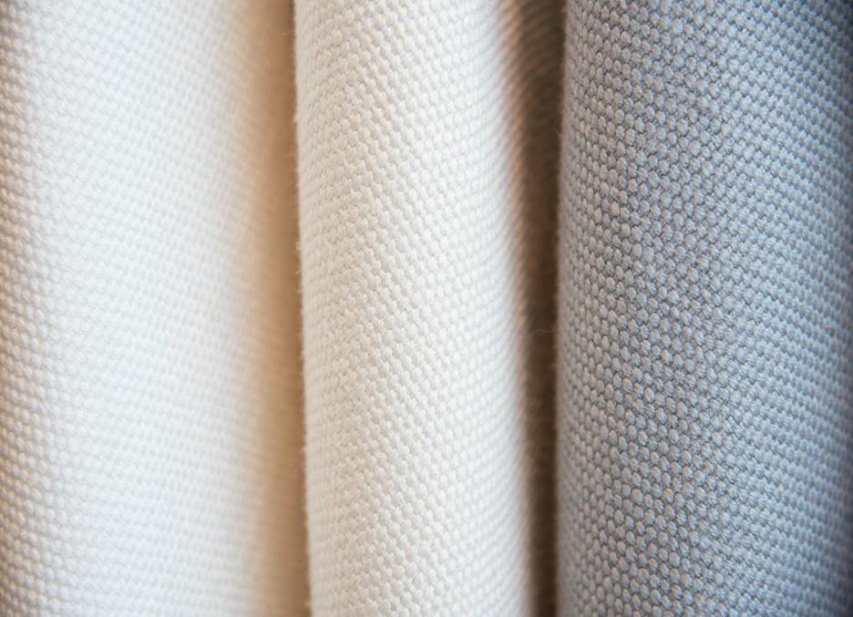

Each material type offers unique qualities and aesthetics, allowing for diverse furniture designs and applications.

1. Woven Plain: This type of fabric is created using a simple weaving technique, where warp and weft threads are interlaced to form a basic crisscross pattern. Woven plain fabrics are known for their strength and durability, making them a popular choice for upholstery.

Plain weave is one of the most fundamental and commonly used types of weave in fabric production. In a plain weave, the warp and weft threads cross each other at right angles, alternating with each warp thread passing over and under each weft thread. The pattern resembles a simple crisscross formation.

# Characteristics of Plain Weave:
- Uniform Texture: The resulting fabric has a uniform texture with a flat and tight appearance.
- Versatility: It is suitable for a wide range of materials, from cotton to silk.
- Durability: Despite its simplicity, plain weave is quite strong and durable.
- Uses: This weave is commonly used for making shirts, quilts, and other types of clothing and household textiles.

Plain weave is often chosen for its simplicity, ease of production, and versatility in various applications.

2. Woven Patterned: These fabrics feature patterns created during the weaving process, with coloured threads woven to form designs. This type of fabric adds texture and visual interest to upholstery and is often used for decorative furniture.

Woven patterned fabrics are created using intricate weaving techniques where different coloured threads are interlaced to form decorative patterns. Unlike plain weave, where the design is quite simple, woven patterned fabrics involve complex arrangements of warp and weft threads to create unique and often elaborate designs.

# Characteristics of Woven Patterned Fabric:
- Intricate Designs: These fabrics feature detailed and varied patterns, ranging from geometric to floral designs, achieved directly in the weaving process.
- Texture and Depth: The use of different weaving techniques and coloured threads gives these fabrics a distinct texture and depth.
- Versatility: Woven patterned fabrics are used in a variety of applications, from upholstery and curtains to clothing.
- Aesthetic Appeal: They are often chosen for their aesthetic appeal and ability to add visual interest to a space or garment.

Woven patterned fabrics are appreciated for their artistic qualities and are a popular choice in interior design and fashion for adding colour and character.

3. Printed Cretonne: Cretonne is a heavy, unglazed cotton fabric. Printed cretonne has designs printed onto it, often featuring floral patterns or bold, vivid motifs. It is commonly used for upholstery due to its durability and vibrant appearance.

Printed Cretonne is a type of fabric that is commonly used in various textile applications.

Printed Cretonne is a specific variation of cretonne fabric that is known for its vibrant and colourful printed patterns. This fabric typically features intricate and decorative designs, which can range from floral motifs to geometric shapes and more. The prints are applied to a solid background, creating a visually appealing and textured fabric.

Key characteristics of Printed Cretonne:

1. Fabric Composition: Printed cretonne is primarily made of cotton. It is a strong and durable fabric, making it suitable for a wide range of uses.

2. Canvas Weave: Cretonne fabrics, including printed cretonne, are woven with a canvas weave. This weave structure contributes to the fabric's strength and resilience.

3. Versatile Use: Printed cretonne is versatile and finds applications in various sewing and upholstery projects. It is commonly used for making curtains, draperies, cushion covers, tablecloths, and other home decor items. Its aesthetic appeal makes it a popular choice for adding a touch of style to interiors.

4. Ease of Sewing: One of the advantages of printed cretonne is that it is easy to sew. It doesn't require special presser feet or needles, making it accessible to both beginner and experienced sewers.

5. Historical Perspective: Originally, cretonne referred to a strong, white fabric with a hempen warp and linen weft. However, over time, the term has come to be associated with strong, printed cotton cloth, which is thicker and often adorned with decorative designs.

Printed cretonne's colourful patterns and durability make it a favoured choice for various textile projects, adding a touch of elegance and style to both clothing and home decor. It is valued not only for its aesthetic qualities but also for its practicality in sewing and upholstery.



An image of printed Cretonne fabric. This fabric is known for its bright, vibrant colours and bold, floral patterns. The design should feature a variety of colourful flowers, including roses, daisies, and tulips, interspersed with green leaves and vines. The background colour of the fabric should be a soft, pastel shade to contrast with the vivid colours of the flowers. The overall appearance should be cheerful and lively, typical of Cretonne fabric designs, with a detailed and intricate pattern.

4. Pile: Pile fabrics, like velvet or corduroy, have a raised surface or 'pile' created by cut or uncut loops of thread. These fabrics provide a luxurious feel and are used for more plush and comfortable upholstery.

1. Purpose: Piles are primarily used to transfer the load of a structure to a deeper, more stable soil or rock layer beneath the surface. They provide stability and prevent settlement, especially in areas with weak or compressible soils.

2. Types of Piles: There are various types of piles, including:
- Driven Piles: These are piles that are forcefully driven or hammered into the ground. Common materials for driven piles include steel, concrete, or timber.
- Bored or Drilled Piles: These are created by drilling a hole into the ground and then filling it with concrete or other suitable materials.
- Screw Piles: These piles have a helical screw-shaped plate on the bottom and are screwed into the ground, providing a solid foundation.
- Sheet Piles: These are thin, interlocking piles often used for retaining walls and excavation support.

3. Applications: Piles are used in various construction scenarios, such as in high-rise buildings, bridges, piers, and foundations for industrial equipment. They are particularly crucial in areas with challenging soil conditions, including soft clay, silt, or areas prone to flooding.

4. Construction Process: The construction of piles involves drilling, driving, or screwing them into the ground, depending on the type chosen. Once in place, the piles are typically connected to the structure's foundation or superstructure, ensuring load transfer.

5. Load-Bearing Capacity: Piles are designed to withstand a specific load capacity, and engineers carefully calculate the number and type of piles needed to support a structure based on its weight and expected loads.

6. Testing: Piles may undergo load testing to verify their load-bearing capacity and suitability for the intended purpose.

In summary, piles play a vital role in ensuring the stability and longevity of various structures by providing a secure foundation, especially in challenging soil conditions. The type of pile used depends on factors like soil conditions, the weight of the structure, and the construction method.

5. Knitted Jersey: A stretchable fabric made by knitting, jersey is less common in traditional upholstery but is used for its softness and comfort. It is more suitable for casual or unique furniture pieces.

Knitted Jersey is a type of fabric known for its unique characteristics and versatility. Here's an expansion on this term:

1. Fabric Construction: Knitted Jersey is made using a specific knitting technique. It consists of interlocking loops of yarn, which create a flexible and stretchy fabric. This construction allows the fabric to have a natural elasticity, making it comfortable to wear.

2. Softness and Comfort: One of the standout features of Knitted Jersey is its exceptional softness. The fabric feels gentle against the skin, making it a popular choice for clothing items like T-shirts, pyjamas, and underwear. Its comfortable feel is ideal for everyday wear.

3. Stretchability: Knitted Jersey has a significant degree of stretch, both horizontally and vertically. This stretchiness makes it suitable for garments that require ease of movement, such as active wear and sportswear.

4. Breathability: Jersey knit fabric is breathable, allowing air circulation through the fabric. This breathability makes it suitable for warm-weather clothing, as it helps to keep the wearer cool and comfortable.

5. Versatility: Knitted Jersey is versatile and comes in various weights and thicknesses. It can be lightweight for summer garments or heavier for colder seasons. This versatility makes it suitable for a wide range of clothing applications.

6. Appearance: Jersey knit fabric typically has a smooth and even surface on one side (the right side) and a textured back side with prominent horisontal ribs. The front side often has conspicuous flat vertical stripes, giving it a distinct appearance.

7. Common Uses: Knitted Jersey is used in a wide range of clothing items, including T-shirts, dresses, skirts, active wear, loungewear, and more. It is also commonly used for making bedsheets and bedding due to its softness and breathability.

8. Maintenance: Jersey fabric is relatively easy to care for. It is often machine washable and retains its shape well, reducing the need for ironing.

In summary, Knitted Jersey is a popular fabric choice known for its softness, stretchability, and comfort. Its versatility and breathability make it a go-to option for a wide variety of clothing and textile applications.

6. Coated Fabrics: These are fabrics coated with a layer of plastic or rubber, making them water-resistant and easy to clean. Vinyl and leatherette are common examples, used for both indoor and outdoor furniture.

Coated Fabrics refer to textiles that have been treated with a special coating or layer to enhance their performance and functionality.

1. Coating Types: Coated fabrics can be treated with various types of coatings, including but not limited to:
- Polymer Coatings: These coatings are often made of polymers like polyurethane (PU) or polyvinyl chloride (PVC). They are used to make fabrics waterproof, providing resistance to moisture and rain. PU-coated fabrics are known for their flexibility and breathability.
- PTFE (Teflon) Coatings: PTFE coatings, commonly known as Teflon, are used to make fabrics non-stick and resistant to stains and chemicals. These coatings are often applied to kitchen textiles, like aprons and oven mitts.
- Silicone Coatings: Silicone-coated fabrics have a smooth, slippery surface. They are used in various applications, including medical textiles, where low friction is required.
- Flame-Retardant Coatings: Fabrics can be coated with flame-retardant materials to make them resistant to fire and heat. These fabrics are used in safety applications, such as firefighter gear.
- Abrasion-Resistant Coatings: Coatings that enhance the fabric's durability and resistance to wear and tear. They are used in applications like industrial workwear.

2. Applications: Coated fabrics find applications in a wide range of industries and products. Some common uses include:
- Outdoor Gear: Coated fabrics are used in making outdoor clothing, tents, backpacks, and rain gear due to their waterproof properties.
- Automotive: In the automotive industry, coated fabrics are used for car interiors, seats, and convertible tops.
- Medical: Medical textiles often use silicone-coated fabrics for their hypoallergenic and easy-to-clean properties.
- Industrial: Industrial applications include conveyor belts, protective clothing, and equipment covers.
- Home Furnishings: Some coated fabrics are used in upholstery for their durability and ease of cleaning.

3. Advantages: Coated fabrics offer several advantages, such as water resistance, stain resistance, and enhanced durability. They are also easy to clean, making them suitable for various environments.

4. Manufacturers: Companies like Coated Fabrics (SA) (Pty) Ltd specialise in coating fabrics with materials like PTFE (Teflon) and silicone, offering specialised solutions for specific industries.

In summary, coated fabrics are textiles that have been treated with coatings to enhance their properties and adapt them to specific applications. They are versatile and find use in a wide array of industries, offering benefits like waterproofing, stain resistance, and durability.

7. Animal Skins: Leather and suede, derived from animal hides, are traditional luxury materials for upholstery. They offer durability, comfort, and a classic aesthetic. Animal skin upholstery requires specific care to maintain its appearance and texture.

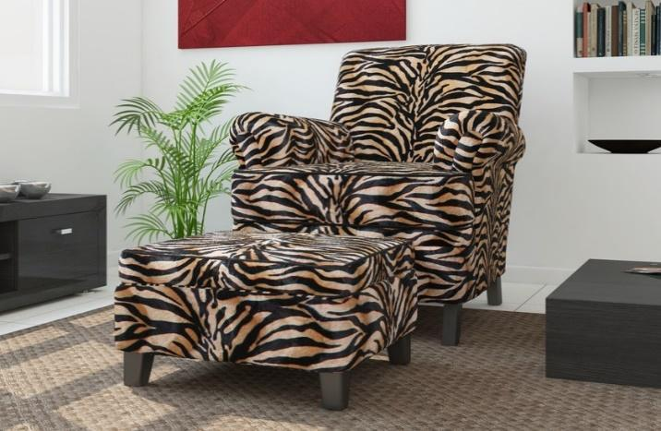

Animal skin, often referred to as leather, has been a popular choice for furniture upholstery for centuries. Its natural beauty, durability, and luxurious feel make it a preferred material for many upholstery projects. Here, we explore the use of animal skin as a fabric for furniture upholstery.

Types of Animal Skin Used:

1. Cowhide Leather: Cowhide is one of the most common types of leather used in furniture upholstery. It is known for its durability and versatility, making it suitable for various furniture styles.

2. Top-Grain Leather: This high-quality leather is derived from the top layer of the hide. It is smooth, supple, and has a natural grain pattern, making it an excellent choice for upscale furniture.

3. Full-Grain Leather: Full-grain leather retains the natural grain and imperfections of the hide. It is prized for its authenticity and character, making each piece of furniture unique.

4. Aniline Leather: Aniline leather is dyed but retains the natural texture and grain. It is soft and luxurious to the touch, ideal for elegant furniture designs.

Advantages of Using Animal Skin:

1. Durability: Leather upholstery is incredibly durable and can withstand daily wear and tear, making it suitable for both residential and commercial settings.

2. Luxurious Appearance: The rich, natural texture of leather adds a touch of luxury and sophistication to any piece of furniture.

3. Comfort: Leather is breathable and adapts to the body's temperature, ensuring comfort in all seasons.

4. Easy Maintenance: Leather is easy to clean and maintain, and minor scratches or blemishes can often be buffed out.

Considerations:

1. Cost: Quality leather can be more expensive than other upholstery materials, but its longevity and timeless appeal justify the investment.

2. Variations: Due to the natural characteristics of animal skin, there may be variations in colour and texture, adding to the uniqueness of each piece.

3. Care: Leather requires regular cleaning and conditioning to preserve its beauty and prevent drying or cracking.

Conclusion:

Animal skin, particularly leather, remains a top choice for furniture upholstery due to its durability, aesthetic appeal, and comfort. When cared for properly, leather furniture can last for generations and continue to exude elegance and charm in any living space. Whether used in classic or contemporary designs, leather adds a touch of timeless luxury to your upholstered furniture.

KT0204 Types, sizes, quantity and quality of consumables needed for cover fitting, finishing and trimming.

1. Thread: Thread is a fundamental consumable used for stitching various parts of a garment together. It comes in various materials such as cotton, polyester, and nylon, with different sizes or thicknesses to suit different fabrics and sewing techniques.

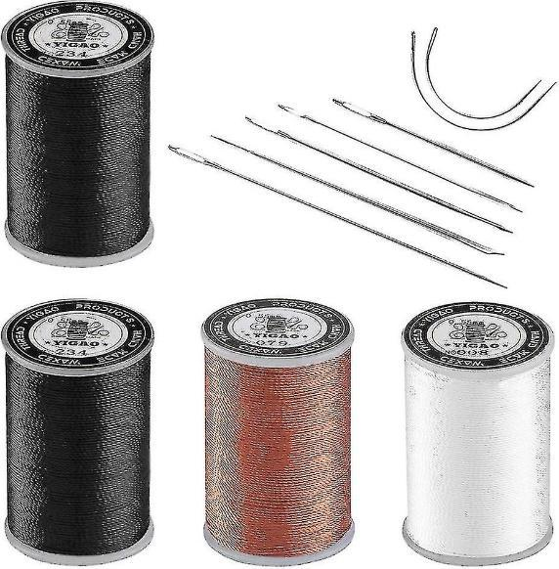

2. Needles: Sewing needles vary in size and type. Ballpoint needles are suitable for knits, while sharp needles work well with woven fabrics. The size of the needle should match the thread and fabric being used.
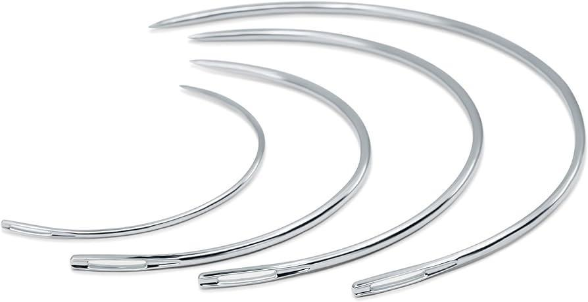

Needles in Furniture Upholstery:

1. Types of Upholstery Needles:
- Upholstery needles used in furniture upholstery come in various types and sizes, each designed for specific tasks.
- Curved Round Point Needles: These needles are commonly used for sewing seams in upholstery. Their curved shape allows for easier penetration through thick fabric and padding.
- Straight Needles: Straight needles are versatile and can be used for various tasks, such as attaching fabric to the frame or repairing loose seams.
- Button Needles: These needles have a loop at the end and are used for tufting or attaching buttons to create decorative patterns on upholstered furniture.
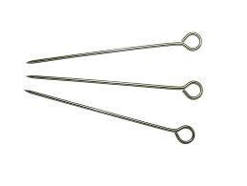
2. Needle Sizes:
- Upholstery needles come in different sizes, typically measured in inches or millimetres. The size you choose depends on the thickness of the fabric and the task at hand. Thicker fabrics and multiple layers may require larger needles.

3. Heavy-Gauge Needles:
- Upholstery work often involves sewing through multiple layers of fabric, padding, and sometimes leather. Heavy-gauge needles are designed to withstand the stress of such tasks without bending or breaking.

4. Needle Sets:
- Many upholstery professionals use sets of needles to have a variety of options readily available. These sets may include different needle types and sizes, ensuring they have the right tool for each job.

5. Thread Compatibility:
- Choosing the right thread for upholstery is essential. The thread should be strong and durable to withstand the demands of furniture use. Upholstery needles are designed to work with heavy-duty upholstery threads.

6. Techniques and Skills:
- Proper use of upholstery needles requires skill and technique. Upholsterers must have precision in their stitches to create strong and neat seams. This skill is honed through experience and training.

7. Repair and Restoration:
- Upholstery needles are not only used in creating new upholstered furniture but also in repair and restoration work. Skilled upholsterers can breathe new life into old furniture by carefully removing old fabric and padding and replacing it with new materials.

8. Maintenance:
- Like any tool, upholstery needles require maintenance. Keeping them clean and sharp ensures they perform effectively. Regularly inspecting for any signs of wear or damage is essential for safety and quality work.

In conclusion, upholstery needles are indispensable tools in furniture upholstery, enabling professionals to create, repair, and restore upholstered pieces. Their variety in type, size, and durability ensures that upholsterers can tackle a wide range of projects, from simple repairs to crafting intricate upholstery designs.

3. Zippers: Zippers come in different types, including regular, invisible, and separating zippers. The choice depends on the design and function of the garment.

In the context of furniture upholstery, zippers play a significant role, primarily in cushion covers and upholstery applications.

Zippers in Furniture Upholstery:

1. Cushion Covers: Zippers are commonly used in cushion covers for furniture such as sofas, chairs, and benches. These zippers provide access to the cushion's interior, allowing for easy removal and replacement of the foam or padding.

2. Concealed Zippers: In many upholstery projects, especially for high-end furniture, concealed zippers are preferred. These zippers are designed to be hidden within the seam, creating a seamless and polished appearance on the upholstered piece.

3. Continuous Zippers: Continuous zippers, also known as upholstery zippers, are often used in furniture upholstery. They come in long rolls or spools and can be custom-cut to the desired length. This flexibility allows for precise sizing, making them suitable for various upholstery projects.

4. Durable Materials: Upholstery zippers are typically made from durable materials like nylon or metal. The choice of material depends on the specific requirements of the project. Nylon zippers are commonly used for indoor furniture, while metal zippers are preferred for outdoor or heavy-duty applications.

5. Replacement and Repair: Zippers in furniture upholstery can wear out over time due to frequent use. Having access to a sipper makes it easier to replace or repair cushion covers, extending the life of the furniture.

6. Customisation: Upholstery zippers come in various colours and finishes, allowing upholsterers to select zippers that complement the fabric and overall design of the furniture piece.

7. Ease of Maintenance: Zippers make it convenient to clean and maintain upholstered furniture. Removable cushion covers with zippers can be easily washed or dry-cleaned, ensuring cleanliness and hygiene.

8. Professional Installation: For complex upholstery projects or when working with valuable furniture pieces, it is advisable to seek the expertise of professional upholsterers. They have the skills and equipment to install zippers neatly and securely.

9. DIY Upholstery: For those interested in DIY upholstery, understanding how to sew zippers correctly is essential. There are online tutorials and resources available to guide enthusiasts in using zippers effectively in their projects.

In summary, zippers are indispensable components in furniture upholstery, facilitating easy access to cushion interiors, customisation, maintenance, and repair. Whether for DIY projects or professional upholstery work, the choice of the right sipper type and proper installation techniques are crucial for achieving a polished and functional result.

4. Buttons and Fasteners: Buttons, snaps, hooks, and other fasteners are used for closures. They come in various sizes, styles, and materials to match the garment's aesthetics and functionality.

In the context of furniture upholstery, buttons and fasteners are crucial components that not only serve functional purposes but also contribute to the aesthetics of the furniture piece.
Buttons and Fasteners in Furniture Upholstery:

1. Tufting and Decoration: Buttons are often used in upholstery to create tufted designs. Tufting involves pulling fabric and securing it with buttons to create a padded, textured surface. This technique is commonly seen on sofas, chairs, and headboards, adding a touch of elegance and sophistication to the furniture.

2. Choice of Materials: Buttons and fasteners come in a variety of materials, including fabric-covered buttons, metal buttons, and plastic fasteners. The choice of material depends on the desired look, durability, and compatibility with the upholstery fabric.

3. Functional Fastening: Fasteners, such as snaps and hook-and-loop tape, are used to secure cushion covers, slipcovers, or other removable upholstery pieces. They make it easy to attach and detach covers for cleaning or replacement.

4. Customisation: Furniture upholstery often involves customisation to match the client's preferences. Buttons and fasteners can be selected in various sizes, shapes, and colours to complement the overall design and fabric choice.

5. Installation Techniques: Upholsterers use specialised tools and techniques to attach buttons securely. This process, known as button tufting, requires precision to ensure that the buttons are evenly spaced and tightly secured.

6. Button Machines: In large-scale upholstery projects, button machines are used to streamline the button-making process. These machines can quickly create fabric-covered buttons that match the upholstery material.

7. Maintenance and Repair: Buttons and fasteners may need replacement or repair over time, especially in high-use furniture pieces. Upholsterers can replace worn-out buttons or damaged fasteners, extending the lifespan of the furniture.

8. Historical Significance: Buttons and tufting have a rich history in furniture design. They have been used for centuries in various furniture styles, from classic Chesterfield sofas to contemporary designs, preserving the tradition of craftsmanship.

9. Upholstery Trends: Upholstery trends evolve, and buttons and fasteners play a role in reflecting these trends. Modern upholstery may feature sleek, unadorned designs, while traditional styles embrace intricate button detailing.

In summary, buttons and fasteners are essential elements in furniture upholstery, serving both functional and decorative purposes. They allow for customisation, contribute to the overall design aesthetics, and are integral to upholstery techniques like tufting. Whether for classic or contemporary furniture, the selection and installation of buttons and fasteners are critical aspects of upholstery craftsmanship.

5. Interfacing: Interfacing is a material applied to certain areas of a garment to provide structure and stability. It comes in various weights and fusible or sew-in options.

In the context of furniture upholstery, interfacing plays a significant role in enhancing the durability, structure, and overall quality of upholstered pieces.

Interfacing in Furniture Upholstery:

1. Structural Support: Interfacing is a material that is often used to provide structural support to various components of upholstered furniture. It adds rigidity to specific areas, such as the back and arms of a sofa or chair, ensuring that these parts maintain their shape over time.

2. Preventing Sagging: One of the key challenges in upholstery is preventing sagging or deformation of the furniture's cushions and padding. Interfacing, when strategically placed, helps distribute weight and pressure evenly, reducing the likelihood of sagging in high-use areas.

3. Fabric Stability: Upholstery fabrics can be heavy and prone to stretching. Interfacing stabilises the fabric, preventing it from becoming misshapen or distorted during the upholstery process and over the lifespan of the furniture.

4. Enhancing Upholstery Techniques: Interfacing is commonly used in conjunction with other upholstery materials like foam and batting. It assists in achieving crisp, clean lines, and defined edges in upholstery projects, giving furniture a polished and professional appearance.

5. Compatibility with Fabrics: Different types of interfacing are available to match the specific requirements of upholstery fabrics. It is essential to choose the right interfacing based on the fabric's weight, thickness, and texture to ensure a seamless and long-lasting upholstery job.

6. Ease of Application: Interfacing can be applied through various methods, including sewing, adhesive bonding, or heat-activated fusible interfacing. The chosen application method depends on the upholstery project's complexity and the upholsterer's preference.

7. Customisation: Interfacing allows for customisation in upholstery design. It can be tailored to specific areas of the furniture piece, providing extra reinforcement where needed, such as the arms or seat cushions.

8. Longevity: Furniture that incorporates interfacing in its upholstery tends to have a longer lifespan due to the added support and stability it provides. It helps maintain the furniture's original shape and appearance even after years of use.

9. Professional Finish: For upholstery professionals, interfacing is an essential tool to achieve a high-quality, professional finish. It contributes to the overall craftsmanship and durability of the upholstered piece.

In summary, interfacing in furniture upholstery is a versatile material that enhances the structural integrity, longevity, and aesthetic appeal of upholstered furniture. It addresses common challenges in upholstery, such as sagging and fabric stability, and allows upholsterers to achieve a polished and durable finish in their projects.

6. Elastic: Elastic bands are used for waistbands, cuffs, and other areas that require stretch. They come in different widths and materials, like woven or knitted elastic.

In the context of the furniture upholstery industry, the term "elastic" refers to specific qualities and materials that play a role in the upholstering process.

Elastic in Furniture Upholstery:

1. Elastic Webbing: Elastic webbing is a crucial component in many upholstered pieces, especially in seating like sofas and chairs. This material is used to provide support and comfort to the furniture's seats and backs. It offers elasticity, allowing the upholstery to bounce back and maintain its shape after use.

2. Sag Prevention: Elastic webbing helps prevent sagging in cushions and seating areas. Its elasticity ensures that the furniture retains its original form and comfort over time, even with regular use.

3. Durability: Upholstered furniture faces considerable stress and wear, and elastic materials contribute to its durability. Elastic webbing is designed to withstand the weight and pressure exerted by people sitting on the furniture, making it a long-lasting choice.

4. Ease of Installation: Elastic webbing is relatively easy to install during the upholstery process. It can be stretched and attached to the frame, providing the necessary support structure for cushions and upholstery fabric.

5. Comfort: Elasticity in upholstery materials enhances the comfort of furniture. It offers a level of bounce and flexibility that contributes to a pleasant sitting experience.

6. Variety of Types: There are different types of elastic webbing available, each with specific characteristics to suit various furniture designs and requirements. Some are wider or narrower, and their elasticity levels can vary, allowing for customisation in upholstery projects.

7. Maintenance: Elastic materials used in upholstery require minimal maintenance. They retain their elasticity and supportive properties even with extended use, reducing the need for frequent replacements.

8. Modern Upholstery Techniques: Elasticity in upholstery materials is especially relevant in modern upholstery techniques. It complements the use of foam and other padding materials to create comfortable and resilient seating.

9. Resilience: Elastic materials contribute to the resilience of upholstered furniture. They ensure that the furniture maintains its shape, avoiding the development of unsightly sags or depressions in seating areas.

In summary, elasticity, particularly in the form of elastic webbing, is a critical element in the furniture upholstery industry. It provides essential support, comfort, and durability to upholstered furniture, ensuring that it can withstand regular use while maintaining its shape and comfort. Different types of elastic materials allow for customisation and adaptation to various upholstery needs and designs.

7. Trim and Embellishments: Decorative trims, lace, ribbons, and sequins are used for adding aesthetic elements to garments. They come in various widths and designs.

In the context of the furniture upholstery industry, "Trim and Embellishments" refer to decorative elements and finishing touches used to enhance the appearance and functionality of upholstered furniture. These elements serve both aesthetic and functional purposes, making upholstery pieces visually appealing and durable. Here's an expansion on Point 7:

Trim and Embellishments in Furniture Upholstery:

1. Piping: Piping is a cord covered with fabric, often used to define the edges and seams of upholstery. It adds a tailored and finished look to furniture, creating clean lines and preventing wear along seams.

2. Fringe: Fringe is a decorative trim made of threads or fabric strands attached to the bottom or edges of upholstery. It adds a touch of elegance and can conceal seams or gaps.

3. Nailhead Trim: Nailhead trim consists of individual decorative nails or studs that are hammered into the furniture's frame or fabric. It creates a classic and sophisticated look, often used in traditional and vintage-style upholstery.

4. Tassels: Tassels are ornamental, hanging embellishments often attached to the corners or edges of upholstery, such as curtains or draperies. They add a touch of luxury and sophistication.

5. Buttons: Upholstery buttons are not only functional but also decorative. They are used to tuft cushions and upholstery, creating a plush and tailored appearance.

6. Braiding: Braided trim is made by weaving together multiple strands of fabric or cord. It can be applied along the seams or edges of upholstery to add texture and visual interest.

7. Gimp: Gimp is a narrow decorative trim that is often used to conceal seams or join different fabric sections. It provides a polished and finished look.

8. Cording: Cording or cord trim is a thicker version of piping. It is often used to reinforce seams and edges while adding a decorative element.

9. Ribbon: Ribbon trim can be applied to upholstery for a touch of colour and pattern. It is versatile and can be used in various creative ways.

10. Banding: Banding is a decorative strip of fabric that is applied to the edges or seams of upholstery. It can be used to frame or highlight specific areas of a piece.

11. Grosgrain: Grosgrain ribbon is a type of fabric ribbon with a ribbed texture. It is often used for decorative detailing in upholstery, adding texture and style.

12. Contrasting Fabrics: Combining different fabrics with varying textures and patterns can create visually striking upholstery. This can include using contrasting fabrics for cushions, pillows, or specific sections of the furniture.

13. Functional Embellishments: Some embellishments, like reinforced corners or extra stitching, can serve both decorative and functional purposes, adding durability and longevity to the upholstery.

In conclusion, trim and embellishments in furniture upholstery play a crucial role in enhancing the overall aesthetics, durability, and style of upholstered pieces. They allow for customisation and creativity, making each piece unique and visually appealing. Upholsterers often select and apply these elements with care to achieve the desired look and functionality for their furniture projects.

Sizes, Quantity, and Quality:

1. Sizes: The size of consumables such as thread, needles, zippers, buttons, and elastic should be chosen based on the design and fabric. For thread and needles, consider the fabric's weight and thickness. For zippers, select the appropriate length. Buttons and elastic should match the garment's measurements.

"Sizes" in the context of upholstery refers to the various dimensions and measurements that are crucial when working with upholstered furniture. Understanding and correctly utilising these sizes is fundamental in upholstery to ensure a successful project. Here are some key aspects related to sizes in upholstery:

1. Furniture Dimensions: The size of the furniture piece itself is of utmost importance. This includes the height, width, depth, and overall shape. Accurate measurements are essential to determine the amount of fabric and materials required for upholstery.

2. Cushion Sizes: Upholstered furniture often involves cushions, which come in various sizes and shapes. Measuring cushions accurately ensures that the upholstery fabric covers them completely and fits snugly.

3. Fabric Yardage: Calculating the required fabric yardage is based on the size of the furniture and its components. Upholsterers need to measure the surface area to determine how much fabric is needed. This calculation considers factors like pattern matching and seam allowances.

4. Foam Thickness: When replacing or adding foam padding, the thickness of the foam is a critical size consideration. It affects the comfort and appearance of the upholstered piece.

5. Button Placement: In tufted upholstery, the placement and spacing of buttons are essential for achieving a uniform and attractive tufted look. Proper measurements ensure that buttons are evenly distributed.

6. Piping and Trim Length: Trim and embellishments, such as piping or fringe, require precise measurements to determine the length needed to go around the edges or seams of the furniture.

7. Pattern Matching: For patterned fabrics, matching patterns across different sections of the upholstery is crucial for a cohesive and professional appearance. This involves measuring and aligning patterns correctly.

8. Seat Height: The height of chair seats or sofa cushions affects comfort and ergonomics. Measuring and maintaining consistent seat heights is vital for user satisfaction.

9. Backrest Height: The height of the backrest on chairs and sofas varies, and it plays a role in the overall aesthetics and comfort. Upholsterers must measure and replicate backrest heights accurately.

10. Armrest Dimensions: Armrest size and shape contribute to the style and functionality of furniture. Precise measurements ensure that armrests are symmetrical and proportionate.

11. Leg Length: If the furniture has exposed legs, their length and style are important design elements. Upholsterers may need to customise leg sizes or replace them.

12. Button Size: In button tufting, the size of the buttons used can impact the depth of the tufts. Selecting the appropriate button size is part of the sizing considerations.

13. Seam Allowances: Adding seam allowances to measurements is essential to accommodate the sewing process. Seam allowances are typically 1/2 inch or more, depending on the upholstery technique.

In conclusion, sizing is a fundamental aspect of upholstery that influences the overall appearance, comfort, and functionality of upholstered furniture. Upholsterers must take precise measurements and consider various dimensions to achieve successful and visually pleasing results in their projects.

2. Quantity: The quantity of consumables required depends on the design, size, and specific requirements. It is essential to plan and estimate the quantity needed before starting a project to avoid shortages.

In the context of furniture upholstery, "Quantity" primarily refers to the amount of fabric required to cover a particular piece of furniture. This amount is usually measured in yards. The required quantity of fabric depends on several factors:

1. Size and Type of Furniture: Larger pieces like sofas will require more fabric compared to smaller ones like chairs. The style of the furniture also impacts fabric needs—more intricate designs might need extra fabric for details.

2. Pattern Matching: If the fabric has a pattern that needs to be aligned, more fabric may be required to ensure the pattern matches up on all parts of the furniture.

3. Fabric Width: Fabric typically comes in various widths, and wider fabric may cover more area with less yardage.

4. Re-upholstery Details: Elements like tufting, pleats, or skirts can increase the amount of fabric needed.

A general rule of thumb, as noted in some sources, suggests that for every foot of furniture length, 1.5 to 2 metres of fabric might be needed. However, this is a broad estimate and can vary greatly based on the above factors.

In the context of furniture upholstery, "Quantity" primarily refers to the amount of fabric required to cover a particular piece of furniture. This amount is usually measured in metres. The required quantity of fabric depends on several factors:

1. Size and Type of Furniture: Larger pieces like sofas will require more fabric compared to smaller ones like chairs. The style of the furniture also impacts fabric needs—more intricate designs might need extra fabric for details.

2. Pattern Matching: If the fabric has a pattern that needs to be aligned, more fabric may be required to ensure the pattern matches up on all parts of the furniture.

3. Fabric Width: Fabric typically comes in various widths, and wider fabric may cover more area with less yardage.

4. Re-upholstery Details: Elements like tufting, pleats, or skirts can increase the amount of fabric needed.

A general rule of thumb, as noted in some sources, suggests that for every foot of furniture length, 1.5 to 2 yards of fabric might be needed. However, this is a broad estimate and can vary greatly based on the above factors.

4. Matching Colours and Styles: When choosing consumables like thread, buttons, and trim, consider colour matching and style coherence with the garment. Using matching colours and complementary styles enhances the overall look of the garment.

In conclusion, selecting the right types, sizes, quantity, and quality of consumables is essential for successful cover fitting, finishing, and trimming in garment construction. Proper choices ensure both functionality and aesthetics in the final product.

KT0205 Density, thickness and types of foam required for the foaming up process.

When considering the foaming up process in the furniture upholstery industry, it is essential to understand the roles of density, thickness, and types of foam. Each aspect contributes significantly to the final quality and comfort of the upholstered furniture.

1. Density of Foam: The density of upholstery foam is a critical factor in determining its durability and comfort. Higher-density foams tend to be more durable and offer better support, but they can also be less comfortable if not used appropriately. Density is typically measured in pounds per cubic foot (PCF).

Expanding on the concept of foam density, especially in the context of upholstery and furniture manufacturing:

1. Definition and Measurement: Foam density is defined as the weight of the foam per unit volume. It is typically measured in pounds per cubic foot (PCF) or in metric terms, kilograms per cubic meter (kg/m³). This measurement reflects how much material is packed into a cubic block of foam, usually a 12" x 12" x 12" size [[1](https://blog.mcelherans.com/foam-density)].

2. Density Range: The density of upholstery foam can vary widely. For instance, higher-density upholstery foam can start from 25 kg/m³. This variation is crucial for different furniture pieces like seats, armchairs, chairs, and mattresses, where durability and comfort are paramount [[3](https://www.antamir.com/upholstery-foam.html)].

3. Quality and Longevity: The density of the foam is directly linked to its quality and longevity. Higher density foam generally indicates better quality and is more long-lasting. For example, many furniture manufacturers recommend using foam with a density of at least 1.8 PCF for seating, as it tends to be more durable [[2](https://www.pfa.org/furniture-case-study/)], [[5](https://www.foambymail.com/blog/foam-density-range-understanding-and-applying-values/)].

4. Flexible Foam Density Range: The density of flexible foams, such as those used in upholstery, can range from as low as 0.5 PCF to as high as 8.0 PCF. This range illustrates the wide variety of foam types available for different applications, from very soft to very firm [[4](https://www.designerstoday.com/news/industry-news/material-matters-getting-to-the-core-of-upholstery-foam/)].

Understanding foam density is crucial for selecting the appropriate foam for various furniture applications, ensuring both comfort and durability in the finished products.

2. Thickness of Foam: The thickness of the foam impacts the comfort level of the furniture. Generally, thicker foam provides a softer feel, whereas thinner foam tends to be firmer. The selection of thickness should be based on the intended use of the furniture piece. For seat cushions, a thickness of 1" to 6" is considered firm, while 7" to 8" thickness is regarded as extremely firm, but still only firm for seating applications [[6](https://www.foambymail.com/foam-types-for-seats-and-cushions.html)].

The thickness of foam used in upholstery plays a crucial role in determining the comfort, support, and overall functionality of the furniture. Here are key aspects to consider:

1. Dependence on Furniture Type and Usage: The appropriate thickness of upholstery foam varies depending on the type of furniture and its intended use. For example, a sofa might require thicker foam for comfort compared to a dining chair which might need firmer, thinner foam [[1](https://rpll.co.uk/how-thick-should-upholstery-foam-be/)].

2. Influence on Comfort and Support: The thickness of the foam directly affects its comfort and support characteristics. Thicker foam can provide more cushioning and is generally perceived as softer, making it suitable for seating areas like sofa cushions and armchairs [[3](https://makers.textiles.org/2017/08/16/choosing-the-right-foam-for-your-seating-project/)].

3. Body Weight Consideration: The weight of the person using the furniture should be considered when selecting foam thickness. Heavier individuals may require thicker foam to provide adequate support [[3](https://makers.textiles.org/2017/08/16/choosing-the-right-foam-for-your-seating-project/)].

4. Foam Firmness Relation: Foam thickness also affects firmness. Generally, a thicker foam will be firmer, providing more resistance and support. This is important for maintaining the shape and structural integrity of the furniture over time [[4](https://foamonline.com/blog/what-is-the-best-foam-to-use-for-sofa-cushions/)].

Selecting the right thickness of foam is a balance of these factors, tailored to the specific needs of the furniture and its users.

3. Types of Foam: There are several types of foam used in upholstery, including polyurethane foam, high-resilience foam, and memory foam. Each type has different properties:
- Polyurethane Foam: Commonly used due to its versatility and affordability. It is available in various densities and firmness levels.
- High-Resilience Foam: More expensive but offers better comfort and longevity. It is known for its bounce-back characteristics.
- Memory Foam: Best known for its pressure-relieving properties, it moulds to the body in response to heat and pressure.

1. Polyurethane Foam: This is the most common type of foam used in furniture upholstery. It is versatile, affordable, and comes in a range of densities and firmness levels. It is ideal for sofa cushions and other types of upholstered furniture due to its durability and comfort [[6](https://medium.com/@kumarip77193/different-foam-types-available-for-sofa-cushions-1c0638b0d3c8)].

2. High-Resilience Foam: A more premium type of polyurethane foam, high-resilience (HR) foam has a higher density and resilience compared to standard polyurethane foam. It offers better comfort and longevity, making it suitable for high-quality furniture that requires a longer life span.

3. Memory Foam: Known for its pressure-relieving properties, memory foam moulds to the body in response to heat and pressure. It is commonly used in mattresses and also finds use in high-end furniture for added comfort.

4. Latex Foam: Natural latex foam is an eco-friendly option, known for its durability and natural resistance to dust mites and other allergens. It provides a unique balance of support and comfort and is often used in premium furniture lines.

5. Rebond Foam: Made from recycled foam scraps, rebond foam is denser and heavier than other types of foam. It is commonly used in commercial furniture and applications where firm support is needed.

Each foam type offers unique properties and benefits, making them suitable for different applications in the furniture upholstery industry.

In summary, selecting the right density, thickness, and type of foam for upholstery requires balancing comfort, support, durability, and application-specific needs. Understanding these aspects ensures the creation of high-quality, comfortable, and durable upholstered furniture.

KT0206 Types of padding for covering coil springs.

When it comes to upholstery, especially with furniture utilising coil springs, padding plays a crucial role in both comfort and durability. The main types of padding used for covering coil springs in upholstery are:

1. Foam Padding: Foam is one of the most common types of padding used in modern upholstery. It provides a firm yet comfortable cushioning that can be easily shaped and sized according to the furniture design. Foam padding comes in various densities, which can be chosen based on the desired level of firmness.

Foam padding is a key component in the upholstery process, especially when used in conjunction with coil springs. Its properties and applications in this context include:

1. Compatibility with Coil Springs: Foam padding works harmoniously with coil springs to enhance comfort and support. It acts as a buffer layer over the springs, providing a smooth surface and preventing the springs from being felt through the upholstery.

2. Varieties and Densities: Available in various densities and types, such as polyurethane foam and memory foam, it allows for customisation according to the desired firmness and support level. High-density foam is more durable and offers better longevity, especially when used atop coil springs.

3. Comfort Enhancement: Foam padding adds a layer of comfort to furniture, absorbing impacts and conforming to the body. This makes furniture with coil springs more comfortable for seating or lying down.

4. Shape and Structure: Foam padding helps in maintaining the shape and structure of the upholstered piece. It fills out the upholstery fabric, giving the furniture a full and inviting appearance.

5. Durability and Longevity: When combined with coil springs, foam padding can enhance the durability of the furniture. It helps in evenly distributing weight and reducing the stress on the springs, thereby prolonging the life of both the springs and the foam.

6. Customisation and Flexibility: Foam padding can be cut and shaped to fit various designs and sizes of furniture, offering great flexibility in upholstery design. This allows for a wide range of applications in both residential and commercial furniture.

In summary, foam padding is a crucial element in upholstery, particularly when used with coil springs, offering comfort, durability, and customisation options.

2. Batting: Batting, made of materials like cotton, wool, or polyester, is often used as an additional layer over the foam. It adds softness and helps in smoothing out the contours of the upholstery. Batting is particularly effective in preventing the foam from wearing out and keeping the fabric from slipping.

Batting, in the context of padding for coil springs, typically refers to a layer of material used to cover and cushion the springs in upholstered furniture or mattresses. The batting serves several key functions:

1. Comfort Enhancement: Batting provides a soft layer over the coil springs, which enhances the overall comfort of the furniture or mattress. It helps in distributing the pressure evenly, preventing any discomfort that might be caused by the direct contact with the springs.

2. Protection: It acts as a protective barrier between the springs and the upholstery fabric or the mattress cover. This prevents the springs from damaging the outer material, thereby prolonging the life of the furniture or mattress.

3. Noise Reduction: Batting can help to reduce the noise made by coil springs when they are compressed. This is particularly important in furniture and mattresses where minimising disturbance from movement is desired.

4. Shape and Structure: It contributes to the overall shape and look of the furniture or mattress. By smoothing out the surface, it gives a more aesthetically pleasing and uniform appearance.

5. Insulation: In some cases, batting can provide a form of thermal insulation, adding to the warmth of the furniture or mattress.

The choice of batting material can vary, with common options including cotton, wool, polyester, or foam. Each material offers different benefits in terms of comfort, durability, and cost.

3. Dacron Wrap: Dacron wrap, a type of polyester batting, is frequently used over foam padding. It provides a plush feel and helps in creating a fuller appearance. This type of padding is also beneficial in reducing the friction between the foam and the upholstery fabric, thereby extending the life of the fabric.

Dacron wrap, in the context of padding for coil springs in upholstery and furniture, refers to a specific type of padding material used to enhance comfort and durability. Here are some key points about Dacron wrap:

1. Material Composition: Dacron is a brand name for a type of polyester fibre. It is lightweight, hypoallergenic, and has good resistance to wear and tear.

2. Function in Upholstery: In the context of coil springs, Dacron wrap is used as a layer of padding over the springs. This serves to cushion the springs and prevent them from being felt through the upholstery fabric. It also helps in maintaining the shape and structure of the cushion or furniture piece.

3. Comfort Enhancement: The Dacron wrap adds a plush, soft feel to the furniture, enhancing the overall comfort. It works by evenly distributing the pressure and providing a smoother surface for the user.

4. Durability and Longevity: By protecting the fabric from the springs, Dacron wrap helps to prolong the life of the furniture. It prevents the springs from wearing down the fabric and maintains the integrity of the cushioning.

5. Aesthetic Appeal: The use of Dacron wrap can contribute to a fuller, more aesthetically pleasing look for the furniture, as it helps in creating a smooth, rounded appearance for cushions and seats.

6. Compatibility with Various Spring Types: Dacron wrap can be used in conjunction with different types of coil springs, including pocket-coil springs and S-springs, to provide a consistent comfort level and prolong the lifespan of the furniture.

In summary, Dacron wrap is an important component in the construction of quality upholstered furniture, enhancing comfort, durability, and aesthetic appeal.

4. Felt: Felt padding is another option, often used for its durability. It can be placed over the springs and under the foam to provide extra cushioning and to help distribute weight evenly.

Felt, in the context of padding for coil springs, refers to a type of fabric that is commonly used in upholstery and furniture construction. Felt is used as a layer in conjunction with coil springs to provide several benefits:

1. Cushioning and Comfort: Felt adds an extra layer of cushioning over the coil springs, enhancing the comfort of the furniture. It helps to distribute weight evenly and prevents the springs from being felt through the upholstery, offering a smoother seating surface.

2. Protection for the Springs and Fabric: By acting as a barrier between the springs and the upholstery fabric, felt helps to protect the fabric from wear and tear caused by the movement and pressure of the springs. It also prevents the springs from directly rubbing against and damaging the fabric.

3. Sound Dampening: Felt can also serve as a sound dampening material, reducing the noise generated when the springs compress and expand. This contributes to a quieter and more pleasant user experience, especially in seating and bedding.

4. Durability and Longevity: Felt enhances the durability of the furniture by reducing the friction between the springs and the upholstery. This contributes to the overall longevity of the piece by minimising wear and tear.

5. Shape Retention: In addition to providing comfort, felt helps in maintaining the shape and form of the furniture. It supports the upholstery fabric, preventing it from sagging or losing shape over time.

Felt is a versatile material in upholstery, valued for its durability, protective qualities, and its contribution to the overall comfort and longevity of furniture pieces.

5. Down and Feather: For a more luxurious feel, down and feather padding can be used. This type of padding is usually encased in a fabric shell and placed over the foam. It offers a very soft, sink-in feel, but requires more maintenance and is typically more expensive.

Down and feather padding, when used in conjunction with coil springs in upholstery, play a significant role in enhancing comfort and luxury. Here are some key aspects:

1. Softness and Comfort: Down and feather are known for their exceptional softness. They add a luxurious, plush feel to the furniture, significantly enhancing comfort. When used atop coil springs, they create a cushioning layer that makes the seating or sleeping surface more comfortable.

2. Durability and Resilience: While down and feather are soft, they also have a good degree of resilience. They can compress under pressure and then bounce back to their original shape. This property helps in maintaining the shape and longevity of the furniture.

3. Breathability: Both down and feather have natural breathability, which contributes to better temperature regulation. This feature ensures that the furniture remains comfortable in various weather conditions, preventing overheating and moisture build-up.

4. Layering with Coil Springs: In upholstery, down and feather are often layered over coil springs, often encapsulated within a fabric casing or ticking. This not only protects the springs but also ensures an even distribution of the padding material for consistent comfort.

5. Luxurious Feel: The use of down and feather in upholstery is often associated with high-end furniture due to its luxurious feel. It provides a sense of opulence and superior comfort, distinguishing the furniture from more basic, foam-only options.

6. Customisation: The ratio of down to feather can be adjusted to create different levels of firmness and support, catering to diverse preferences and needs.

In summary, down and feather padding enhance the comfort, durability, breathability, and overall luxury of furniture items, especially when combined with the support structure provided by coil springs.

6. Rubberised Hair: This is a less common type of padding made from animal hair (like horsehair) that has been processed with rubber. It is known for its durability and support, providing a firmer seating surface.

Rubberised hair, in the context of padding for coil springs, is a unique and durable material used in upholstery. Here are some key points about it:

1. Composition and Characteristics: Rubberised hair is a blend of natural fibers (like horsehair or hog hair) and rubber, which makes it durable, resilient, and resistant to wear. It retains its shape well and offers a firm, supportive cushioning.

2. Application Over Coil Springs: It is typically used as a layer over coil springs in furniture. The rubberised hair provides a firm yet comfortable padding that helps distribute weight evenly and reduces the feel of the springs underneath.

3. Durability and Longevity: Due to its rubber content, rubberised hair is resistant to moisture and pests like moths, contributing to the longevity of the upholstery. It withstands compression and retains its shape over time.

4. Use in High-Quality Upholstery: Rubberised hair is often found in higher quality furniture due to its superior durability and comfort compared to cheaper synthetic materials.

5. Environmental and Health Aspects: Being a natural product, rubberised hair is a more environmentally friendly option than purely synthetic foams. It also tends to be non-allergenic, making it suitable for sensitive users.

6. Historical Usage: Historically, rubberised hair was a popular choice in upholstery before the widespread use of synthetic materials. It was prized for its durability and comfort.

In summary, rubberised hair is an excellent material for padding coil springs, offering durability, comfort, and a more natural alternative to synthetic foams.

Each type of padding offers different benefits in terms of comfort, durability, and aesthetics, and the choice often depends on the specific requirements of the furniture piece and the preferences of the user.

KT0207 Consumables required for the foaming up process
(including adhesives and solvents, profile jigs and templates)

In the furniture upholstery industry, the foaming up process is crucial for creating comfortable, durable, and high-quality furniture. Key consumables in this process include adhesives, solvents, profile jigs, and templates:

1. Foam Bonding Adhesives: These are essential for attaching foam to furniture frames and other materials. The latest generation adhesives offer reduced solvents due to higher solids content, easy processing due to lower viscosity, and suitability for all types of foam【1†source】.

Foam bonding adhesives play a critical role in the upholstery industry, particularly in the production of furniture and mattresses. Here are key aspects of these adhesives:

1. Diversity in Application: These adhesives are used across various sectors, including furniture, upholstery, and mattress manufacturing. Their versatility allows for application in different stages of the manufacturing process【1†source】.

2. Modern Adhesive Systems: The furniture manufacturing industry has seen the evolution of adhesive systems to accommodate a wide range of materials, ensuring strong and durable bonds between different components such as foam and fabric or foam and wooden frames【2†source】.

3. Types of Adhesives: The industry utilises various types of adhesives, including spray adhesives, which are ideal for permanent bonding. These are particularly useful in upholstery and foam bonding, as well as in creating exhibition and shop fitting elements【4†source】.

4. Specific Formulations for Furniture: Adhesives used in the upholstery industry are often specially formulated to bond materials like foam, moulded foam, and upholstery wadding. This specificity ensures optimal performance and durability of the bonded materials【5†source】.

5. Experience and Expertise: The development and application of these adhesives are backed by extensive industry experience. Companies specialising in adhesive manufacturing for the furniture industry have a deep understanding of the requirements and challenges in upholstery production【6†source】.

In summary, foam bonding adhesives are essential in the furniture upholstery industry for their versatility, strength, and ability to bond a variety of materials used in furniture manufacturing.

2. Solvents: Used in solvent-based adhesives, they create an adhesive polymer solution. It is important to consider alternatives to solvents like methylene chloride, which have similar volatility and effectiveness but are more environmentally friendly【3†source】【5†source】.

Solvents play a crucial role in the furniture upholstery industry, particularly in the processes of cleaning, adhesive application, and furniture finishing:

1. Usage in Adhesives: Solvents have been a staple in upholstery adhesives for decades. They are essential in creating strong bonds, particularly in solvent-based adhesives, which are widely used for joining upholstery materials and foam cutting【1†source】.

2. Dry-Cleaning Solvents: In upholstery maintenance, water-free dry-cleaning solvents are used extensively. These solvents are effective in removing dirt, stains, and odours from upholstery fabrics without damaging the material. They are a preferred choice for cleaning delicate fabrics that cannot tolerate water-based cleaning methods【2†source】【5†source】.

3. Environmental Considerations: There has been a shift towards more environmentally friendly solvents in recent years. The industry is moving away from traditional, strong solvent-based adhesives to alternatives that are less harmful to the environment and safer for workers【3†source】.

4. Safety and Handling: In furniture stripping and finishing processes, solvents present chemical hazards. Their handling requires careful control to minimise exposure and ensure worker safety, particularly during stripping and rinsing of furniture pieces【4†source】.

5. Fabric Protection: Solvent-based upholstery protectors are formulated to provide maximum fabric protection against water and oil-based stains. These protectors help extend the life and appearance of upholstery by creating a barrier that repels spills and stains【6†source】.

In conclusion, solvents are integral to various aspects of the furniture upholstery industry, from manufacturing to maintenance. However, their use requires careful consideration regarding environmental impact and safety.

3. Profile Jigs: Jigs are crucial for ensuring repeatability and accuracy in furniture production. They can be hand-held or mounted on workbenches, and are used to consistently shape and assemble components【2†source】【6†source】.

Profile jigs are an essential tool in the furniture upholstery industry, particularly in the production of upholstered furniture. They serve several critical functions:

1. Accuracy and Consistency: Profile jigs are used to ensure precise cutting, shaping, and assembling of furniture parts. They help maintain uniformity in the dimensions and profiles of furniture pieces, which is crucial for mass production and quality control.

2. Versatility in Material Handling: Given the diversity of materials used in upholstered furniture manufacturing – such as various foams, textiles, and leathers – profile jigs must be adaptable to work with different textures and densities. This versatility allows for efficient processing of multiple materials【2†source】.

3. Ergonomic Design: Modern jigs are designed with ergonomics in mind to facilitate ease of use. This not only increases productivity but also enhances the safety of the workers by reducing the risk of repetitive strain injuries.

4. Customisation and Innovation: Profile jigs can be custom-made to suit specific furniture designs. They are continually being refined and innovated to keep up with new trends and technologies in furniture design and manufacturing.

5. Enhanced Production Efficiency: By streamlining the production process, profile jigs help in reducing manufacturing time and costs, while also improving the overall quality of the finished products.

In summary, profile jigs are a vital component in the upholstery industry, significantly impacting the efficiency, quality, and consistency of upholstered furniture production.

4. Templates: Templates aid in the precise transfer of measurements and shapes onto materials, ensuring consistency in the cutting and assembly of furniture pieces. They are tried and tested tools in everyday applications【2†source】【6†source】.

Templates in the furniture upholstery industry are essential tools used for precision and consistency. Here are key points about their use:

1. Precision in Cutting and Design: Templates are crucial for accurately transferring measurements and designs onto materials. They ensure that each piece of fabric, foam, or other material is cut to the exact specifications required for a particular furniture design.

2. Consistency and Efficiency: By using templates, manufacturers can replicate the same design multiple times with high consistency. This is especially important in mass production where uniformity is key.

3. Adaptability for Different Materials: Given the variety of materials used in upholstery, such as textiles, leather, and different types of foams, templates must be adaptable. They should be capable of accurately outlining shapes on diverse textures and densities【2†source】.

4. Cost-Effectiveness: Using templates reduces material wastage by ensuring precise cutting. This not only saves costs but also contributes to more sustainable manufacturing practices.

5. Customisation: Templates can be custom-made for unique furniture designs, allowing for a wide range of creative and bespoke furniture pieces.

6. Time-Saving: Templates streamline the production process, significantly reducing the time taken from design to finished product.

In summary, templates are indispensable in the furniture upholstery industry for ensuring accuracy, consistency, efficiency, and reducing costs in the production process.

These consumables play a vital role in the production of upholstered furniture, impacting the final product's quality, durability, and compliance with safety standards.

KT0208 Using profile jigs and templates.

In the furniture upholstery industry, precision and consistency are essential for creating high-quality upholstered pieces. One of the key techniques that professionals in this field use is the use of profile jigs and templates. These tools help ensure that fabric cuts, patterns, and shapes are accurate, resulting in well-finished furniture. In KT0208, we will explore the importance of profile jigs and templates and how to effectively use them.

What are Profile Jigs and Templates?
1. Profile Jigs: Profile jigs are specially designed templates or guides that assist upholsterers in cutting and shaping fabric or upholstery materials. They are often made from durable materials like wood, plastic, or metal and are customised to match the specific contours and shapes of furniture pieces.

2. Templates: Templates are flat, rigid patterns used to trace and cut fabric pieces accurately. They come in various shapes and sizes and are particularly useful for repetitive patterns or designs.

Benefits of Using Profile Jigs and Templates
3. Precision: Using profile jigs and templates ensures precision in fabric cutting and shaping, reducing errors and material wastage.

4. Consistency: Upholsterers can achieve consistent results when working on multiple pieces of furniture, maintaining uniformity in design.

5. Time Efficiency: These tools streamline the cutting process, saving time and allowing for increased productivity.

How to Use Profile Jigs and Templates
6. Selecting the Right Template: Choose the appropriate template or jig that matches the shape and size of the furniture piece you're working on.

7. Securing the Material: Ensure the fabric or upholstery material is securely fastened to prevent any movement during cutting.

8. Tracing and Cutting: Place the template or jig on the material and trace the outline. Use sharp scissors or cutting tools to cut along the traced line.

9. Repeat as Needed: If you have multiple pieces to cut, repeat the process for consistency.

Maintenance and Care
10. Clean and Store Properly: After use, clean the templates and jigs and store them in a dry, clean place to prevent damage or warping.

11. Regular Inspection: Periodically inspect your tools for any signs of wear and tear, and replace them if necessary to maintain accuracy.

Conclusion
Profile jigs and templates are invaluable tools in the furniture upholstery industry, ensuring precision, consistency, and efficiency in fabric cutting and shaping. Mastering their use is essential for professionals looking to excel in this field.

KT0209 Fabrics used for covering webbing, springs, foam and padding
(including calico, hessian, polypropylene Dacron and flock).
# Fabrics Used for Covering Webbing, Springs, Foam, and Padding in Furniture Upholstery

In the furniture upholstery industry, selecting the right fabrics for covering webbing, springs, foam, and padding is crucial for creating durable and aesthetically pleasing furniture pieces. Here, we'll explore various fabrics commonly used in upholstery, including calico, hessian, polypropylene, Dacron, and flock, and their applications in this context.

1. Calico
- Material: Calico is a plain-woven cotton fabric.
- Use: It is often used as a foundation or lining fabric for upholstery. Calico provides a smooth surface for attaching other materials and helps in maintaining the shape of the furniture.
- Benefits: Calico is breathable and lightweight, making it suitable for covering springs and foam. It also takes dye well, allowing for customisation.

2. Hessian (Burlap)
- Material: Hessian is a coarse, woven fabric made from jute fibres.
- Use: Hessian is used primarily for covering webbing and springs in upholstery. It provides strength and support to the furniture structure.
- Benefits: Hessian's natural texture adds a rustic charm to upholstered pieces. It is known for its durability and resistance to wear and tear.

3. Polypropylene
- Material: Polypropylene is a synthetic fabric known for its strength.
- Use: It is commonly used as a protective covering for foam cushions. Polypropylene covers help in preventing moisture absorption and extending the life of the foam.
- Benefits: Polypropylene is resistant to mould and mildew, making it an excellent choice for outdoor furniture. It is also easy to clean and maintain.

4. Dacron (Polyester Fiberfil)
- Material: Dacron is a brand name for polyester fibrefill.
- Use: Dacron is used as padding material to add softness and loft to cushions and upholstery. It is often wrapped around foam or batting.
- Benefits: Dacron provides a plush feel to furniture, enhances comfort, and helps cushions maintain their shape. It is hypoallergenic and resists moisture absorption.

5. Flock
- Material: Flock refers to finely chopped fibres of various materials, including cotton, rayon, and wool.
- Use: Flock is used for covering upholstery, especially in traditional and luxury furniture. It adds a rich, velvety texture to the surface.
- Benefits: Flock upholstery creates a luxurious look and feel. It is often seen in high-end furniture pieces and adds elegance to the design.

Understanding these fabrics' characteristics and applications is essential for upholstery professionals. Each fabric plays a specific role in enhancing the quality, comfort, and aesthetics of upholstered furniture in the context of webbing, springs, foam, and padding.

KT0210 Types and gauges of various springs needed for the knocker-on process, including coil springs and zig-zag springs.

Certainly, here is the learning content on the types and gauges of various springs needed for the knocker-on process in the furniture upholstery industry:

# Types and Gauges of Springs in Furniture Upholstery

In the furniture upholstery industry, choosing the right types and gauges of springs is essential to ensure the comfort and longevity of upholstered furniture. Two common types of springs used in the knocker-on process are coil springs and zig-zag springs:

1. Coil Springs:
- Description: Coil springs, also known as helical springs, are a fundamental component in upholstery. They provide support and comfort to seats and cushions.
- Types:
- Bonnell Springs: These are traditional hourglass-shaped coil springs, ideal for sofas and mattresses.
- Pocket Springs: Individually encased springs in fabric pockets, offering tailored support and reducing motion transfer.
- Gauges: Coil springs come in various wire thicknesses or gauges, typically ranging from 9 to 14 gauge. The choice of gauge depends on the expected load and desired level of support and comfort.

2. Zig-Zag Springs (Sinuous Springs):
- Description: Zig-zag springs, also known as sinuous springs, are widely used in upholstery for their flexibility and durability.
- Types:
- No-Sag Springs: These heavy-duty springs prevent sagging in seating areas, providing firm support.
- Back Springs: Smaller zig-zag springs are often used in the backrest of furniture, offering resilience and comfort.
- Gauges: zig-zag springs come in various gauges, typically ranging from 8 to 12 gauge. The choice of gauge depends on the specific furniture piece and the expected load-bearing requirements.

Understanding the differences between these types of springs and selecting the appropriate gauge is crucial for furniture upholsterers. It ensures that the upholstered furniture not only looks aesthetically pleasing but also provides the desired level of comfort and support for customers.

By mastering the knowledge of these springs and their gauges, professionals in the furniture upholstery industry can create high-quality, comfortable, and long-lasting pieces of furniture.

- Coil Springs:

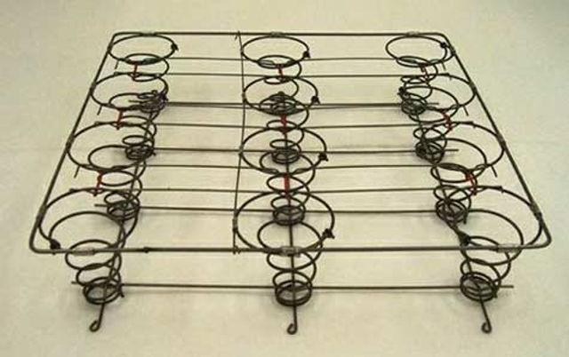
- Description: Coil springs, also known as helical springs, are widely utilised in the furniture upholstery industry. They are characterised by their cylindrical shape and are made from high-quality steel wire.
- Usage: Coil springs are often used in the seats and backs of sofas, armchairs, and other upholstered furniture pieces. They provide support, resilience, and durability to the seating area.
- Function: When a person sits or applies pressure to the upholstery, coil springs compress and then rebound, offering comfort and preventing sagging. They distribute weight evenly, ensuring a comfortable seating experience.
- Variations: Coil springs come in various types, including Bonnell springs and pocket springs. Bonnell springs are interconnected and provide consistent support. Pocket springs are individually encased in fabric pockets, offering tailored support and reducing motion transfer.
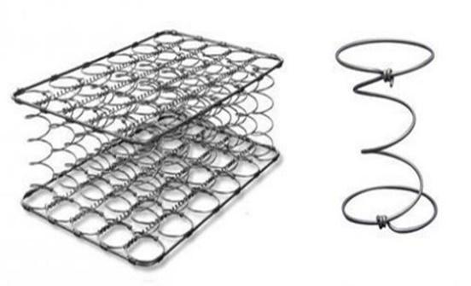

- Gauges: The gauge of coil springs varies, typically ranging from 9 to 14 gauge. The choice of gauge depends on factors such as the type of furniture, expected load-bearing capacity, and desired comfort level.

2. Zig-Zag Springs (Sinuous Springs):
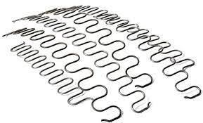
- Description: Zig-zag springs, also known as sinuous springs, are another essential component of furniture upholstery. They are characterised by their S-shaped or zig-zag pattern and are made from heavy-gauge steel wire.
- Usage: Zig-zag springs are commonly used for the seats and backs of upholstered furniture. They are particularly popular for their cost-effectiveness and ease of installation.
- Function: These springs provide firm support to the seating area. They are known for their durability and ability to prevent sagging over time. Zig-zag springs are typically installed in a serpentine pattern, creating a uniform and supportive base.
- Variations: Zig-zag springs can come in different gauges, typically ranging from 8 to 12 gauge. The choice of gauge depends on the specific furniture piece and the expected load it will bear.

In summary, both coil springs and zig-zag springs are indispensable in the furniture upholstery industry. They contribute to the comfort and longevity of upholstered furniture, with each type having its unique characteristics and applications. Understanding the nuances of these springs is crucial for upholsterers to create high-quality and comfortable furniture pieces that meet customer expectations.

KT0211 Types, sizes, quantity and quality of consumables including clips, nails, staples, edge rolls, twine and cord needed for the springing up process.

Knowledge Topic KT0211: Types, Sizes, Quantity, and Quality of Consumables for the Springing Up Process in Furniture Upholstery

In the furniture upholstery industry, understanding the types, sizes, quantity, and quality of consumables used in the springing up process is crucial for producing high-quality upholstered furniture. This knowledge topic will delve into the essential consumables, their metric measurements, and their importance in the upholstery process.

Types of Consumables:

1. Coil Springs:
- Diameter: Coil springs typically range from 2.5mm to 4mm.
- Quantity: The number of coil springs required depends on the size of the furniture piece and desired support.
- Quality: Ensure that coil springs are made of durable materials and have a consistent spring rate.

2. Webbing:
- Width: Webbing widths vary but commonly range from 25mm to 50mm.
- Quantity: Sufficient webbing is needed to create a strong foundation.
- Quality: High-quality webbing should be tightly woven and resistant to stretching.

3. Edge Rolls:
- Diameter: Edge rolls come in various diameters, typically ranging from 25mm to 50mm.
- Quantity: The quantity required depends on the piece's perimeter and desired cushioning.
- Quality: Quality edge rolls are firm and provide excellent shape retention.

4. Twine and Cord:
- Thickness: Twine and cord come in different thicknesses, usually measured in millimetres.
- Quantity: The amount needed depends on the intricacy of the upholstery design.
- Quality: Ensure that twine and cord are strong and resistant to fraying.

5. Staples, Clips, and Nails:
- Size: Staples, clips, and nails are available in various sizes, with metric measurements for length and width.
- Quantity: The quantity required varies based on the upholstery method and the size of the furniture piece.
- Quality: Use high-quality fasteners to ensure secure and long-lasting upholstery.

Importance of Consumables:

- Support: Coil springs and webbing provide the necessary support for seating areas, ensuring comfort and durability.
- Shape Retention: Edge rolls maintain the shape of cushions and prevent sagging over time.
- Detailing: Twine and cord are used for decorative detailing and finishing touches.
- Secure Fastening: Staples, clips, and nails secure fabric and other materials to the frame, ensuring a professional finish.

Conclusion:

Understanding the types, sizes, quantity, and quality of consumables for the springing up process is fundamental in the furniture upholstery industry. Using the right consumables in the correct measurements ensures the longevity, comfort, and aesthetic appeal of upholstered furniture. Upholsterers should carefully select and apply these consumables to achieve the desired quality in their work.

KT0212 Types of webbing needed for the knocker on process,
including manmade elastic and rubber webbing, and those made from natural fibres like jute webbing and hessian.
For KT0211, which covers the types, sizes, quantity, and quality of consumables needed for the springing up process in furniture upholstery, it is essential to understand the various materials and their appropriate use:

1. Clips:
- Type: Two main types are used - flexolator clips and serpentine spring clips.
- Size: Varies based on the spring system; usually, manufacturers specify the appropriate size.
- Quantity: Depends on the design and size of the furniture. Typically, several clips per spring are required.
- Quality: Durable metal, resistant to corrosion and capable of maintaining tension over time.

2. Nails:
- Type: Common types include decorative upholstery tacks and functional upholstery nails.
- Size: Ranges from small (for delicate work) to large (for securing heavier materials).
- Quantity: Varies with the project; used sparingly for aesthetic purposes or more liberally for structural stability.
- Quality: Should be rust-resistant and strong enough to hold materials without bending.

3. Staples:
- Type: Heavy-duty upholstery staples are most common.
- Size: Typically, 1/4" to 1/2" leg length, but varies based on the material thickness.
- Quantity: Used extensively; quantity depends on the project's size and the materials' nature.
- Quality: High-quality steel, resistant to bending and rusting.

4. Edge Rolls:
- Type: Usually made of foam, cotton, or Dacron.
- Size: Varies; chosen based on the edge's desired firmness and thickness.
- Quantity: Determined by the length of the edges to be covered.
- Quality: Should maintain shape and not compress excessively over time.

5. Twine and Cord:
- Type: Jute twine is commonly used; synthetic options are also available.
- Size: Thickness varies; thicker twine is used for heavier springs.
- Quantity: Dependent on the number of springs and the tying technique.
- Quality: Strong and durable, capable of holding tension without fraying or breaking.

It Is important for those involved in furniture upholstery to choose the right types of consumables for their specific project, as this can greatly affect the furniture's durability, comfort, and appearance.

KT0213 Labels, codes and the coding system and traceability.

Labels, codes, and coding systems play a crucial role in the furniture upholstery industry, facilitating traceability, quality control, and compliance with regulations.

1. Importance of Traceability: Traceability in the furniture upholstery industry is essential for several reasons. It ensures compliance with safety and quality standards, aids in managing recalls, and enhances customer trust. Traceability systems often rely on labels and codes to track the origin, production, and distribution of products [[4](https://www.firesafe.org.uk/furniture-and-furnishings-fire-safety-regulations-19881989-and-1993/)], [[6](https://www.grainandframe.com/care-guides/furniture-fire-regulations-furnishing-uk/)].

Traceability in the furniture upholstery industry is vital for multiple reasons:

1. Compliance with Regulations: Furniture manufacturers, importers, and retailers are required to maintain records such as invoices to ensure each item's traceability. This practice is essential for complying with various regulatory requirements. Keeping detailed records helps companies demonstrate compliance with safety, quality, and environmental standards [[1](https://www.businesscompanion.info/en/quick-guides/product-safety/new-upholstered-furniture)], [[2](https://www.deskera.com/blog/understanding-the-regulatory-requirements-for-furniture-manufacturing/)].

2. Quality Control and Safety: Traceability plays a significant role in quality control processes. It allows manufacturers to track the production journey of each item, ensuring that all materials and processes meet the required safety and durability standards. This is particularly crucial in the furniture industry, where product safety directly impacts consumer well-being [[2](https://www.deskera.com/blog/understanding-the-regulatory-requirements-for-furniture-manufacturing/)], [[3](https://www.deskera.com/blog/best-practices-for-furniture-manufacturing-quality-control/)].

3. Product Recalls and Consumer Trust: In cases of product recalls, traceability enables manufacturers to quickly identify and address faulty products. This rapid response is crucial for maintaining consumer trust and minimising potential harm from defective products [[3](https://www.deskera.com/blog/best-practices-for-furniture-manufacturing-quality-control/)].

4. Sustainability and Environmental Responsibility: Traceability also supports sustainability efforts. By tracing the origins of materials used in furniture, manufacturers can ensure that their products are environmentally friendly and sustainable. This aspect is increasingly important as consumers become more eco-conscious [[6](https://fibreguard.com/blog/fibreguard-perormance-fabrics-for-sustainable-furniture-manufacturers)].

In summary, traceability in the furniture upholstery industry is essential for ensuring regulatory compliance, maintaining high quality and safety standards, effectively managing product recalls, and upholding environmental responsibility.

2. Labels and Codes: Labels on upholstered furniture often contain information like manufacturer details, materials used, and production dates. Codes, especially barcodes or QR codes, are increasingly used to store detailed product information in a compact, easily accessible format. This shift from 1D to 2D codes, like QR codes, offers more data storage and better traceability options [[3](https://lp.rea-jet.com/en-un/2d-code-coding-marking-flatpack-furniture-industry)].

Labels and codes are essential tools in the furniture upholstery industry for conveying important information about products:

1. Standard Upholstery Cleaning Codes: Manufacturers use standardised upholstery cleaning codes to advise on the appropriate cleaning methods for different fabric types. These codes are crucial for maintaining the quality and longevity of furniture. They guide both consumers and professional cleaners on how to clean the upholstery without damaging it [[2](https://danggoodcarpetandfurnacecleaning.com/upholstery-cleaning-codes/)], [[4](https://rainbowrestores.com/blog/how-to-identify-cleaning-codes-on-furniture-and-upholstery)], [[6](https://www.plumbs.co.uk/articles/how-to/how-to-read-furniture-cleaning-codes)].

2. Location of Codes: Upholstery fabric codes are typically found on the underside of the main section of the furniture. These labels, akin to clothing labels, provide concise cleaning instructions, which are critical for both consumers and upholstery maintenance professionals [[6](https://www.plumbs.co.uk/articles/how-to/how-to-read-furniture-cleaning-codes)].

3. Importance in Quality Control: These codes and labels not only guide cleaning processes but also play a role in quality control. They ensure that furniture manufacturers comply with laws and regulations, maintaining safety and quality standards throughout the production process [[3](https://www.deskera.com/blog/understanding-the-regulatory-requirements-for-furniture-manufacturing/)].

In summary, labels and codes in the furniture upholstery industry provide essential information for the proper maintenance and care of the furniture, ensuring adherence to quality standards and regulatory requirements.

3. Coding Systems: Modern coding systems in the furniture upholstery industry may include technologies for marking and coding products efficiently. These systems can handle various materials and product shapes, ensuring that codes are legible and durable throughout the product's lifecycle. The adoption of advanced coding technologies helps in meeting the increasing demands for traceability and compliance with regulations [[1](https://controlprint.com/choosing-the-right-coding-solution-for-the-wood-and-furniture-manufacturing-industry-factors-to-consider-in-2023/)].
Coding systems in the furniture upholstery industry are integral for ensuring traceability, quality control, and regulatory compliance:

1. Enhancing Traceability and Quality Control: Advanced coding systems allow for the tracking of furniture products throughout their lifecycle. This traceability is crucial for maintaining quality control, as it enables manufacturers to trace the origin and history of their products, ensuring that all components meet safety and quality standards [[1](https://www.deskera.com/blog/best-practices-for-furniture-manufacturing-quality-control)], [[3](https://www.deskera.com/blog/understanding-the-regulatory-requirements-for-furniture-manufacturing/)], [[4](https://controlprint.com/choosing-the-right-coding-solution-for-the-wood-and-furniture-manufacturing-industry-factors-to-consider-in-2023/)].

2. Compliance with Regulations: Coding systems help manufacturers comply with various regulations. By accurately coding products, manufacturers can provide evidence of compliance with safety standards and environmental protections, which is especially important in light of increasing regulations in the furniture industry [[2](https://www.businesscompanion.info/en/quick-guides/product-safety/new-upholstered-furniture)], [[4](https://controlprint.com/choosing-the-right-coding-solution-for-the-wood-and-furniture-manufacturing-industry-factors-to-consider-in-2023/)].

3. Preventing Material Failures: Proper coding can also assist in preventing material failures. By tracking materials used in upholstery, such as fabric or foam, manufacturers can ensure that they are compliant and of high quality, reducing the risk of product failures [[6](https://www.fira-international.com/resources/testing-times-for-furniture-retailers)].

4. Supporting Environmental Claims: In the context of increasing focus on sustainability, coding systems can verify environmental claims, such as the use of recycled materials, by providing traceability and quality assurance for these materials, thereby preventing greenwashing [[5](https://www.fabraa.com/news/preventing-greenwashing-in-the-furniture-industry/)].

In summary, coding systems in the furniture upholstery industry are essential for maintaining product quality, ensuring regulatory compliance, preventing material failures, and supporting environmental sustainability.
4. Regulatory Compliance: Compliance with safety and fire regulations is a critical aspect of the furniture upholstery industry. Labels and codes are instrumental in demonstrating compliance with these regulations. Manufacturers, importers, and retailers are required to maintain records for all upholstered furniture items to ensure they meet the necessary standards [[4](https://www.firesafe.org.uk/furniture-and-furnishings-fire-safety-regulations-19881989-and-1993/)], [[6](https://www.grainandframe.com/care-guides/furniture-fire-regulations-furnishing-uk/)].

Regulatory compliance is a critical aspect of the furniture upholstery industry, encompassing various laws and standards to ensure safety, quality, and fair competition:

1. Compliance with Safety Standards: Upholstered furniture is subject to strict safety regulations, especially concerning flammability. These regulations are designed to ensure that products like beds, sofa beds, cots, and other upholstered items meet specific safety criteria to protect consumers from fire hazards and other risks [[4](https://www.businesscompanion.info/en/quick-guides/product-safety/new-upholstered-furniture)].

2. Quality and Durability Requirements: The furniture industry is governed by regulations that dictate the quality and durability of products. These standards are in place to guarantee that furniture items can withstand regular use without compromising safety or performance. Furniture testing services, such as those offered by SGS in South Africa, help manufacturers confirm their compliance with these quality and durability standards [[2](https://www.deskera.com/blog/understanding-the-regulatory-requirements-for-furniture-manufacturing)], [[3](https://www.sgs.com/en-sa/services/furniture-testing)].

3. Fair Competition and Labelling: Regulations also ensure fair competition within the industry. This includes requirements for accurate labelling and advertising, ensuring that consumers receive truthful information about the products they purchase. Such measures help maintain a level playing field among manufacturers and retailers [[6](https://www.deskera.com/blog/understanding-the-latest-regulations-for-furniture-manufacturing/)].

4. Comprehensive Regulatory Framework: The furniture industry is highly regulated, with laws and standards covering all aspects of operations, from material sourcing to final product sale. Compliance with these regulations is mandatory for manufacturers, importers, and retailers to operate legally and ethically in the market [[2](https://www.deskera.com/blog/understanding-the-regulatory-requirements-for-furniture-manufacturing/)].

In conclusion, regulatory compliance in the furniture upholstery industry is multifaceted, focusing on safety, quality, fair competition, and ethical business practices. Adherence to these regulations is crucial for the protection of consumers and the integrity of the industry.

KT0214 Principles and concepts of safe materials handling and storage methods.

The principles and concepts of safe materials handling and storage in the furniture upholstery industry are pivotal to maintaining workplace safety and efficiency:

1. Proper Storage of Materials: It is essential for furniture manufacturers to correctly store raw materials and waste. Proper storage helps in saving costs, reducing waste, and preventing workplace accidents. Materials must be stored in a way that they are easily accessible and do not pose a risk of falling or causing obstructions [[1](https://www.nibusinessinfo.co.uk/content/furniture-manufacturing-handling-and-storing-materials)].

Proper storage of materials in the furniture upholstery industry is crucial for maintaining the quality of products and ensuring workplace safety:

1. Optimising Storage Space: Efficient use of storage space is essential. Materials should be organised in a way that maximises space utilisation while ensuring easy access. This helps in reducing clutter and the risk of accidents in the workplace [[1](https://www.nibusinessinfo.co.uk/content/furniture-manufacturing-handling-and-storing-materials)].

2. Maintaining Material Quality: For upholstered items, specific storage conditions are required to preserve their quality. Thoroughly cleaning, vacuuming, and steam-cleaning upholstered pieces before storage is important. Fabric-specific spot or stain removers should be used as needed, and materials should always be completely dry before storage to prevent mould and mildew [[2](https://www.extraspace.com/blog/self-storage/protecting-furniture-in-storage/)].

3. Protection from Damage: When storing fabric and upholstery, it is important to ensure they are protected from potential damage. This includes safeguarding them from environmental factors such as humidity, sunlight, and pests. Covering fabrics and upholstery with appropriate materials can help maintain their condition over the long term [[3](https://www.spacecentreselfstorage.co.uk/the-ultimate-guide-to-storing-fabric-and-furniture/)].

4. Safety Compliance: Adhering to safety compliance guidelines is vital. Regular risk assessments should be conducted to identify, manage, and control hazards related to material storage, ensuring the safety of employees and the workplace [[4](https://www.makrosafe.co.sa/Wood-and-Upholstery-Industry)].

Implementing these practices in the storage of materials not only helps in maintaining the integrity and quality of the upholstery but also contributes to a safer and more efficient working environment.

2. Segregation of Dissimilar Materials: Different materials that could be hazardous when in contact with each other should be stored separately. This is crucial for preventing chemical reactions or fire hazards. Ergonomics should also be considered in material handling to minimise the risk of injuries [[2](https://www.safetyinfo.com/material-handling-and-storage-safety-index/)].

Segregation of dissimilar materials is a critical safety and quality control measure in the furniture upholstery industry:

1. Preventing Chemical Reactions: Certain materials can react dangerously when they come into contact with each other. Storing dissimilar materials apart, especially those that are chemically reactive, minimises the risk of hazardous reactions that could lead to fires or toxic fumes [[2](https://www.safetyinfo.com/material-handling-and-storage-safety-index/)].

2. Maintaining Material Integrity: Different types of upholstery fabrics and fillings, such as cotton, linen, wool, leather, and synthetic materials, have unique storage requirements. Segregating these materials prevents cross-contamination that could affect their quality and longevity [[1](https://revolutionfabrics.com/blogs/gotcha-covered/upholstery-fabric-types)], [[2](https://www.chelseacleaning.co.sa/blog/the-furniture-upholstery-fabric-guide/)].

3. Quality Control in Manufacturing: The manufacturing of upholstered furniture involves diverse materials like foams, textiles, and leather. Segregation ensures that the right materials are used in the correct applications, maintaining the overall quality of the finished product [[3](https://www.jowat.com/en/applications/furniture-industry/seating-and-upholstery-furniture/upholstery/)].

Implementing strict segregation practices for dissimilar materials is essential for ensuring safety, maintaining quality, and preventing material degradation in the furniture upholstery industry.

3. Safety in Material Handling: It is important to handle materials safely, especially when working at heights, like on ladders or step stools. Ensuring that materials are securely stored and handled correctly minimises the risk of accidents, such as being stuck between materials or injuries from falling objects [[3](https://advancedct.com/five-essential-steps-for-material-handling-safety/)].

Safety in material handling is paramount in the furniture upholstery industry to prevent workplace injuries and ensure operational efficiency:

1. Proper Use of Handling Equipment: Utilising conveyors, slides, or other devices for moving materials helps to minimise the need for manual lifting or pushing of objects. This reduces the risk of musculoskeletal injuries associated with heavy lifting [[2](https://advancedct.com/five-essential-steps-for-material-handling-safety/)].

2. Training and Utilisation of Equipment: Employees should be adequately trained in the proper utilisation of manual material handling equipment. Training ensures that workers know the safest ways to use equipment, which helps prevent accidents and injuries [[3](https://www.plantengineering.com/articles/10-tips-for-achieving-material-handling-safety/)].

3. Ergonomics in Lifting and Carrying: When lifting or carrying loads, it is important to keep them as close to the body as possible and avoid twisting movements. Proper lifting techniques, such as aligning the nose, shoulders, hips, and toes in the same direction, help in reducing the strain on the body [[4](https://ehs.unc.edu/topics/ergonomics/lifting-and-material-handling/)].

4. Awareness of Laceration and Puncture Hazards: Workers should be cautious of laceration and puncture hazards, particularly when packing or unpacking crates or boxes. This includes being mindful of protrusions like nails, screws, staples, or splintering wood [[5](https://weeklysafety.com/blog/material-handling)].

5. Consideration of Worksite Surroundings: Workers must be aware of their surroundings, especially in worksites with potential obstacles. Taking special precautions in such environments is crucial to prevent accidents related to material handling [[6](https://torcanlift.com/material-handling-equipment-safety-tips-for-safe-work/)].

Incorporating these safety practices in material handling not only protects workers but also contributes to a more efficient and productive work environment.

4. Integration of Material Movement and Storage: All material movement and storage activities should be integrated to form a coordinated operational system. This approach enhances efficiency and safety, ensuring that all procedures are streamlined and standardised [[4](https://www.safetyliftingear.com/news/post/principles-of-material-handling)].

Integration of material movement and storage is a fundamental aspect of ensuring efficiency and safety in the furniture upholstery industry:

1. Connected Systems and Processes: Integrated material handling systems connect various equipment and software to support all aspects of the production cycle, including receiving, processing, storage, picking, and shipping activities. This interconnectedness ensures a seamless flow of materials throughout the facility [[1](https://www.mhi.org/fundamentals/integrated-material-handling)], [[3](https://www.osequip.com/7-key-benefits-of-an-integrated-material-handling-system-2/)].

2. Enhancing Operational Efficiency: By integrating material handling and storage systems, operations become more efficient. It allows for better coordination of different stages of handling, from initial receipt of materials to their eventual use or shipment. This efficiency reduces waste, minimises delays, and optimises resource utilisation [[2](https://www.mhi.org/fundamentals/material-handling)], [[4](https://rebstorage.com/articles-white-papers/what-is-material-handling/)].

3. Improving Inventory Management: Integration also plays a critical role in effective inventory management. It helps in maintaining an accurate and real-time overview of material availability, location, and movement, which is essential for timely production and order fulfilment [[6](https://emergeapp.net/warehouse/warehouse-material-handling/)].

4. Facilitating Automated Solutions: In many modern facilities, material handling and storage integration includes the use of automated or semi-automated systems. These systems can significantly reduce manual labour, enhance accuracy, and improve overall safety in the workplace [[4](https://rebstorage.com/articles-white-papers/what-is-material-handling/)].

Integration of material movement and storage systems is thus key to achieving a streamlined, efficient, and safe operation in the furniture upholstery industry.

5. Utilisation of Material Handling Equipment: Different types of material handling equipment, such as storage and handling tools, bulk material machinery, industrial trucks, and engineered systems, should be used appropriately. Each type of equipment is designed for specific tasks and materials, and their proper use is essential for safe material handling [[5](https://modula.us/blog/what-is-material-handling-principles-benefits-equipment)].

Effective utilisation of material handling equipment is essential in the furniture upholstery industry for enhancing operational efficiency and safety:

1. Improving Handling and Capacity: The use of material handling equipment, such as conveyors, hoists, and automated systems, improves the handling of materials in furniture warehouses. This equipment enhances the capacity and efficiency of operations by simplifying the movement of bulky and heavy materials [[2](https://www.raymondcorp.com/information/industries-and-applications/furniture)], [[5](https://www.eotcranekit.com/industries/electric-overhead-cranes-and-hoists-for-furniture-manufacturing.html)].

2. Simplifying Factory Production: In factory production environments, material handling equipment plays a critical role in making work more efficient. It aids in the seamless transportation of materials from one point to another, reducing manual labour and the associated risks [[3](https://www.atlatt.com/product-category/furniture/material-handling-furniture/)].

3. Optimisation of Plant Layout and Processes: The strategic use of material handling equipment can lead to the optimisation of plant layout and materials handling systems. This optimisation contributes to smoother workflows and more efficient use of space and resources [[4](https://www.researchgate.net/publication/323848357_Optimisation_of_a_Plant_Layout_and_Materials_Handling_System_for_a_Furniture_Manufacturing_Company)].

Utilising the right material handling equipment is key to enhancing productivity, safety, and operational efficiency in the furniture upholstery industry.

6. Systematic and Scientific Approach: Material handling should be viewed as a systematic and scientific method involving moving, packing, and storing material in appropriate locations. The main objectives are to improve efficiency, reduce costs, and enhance safety [[6](https://www.managementstudyguide.com/material-handling.htm)].

A systematic and scientific approach in material handling within the furniture upholstery industry is crucial for ensuring efficiency, safety, and quality:

1. Structured and Organised Methodology: This approach involves a structured and organised methodology to handle materials. It includes careful planning, executing, and monitoring of all processes related to material handling, ensuring that every step is optimised for efficiency and safety [[1](https://openstax.org/books/introduction-political-science/pages/1-3-political-science-the-systematic-study-of-politics)].

2. Application of Scientific Methods: Scientific methods are applied to acquire, analyse, and interpret data related to material handling. This includes assessing the best ways to move, store, and manage materials, using evidence and research to guide decision-making [[4](https://www.ncbi.nlm.nih.gov/pmc/articles/PMC5491675/)].

3. Objective Establishment of Facts: Utilising the scientific method, facts about the best material handling practices are objectively established. This involves testing, experimentation, and continuous improvement to enhance the material handling processes [[5](https://www.techtarget.com/whatis/definition/scientific-method)].

4. Knowledge Acquisition and Application: The systematic and scientific approach aids in the acquisition of organised knowledge in material handling. This knowledge is then applied to improve various aspects of the workflow, including safety, efficiency, and resource utilisation [[6](https://courses.lumenlearning.com/suny-hccc-research-methods/chapter/chapter-1-science-and-scientific-research/)].

Adopting this approach in the furniture upholstery industry leads to more informed decisions, improved operational workflows, and a safer working environment.

These principles and practices ensure the safety, efficiency, and cost-effectiveness of material handling and storage in the furniture upholstery industry.

FORMATIVE ASSESSMENT

- IAC0201 The use of specifications and workplace instructions to determine the type, quality, sizes and quantities of raw materials and consumables for the frame preparation process is reasoned.
- IAC0202 Raw materials used in furniture making are listed and the characteristics of each are defined.
- IAC0203 Consumables used in covering processes, including gimps, piping, skirting, tack strips, decorative single, continuous and fake nails, needles, staples, tacks, twine, thread, metal tack strips, adhesive, staples and tacks are identified and the length / quantity are calculated.
- IAC0204 Typical defects and faults encountered when working with covering raw materials and consumables are described and the reporting and rectification process are analysed.
- IAC0205 Various types of frames and their raw materials and type of foundation materials to be used for each component are identified.
- IAC0206 Types and gauges of various springs needed for the knocker-on process are identified including coil springs and zig-zag springs.
- IAC0207 Types, sizes, quantity and quality of consumables such as clips, nails, staples, edge rolls, twine and cord needed for the springing up process are identified.
- IAC0208 Differences between the types of webbing needed for the knocker on process, such as manmade elastic and rubber webbing, and natural fibres like jute webbing are evaluated.
- IAC0209 Types, sizes, quantity and quality of consumables such as clips, tacks, and staples needed for the webbing up process are identified.
- IAC0210 Methods for identifying density and thickness of various types of foam required for the foaming up process are described.
- IAC0211 Consumables required for the foaming up process are listed.
- IAC0212 Raw materials required for the padding and covering of coil springs are listed.
- IAC0213 Fabrics used for covering webbing, springs, foam and padding including calico, hessian (burlap), polypropylene, Dacron, cambric and flock are listed.
- IAC0214 Principles and concepts of safe materials handling and storage methods are reasoned. (Weight 20%)

1. IAC0201: Create scenarios where learners must interpret specifications and workplace instructions to select appropriate materials for frame preparation. Assess their reasoning skills in choosing the correct type, quality, sizes, and quantities.

2. IAC0202: Ask learners to list and describe various raw materials used in furniture making, focusing on their unique characteristics.

3. IAC0203: Present a practical task where learners identify and calculate the length/quantity of consumables used in covering processes, ensuring they understand the application of each item.

4. IAC0204: Provide case studies or simulations of defects and faults in covering materials, asking learners to describe these and analyse the reporting and rectification processes.

5. IAC0205: Include an activity where learners identify different frame types, their raw materials, and corresponding foundation materials.

6. IAC0206: Have learners research and present on various springs used in the knocker-on process, identifying types and gauges.

7. IAC0207: Create practical tasks where learners identify the types, sizes, quantity, and quality of consumables needed for the springing up process.

8. IAC0208: Engage learners in a comparative analysis of different webbing types used in the knocker-on process.

9. IAC0209: Assess learners' ability to identify and quantify the consumables needed for the webbing up process.

10. IAC0210: Provide tasks that require learners to identify the density and thickness of various foams, emphasising the relevance to the foaming up process.

11. IAC0211: List consumables for the foaming up process and ask learners to elaborate on their uses.

12. IAC0212: Have learners list raw materials needed for padding and covering coil springs, focusing on material selection.

13. IAC0213: Task learners with listing and describing various fabrics used in covering different components.

14. IAC0214: Create scenarios or case studies where learners must apply principles of safe materials handling and storage, with a significant weighting to emphasize its importance.

Each task should be designed to provide feedback, enhancing the learning experience and ensuring that learners can apply these competencies in a practical setting.

SECTION: 3 KM-03-KT03: Use of chemicals: adhesives and solvents (10%)

Learning Outcome
At the end of this section, learners should cover:

- KT0301 Chemical types, characteristics, properties and purpose.
- KT0302 Adhesives and solvents, characteristics and uses, flammable and hazardous, safe handling and storage.
- KT0303 Application equipment, tools and dispensers.
- KT0304 Measuring and mixing techniques and procedures.
- KT0305 Preparation and application techniques.
- KT0306 Safety hazards and risks.

INTRODUCTION

Introduction to Knowledge Module KM-03-KT03: Use of Chemicals - Adhesives and Solvents

Knowledge Module KM-03-KT03 focuses on the critical area of utilising chemicals, specifically adhesives and solvents. This module is designed to provide learners with a comprehensive understanding of various aspects related to chemical use in industrial settings. The learning outcomes, outlined as knowledge topic elements, encompass a wide spectrum of information and skills essential for safe and effective chemical handling.

KT0301: Chemical types, characteristics, properties, and purpose
In this section, learners will delve into the world of chemicals, exploring their diverse types, unique characteristics, properties, and the purposes they serve in industrial applications. Understanding the fundamental nature of chemicals is crucial for their safe and effective utilisation.

KT0302: Adhesives and solvents, characteristics and uses, flammable and hasardous, safe handling, and storage
This knowledge topic delves deeper into adhesives and solvents, examining their specific characteristics, uses, and potential hazards. Learners will gain insights into identifying flammable and hazardous substances and will be equipped with essential knowledge on how to safely handle and store them.

KT0303: Application equipment, tools, and dispensers
In this section, learners will explore the equipment, tools, and dispensers used for the application of adhesives and solvents. Proficiency in selecting and using the right tools is vital for precise and efficient chemical application.

KT0304: Measuring and mixing techniques and procedures
Measuring and mixing chemicals accurately is a critical skill. This knowledge topic focuses on the techniques and procedures required to ensure precise measurements and effective mixing, guaranteeing optimal chemical performance.

KT0305: Preparation and application techniques
Learners will learn the techniques involved in preparing surfaces for chemical application and the methods for applying adhesives and solvents effectively. This knowledge is essential for achieving strong bonds and desired outcomes.

KT0306: Safety hazards and risks
Understanding safety hazards and risks associated with chemical use is paramount. This module will educate learners about potential dangers and provide guidance on mitigating risks to ensure a safe working environment.

In conclusion, Knowledge Module KM-03-KT03 equips learners with the knowledge and skills necessary for the responsible and safe use of adhesives and solvents in industrial settings. It lays the foundation for informed decision-making and competence in chemical handling.

KT0301 Chemical types, characteristics, properties and purpose.

In the furniture upholstery industry, understanding the various chemicals used in the process is essential for achieving high-quality results. Knowledge Topic Element KT0301 delves into the types, characteristics, properties, and purposes of chemicals relevant to this industry.

1. Chemical Types:
- Chemicals in the furniture upholstery industry encompass a range of types, including adhesives, solvents, and additives.
- Adhesives are crucial for bonding fabrics and materials, while solvents aid in cleaning and preparation.
- Additives can enhance fabric properties, such as flame resistance or stain repellency.

2. Characteristics:
- Adhesives may have varying levels of viscosity, curing time, and bonding strength.
- Solvents can be classified as organic or inorganic, with different solubility properties.
- Additives can possess characteristics like flame-retardant or antimicrobial properties.

3. Properties:
- Adhesives may exhibit properties like flexibility, heat resistance, and durability.
- Solvents' properties include volatility, evaporation rate, and compatibility with upholstery materials.
- Additives may have properties related to colour, texture, or performance enhancement.

4. Purpose:
- Adhesives serve the purpose of securely bonding upholstery fabrics to furniture frames or cushioning materials.
- Solvents are used for cleaning surfaces, removing old adhesives, and preparing materials for upholstery.
- Additives enhance the properties of upholstery materials, making them more suitable for specific applications.

Understanding these aspects of chemical types, characteristics, properties, and purpose is essential for professionals in the furniture upholstery industry. It enables them to select the right chemicals for each application, ensuring the durability and quality of upholstered furniture while adhering to safety standards and regulations.

KT0302 Adhesives and solvents, characteristics and uses, flammable and hazardous, safe handling and storage.

In the furniture upholstery industry, adhesives and solvents play a vital role in achieving strong bonds, preparing materials, and ensuring the overall quality of upholstered products. Understanding their characteristics, uses, flammable and hazardous properties, and safe handling and storage is crucial for professionals in this field.

1. Characteristics of Adhesives and Solvents:
- Adhesives come in various forms, including liquid, paste, or spray. They exhibit different bonding strengths, drying times, and flexibility.
- Solvents are substances used for dissolving, cleaning, or thinning. They can range from non-volatile to highly volatile, affecting their evaporation rates and effectiveness.

2. Uses in Furniture Upholstery:
- Adhesives are employed to bond upholstery fabrics to furniture frames, cushions, or foam, ensuring durability and aesthetics.
- Solvents are used for cleaning surfaces, removing old adhesives, and preparing materials for upholstery, creating a clean and adhesive-friendly surface.

3. Flammable and Hazardous Properties:
- Some adhesives and solvents can be highly flammable, posing a fire risk if not handled properly.
- Hazardous properties may include toxicity, harmful fumes, and environmental impact.

4. Safe Handling Practices:
- Professionals should wear appropriate personal protective equipment (PPE) such as gloves and eye protection when working with adhesives and solvents.
- Adequate ventilation is crucial to disperse fumes and reduce the risk of inhalation.

5. Storage Guidelines:
- Adhesives and solvents should be stored in well-ventilated areas away from heat sources, open flames, or sparks.
- Proper labelling and organisation help prevent mix-ups and ensure safe access.

Professionals in the furniture upholstery industry must prioritise safety, proper handling, and storage practices when dealing with adhesives and solvents. Mastery of these elements contributes to the production of high-quality upholstered furniture while minimising risks.

KT0303 Application equipment, tools and dispensers.

In the furniture upholstery industry, the selection and proficient use of application equipment, tools, and dispensers are crucial for achieving high-quality results. Knowledge Topic Element KT0303 delves into these essential aspects:

1. Application Equipment:
- Upholstery professionals utilise various application equipment, including upholstery guns, staple guns, and glue guns.
- Upholstery guns are used to apply staples and fasten upholstery fabric to furniture frames securely.
- Staple guns are employed for attaching fabric to wooden or metal frames, providing a strong hold.
- Glue guns are used to apply adhesives evenly and precisely, ensuring seamless bonding.

2. Tools for Upholstery:
- A range of specialised tools is employed in the upholstery process, such as upholstery needles, shears, and mallets.
- Upholstery needles aid in threading and sewing fabric and materials.
- Shears are used for cutting fabric to size and shape accurately.
- Mallets assist in securing upholstery components without damaging them.

3. Dispensers for Adhesives and Solvents:
- Dispensers play a crucial role in the controlled application of adhesives and solvents.
- These may include spray dispensers, nozzle applicators, and brushes designed for specific adhesive types.
- Properly selected dispensers ensure uniform and efficient application, reducing waste and improving quality.

4. Techniques and Proficiency:
- Professionals must be proficient in using these tools and equipment to ensure precision and efficiency in upholstery work.
- Understanding the correct techniques for each tool and dispenser is essential for achieving desired results.

5. Maintenance and Safety:
- Regular maintenance of tools and equipment is necessary to prolong their lifespan and ensure safety.
- Professionals should adhere to safety guidelines and wear appropriate personal protective equipment (PPE) when using tools and dispensers.

Mastery of application equipment, tools, and dispensers is fundamental for upholstery experts. It allows them to execute precise and efficient work, contributing to the production of high-quality upholstered furniture.

KT0304 Measuring and mixing techniques and procedures.

In the furniture upholstery industry, precise measuring and effective mixing of materials are critical for achieving high-quality results. Knowledge Topic Element KT0304 focuses on the techniques and procedures for accurate measurement and proper mixing:

1. Materials for Measurement and Mixing:
- Upholstery professionals work with various materials, including adhesives, solvents, foams, and fabrics.
- These materials have specific measurements and mixing requirements based on the type and application.

2. Measuring Techniques:
- Professionals should use appropriate measuring tools such as graduated containers, syringes, or scales.
- Measuring by volume or weight ensures accuracy in material proportions.

3. Mixing Procedures:
- Different materials may require various mixing methods. For example, some adhesives need thorough stirring, while others may require shaking or blending.
- Professionals must follow manufacturer guidelines for the correct mixing process.

4. Consistency and Uniformity:
- Achieving consistent and uniform mixtures is essential for the quality of upholstered products.
- Professionals should pay attention to texture, color, and viscosity to ensure uniformity.

5. Safety Precautions:
- Upholstery materials, especially adhesives and solvents, may contain hasardous components.
- Professionals should wear appropriate personal protective equipment (PPE) and work in well-ventilated areas to ensure safety.

6. Quality Control:
- Regularly inspecting mixed materials for any irregularities, such as lumps or separation, is essential to maintain product quality.
- Adjusting mixtures as needed to meet specific project requirements.

7. Documentation and Record-Keeping:
- Upholstery professionals should maintain records of measurements and mixing procedures to replicate successful outcomes and troubleshoot any issues.

Understanding and mastering these measuring and mixing techniques and procedures is crucial for furniture upholstery professionals. It ensures the consistency, durability, and aesthetic appeal of upholstered furniture while adhering to safety standards.

KT0305 Preparation and application techniques.

In the furniture upholstery industry, successful preparation and application techniques are vital to achieve high-quality results. Knowledge Topic Element KT0305 focuses on these essential aspects:

1. Preparation Phase:
- Surface Inspection: Before beginning any upholstery work, professionals should thoroughly inspect the furniture's surface. They should identify any damages, imperfections, or structural issues that need repair.

- Materials Selection: Choosing the right upholstery fabric and foam is crucial. Factors such as durability, aesthetics, and comfort should be considered.

- Stripping and Cleaning: Removing old upholstery, adhesives, and contaminants from the furniture frame is essential for a clean canvas. Proper cleaning ensures adhesion and prevents uneven surfaces.

2. Cutting and Pattern Matching:
- Precision Cutting: Accurate cutting of fabric and foam to match the furniture's shape is essential. Professionals should use appropriate tools to ensure clean edges and precise fit.

- Pattern Matching: When working with patterned fabrics, aligning patterns correctly is crucial to maintain visual consistency across the upholstery.

3. Application Techniques:
- Stretching and Stapling: Upholsterers should stretch the fabric tautly over the furniture frame and use staple guns to secure it. Proper stretching ensures a smooth and wrinkle-free appearance.

- Gluing and Bonding: Adhesive application techniques vary depending on the type of adhesive used. Proper bonding is essential for a secure and long-lasting upholstery job.

- Sewing and Tufting: For certain upholstery styles, sewing and tufting techniques are employed to create decorative patterns and seams. Mastery of these techniques is essential for customised designs.

4. Finishing Touches:
- Trimming and Seam Finishing: Trimming excess fabric and neatly finishing seams contribute to the final appearance. This step requires precision and attention to detail.

- Inspection and Quality Control: Upholsterers should thoroughly inspect the finished piece, ensuring it meets quality standards. Any necessary adjustments or corrections should be made.

5. Documentation and Record-Keeping:
- Upholstery professionals should maintain records of materials used, techniques applied, and any specific customer preferences. This information aids in future projects and ensures consistency.

Understanding and mastering these preparation and application techniques are essential for furniture upholstery professionals. It ensures the creation of durable, aesthetically pleasing, and comfortable upholstered furniture pieces.

KT0306 Safety hazards and risks

Knowledge Topic Element KT0306: Safety Hazards and Risks in the Furniture Upholstery Industry

Safety is paramount in the furniture upholstery industry, where various hazards and risks can affect workers' well-being. Understanding and mitigating these hazards is crucial for a safe working environment. KT0306 focuses on safety hazards and risks in this industry:

1. Manual Handling Hazards:
- Risk: Lifting and moving heavy furniture pieces can lead to musculoskeletal injuries.
- Prevention: Provide training in proper lifting techniques and use of lifting aids. Implement ergonomic workstations to reduce strain.

2. Hazardous Substances:
- Risk: Exposure to chemicals in adhesives, solvents, and upholstery materials can lead to health issues.
- Prevention: Use Personal Protective Equipment (PPE) such as gloves and masks. Ensure proper ventilation and provide training on safe chemical handling.

3. Machinery and Equipment:
- Risk: Improper use of upholstery machines and tools can result in accidents.
- Prevention: Conduct regular maintenance and inspections of equipment. Train workers on equipment safety protocols.

4. Sharp Objects and Tools:
- Risk: Mishandling of cutting tools and needles can lead to cuts and puncture injuries.
- Prevention: Encourage the use of safety knives and provide training on tool safety.

5. Fire Hazards:
- Risk: The use of flammable materials and chemicals poses a fire risk.
- Prevention: Maintain fire extinguishers and ensure workers are aware of fire evacuation procedures. Store flammable materials properly.

6. Electrical Hazards:
- Risk: Faulty wiring and electrical equipment can lead to electric shocks or fires.
- Prevention: Regularly inspect electrical systems and equipment. Train workers on electrical safety.

7. Noise Exposure:
- Risk: Prolonged exposure to noisy machinery can cause hearing damage.
- Prevention: Provide hearing protection and establish noise control measures where possible.

8. Dust and Particulate Matter:
- Risk: Dust generated during upholstery work can lead to respiratory issues.
- Prevention: Implement dust extraction systems and provide respiratory protection.

9. Ergonomic Risks:
- Risk: Poor ergonomics can lead to discomfort and long-term health issues.
- Prevention: Adjust workstations to promote ergonomic posture and provide ergonomic training.

10. Safety Training and Awareness:
- Risk: Lack of safety knowledge and awareness can contribute to accidents.
- Prevention: Conduct regular safety training sessions and encourage a culture of safety awareness among workers.

Understanding, identifying, and addressing these safety hazards and risks is crucial for creating a safe and productive environment in the furniture upholstery industry. Regular training, safety protocols, and risk assessments are essential components of a comprehensive safety strategy.

FORMATIVE ASSESSMENT

- IAC0301 The various types of chemicals used in upholstery processes are named.
- IAC0302 Characteristics and properties of the chemicals used in upholstery processes are described.
- IAC0303 The purpose of each of these chemicals used in the process is explained.
- IAC0304 Various types of solvents used in upholstery processes are listed.
- IAC0305 Characteristics and properties of these solvents are explained.
- IAC0306 The purpose of each solvent used in the process is explained.
- IAC0307 The application techniques and sequence used for chemicals and solvents are described.
- IAC0308 Safety procedures, hazards and risks associated with handling of chemicals and solvents are described.
- IAC0309 Standard operating procedures dealing with spillages, waste and effluent are explained.
- IAC0310 Types, usage and care of personal protective equipment used in textile wet product preparation processes are described.
.

SECTION: 4 KM-03-KT04: Upholstery tools and equipment (10%)

Learning Outcome
At the end of this section, learners should cover:

- KT0401 Upholstery hand tools for the furniture covering processes: operation, components and parts, uses, safe storage and handling.
- KT0402 Pneumatic tools, settings and operation of, components and parts, relationship between parts, uses, safe storage and handling, supply systems for the furniture covering processes.
- KT0403 Upholstery electric portable power tools for the furniture covering processes: settings and operation of, components and parts, uses, safe storage and handling.
- KT0404 Upholstery covering equipment.
- KT0405 Personal protective equipment and materials handling equipment.
- KT0406 Tools and equipment maintenance, fault finding and standard operating procedures.
- KT0407 Safety measures and mechanisms.

INTRODUCTION

In the realm of furniture upholstery, a comprehensive understanding of tools and equipment is crucial for both craftsmanship and safety. This introduction to Knowledge Topic KM-03-KT04 covers the essential aspects of upholstery tools and equipment, focusing on their operation, maintenance, and safety protocols.

1. KT0401 - Upholstery Hand Tools: These are the fundamental tools used in the furniture covering processes. Their operation involves a variety of manual tasks from cutting fabrics to fixing materials. The key components and parts include scissors, hammers, and staple removers, among others. Their uses range from fabric cutting to securing upholstery. Safe storage and handling of these tools are vital to prevent injuries and ensure their longevity.

2. KT0402 - Pneumatic Tools: These are powered by compressed air and are essential for more efficient and heavy-duty tasks in upholstery. Understanding their settings and operations, including how the parts interrelate, is critical. They are used for tasks like stapling and nailing with precision and strength. Safe storage, handling, and knowledge of the supply systems are crucial for safe and effective use.

3. KT0403 - Upholstery Electric Portable Power Tools: These tools bring speed and power to the upholstery process. Familiarity with their settings and operations, as well as their components, enhances efficiency in tasks like sanding and drilling. Proper usage, along with safe storage and handling, ensures both safety and tool integrity.

4. KT0404 - Upholstery Covering Equipment: This includes a range of equipment used in covering and finishing furniture. These tools ensure the upholstery fits perfectly and looks aesthetically pleasing.

5. KT0405 - Personal Protective Equipment and Materials Handling Equipment: The use of safety gear like gloves, goggles, and aprons is essential to protect from potential hazards. Materials handling equipment aids in the safe and efficient movement of furniture and materials.

6. KT0406 - Tools and Equipment Maintenance: Regular maintenance, including fault finding and adhering to standard operating procedures, is crucial for the longevity of the tools and the safety of the users.

7. KT0407 - Safety Measures and Mechanisms: Understanding and implementing safety measures and mechanisms is paramount. This includes knowledge of emergency procedures, correct tool usage, and workspace safety practices.

Each of these elements plays a vital role in the upholstery process, ensuring both the quality of the work and the safety of the artisans.

KT0401 Upholstery hand tools for the furniture covering processes:
(Operation, components and parts, uses, safe storage and handling).

1. Operation:
- Upholstery tools are used in the process of furniture covering, which involves adding padding, springs, webbing, and fabric or leather covers to furniture.
- The operation of these tools requires a combination of skill and precision, as they are used to cut, fasten, shape, and adjust various upholstery materials.

1. Understanding the Process:
- The operation of upholstery involves various stages such as stripping the old coverings and materials, preparing the frame, installing springs and padding, and finally, covering the furniture with new fabric or leather.
- Each stage requires specific tools and techniques to ensure quality and durability.

2. Skill and Technique:
- Upholstery is a skilled craft where precision and attention to detail are paramount.
- The operation of upholstery tools requires a steady hand and an understanding of the materials being worked with, as well as the end goal of the project.

3. Tool Specifics:
- Different tools are used for different aspects of the upholstery process. For example, webbing stretchers are used to tighten and secure the webbing, while staple guns are used to attach fabric to the frame.
- Understanding the specific use and operation of each tool is crucial to achieving a professional finish.

4. Material Considerations:
- Different types of fabrics and leathers may require different tools and techniques.
- It is important to understand the characteristics of the material being used, such as its thickness, stretchability, and resistance to wear and tear.

5. Safety and Efficiency:
- Upholstery work involves sharp tools and heavy materials, making safety a key concern. Proper handling and operation of tools can prevent injuries.
- Efficiency in using these tools not only saves time but also ensures a high-quality finish. For instance, using a correctly sized needle for sewing can prevent fabric damage.

In summary, the operation of upholstery hand tools in furniture covering processes is a blend of art and skill, requiring a deep understanding of the tools, materials, and techniques involved. Each tool has a specific role and needs to be used with precision and care to achieve the desired outcome while ensuring safety and efficiency.

2. Components and Parts:
- Common upholstery tools include hammers, staplers, scissors, tack pullers, and sewing needles.
- Each tool is made up of specific components like blades, handles, and gripping surfaces, which are designed for specific tasks in upholstery.

1. Hammer and Mallet:
- Components: The hammer typically has a metal head and a wooden or composite handle. Mallets may have a rubber, leather, or wooden head, designed to impart force without damaging the material.
- Parts: Head for striking, handle for grip.

2. Stapler and Tack Puller:
- Components: Staplers usually have a metal body with a spring-loaded mechanism for driving staples. Tack pullers often have a forked metal head and a wooden or plastic handle.
- Parts: Stapler has a magazine for staples, a trigger, and a driving blade. Tack puller has a prying end and a handle.

3. Scissors and Shears:
- Components: These are typically made from high-carbon steel for sharpness and durability, with handles often made from plastic or rubber for comfort.
- Parts: Blades for cutting, pivot point for opening and closing, handles for grip.

4. Sewing Needles:
- Components: Sewing needles are usually made of steel, with a pointed tip and an eye for the thread.
- Parts: Point, eye, and shaft.

5. Webbing Stretcher:
- Components: Usually consists of a wooden or metal handle and teeth or spikes at one end to grip the webbing.
- Parts: Handle for holding, teeth or spikes for gripping webbing.

6. Upholstery Nails and Tacks:
- Components: Made of metal, these small fasteners are used to secure fabric and other materials to furniture frames.
- Parts: Head for striking and a sharp point for penetration.

Each of these tools has specific components and parts designed for particular tasks in upholstery. Understanding these details is crucial for selecting the right tool for a given task and using it effectively.
3. Uses:
- Hammers and mallets are used for securing tacks and staples.
- Scissors and shears are essential for cutting fabrics and other materials.
- Staple guns and tack hammers are used for attaching fabric to the furniture frame.
- Sewing needles and thread are used for joining pieces of fabric or for decorative stitching.

1. Hammers and Mallets:
- Used for securing upholstery tacks and staples into the furniture frame.
- Essential for ensuring fabric and padding are tightly attached to the frame.

2. Scissors and Shears:
- Employed for cutting upholstery fabric, leather, and other materials to size.
- Precision cutting ensures a snug and accurate fit of the material on the furniture.

3. Staple Guns:
- Used to fasten fabric to the furniture frames quickly and efficiently.
- Ideal for attaching fabric in hard-to-reach areas or where stronger hold is required.

4. Tack Hammers:
- Specifically designed for driving small upholstery nails and tacks.
- Useful in decorative detailing and for securing fabric edges.

5. Sewing Needles and Thread:
- Used for hand-stitching sections of fabric together or for applying decorative stitches.
- Essential for repairing upholstery or joining fabric pieces where a sewing machine cannot be used.

6. Tack Pullers and Staple Removers:
- Employed to remove old staples and tacks during the reupholstering process.
- Essential for disassembling old upholstery before applying new materials.

7. Webbing Stretchers:
- Used to tighten and secure webbing (supportive fabric strips) on furniture frames.
- Crucial for maintaining the structural integrity and comfort of upholstered furniture.

These tools play vital roles in different stages of the upholstery process, from dismantling old materials to precisely attaching new fabric and finishing touches. Mastery of these tools and their uses is crucial for any successful upholstery project.

4. Safe Storage and Handling:
- Store sharp tools like scissors and needles in protective cases or holders.
- Keep staplers and hammers in dry, secure places to prevent rusting and degradation.
- Organise tools in a toolbox or a storage rack to avoid misplacement and to ensure easy access.
- Always handle tools with care, especially sharp ones, to prevent injuries.

1. Organised Tool Storage:
- Upholstery tools should be stored in an organised manner, preferably in a toolbox or a wall-mounted tool rack. This not only keeps the workspace tidy but also makes it easier to find the right tool when needed.

2. Protective Cases for Sharp Tools:
- Sharp tools like scissors, needles, and tack pullers should be stored in protective cases or sheaths. This prevents accidental injuries and also protects the tools from damage.

3. Dry, Secure Environment:
- Tools, especially those made of metal, should be kept in a dry environment to prevent rust and corrosion. Humidity can be detrimental to metal parts, leading to wear and inefficiency.

4. Regular Maintenance:
- Regular cleaning and maintenance of tools are essential. This includes sharpening cutting tools, oiling moving parts, and checking for any damage or wear.

5. Safe Handling Practices:
- When using upholstery tools, it is important to handle them safely. This includes using the correct grip, keeping hands away from sharp edges, and never leaving tools in a position where they could cause an accident.

6. Training and Familiarity:
- Anyone using upholstery tools should be properly trained in their use. Understanding the correct and safe way to use each tool is crucial to prevent accidents.

7. Personal Protective Equipment (PPE):
- Depending on the task, appropriate PPE such as gloves, eye protection, or hearing protection should be used to safeguard against potential hazards.

By following these guidelines for safe storage and handling, the lifespan of upholstery tools can be extended, and the risk of accidents significantly reduced.

# Key Tips:
- Always use the right tool for the specific task to ensure efficiency and safety.
- Regular maintenance of the tools, such as sharpening and cleaning, is crucial for their longevity and effectiveness.
- Personal protective equipment (PPE), like gloves and eye protection, should be used during upholstery work to prevent injuries.

KT0402 Pneumatic tools
(Settings and operation of, components and parts, relationship between parts, uses, safe storage and handling, supply systems for the furniture covering processes).
1. Introduction to Pneumatic Tools:
- Pneumatic tools are powered by compressed air. They are commonly used in various industrial and manufacturing processes, including furniture covering.
- Key components include an air compressor, air hoses, and the tool itself.

2. Settings and Operation:
- Settings: Adjust the air pressure according to the tool's specifications. Ensure all connections are secure.
- Operation: Understand the specific operational function of each tool. Use controls correctly to manage air flow and tool operation.

1. Adjusting Settings:
- Air Pressure: Essential to adjust the air pressure to match the tool's requirements. Incorrect pressure can lead to inefficient operation or damage to the tool.
- Regulators and Gauges: Use regulators to control air pressure and gauges to monitor it.
- Tool-Specific Settings: Some tools may have additional settings like speed or torque, which should be adjusted according to the task at hand.

2. Operating the Tools:
- Starting the Tool: Connect the tool to the air supply, ensure secure fittings, and then activate using the trigger or switch.
- Handling Techniques: Proper handling is crucial for safety and efficiency. Maintain a firm grip and be aware of the tool's power and recoil.
- Safety Precautions: Always wear appropriate personal protective equipment (PPE), such as goggles and gloves. Be aware of the surroundings to avoid accidents.

3. Maintenance during Operation:
- Lubrication: Some tools require in-line lubrication for smooth operation.
- Air Quality: Ensure the air is clean and dry to prevent internal damage to the tools.
- Leak Checks: Regularly check for leaks in hoses and connections, as these can affect tool performance.

4. Shutting Down:
- After use, turn off the air supply and disconnect the tool. Release any stored air pressure in the tool to ensure safety.

By carefully managing the settings and operation of pneumatic tools, users can ensure their safe, efficient, and effective use in various tasks.

3. Components and Parts:
- Air Compressor: Generates and supplies compressed air.
- Air Hoses: Transport air from the compressor to the tool.
- Tool Mechanism: Includes triggers, valves, and other operational parts.

1. Air Compressor:
- The heart of the pneumatic system, generating and supplying compressed air.
- Available in various types and capacities depending on the application.

2. Air Tank (Reservoir):
- Stores compressed air, providing a steady supply and smoothing out pressure fluctuations.
- Helps in managing the demand-supply balance of compressed air.

3. Air Filter:
- Removes contaminants from the air, such as dust and moisture, to protect the tools and improve efficiency.
- Essential for maintaining air quality and prolonging tool life.

4. Air Regulator:
- Controls the pressure of air delivered to the tools.
- Allows for adjustment of air flow to suit different tools and tasks.

5. Lubricator:
- Adds a regulated amount of oil into the air stream to lubricate the moving parts of pneumatic tools.
- Reduces wear and tear, extending the life of the tools.

6. Actuator:
- The component that converts compressed air into mechanical motion.
- Includes cylinders, motors, and other devices that perform work.

7. Valves and Controls:
- Regulate the flow and direction of air within the system.
- Include control valves, directional valves, and flow controls.

8. Piping and Hoses:
- Transport compressed air from the compressor and tank to the tools.
- Must be durable and correctly sized to handle the pressure and volume of air.

These components work together to form a complete pneumatic system, each playing a crucial role in ensuring efficient and effective operation of the pneumatic tools.

4. Relationship Between Parts:
- Each component works in harmony. The compressor generates air, the hoses transport it, and the tool uses the air to function effectively.

1. Air Compressor and Air Generation:
- The air compressor is the primary source of power in a pneumatic system.
- It compresses atmospheric air to a higher pressure, making it usable for tools and machinery.

2. Hoses and Air Transportation:
- Pneumatic hoses act as conduits, transporting the compressed air from the compressor to the tools.
- They need to be robust and flexible to handle high-pressure air and the physical demands of a workplace.

3. Tools and Air Utilisation:
- Pneumatic tools are specifically designed to use the compressed air for their operation.
- The tools convert the energy of compressed air into mechanical work, such as drilling, hammering, or cutting.

4. Regulators and Pressure Control:
- Regulators are crucial for controlling the pressure of air delivered to tools.
- They ensure that each tool receives the appropriate air pressure for its optimal operation.

5. Fittings and Connections:
- Fittings and connectors are used to join various parts of the system, ensuring a secure and leak-free path for air.
- They play a vital role in maintaining the integrity and efficiency of the pneumatic system.

6. Seamless Integration for Effective Operation:
- Every component, from the compressor to the fittings, needs to work in harmony.
- This integrated approach ensures that the system operates efficiently and safely, with each part playing its role in the overall functionality.

Understanding the relationship and interdependence of these components is key to maintaining an effective and reliable pneumatic system.

5. Uses in Furniture Covering Processes:
- Pneumatic tools are used for tasks like stapling, nailing, and applying adhesives in furniture upholstery.

1. Stapling:
- Pneumatic staplers are commonly used for fastening fabric and other materials to furniture frames.
- They provide a quick, reliable, and consistent means of attaching materials, ensuring a tight and secure fit.

2. Nailing:
- Pneumatic nail guns are utilised for assembling wooden frames and attaching components.
- They offer high precision and speed, significantly reducing the time taken for manual nailing.

3. Applying Adhesives:
- Pneumatic adhesive guns enable the controlled application of glues and adhesives.
- This is particularly useful in attaching foam padding, fabric layers, or decorative elements to furniture.

4. Fabric Cutting and Trimming:
- Pneumatic cutting tools assist in accurately cutting fabrics and other upholstery materials.
- These tools allow for clean, precise cuts, which are essential for a neat finish.

5. Sanding and Finishing:
- Pneumatic sanders are used for smoothing and preparing wooden surfaces for finishing.
- They ensure an even and smooth surface, which is crucial for the overall aesthetic and comfort of the furniture.

6. Painting and Polishing:
- Pneumatic paint sprayers and polishers are employed for applying finishes to furniture.
- They provide a uniform coat, enhancing the appearance and durability of the furniture.

In summary, pneumatic tools play a vital role in various stages of furniture upholstery, from construction to finishing, enhancing efficiency, precision, and quality of the final product.

6. Safe Storage and Handling:
- Storage: Store tools in a dry, clean environment. Disconnect from air supply.
- Handling: Use proper personal protective equipment (PPE). Be aware of the tool's kickback and handle it with care.

1. Storage:
- Environment: Store in a dry, clean environment to prevent rust and deterioration.
- Disconnecting Air Supply: Always disconnect tools from the air supply to prevent accidental operation.
- Organised Storage: Arrange tools in a manner that prevents damage and makes them easily accessible for the next use.
- Temperature Control: Avoid extreme temperatures which can damage the tools.

2. Handling:
- Personal Protective Equipment (PPE): Use safety glasses, gloves, and hearing protection as required.
- Awareness of Kickback: Understand the potential kickback of each tool and handle accordingly to maintain control.
- Regular Inspection: Inspect tools for wear and tear before each use. Check hoses, connectors, and fittings for leaks or damage.
- Proper Operation: Follow the manufacturer's guidelines for safe operation. Never modify tools or remove safety devices.

3. Maintenance:
- Cleaning: Regularly clean tools to remove dust, debris, and any contaminants.
- Lubrication: Lubricate moving parts as recommended to ensure smooth operation.
- Repair and Replace: Promptly repair or replace damaged parts to maintain safety and efficiency.

By adhering to these storage and handling practices, the life span of pneumatic tools can be extended, and workplace safety can be significantly improved.

7. Supply Systems:
- Ensure the supply system can deliver consistent air pressure and flow. Regularly check for leaks or damages in hoses and connections.

# Conclusion
- Understanding each aspect of pneumatic tools, from their components to their safe operation and storage, is crucial for efficient and safe use in furniture covering processes.

KT0403 Upholstery electric portable power tools for the furniture covering processes: settings and operation of, components and parts, uses, safe storage and handling.

Upholstery electric portable power tools are essential in the furniture covering processes. Here's an overview focusing on settings and operation, components and parts, uses, as well as safe storage and handling:

1. Settings and Operation
- Speed Settings: Most tools come with variable speed settings to suit different materials and tasks.
- Power Adjustment: Adjust the power output to match the task at hand, preventing damage to both the tool and the material.
- Safety Features: Familiarise with safety switches, emergency stop buttons, and lock-off triggers.

2. Components and Parts
- Motor: The primary source of power for the tool.
- Blades or Bits: Changeable parts used for cutting, drilling, or shaping.
- Handles and Grips: Ergonomically designed for comfort and to reduce fatigue.
- Batteries or Power Cords: Depending on whether the tool is cordless or corded.

3. Uses
- Cutting and Shaping: For cutting fabrics, foam, and other materials.
- Stapling and Nailing: Essential for attaching fabric to frames.
- Sanding: For smoothing surfaces before covering.

4. Safe Storage and Handling
- Storage: Keep tools in a dry, secure place to prevent damage and unauthorised use.
- Handling: Always use the correct grip and body positioning.
- Maintenance: Regularly check and maintain tools to ensure they are in good working order.

5. Safety Precautions
- Personal Protective Equipment (PPE): Wear appropriate PPE like gloves, safety glasses, and hearing protection.
- Work Area: Keep the area clean and free of obstructions.
- Inspection: Routinely inspect tools for wear and tear.

Remember, proper training and adherence to the manufacturer's guidelines are crucial for safe and efficient use of upholstery electric portable power tools.

KT0404 Upholstery covering equipment.

Upholstery covering equipment is vital in the furniture making and refurbishing process. The following points outline the key aspects of this equipment:

1. Types of Equipment:
- Staple Guns: Used for attaching fabric to furniture frames. They come in various types, including manual, electric, and pneumatic.
- Sewing Machines: Essential for joining fabric pieces, available in standard and heavy-duty models for thicker fabrics.
- Foam Cutters: Used to cut and shape foam for cushions and padding.

🗒️ Answer
Expanding on the types of upholstery equipment:

1. Staple Guns:
- Manual Staple Guns: Operate by hand pressure, suitable for light-duty tasks. They require more physical effort but are cost-effective and portable.
- Electric Staple Guns: Require an electrical power source. They offer more power and consistency in stapling, ideal for medium to heavy-duty tasks.
- Pneumatic Staple Guns: Use compressed air for operation. They provide the highest level of power and efficiency, best suited for professional and heavy-duty upholstery work.
- Applications: Commonly used for securing fabric and other materials to furniture frames. They offer quick and reliable fastening.

2. Sewing Machines:
- Standard Sewing Machines: Suitable for general fabric sewing, lighter upholstery work, and domestic use.
- Heavy-Duty Sewing Machines: Designed to handle thicker fabrics and multiple layers, often used in commercial upholstery. They have stronger motors and more durable components.
- Features: Include variable stitch lengths, heavy-duty frames, and attachments for different types of stitches.
- Applications: Used for creating seams, hems, and decorative stitching on upholstery fabrics.

3. Foam Cutters:
- Types: Include hand-held saws, electric carving knives, and industrial-grade cutting machines.
- Electric Foam Cutters: Provide precise cuts and are ideal for shaping and sising foam cushions.
- Safety: It is crucial to use appropriate safety gear as foam can produce fine dust particles during cutting.
- Applications: Essential for customising foam padding to fit specific furniture shapes and sizes, ensuring comfort and durability in upholstered furniture.

These tools are indispensable in the upholstery process, each serving a specific function to achieve a professional finish in furniture covering.

2. Features and Functions:
- Adjustability: Equipment often features adjustments for handling different thicknesses and types of materials.
- Precision: High precision in cutting and sewing ensures a neat and professional finish.
- Durability: These tools are designed for heavy use and longevity.

1. Adjustability:
- Material Thickness Handling: Tools are designed with adjustable settings to handle various material thicknesses, from delicate fabrics to thick leathers.
- Application Versatility: This feature allows for the customisation of the equipment for different tasks, such as adjusting tension in sewing machines or the depth of staple penetration in staple guns.
- User Comfort: Ergonomic adjustments, like handle position or tool height, can be tailored for individual comfort, reducing fatigue during prolonged use.

2. Precision:
- Accurate Cutting and Sewing: Tools like foam cutters and sewing machines offer precise controls for clean, straight cuts and even stitches, essential for high-quality upholstery work.
- Fine-tuning Mechanisms: Equipment often includes fine-tuning options, such as stitch length adjustments on sewing machines, to ensure precision in detailed work.
- Consistent Results: High precision tools contribute to consistent quality in finished products, a crucial aspect for professional upholstery businesses.

3. Durability:
- Heavy-Duty Construction: Upholstery tools are built with robust materials to withstand the rigors of continuous use in both domestic and commercial settings.
- Longevity: Durable tools reduce the need for frequent replacements, offering long-term cost savings.
- Maintenance and Repair: Durability is also supported by the availability of maintenance and repair options, ensuring that tools can be kept in optimal working condition over time.

These features and functions of upholstery equipment play a critical role in the efficiency, quality, and sustainability of upholstery work.

3. Safety Equipment:
- Protective Gloves: To safeguard against cuts and abrasions.
- Safety Glasses: Essential when using staple guns or cutting tools to protect eyes from debris.
- Hearing Protection: Recommended when using loud power tools.

1. Protective Gloves:
- Function: Designed to protect hands from cuts and abrasions, especially when handling sharp tools like scissors, knives, or when working with rough materials.
- Types: Range from lightweight, flexible gloves for general handling to more robust, cut-resistant gloves for high-risk tasks.
- Material: Often made from materials like leather, Kevlar, or nitrile to provide both dexterity and protection.

2. Safety Glasses:
- Function: Protect eyes from flying debris, particularly when using power tools like staple guns or cutting equipment.
- Types: Includes safety goggles that fit snugly around the eyes and safety spectacles with side shields.
- Features: Should be anti-fog, scratch-resistant, and may offer UV protection. Some are designed to fit over prescription glasses.

3. Hearing Protection:
- Necessity: Essential when operating loud power tools like pneumatic staple guns or industrial sewing machines, which can exceed safe sound levels.
- Types: Earplugs and earmuffs are the most common. Earplugs are inserted in the ear canal, while earmuffs fit over the entire outer ear.
- Selection: Choose based on the noise reduction rating (NRR), comfort, and suitability for the specific upholstery environment.

The use of appropriate safety equipment minimises the risk of injury, ensuring a safer working environment in upholstery tasks.

4. Maintenance:
- Regular Cleaning: Essential to keep equipment in good working order.
- Lubrication: Necessary for moving parts to ensure smooth operation.
- Blade and Bit Replacement: To maintain efficiency and precision.

1. Regular Cleaning:
- Importance: Prevents build-up of dust, fabric fibres, and debris which can impair the function and longevity of the tools.
- Procedure: Use a soft brush or cloth to clean the surfaces and accessible parts. For detailed cleaning, use compressed air or a vacuum cleaner with a brush attachment.
- Frequency: Ideally, tools should be cleaned after each use to maintain their optimal condition【5†source】【6†source】.

2. Lubrication:
- Purpose: Reduces friction in moving parts, preventing wear and tear. Ensures smooth operation of mechanisms like sewing machine gears and scissors.
- Types of Lubricants: Use the specific lubricants recommended by the tool's manufacturer. Common types include machine oil for sewing machines and silicone spray for pneumatic tools.
- Frequency: Depending on the usage, lubrication should be done regularly, such as monthly, or as per the manufacturer’s guidelines【2†source】.

3. Blade and Bit Replacement:
- Need for Replacement: Dull blades and bits lead to imprecise cuts and can damage the material. Sharp tools are essential for accuracy and ease of use.
- Signs of Wear: Look for signs like rough cuts, difficulty in cutting, or extra force needed to operate the tool.
- Process: Follow the manufacturer’s instructions for safe replacement of blades and bits. Always use the correct type and size of blade or bit for your specific tool【2†source】.

Regular maintenance is crucial for the efficiency, safety, and longevity of upholstery equipment.

5. Skill Development:
- Proper Training: Essential for safe and effective use of upholstery covering equipment.
- Practice: Regular practice helps in developing the skill to use these tools proficiently.

1. Proper Training:
- Importance: Training provides the foundational knowledge and techniques required for using upholstery equipment safely and effectively. It ensures understanding of the tools' capabilities and limitations.
- Types of Training: Can range from formal apprenticeships and courses at technical schools to online tutorials and workshops【1†source】【3†source】.
- Areas Covered: Training typically includes techniques for fabric cutting, pattern making, sewing, and the use of various upholstery tools.

2. Practice:
- Role in Skill Enhancement: Regular practice is crucial for honing the skills learned during training. It allows for the refinement of techniques and the development of a deeper understanding of the materials and tools.
- Methods: Practicing on different types of projects, from simple seat covers to more complex upholstered furniture, helps in building a diverse skill set.
- Continuous Learning: Upholstery is a field where trends and techniques evolve, so ongoing practice and learning are important for staying updated and improving craftsmanship.

In summary, the combination of proper training and regular practice is key to mastering the art of upholstery, ensuring both the safe use of equipment and the achievement of high-quality results.

Upholstery covering equipment plays a critical role in achieving the desired quality and finish in furniture making and restoration.

KT0405 Personal protective equipment and materials handling equipment.
For the learner guide KT0405 focusing on Personal Protective Equipment (PPE) and Materials Handling Equipment in the furniture upholstery industry, the following content can be included:
1. Introduction to Personal Protective Equipment (PPE) in Upholstery
- Overview of PPE and its importance in the furniture upholstery industry.
- Types of PPE commonly used in upholstery: gloves, safety glasses, ear protection, masks, and aprons.
- The role of PPE in preventing workplace injuries.

2. Understanding Different Types of PPE
- Gloves: Different types (leather, cut-resistant, etc.) and their uses in handling different materials.
- Safety Glasses: Importance of eye protection from dust, flying particles, and chemical splashes.
- Ear Protection: Types of ear protection (earplugs, earmuffs) used to safeguard against machinery noise.
- Masks and Respirators: Protecting against dust, fumes, and chemical vapours.
- Aprons and Protective Clothing: Types of protective clothing to shield against spills and cuts.

3. Materials Handling Equipment in Upholstery
- Overview of equipment used for lifting, moving, and storing materials in upholstery workshops.
- Types of equipment: trolleys, hand trucks, pallet jacks, and storage racks.
- Safe handling practices to prevent injuries and damage to materials.

4. Safety Standards and Compliance
- Overview of safety standards relevant to PPE and material handling in the upholstery industry.
- The importance of adhering to industry-specific regulations and guidelines.
- Regular maintenance and inspection of PPE and handling equipment.

5. Training and Proper Use of PPE and Handling Equipment
- Importance of training in the correct use of PPE and handling equipment.
- Procedures for correctly fitting, wearing, and maintaining PPE.
- Training resources and methods for effective learning.

6. Emergency Procedures and First Aid
- Basic first aid procedures relevant to the upholstery industry.
- Steps to take in case of an accident involving handling equipment or PPE failure.
- Emergency contacts and procedures.

7. Regular Review and Update of Safety Practices
- Importance of staying updated with new safety practices and equipment.
- Regular review of safety procedures and PPE standards.
- Encouraging a culture of safety and continuous learning in the workplace.

This guide should be designed to be accessible and engaging for learners, incorporating visuals and practical examples where possible. Regular updates and reviews of the content are recommended to ensure relevance and compliance with the latest safety standards in the industry.

KT0406 Tools and equipment maintenance, fault finding and standard operating procedures.

For the learner guide KT0406 focusing on Tools and Equipment Maintenance, Fault Finding, and Standard Operating Procedures in the furniture upholstery industry, the following content can be outlined:

1. Overview of Tools and Equipment Maintenance
- The importance of regular maintenance for tools and equipment in upholstery to ensure safety and efficiency【5†source】.
- Types of maintenance: preventative, predictive, and corrective【5†source】.

Expanding on the overview of tools and equipment maintenance, particularly in the context of the furniture upholstery industry:

1. Definition and Importance
- Equipment maintenance management is a structured process that includes planning, organising, and carrying out maintenance activities to ensure tools and equipment are in optimal working order【1†source】.
- Regular maintenance is crucial to extend the lifespan of tools, maintain their efficiency, and ensure safety in the workplace.

2. Types of Maintenance
- Preventive Maintenance: This involves regular, scheduled maintenance to prevent breakdowns and prolong the life of equipment【6†source】.
- Corrective Maintenance: This type of maintenance occurs when equipment breaks down or malfunctions, requiring immediate repair to return to functionality【5†source】.

3. Maintenance Processes
- Inspection: Regularly inspecting tools to identify wear and tear or potential issues that could lead to breakdowns【2†source】.
- Cleaning: Keeping tools clean to prevent build-up of materials that could hinder their performance.
- Lubrication: Proper lubrication of moving parts to reduce friction and wear.
- Adjustment: Making necessary adjustments to ensure tools are operating as intended.

4. Documentation and Record Keeping
- Maintaining detailed records of maintenance activities, including dates of maintenance, nature of work done, and any parts replaced. This helps in tracking the performance and maintenance needs of equipment.

5. Training and Compliance
- Ensuring that staff are properly trained in maintenance procedures and understand the importance of regular maintenance.
- Complying with industry standards and safety regulations regarding equipment maintenance.

By focusing on these key aspects of tools and equipment maintenance, businesses in the furniture upholstery industry can significantly reduce downtime, improve efficiency, and ensure a safer working environment.

2. Routine Maintenance Procedures
- Step-by-step guide for routine maintenance checks on common upholstery tools and equipment.
- Scheduling maintenance activities to minimise disruption in operations.

Routine maintenance procedures in the furniture upholstery industry are essential to ensure the longevity and quality of upholstered furniture pieces. Upholstered furniture, such as sofas, chairs, and cushions, requires specific care to preserve its appearance and functionality. Here are key points for routine maintenance procedures in the furniture upholstery industry:

1. Regular Cleaning: Routine maintenance begins with regular cleaning. Dust and dirt can accumulate on upholstered surfaces, leading to wear and tear over time. Use a vacuum cleaner with an upholstery attachment to remove dust and debris from the fabric regularly [[1](https://www.globalinspirationsdesign.com/care-maintenance-furniture/)].

2. Stain Prevention and Treatment: Accidents can happen, and spills are a common occurrence. To maintain upholstered furniture, it is crucial to attend to stains and spills immediately. Use a damp cloth or a suitable upholstery cleaner to blot and treat stains. Always follow the manufacturer's recommendations for stain removal [[3](https://cityfurnish.com/blog/upholstered-furniture-care-tips)][4](https://digitalcommons.unl.edu/cgi/viewcontent.cgi?article=5607&context=extensionhist)].

3. Sunlight Exposure: Avoid placing upholstered furniture in direct sunlight. Prolonged exposure to UV rays can fade and damage the fabric over time. Position your furniture in a location where it is shielded from harsh sunlight or use curtains and blinds to block direct sunlight [[5](https://www.alanhendersonupholstery.co.uk/tips-for-maintaining-upholstered-furniture/)].

4. Regular Maintenance and Inspection: Periodically inspect your upholstered furniture for any loose seams, buttons, or structural issues. Addressing these problems promptly can prevent them from worsening and extend the lifespan of the furniture [[6](https://www.linkedin.com/pulse/office-furniture-care-maintenance-comprehensive-guide-initfurniture)].

5. Professional Cleaning: Consider professional upholstery cleaning services, especially for deep cleaning. Professionals have the expertise and equipment to remove deep-seated dirt and stains while preserving the fabric's integrity.

6. Choosing the Right Fabric: When purchasing upholstered furniture, select fabrics that are durable and suitable for your lifestyle. Some fabrics are more stain-resistant and easier to maintain than others. Making an informed choice at the outset can simplify routine maintenance.

In summary, routine maintenance procedures for the furniture upholstery industry involve regular cleaning, prompt stain treatment, protection from sunlight, periodic inspections, and considering professional cleaning when necessary. These practices help keep upholstered furniture in excellent condition, ensuring both its aesthetic appeal and functionality are preserved.
3. Fault Finding in Tools and Equipment
- Techniques for identifying common faults in upholstery tools and equipment.
- Use of diagnostic tools and methods to quickly and accurately locate problems.

Fault finding in tools and equipment is a crucial aspect of maintaining operational efficiency and safety in the furniture upholstery industry. Detecting and addressing issues promptly ensures that the upholstery process runs smoothly and minimises downtime. Here are key points related to fault finding in tools and equipment within the furniture upholstery industry:

1. Regular Inspection: Upholstery professionals should routinely inspect their tools and equipment before and after each use. This includes checking for loose parts, damaged components, and signs of wear and tear. Identifying issues early prevents potential accidents and ensures that tools function optimally [[4](https://www.cobanibleu.com/top-five-upholstery-tips-beginners)].

2. Testing Functionality: Upholstery tools such as staplers, sewing machines, and fabric cutters need to be tested for functionality. This involves running the equipment without material to check if it operates smoothly, stitches properly, or cuts cleanly. Any irregularities should be addressed immediately to avoid disruptions during work [[6](https://www.dtwd.wa.gov.au/sites/default/files/teachingproducts/BC2015_CCBY.PDF)].

3. Cleaning and Maintenance: Regular cleaning is essential for many upholstery tools and equipment. Dust and debris can accumulate, affecting performance. Proper cleaning and lubrication of moving parts can prevent breakdowns and extend the lifespan of tools [[5](https://www.ncbi.nlm.nih.gov/pmc/articles/PMC2975114/)].

4. Troubleshooting: Upholstery professionals should have troubleshooting skills to diagnose and rectify common equipment problems. This may involve identifying electrical issues, changing worn-out parts, or adjusting settings to achieve the desired results. Training and knowledge of equipment functionality are essential for effective fault finding [[6](https://www.dtwd.wa.gov.au/sites/default/files/teachingproducts/BC2015_CCBY.PDF)].

5. Safety Measures: Fault finding also includes ensuring that safety features on equipment are functional. This includes emergency stops, safety guards, and protective measures to prevent accidents or injuries during operation.

6. Documentation: Maintaining records of equipment inspections, repairs, and maintenance is valuable for tracking the history of each tool. It helps in planning for replacement or upgrades and ensures accountability for equipment care.

In summary, fault finding in tools and equipment for the furniture upholstery industry involves regular inspection, functionality testing, cleaning, troubleshooting, safety checks, and documentation. By adopting a proactive approach to fault finding, upholstery professionals can maintain a safe and efficient working environment while delivering high-quality upholstered furniture.
4. Standard Operating Procedures (SOPs) for Maintenance
- Developing and implementing SOPs for maintaining upholstery tools and equipment【2†source】.
- The role of SOPs in ensuring consistent and safe maintenance practices.

Standard Operating Procedures (SOPs) for maintenance are essential in the furniture upholstery industry to ensure the proper care and upkeep of tools, equipment, and facilities. These procedures help maintain a safe and efficient working environment. Here are key aspects of SOPs for maintenance in the furniture upholstery industry:

1. Equipment Inspection: SOPs should include guidelines for regularly inspecting tools and equipment used in upholstery work. This involves checking for wear and tear, loose parts, and signs of damage. Inspections help identify potential issues before they escalate, reducing downtime and ensuring safety.

2. Cleaning and Lubrication: Maintenance SOPs should detail cleaning procedures for tools and equipment. Proper cleaning and lubrication prevent dust buildup, corrosion, and ensure smooth operation. Upholstery professionals should know how to clean and maintain their tools effectively.

3. Routine Maintenance Schedule: SOPs should establish a routine maintenance schedule, specifying when different equipment and tools need servicing. This schedule ensures that maintenance tasks are not overlooked and that equipment remains in optimal working condition.

4. Troubleshooting: SOPs should include troubleshooting steps for common equipment issues. Upholstery professionals should be trained to diagnose problems, identify potential solutions, and perform minor repairs. This can help minimise downtime and reduce repair costs.

5. Safety Procedures: Safety is paramount in the upholstery industry. SOPs should outline safety protocols when conducting maintenance activities. This includes proper shutdown procedures, use of personal protective equipment (PPE), and guidelines for handling potentially hasardous materials or substances.

6. Documentation: SOPs should emphasize the importance of maintaining records. This includes documenting equipment inspections, maintenance tasks performed, and any repairs or replacements. Proper documentation helps track the history of equipment and ensures accountability.

7. Training and Education: Upholstery professionals should receive training on the SOPs for maintenance. This ensures that they understand and follow the procedures correctly, promoting consistency and effectiveness in maintenance practices.

8. Continuous Improvement: SOPs should encourage a culture of continuous improvement. Regularly reviewing and updating procedures based on lessons learned and technological advancements ensures that maintenance practices remain up-to-date and effective.

In summary, Standard Operating Procedures for maintenance in the furniture upholstery industry encompass equipment inspection, cleaning, routine maintenance scheduling, troubleshooting, safety measures, documentation, training, and a commitment to continuous improvement. These procedures are essential for maintaining a safe and efficient workspace while preserving the longevity of tools and equipment.
5. Record Keeping and Documentation
- Importance of maintaining records of maintenance activities and faults identified.
- Using maintenance logs to track equipment performance and predict future maintenance needs.

Record keeping and documentation are integral components of quality control and regulatory compliance in the furniture upholstery industry. Proper documentation practices ensure traceability, product quality, and adherence to industry standards. Here are key aspects of record keeping and documentation in the furniture upholstery industry:

1. Quality Control Records: Upholstery manufacturers should maintain records of quality control processes. This includes documentation of inspections, tests, and checks performed at various stages of manufacturing. These records help identify and rectify defects, ensuring that finished products meet quality standards [[1](https://www.deskera.com/blog/best-practices-for-furniture-manufacturing-quality-control/)].

2. Traceability: Records should provide traceability for upholstered furniture items. Manufacturers, importers, and retailers are required to keep records such as invoices, purchase orders, and production logs to track the origin and movement of furniture items. This is essential for product safety and compliance [[2](https://www.businesscompanion.info/en/quick-guides/product-safety/new-upholstered-furniture)].

3. Regulatory Compliance: Upholstery manufacturers must comply with regulatory requirements. Records should include documentation of design, development, and production processes to ensure adherence to safety and quality regulations. Detailed records help demonstrate compliance during audits or inspections [[3](https://www.deskera.com/blog/understanding-the-regulatory-requirements-for-furniture-manufacturing/)].

4. Health and Safety Records: In addition to product-related records, the upholstery industry also requires health and safety documentation. This includes records of safety inspections, incident reports, and safety training records. Upholstery businesses must maintain documentation involving checklists and action plans to promote a safe working environment [[4](https://www.makrosafe.co.sa/blog/health-and-safety-record-keeping?cat=Wood%20and%20Upholstery%20Industry)].

5. Inspection Records: Upholstery professionals should keep records of furniture inspections, including details of defects, repairs, and the results of quality control checks. This information helps in identifying areas for improvement and maintaining product consistency [[5](https://proqc.com/blog/furniture-inspection-quality-control-method-checklist/)].

6. Training and Assessment Records: Training and assessment records are essential for ensuring that upholstery professionals are knowledgeable and competent. Records of completed training programs and assessments help verify the skill levels of employees and promote ongoing education in the industry [[6](https://www.education.gov.sa/LinkClick.aspx?fileticket=gNKKqrkC5UI%3D&tabid=2080&portalid=0&mid=8018)].

In summary, record keeping and documentation in the furniture upholstery industry encompass quality control records, traceability for products, regulatory compliance documentation, health and safety records, inspection records, and training and assessment records. These practices not only ensure product quality and safety but also facilitate transparency, accountability, and continuous improvement within the industry.
6. Quality Control in Maintenance
- Ensuring that maintenance activities meet industry quality standards【4†source】.
- Regular reviews and updates to maintenance procedures to align with best practices.

Quality control in maintenance for the furniture upholstery industry is crucial to ensure the longevity, safety, and performance of upholstered furniture. Here are key aspects of quality control in maintenance for this industry:

1. Inspection and Assessment: Regular inspections of upholstered furniture are essential to identify any wear, tear, or damage. Quality control experts assess the condition of the furniture, including the upholstery fabric, frame, springs, and cushions. This helps in detecting issues early and planning for necessary repairs or maintenance [[4](https://proqc.com/blog/furniture-inspection-quality-control-method-checklist/)].

2. Cleaning and Maintenance Guidelines: Upholstery maintenance includes cleaning procedures. Quality control standards provide guidelines on the appropriate cleaning methods, detergents, and equipment to ensure that cleaning does not damage the fabric or the furniture's structure. Proper cleaning and maintenance extend the life of the furniture [[5](https://blog.artonemfg.com/blog/hospitality-furniture-quality-control)].

3. Repairs and Restoration: If any defects or damages are found during inspections, quality control processes should include protocols for repairs and restoration. This involves skilled craftsmen or technicians addressing issues such as torn fabric, loose springs, or damaged frames. The goal is to return the furniture to a safe and functional state [[6](https://tetrainspection.com/furniture-inspection/)].

4. Testing and Performance Standards: Quality control may involve testing upholstered furniture for compliance with performance standards. This includes evaluating factors like durability, flammability, and load-bearing capacity. Compliance with industry standards ensures that furniture meets safety and quality requirements [[2](https://www.deskera.com/blog/quality-control-in-furniture-manufacturing/)].

5. Documentation and Reporting: Proper record-keeping is vital for quality control in maintenance. Records should document inspection results, maintenance activities, repairs made, and any deviations from quality standards. This documentation helps track the history of each piece of furniture and ensures accountability [[1](https://www.deskera.com/blog/best-practices-for-furniture-manufacturing-quality-control/)].

6. Training and Skill Development: Upholstery professionals involved in maintenance should receive appropriate training and skill development. Quality control standards may include requirements for ongoing education to ensure that technicians are up-to-date with the latest techniques and materials in the industry [[6](https://tetrainspection.com/furniture-inspection/)].

7. Customer Satisfaction: Ultimately, quality control in maintenance aims to ensure customer satisfaction. Upholstered furniture should not only meet safety and quality standards but also meet the expectations of customers in terms of appearance and comfort. Feedback from customers can be incorporated into quality improvement processes.

In summary, quality control in maintenance for the furniture upholstery industry involves regular inspections, adherence to cleaning and maintenance guidelines, repairs and restoration when needed, testing for performance standards, thorough documentation, training for professionals, and a focus on customer satisfaction. These practices contribute to the overall quality and safety of upholstered furniture.

7. Health and Safety Considerations

- Health and safety guidelines to be followed during maintenance activities.
- Proper handling and storage of tools and equipment post-maintenance.

Health and safety considerations are of paramount importance in the furniture upholstery industry to protect workers, ensure compliance with regulations, and maintain a safe working environment. Here are key aspects of health and safety considerations in the furniture upholstery industry:

1. Manual Handling: The industry often involves lifting heavy furniture pieces and materials. Proper training in manual handling techniques is essential to prevent musculoskeletal injuries among workers. This includes using lifting aids and maintaining correct posture to reduce the risk of strains and injuries [[2](https://www.furnitureproduction.net/resources/articles/2013/10/1551098359-health-and-safety-furniture-industry)].

2. Hazardous Substances: Upholstery materials, adhesives, and coatings may contain hazardous substances. Workers should be educated about the potential risks and provided with personal protective equipment (PPE) such as gloves and masks when working with these materials. Proper ventilation and storage of chemicals are also crucial [[2](https://www.furnitureproduction.net/resources/articles/2013/10/1551098359-health-and-safety-furniture-industry)].

3. Machinery Safety: Upholstery workshops often have machinery such as sewing machines and fabric cutters. Ensuring that these machines are regularly maintained and equipped with safety guards can prevent accidents. Workers should receive training in operating these machines safely [[6](https://www.webstraining.com/41-news-health-and-safety-in-the-furniture-and-woodworking-sector)].

4. Fire Safety: Given that upholstered materials are flammable, fire safety measures are essential. Fire extinguishers, smoke detectors, and fire exits should be in place and regularly inspected. Fabrics with fire-resistant properties may be used to reduce fire hazards [[5](https://elitepublishing.com.au/safety-in-the-furniture-industry)].

5. Personal Protective Equipment (PPE): Upholstery workers should be provided with appropriate PPE, including safety glasses, gloves, and dust masks, depending on the tasks they perform. Ensuring that workers wear the necessary PPE helps protect them from potential hazards [[2](https://www.furnitureproduction.net/resources/articles/2013/10/1551098359-health-and-safety-furniture-industry)].

6. Training and Education: Ongoing training and education programs should be in place to ensure that workers are aware of health and safety procedures. This includes induction training for new employees and regular refresher courses for existing staff to keep them informed about any updates in safety practices [[2](https://www.furnitureproduction.net/resources/articles/2013/10/1551098359-health-and-safety-furniture-industry)].

7. Emergency Response: An emergency response plan should be in place, including procedures for dealing with accidents, injuries, or fires. All workers should be familiar with these protocols, and first aid kits should be readily available in the workplace [[4](https://proqc.com/newsletter/how-to-reduce-hse-risks-in-the-furniture-industry/)].

8. Regulatory Compliance: Upholstery businesses must adhere to local and national health and safety regulations. Regular inspections and audits may be conducted to ensure compliance. Failure to meet these standards can result in legal consequences and endanger the well-being of workers [[5](https://elitepublishing.com.au/safety-in-the-furniture-industry)].

In summary, health and safety considerations in the furniture upholstery industry encompass manual handling, handling of hazardous substances, machinery safety, fire safety, provision of PPE, training and education, emergency response planning, and strict regulatory compliance. These measures are essential for protecting the health and well-being of workers and maintaining a safe working environment.
8. Training and Skill Development
- Importance of training staff in proper maintenance procedures and fault-finding techniques.
- Resources for continuous learning and skill enhancement in maintenance.

Training and skill development play a crucial role in the furniture upholstery industry, ensuring that workers are well-equipped with the knowledge and capabilities required for their roles. Here are key aspects of training and skill development in this industry:

1. Formal Education Programs: Many institutions and training centres offer formal courses in upholstery and furniture making. These programs provide comprehensive training in upholstery techniques, materials, and safety protocols. They often result in certifications or diplomas that can enhance a worker's credentials [[4](https://kimsupholstery.com/tips-techniques/upholstery-skills-and-education-upholstery-projects-at-every-level/)].

2. On-the-Job Training: Apprenticeships and on-the-job training are common in the upholstery industry. Newcomers work alongside experienced upholsterers to learn practical skills, such as fabric cutting, stitching, and assembly. This hands-on training is invaluable for building proficiency [[4](https://kimsupholstery.com/tips-techniques/upholstery-skills-and-education-upholstery-projects-at-every-level/)].

3. Specialised Workshops: Upholstery workshops and short courses focus on specific skills or techniques. These workshops cater to both beginners and experienced professionals looking to enhance their expertise. Topics can include advanced stitching techniques, leather upholstery, or antique furniture restoration [[4](https://kimsupholstery.com/tips-techniques/upholstery-skills-and-education-upholstery-projects-at-every-level/)].

4. Health and Safety Training: Given the potential risks in the upholstery environment, health and safety training are essential. Workers learn how to handle materials safely, operate machinery, and use personal protective equipment. This training helps prevent accidents and injuries [[2](https://www.furnitureproduction.net/resources/articles/2013/10/1551098359-health-and-safety-furniture-industry)].

5. Continuous Learning: Upholstery is an evolving field with new materials and techniques emerging. Upholsterers should engage in continuous learning to stay updated with industry trends and innovations. Seminars, webinars, and trade shows offer opportunities to expand knowledge [[4](https://kimsupholstery.com/tips-techniques/upholstery-skills-and-education-upholstery-projects-at-every-level/)].

6. Quality Control Training: Upholstery businesses may provide training in quality control to ensure that products meet high standards. This includes inspecting finished pieces for defects, ensuring proper measurements, and adhering to design specifications [[4](https://kimsupholstery.com/tips-techniques/upholstery-skills-and-education-upholstery-projects-at-every-level/)].

7. Management and Business Skills: For those looking to start their upholstery businesses, training in management and business skills is vital. It covers aspects such as budgeting, marketing, and customer relations, enabling entrepreneurs to run successful ventures [[4](https://kimsupholstery.com/tips-techniques/upholstery-skills-and-education-upholstery-projects-at-every-level/)].

8. Industry Certifications: Some upholstery professionals pursue industry-specific certifications, which can enhance their credibility and job prospects. Certifications may focus on upholstery craftsmanship, materials knowledge, or safety compliance. These certifications validate a worker's expertise and commitment to quality [[3](https://allqs.saqa.org.sa/showQualification.php?id=49092)].

In summary, training and skill development in the furniture upholstery industry encompass formal education programs, on-the-job training, specialised workshops, health and safety training, continuous learning, quality control training, management skills, and industry certifications. These avenues empower workers to excel in their roles and contribute to the overall success of the upholstery business.

KT0407 Safety measures and mechanisms.

Safety Measures and Mechanisms for the Furniture Upholstery Industry

The furniture upholstery industry involves various processes that can pose safety hazards to workers. Ensuring a safe working environment is essential to protect employees and maintain product quality. Here are key safety measures and mechanisms in the furniture upholstery industry:

1. Training and Education: Properly train employees in upholstery techniques, machinery operation, and safety protocols. Regularly update training to keep workers informed about new safety procedures.

2. Personal Protective Equipment (PPE): Provide appropriate PPE such as gloves, safety goggles, and dust masks to protect workers from hazards like chemicals and airborne particles.

3. Machinery Safety: Regularly inspect and maintain machinery to prevent accidents. Ensure that emergency stop buttons are functional, and guards are in place.

4. Material Handling: Train workers in proper lifting techniques to avoid strains and injuries. Provide lifting aids like trolleys or hoists for heavy materials.

5. Fire Safety: Upholstery materials can be flammable. Install fire prevention measures like smoke detectors, fire extinguishers, and fire-resistant materials. Educate employees about fire evacuation procedures.

6. Ventilation: Proper ventilation is crucial to reduce exposure to airborne particles and fumes from adhesives and chemicals. Install effective ventilation systems and provide respirators when necessary.

7. Ergonomics: Design workstations ergonomically to reduce the risk of musculoskeletal disorders. Provide adjustable chairs and workbenches to accommodate various tasks.

8. Hazardous Substance Handling: Ensure proper labelling and storage of chemicals. Train employees on safe handling, disposal, and the use of appropriate personal protective equipment when dealing with hazardous substances.

9. Quality Control: Implement quality control measures to identify and rectify defects early, reducing the risk of injury due to faulty furniture.

10. Emergency Response: Develop and communicate emergency response plans. Conduct drills to ensure employees know how to respond in case of accidents or fires.

11. Regular Inspections: Conduct routine safety inspections to identify and address potential hazards promptly.

12. Compliance with Regulations: Stay up-to-date with industry regulations and comply with safety standards and requirements.

13. Safety Culture: Foster a safety-conscious culture where employees are encouraged to report safety concerns and near-miss incidents.

14. First Aid: Maintain well-equipped first aid kits and ensure that employees are trained in basic first aid procedures.

15. Record-Keeping: Maintain records of safety training, inspections, and incidents for compliance and continuous improvement.

By implementing these safety measures and mechanisms, the furniture upholstery industry can create a safer working environment, reduce the risk of accidents and injuries, and ensure the well-being of its workforce. Compliance with safety regulations is essential to maintain industry standards and protect both employees and consumers.

FORMATIVE ASSESSMENT

- IAC0401 Hand tools used by the cover fitter are identified and respective purposes are explained.
- IAC0402 Parts of hand tools are identified the maintenance procedures for each tool are described.
- IAC0403 The consequences of not handling, cleaning and maintaining hand tools correctly are assessed.
- IAC0404 Pneumatic power tools used by the cover fitter are identified and respective purpose explained.
- IAC0405 Parts and safety mechanisms of pneumatic power tools are identified and maintenance procedures for each tool is explained.
- IAC0406 Consequences of not handling, cleaning and maintaining pneumatic power tools correctly are assessed.
- IAC0407 Electric power tools used by the cover fitter are identified and respective purposes described.
- IAC0408 Parts and safety mechanisms of electric power tools are identified and maintenance procedures for each tool is explained.
- IAC0409 Consequences of not handling, cleaning and maintaining electric power tools correctly are assessed.
- IAC0410 The selection and loading staples, nails, bits and other consumables into the relevant power tool are reasoned.
(Weight 10%)

SECTION:5 KM-03-KT05: Upholstery measuring tools techniques and calculations (10%)

Learning Outcome
At the end of this section, learners should cover:
- KT0501 Principles of accurate measurements during the frame preparation process.
- KT0502 Units of measurement and measuring tools and equipment required for the frame preparation process.
- KT0503 Measuring techniques.
- KT0504 Calculations and angles.
- KT0505 Calculating allowances.
- KT0506 Problem solving.

INTRODUCTION

Introduction to KM-03-KT05: Upholstery Tools and Equipment

KM-03-KT05 focuses on the essential aspects of upholstery tools and equipment, emphasising their importance in the frame preparation process. This Knowledge Topic comprises a comprehensive understanding of various elements necessary for successful upholstery work. Here is an overview of each element within KM-03-KT05:

1. KT0501: Principles of Accurate Measurements during the Frame Preparation Process: Accurate measurements are fundamental in upholstery work to ensure a perfect fit and finish. This element delves into the principles that underlie precise measurements in frame preparation.

2. KT0502: Units of Measurement and Measuring Tools and Equipment: Upholsterers need to be well-versed in different units of measurement and the tools and equipment required to take these measurements effectively. This element explores the various units used and the tools needed.

3. KT0503: Measuring Techniques: Beyond tools and units, understanding the proper techniques for measuring is crucial. This element covers the best practices for achieving precise measurements.

4. KT0504: Calculations and Angles: Upholstery work often involves calculations and angles to ensure a proper fit and aesthetic appeal. This element delves into the mathematical aspects of the craft.

5. KT0505: Calculating Allowances: Calculating allowances is an essential skill in upholstery to accommodate fabric and padding. This element explains how to calculate allowances accurately.

6. KT0506: Problem Solving: Upholstery work can present challenges, and this element equips learners with problem-solving skills to address issues that may arise during the frame preparation process.

Together, these elements provide a comprehensive foundation for individuals pursuing upholstery work, emphasising precision, practical skills, and the ability to overcome challenges in this craft.

KT0501 Principles of accurate measurements during the frame preparation process.

The principles of accurate measurements during the frame preparation process in the furniture upholstery industry are crucial for ensuring quality, durability, and comfort in upholstered furniture. Key aspects include:

1. Understanding Frame Design: Recognise the importance of the frame as the foundation of upholstered furniture. A well-designed frame ensures structural integrity and supports all other components effectively [[5](https://www.education.gov.sa/LinkClick.aspx?fileticket=gNKKqrkC5UI%3D&tabid=2080&portalid=0&mid=8018)].

Understanding frame design is a fundamental aspect of furniture upholstery, as it significantly impacts the durability, functionality, and aesthetics of the finished piece. Key points include:

1. Structural Integrity: The frame is the skeleton of any upholstered furniture and must be robust enough to withstand regular use. It determines the overall strength and longevity of the piece [[2](https://annes-upholstery.co.sa/frame-structure)], [[3](https://furnitureandthings.com/product-knowledge/about-upholstery/)].

2. Material Selection: Quality frames are typically made from hard, kiln-dried woods like oak, ash, or beech. The choice of material affects the frame's durability and resistance to warping or shrinking [[2](https://annes-upholstery.co.sa/frame-structure)].

3. Design and Shape: The frame defines the basic shape of the furniture. It should be designed to support the contours and dimensions of the final upholstered product, considering both comfort and aesthetic appeal [[4](https://www.heico-direct.co.uk/types-of-frame-used-in-upholstery/)].

4. Joint Construction: The joints in the frame should be securely connected, often using techniques like doweling, mortise and tenon, or reinforced corner blocks. This ensures stability and prevents wobbling or squeaking over time [[2](https://annes-upholstery.co.sa/frame-structure)].

5. Customisation Potential: While many frames have a basic design, they can be developed in shape and style to meet specific design requirements or trends. This flexibility allows for customisation in upholstery projects [[4](https://www.heico-direct.co.uk/types-of-frame-used-in-upholstery/)].

6. Ergonomic Considerations: The frame design should also consider ergonomic factors, like the height and depth of seats, to ensure comfort for the user.

Understanding these principles in frame design is crucial for creating high-quality, durable, and comfortable upholstered furniture.

2. Dimensional Accuracy: Ensure all measurements of the frame are accurate to maintain the symmetry and balance of the final product. This includes lengths, widths, depths, and angles of the frame components [[1](https://regqs.saqa.org.sa/viewQualification.php?id=103199)].

Dimensional accuracy is a critical factor in the furniture upholstery industry, ensuring that each component fits perfectly and the final product meets design specifications. Key aspects include:

1. Precise Measurements: Accurate measurements of the furniture's dimensions, such as length, width, height, and depth, are essential. This ensures that all parts fit together correctly and maintain the intended design and functionality [[1](https://www.deskera.com/blog/best-practices-for-furniture-manufacturing-quality-control/)].

2. Consistency in Production: Maintaining consistent dimensions across multiple units is crucial, especially in mass production. This uniformity guarantees that each piece of furniture conforms to the same quality and design standards [[3](https://www.deskera.com/blog/quality-control-in-furniture-manufacturing/)].

3. Inspection and Quality Control: Regular dimensional inspections are integral to quality control, helping identify and rectify any deviations from the specified measurements. This process ensures that the end product meets all necessary standards of quality and comfort [[1](https://www.deskera.com/blog/best-practices-for-furniture-manufacturing-quality-control/)], [[3](https://www.deskera.com/blog/quality-control-in-furniture-manufacturing/)].

4. Impact on Comfort and Ergonomics: Dimensional accuracy also affects the comfort and ergonomic aspects of furniture. Precise dimensions ensure that cushions, armrests, and backs are of the correct size and shape for optimal user comfort [[2](https://www.bmscasa.com/quality/)], [[5](https://www.sciencedirect.com/science/article/abs/pii/S0169814101000671)].

5. Adapting to Design Variations: Dimensional accuracy allows for flexibility in design, enabling the creation of various styles and shapes while ensuring that each piece remains functional and aesthetically pleasing.

In summary, dimensional accuracy is fundamental in achieving high-quality, durable, and comfortable furniture in the upholstery industry.

3. Material Selection and Tolerances: Choose appropriate materials for the frame, considering factors like strength, flexibility, and weight. Understand material tolerances to account for any potential variances in measurements [[6](https://www.deskera.com/blog/basics-of-furniture-production/)].

Material selection and tolerances are vital aspects in the upholstery industry, impacting the quality, durability, and appearance of the finished furniture. Here are key considerations:

1. Quality of Materials: Furniture manufacturers should choose only the highest quality materials available. This includes selecting the right type of hardwoods, quality leathers, fabrics, and finishes that meet industry standards. The choice of materials affects the furniture's longevity, comfort, and aesthetic appeal [[1](https://www.deskera.com/blog/quality-control-in-furniture-manufacturing/)].

2. Fabric Performance and Testing: The performance of upholstery fabric is crucial. Fabric testing is an integral part of the development process, ensuring that the material is suitable for its intended use. This includes tests for durability, colorfastness, and resistance to wear and tear [[3](https://fibreguard.com/sell/blog/how-to-check-upholstery-fabric-performance-before-you-buy)].

3. Tolerances in Material Properties: Understanding the tolerances of different materials is essential. Tolerances refer to the allowable limit of variation in a material's physical properties, such as strength, flexibility, and weight. These tolerances must be considered in the design and manufacturing process to ensure the final product meets expected quality and performance standards.

4. Influence on Furniture Covers: The selection of fabrics and stitching techniques influences the strength and durability of furniture covers. It is important to determine the influence of these factors early in the design process to make appropriate material choices [[4](https://www.mdpi.com/1996-1944/15/11/3854)].

5. Ensuring Safety and Durability: Quality control throughout the material selection process ensures that the furniture products are safe and durable. This includes thorough inspection of raw materials and adherence to safety standards [[2](https://www.deskera.com/blog/best-practices-for-furniture-manufacturing-quality-control/)].

By carefully selecting materials and understanding their tolerances, manufacturers can produce high-quality, durable, and aesthetically pleasing furniture.

4. Application of Finite Element Method (FEM): Use FEM for precise modelling and analysis of the frame structure. This helps in predicting the behaviour of the frame under different loads and conditions, ensuring that it can withstand regular use [[2](https://www.mdpi.com/1996-1944/15/17/6084)], [[3](https://www.researchgate.net/publication/328096160_Approach_to_designing_an_upholstered_furniture_frame_by_the_finite_element_method)].

The Finite Element Method (FEM) is a highly effective tool in the design and analysis of upholstered furniture frames, offering several key benefits:

1. Structural Analysis: FEM allows for detailed structural analysis of furniture frames. It helps in understanding how different components of a frame will behave under various conditions, such as weight load, stress, and usage over time [[1](https://www.mdpi.com/1996-1944/15/17/6084)], [[2](https://www.researchgate.net/publication/328096160_Approach_to_designing_an_upholstered_furniture_frame_by_the_finite_element_method)].

2. Design Optimisation: By using FEM, designers can optimise the frame structure for both strength and material efficiency. This method helps in identifying areas where material can be reduced without compromising the integrity of the frame, leading to cost-effective and resource-efficient designs [[1](https://www.mdpi.com/1996-1944/15/17/6084)], [[3](https://www.researchgate.net/publication/346609934_A_METHODOLOGICAL_APPROACH_FOR_NUMERICAL_ANALYSIS_OF_UPHOLSTERED_SOFA_WITH_FINITE_ELEMENT_METHOD_FEM)].

3. Predicting Durability: FEM assists in predicting the longevity and durability of the furniture by simulating how the frame will respond to long-term use. This is crucial for ensuring the furniture's reliability and safety [[4](https://www.academia.edu/94766369/A_Methodological_Approach_for_Numerical_Analysis_of_Upholstered_Sofa_with_Finite_Element_Method_FEM_)].

4. Complex Geometries and Materials Analysis: The method is particularly useful in dealing with complex geometries and a variety of materials, allowing for a more accurate and comprehensive analysis of the furniture's structural behavior [[5](https://www.semanticscholar.org/paper/Finite-element-analysis-of-wooden-chair-strength-in-Hilmi-Apay/9b3f81c5783b8200b694b398b5b4a6365142a555)].

5. Supporting Innovative Designs: FEM supports the development of innovative furniture designs by providing detailed insights into how new shapes and materials will perform, thereby encouraging creativity in design while maintaining structural integrity [[6](https://www.internationalscholarsjournals.com/abstract/the-use-of-finite-element-method-in-the-furniture-industry-67078.html)].

Overall, the application of FEM in furniture design significantly enhances the quality, safety, and innovation of upholstered furniture.

5. Consideration of Support Systems: Account for the support systems (like springs, webbing) that will be attached to the frame. Their placement and tension need to be measured accurately for consistent comfort and durability [[1](https://regqs.saqa.org.sa/viewQualification.php?id=103199)], [[5](https://www.education.gov.sa/LinkClick.aspx?fileticket=gNKKqrkC5UI%3D&tabid=2080&portalid=0&mid=8018)].

Consideration of support systems in upholstery involves understanding and implementing the components that provide stability and comfort to the furniture. Key elements include:

1. Frame as the Foundation: The frame is the core of the support system, providing structural support for the entire piece. It needs to be strong and well-constructed to bear weight and withstand use over time [[3](https://furnitureandthings.com/product-knowledge/about-upholstery/)].

2. Webbing and Springs: Webbing and springs are attached to the frame to form the basis of the support. They need to be evenly and securely attached to ensure even distribution of weight and to prevent sagging. The type and arrangement of springs can vary depending on the desired level of support and comfort [[4](https://regqs.saqa.org.sa/viewQualification.php?id=103199)].

3. Foam and Padding: Above the webbing and springs, foam and padding are added for comfort. The density and thickness of these materials are crucial for determining the firmness and comfort level of the furniture. They also play a role in the overall shape and look of the upholstered item [[3](https://furnitureandthings.com/product-knowledge/about-upholstery/)].

4. Durability and Comfort Balance: The support systems must balance durability and comfort. While a strong frame and tight webbing provide durability, the springs, foam, and padding contribute to the comfort and overall user experience.

5. Quality Control: Regular inspection and quality control of these support elements are vital to ensure long-term durability and comfort. This includes checking the strength and resilience of the webbing, springs, and foam [[1](https://www.upholsteryresource.com/node/69)], [[2](https://kimsupholstery.com/diy/preparing-furniture-for-reupholstery-the-teardown-process/)].

In summary, the support systems in upholstery play a critical role in the functionality, comfort, and longevity of the furniture, and careful consideration must be given to their selection and implementation.

6. Ergonomics and Comfort: Factor in ergonomic measurements to ensure that the furniture meets comfort standards. This includes the height, depth, and angle of seats and backrests.

Ergonomics and comfort are essential considerations in the design and production of upholstered furniture, impacting both the user experience and health. Key aspects include:

1. User-Centric Design: Ergonomics focuses on designing furniture that conforms to the user's body, reducing discomfort and the risk of strain or injury. This involves considering the shape, size, and contours of the furniture to match human body mechanics [[1](https://www.mdpi.com/2071-1050/15/12/9202)].

2. Adjustability and Flexibility: Furniture should ideally offer adjustability to accommodate different body sizes and postures. Features like adjustable backrests, armrests, and seat heights contribute to a more personalised and comfortable experience.

3. Material Selection for Comfort: The choice of materials, such as cushioning foams and fabrics, plays a significant role in comfort. Materials should provide adequate support while being soft enough to prevent pressure points and enhance comfort [[5](https://www.hindawi.com/journals/cin/2021/2214971/)].

4. Support and Posture Alignment: Proper support is crucial to maintain good posture and prevent back pain. Furniture should support the natural curvature of the spine and encourage a comfortable yet healthy sitting or lying position [[6](https://riseandshine.childrensnational.org/online-learning-ergonomics/)].

5. Assessment of Ergonomic Factors: Regular assessment of ergonomic factors in furniture design is important. This includes evaluating how different designs and materials affect user comfort and musculoskeletal health over time [[2](https://www.researchgate.net/publication/367322324_Determining_Ergonomic_Appraisal_Factors_Affecting_the_Learning_Motivation_and_Academic_Performance_of_Students_during_Online_Classes)].

In summary, incorporating ergonomics and comfort into furniture design enhances the overall user experience, ensuring that the furniture not only looks good but also supports health and well-being.

7. Quality Control and Standardisation: Adhere to industry standards and quality control measures throughout the measurement process to ensure consistency and safety of the furniture [[4](https://www.deskera.com/blog/designing-for-furniture-manufacturing/)].

Quality Control and Standardisation in the furniture upholstery industry are crucial for ensuring that products meet consistently high standards. Key elements include:

1. Implementation of Quality Standards: Adopting and adhering to established quality standards, such as ISO 9001, is vital. These standards provide a framework for ensuring product quality and consistency across the production process [[4](https://www.etq.com/blog/7-quality-management-principles-under-iso-90012015/)].

2. Use of Quality Tools: Employing the 7 basic quality tools – stratification, histogram, check sheet, cause and effect diagram, Pareto chart, control charts, and scatter diagram – can help in identifying, analysing, and solving quality-related issues [[1](https://www.lucidchart.com/blog/what-are-the-7-basic-quality-tools)], [[6](https://asq.org/quality-resources/seven-basic-quality-tools)].

3. Regular Quality Audits: Conducting regular quality audits ensures that the manufacturing process meets the required standards and identifies areas for improvement [[3](https://www.qimaone.com/resource-hub/article/quality-management-system)].

4. Customer Focus: Prioritising customer satisfaction by ensuring that furniture meets their expectations in terms of durability, comfort, and design is a key aspect of quality control [[4](https://www.etq.com/blog/7-quality-management-principles-under-iso-90012015/)].

5. Continuous Improvement: Establishing a culture of continuous improvement in quality control processes helps in keeping up with changing standards and customer expectations [[2](https://safetyculture.com/topics/quality-assurance-and-quality-control/quality-standards/)].

By integrating these practices, manufacturers can achieve a high level of quality control and standardisation, leading to reliable, high-quality upholstered furniture.

8. Feedback and Adjustments: Continuously gather feedback during the prototype and manufacturing stages to make necessary adjustments for optimising the measurements and overall design.

Feedback and adjustments are crucial in the continuous improvement of products and services, including in the furniture upholstery industry. This process involves several key steps:

1. Gathering Feedback: Collecting feedback from various stakeholders, such as customers, employees, and suppliers, provides valuable insights into the performance and quality of the products. This can include customer reviews, surveys, and direct observations [[1](https://www.education.vic.gov.au/school/teachers/teachingresources/practice/Pages/insight-feedback.aspx)], [[2](https://elearningindustry.com/meaningful-online-feedback-important)].

2. Reflective Analysis: Analysing the feedback critically helps to identify areas that need improvement. This involves reflecting on both positive and negative aspects and understanding the underlying reasons for any issues raised [[2](https://elearningindustry.com/meaningful-online-feedback-important)], [[3](https://opentextbooks.uregina.ca/aguideforbusyeducators/chapter/fair-and-formative-feedback-in-online-learning/)].

3. Making Adjustments: Based on the feedback, adjustments can be made in various areas such as design, material selection, manufacturing processes, or customer service. This step is essential to address any shortcomings and enhance overall quality [[4](https://www.edutopia.org/article/focusing-feedback-distance-learning/)], [[5](https://bethaniehansen.com/52-effective-feedback-in-your-online-teaching/)].

4. Implementing Changes: Once adjustments have been identified, they need to be effectively implemented. This may involve training staff, updating processes, or changing suppliers.

5. Monitoring the Impact: After implementing changes, it is important to monitor their impact to ensure that they are effective in addressing the issues identified through the feedback [[6](https://er.educause.edu/articles/2020/6/leveraging-feedback-experiences-in-online-learning)].

6. Continuous Improvement Cycle: Feedback and adjustments should be viewed as an ongoing cycle, where continuous improvement is a key objective. Regularly revisiting and refining processes based on new feedback ensures sustained quality and customer satisfaction.

In summary, feedback and adjustments form an essential cycle of improvement, helping businesses to evolve and meet the changing needs and expectations of their customers.

KT0502 Units of measurement and measuring tools and equipment required for the frame preparation process.

For KT0502, focusing on units of measurement and the measuring tools and equipment required for the frame preparation process in upholstery, several key elements are essential:

1. Understanding the Metric System: The metric system is commonly used in frame preparation, involving units such as meters (m), centimetres (cm), and millimetres (mm) for length measurements. This system provides a standard and universal approach to measuring components of the frame [[1](https://study.com/academy/lesson/scientific-measurement-common-instruments.html)], [[3](https://www.britannica.com/technology/measurement)].

Understanding the Metric System is fundamental in various fields, including the furniture upholstery industry, for accurate and consistent measurements:

1. Basic Units: The metric system is a decimal-based system of measurement. It uses units like meters (m) for length, litres (L) for volume, and grams (g) for mass. These base units are essential for measuring materials and dimensions in frame preparation [[2](https://www.splashlearn.com/math-vocabulary/geometry/metric-system)].

2. Conversion Simplicity: One of the key advantages of the metric system is its simplicity in converting between units. Each unit is based on multiples of ten, making conversions straightforward. For example, 1 meter equals 100 centimetres and 1,000 millimetres [[3](https://www.wikihow.com/Understand-the-Metric-System)].

3. Standardisation: The metric system offers a standardised approach to measurement, which is crucial for ensuring consistency in the dimensions of furniture frames, regardless of where they are produced or who measures them [[1](https://courses.lumenlearning.com/waymakermath4libarts/chapter/the-metric-system/)].

4. Precision in Measurement: Precision is key in furniture making. The metric system's decimal structure allows for highly precise measurements, which is essential for ensuring the correct fit and alignment of various parts of a furniture frame [[4](https://science.howstuffworks.com/metric-system.htm)].

5. Global Recognition: As an internationally recognised system, using the metric system in frame preparation aligns with global standards, facilitating international trade and collaboration [[6](https://www.studypug.com/algebra-help/metric-systems)].

In summary, a thorough understanding of the metric system is crucial for precision, standardisation, and ease of conversion in measurements, which are vital in the furniture upholstery industry.

2. Measuring Tools for Length: Tools like tape measures, rulers, and callipers are crucial for accurately measuring the dimensions of the frame. These tools help ensure that the frame conforms to the specified sizes and that all parts fit together correctly [[1](https://study.com/academy/lesson/scientific-measurement-common-instruments.html)], [[6](https://en.wikipedia.org/wiki/List_of_measuring_instruments)].

Measuring tools for length are essential in accurately preparing and assembling frames in the furniture upholstery industry:

1. Tape Measure: A tape measure is a flexible ruler used to measure distance or size. It is commonly used in furniture making for measuring larger distances, such as the length or width of a frame. Its flexibility makes it suitable for both straight and curved surfaces [[2](https://study.com/academy/lesson/measuring-tools-techniques.html)], [[6](https://study.com/academy/lesson/scientific-measurement-common-instruments.html)].

2. Steel Rule: A steel rule is a rigid ruler made of metal, offering higher precision than a tape measure. It is ideal for measuring shorter lengths and straight edges, ensuring high accuracy in cuts and alignments [[2](https://study.com/academy/lesson/measuring-tools-techniques.html)].

3. Micrometres: For very precise measurements, especially in small or intricate parts of the frame, micrometres are used. They can measure small distances with high accuracy, crucial in ensuring the precision of joints and connections in the frame [[2](https://study.com/academy/lesson/measuring-tools-techniques.html)], [[6](https://study.com/academy/lesson/scientific-measurement-common-instruments.html)].

4. Callipers: Callipers, including Vernier, dial, or digital models, are used for measuring the distance between two opposite sides of an object. They are useful in the upholstery industry for measuring thicknesses and internal dimensions of frame parts [[3](https://www.linquip.com/blog/different-type-of-industrial-measuring-tools/)].

5. Speed Square and Protractor: While not directly measuring length, these tools are essential for ensuring accurate angles and lengths during frame assembly. They help in marking and measuring corners and ensuring the right angle cuts [[1](https://www.popularmechanics.com/home/tools/how-to/g2743/measuring-tools-and-instruments/)].

The use of these measuring tools ensures precision and consistency in the frame preparation process, contributing to the overall quality of the upholstered furniture.

3. Precision Instruments: For more precise measurements, especially in intricate frame designs, instruments like micrometres and Vernier callipers are used. They provide more accurate readings, necessary for detailed work [[6](https://en.wikipedia.org/wiki/List_of_measuring_instruments)].

Precision instruments play a crucial role in ensuring accuracy and efficiency in various industrial and technical fields, including the furniture upholstery industry:

1. Definition and Function: Precision instruments are tools designed for tasks that require high levels of precision and accuracy. They are typically used in situations where standard measuring tools cannot deliver the required exactness [[2](https://www.collinsdictionary.com/dictionary/english/precision-instrument)], [[3](https://dictionary.cambridge.org/dictionary/english/precision-instrument)].

2. Greater Degree of Accuracy: Unlike standard measurement tools, precision instruments can measure with greater precision and accuracy. This is essential in industries where even the slightest measurement error can lead to significant issues in the final product [[4](https://www.go1.com/lo/introduction-to-precision-instruments/28228880)].

3. Examples in Upholstery: In the upholstery industry, precision instruments like micrometres, Vernier callipers, and dial gauges are used. These tools are crucial for measuring the thickness of materials, the depth of grooves, or the dimensions of small components in furniture frames.

4. Enhancing Quality Control: By using precision instruments, manufacturers can ensure that each part of a furniture piece meets the exact specifications. This is key to maintaining quality control and ensuring the durability and functionality of the final product.

Precision instruments are, therefore, indispensable in industries where accuracy is paramount, aiding in the creation of high-quality products that meet stringent standards.

4. Square and Angle Measurement Tools: Squares, protractors, and angle finders are important for ensuring that corners and joints in the frame are correctly aligned and set at the proper angles. This is vital for the structural integrity of the frame [[6](https://en.wikipedia.org/wiki/List_of_measuring_instruments)].

Square and angle measurement tools are essential in various fields, including carpentry, woodworking, and furniture making, to ensure accuracy and precision in projects:

1. Combination Square: A versatile tool used for various tasks, including measuring 45° and 90° angles, determining flatness, and marking straight lines. It consists of a ruler and one or more interchangeable heads that can be used for different purposes [[3](https://www.johnsonlevel.com/News/CombinationSquares)].

2. Try Square: A try square is specifically designed to measure and mark right angles (90°). It consists of a wooden or metal handle attached to a steel blade. It is commonly used in woodworking for marking and measuring cuts on wood pieces [[5](https://www.johnsonlevel.com/News/TrySquare)].

3. Speed Square: A triangular-shaped tool often used in framing and carpentry. It is useful for marking angles for cuts, especially in roofing and framing, and can also be used as a guide for cross-cutting boards [[1](https://en.wikipedia.org/wiki/Square_(tool))].

4. Protractor and Angle Finders: These tools are used for measuring and marking various angles other than 90°. Protractors can be simple semi-circular tools or more complex digital angle finders, which provide precise measurements [[4](https://www.thisoldhouse.com/tools/21017623/working-the-angles)].

5. Bevel Gauge (T-Bevel): A bevel gauge, or T-bevel, is an adjustable tool used to transfer existing angles or set and mark angles. It is particularly useful in custom furniture making where non-standard angles need to be accurately replicated [[4](https://www.thisoldhouse.com/tools/21017623/working-the-angles)].

These tools are fundamental in ensuring that the components of a project are cut and aligned correctly, contributing to the structural integrity and aesthetic quality of the final product.

5. Level and Plumb Tools: Levels and plumb bobs ensure that the frame is perfectly horizontal or vertical where required. This is crucial for maintaining balance and stability in the final furniture piece [[6](https://en.wikipedia.org/wiki/List_of_measuring_instruments)].

Level and plumb tools are essential in ensuring accuracy in various construction and carpentry tasks, including furniture making:

1. Level Tool: A level tool is used to determine if a surface is horizontal (level) or vertical (plumb). It typically features a liquid-filled tube with an air bubble, which indicates levelness when centred between marked lines on the tube. Levels are crucial in ensuring that surfaces are perfectly horizontal or vertical, which is vital for the stability and aesthetics of furniture and buildings [[2](https://www.thisoldhouse.com/tools/21015437/how-to-choose-and-use-a-level)].

2. Plumb Bob: A plumb bob is a weight, usually with a pointed tip on the bottom, suspended from a string and used as a vertical reference line. This ancient tool ensures that structures are vertically straight and is especially useful in checking the vertical alignment of furniture frames or walls [[3](https://www.aliexpress.com/i/1005002057327422.html)].

3. Laser Levels: Laser levels project a straight, level laser beam and can be used in place of traditional bubble levels. They are particularly useful for longer distances where traditional levels may not be as effective. Laser levels are ideal for ensuring straight and level lines over longer distances, such as in large furniture pieces or room layouts [[5](https://www.amason.com/Laser-Elikliv-Self-Leveling-Line-Operate-Ideal/dp/B0BNB71FM9)].

4. Extendable Levels: Extendable levels can be adjusted to different lengths, making them versatile for various project sizes. They are particularly useful in large-scale projects where standard levels may not reach [[1](https://www.burnstools.com/pix-5-0-plumbit-extendable-level-13-10)].

These tools are indispensable for ensuring precision in the alignment and balance of various structures, contributing significantly to the quality and safety of the finished product.

6. Documentation and Recording: Proper documentation of all measurements is crucial. This can involve using check sheets or tally sheets to record measurements and ensure consistency across multiple units of the same design [[2](https://lessonresearch.net/content-resource/measurement-2/)].

Documentation and recording are vital components in various professional fields, including education, research, and industry, for maintaining accurate records and tracking progress:

1. Importance in Educational Settings: In online teaching, documentation and recording involve keeping track of course materials, student progress, and feedback. This includes recording lectures, maintaining lesson plans, and documenting student interactions and assessments. Effective documentation helps in providing a consistent learning experience and facilitates the review and revision of course content [[1](https://teachonline.asu.edu/2018/09/best-practices-for-teaching-online/)], [[2](https://teachremotely.harvard.edu/best-practices)].

2. Use in Research and Development: In research, documentation involves recording experimental procedures, data collection, and analysis. This is crucial for validating results, sharing findings with the scientific community, and ensuring that experiments can be replicated and verified [[3](https://teaching.resources.osu.edu/teaching-topics/best-practices-recording-lecture)].

3. Role in Industry and Manufacturing: In industrial settings, documentation includes recording manufacturing processes, quality control measures, and compliance with regulatory standards. Proper documentation ensures product consistency, facilitates process improvements, and is essential for regulatory compliance [[4](https://citl.illinois.edu/citl-101/online-strategy-development/develop-or-revise-an-online-course/online-course-in-a-box/building-your-course/recording-lectures/before-you-record-recording-basics)].

4. Technological Tools for Documentation: The use of digital tools and software has made documentation and recording more efficient. Tools like digital recorders, online platforms, and specialised software aid in accurately capturing and storing information.

Documentation and recording are thus foundational practices that contribute significantly to the efficacy and integrity of various professional activities.

By using these units of measurement and tools, professionals in the upholstery industry can ensure accuracy and precision in the frame preparation process, leading to high-quality final products.

KT0503 Measuring techniques.
Certainly, here is the knowledge content on measuring techniques for the furniture upholstery industry, specifically for the Occupational Qualification: Furniture Upholsterer.

# Measuring Techniques for Furniture Upholsterers

Furniture upholsterers play a crucial role in transforming furniture pieces with fabric, padding, and covers. Accurate measuring techniques are essential for a successful upholstery job. Here's a guide to measuring techniques in the furniture upholstery industry:

1. Measuring Tools: Upholsterers use various measuring tools such as tape measures, rulers, and callipers. Ensure your tools are in good condition and provide precise measurements.

Measuring Tools for Upholsterers

Precision is paramount in furniture upholstery, and upholsterers rely on a range of measuring tools to ensure accurate and consistent results. Here are some essential measuring tools used by upholsterers:

1. Tape Measures: Tape measures are fundamental tools for upholsterers. They come in various lengths, typically ranging from 3 to 25 feet (approximately 1 to 7.5 meters) or more. Upholsterers use tape measures to measure the length and width of furniture pieces accurately. It is essential to choose a tape measure with clear, easy-to-read markings and a reliable locking mechanism to hold measurements in place. Regularly check and replace worn-out tape measures to maintain precision.

2. Rulers: Rulers are used for measuring smaller dimensions and ensuring straight lines. Upholsterers often use rulers with both metric and imperial measurements, depending on their preference and location. A good-quality ruler should have well-defined markings and a sturdy construction to prevent bending or warping, which can affect measurements.

3. Callipers: Callipers are precision measuring tools that come in handy when accuracy is critical. Upholsterers use callipers to measure heights, thicknesses, and diameters precisely. Digital callipers provide digital readouts for added precision. Regularly calibrate callipers to maintain accuracy.

4. Squares: Squares, such as carpenter's squares or combination squares, help ensure right angles and straight edges. Upholsterers use them to mark and measure fabric and other materials accurately. Make sure squares are properly aligned and in good condition to prevent measurement errors.

5. Angle Finders: Angle finders or protractors assist in measuring and marking angles, which is essential when working on furniture with complex designs. Upholsterers can use digital angle finders for precision angle measurements.

6. Template Tools: Upholsterers often create templates for irregularly shaped furniture pieces. Template tools help transfer the shape and dimensions accurately onto fabric or padding material.

7. Marking Instruments: These include pens, chalk, or fabric markers used to make temporary marks on fabric for cutting or sewing guidelines. Ensure that these marking tools are easy to see and won't leave permanent marks on the fabric.

8. Digital Measurement Devices: Some upholsterers may use digital measurement devices, such as laser distance meters, for quick and highly accurate measurements. These devices provide digital readouts and can be particularly useful for larger projects.

In conclusion, the choice and maintenance of measuring tools are crucial for upholsterers. Upholstery is a craft that demands precision, and having high-quality, well-maintained measuring tools ensures that each cut, stitch, and fit is accurate. Regularly inspect and replace measuring tools to maintain the highest level of precision in furniture upholstery projects.

2. Fabric Measurement:
- Length and Width: Measure the length and width of the furniture piece accurately. Measure from seam to seam for precise dimensions.
- Pattern Repeat: When working with patterned fabrics, consider the pattern repeat. This ensures that the pattern aligns correctly on different parts of the furniture.

Accurate fabric measurement is a critical step in the upholstery process. It ensures that you have the right amount of fabric and that patterns align correctly. Here are the key fabric measurement techniques:

# Length and Width Measurement:

1. Length Measurement: To measure the length of a furniture piece, start from one end (usually the front or top) and extend the tape measure or ruler to the opposite end. Ensure you follow the contours of the piece for the most accurate measurement. Measure from seam to seam to include any seams or edges that need covering. Take multiple measurements if the furniture has irregular shapes or curves, and record the longest measurement to ensure you have enough fabric.

2. Width Measurement: Measuring the width is similar to measuring the length. Start at one side and extend the measuring tool to the other side, following the contours. Again, measure from seam to seam for precise dimensions. For sofas and chairs, measure the width from arm to arm or from the outermost edges. If there are multiple cushions or sections, measure each separately to account for variations.

# Pattern Repeat Consideration:
When working with patterned fabrics, it is crucial to consider the pattern repeat. Pattern repeat refers to how the design repeats itself across the fabric's width and length. Here is how to handle pattern repeats:

1. Identify the Pattern Repeat: Examine the fabric closely to identify the pattern repeat. It is usually specified on the fabric label. The repeat can be vertical (along the length) or horizontal (across the width).

2. Account for Pattern Repeat: To ensure that the pattern aligns correctly on different parts of the furniture, you must account for the pattern repeat in your measurements. When measuring the length and width, add the pattern repeat dimension to each measurement. This ensures that when you cut and position the fabric, the pattern matches seamlessly across the piece.

3. Extra Fabric: It is a good practice to order extra fabric when dealing with pattern repeats. This additional fabric is called the "pattern matching allowance" and ensures that you have enough material to align the pattern correctly. The amount of extra fabric required depends on the size and complexity of the pattern repeat.

By accurately measuring the length, width, and considering pattern repeats, upholsterers can ensure that their fabric choices result in a professional and visually appealing finish. These techniques are essential for achieving precise fits and pattern alignment in furniture upholstery projects.

3. Cushion Thickness: Measure the thickness of cushions if they are part of the upholstery. Accurate cushion thickness contributes to comfort and aesthetics.

When dealing with furniture upholstery, particularly items that involve cushions such as sofas, chairs, or benches, accurately measuring cushion thickness is crucial. The thickness of cushions significantly impacts both comfort and aesthetics. Here's why it is important and how to measure it:

# Importance of Accurate Cushion Thickness:

1. Comfort: The thickness of cushions directly affects the comfort of seating or resting on upholstered furniture. Thicker cushions often provide better support and comfort, making the furniture more inviting and enjoyable to use. Accurate cushion thickness measurement ensures that the cushions meet the desired comfort standards.

2. Aesthetics: Cushion thickness also plays a vital role in the overall look and aesthetics of upholstered furniture. Thick cushions can give a piece a more substantial and luxurious appearance, while thinner cushions may offer a sleek and modern look. Accurate measurement ensures that the chosen cushion thickness aligns with the design and style goals of the upholstery project.

# How to Measure Cushion Thickness:

1. Remove the Cover: If the cushion has a removable cover, carefully unzip or unfasten it to access the inner foam or filling.

2. Measure the Foam or Filling: Using a measuring tape or ruler, measure the thickness of the cushion from one side to the other. Ensure you measure at the centre of the cushion for the most accurate reading. Avoid measuring at the corners or edges, as these areas may have tighter stitching that can affect the measurement.

3. Record the Measurement: Note down the thickness measurement in either inches or centimetres, depending on your preference.

4. Consider Replacement or Padding: Depending on the desired thickness and the condition of the existing cushion, you may need to consider replacing the foam or adding extra padding to achieve the desired thickness.

By accurately measuring cushion thickness, upholsterers can select or customise cushions that not only enhance comfort but also complement the aesthetics of the furniture piece. Whether it is for a plush sofa or a minimalist chair, the right cushion thickness contributes to the overall appeal and functionality of upholstered furniture.

4. Seam Allowance: Allow for seam allowance when cutting fabric. Typically, a 1.27 cm (approximately 1/2-inch) allowance is added to fabric edges for sewing seams.

Seam allowance is a fundamental concept in sewing that plays a crucial role in the construction of garments and other fabric-based projects. It refers to the space or margin between the fabric's raw edge and the stitching line. Here is why seam allowance is important and why a standard allowance of approximately 1.27 cm (approximately 1/2-inch) is commonly used:

# Importance of Seam Allowance:

1. Room for Stitching: Seam allowance provides the necessary space for sewing stitches along the intended seam line. It ensures that the sewing machine needle and thread can pass through the fabric without catching the raw edge, preventing fraying and securing the seam.

2. Flexibility for Adjustments: Having a seam allowance allows for adjustments during and after sewing. If you need to alter the fit or make corrections, having extra fabric in the seam allowance provides room to work without compromising the overall structure of the project.

3. Strength and Durability: A wider seam allowance, such as the 1.27 cm (1/2-inch) standard, enhances the strength and durability of seams. This is especially important in garments and items subject to stress, like clothing or bags.

4. Clean Finish: Seam allowance allows for clean finishing techniques, such as seam allowances that are pressed open, to create a neat and professional look on the inside of the project.

5. Pattern Adjustments: For sewing from commercial patterns, the included seam allowance is crucial for accurate pattern matching and alignment.

# Standard Seam Allowance:

The standard seam allowance used in most sewing projects is approximately 1.27 cm (approximately 1/2-inch). However, the allowance can vary depending on the type of project, the sewing technique, or personal preferences. Some projects, like quilting, may use narrower allowances, while others, like heavy-duty upholstery, might require wider allowances for added strength.

In summary, seam allowance is a fundamental consideration in sewing, ensuring the success of your projects. It provides space for stitching, allows for adjustments, enhances durability, and contributes to a polished finish. While the standard is around 1.27 cm (approximately 1/2-inch), it is essential to adapt the allowance to suit your specific sewing needs and techniques.

5. Pattern Matching: When working with patterned fabrics, take extra care in matching patterns. Measure and align fabric pieces to create a seamless appearance.

Pattern matching is a critical aspect of upholstery when dealing with fabrics that feature distinct patterns, motifs, or repeats. The goal is to create a visually seamless and harmonious appearance by aligning the patterns correctly across different fabric pieces. Here's why pattern matching is essential and how to achieve it:

# Importance of Pattern Matching:

1. Aesthetic Appeal: Proper pattern matching enhances the overall aesthetic appeal of upholstered furniture. When patterns align seamlessly, it creates a polished and professional look.

2. Visual Continuity: Matching patterns ensures visual continuity across the upholstery, making it appear as if the fabric was one continuous piece. This is especially crucial for large furniture items like sofas and armchairs.

3. Client Satisfaction: Upholsterers often work with clients who have specific pattern preferences. Meeting their expectations by aligning patterns accurately can lead to higher client satisfaction.

4. Attention to Detail: Pattern matching demonstrates your attention to detail and craftsmanship. It sets your work apart and showcases your expertise in upholstery.

# How to Achieve Pattern Matching:

1. Measure and Plan: Before cutting the fabric, carefully measure the dimensions of the furniture piece and the fabric repeat pattern. Plan how the fabric pieces will align and match.

2. Centre Patterns: Centre patterns as much as reasonably possible. Ensure that the central motif or design element is in the same position on each fabric piece.

3. Cut and Align: When cutting fabric pieces, pay close attention to the pattern repeat. Match the patterns at the seams, corners, and any visible areas where fabric pieces meet.

4. Use Templates: Create templates or pattern guides to assist in precise cutting and alignment. Templates can help you visualise how the patterns will match before sewing.

5. Sew with Precision: When sewing, maintain consistent seam allowances and handle the fabric with care to avoid shifting the pattern alignment.

6. Quality Control: Regularly inspect your work during the upholstery process to ensure patterns continue to match correctly.

7. Consider Fabric Placement: Think about how the fabric will be placed on the furniture. Ensure that prominent areas like the front of a chair or the top of a sofa have the best pattern alignment.

In conclusion, pattern matching is a crucial skill in upholstery that significantly contributes to the overall quality and appearance of the finished piece. It requires careful planning, precise cutting, and meticulous attention to detail. Upholsterers who master pattern matching can create stunning and visually appealing furniture that delights clients and showcases their expertise.

6. Consideration for Re-upholstery: If you are reupholstering existing furniture, measure the existing fabric and padding carefully. This helps in estimating the material needed for the project.

When embarking on a re-upholstery project for existing furniture, it is essential to approach it with precision and attention to detail. Measuring the existing fabric and padding carefully is a crucial step. Here is why it is important and how it aids in estimating the materials needed for the project:

# Importance of Measuring Existing Fabric and Padding:

1. Material Estimation: Accurate measurements of the existing fabric and padding provide the foundation for estimating the amount of new material required. This prevents wastage and ensures you purchase the right quantity.

2. Cost Efficiency: Precise measurements help you budget effectively by avoiding over-purchasing or underestimating materials. It contributes to cost efficiency in the re-upholstery process.

3. Pattern Matching: If the existing furniture features patterns, measuring the old fabric allows you to match patterns correctly with the new material, maintaining design continuity.

4. Seam Alignment: Knowing the dimensions of the existing fabric assists in planning seam alignments and ensuring a professional finish with well-matched seams.

5. Padding Assessment: Measuring the existing padding thickness and density helps you determine whether it needs replacement or if it can be reused, saving on material costs.

# How to Measure Existing Fabric and Padding:

1. Remove Old Fabric: Carefully remove the old fabric from the furniture piece, taking care not to damage it, as it can serve as a template for the new material.

2. Measure Fabric: Lay out the old fabric on a flat surface and measure its dimensions. Be precise, measuring from seam to seam and noting any pattern repeats.

3. Evaluate Padding: Examine the existing padding or cushioning. Measure its thickness and assess its condition. Decide whether it can be reused or needs replacement.

4. Document Details: Record all measurements and details, including the number of cushions or pieces that require re-upholstery.

5. Pattern and Material Selection: Based on your measurements, choose the appropriate fabric pattern and material type for the re-upholstery project.

6. Consult a Professional: If you are unsure about any aspect of the re-upholstery process, - please consult your facilitator or mentor.

In conclusion, measuring existing fabric and padding is a fundamental step in reupholstering existing furniture. It serves as the basis for material estimation, cost-effective planning, and achieving a polished final result. By taking precise measurements and assessing the condition of the existing components, you can ensure a successful and satisfying re-upholstery project.

7. Metric Measurements: While the industry may use metric or imperial measurements, it is essential to be comfortable with both systems, especially if you work internationally. Ensure consistency in your chosen measurement system.

Metric Measurements in the Furniture and Woodworking Industry

In the furniture and woodworking industry, the choice between metric and imperial measurements can vary depending on geographic location, tradition, and specific applications. Here is why it is crucial to be comfortable with both measurement systems, particularly if you work internationally, and the importance of maintaining consistency in your chosen system:

# 1. International Compatibility:

- Global Market: The furniture and woodworking industry is not confined to a single country. If you work internationally or export your products, you may encounter clients, suppliers, or regulations that use the metric system exclusively.

- Interoperability: Metric measurements are widely adopted worldwide, making it easier to communicate and collaborate with professionals and organisations from different countries. Being proficient in metric units enhances your versatility in a global context.

# 2. Precision and Consistency:

- Accuracy: The metric system is known for its precision, which can be advantageous in woodworking and furniture making, where small variations can affect the final product's quality.

- Consistency: Maintaining consistency in your chosen measurement system is essential. Mixing metric and imperial units within the same project can lead to errors, inaccuracies, and potential design flaws.

# 3. Alignment with Industry Standards:

- Standardisation: Some international standards and regulations in the furniture and woodworking industry may require the use of metric measurements. Complying with these standards ensures your products meet quality and safety requirements.

# 4. Adaptability:

- Adaptation: While you may have a preferred measurement system, being adaptable and comfortable with both metric and imperial measurements allows you to accommodate client preferences or specific project requirements.

# 5. Precision and Efficiency:

- Tool Compatibility: Woodworking tools and materials often come with metric or imperial markings. Being proficient in both systems ensures you can work efficiently with a wide range of equipment.

In conclusion, being well-versed in both metric and imperial measurements is a valuable skill in the furniture and woodworking industry, particularly if your work extends beyond national borders. It promotes international compatibility, precision, and adherence to industry standards. Ultimately, consistency in your chosen measurement system, whether metric or imperial, is crucial for accurate and efficient woodworking and furniture production.

8. Accuracy is Key: Double-check all measurements to avoid costly mistakes and ensure a professional finish.

Accuracy is Key in Upholstery and Furniture Making

When it comes to upholstery and furniture making, precision and accuracy play a pivotal role in ensuring a successful and professional outcome. Here is why accuracy is paramount:

# 1. Quality Craftsmanship:

- Fit and Finish: Accurate measurements result in furniture pieces that fit together seamlessly. This attention to detail enhances the overall appearance and functionality of the furniture.

- Durability: Precise cuts and measurements lead to sturdy and long-lasting furniture. A well-crafted piece is less likely to develop structural issues over time.

# 2. Cost Efficiency:

- Material Optimisation: Accurate measurements reduce material wastage. This not only saves money but also contributes to sustainability by minimising resource consumption.

- Avoid Rework: Inaccurate measurements can lead to costly mistakes, necessitating rework or the purchase of additional materials. Avoiding errors from the start is a cost-effective strategy.

# 3. Professional Reputation:

- Client Satisfaction: Accurate work reflects professionalism and attention to detail, instilling confidence in clients. Satisfied clients are more likely to recommend your services and return for future projects.

- Industry Standards: Upholstery and furniture making often adhere to industry standards. Meeting or exceeding these standards is crucial for maintaining a good reputation and ensuring the safety and functionality of your products.

# 4. Time Efficiency:

- Streamlined Process: Accurate measurements streamline the entire upholstery or furniture-making process. You will spend less time correcting mistakes and more time focusing on craftsmanship.

- Efficient Workflow: Precision allows for smoother collaboration with team members or suppliers, leading to a more efficient workflow.

# 5. Design Integrity:

- Preserving Design: Accurate measurements ensure that the original design intent is maintained. Any deviations can compromise the aesthetics and functionality of a piece.

# 6. Safety:

- Structural Integrity: Accurate measurements are essential for maintaining the structural integrity of furniture. This is especially crucial for items like chairs and sofas, which need to support the weight of occupants safely.

In conclusion, in upholstery and furniture making, accuracy is not just a preference; it is a necessity. It directly impacts the quality, cost, and reputation of your work. By double-checking all measurements and taking the time to ensure precision, you can avoid costly mistakes, create professional-grade furniture, and establish yourself as a skilled craftsman in the industry.

These measuring techniques are fundamental for furniture upholsterers. Proper measurements ensure that fabric and materials are used efficiently, patterns align correctly, and the final product meets quality standards. Upholsterers should also stay updated with industry-specific measurement practices to excel in their field.

KT0504 Calculations and angles.

## Introduction
- Furniture upholstery is a craft that involves precision and accuracy.
- Calculation and angles are crucial aspects of upholstery to ensure a professional finish.

## Calculating Fabric Requirements
1. Measuring Furniture
- Start by measuring the dimensions of the furniture piece.
- Measure the length, width, and height accurately.

1. Measuring Furniture
- When estimating fabric yardage for upholstery, accurate measurements are essential to avoid fabric wastage and ensure a professional finish.
- Begin by gathering the necessary tools: a measuring tape, a notepad, and a pen.
- Measure the furniture piece step by step:
- Length: Measure the longest horizontal dimension from one end to the other. This typically includes the front or top surface.
- Width: Measure the widest horizontal dimension perpendicular to the length.
- Height: Measure the vertical dimension from the floor to the highest point, which may include the backrest or arms.
- Ensure that all measurements are in metric units for consistency.
- If the furniture has irregular shapes or features, take additional measurements:
- Depth: Measure the distance from the front to the back, especially if the piece has significant depth.
- Curved Areas: For curved or rounded elements like arms or backs, use a flexible tape measure to follow the contours accurately.
- Record each measurement neatly on your notepad.
- Consider labelling each measurement, such as "Length," "Width," to avoid confusion.
- Always double-check your measurements to minimise errors.
- If you are working with a sectional or modular furniture piece, measure each section separately.

By following these steps, you'll have precise measurements of the furniture, which will be the foundation for accurately calculating the required fabric yardage for your upholstery project. These measurements will help you create a tailored and professional look for your upholstered furniture.

Remember to add extra fabric for seam allowances, pattern matching, and any other specific requirements based on the furniture's design and your upholstery technique.

2. Calculating Fabric Meterage
- Calculate the surface area to be upholstered.
- Use the formula: Area = Length × Width × 2 + Length × Height × 2 + Width × Height × 2.
- Add extra fabric for seam allowances and pattern matching.

When determining the amount of fabric needed for an upholstery project, it is crucial to calculate the surface area to be upholstered accurately. Follow these steps:

1. Measure the Furniture:
- Begin by measuring the furniture piece meticulously, as mentioned earlier.
- Record the length, width, height, and any other relevant measurements.

2. Calculate Surface Area:
- To find the total surface area to be covered, use the formula: Area = Length × Width × 2 + Length × Height × 2 + Width × Height × 2.
- Multiply the length by the width and double it since you have two sides with these dimensions.
- Multiply the length by the height and double it.
- Multiply the width by the height and double it.
- Add these three results together to get the total surface area in square units (e.g., square meters or square feet).

3. Consider Extra Fabric:
- Upholstery projects require additional fabric for:
- Seam Allowances: Typically, add an extra inch (2.54 cm) or more around each piece for seam allowances. The exact amount depends on your sewing skills and the complexity of the project.
- Pattern Matching: If you are working with patterned fabric, you may need extra fabric to ensure patterns align correctly. Consult the fabric's pattern repeat and adjust your measurements accordingly.

4. Calculate Fabric Meterage:
- Once you have factored in seam allowances and pattern matching, divide the total surface area by the fabric width to determine how many fabric widths you need.
- Upholstery fabric is conventionally measured in yards. To convert your measurement into yards, divide by 36 (the number of inches in one yard).

By following these steps, you can accurately calculate the fabric yardage required for your upholstery project. Always add a bit more fabric than your calculations suggest to account for any unexpected variations or errors during the upholstery process.

3. Pattern Matching
- Discuss the importance of aligning patterns when using patterned fabrics.
- Show how to calculate extra fabric for pattern matching.

## Pattern Matching in Fabric Work

Pattern matching is a crucial consideration when working with patterned fabrics, whether you are sewing garments, making home decor items, or upholstering furniture. Here is why it is important and how to calculate the extra fabric needed for pattern matching:

1. Importance of Aligning Patterns:
- Aesthetic Appeal: Properly aligned patterns create a visually pleasing and professional finish. Misaligned patterns can make a project appear amateurish.
- Continuity: Matching patterns ensures a seamless flow of design across seams and edges, enhancing the overall look.
- Symmetry: Patterns often have a central motif or design element that should align perfectly for symmetry.

2. Types of Pattern Matching:
- Plaid and Stripe Matching: Aligning plaids or stripes requires matching the pattern at the seams, so it appears continuous.
- One-Way Design Prints: Fabrics with designs that should run in one direction (e.g., florals, animals) need careful alignment.

3. Calculating Extra Fabric for Pattern Matching:
- To calculate the extra fabric needed for pattern matching, follow these steps:
- Measure the repeat distance of the fabric pattern. This is the distance between identical design elements, typically indicated by vertical or horizontal lines.
- Count the number of pattern repeats needed to match the pattern across seams or edges.
- Multiply the pattern repeat distance by the number of repeats needed to get the extra fabric required for pattern matching.

Example: If the pattern repeat is 12 inches, and you need three repeats to match the pattern on a cushion, you would need an additional 36 inches (3 repeats x 12 inches) of fabric.

By accounting for pattern matching in your fabric calculations, you ensure that your project looks well-crafted and showcases the pattern as intended. It is a crucial step, especially when working with intricate or large-scale patterned fabrics.

## Angles and Precision
1. Handling Corners
- Explain the challenges of upholstering corners.
- Teach techniques for folding and securing fabric neatly around corners.

### Upholstering Corners: Challenges and Techniques

1. Challenges of Upholstering Corners:
- Bulk and Wrinkles: Corners are often areas where excess fabric can create bulk and unsightly wrinkles if not handled properly.
- Precision: Achieving a clean and precise corner is crucial for a professional and polished look.
- Durability: Corners are subjected to stress and wear, so they need to be securely upholstered to ensure longevity.

2. Techniques for Folding and Securing Fabric Neatly Around Corners:
- Mitred Corners: This technique involves folding the fabric at a 45-degree angle to create a neat and sharp corner. It is commonly used for cushion corners and other square or rectangular shapes.
- To create a mitred corner, fold the fabric diagonally so that the edge aligns perfectly with the adjacent side. Secure it in place with staples or pins.
- Trim any excess fabric to reduce bulk.

- Double Welting: When upholstering furniture with curves or rounded corners, double welting can help achieve a smooth and tailored look.
- Apply a strip of welt cord along the edge of the fabric, and then fold the fabric over it.
- Fold the fabric neatly around the curves, adjusting it as needed to maintain a clean line.
- Secure the fabric with staples or glue while ensuring it conforms to the shape smoothly.

- Pleating: For corners with more fabric than can be neatly folded, pleating can be an effective technique.
- Create small pleats or folds in the fabric to distribute the excess evenly and prevent bulk.
- Secure the pleats in place with staples or pins.

- Use of Corner Guards: In some cases, especially for high-stress corners, corner guards or metal brackets can be added to reinforce and protect the corners.

Remember, the key to handling corners in upholstery is practice and precision. Take your time to fold, secure, and trim the fabric meticulously to achieve the desired finish. Properly upholstered corners enhance the overall aesthetics and durability of your upholstery projects.

These techniques, combined with attention to detail, will help you master the art of upholstering corners with finesse.

2. Mitring Corners
- Introduce the concept of mitring corners for a clean finish.
- Describe the steps to create precise 45-degree angles.

- Introduction to Mitring Corners:
- Mitring corners is a woodworking and carpentry technique used to create clean and seamless joints, especially at 90-degree angles.
- This technique is commonly employed in various DIY projects, picture frames, moulding, and other woodworking applications to ensure a professional and polished appearance.
- The key benefit of mitring corners is the elimination of visible seams or gaps, resulting in a smooth, continuous surface.

- Steps to Create Precise 45-Degree Angles:
- Measure: Begin by measuring the length of the material you want to mitre.
- Set the Saw: Most mitre cuts are made at a 45-degree angle. Adjust your mitre saw, circular saw, or hand saw to this angle.
- Secure Material: Secure the material you're cutting on a stable surface or in a mitre box to ensure stability during the cut.
- Align the Cut Line: Mark the cut line on the material. This mark represents where the two pieces will join at a 45-degree angle.
- Cut: Carefully cut along the marked line using your saw, making sure to maintain the 45-degree angle.
- Test Fit: After cutting both pieces, test fit them together to check for a tight, seamless joint.
- Secure: Use appropriate fasteners like nails, screws, or glue to secure the mitred pieces together, ensuring a strong and stable joint.

Remember that precision and accuracy are essential when mitring corners. Take your time to measure and cut accurately, as even slight deviations can result in ill-fitting joints. Practice and patience will help you master this technique for achieving clean, professional-looking corners in your woodworking and carpentry projects.

- Upholstering Round Edges
- Explain the technique for smoothly upholstering round edges.
- Discuss how to calculate the right fabric length.

Upholstering Round Edges: A Skilful Technique

1. Technique for Smoothly Upholstering Round Edges:
- Upholstering round edges can be challenging but rewarding when done correctly. Here's a step-by-step technique:
- Preparation: Ensure the padding and foam underneath the fabric are properly shaped to match the curvature of the round edge. This provides a smooth foundation for the fabric.
- Cutting Fabric: Cut a piece of fabric that is large enough to cover the entire rounded area with some excess.
- Stretch and Staple: Start by stapling one end of the fabric to the underside of the rounded edge. Then, gently stretch the fabric over the curve, pulling it taut but not excessively so.
- Stapling Sequence: Staple the fabric in a sequence, alternating from one side of the curve to the other to maintain even tension. Work your way around the curve, creating small, neat pleats or folds if necessary to avoid wrinkles.
- Trim Excess: Once the fabric is securely stapled all around the curve, trim any excess fabric, leaving a neat edge.
- Finishing Touch: To hide staples and create a clean finish, you can use decorative trim or gimp along the edge.

2. Calculating the Right Fabric Length:
- To determine how much fabric you need for upholstering round edges, measure the length of the curved area you intend to cover.
- Add extra fabric for the curve and for stapling. A good rule of thumb is to add at least 76.2mm – 101.6mm (3-4 inches) to the length to ensure you have enough fabric to work with.
- Keep in mind that the exact amount of extra fabric needed may vary based on the depth and tightness of the curve.
- It is advisable to cut a piece of fabric larger than your calculated measurement to have some margin for adjustments during the upholstery process.

Remember that practicing this technique is essential for achieving smooth, wrinkle-free results when upholstering round edges. It may take some trial and error to get the tension and pleating just right, but with patience and practice, you can achieve a professional finish.

## Practical Exercises
1. Measuring Practice
- Provide sample furniture dimensions for practice.
- Ask learners to calculate fabric yardage needed.

2. Corner Upholstery
- Offer corner upholstery practice with step-by-step guidance.
- Encourage learners to achieve precise angles.

3. Round Edge Upholstery
- Provide round-edged furniture templates.
- Instruct on measuring and upholstering round edges.

## Conclusion
- Recap the importance of accurate calculations and angles in furniture upholstery.
- Encourage continuous practice to master these essential skills.

KT0505 Calculating allowances.

Calculating allowances in the furniture upholstery industry involves several key factors:

1. Material Costs: This includes the cost of fabrics, fillings, and other materials used in upholstery. It is crucial to account for the quality, type, and source of materials, as these factors significantly impact the overall cost.

2. Labour Costs: Upholstery is a labour-intensive process. Accurately calculating labour costs involves considering the time taken for each piece, the skill level required, and the hourly wage of the workers.

3. Overhead Costs: This encompasses various indirect costs such as electricity, rent, equipment maintenance, and other utilities. These costs should be proportionally allocated to each piece of furniture based on usage or time.

4. Wastage and Spoilage: In upholstery, some material wastage is inevitable. It is important to estimate and include the cost of wastage and spoilage in the overall allowance calculation.

5. Transportation and Logistics: Costs associated with transporting materials to the workshop and delivering the finished product to the customer or retail outlets.

6. Profit Margin: After accounting for all expenses, a profit margin is added to determine the final selling price. This margin can vary based on market competition, brand value, and customer base.

7. Allowances and Uncollectible Accounts: Factoring in potential losses from uncollectible accounts or customer discounts is also important in the overall pricing strategy【1†source】.

8. Technological and Design Innovations: Rapid advances in technology and changing customer demands can influence the cost, especially if the company invests in innovative designs or machinery【3†source】.

9. Market Trends and Competition: The furniture upholstery industry is driven by competition and customer preferences. Keeping an eye on market trends can help in adjusting allowances to stay competitive【3†source】.

10. Regulatory Compliance: Compliance with safety and environmental regulations can also incur costs that need to be factored into the overall allowance.

Calculating allowances for materials in the furniture upholstery industry involves several considerations:

1. Estimation of Fabric Yardage: Measure all parts of the furniture that require fabric, including side panels. Add an extra inch around each part for seam allowances. On average, upholstering a single sofa might require approximately two yards of fabric, but this can vary based on the furniture size and design complexity【1†source】.

2. Selection and Inspection of Materials: It is important to identify, select, and inspect the raw materials, consumables, and ancillary materials required for upholstery. This process ensures that the materials meet the quality standards and are appropriate for the specific type of furniture【2†source】.

3. Type of Fabric: Choose between natural and synthetic fabrics based on durability, texture, and customer preferences. The choice of fabric will significantly influence the cost and the final look of the upholstered furniture【3†source】.

4. Regulatory Compliance: Ensure that the materials used comply with regulations, especially concerning the flammability of upholstered furniture. This might necessitate the use of specific materials that meet safety standards, potentially affecting the overall cost【4†source】.

5. Wastage Factor: Account for wastage due to cutting and joining fabrics, especially in patterned materials where alignment is crucial. This factor is crucial for accurate cost estimation.

6. Repair and Rebuild Costs: If the upholstery project involves repairing or rebuilding existing furniture, like sofas or chairs, the cost of additional materials needed for these processes should be included in the allowance calculation【5†source】.

7. Upholstery Techniques: Different upholstery techniques might require varying amounts of fabric and materials. For example, tufting or deep buttoning will use more fabric than simple flat surfaces【6†source】.

KT0506 Problem solving

Expanding on problem-solving in the context of upholstery measurements, tools, techniques, and calculations, it is crucial to focus on practical approaches and innovative solutions:

1. Creative Problem-Solving with Upholstery Measurements:
- Develop skills to accurately measure complex furniture shapes, including curved or angular pieces. This involves innovative thinking to adapt measurement techniques for non-standard designs.

2. Strategic Use of Measuring Tools:
- Employ a variety of measuring tools for different needs. For example, use flexible tape measures for curved surfaces and callipers for small, detailed areas. Understanding the strengths and limitations of each tool is key to effective problem-solving.

3. Advanced Calculation Techniques:
- Embrace advanced calculation techniques for fabric requirements, considering factors like pattern repeats, fabric width, and unique design elements. This might involve using software tools or AI-enhanced calculators for greater accuracy and efficiency.

4. Addressing Material Challenges:
- Tackle issues related to material properties, like stretchiness or transparency, which can affect how measurements are taken and interpreted. Problem-solving in this context requires a deep understanding of material characteristics and how they interact with furniture design.

5. Innovative Techniques and AI Integration:
- Explore the integration of AI in upholstery, such as using AI tools for pattern recognition and optimisation, to minimise waste and improve precision. AI can also assist in predictive analysis for material usage and cost estimation, enhancing the overall efficiency of the upholstery process【2†source】【3†source】【6†source】.

6. Collaborative Problem-Solving:
- Encourage collaborative problem-solving, where upholsterers, designers, and clients work together to address unique design challenges. This approach fosters creativity and leverages diverse perspectives for more effective solutions.

7. Ongoing Learning and Adaptation:
- Stay updated with the latest tools, techniques, and industry trends. Continuous learning and adaptation are crucial for effective problem-solving in the dynamic field of upholstery.

This approach to problem-solving in upholstery emphasizes creative thinking, technological integration, and collaborative efforts, ensuring high-quality and innovative solutions in the craft.

Problem-solving in upholstery measurements, tools, techniques, and calculations is a crucial skill set for professionals in the field. It involves understanding and addressing challenges in measurement accuracy, tool selection, and material estimation.

1. Understanding Upholstery Measurements:
- Develop the ability to accurately measure furniture pieces, considering all dimensions and intricate shapes. This includes understanding how to measure for different types of upholstery, such as traditional, modern, or custom designs【1†source】.

Understanding upholstery measurements is fundamental to successful upholstery projects. It involves a comprehensive approach to accurately measure furniture pieces, catering to all dimensions and intricate shapes. This process is tailored to different types of upholstery, including traditional, modern, or custom designs.

Measuring Dimensions: Begin by measuring the basic dimensions - height, width, and depth of the furniture. For chairs, include measurements of the back, seat, arms, and legs. Sofas require additional measurements like the length and height of the back, the depth of the seat, and the height of the arms.

Accounting for Intricate Shapes: For furniture with curves, tufting, or unique designs, take detailed measurements of these areas. Use flexible measuring tapes to contour around curves and record the dimensions of any tufted areas, ensuring enough material is allowed for these features.

Measuring for Different Upholstery Types:
- Traditional Upholstery: Focus on details like button placement, pleating, and the depth of cushioning. Traditional styles often have unique patterns and shapes that require precise measurements.
- Modern Upholstery: Modern designs often have cleaner lines and simpler shapes. Measure for sleek finishes, ensuring tight and accurate dimensions for a neat appearance.
- Custom Designs: Custom upholstery can include a variety of shapes and styles. Here, measurement accuracy is key to bringing the bespoke design to life. It often requires innovative measurement techniques to capture the exact dimensions of custom features.

Adding Seam Allowances: Always add seam allowances to your measurements. This extra material is crucial for fitting the fabric onto the furniture snugly, allowing for adjustments during the upholstery process.

Noting the Details: Document all measurements carefully, including notes on any peculiarities like slopes or asymmetries in the furniture. This detailed record ensures that all aspects of the furniture are covered when cutting and sewing the upholstery fabric.

In summary, understanding upholstery measurements is a skill that combines precision, attention to detail, and the ability to adapt to various furniture designs. It is the foundation upon which the entire upholstery process is built.

## 🌐 Sources
- [The Best Resources For Upholstery Education](https://www.cobanibleu.com/the-best-resources-for-upholstery-education/)

2. Selection and Use of Measuring Tools:
- Gain expertise in selecting the right measuring tools for different upholstery tasks. This includes understanding the applications of tools like roll meters, callipers, micrometres, elbow rulers, angle rulers, and scales, and how to use them effectively in upholstery【2†source】.

Selecting and using the right measuring tools is crucial in upholstery to ensure accuracy and efficiency. Each tool has specific applications and knowing how to use them effectively can significantly improve the quality of your upholstery work.

- Roll Meter (Tape Measure):
  - Ideal for measuring fabric and flexible materials.
  - Use it to measure curved or irregular surfaces on furniture.
  - Essential for taking body dimensions of sofas, chairs, and other upholstered items.

- Callipers:
  - Perfect for measuring thicknesses and small distances accurately.
  - Useful in upholstery for measuring the thickness of foam, piping, or other small components.



- Micrometer:
  - Provides highly accurate measurements, especially useful for precision components in upholstery like small fittings.
  - Used when exact dimensions are critical, such as in custom or high-end upholstery work.

- Elbow Ruler:
  - Useful for measuring right angles and corners, particularly in furniture with geometric shapes.
  - Helps ensure angles are correct, which is crucial for the aesthetics and fit of the upholstery.

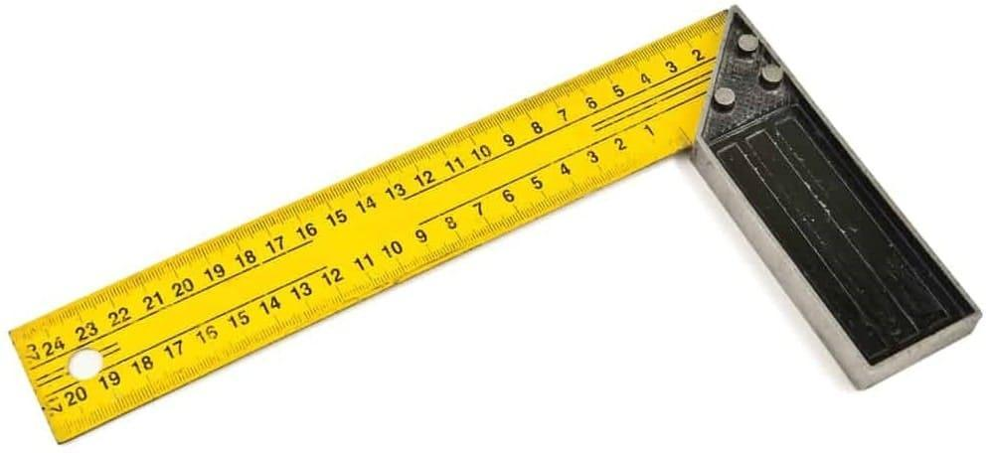

- Angle Ruler:
  - Ideal for measuring and transferring angles, particularly on custom-designed furniture pieces.
  - Essential for ensuring the proper fit on angled sections of furniture.

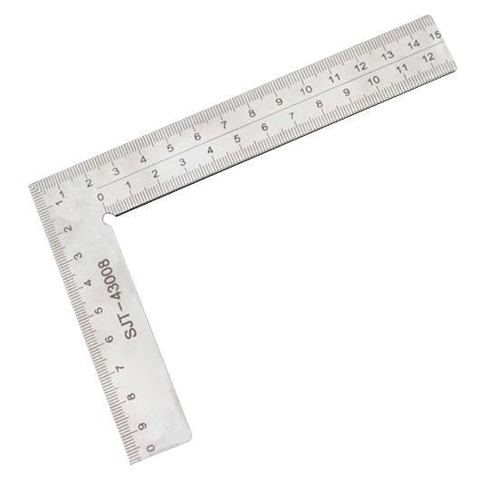

- Scales:
  - Used for converting measurements and for creating scaled-down drawings or patterns.
  - Helps in visualising the final product and in planning the layout of fabric or other materials.

Each tool serves a specific purpose in upholstery. Understanding when and how to use these tools can significantly enhance the accuracy of your measurements, leading to better-fitted and more professionally finished upholstery projects.

3. Calculation Techniques:
- Learn various calculation techniques necessary for upholstery, such as estimating fabric requirements, calculating seam allowances, and adjusting for fabric patterns. This includes understanding how to perform both simple and complex calculations, and when to use each【3†source】【6†source】.

Calculation techniques are essential in upholstery for accurate fabric requirements, seam allowances, and pattern adjustments. These calculations range from basic to complex, each suited for different aspects of the upholstery process.

- Estimating Fabric Requirements:
  - Determine the amount of fabric needed based on the dimensions of the furniture piece. Include extra fabric for pattern matching, especially for large or repeating patterns.
  - For irregular shapes, use geometrical calculations to approximate the area, adding a margin for error.

- Calculating Seam Allowances:
  - Add extra fabric to the measurements for stitching seams. Standard seam allowance in upholstery is typically around 1.5 to 2 cm, but this can vary based on the fabric type and design.
  - For tight corners or curves, adjust the seam allowance to ensure the fabric can be manipulated without causing puckering.

- Adjusting for Fabric Patterns:
  - When working with patterned fabrics, align the pattern across seams. This often requires additional fabric to match the patterns at the seams.
  - Calculate the repeat of the pattern and factor this into the total fabric required, ensuring pattern continuity across the furniture.

- Simple Calculations:
  - Use for straightforward tasks like measuring square or rectangular sections of furniture. Simple addition, subtraction, and multiplication are often sufficient.

- Complex Calculations:
  - Employed for intricate designs or irregular shapes. Complex calculations may involve geometry, especially for circular or uniquely shaped furniture pieces.
  - Software tools or calculators can be used for these calculations to ensure precision.

Understanding these calculation techniques allows for efficient material usage, cost estimation, and ensures the final product's aesthetic and functional quality. Mastery of both simple and complex calculations is vital for professional upholstery work.

4. Problem-Solving Skills:
- Develop problem-solving skills to address issues that arise in upholstery measurements and calculations, such as dealing with irregular shapes, mismatched patterns, or material limitations.
- Encourage creative thinking and adaptability to find solutions to unique challenges in upholstery projects.

Developing problem-solving skills in upholstery involves tackling challenges related to measurements, calculations, and material handling. This skill set is crucial for ensuring high-quality results and addressing unique project challenges.

1. Dealing with Irregular Shapes:
- Use geometric principles to measure irregular shapes accurately. This might involve breaking down complex shapes into simpler geometric forms for easier measurement.
- Create templates or mock-ups to test the fit before cutting the actual fabric, minimising errors and wastage.

2. Managing Mismatched Patterns:
- When working with patterned fabrics, aligning patterns at seams is critical. Plan the layout of fabric pieces to match patterns before cutting.
- Use digital tools or software for visualising pattern layout, ensuring seamless continuity across the upholstery.

3. Handling Material Limitations:
- In cases of limited fabric availability, optimise the layout for minimal waste. This might involve rearranging pieces or adjusting designs to fit within the available material.
- When dealing with delicate or unusual materials, adjust techniques and tools accordingly to prevent damage.

4. Encouraging Creative Thinking:
- Foster an environment where innovative ideas are welcome. Encourage experimentation with different materials, techniques, or designs to find unique solutions.
- Stay open to unconventional methods or materials that might offer better solutions to specific upholstery challenges.

5. Adaptability in Projects:
- Be prepared to modify plans as new challenges arise during a project. This flexibility is key to addressing unexpected issues without compromising on quality.
- Collaborate with clients or team members for fresh perspectives and solutions, especially for custom or complex upholstery tasks.

By cultivating these problem-solving skills, upholsterers can effectively manage diverse challenges, ensuring that each project is completed to the highest standard, even under challenging circumstances.

5. Practical Application:
- Apply these skills in real-world scenarios, practicing with various furniture types and materials. This hands-on experience is vital in honing problem-solving abilities in the field of upholstery.

Applying the learned skills in practical, real-world scenarios is a critical step in mastering upholstery. This hands-on experience allows for the consolidation of theoretical knowledge and the development of problem-solving abilities. Here's how it can be implemented:

1. Working with Different Furniture Types:
- Practice on a variety of furniture pieces, such as sofas, armchairs, ottomans, and dining chairs. Each type presents unique challenges in terms of shape, size, and design.
- Experiment with furniture of different styles, from antique to contemporary, to understand the nuances involved in upholstering each.

2. Exploring Various Materials:
- Use a range of upholstery materials including different types of fabrics, leathers, and vinyl. Each material behaves differently and requires specific handling techniques.
- Understand the properties of each material, such as stretch, durability, and care requirements, to determine the best application for each.

3. Real-World Problem Solving:
- Tackle common challenges encountered in upholstery, such as repairing damaged furniture, re-styling outdated pieces, or customising designs to client specifications.
- Develop solutions for material limitations, budget constraints, or unusual design requests.

4. Learning from Experience:
- Reflect on each completed project to identify what worked well and what could be improved. This reflection is key to continuous learning and skill enhancement.
- Seek feedback from clients or mentors to gain different perspectives and insights.

5. Collaboration and Networking:
- Work alongside experienced upholsterers or join community projects to gain exposure to different techniques and approaches.
- Participate in workshops, trade shows, or online forums to stay updated with the latest trends and innovations in the field.

Practical application of upholstery skills not only enhances technical proficiency but also fosters creativity and adaptability, essential traits for success in this craft.

6. Continuous Learning:
- Emphasize the importance of ongoing learning and staying updated with new tools, techniques, and industry standards. This includes participating in training, workshops, and other educational opportunities related to upholstery measurements and calculations.

Continuous learning is vital in the field of upholstery, ensuring professionals stay abreast of evolving tools, techniques, and standards. This ongoing education is crucial for maintaining high-quality workmanship and adapting to industry advancements.

1. Staying Updated with Tools and Techniques:
- Regularly explore and familiarise yourself with new tools and emerging techniques in upholstery. This can involve learning about advanced measuring instruments, cutting tools, or sewing machines.
- Understand and adapt to new materials and fabrics that come into the market, recognising their properties and best usage in upholstery.

2. Adhering to Industry Standards:
- Keep abreast of changes in industry standards, including quality, safety, and environmental regulations. This knowledge is crucial for ensuring compliance and delivering up-to-standard work.
- Stay informed about trends in furniture design and upholstery styles, which can influence client expectations and preferences.

3. Participating in Training and Workshops:
- Enrol in professional training courses, workshops, or seminars focused on upholstery. These can range from basic skills refreshers to advanced technique workshops.
- Online courses and webinars can also be valuable, offering flexibility and access to a wide range of topics.

4. Networking and Community Engagement:
- Join professional associations or online communities related to upholstery. These platforms provide opportunities for learning, sharing experiences, and staying connected with industry developments.
- Attend trade shows, exhibitions, or conferences to network with other professionals and learn about new products and innovations.

5. Embracing a Culture of Learning:
- Cultivate a mind-set of continuous improvement and openness to learning. This mind-set fosters professional growth and adaptation to change.
- Encourage and mentor others in the field, sharing knowledge and learning through teaching.

Continuous learning is not just about acquiring new skills; it is about evolving with the craft and maintaining a competitive edge in the dynamic field of upholstery.

By mastering these problem-solving skills, upholstery professionals can ensure precision in their work, leading to high-quality and satisfying outcomes for their projects.

FORMATIVE ASSESSMENT

- IAC0501 Various units, conversions and terminology for measurements, including quantity, deflection, and compressed air volume and pressure are explained and applied.
- IAC0502 Calculations required during the upholstery process are explained and applied.
- IAC0503 Measuring tools such as steel tape measure, cloth tape measure, squares, steel rules, Vernier calliper, templates and patterns, and pressure gauges and their parts are identified and their functions analysed.
- IAC0504 Calculations involving dimensions, spacing, quantities, volume, and air pressure using consistent units and conversions and appropriate mathematical operation are completed, recorded and checked.
- IAC0505 Consequences of inaccurate measurements on the upholstery process and the output of the department are assessed.
(Weight 10%)

SECTION: 6 KM-03-KT06: Upholstered furniture manufacturing processes (10%)

Learning Outcome
At the end of this section, learners should cover:

- KT0601 Upholstered furniture manufacturing process from raw frame to finished product.
- KT0602 Process flow and productivity.
- KT0603 Operations in the process flow: knocker on operations, foaming up operations, padding sprung foundations and frames and covering operations.
- KT0604 Routing sheets.
- KT0605 Cutting lists.
- KT0606 Product specifications.
- KT0607 Finishing aids.

INTRODUCTION

Welcome to the learning module on Upholstered Furniture Manufacturing Processes, an essential component for those engaged in or aspiring to be a part of the furniture manufacturing industry. This module, KM-03-KT06, covers the comprehensive process of creating upholstered furniture, from the initial raw frame to the final finished product. We will delve into the intricate steps and techniques involved in transforming basic materials into high-quality, upholstered furniture items.

1. KT0601 - Upholstered Furniture Manufacturing Process: This topic provides a detailed overview of the entire manufacturing process. It starts with the raw frame, often made of wood or metal, and takes you through each step until the furniture piece is fully upholstered and ready for use.

2. KT0602 - Process Flow and Productivity: Understanding the flow of operations and the importance of maintaining productivity in the manufacturing process is crucial. This topic discusses the sequence of tasks, time management, and strategies to optimise efficiency in production.

3. KT0603 - Operations in the Process Flow: Here, we will explore specific operations in the manufacturing process, including knocker-on operations, foaming up operations, padding of sprung foundations and frames, and covering operations. Each operation is critical and requires specialised skills and knowledge.

4. KT0604 - Routing Sheets: The importance of routing sheets in manufacturing is highlighted in this topic. Routing sheets serve as a guide, detailing the path a product takes through the manufacturing process, ensuring consistency and quality control.

5. KT0605 - Cutting Lists: We will examine how cutting lists are utilised in the manufacturing process, ensuring that all pieces of material are cut to the correct size and specifications, thus minimising waste and ensuring efficiency.

6. KT0606 - Product Specifications: This topic emphasizes the importance of adhering to product specifications. Specifications include dimensions, materials, and design details that are crucial for meeting quality standards and customer expectations.

7. KT0607 - Finishing Aids: Finally, we will look into various finishing aids used in the upholstery process. These aids might include tools, materials, or techniques that enhance the final appearance and durability of the upholstered furniture.

By the end of this module, you will have a thorough understanding of the steps, tools, and considerations involved in the manufacturing of upholstered furniture. This knowledge is vital for anyone involved in the furniture manufacturing industry, from designers and craftsmen to production managers and quality control specialists. KT0601 Upholstered furniture manufacturing process from raw frame to finished product.

KT0601 Upholstered furniture manufacturing process from raw frame to finished product.

The manufacturing process of upholstered furniture is a multi-step journey that transforms raw materials into comfortable, stylish, and durable pieces of furniture. Here is a detailed look at this process:

1. Starting with the Frame: The foundation of any upholstered furniture is its frame, typically made of wood or metal. The strength and quality of the frame determine the durability of the furniture. Wood frames are often crafted from hardwoods for their sturdiness, while metal frames offer a modern aesthetic and robust support.

2. Design and Pattern Making: Once the frame is ready, the design phase begins. This involves creating patterns for the fabric based on the furniture's dimensions. Precision in this step is crucial as it influences the fit and appearance of the final product.

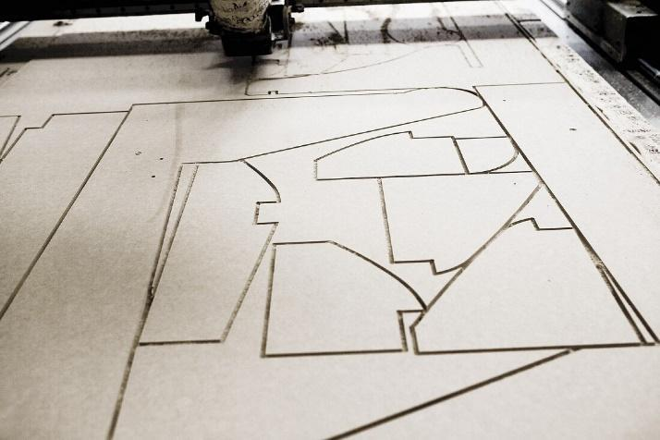

3. Cutting and Sewing: The fabric, chosen based on texture, colour, and durability, is then cut according to the patterns. Sewing follows, where pieces are meticulously stitched together, keeping in mind the style and design of the furniture.

4. Foaming and Padding: The next step involves adding foam and padding to the frame. This provides comfort and shape to the furniture. The foam is cut and glued to the frame, and then padding is added for extra comfort and aesthetic appeal.

5. Upholstery: The cut and sewn fabric pieces are then upholstered onto the furniture. This requires skill to ensure that the fabric is smooth, tight, and correctly aligned. Details like tufting, buttons, or piping are added in this stage.

6. Finishing Touches: Finally, any additional features such as legs, decorative trims, or cushions are added. The furniture is inspected for quality, ensuring that every aspect from stitching to the structural integrity meets the required standards.

7. Quality Check and Completion: The last stage involves a thorough quality check. This ensures that the furniture not only looks good but is also comfortable, functional, and ready for use.

Each stage of this process requires a blend of craftsmanship and precision, showcasing the art and science behind the creation of upholstered furniture. This detailed process ensures that the final product is not just a piece of furniture but a manifestation of design, comfort, and durability.

KT0602 Process flow and productivity.

Understanding the process flow and productivity in furniture manufacturing is essential for efficient production. Here is an explanation:

The process flow in furniture manufacturing involves a series of interconnected tasks and steps that transform raw materials into finished furniture pieces. This flow typically includes the following stages:

1. Design and Planning: The process begins with designing the furniture piece. This includes creating detailed blueprints, selecting materials, and determining production methods. Efficient planning ensures that resources are used optimally.

2. Material Selection: High-quality materials are crucial for durable furniture. This step involves choosing the right type of wood, metal, upholstery fabric, foam, and other components based on the design and intended use of the furniture.

3. Cutting and Shaping: Raw materials are cut and shaped into the required parts and components. Advanced machinery is often used to achieve precision and consistency in these tasks.

4. Assembly: Parts and components are assembled to create the furniture frame. Skilled craftsmen ensure that all elements fit together accurately, creating a solid foundation for the piece.

5. Upholstery: If the furniture piece requires upholstery, this step involves attaching fabric or leather to the frame. Upholstery not only enhances aesthetics but also adds comfort and functionality.

6. Finishing: The furniture is sanded, stained, painted, or finished in accordance with the design and desired appearance. This step also includes quality control to ensure a flawless finish.

7. Quality Control: At various stages of production, quality checks are conducted to identify and rectify any defects or imperfections. This ensures that the final product meets high-quality standards.

8. Packaging and Shipping: Once the furniture passes quality control, it is packaged securely for transportation to retailers or customers. Proper packaging helps protect the furniture during transit.

9. Customer Delivery: The furniture is delivered to customers, either through retailers or directly from the manufacturer.

To maintain productivity, manufacturers focus on time management and optimisation strategies such as lean manufacturing principles. Lean manufacturing aims to eliminate waste, reduce production times, and enhance overall efficiency.

In summary, understanding the process flow and productivity in furniture manufacturing involves a well-coordinated series of steps, from design and material selection to finishing and delivery. Efficient management of these processes and the adoption of productivity-enhancing strategies are essential for successful and competitive furniture production [[1](https://www.deskera.com/blog/furniture-manufacturing-process-how-furniture-is-made/)].

KT0603 Operations in the process flow: knocker on operations, foaming up operations, padding sprung foundations and frames and covering operations.

In the context of KT0603 - Operations in the Process Flow, each operation within the manufacturing process plays a pivotal role.

1. Knocker-On Operations: This stage typically involves the assembly or construction phase in manufacturing. It refers to the process of joining or fixing components together, which could be through methods like welding, screwing, or other mechanical means. The precision and expertise required here are crucial for the integrity and quality of the final product.

2. Foaming Up Operations: This is a critical process in the production of items like furniture, mattresses, or automotive seats. It involves the creation of polyurethane foam, a versatile material known for its cushioning properties. The process entails mixing various chemical components, which then react and expand to form the foam. This operation must be carefully controlled to ensure the foam has the desired density, firmness, and durability. The process for the production of padding of polyurethane foam cast in situ from a foaming mixture in a textile covering is an example of this operation [[1](https://patents.google.com/patent/US5294386A/en)].

3. Padding of Sprung Foundations and Frames: Padding is a crucial step in providing comfort and aesthetics to products such as furniture and mattresses. This operation involves applying layers of material (like foam, batting, or springs) over the frame or foundation to create a soft, cushioned surface. The skill in this operation lies in evenly distributing the padding material and ensuring it complements the structure's shape and design.

4. Covering Operations: The final step in many manufacturing processes, covering involves applying a fabric or material over the product. This could be for aesthetic reasons, protection, or to add functional features. The material chosen and the method of covering (like sewing, gluing, or stapling) are significant as they contribute to the product's final appearance and durability.

Each of these operations requires a different set of skills and knowledge, emphasising the importance of specialised training and expertise in manufacturing processes.

KT0604 Routing sheets.

In the context of KT0604, the significance of routing sheets in manufacturing cannot be overstated. Routing sheets play a crucial role in the manufacturing process:

1. Blueprint of Manufacturing Process: Routing sheets are essentially the map of the manufacturing process. They provide detailed guidance on the path a product takes from the start to the end of production. This detailed guidance is essential for maintaining the consistency and quality of the final product.

2. Defining the Operational Sequence: They establish the specific steps required to produce an item, defining the operational sequence in the process. This helps in organising the workflow efficiently and ensures that every step is executed in the correct order.

3. Resource Allocation and Planning: Routing sheets include information on the materials and equipment required at each stage of the manufacturing process. This aids in effective resource allocation, ensuring that the necessary resources are available where and when they are needed.

4. Quality Control and Consistency: By providing a standardised process, routing sheets play a vital role in quality control. They ensure that every product is manufactured to the same standard, maintaining consistency across batches.

5. Production Planning and Efficiency: Routing sheets are integral to production planning. They help in forecasting timelines, scheduling work, and managing the flow of work through the manufacturing process. This leads to improved efficiency and productivity in the manufacturing operation.

In summary, routing sheets are indispensable in manufacturing, providing a structured approach to production that enhances efficiency, quality, and consistency.

KT0605 Cutting lists.

In the realm of manufacturing, KT0605 delves into the critical role of cutting lists. These lists are pivotal for several reasons:

1. Precision in Material Usage: Cutting lists specify the exact dimensions to which materials must be cut. This precision is crucial for ensuring that each piece of material is cut to the correct size and specifications, aligning with the design and functional requirements of the product.

2. Minimising Waste: By clearly defining the dimensions and quantities of materials needed, cutting lists play a vital role in reducing waste. Precise cutting reduces the amount of scrap and offcuts, thereby contributing to more sustainable manufacturing practices. Efficient layouts and precise cutting lists are key in optimising material usage, especially in industries like woodworking [[6](https://www.linkedin.com/pulse/minimising-waste-woodworking-embracing-sustainability-siyad-ahmadli)].

3. Enhancing Efficiency: The use of cutting lists streamlines the manufacturing process. Workers have clear instructions on how to process materials, which reduces the time spent on measuring and decision-making. This leads to a more efficient workflow and can significantly boost productivity.

4. Cost-Effective Operations: With minimised waste and enhanced efficiency, cutting lists also contribute to cost savings. Less material waste means lower material costs, and efficient operations reduce labour and operational expenses.

5. Quality Control: Consistency in the size and quality of the cut materials is essential for the overall quality of the final product. Cutting lists ensure that all components fit together as designed, maintaining the integrity and functionality of the product.

In summary, cutting lists are an indispensable tool in the manufacturing process, playing a crucial role in ensuring precision, minimising waste, enhancing efficiency, reducing costs, and maintaining quality.

KT0606 Product specifications.

The topic of KT0606 focuses on the significance of product specifications in the manufacturing and design process. Product specifications are critical for several reasons:

1. Defining Product Characteristics: Specifications provide detailed descriptions of a product's characteristics, including dimensions, materials, and design details. This precise information is essential for creating a product that meets the intended design and functionality.

2. Quality Control: Adhering to product specifications ensures that each product meets the desired quality standards. This consistency is vital for maintaining the trust and satisfaction of customers.

3. Facilitating Production: Detailed specifications guide the manufacturing process, enabling efficient and accurate production. They help in minimising errors and reducing the need for rework, which in turn saves time and resources.

4. Ensuring Compliance: In many industries, products must meet certain regulatory standards. Specifications help ensure that products comply with these regulations, avoiding legal issues and ensuring consumer safety.

5. Customer Satisfaction: Accurately following product specifications is crucial for meeting customer expectations. Products that match their advertised specifications are more likely to satisfy customers and foster brand loyalty.

6. Streamlining Communication: Specifications serve as a clear communication tool between different departments involved in the product lifecycle, from design to production to marketing.

Overall, product specifications are a fundamental aspect of the manufacturing and design process, pivotal in ensuring quality, efficiency, compliance, and customer satisfaction.

KT0607 Finishing aids.

1. Tools: Upholsterers often use a variety of tools as finishing aids. These tools can include staple guns, tack hammers, and scissors. Staple guns are used to secure fabric to the frame, while tack hammers help in attaching decorative nails or tacks for a polished look. Scissors are essential for precise cutting of fabric and trimmings.

2. Materials: Finishing aids also encompass various materials. Upholstery fabrics are a crucial component, with choices ranging from durable, stain-resistant options for high-traffic areas to luxurious fabrics for a sophisticated appearance. Additionally, padding materials like foam or batting enhance comfort and appearance.

3. Techniques: Skilled upholstery professionals employ techniques such as piping and button tufting to elevate the final appearance of furniture. Piping involves adding a decorative cord around seams, creating a tailored finish. Button tufting, on the other hand, involves adding buttons to create a tufted appearance, adding texture and elegance.

4. Finishing Products: Upholstery often requires the use of finishing products like adhesives and finishes. Adhesives are used to secure fabric or padding in place, while finishes can protect the fabric from stains or provide a desired sheen.

5. Trimming: Decorative trims, such as braids, fringes, and tassels, serve as finishing aids that can add flair and personality to upholstered furniture. These trims are applied along seams or edges for a decorative touch.

6. Quality Assurance: Lastly, quality control is vital in upholstery. Assessing the final product for any imperfections or loose ends is a crucial finishing step to ensure durability and a polished appearance.

In summary, KT0607 - Finishing Aids in upholstery encompasses tools, materials, techniques, finishing products, and attention to detail. These elements collectively contribute to enhancing the final appearance and durability of upholstered furniture, ensuring that it meets both functional and aesthetic standards.

FORMATIVE ASSESSMENT

- IAC0601 Workshop processes of producing upholstered items from raw frame to finished product and the implications of design and construction faults on the final product are analysed.
- IAC0602 The process of furniture manufacture is briefly outlined.
- IAC0603 The operations in furniture manufacture such as: knocking-on operations, foaming-up operations, padding and sprung foundations and frames and covering operations are reviewed.
- IAC0604 The role of the routing sheet is described.
- IAC0605 Job card information such as component sizes and details, shoulder-to-shoulder size and chemicals to use is explained.
- IAC0606 Product specifications are understood and their impact on the manufacturing process is discussed in terms of the process flow and methods that will be used.
(Weight 10%)

SECTION: 7 KM-03-KT07: Upholstery covering principles (10%)

Learning Outcome
At the end of this section, learners should cover:

- KT0701 Stretch, tension and deflection of fabric.
- KT0702 Spacing of tacks, nails and staples.
- KT0703 Uniformity of a pair of arms and wings, pleating and folding and buttoning.
- KT0704 Positioning of the cover and alignments.
- KT0705 Pattern matching (fabric).
- KT0706 Principles and concepts of preparing and stacking covered frames for the next step in the production process.

INTRODUCTION

Upholstery is an essential aspect of furniture making that combines artistry with technical skill to transform simple materials into comfortable, aesthetically pleasing furnishings. In this module, KM-03-KT07, we delve into the core principles of upholstery covering, which is a crucial stage in the upholstery process. This module will cover six key knowledge topics, each focusing on a specific aspect of upholstery covering:

1. KT0701 - Stretch, Tension, and Deflection of Fabric: This topic addresses the fundamental principles of how fabric behaves when applied to furniture. Understanding how to manage the stretch, tension, and deflection of various fabrics is vital for ensuring a smooth, well-fitted upholstery cover that maintains its shape and appearance over time.

2. KT0702 - Spacing of Tacks, Nails, and Staples: This section covers the techniques and best practices for securing fabric to furniture frames. Proper spacing of tacks, nails, and staples is crucial for both the durability and the aesthetic quality of the upholstered item.

3. KT0703 - Uniformity of a Pair of Arms and Wings, Pleating, Folding, and Buttoning: This topic explores the skills needed to achieve symmetry and uniformity in more complex areas of upholstery, such as arms and wings. It also covers the art of pleating, folding, and buttoning, which are essential for adding decorative details and finishing touches.

4. KT0704 - Positioning of the Cover and Alignments: This section emphasizes the importance of correctly positioning the upholstery cover on the furniture frame. Accurate alignment ensures a neat and professional finish.

5. KT0705 - Pattern Matching (Fabric): This topic focuses on the techniques required for matching patterns in the fabric, a skill that is crucial for maintaining a cohesive and pleasing aesthetic, especially in furniture pieces that require multiple sections of fabric.

6. KT0706 - Principles and Concepts of Preparing and Stacking Covered Frames for the Next Step in the Production Process: This final topic covers the post-upholstery procedures, including how to properly prepare and stack upholstered frames, ensuring they are ready for the subsequent stages in the production process.

By the end of this module, learners will have a comprehensive understanding of the techniques and principles essential for mastering upholstery covering, an invaluable skill set for any aspiring furniture upholsterer.

KT0701 Stretch, tension and deflection of fabric.

KT0701 - Stretch, Tension, and Deflection of Fabric plays a critical role in upholstery, as it involves the application of fabric to furniture in a way that is both aesthetically pleasing and functionally durable. Understanding these principles is essential for ensuring a high-quality finish in upholstered furniture.

1. Stretch of Fabric: Different fabrics have varying degrees of stretchiness. Woven fabrics, for example, typically have less stretch unless they contain elastic fibers like spandex. The stretch property of a fabric determines how it conforms to the contours of the furniture. Upholsterers must choose fabrics with appropriate stretch qualities for specific furniture designs to ensure a snug fit without warping or distortion.

2. Tension in Fabric: Tension refers to the force applied to the fabric to stretch it over the furniture frame. Proper tension is crucial to prevent sagging or puckering of the fabric. It is a balancing act; too much tension can cause the fabric to tear or distort, while too little tension can lead to a loose and unprofessional finish.

3. Deflection of Fabric: This refers to the fabric's ability to return to its original shape after being stretched or compressed. It is particularly important in seating areas where the fabric needs to withstand repeated use. A fabric with good deflection properties will maintain its shape and appearance over time, contributing to the longevity and comfort of the furniture.

Understanding these principles allows upholsterers to select the right fabric and apply it correctly, ensuring that the finished product is not only visually appealing but also stands up to wear and tear over time.

KT0702 Spacing of tacks, nails and staples.

KT0702 - Spacing of Tacks, Nails, and Staples is a fundamental aspect of upholstery that significantly impacts both the durability and appearance of the final product. This section delves into the meticulous process of securing fabric to furniture frames using these fasteners.
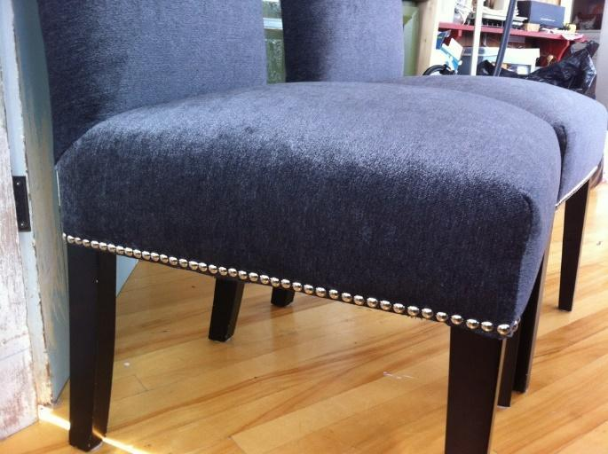
1. Importance of Proper Spacing: Correct spacing is crucial in preventing the fabric from tearing and ensuring that it remains taut and evenly distributed over the furniture frame. Uneven spacing can lead to loose fabric, puckering, or unsightly bulging, which detracts from the finished appearance.

2. Techniques for Tacks, Nails, and Staples:
- Tacks: Traditionally used in upholstery, tacks should be spaced evenly and driven straight into the frame. The distance between tacks can vary based on the fabric's thickness and the frame's material but generally should be consistent to ensure a smooth surface.
- Nails: While less common than staples in modern upholstery, nails can be used for decorative purposes or in specific types of furniture. Like tacks, they should be evenly spaced and securely fastened.
- Staples: The most commonly used fastener in contemporary upholstery, staples should be placed close enough to prevent fabric slippage but not so close as to cause the fabric to tear under tension. The staple gun should be held firmly to ensure that each staple is fully and evenly inserted.

3. Best Practices:
- Start by securing the fabric at key points (centre of each side) before working outwards.
- Ensure the fabric is pulled evenly to maintain consistent tension.
- Regularly check for uniformity in spacing and adjust as needed.

Proper application of these fastening techniques ensures that the upholstery remains secure and visually appealing throughout its lifespan.

KT0703 Uniformity of a pair of arms and wings, pleating and folding and buttoning.

KT0703 delves into the intricate aspects of upholstery that require a high level of skill and attention to detail. Achieving uniformity in complex areas and mastering decorative techniques are crucial for professional upholstery work.

1. Uniformity in Arms and Wings:
- This involves ensuring that both arms and wings of a piece of furniture are symmetrical and consistent in appearance.
- Precision in measurement and cutting is vital to ensure each piece mirrors its counterpart exactly.
- Consistent padding thickness and fabric tension are also crucial to avoid any asymmetry.

2. Pleating:
- Pleating involves folding fabric in a pattern and securing it, usually seen in areas like the backrest or sides of furniture.
- It requires careful calculation and even spacing to ensure the pleats are uniform and contribute to the overall aesthetics of the furniture.
https://youtu.be/kjqPV8UBW04?si=16oDZSZD-7wolS7r
https://spruceaustin.com/general/spruce-upholstery-tip-how-to-position-pleats/

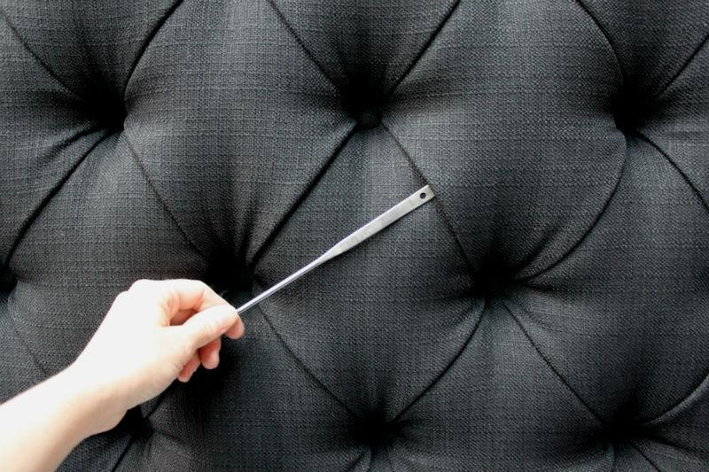

3. Folding:
- Folding is another technique used in upholstery to create clean, sharp lines or soft, flowing curves.
- It is often used in corners and edges and must be executed with precision for a neat finish.

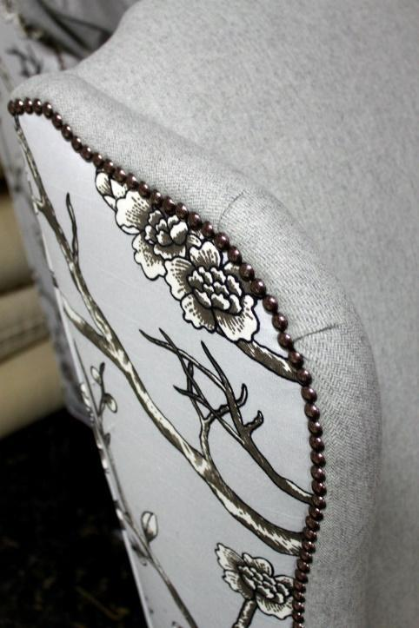

4. Buttoning:
- Also known as tufting, buttoning is a traditional technique that creates a pattern of buttons pulled deep into the upholstery.
- It requires evenly spaced buttons and consistent depth of indentation for a uniform look.
- This technique is not only decorative but also helps to secure the fabric and padding in place.

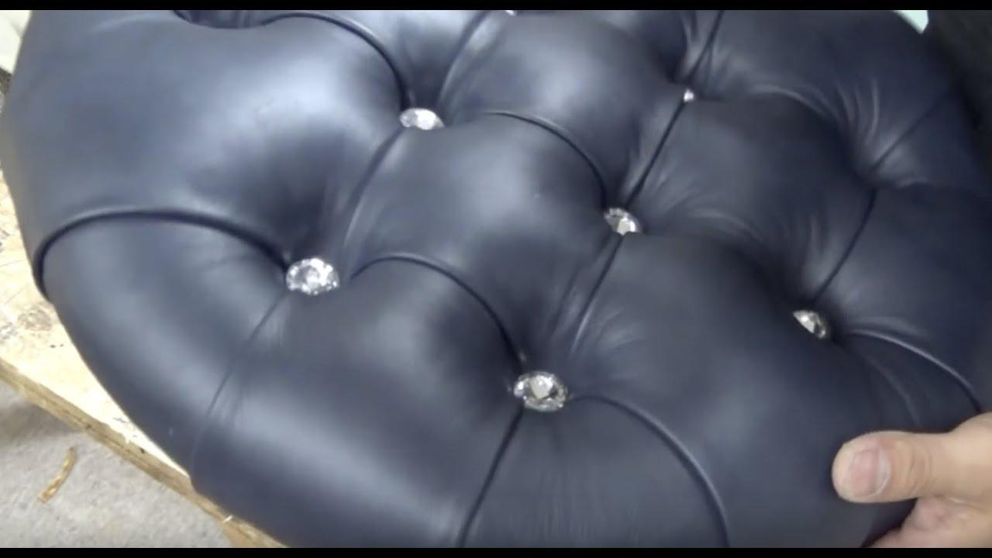

https://youtu.be/R3As72wYbsI?si=HOjfy0G3DmZdfu_N

Mastering these skills enhances the functionality and aesthetic appeal of upholstered furniture, adding value and style to each piece.

## 🌐 Sources

KT0704 Positioning of the cover and alignments.

Topic 4. KT0704 - Positioning of the Cover and Alignments: This section is crucial in the process of upholstery as it underscores the significance of properly positioning the upholstery cover on the furniture frame. Accurate alignment plays a pivotal role in achieving a neat and professional finish for your furniture. Here is why this step is essential:

1. Aesthetics: Proper alignment ensures that the fabric or leather cover fits seamlessly over the frame, avoiding wrinkles, creases, or uneven patterns. This results in a visually appealing piece of furniture that reflects attention to detail.

2. Comfort: Precise alignment ensures that the padding and cushioning beneath the upholstery are evenly distributed. This contributes to the comfort and support provided by the furniture when used.

3. Durability: When the upholstery cover is aligned correctly, it is less prone to wear and tear. Misalignment can lead to excessive stress on certain areas, potentially causing premature damage.

4. Professionalism: Whether you are reupholstering a piece or creating custom slipcovers, accurate alignment gives your furniture a professional look, making it appear as if it came straight from a showroom.

To achieve optimal results in furniture upholstery, it is crucial to pay meticulous attention to the alignment of the cover. This process may involve measuring, marking, and carefully securing the fabric or leather to the frame, ensuring a flawless finish that enhances both the aesthetics and longevity of your furniture.

KT0705 Pattern matching (fabric).

Topic 5, KT0705 - Pattern Matching (Fabric), which is essential for achieving a cohesive and aesthetically pleasing look, particularly in furniture upholstery where multiple sections of fabric are involved.

Pattern matching in fabric upholstery is an intricate skill vital for ensuring that the patterns on different fabric sections align seamlessly. Here's why it is crucial:

1. Aesthetic Consistency: When upholstering furniture with patterns, like stripes, florals, or plaids, precise pattern matching creates a harmonious and consistent appearance. Misalignment can disrupt the visual flow.

2. Professional Finish: Whether you are reupholstering a chair or creating custom slipcovers, accurate pattern matching gives your furniture a professional and polished finish, elevating its overall look.

3. Attention to Detail: Pattern matching demonstrates your commitment to detail and craftsmanship. It showcases your upholstery skills and enhances the value of your work.

4. Client Satisfaction: Clients often seek pattern-matched upholstery for bespoke or high-end pieces. Meeting their expectations by mastering this skill can lead to satisfied customers and repeat business.

To achieve successful pattern matching, you should consider factors like fabric orientation, layout, and precise cutting. Upholsterers often use templates, pins, and careful measurements to ensure patterns align flawlessly.

Overall, KT0705 emphasizes the importance of honing your pattern matching skills to maintain a cohesive and visually appealing aesthetic in furniture upholstery projects, making your work stand out in the world of upholstery.

KT0706 Principles and concepts of preparing and stacking covered frames for the next step in the production process.

Topic 6, KT0706 - Principles and Concepts of Preparing and Stacking Covered Frames for the Next Step in the Production Process, which focuses on the crucial post-upholstery procedures to prepare and stack upholstered frames for the next stages in the production process.

The principles and concepts of preparing and stacking covered frames in upholstery play a vital role in ensuring the efficiency and quality of the production process. Here are key points to consider:

1. Quality Assurance: After upholstery, it is essential to inspect the finished frames for any imperfections, such as loose fabric, uneven padding, or stitching issues. Addressing these problems ensures the final product meets quality standards.

2. Protection: Upholstered frames should be protected from potential damage during handling and storage. This can include covering them with appropriate materials like cloth or plastic to prevent dirt, dust, or scratches.

3. Organisation: Proper organisation of upholstered frames is crucial for efficient workflow. Frames should be stacked in a logical order, ensuring easy access to the required pieces for the next production steps.

4. Space Optimisation: Effective stacking techniques help maximise the use of available space in the workshop or production area. This ensures that the workspace remains organised and clutter-free.

5. Safety: Safety measures should be in place when handling and stacking frames, including the use of appropriate equipment like dollies or carts to minimise the risk of injury.

6. Documentation: Maintaining records of the upholstered frames, including their specifications and any issues identified during inspection, is essential for tracking progress and ensuring accountability.

Overall, KT0706 underscores the importance of a well-defined process for preparing and stacking upholstered frames. This ensures that the frames are in optimal condition for the subsequent stages of production, contributing to the overall efficiency and quality of the upholstery process.

FORMATIVE ASSESSMENT

- IAC0701 Covering principles are identified and the effect thereof on quality end-product is analysed.
(Weight 10%)

SECTION: 8 KM-03-KT08: Upholstered furniture covering operations and techniques (20%)

Learning Outcome
At the end of this section, learners should cover:
- KT0801 Correct sequence and procedure.
- KT0802 Slip stitching with circular needle and piping slip stitching.
- KT0803 Buttoning.
- KT0804 Tufting.
- KT0805 Tacking, stapling, nailing.
- KT0806 Pleating and folding fabric.
- KT0807 Pulling, tensioning and stretching.
- KT0808 Preventing tack ties.
- KT0809 Shaping edges and corners by using hand skills.
- KT0810 Measuring centralising the cover, spacing of buttons and studs, front borders of chairs.
- KT0811 Attaching decorative trimmings.
- KT0812 Cutting in of covers.
- KT0813 Foam marking.

INTRODUCTION

Introduction to Upholstered Furniture Covering Operations and Techniques

Upholstered furniture is a blend of artistry and craftsmanship, where every detail matters to create comfortable and visually appealing pieces. In this comprehensive learning content, we will explore various aspects of upholstered furniture covering operations and techniques. These techniques are essential for upholsterers, designers, and anyone interested in the world of furniture design and restoration.

KT0801 Correct Sequence and Procedure: We will begin by understanding the correct sequence and procedures involved in upholstering furniture. This knowledge forms the foundation for successful upholstery work.

KT0802 Slip Stitching with Circular Needle and Piping Slip Stitching: Discover the intricacies of slip stitching, a fundamental skill in upholstery, and learn how to achieve seamless results. We will also delve into piping slip stitching for a polished finish.

KT0803 Buttoning: Buttoning adds elegance and structure to upholstered pieces. Explore the art of buttoning, from design considerations to the actual buttoning process.

KT0804 Tufting: Tufting creates beautiful patterns and textures on upholstery. We will cover the techniques for achieving various tufting styles and their applications.

KT0805 Tacking, Stapling, and Nailing: Learn the different methods of securing fabric to the furniture frame, including tacking, stapling, and nailing, and understand when each is most appropriate.

KT0806 Pleating and Folding Fabric: Discover how to create pleats and folds in fabric to achieve tailored looks and intricate designs in upholstery.

KT0807 Pulling, Tensioning, and Stretching: Achieving the right tension in upholstery is critical. Explore techniques for properly pulling, tensioning, and stretching fabric for a flawless finish.

KT0808 Preventing Tack Ties: Preventing tack ties ensures the longevity of upholstered pieces. We will discuss strategies to avoid common issues related to tack ties.

KT0809 Shaping – Edges and Corners by Using Hand Skills: Master the art of shaping edges and corners by applying hand skills, an essential aspect of creating well-defined furniture contours.

KT0810 Measuring – Centralising the Cover, Spacing of Buttons and Studs, Front Borders of Chairs: Precision is key in upholstery. Learn how to measure accurately for centralising covers, spacing buttons and studs, and defining front borders.

KT0811 Attaching Decorative Trimmings: Explore the world of decorative trimmings and discover how they can enhance the aesthetic appeal of upholstered furniture.

KT0812 Cutting in of Covers: Cutting fabric accurately is crucial for achieving a seamless look. We will cover techniques for precise cutting of fabric covers.

KT0813 Foam Marking: Understand the importance of foam marking in upholstery for shaping and contouring upholstered pieces.

This learning content aims to equip you with the knowledge and skills required to excel in the field of upholstered furniture covering operations and techniques. Whether you are a professional upholsterer or a furniture enthusiast, these topics will broaden your understanding and enhance your capabilities in the world of upholstery. Let's embark on this creative journey together!

KT0801 Correct sequence and procedure

Upholstering furniture is a meticulous craft that requires a systematic approach to ensure a successful and professional result. Understanding the correct sequence and procedures is fundamental for any upholsterer, as it sets the stage for the entire process. Here, we will delve into the key aspects of KT0801, focusing on the correct sequence and procedures involved in upholstering furniture.

1. Assessment and Evaluation: The first step in any upholstery project is to assess the current state of the furniture. This includes inspecting the frame, identifying any structural issues, and evaluating the condition of the existing upholstery. Understanding the starting point is crucial for planning the restoration or re-upholstery process.

2. Dismantling and Stripping: Once the assessment is complete, the next phase involves dismantling the furniture. This includes removing the old upholstery, padding, and any fasteners such as staples or tacks. Stripping the piece down to its frame is essential to start with a clean slate.

3. Frame Repair and Restoration: During the stripping process, it is common to uncover frame issues that need attention. Repairing and restoring the frame is a critical step to ensure the furniture's structural integrity. This may involve replacing broken parts, reinforcing joints, and sanding or refinishing the wood.

4. Selection of Upholstery Materials: Before proceeding, select appropriate upholstery materials such as fabric, padding, springs, and any decorative elements like buttons or studs. Consider factors like durability, aesthetics, and the client's preferences.

5. Cutting and Measuring: Precise measurements and cutting of upholstery materials are essential for achieving a seamless fit. Ensure that fabric patterns are correctly aligned, and patterns are matched if necessary.

6. Padding and Springs: Begin by applying the padding and springs to the frame. The choice of padding materials and the proper installation of springs are essential for comfort and support.

7. Covering and Stitching: Attach the fabric cover to the frame, starting with the main sections and then progressing to details like armrests and cushions. Upholsterers use specific stitching techniques to secure the fabric neatly and securely.

8. Finishing Touches: Complete the upholstery by adding any final details, such as decorative buttons or studs. Ensure that the fabric is taut and free of wrinkles or creases.

9. Quality Control and Inspection: Before presenting the finished piece to the client, conduct a thorough quality control check. Ensure that the upholstery is flawless, comfortable, and meets the client's expectations.

10. Delivery or Installation: Finally, deliver the upholstered furniture to the client's location or install it in the designated space, depending on the project's scope.

Understanding and following this correct sequence and procedure in upholstering furniture is essential for achieving professional results and ensuring client satisfaction. Each step contributes to the overall quality and longevity of the upholstered piece, making it a foundational knowledge topic in upholstery.

KT0802 Slip stitching with circular needle and piping slip stitching.

Slip stitching is a fundamental skill in upholstery that allows for the creation of seamless and polished finishes. It is especially crucial when working with upholstery fabric, ensuring that seams are concealed and the final product appears professionally crafted. Let's explore the intricacies of slip stitching and piping slip stitching for upholstery:

Slip Stitching:

1. Definition: Slip stitching, also known as blind stitching, is a technique used to join two pieces of fabric invisibly. It involves sewing stitches that are concealed within the folded edges of the fabric, leaving no visible thread on the surface.

2. Procedure: To perform slip stitching with a circular needle in upholstery, follow these steps:
- Thread a needle with a thread that matches the fabric.
- Fold the edges of the fabric pieces to be joined inward.
- Insert the needle from the underside of one folded edge, passing it through the folded layers.
- Pull the needle through, leaving a small loop on the surface.
- Insert the needle into the opposite folded edge, picking up a small amount of fabric.
- Pull the needle through, gently tightening the stitches.
- Repeat this process along the seam, ensuring the stitches are evenly spaced and not too tight to allow for flexibility.

3. Application: Slip stitching is commonly used in upholstery to join seams on cushions, pillows, and other fabric elements. It provides a clean and seamless appearance, making it ideal for achieving a professional finish.

Piping Slip Stitching:

1. Definition: Piping slip stitching is a variation of slip stitching used to attach piping cord to the edges of upholstery fabric. Piping adds decorative detail and reinforces seams.

2. Procedure: To perform piping slip stitching in upholstery, follow these steps:
- Place the piping cord along the edge of one fabric piece, aligning it with the raw edges.
- Fold the other fabric piece over the piping cord, encasing it.
- Thread a needle with matching thread.
- Insert the needle through the folded fabric, securing the piping cord inside.
- Begin slip stitching along the folded edge, ensuring that the stitches catch both fabric layers and the piping cord.

3. Application: Piping slip stitching is commonly used to create decorative edges on cushions, upholstery seams, and along the borders of furniture pieces. It adds a tailored and polished look to upholstered items.

Mastering slip stitching and piping slip stitching in upholstery is essential for achieving seamless, professional results. These techniques ensure that seams are concealed and that the final product exhibits the highest level of craftsmanship.
KT0803 Buttoning.

Buttoning is a meticulous and artful technique in upholstery that enhances the elegance and structural integrity of upholstered pieces. This skilful practice involves strategically placing buttons into the fabric to create a tufted or buttoned effect, adding sophistication and dimension to furniture. Let's delve into the art of buttoning, covering design considerations and the buttoning process:

Design Considerations:

1. Aesthetic Appeal: Buttoning can transform a plain upholstery surface into a visually appealing and luxurious one. Consider the overall design aesthetic, such as whether you want a classic, contemporary, or vintage look, when planning the button layout.

2. Pattern and Spacing: Decide on the button pattern and spacing between buttons. Common patterns include diamond tufting and square tufting. The spacing should be consistent to achieve a balanced appearance.

3. Button Size and Material: Choose the size and material of buttons carefully. Larger buttons can create a bold statement, while smaller ones offer a more subtle look. Button materials like fabric-covered or decorative buttons can be selected to complement the upholstery fabric.

The Buttoning Process:

1. Marking and Measurement: Begin by marking the desired button positions on the fabric. Use measuring tools to ensure precise spacing and alignment.

2. Button Assembly: Create the buttons by covering them with fabric that matches or complements the upholstery. Secure the fabric around the button forms and fasten it tightly.

3. Thread Selection: Choose a strong and durable thread that matches the upholstery fabric. Double-threading is often recommended for added strength.

4. Button Attachment: Insert a long needle threaded with the chosen button thread from the backside of the upholstery fabric to the front at one of the marked positions. Pass it through the button and back through to the rear. Repeat this process several times to secure the button firmly.

5. Tightening and Tufting: After attaching all buttons, pull the thread taut to create the desired tufted effect. Knot the thread securely at the back to hold the tension.

6. Finishing Touch: Conceal the threads and knots by adding a fabric-covered panel or dust cover to the underside of the upholstered piece for a polished look.

Buttoning is an essential skill in upholstery that elevates the craftsmanship of furniture pieces. It involves both aesthetic and technical considerations, and mastering this art can result in stunning and timeless upholstery designs.

KT0804 Tufting

Tufting is a distinctive upholstery technique that adds charm, texture, and visual interest to furniture pieces. It involves creating patterns of raised buttons or folds on the surface of upholstery, resulting in a stunning and elegant appearance. In this section, we will explore tufting in detail, covering techniques for achieving various tufting styles and their applications.

Common Tufting Styles:

1. Diamond Tufting: Diamond tufting is one of the most classic and widely used tufting techniques. It creates a pattern of diamond-shaped clusters of buttons or folds on the upholstery surface. This style is often seen on sofas, chaises, and headboards, lending a timeless and luxurious look.

2. Button Tufting: Button tufting involves attaching buttons at regular intervals to create a tufted effect. This style is versatile and can be applied to various furniture pieces, including chairs, ottomans, and benches. Button tufting adds sophistication and depth to the upholstery.

3. Biscuit Tufting: Biscuit tufting, also known as square tufting, creates a grid-like pattern of square or rectangular tufts on the upholstery surface. It offers a clean and modern aesthetic and is often used on contemporary furniture designs.

Tufting Techniques:

1. Marking and Measuring: Before tufting, carefully mark the desired button positions on the fabric, ensuring even spacing and alignment.

2. Button Assembly: Create buttons covered in fabric that matches the upholstery. Attach a button form to the fabric, securing it tightly.

3. Thread and Needle Selection: Choose a strong and durable thread that complements the fabric. Use a long upholstery needle to pass the thread through the button and fabric.

4. Tufting Process: Insert the needle through the fabric from the back to the front at one of the marked positions. Pass it through the button and back through to the rear. Repeat this process several times to secure the button tightly and create the tufted effect.

Applications:
- Tufting is commonly used on furniture pieces such as sofas, chairs, headboards, ottomans, and benches to enhance their appearance and comfort.
- It can be applied to various upholstery materials, including fabric, leather, and vinyl.
- Tufting styles can range from traditional to contemporary, making it a versatile choice for different interior design aesthetics.

Mastering the art of tufting is essential for upholstery professionals, as it allows them to create exquisite patterns and textures that elevate the beauty of furniture pieces. Whether you're aiming for a timeless classic or a modern look, tufting offers endless design possibilities in the world of upholstery.

KT0805 Tacking, stapling, nailing.

In the world of upholstery, securing fabric to the furniture frame is a crucial step in creating a polished and well-crafted piece. Three primary methods for accomplishing this task are tacking, stapling, and nailing. Each method has its own advantages and is appropriate in different situations.

1. Tacking:
- Tacking involves using small nails, known as upholstery tacks, to fasten the fabric to the furniture frame.
- This method is often used in traditional and intricate upholstery work where precision and a decorative finish are required.
- Upholstery tacks are hammered in by hand, allowing for precise control over placement and tension.
- Tacking is ideal for securing fabric in areas with complex curves, corners, or detailed patterns.

2. Stapling:
- Stapling is a more modern and efficient method that utilises a staple gun to attach the fabric to the frame.
- It is commonly used in contemporary upholstery and for projects where speed and ease of use are important.
- Stapling provides a strong and secure hold, making it suitable for large upholstery projects like sofas and chairs.
- It is particularly effective for attaching fabric to flat surfaces, such as the underside of seats.

3. Nailing:
- Nailing involves using small nails or upholstery nails to secure the fabric to the frame.
- This method is versatile and can be employed in various upholstery applications.
- Nails can be driven in by hand or with the help of a nail gun for faster work.
- Nailing is often chosen when a combination of precision and speed is needed, as it offers a good balance between the two.

When to Use Each Method:
- Tacking: Use tacking when working on antique or classic furniture pieces that require a traditional and decorative finish. It is also suitable for areas with intricate details and curves.

- Stapling: Opt for stapling in projects where efficiency and a strong hold are key, especially for modern and flat-surfaced furniture items.

- Nailing: Choose nailing when versatility is needed, and you want a balance between precision and speed. It works well for various upholstery tasks.

Ultimately, the choice of tacking, stapling, or nailing depends on the specific requirements of your upholstery project, the type of furniture you are working on, and your personal preferences as an upholsterer. Each method has its own merits, and skilled upholsterers often employ a combination of these techniques to achieve the desired results.

KT0806 Pleating and folding fabric.

Pleating and folding fabric is a versatile technique used in upholstery to achieve tailored looks, add texture, and create intricate designs. This method allows upholsterers to transform plain fabric into visually appealing and functional elements in furniture. Here is how you can explore pleating and folding fabric in upholstery:

1. Box Pleats: Box pleats are evenly spaced, double folds in the fabric, forming a box-like structure. They are often used in upholstery for a clean and structured appearance. Box pleats can be applied along the edges of cushions, curtains, or furniture skirts.

2. Knife Pleats: Knife pleats are single folds in one direction, creating a sleek and contemporary look. They are commonly used for creating pleated panels on chair backs, headboards, or valances.

3. Accordion Pleats: Accordion pleats are repetitive, narrow folds that run closely together, resembling the folds of an accordion. This style is versatile and can be used to create textured surfaces on upholstery, such as on chair backs or wall panels.

4. Decorative Folds: Beyond standard pleats, creative upholsterers can experiment with decorative folds. These include origami-inspired folds, irregular tucks, and layered fabric manipulation. Such folds add uniqueness and visual interest to upholstery designs.

5. Tailored Upholstery: Pleating and folding fabric is an essential skill for achieving tailored looks in upholstery. It allows you to control the fabric's shape and create custom-fit covers, cushions, and other upholstered elements.

6. Design Considerations: When incorporating pleats and folds into upholstery, consider the overall design, fabric choice, and the specific piece of furniture. Pleating can be used to highlight certain features, add depth, or create symmetry in the design.

7. Techniques and Tutorials: There are various resources, including tutorials and videos that can help you master the art of pleating and folding fabric in upholstery. These resources provide step-by-step guidance on creating different pleat styles.

By mastering pleating and folding techniques, upholsterers can elevate their craft, adding sophistication and uniqueness to their furniture creations. Whether you aim for a classic, tailored appearance or desire intricate and artistic designs, pleating and folding fabric is a valuable skill in the world of upholstery.

KT0807 Pulling, tensioning and stretching.

Achieving the correct tension in upholstery is crucial for creating a flawless and professional finish. Whether you are working on a chair, sofa, or any upholstered piece, mastering the techniques of pulling, tensioning, and stretching fabric is essential. Here's a detailed exploration of these key techniques:

1. Pulling Fabric: Pulling fabric involves gently tugging or stretching the material to eliminate wrinkles and achieve a smooth surface. Start by securing one end of the fabric to the frame using staples, tacks, or adhesive. Then, work your way along the fabric, pulling it taut while attaching it to the frame on the opposite side. This process should be done systematically to ensure even tension throughout.

2. Tensioning: Tensioning is the process of applying consistent pressure on the fabric to prevent sagging or slackness over time. It is essential to maintain an even tension across the entire upholstery piece. To achieve this, use tools like webbing stretchers or clamp the fabric in place temporarily while you secure it to the frame. This ensures that the fabric remains tight and doesn't loosen with use.

3. Stretching Fabric: Stretching fabric involves using your hands or tools to gently stretch the material in different directions. This technique is especially useful for achieving a snug fit around corners and curves. When stretching fabric, be cautious not to over-stretch, which can distort the pattern or weaken the fabric.

4. Proper Tools: Upholstery tools such as staple guns, webbing stretchers, and rubber mallets are invaluable for achieving the right tension. These tools help you secure the fabric firmly and evenly, ensuring a professional finish.

5. Fabric Type: Different fabrics have varying degrees of elasticity. Understanding the properties of the fabric you're working with is essential. For instance, a stretchy fabric may require less tension than a rigid one.

6. Consistency: Consistency in tension is key to preventing uneven wear and maintaining the appearance of the upholstery over time. Take your time to ensure that the tension is uniform across the entire piece.

7. Practice: Achieving the perfect tension in upholstery requires practice and skill development. Upholsterers often hone their techniques through experience, so don't be discouraged if it takes time to master.

By mastering the art of pulling, tensioning, and stretching fabric, you will be well on your way to creating upholstery with a flawless finish that not only looks great but also lasts for years to come. These techniques are fundamental to the craft and are essential for any upholsterer looking to produce high-quality work.

KT0808 Preventing tack ties.

Tack ties are crucial components in upholstery, but if not handled properly, they can lead to issues that affect the longevity and appearance of upholstered pieces. Here, we'll explore strategies to prevent common problems related to tack ties:

1. Proper Tack Placement: One of the primary causes of tack ties is improper placement. Ensure that you position your tacks accurately, driving them into the frame securely without damaging the fabric. This prevents the fabric from tearing or getting puckered around the tacks.

2. Use the Right Tack Size: Choosing the correct tack size is essential. Tacks that are too long may damage the frame, while those that are too short may not hold the fabric securely. Select the appropriate tack size based on the thickness of the fabric and the frame material.

3. Spacing Matters: Proper spacing between tacks is crucial. Too many tacks close together can create a bulky and unattractive appearance, while too few may not provide adequate support. Follow guidelines for recommended tack spacing to ensure even tension and a clean finish.

4. Tack Material: The material of the tack matters. For delicate fabrics, consider using tacks with smooth heads to prevent snags. Additionally, brass tacks are a good choice for avoiding rust-related issues.

5. Tack Removal: When reupholstering or making adjustments, be diligent about removing old tacks and staples. Leftover tacks from previous upholstery work can interfere with the new upholstery job and lead to tack ties.

6. Quality Upholstery Tools: Using high-quality upholstery tools, such as tack pullers and pliers, can make a significant difference in preventing tack ties. These tools allow for precise tack removal and placement.

7. Professional Guidance: If you are new to upholstery or working on a complex project, seeking advice from experienced upholsterers or consulting upholstery guides and tutorials can help you avoid tack tie-related problems.

8. Regular Maintenance: Upholstered pieces benefit from regular maintenance. Check for loose or damaged tacks over time and address them promptly to prevent further issues.

By following these strategies, you can prevent common problems related to tack ties, ensuring that your upholstered pieces remain in excellent condition and have a longer lifespan. Proper tack handling is essential for achieving a clean and professional upholstery finish.

KT0809 Shaping edges and corners by using hand skills.

Mastering the art of shaping edges and corners using hand skills is a fundamental aspect of upholstery, particularly when aiming to create well-defined furniture contours. Here is an in-depth look at this essential technique:

1. Understanding the Importance: Shaping edges and corners is crucial because it contributes to the overall appearance and comfort of upholstered furniture. Well-shaped edges and corners give furniture a polished and professional look.

2. Materials and Tools: To shape edges and corners effectively, you'll need the right materials and tools. These include high-density foam or batting, scissors or utility knives, adhesive sprays, and hand tools like tack hammers and rubber mallets.

3. Layering Materials: Layering materials such as foam and batting is a common approach. Begin by cutting the materials to the desired shape and size, then attach them to the furniture frame using adhesive sprays. Layering ensures that edges and corners are adequately padded.

4. Meticulous Trimming: Achieving well-defined contours requires meticulous trimming of excess material. Skilled upholsterers use sharp scissors or utility knives to trim the foam or batting precisely, following the shape of the furniture.

5. Hand Skills and Tension: Hand skills come into play when stretching and pulling the upholstery fabric over the shaped edges and corners. Upholsterers use their hands to apply tension to the fabric, ensuring it conforms smoothly to the contours without wrinkles or puckering.

6. Securing with Tacks or Staples: Once the fabric is properly tensioned over the shaped edges and corners, it is secured to the frame using tacks or staples. Upholsterers use tack hammers or rubber mallets to drive tacks or staples securely, ensuring a snug fit.

7. Practice and Precision: Achieving mastery in shaping edges and corners takes practice and precision. Upholsterers often refine their hand skills over time, learning to work with different fabrics and furniture designs.

8. Consistency in Design: Properly shaped edges and corners ensure consistency in the design and aesthetics of upholstered furniture, making it visually appealing and comfortable.

In summary, mastering the art of shaping edges and corners using hand skills is an essential aspect of upholstery. It involves understanding materials, precise trimming, applying tension, and securing fabric properly. This technique elevates the quality and appearance of upholstered furniture, allowing for well-defined contours and a professional finish.

KT0810 Measuring centralising the cover, spacing of buttons and studs, front borders of chairs.

In the realm of upholstery, precision is paramount to achieving professional and visually appealing results. Accurate measuring plays a crucial role in centralising the cover, spacing buttons and studs, and defining the front borders of chairs. Here's an in-depth exploration of these essential measurement techniques:

1. Centralising the Cover:
- Start by positioning the furniture piece in a well-lit area.
- Measure the width and length of the furniture's seating area. Divide both measurements by two to find the centre point.
- Similarly, measure the width and length of your upholstery fabric and find its centre point.
- Align the fabric's centre point with the furniture's centre point to ensure the cover is centralised.
- Secure the fabric in place along the centreline before proceeding with the upholstery process.

2. Spacing Buttons and Studs:
- Measure and mark equal intervals on the furniture's backrest or cushion where you want to place buttons or studs.
- Ensure these marks are equidistant from each other to maintain symmetry.
- For buttons, measure the distance from the edge of the furniture to the center of each button placement.
- Use a template or guide to make consistent buttonholes or depressions in the fabric.
- When spacing studs, measure the distance between each stud and the furniture's edge to maintain uniformity.
- Secure buttons or studs precisely according to your measurements for a polished appearance.

3. Defining Front Borders of Chairs:
- Measure the width of the front of the chair's seat or the area where you want to define the border.
- Determine the desired border width and mark it on the fabric.
- Ensure that the border width measurement is consistent on both sides of the chair.
- When attaching the fabric, align it with the marked border positions and secure it evenly along the front edge.

Precision in measuring not only enhances the aesthetic appeal of upholstered furniture but also ensures a comfortable and well-finished product. Whether centralising covers, spacing buttons and studs, or defining front borders, accurate measurements are the cornerstone of quality upholstery work.

KT0811 Attaching decorative trimmings.

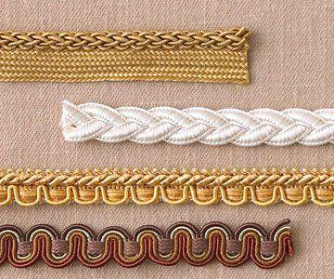
Decorative trimmings are a hidden gem in the world of upholstery, capable of transforming the appearance of upholstered furniture and adding a touch of luxury and sophistication. Let us delve into the fascinating realm of attaching decorative trimmings and understand how they enhance the aesthetic appeal of furniture:

1. Types of Decorative Trimmings:
- Decorative trimmings encompass a wide range of options, including braids, cords, fringes, tassels, and nail head trims.
- Braids and cords are elegant choices for outlining the edges of cushions or upholstery, creating a defined and tailored look.
- Fringes and tassels can add a playful and ornate element to furniture, especially for traditional or vintage styles.
- Nail head trims provide a modern and sleek appearance, often used to create patterns or accents on furniture.

2. Enhancing Aesthetic Appeal:
- Decorative trimmings serve as the finishing touch, elevating the overall aesthetics of furniture pieces.
- They can complement the fabric's colour or pattern, creating a harmonious and visually pleasing composition.
- By adding contrast or a pop of colour, trimmings can make a bold design statement and draw attention to specific details.

3. Personalisation and Style:
- Decorative trimmings offer endless opportunities for personalisation and customisation.
- They allow you to tailor furniture to suit a particular style, whether it is classic, contemporary, or eclectic.
- Mixing and matching different trimmings can create unique and one-of-a-kind pieces.

4. Attention to Detail:
- Properly attaching trimmings requires precision and attention to detail.
- Careful placement ensures that the trim follows the contours of the furniture, enhancing its shape and form.
- Whether highlighting curves, edges, or seams, trimmings contribute to the overall craftsmanship.

In summary, decorative trimmings are more than just embellishments; they are integral to the art of upholstery. These exquisite details have the power to turn ordinary furniture into extraordinary works of art, adding charm, character, and a touch of opulence to any interior space.

KT0812 Cutting in of covers.

Accurate cutting of fabric covers is a fundamental skill in upholstery that can make the difference between a flawless finish and a less polished result. Let's explore the techniques and tips for achieving precise cuts when working on upholstery projects:

1. Selecting the Right Tools:
- Start with sharp fabric scissors or rotary cutters. Dull tools can cause uneven edges and fraying.
- Ensure that your cutting surface is clean and smooth, free of any debris that might snag the fabric.

2. Measuring and Marking:
- Before cutting, carefully measure and mark the fabric according to your upholstery pattern or dimensions.
- Use chalk or fabric markers that easily wash out to create clear and visible cutting lines.

3. Straight Cuts:
- For straight cuts, align a straightedge (such as a yardstick or T-square) along your marked line to guide your cutting tool.
- Apply even pressure and cut in one continuous motion to avoid jagged edges.

4. Curved Cuts:
- When cutting curves or intricate shapes, go slowly and follow the marked lines precisely.
- Consider using smaller, more manoeuvrable scissors for intricate cuts.

5. Pattern Matching:
- If your upholstery project involves patterned fabric, take extra care to match the patterns along seams and edges.
- Cut one piece at a time while ensuring alignment with the adjacent pieces.

6. Seam Allowances:
- Remember to account for seam allowances when cutting fabric. Upholstery typically requires wider allowances than clothing.
- Seam allowances provide the necessary fabric for stitching and creating clean seams.

7. Double-Check Measurements:
- Measure twice, cut once. Double-check your measurements and markings before making the final cut to prevent costly mistakes.

8. Practice and Patience:
- Precision in fabric cutting comes with practice and patience. Don't rush the process, especially when working on intricate designs.

9. Spare Fabric:
- It is a good practice to have some spare fabric on hand in case of errors or the need for repairs.

10. Finishing Edges:
- After cutting, consider finishing the fabric edges with techniques like serging or using fray prevention products to prevent fraying.

In upholstery, where precision is paramount, mastering the art of cutting fabric accurately is a valuable skill. With the right tools, careful measurements, and attention to detail, you can ensure that your fabric covers fit seamlessly, enhancing the overall quality and appearance of your upholstered furniture.

KT0813 Foam marking

Foam marking is a crucial aspect of upholstery that plays a significant role in achieving the desired shape and contour for upholstered pieces.

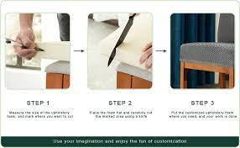
This picture will be replaced with an appropriate one

1. Precision and Accuracy:
- Foam marking involves outlining the shape and contours required for the upholstered piece directly on the foam.
- This process ensures precise and accurate measurements, allowing upholsterers to create templates for cutting fabric and foam that fit perfectly.

2. Customisation:
- Every upholstered piece is unique, and foam marking allows for customisation.
- Upholsterers can tailor the foam to match the specific design, dimensions, and curves required for a particular project.

3. Complex Shapes:
- Upholstered furniture often features complex shapes and curves, such as armrests, headrests, and decorative elements.
- Foam marking simplifies the process of reproducing these intricate shapes consistently.

4. Minimising Waste:
- Foam can be expensive, and incorrect cutting can lead to wastage.
- Foam marking helps minimise waste by ensuring that the foam is cut precisely to the required dimensions, reducing material costs.

5. Efficiency and Time Savings:
- Foam marking streamlines the upholstery process by providing clear guidelines for cutting and shaping.
- This efficiency saves time, allowing upholsterers to complete projects more quickly.

6. Enhanced Comfort:
- Properly marked and shaped foam contributes to the overall comfort and ergonomic design of upholstered furniture.
- It ensures that the foam provides the right support and cushioning in all the right places.

7. Professional Finish:
- Foam marking is a hallmark of professional upholstery work.
- It results in a clean, finished look with no lumps, bumps, or irregularities in the foam padding.

8. Reduced Errors:
- By transferring design and measurement details onto the foam, upholsterers reduce the chances of errors during the cutting and shaping stages.

9. Consistency:
- Foam marking ensures consistency in the foam's shape and density throughout the entire upholstered piece.

In summary, foam marking is an essential step in upholstery that combines precision, customisation, and efficiency. It serves as the blueprint for creating comfortable, aesthetically pleasing, and functional upholstered furniture. Upholsterers who master the art of foam marking can consistently produce high-quality pieces that meet both aesthetic and ergonomic standards.

FORMATIVE ASSESSMENT

- IAC0801 Upholstery covering techniques are defined and the application thereof is described.
- IAC0802 Using the correct terminology, explain the difference in the sequence of fitting covers to a drop-on and a drop-in dining chair seat.
- IAC0803 Using the correct terminology, explain the difference in the sequence of fitting covers to a fully covered and a show wood chair.
- IAC0804 Using the correct terminology, explain the difference in the sequence of fitting covers to various prepared frames, including a round pouffe with padded sides, fully upholstered sofa, dining room chair with upholstered back, and an arm chair with a loose seat cushion.
- IAC0805 Explain the principles and concepts of stretching techniques when using hand tools, power tools, and tacking strips to attach covers to the frame.
- IAC0806 Explain the principles and concepts of blind stitching and blind tacking when attaching covers to the frame.
- IAC0807 Identify covering faults in covering materials, consumables and techniques and explain the causes and how to rectify and prevent them.
- IAC0808 Explain the principles and concepts of measuring, cutting and attaching the specified fabric to cover the foam and paddings.
- IAC0809 Identify the principles of following workplace procedures to handle, stack and store completed furniture for the next procedure and explain the types and consequences of damage to the product.
(Weight 20%)

Provider Programme Accreditation Criteria

Physical Requirements:
- The provider must have lesson plans and structured learning material or provide learners with access to structured learning material that addresses all the topics in all the knowledge modules.
Human Resource Requirements:
- Lecturer/learner ratio of 1:20.
- Qualifications of lecturers: 5 years relevant experience.
Legal Requirements:
- OHS compliant.
3.4 Exemptions
- No exemptions, but the module can be achieved in full through a normal RPL process.

SOURCES – DO NOT REMOVE

🌐 Sources

1. [ASU - Best Practices for Teaching Online](https://teachonline.asu.edu/2018/09/best-practices-for-teaching-online/)
2. [Harvard - Pedagogical Best Practices: Residential, Blended, and](https://teachremotely.harvard.edu/best-practices)
3. [OSU - Best Practices for Recording Lecture Videos](https://teaching.resources.osu.edu/teaching-topics/best-practices-recording-lecture)
4. [CITL - Before You Record- Recording Basics](https://citl.illinois.edu/citl-101/online-strategy-development/develop-or-revise-an-online-course/online-course-in-a-box/building-your-course/recording-lectures/before-you-record-recording-basics)

🌐 Sources

1. [Study.com - Measurement in Science | Measuring Tools & Examples](https://study.com/academy/lesson/scientific-measurement-common-instruments.html)
2. [Lesson Research - Measurement](https://lessonresearch.net/content-resource/measurement-2/)
3. [Britannica - Measurement | Definition, Types, Instruments, & Facts](https://www.britannica.com/technology/measurement)
4. [Lumen Learning - Chapter 6 Measurement of Constructs | Research Methods](https://courses.lumenlearning.com/suny-hccc-research-methods/chapter/chapter-6-measurement-of-constructs/)
5. [Study.com - Measurement Lesson Plan](https://study.com/academy/lesson/measurement-lesson-plan.html)
6. [Wikipedia - List of measuring instruments](https://en.wikipedia.org/wiki/List_of_measuring_instruments)
🌐 Sources
- [SAQA - Upholstery Cover Fitter](https://allqs.saqa.org.sa/showQualification.php?id=103187)
- [SAQA - Upholstery. The qualification](https://regqs.saqa.org.sa/viewQualification.php?id=103199)

🌐 Sources
- [The Ultimate Guide to Bar and Restaurant Furniture - LinkedIn](https://www.linkedin.com/pulse/ultimate-guide-bar-restaurant-furniture-innofabindia-nse4c)
- [The perfect specification for all environments - Government Business](https://governmentbusiness.co.uk/features/perfect-specification-all-environments)
🌐 Sources
- [Understanding the Regulatory Requirements of Furniture - Deskera](https://www.deskera.com/blog/understanding-the-regulatory-requirements-for-furniture-manufacturing/)
- [Quality Control in Furniture Manufacturing - Deskera](https://www.deskera.com/blog/quality-control-in-furniture-manufacturing/)
- [Furniture Design & Technology: Standards - Atlantic TU](https://atlantictu.libguides.com/furnituredesign/standards)
- [Furniture Standards & Certifications - myUSF](https://myusf.usfca.edu/purchasing/facstaff/furniture/standards)
- [New upholstered furniture - Business Companion](https://www.businesscompanion.info/en/quick-guides/product-safety/new-upholstered-furniture)
- [Upholstered Furniture Business Education | CPSC.gov](https://www.cpsc.gov/Business--Manufacturing/Business-Education/Business-Guidance/Upholstered-Furniture)
🌐 Sources
- [Understanding the Regulatory Requirements of Furniture - Deskera](https://www.deskera.com/blog/understanding-the-regulatory-requirements-for-furniture-manufacturing/)
- [Wood and Upholstery Industry Safety Compliance - Makrosafe](https://www.makrosafe.co.sa/Wood-and-Upholstery-Industry)
- [Upholstered Furniture Business Education | CPSC.gov](https://www.cpsc.gov/Business--Manufacturing/Business-Education/Business-Guidance/Upholstered-Furniture)
- [5 reasons furniture products fail compliance testing and/or certification - Eurofins](https://www.eurofins.com/toys-hardlines/resources/articles/5-reasons-furniture-products-fail-compliance-testing-andor-certification/)
- [New upholstered furniture - Business Companion](https://www.businesscompanion.info/en/quick-guides/product-safety/new-upholstered-furniture)
- [Exploring US furniture compliance requirements - Eurofins](https://www.eurofins.com/toys-hardlines/resources/articles/exploring-us-furniture-compliance-requirements/)

🌐 Sources
- [SABS - South African Bureau of Standards](https://www.iso.org/member/1485.html)
- [South Africa - Standards for Trade](https://www.trade.gov/country-commercial-guides/south-africa-standards-trade)
- [South Africa - Global Market Access](https://www.tuvsud.com/en/services/global-market-access/south-africa)
- [Quality Assurance and Quality Control | SGS South Africa](https://www.sgs.com/en-sa/services/quality-assurance-and-quality-control)
- [South Africa - Labeling/Marking Requirements](https://www.trade.gov/country-commercial-guides/south-africa-labelingmarking-requirements)
🌐 Sources
- [5 Ways to Perfect Millwork Drawings for Furniture - HiTech CADD Services](https://www.hitechcaddservices.com/news/5-ways-perfect-millwork-drawings-for-furniture-manufacturing/)
- [Design Construction Drawings for your Furniture - Upwork](https://www.upwork.com/services/product/design-construction-drawings-for-your-furniture-manufacturing-industry-1412465298791997440)
- [CAD Drawings: Demands for Millwork, Casework - TrueCADD](https://www.truecadd.com/news/how-cad-drawings-help-millwork-bespoke-furniture-manufacturers)
- [Millwork Shop Drawings: How To Use Them For Furniture Design - ArchiCGI](https://drawings.archicgi.com/millwork-shop-drawings-how-to-use-them-for-furniture-design/)
- [I will create furniture technical and manufacturing drawings - Fiverr](https://www.fiverr.com/mntipo420/create-furniture-technical-and-manufacturing-drawings)
- [Technical Drawings and Documentation for Furniture Manufacturing - Scandinavian House](https://www.scandinavian.house/services/technical-drawings-furniture/)
🌐 Sources
- [Designing for Furniture Manufacturing: A Detailed Guide! - Deskera](https://www.deskera.com/blog/designing-for-furniture-manufacturing/)
- [Furniture Prototyping Helps Manufacturers Succeed - XO3D](https://xo3d.co.uk/furniture-prototyping-can-help-you-succeed/)
- [Making Upholstery Prototypes - Upholstery Resource](https://www.upholsteryresource.com/node/261)
- [Digital prototyping: the future of sofa design - FibreGuard](https://fibreguard.com/blog/digital-prototyping-the-future-of-sofa-design)
- [Expand your furniture prototyping with digital fabric twins - Twinbru](https://blog.twinbru.com/sitting-pretty-expand-your-furniture-prototyping-with-digital-fabric-twins)
- [Furniture Prototyping: 5 Advantages for the Manufacturing - CGI Furniture](https://cgifurniture.com/furniture-prototyping-5-benefits/)
🌐 Sources
- [Customer-specific job cards - IBM](https://www.ibm.com/docs/SS5RRF_7.6.1/com.ibm.spr.doc/common/c_cust_jp.html)
- [Enhancing Operational Control with Digital Job Cards - Deskera](https://www.deskera.com/blog/enhancing-operational-control-with-digital-job-cards/)

- [6 Steps To Write Product Specifications (+ Examples) - The Product Manager](https://theproductmanager.com/topics/product-specification/)
- [Sample Focus | The Easiest Way to Find Free Audio Samples - Sample Focus](https://samplefocus.com/)
- [10 Types of Prototypes (With Explanations and Tips) - Indeed](https://www.indeed.com/career-advice/career-development/types-of-prototyping)
- [Cutting List for Kitchens - Cutting List Software](https://cuttinglistforkitchens.co.sa/)
- [British English and American English | LearnEnglish - British Council](https://learnenglish.britishcouncil.org/grammar/b1-b2-grammar/british-english-american-english)

🌐 Sources
- [Specification (technical standard) - Wikipedia](https://en.wikipedia.org/wiki/Specification_(technical_standard))
- [How to write a specification – Procurement Essentials - CCS](https://www.crowncommercial.gov.uk/news/how-to-write-a-specification-procurement-essentials)
- [Government Standards and Specifications - Oklahoma State University](https://info.library.okstate.edu/c.php?g=151802&p=998794)
- [Technical Specifications | Definition, Types & Examples - Study.com](https://study.com/academy/lesson/writing-technical-specifications.html)
- [Specification - Procurement Journey](https://www.procurementjourney.scot/route-3/develop-documents/specification)

🌐 Sources
- [5.5 Quality Assessment - University of York](https://www.york.ac.uk/crd/SysRev/!SSL!/WebHelp/5_5_QUALITY_ASSESSMENT.htm)
- [Project Quality Assessment - Course Sidekick](https://www.coursesidekick.com/management/192246)
- [Good review practice: a researcher guide to systematic reviews - IFIS](https://ifis.libguides.com/systematic_reviews/evaluation-of-included-studies)
- [The role of quality assessment design in strengthening academic integrity - University of Wollongong](https://ltc.uow.edu.au/hub/article/assessment-design-to-strengthen-academic-integrity)
- [Quality Assessment - an overview - ScienceDirect](https://www.sciencedirect.com/topics/engineering/quality-assessment)
🌐 Sources
- [Quality and Quantity Determination - KNEC Notes](https://knecnotes.co.ke/quality-and-quantity-determination/)
- [Lot Sising and Order Quantity Determination in Industrial Manufacturing - PlanetTogether](https://www.planettogether.com/blog/lot-sising-and-order-quantity-determination-in-industrial-manufacturing-streamlining-processes-with-advanced-integration)
- [Example: Quantity Determination - SAP](https://help.sap.com/docs/SAP_ERP/af181e123e50445fbab04de3e910a867/eb48d953189a424de10000000a174cb4.html)

- [Information mining of customers preferences for product specifications - ScienceDirect](https://www.sciencedirect.com/science/article/pii/S2212827122006692/pdf?md5=c17d4bf9d554d19cdfe4ae50bac81843&pid=1-s2.0-S2212827122006692-main.pdf)
- [Economic Order Quantity Model in Inventory Management - Investopedia](https://www.investopedia.com/ask/answers/052715/how-economic-order-quantity-model-used-inventory-management.asp)
- [Economic Order Quantity: What is EOQ + Formula - ShipBob](https://www.shipbob.com/blog/economic-order-quantity/)
🌐 Sources
- [Public Administration Management Act: Regulations - Gov.sa](https://www.gov.sa/document?search_query=regulations&amp%3Bfield_gcisdoc_doctype=All&amp%3Bfield_gcisdoc_subjects=512&amp%3Bstart_date=&amp%3Bend_date=&page=35)
- [National Health Act: Regulations - Gov.sa](https://www.gov.sa/document?search_query=&field_gcisdoc_doctype=All&field_gcisdoc_subjects=531&start_date=&end_date=&page=2)
- [Compliance with laws and regulations in government - AGSA](https://www.agsa.co.sa/MediaRoom/Previouscolumns/tabid/237/ArticleID/122/Compliance-with-laws-and-regulations-in-government-will-fulfil-the-aspirations-of-citisens.aspx)
🌐 Sources
- [Read and interpret work documents - Training.gov.au](https://training.gov.au/Training/Details/MSFGN3001?releaseId=c7e6f100-33b0-486f-a299-3ecd2ddaa7c8)
- [Why is it important to follow clear work instructions - Picomto](https://www.picomto.com/en/why-follow-clear-work-instructions/)
- [The Ultimate Guide to Work Instructions - SafetyCulture](https://safetyculture.com/topics/work-instruction/)
- [The Importance of Work Instructions - Asumuta](https://www.asumuta.com/resources/blog/the-importance-of-work-instructions-and-how-to-write-them/)
- [5 Steps to Giving & Following Instructions in the Workplace - ThinkX](https://thinkx.net/blog/5-steps-to-giving-and-following-instructions-in-the-workplace)
🌐 Sources
- [Effective Communication: Definition, 7 Steps, Examples - KnowledgeHut](https://www.knowledgehut.com/blog/project-management/effective-communication)
- [Effective Communication - HelpGuide.org](https://www.helpguide.org/articles/relationships-communication/effective-communication.htm)
- [Effective Communication: 6 Ways to Improve - MasterClass](https://www.masterclass.com/articles/how-to-improve-your-communication-skills)
- [6 Barriers to Effective Communication - Drexel University](https://drexel.edu/graduatecollege/professional-development/blog/2018/July/6-barriers-to-effective-communication/)
- [Characteristics of Effective Communication - Lumen Learning](https://courses.lumenlearning.com/suny-esc-communicationforprofessionals/chapter/characteristics-of-effective-professional-communication/)
- [What Is Effective Communication? - Coursera](https://www.coursera.org/articles/communication-effectiveness)

🌐 Sources
- [Read, interpret and use construction drawings - Management College of Southern Africa](https://www.studocu.com/en-sa/document/management-college-of-southern-africa/supervision-of-construction-process/read-interpret-and-use-construction-drawings-and-specifications/27757831)
- [14580 - SAQA](https://allqs.saqa.org.sa/showUnitStandard.php?id=14580)
🌐 Sources
1. [Wikipedia - Upholstery frame](https://en.wikipedia.org/wiki/Upholstery_frame#:~:text=In%20furniture%2Dmaking%2C%20the%20upholstery,prior%20to%20its%20being%20upholstered.)
2. [academic-accelerator.com - Upholstery Frame: Most Up-to-Date Encyclopedia, News &](https://academic-accelerator.com/encyclopedia/upholstery-frame)
4. [heico-direct.co.uk - Types Of Frames Used in Upholstery](https://www.heico-direct.co.uk/types-of-frame-used-in-upholstery/)
5. [furnitureandthings.com - About Upholstery](https://furnitureandthings.com/product-knowledge/about-upholstery/)
🌐 Sources
1. [Wikipedia - Upholstery frame](https://en.wikipedia.org/wiki/Upholstery_frame)
2. [furnitureandthings.com - About Upholstery](https://furnitureandthings.com/product-knowledge/about-upholstery/)
3. [researchgate.net - Approach to designing an upholstered furniture frame by the finite element method](https://www.researchgate.net/publication/328096160_Approach_to_designing_an_upholstered_furniture_frame_by_the_finite_element_method)
4. [furniturefair.net - How Frame Construction Affects Furniture Quality For](https://furniturefair.net/blogs/lc/how-does-construction-affect-quality)
5. [ncbi.nlm.nih.gov - Elements of Designing Upholstered Furniture Sandwich](https://www.ncbi.nlm.nih.gov/pmc/articles/PMC9458000/)
6. [annes-upholstery.co.sa - So what is a good furniture frame?](https://annes-upholstery.co.sa/frame-structure)

🌐 Sources
3. [forums.maslowcnc.com - How to make an high-quality, planar waste-board - Frame](https://forums.maslowcnc.com/t/how-to-make-an-high-quality-planar-waste-board/15122)

🌐 Sources
2. [authenticupholstery.wordpress.com - Upholstery: Definition, Types, Tools, Materials & Fabric](https://authenticupholstery.wordpress.com/2015/10/26/upholstery-definition-types-tools-materials-fabric/)
3. [textilelearner.net - Upholstery Textile: An Overview](https://textilelearner.net/upholstery-textile-an-overview/)
4. [education.gov.sa - Curriculum and Assessment Policy Statement: Technical](https://www.education.gov.sa/LinkClick.aspx?fileticket=gNKKqrkC5UI%3D&tabid=2080&portalid=0&mid=8018)

🌐 Sources
1. [pinterest.com - Different Types of Furniture Springs](https://www.pinterest.com/pin/different-types-of-furniture-springs--490751690652433355/)
2. [djcustomupholstery.com - Different Types of Furniture Springs](https://www.djcustomupholstery.com/post/manage-your-blog-from-your-live-site)
4. [furniturefair.net - What Types Of Springs Are Used In Furniture?](https://furniturefair.net/blogs/lc/different-types-of-springs)
6. [sonpra-upholsterysuppliers.co.sa - Spring Sig Sag 30m/Roll 9G](https://sonpra-upholsterysuppliers.co.sa/product/spring- zig-zag-30m-roll-9g/)
🌐 Sources
1. [kovifabrics.com - Upholstery Padding: What to Use for Your Preferences](https://www.kovifabrics.com/blog/upholstery-padding/)
2. [furnishingidea.com - Padding materials, padding fibres, bagged springs](https://www.furnishingidea.com/paddings-materials)
3. [furnitureandthings.com - About Upholstery](https://furnitureandthings.com/product-knowledge/about-upholstery/)
5. [foamshop.co.uk - Upholstery Padding Materials - Sundries | The Foam Shop](https://www.foamshop.co.uk/store/upholstery-padding-materials)
6. [winterssewing.com - Upholstery Paddings](https://www.winterssewing.com/node/37)
🌐 Sources
1. [elisabethmadethis.com - 9 essential tools you need for amazing DIY upholstery](https://elisabethmadethis.com/tools-you-need-for-amasing-diy-upholstery/)
2. [suitecitywoman.com - 30 DIY Upholstery Tools for the Beginner to Intermediate](https://suitecitywoman.com/2017/07/26/30-diy-upholstery-tools-for-the-beginner-to-intermediate/)

🌐 Sources
1. [makrosafe.co.sa - Wood and Upholstery Industry Safety Compliance](https://www.makrosafe.co.sa/Wood-and-Upholstery-Industry)
2. [businesscompanion.info - New upholstered furniture](https://www.businesscompanion.info/en/quick-guides/product-safety/new-upholstered-furniture)
5. [seatingmatters.com - Infection Control in Furnishings](https://seatingmatters.com/learn/blog/infection-control)
6. [deskera.com - Utilising the Best Practices for Safe and Sustainable Furniture Production](https://www.deskera.com/blog/utilising-the-best-practices-for-safe-and-sustainable-furniture-production/)
🌐 Sources
1. [furniturenews.net - Why does sustainability matter in the upholstery sector?](https://www.furniturenews.net/resources/articles/2021/11/51751589-why-does-sustainability-matter-upholstery-sector)
2. [dumpedandditched.com - Sustainable Upholstery](https://www.dumpedandditched.com/blog/2021/9/9/sustainable-upholstery)
3. [vintiqueupholstery.com - Sustainability: Small changes, big difference](https://vintiqueupholstery.com/sustainability-small-changes-big-difference/)
5. [flexxform.co - Upholstery and Sustainability](https://www.flexxform.co/post/upholstery-and-sustainability)

🌐 Sources
1. [regqs.saqa.org.sa - Upholstery. The qualification](https://regqs.saqa.org.sa/viewQualification.php?id=103199)
2. [education.gov.sa - Curriculum and Assessment Policy Statement: Technical](https://www.education.gov.sa/LinkClick.aspx?fileticket=gNKKqrkC5UI%3D&tabid=2080&portalid=0&mid=8018)
3. [allqs.saqa.org.sa - National Certificate: Furniture Making: Wood](https://allqs.saqa.org.sa/showQualification.php?id=49105)
4. [cct.edu.sa - FURNITURE MAKING L3: Wood (Upholstery)](https://www.cct.edu.sa/index.php/en/furniture-making-l3-wood-upholstery)
5. [cct.edu.sa - FURNITURE MAKING L2: Wood (Upholstery)](https://www.cct.edu.sa/index.php/en/furniture-making-l2-wood-upholstery)
6. [cobanibleu.com - The Best Resources For Upholstery Education](https://www.cobanibleu.com/the-best-resources-for-upholstery-education/)
🌐 Sources
1. [makrosafe.co.sa - Wood and Upholstery Industry Safety Compliance](https://www.makrosafe.co.sa/Wood-and-Upholstery-Industry)
2. [makrosafe.co.sa - Health and Safety and Environment Compliance](https://www.makrosafe.co.sa/blog/Health-and-Safety-and-Environment-Compliance?cat=Wood%20and%20Upholstery%20Industry)
4. [sgs.com - Furniture Testing | SGS South Africa](https://www.sgs.com/en-sa/services/furniture-testing)
5. [businesscompanion.info - New upholstered furniture](https://www.businesscompanion.info/en/quick-guides/product-safety/new-upholstered-furniture)

🌐 Sources
1. [makrosafe.co.sa - Wood and Upholstery Industry Safety Compliance](https://www.makrosafe.co.sa/Wood-and-Upholstery-Industry)
2. [makrosafe.co.sa - Are you in danger of facing penalties for non-compliance?](https://www.makrosafe.co.sa/blog/Are-you-in-danger-of-facing-penalties?cat=Wood%20and%20Upholstery%20Industry)
🌐 Sources
1. [makrosafe.co.sa - Are you in danger of facing penalties for non-compliance?](https://www.makrosafe.co.sa/blog/Are-you-in-danger-of-facing-penalties?cat=Wood%20and%20Upholstery%20Industry)
3. [lexisnexis.co.sa - Consequences of non-compliance](https://www.lexisnexis.co.sa/lexis-digest/corporate/lexisassure-are-non-compliance-consequences-worth-the-risk)
5. [makrosafe.co.sa - Wood and Upholstery Industry Safety Compliance](https://www.makrosafe.co.sa/Wood-and-Upholstery-Industry)
🌐 Sources
1. [makrosafe.co.sa - Wood and Upholstery Industry Safety Compliance](https://www.makrosafe.co.sa/Wood-and-Upholstery-Industry)
2. [pagelschulenburg.co.sa - Why is compliance important for business](https://pagelschulenburg.co.sa/why-is-compliance-important-for-business/)
3. [inlexso.co.sa - What is the importance of compliance?](https://inlexso.co.sa/2015/06/24/what-is-the-importance-of-compliance-2/)
6. [safetywallet.co.sa - Why health and safety compliance is important for employers](https://www.safetywallet.co.sa/Blog/Why-health-and-safety-compliance-is-important-for-employers)

🌐 Sources
1. [makrosafe.co.sa - Wood and Upholstery Industry Safety Compliance](https://www.makrosafe.co.sa/Wood-and-Upholstery-Industry)
2. [sgs.com - Furniture Testing | SGS South Africa](https://www.sgs.com/en-sa/services/furniture-testing)
3. [ul.com - 6 Tips for Simplifying the Furniture Compliance Process](https://www.ul.com/news/6-tips-simplifying-furniture-compliance-process)
🌐 Sources
1. [pubmed.ncbi.nlm.nih.gov - Is compliance part of selfcare or is noncompliance a ...](https://pubmed.ncbi.nlm.nih.gov/8087321/)
2. [pubmed.ncbi.nlm.nih.gov - Self-care: re-thinking the role of compliance](https://pubmed.ncbi.nlm.nih.gov/9348770/)
3. [linkedin.com - Compliance is self care - Charlenne Onyango-Obbo](https://www.linkedin.com/pulse/compliance-self-care-charlenne-onyango-obbo)
4. [scirp.org - The Process of Compliance with Self-Care among Patients ...](https://www.scirp.org/journal/paperinformation.aspx?paperid=100509)
5. [frontiersin.org - Relationship between self-care compliance, trust, and ...](https://www.frontiersin.org/articles/10.3389/fpubh.2022.1085047)

🌐 Sources
2. [researchgate.net - Compliance Theories: A Literature Review](https://www.researchgate.net/publication/256009949_Compliance_Theories_A_Literature_Review)
3. [lexisnexis.co.sa - Consequences of non-compliance](https://www.lexisnexis.co.sa/lexis-digest/corporate/lexisassure-are-non-compliance-consequences-worth-the-risk)
4. [medium.com - Importance of the Theory of Regulatory Compliance](https://medium.com/@rickfiene/importance-of-the-theory-of-regulatory-compliance-8335b3a5fbc)
5. [pubmed.ncbi.nlm.nih.gov - [Is compliance part of selfcare or is noncompliance a ...](https://pubmed.ncbi.nlm.nih.gov/8087321/)
🌐 Sources
1. [bloomberglaw.com - Corporate Compliance, Overview - Reputational Risk Overview](https://www.bloomberglaw.com/external/document/X40APISC000000/corporate-compliance-overview-reputational-risk-overview#:~:text=What%20is%20Reputational%20Risk%3F&text=Pulling%20together%20these%20elements%2C%20think,stakeholders'%20perception%20of%20the%20company)
2. [info.acurisriskintelligence.com - Managing Reputational Risk Through Compliance](https://info.acurisriskintelligence.com/managing-reputational-risk-through-compliance/)
3. [financialcrimeacademy.org - Avoiding Reputational Harm](https://financialcrimeacademy.org/avoiding-reputational-harm/)
4. [investopedia.com - Reputational Risk: Definition, Dangers, Causes, and ...](https://www.investopedia.com/terms/r/reputational-risk.asp)
5. [centraleyes.com - What Are Examples of Reputational Risks?](https://www.centraleyes.com/question/what-are-examples-of-reputational-risks/)
6. [mitratech.com - Reputational Damage Control: Protecting A Company's ...](https://mitratech.com/resource-hub/blog/reputational-damage-protecting-company/)
🌐 Sources
1. [atlantis-press.com - Research on Legal Compliance in the Application of ...](https://atlantis-press.com/proceedings/emle-19/125931575)
2. [gov.sa - Document](https://www.gov.sa/document?search_query=&field_gcisdoc_doctype=All&field_gcisdoc_subjects=All&start_date=1sqjhq%27%22%28%29%7B%7D%3Cx%3E%3A/1sqjhq%3B9&end_date=&page=233)
3. [gov.sa - Document](https://www.gov.sa/document?search_query=Development%20Facilitation%20Act&field_gcisdoc_doctype=All&field_gcisdoc_subjects=All&start_date=&end_date=&page=1007)
4. [state.gov - 2022 Investment Climate Statements: South Africa](https://www.state.gov/reports/2022-investment-climate-statements/south-africa/)
5. [researchgate.net - (PDF) Research on Legal Compliance in the Application of ...](https://www.researchgate.net/publication/338602383_Research_on_Legal_Compliance_in_the_Application_of_Government_Big_Data)

🌐 Sources
1. [eurofins.com - 5 reasons furniture products fail compliance testing and/or ...](https://www.eurofins.com/toys-hardlines/resources/articles/5-reasons-furniture-products-fail-compliance-testing-andor-certification/)
2. [uptrend.pl - Returns and complaints - Uptrend](https://uptrend.pl/en/returns-and-complaints/)
3. [rawood.eu - Complaints and returns - RaWood Furniture](https://rawood.eu/complaints/)
4. [borcas.eu - Returns and complaints of orders in the borcas store](https://borcas.eu/en/returns-and-complaints/)
5. [researchgate.net - (PDF) Consumer Protection in South Africa: Challenges ...](https://www.researchgate.net/publication/273353180_Consumer_Protection_in_South_Africa_Challenges_and_Opportunities_for_Furniture_Retailers_in_Cape_Town_South_Africa)
6. [astrafurn.co.sa - Returns Policy](https://www.astrafurn.co.sa/returns-policy/)

🌐 Sources
- [sonpra-upholsterysuppliers.co.sa - Upholstery Foam Batting](https://sonpra-upholsterysuppliers.co.sa/product/upholstery-foam-batting/)
- [youtube.com - how to foaming process round chair sofa part 1](https://www.youtube.com/watch?v=0P_2dffAvaA)
- [furnitureandthings.com - About Upholstery](https://furnitureandthings.com/product-knowledge/about-upholstery/)
- [finewoodworking.com - A Woodworker's Guide to Upholstery: Building Up Foam Layers](https://www.finewoodworking.com/project-guides/chairs-benches-and-stools/ep-2-building-foam-layers)
- [todayshomeowner.com - Furniture Upholstery Guide: Foam, Batting, and Animal Hair](https://todayshomeowner.com/furniture/guides/homeowners-guide-to-furniture-stuffing-upholstery-foam-batting-and-animal-hair/)
- [thehomesihavemade.com - How to Cut Upholstery Foam](https://thehomesihavemade.com/how-to-cut-upholstery-foam/)
🌐 Sources
- [wikipedia.org - Upholstery coil springs](https://en.wikipedia.org/wiki/Upholstery_coil_springs)
- [google.com - Spring pad for vehicle suspension apparatus](https://patents.google.com/patent/WO2017104910A1/en)
- [apaengineering.com - FEA Driven Design improvement of Coil Spring pad](https://apaengineering.com/engineering-services-case-study/fea-driven-design-improvement-of-coil-spring-pad)
- [tirereview.com - The Role of Springs in Suspension Systems](https://www.tirereview.com/the-role-of-springs-in-suspension-systems/)
- [youtube.com - Coil Springs - ENGINEERING STUDY MATERIALS](https://www.youtube.com/watch?v=4mQSvFD56fA)
- [rapiddirect.com - Different Types of Springs and Their Application](https://www.rapiddirect.com/blog/types-of-springs-and-applications/)
🌐 Sources
- [liquidpackagingsolution.com - Filling Foamy Products - The Bottom Up Fill Solution](https://www.liquidpackagingsolution.com/news/filling-foamy-products---the-bottom-up-fill-solution)
- [blog.apexinternational.com - The Feat of the Foam](https://blog.apexinternational.com/academy/the-feat-of-the-foam)
- [info.ipack.com - Packaging Knowledge: Foam in Place](https://info.ipack.com/guide/foam-in-place-packaging)
- [labmanager.com - How to Deal with Solvent Bumping and Foaming During Lab Evaporation](https://www.labmanager.com/how-to-deal-with-solvent-bumping-and-foaming-during-lab-evaporation-3219)
- [google.com - foaming composition, soluble consumable food product](https://patents.google.com/patent/BRPI0514492B1/en)
- [linde-gas.com - Foaming](https://www.linde-gas.com/en/processes/plastic_and_rubber_processing/foaming/foaming.html)
🌐 Sources
- [trend-uk.com - Jigs and Templates - Router Basics](https://www.trend-uk.com/knowledgebase/router-basics/jigs-templates)
- [85a.uk - Point blade filing jigs](https://85a.uk/templot/archive/topics/topic_1386.php)
- [talkbass.com - Building: Tools, Fixtures, Jigs & Templates](https://www.talkbass.com/threads/building-tools-fixtures-jigs-templates.1106585/)
- [youtube.com - Mega Profile Router Template / Jig - Epic 1-Meter!](https://www.youtube.com/watch?v=Ol590UMTxBg)
- [amason.com - 8 Piece Corner Radius Template Set for Routers](https://www.amason.com/Corner-Radius-Template-Routers-Woodworking/dp/B0877CS8Q9)
- [canadianwoodworking.com - Patterns, Templates & Jigs](https://canadianwoodworking.com/techniques_and_tips/patterns-templates-jigs/)

🌐 Sources
- [dishafashioninstitute.com - Fabric Selection for Garments: 9 Key Factors That](https://www.dishafashioninstitute.com/fabric-selection-for-garments)
- [pinterest.com - Pin on Blue Silk Fabric](https://www.pinterest.com/pin/white-floral-print-royal-blue-silk-crepe-de-chine-fabric-by-etsy--759912137099262164/)
- [mcneel.com - What is the best way to create fabric (for example sheets on a bed naturally)](https://discourse.mcneel.com/t/what-is-the-best-way-to-create-fabric-for-example-sheets-on-a-bed-naturally/38969)
- [youtube.com - How to Select Fabric for Sewing Projects | Vintage on Tap](https://www.youtube.com/watch?v=svDDmF-IqwI)
- [etsy.com - TITAN Equals in Camel Tan Cotton Quilt Fabric Geometric](https://www.etsy.com/listing/581051478/titan-equals-in-camel-tan-cotton-quilt)
- [flickr.com - New Spoonflower Distro 'shop'?](https://www.flickr.com/groups/719712@N23/discuss/72157705148027372/)

🌐 Sources

- [dictionary.com - TYPE Definition & Usage Examples](https://www.dictionary.com/browse/types)
- [sassychic.co.sa - Size Guide](https://www.sassychic.co.sa/size-guide)
- [collinsdictionary.com - QUANTITIES definition and meaning](https://www.collinsdictionary.com/dictionary/english/quantities)
- [dergipark.org.tr - Consumer Attitudes and Preferences about Upholstered](https://dergipark.org.tr/tr/download/article-file/1058591)
- [dictionary.cambridge.org - TYPE | English meaning](https://dictionary.cambridge.org/dictionary/english/type)
- [equilibrio.co.sa - Size Guide](https://equilibrio.co.sa/size-guide/)

🌐 Sources
- [gis.stackexchange.com - Expanding label blocking area for point icons](https://gis.stackexchange.com/questions/345379/expanding-label-blocking-area-for-point-icons)
- [instructables.com - Best Codes](https://www.instructables.com/Best-Codes/)
- [the9000store.com - Identification and Traceability](https://the9000store.com/iso-9001-2015-requirements/iso-9001-2015-operational-requirements/identification-traceability/)
- [community.atlassian.com - adding a label to an expand macro](https://community.atlassian.com/t5/Confluence-questions/adding-a-label-to-an-expand-macro/qaq-p/708308)
- [britannica.com - Code | Definition & Facts](https://www.britannica.com/topic/code-communications)
- [katanamrp.com - Product Traceability in Manufacturing](https://katanamrp.com/blog/product-traceability/)

🌐 Sources
- [safetyinfo.com - Material Handling and Storage Safety Topics](https://www.safetyinfo.com/material-handling-and-storage-safety-index/)
- [cas.wsu.edu - General Materials Handling and Storage](https://cas.wsu.edu/safety/general-materials-handling-and-storage/)
- [advancedct.com - Five Essential Steps for Material Handling Safety](https://advancedct.com/five-essential-steps-for-material-handling-safety/)
- [likesieure.shop - 7018b firmware](https://likesieure.shop/7018b-firmware.htm)

