

FURNITURE UPHOLSTERER

KM06 CUTTING LAY REQUIREMENTS FOR UPHOLSTERY FABRICS AND MATERIALS

LEARNER GUIDE

Cutting Lay Requirements for Upholstery Fabrics and Materials
LEARNER GUIDE

Module # | KM-06
NQF Level | 3
Notional hours | 30
Credit(s) | 3
Curriculum Code | 683401000
SAQA QUAL ID | 103199
Qualification Title | Occupational Certificate: Furniture Upholsterer NQF Level 4, Credits 549

LEARNER CONTACT INFORMATION:

Name
Contact Address
Telephone (H)
Telephone (W)
Cellular

TABLE OF CONTENTS

PURPOSE OF THE QUALIFICATION 4
QUALIFICATION RULES 6
EXIT LEVEL OUTCOMES 9
ENTRY REQUIREMENTS: 10
ARTICULATION OPTIONS 11
ASSESSMENT REQUIREMENTS 12
Provider Programme Accreditation Criteria 13
SECTION 1: KM-06-KT01: Properties and characteristics of fabrics, leather and other raw materials used for advanced upholstery (15%) 15
SECTION 2: KM-06-KT02: Cutting lays (15%) 39
SECTION 3: KM-06-KT03: Laying up principles (15%) 53
SECTION:4 KM-06-KT04: Lay planning (15%) 69
SECTION:6 KM-06-KT05: Process of building up the lay / lay-up methodology (25%) 83
SECTION:6 KM-06-KT06: Quality of the lay (15%) 95

PURPOSE OF THE QUALIFICATION:

Purpose:
The purpose of this qualification is to equip a learner with knowledge, skills and competencies to perform duties as a Furniture Upholsterer.

A Furniture Upholsterer manufactures an upholstered furnishing item by fitting suspension and padding and covering a frame to give it shape, comfort, and functionality for a range of domestic, commercial and decorative uses.

A qualified learner will be able to:
Read and interpret a design, drawing or sketch and take accurate measurements and calculate/estimate the number of fabrics, leather, man-made fabrics, padding and other raw material such as springs and webbing.
Make upholstery patterns and produce templates from sketches, customer descriptions or blueprints which match all quality standards.
Lay out, measure, cut and sew upholstery materials following patterns, templates, sketches, or design specifications.
Interpret specifications and prepare foundations for upholstered frames by attaching webbing, springs, foam and/or padding securely to the frame.
Fit slipcovers and loose material panels to cover frames with materials using staples, tacks and/or glue.
Manufacture upholstered furniture, upholstery prototypes and repair and re-upholster damaged furniture.

Rationale:
This qualification will equip learners with the necessary skills and competencies to operate as upholsterers by applying upholstery skills to fit springs, webbing, padding and covering a wide range of objects covered with fabric, leather, rexine or other upholstery material. After successful completion of this qualification, the learner will be skilled and capable of creating ergonomic and comfortable furniture using both traditional and modern techniques, materials and fabrics to produce aesthetically pleasing and fit for purpose consumer products.
Learners will find employment as frame preparers, cover fitters, patternmakers and furniture finishers, upholsterers or upholstery prototype makers and upholstery repairers. These skills will also open opportunities for self-employment.

Target groups identified include school leavers with a National Qualifications Framework (NQF) Level 2 qualification or persons who have been working in the furniture industry without formal qualifications and have the desire to formalise their skills and knowledge.

Employers will benefit from appointing qualified workers in terms of increased productivity and ability to be competitive in the international market and seek markets abroad supplying quality upholstered furniture and furnishings.

QUALIFICATION RULES:

This qualification is made up of the following compulsory Knowledge, Practical Skill and Workplace Learning Modules:

Knowledge Modules:
683401000-KM-01, Basic Principles for Manufacturing of Upholstered Furniture, NQF Level 2, Credits 4
683401000-KM-02, Upholstered furniture frame preparation, NQF Level 2, Credits 8
683401000-KM-03, Upholstered Furniture Basic Cover Fitting, NQF Level 2, Credits 8
683401000-KM-04, Advanced Upholstery Furniture Technology, NQF Level 3, Credits 2
683401000-KM-05, Upholstery Pattern and Template Making Principles, Methods and Equipment, NQF Level 3, Credits 5
683401000-KM-06, Cutting Lay Requirements for Upholstery Fabrics and Materials, NQF Level 3, Credits 3
683401000-KM-07, Advanced Covering Techniques for Complex and Exposed Frames, NQF Level 3, Credits 4
683401000-KM-08, Advanced Complex Covers for Upholstery, NQF Level 3, Credits 4
683401000-KM-09, Complex Shaped Cushions and Padded Items, NQF Level 3, Credits 2
683401000-KM-10, Deep Buttoning of Upholstered Furniture, NQF Level 3, Credits 5
683401000-KM-11, Upholstered Furniture and Prototype Making Principles, NQF Level 4, Credits 13
683401000-KM-12, Raw Materials, Consumables, Tools and Equipment Used in Manufacturing of Upholstered Furniture Prototypes, NQF Level 4, Credits 8
683401000-KM-13, Manufacturing Principles and Processes for Upholstered Furniture Prototype Manufacturing and Reengineering, NQF Level 4, Credits 17
683401000-KM-14, Cutting and Sewing of Fabric and Material for Upholstered Furniture Prototypes, NQF Level 2, Credits 10
683401000-KM-15, Cover Making and Covering Methods for Upholstered Furniture Prototypes and Repairs, NQF Level 4, Credits 15
683401000-KM-16, Technical Specifications and Configuration of Upholstery Production Equipment for Manufacturing, NQF Level 4, Credits 10
683401000-KM-17, Communication and Interpersonal Relations in the Workplace, NQF Level 4, Credits 7
683401000-KM-18, Leadership and supervision in the upholstery departments, NQF Level 3, Credits 4
Total number of credits for Knowledge Modules: 129

Practical Skill Modules:
683401000-PM-01, Prepare Foundations for Upholstered Frames, NQF Level 2, Credits 20
683401000-PM-02, Cover Prepared Upholstered Frames with Fabric and Other Materials, NQF Level 2, Credits 20
683401000-PM-03, Perform Advanced Covering Operations for Complex and Exposed Frames, NQF Level 3, Credits 10
683401000-PM-04, Perform Deep Buttoning Procedures to Decorate Upholstered Furniture, NQF Level 3, Credits 10
683401000-PM-05, Produce Cutting Lay Requirements for Cutting of Upholstered Cover Components, NQF Level 3, Credits 4
683401000-PM-06, Produce upholstery patterns and templates for the upholstery frame preparation and cutting departments, NQF Level 3, Credits 16
683401000-PM-07, Lay Out, Measure, Cut and Sew Upholstery Materials According to Templates or Specifications and Optimising Material Usage, NQF Level 2, Credits 20
683401000-PM-08, Manufacture Upholstery Bespoke Furniture or Prototypes for Bulk Production, NQF Level 4, Credits 30
683401000-PM-09, Repair and Re-Upholster Upholstery Furniture, NQF Level 4, Credits 10
683401000-PM-10, Inspect Upholstery Furniture During Various Stages of the Manufacturing Process to Ensure Conformance to Quality Standards, NQF Level 4, Credits 15
683401000-PM-11, Reengineer Upholstery Furniture Products to Address Development or Manufacturing Defects, NQF Level 4, Credits 15
683401000-PM-12, Develop Technical Specifications and Line Setup Requirements for Manufacturing of Upholstery Furniture, NQF Level 4, Credits 15
683401000-PM-13, Guide Teams in the Upholstery Manufacturing Departments to Achieve Set Targets and Outputs, NQF Level 3, Credits 4
Total number of credits for Practical Skill Modules: 189

Work Experience Modules:
683401000-WM-01, Upholstery Furniture Frame Preparation Processes, NQF Level 2, Credits 24
683401000-WM-02, Upholstery Furniture Frame Cover Fitting Processes, NQF Level 2, Credits 24
683401000-WM-03, Upholstery Pattern and Template Making Processes, NQF Level 3, Credits 15
683401000-WM-04, Upholstery Cutting Lay Preparation, NQF Level 3, Credits 10
683401000-WM-05, Advanced Upholstery Covering Processes, NQF Level 3, Credits 25
683401000-WM-06, Material Cutting and Sewing Processes for Upholstery Prototypes or Bespoke Furniture, NQF Level 2, Credits 24
683401000-WM-07, Bespoke Upholstery Furniture and/or Upholstery Prototypes Manufacturing and Reparations, NQF Level 4, Credits 56
683401000-WM-08, Furniture Re-upholstery Department, NQF Level 4, Credits 17
683401000-WM-09, Upholstery Furniture Technical Specifications and Re-engineering, NQF Level 4, Credits 20
683401000-WM-10, Supervision in the Upholstery Department, NQF Level 4, Credits 16
Total number of credits for Work Experience Modules: 231

EXIT LEVEL OUTCOMES:

Interpret drawings and product specifications and compile a list of materials and consumables for upholstery of furniture.
Prepare upholstery frame for final covering by hand-building the suspension of the frame applying safety procedures and conduct a quality inspection.
Fit and attach prepared covers and loose material panels onto prepared upholstery frames using staples, tacks and/or glue.
Produce a cutting lay for upholstery cover components by considering optimal use of material and cut and sew upholstery components to specifications.
Upholster furniture by fitting and attaching upholstery covers to complex and exposed prepared upholstery frames using hand and power tools.
Demonstrate an understanding and knowledge of the manufacturing of upholstery furniture.

Occupation Regulation
All trades are regulated by the Department of Higher Education and Training (DHET) through the National Artisan Moderation Body (NAMB). To become a qualified artisan you have to pass a trade test at a national trade test centre that is accredited by the Quality Council for Trades and Occupations (QCTO). All national trade test centres are quality assured and recommended for accreditation by the NAMB.

ENTRY REQUIREMENTS:

Recognition of Prior Learning (RPL):
RPL for access to the external integrated summative assessment:
Accredited providers and approved workplaces must apply the internal assessment criteria specified in the related curriculum document to establish and confirm prior learning. Accredited providers and workplaces must confirm prior learning by issuing a statement of result or certifying a work experience record.

RPL for access to the qualification:
Accredited providers and approved workplaces may recognise prior learning against the relevant access requirements.

Entry Requirements:
NQF Level 1 qualification with Mathematics.

ARTICULATION OPTIONS

Horizontal Articulation:
Further Education and Training Certificate: Craft Enterprise, Level 4.

Vertical Articulation:
National Certificate: N4 Textiles, Level 5.

ASSESSMENT REQUIREMENTS

Integrated Formative Assessment:
The skills development provider will use the curriculum to guide them on the stipulated internal assessment criteria and weighting. They will also apply the scope of practical skills and applied knowledge as stipulated by the internal assessment criteria. This formative assessment leads to entrance into the integrated external summative assessment.

Integrated Summative Assessment:
An external integrated summative assessment, conducted through the relevant QCTO Assessment Quality partner is required for the issuing of this qualification. The external integrated summative assessment will focus on the exit level outcomes and associated assessment criteria. The external assessment model requires that the external assessment will be conducted through a combination of a written assessment and practical task at an accredited trade test centre. The written examination will be concluded at an accredited trade test centre and marked by registered assessors. Practical tasks will also be assessed by registered assessors. The combination of the written and practical assessment will be conducted over a period of two working days.

Provider Programme Accreditation Criteria:

Physical Requirements:
The provider must have lesson plans and structured learning material or provide learners with access to structured learning material that addresses all the topics in all the knowledge modules.

Human Resource Requirements:
Lecturer/learner ratio of 1:20.
Qualifications of lecturers: 5 years relevant experience or NQF 2 58227 with 2 years of experience

Legal Requirements:
OHS compliant

Exemptions
No exemptions, but the module can be achieved in full through a normal RPL process

TOPIC ELEMENTS TO BE COVERED INCLUDE:

Purpose of the Knowledge Modules
The main focus of the learning in this knowledge module is to build an understanding of upholstery design, construction specifications, materials, equipment and production techniques associated with preparing an upholstered furniture frame for covering by hand building the suspension.

The learning will enable learners to demonstrate an understanding of:
KM-06-KT01: Properties and characteristics of fabrics, leather and other raw materials used for advanced upholstery (15%)
KM-06-KT02: Cutting lays (15%)
KM-06-KT03: Laying up principles (15%)
KM-06-KT04: Lay planning (15%)
KM-06-KT05: Process of building up the lay / lay-up methodology (25%)
KM-06-KT06: Quality of the lay (15%)

KM-06-KT01: Properties and characteristics of fabrics, leather and other raw materials used for advanced upholstery (15%)

Learning Outcome
At the end of this section, learners should cover:

KT0101 Types of fabrics used for advanced upholstery.
KT0102 Manufacturing processes of fabrics, leather and materials.
KT0103 Properties and characteristics of fabrics, leather and materials.
KT0104 Testing of fabrics and leather.
KT0105 Fabric and leather quality (flaws and defects).
KT0106 Labelling of the fabrics and leather.
KT0107 Manual handling of fabric and leather.
KT0108 Handling and storage of fabric and leather.
KT0109 Advanced upholstery end-products.

KT0101 Types of fabrics used for advanced upholstery.
Exploring advanced upholstery begins with understanding the diverse types of fabrics that form the foundation of upholstered masterpieces. This module explores the characteristics and applications of fabrics, laying the groundwork for informed choices in the creation of comfortable, durable, and aesthetically pleasing upholstered furnishings.

Natural Fabrics Overview
Cotton:

Cotton stands as a quintessential natural fabric in advanced upholstery, known for its breathability, softness, and versatility.
Its absorbent nature makes it ideal for upholstery in living spaces, offering comfort and a timeless aesthetic.
Cotton also boasts excellent dye retention, allowing for vibrant and long-lasting colour options.

Linen:

Linen, derived from the flax plant, brings a touch of sophistication to advanced upholstery.
Renowned for its natural lustre, breathability, and durability, linen adapts well to various styles.
Its crisp texture and resistance to pilling contribute to its popularity in creating elegant and enduring upholstered pieces.

Wool:
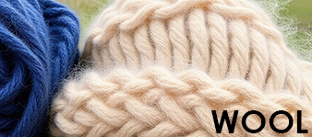

Wool, sourced from sheep, is a natural fabric cherished for its inherent warmth, resilience, and luxurious feel.
In advanced upholstery, wool adds a layer of comfort and sophistication, often chosen for its natural flame resistance and insulating properties.
Its versatility allows for applications in both classic and contemporary designs.

Synthetic Fabrics Exploration
Polyester:

Polyester, a synthetic fabric, has become a staple in advanced upholstery due to its durability, resistance to wrinkles, and ease of maintenance.
Its inherent strength makes it suitable for high-traffic areas, while its ability to resist fading and staining adds to its practicality.
Polyester is often chosen for its budget-friendly and versatile characteristics.

Nylon:

Nylon, known for its resilience and abrasion resistance, is a synthetic fabric favoured in upholstery for its strength and versatility.
Its ability to withstand heavy use makes it suitable for various furniture pieces, especially those subjected to frequent movement.
Nylon's inherent elasticity contributes to its longevity and comfort.

Microfiber:

Microfiber, a synthetic blend often composed of polyester and polyamide, offers a luxurious feel and exceptional durability.
Its fine fibres create a soft and plush texture, resembling natural materials like suede.
Microfiber is appreciated for its resistance to stains and easy cleaning, making it a popular choice for advanced upholstery in homes and commercial spaces.

Blended Fabrics
Combination of Natural and Synthetic Fibres:
Blended fabrics in advanced upholstery bring forth a harmonious fusion of natural and synthetic fibres, leveraging the strengths of each.
Combining the breathability of natural fibres with the durability of synthetics results in textiles that offer both comfort and longevity.
These blends often enhance texture, colour retention, and ease of care, presenting upholstery options that cater to diverse preferences and requirements.
The balance achieved in blended fabrics provides a versatile and adaptable choice for creating upholstered pieces that seamlessly integrate style and functionality.

Visual and Mechanical Ways of Identifying Fabrics and Leather
Burn Test:
The burn test is a method of identifying fabrics by observing how they burn and the characteristics of the ash or residue left behind.
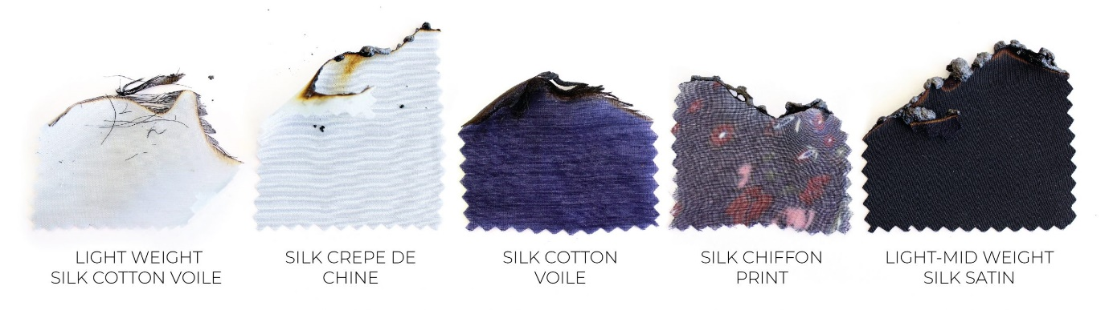
https://blog.megannielsen.com/2022/07/testing-your-textiles-how-to-use-burn-tests-fabric-characteristics-to-identify-composition/

Procedure:
Cotton:
Burns with a steady flame, smells like burning paper, and leaves a soft grey ash.

Wool:
Burns slowly with a faint odour of burning hair, and the ash is brittle and dark.
Polyester:
Burns with a melting, sizzling flame and leaves a hard, bead-like ash.

Silk:
Burns slowly with a smell of burning hair, and the ash is crispy and crushable.

Solubility Testing:
Solubility testing involves dissolving a small piece of fabric or leather in a solvent to identify its composition.

Procedure:
Cotton: Dissolves in water.
Polyester: Insoluble in water but dissolves in acetone.
Wool: Dissolves in certain solvents like bleach.
Leather: May show different solubility patterns based on tanning methods.

Identifying Natural Fabrics:
Guidelines:
Cotton:
Recognizable by its soft feel and breathability.

Wool:
Coarse texture, often with a natural sheen.
Silk:
Smooth and lustrous with a cool touch.

Polyester:
Smooth texture, often with a synthetic sheen.

Nylon:
Durable and has a somewhat slippery feel.

Microfiber:
Ultra-fine fibres, soft and suede-like texture.

Characteristics of Properties:
Comfort:
Relates to the softness, breathability, and tactile feel of the fabric or leather.

Appearance:
Encompasses visual aspects like colour, pattern, and finish.

Flame Resistance:
The ability of the material to resist catching fire or sustaining a flame.

Absorbency:
The capacity of the material to absorb liquids.

Fabric Pile and Grain Lines:
Pile refers to the surface texture, while grain lines indicate the direction of fibres in woven fabrics.

Stretch:
The degree to which a material can be stretched without losing its shape.

Durability:
The ability of the material to withstand wear, tear, and stress.
Creases and Wrinkles:
The tendency of the material to form folds or wrinkles.

Colours and Shades:
The variety of colours and their nuances within the material.

Impact on Upholstery:
Comfort:
Influences the overall feel and usability of upholstered furniture.

Appearance:
Determines the visual aesthetics of the furniture piece.

Flame Resistance:
Critical for ensuring safety compliance in upholstered products.

Absorbency:
Relevant for maintenance and cleanliness.

Fabric Pile and Grain Lines:
Affects the visual texture and design layout of the upholstery.

Stretch:
Important for fitting the material onto the furniture frame.

Durability:
A key factor in determining the lifespan of the upholstered furniture.

Creases and Wrinkles:
Impact the overall appearance and maintenance requirements.

Colours and Shades:
Contribute to the design and style of the furniture piece.

KT0102 Manufacturing processes of fabrics, leather and materials.
Embark on a journey through the intricate world of manufacturing processes that breathe life into fabrics, leather, and materials used in advanced upholstery. This module unravels the complexities of weaving, knitting, and non-woven techniques, providing a comprehensive understanding of how these processes shape the materials destined for high-quality upholstered creations.
Fabric Manufacturing Process
Fibre Production:
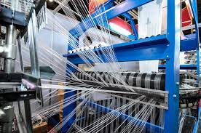

The process begins with the production of fibres, either natural (cotton, wool, silk) or synthetic (polyester, nylon, rayon).
Natural fibres are extracted from plants or animals, while synthetic fibres are created through chemical processes. Fibre quality and characteristics impact the final fabric.

Yarn Formation
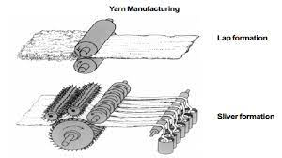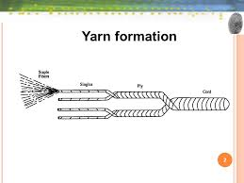
Fibres are twisted or spun to create yarn, which is a continuous strand of fibres.
The spinning process aligns the fibres, creating strength and cohesion. Yarn can be single or plied (multiple strands twisted together).
Weaving or Knitting
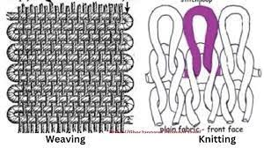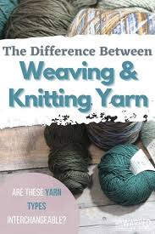

Yarn is interlaced to form fabric in weaving or looped to create fabric in knitting.
Weaving involves the horizontal (weft) and vertical (warp) interlacing of yarn, creating woven fabric. Knitting forms fabric by looping yarn together.

Dyeing and Printing
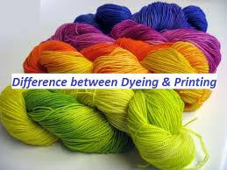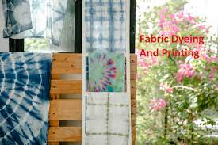
Fabric is coloured or patterned.
Dyeing involves immersing fabric in colour solutions, while printing applies patterns using pigments or dyes. Both processes enhance the aesthetic appeal of the fabric.

Finishing:
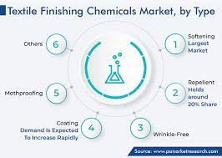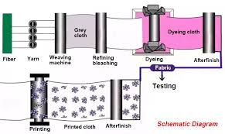
Final treatments for texture, appearance, and performance.
Finishing processes include treatments like bleaching, softening, or coating to achieve specific properties, such as smoothness, water resistance, or flame retardancy.

Quality Control:
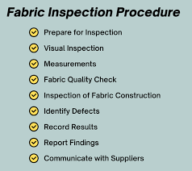
Inspection and testing to ensure fabric meets standards.
Rigorous quality control measures assess fabric characteristics, such as strength, colour-fastness, and durability, to meet industry and product specifications.

Leather Manufacturing Process
Preparation of Raw Hides
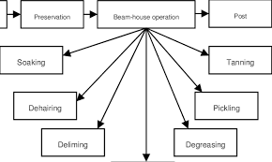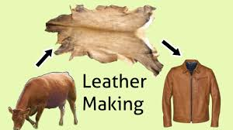
Initial treatment of animal hides.
Raw hides are cleaned, treated with chemicals to remove hair and flesh, and then preserved through salting or brining.

Tanning
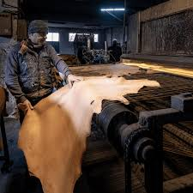
Transformation of hides into leather.
Tanning involves treating hides with chemicals (usually tannins) to stabilize and preserve them, imparting flexibility and durability to the leather.

Splitting and Shaving
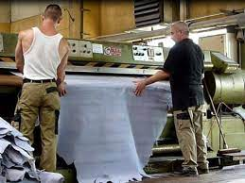
Adjusting thickness and removing imperfections.
Leather hides may be split into layers to achieve desired thickness. Shaving removes imperfections, creating a smooth surface.

Dyeing and Finishing
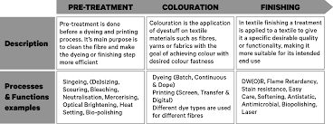
Colouring and final treatments.
Leather can be dyed to achieve various colours. Finishing involves treatments for texture, gloss, and added functionalities like water resistance or UV protection.

Cutting and Stitching

Shaping leather into usable components.
Leather is cut into patterns for various products and then stitched or bonded together to create finished items.

Quality Assurance
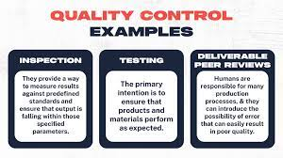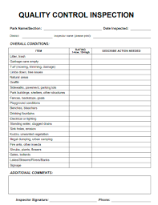
Inspection and testing of the final product.
Quality checks ensure that the leather meets standards for strength, colour, and overall appearance.
Materials Manufacturing Process (e.g., Synthetic Materials, Plastics)

Polymerisation
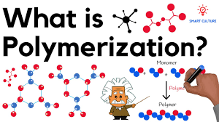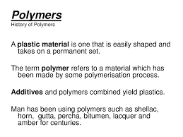
Creation of polymers.
Monomers are chemically bonded to form polymers, which serve as the building blocks for various materials.

Extrusion or Moulding
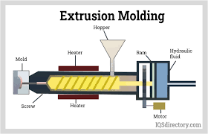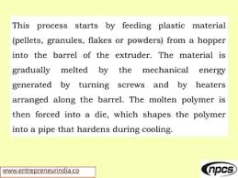
Shaping the material.
Polymers are heated and forced through moulds (extrusion) or injected into moulds (moulding) to create specific shapes.

Cooling and Solidification
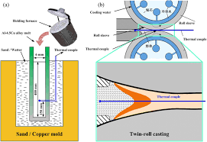
Setting the shape.
The shaped material is cooled and solidified, preserving its form and structure.

Cutting and Assembly
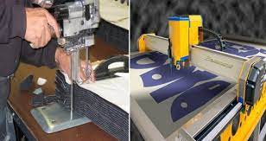
Shaping and combining materials.
Finished materials are cut into desired shapes and assembled to create final products, such as components for manufacturing goods.
Surface Treatment

Enhancing appearance or properties.
Materials may undergo surface treatments, including coatings, laminations, or texturing, to improve aesthetics or provide additional functionalities.

Quality Control
Inspection for consistency and performance.
Rigorous quality control measures ensure that the manufactured materials meet standards for strength, durability, and other specified properties.
Each manufacturing process involves intricate steps aimed at producing materials with specific characteristics and functionalities. Rigorous quality control and adherence to standards are essential throughout these processes to ensure the final products meet the desired specifications and standards.

KT0103 Properties and characteristics of fabrics, leather and materials.
The art of advanced upholstery hinges on an in-depth comprehension of the properties and characteristics inherent in fabrics, leather, and materials. Here we explore features such as comfort, appearance, flame resistance, absorbency, and more, unravelling the essence of what makes each material unique and crucial in the world of upholstery.
Comfort
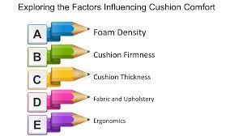

Factors affecting the comfort of upholstery materials:
Softness:
Softness is a critical factor influencing the comfort of upholstery materials. Materials that are plush and supple enhance the tactile experience for users.
Breathability:
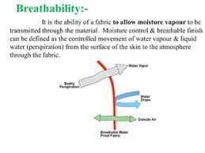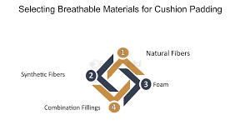
The ability of materials to allow air circulation is crucial for preventing discomfort caused by heat and moisture build-up.

Temperature Regulation:
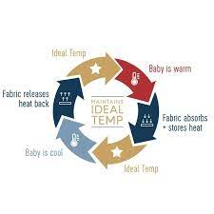
Upholstery materials should have the ability to regulate temperature, ensuring that users feel comfortable in varying climates. Breathable materials and those with moisture-wicking properties contribute to effective temperature regulation.

Appearance
Analysing the visual aspects of fabrics and leather:

Patterns:
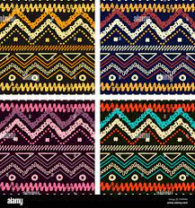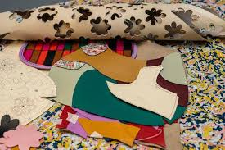

The choice of patterns in fabrics and leather significantly impacts the visual appeal of upholstery. Patterns can range from intricate designs to simple geometric shapes, influencing the overall aesthetic of furniture.

Colours:
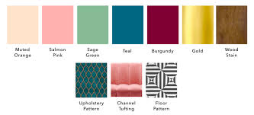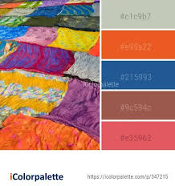
The colour palette chosen for upholstery materials plays a pivotal role in determining the visual harmony with the surrounding environment. Colours can evoke specific moods and complement the overall design scheme.

Finishes:
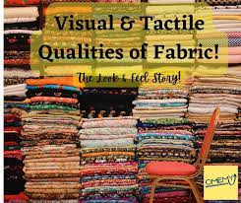

Finishes, such as gloss or matte, contribute to the tactile and visual characteristics of materials. Understanding the impact of different finishes is crucial for achieving the desired aesthetic.

Flame Resistance
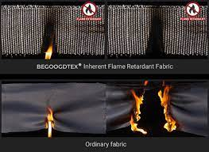

Explaining the importance of flame-resistant properties in upholstery materials:
Upholstery materials should meet safety standards, and flame resistance is a critical property for compliance.
Flame-resistant materials reduce the risk of fire hazards, making them essential for public spaces, homes, and commercial settings.
Understanding the flame resistance of materials is vital for ensuring user safety and adhering to regulatory requirements.

Absorbency
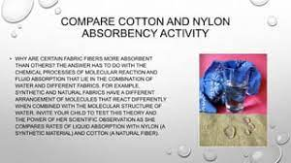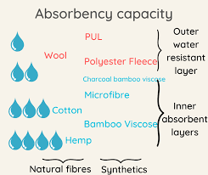

Addressing the absorbent nature of fabrics and its relevance:
Fabrics used in upholstery may vary in their absorbent properties, impacting how they handle spills and stains.
Absorbency is crucial for maintaining cleanliness, as materials that repel liquids may be easier to clean, while absorbent materials may require additional protection or treatment.
Consideration of absorbency is essential in choosing materials based on the expected usage and potential exposure to spills or moisture.

Fabric Pile and Grain Lines
Defining and discussing the significance of fabric pile and grain lines in upholstery design:

Fabric Pile:
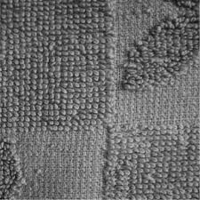
Refers to the surface texture created by raised fibres on the fabric. Understanding pile is crucial for selecting materials with the desired tactile feel and appearance.
Grain Lines:
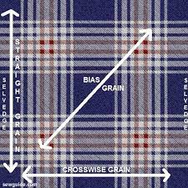
The orientation of fibres in a fabric. Proper alignment of grain lines is essential for achieving a uniform and visually pleasing appearance in upholstered furniture.
Upholstery designers must consider fabric pile and grain lines to ensure that the final product meets aesthetic and comfort expectations.
In summary, a comprehensive understanding of the properties and characteristics of fabrics, leather, and materials is essential for making informed decisions in upholstery design. Whether focusing on comfort, appearance, safety, absorbency, or specific design elements like pile and grain lines, designers and manufacturers can tailor their choices to meet the functional and aesthetic requirements of various applications.

KT0104 Testing of fabrics and leather.
Testing forms the bedrock of quality assurance in advanced upholstery, ensuring that fabrics and leather meet the highest standards. This module dives into the meticulous processes of testing, from shrinkage assessments to colour fastness tests, elucidating the significance of each test in guaranteeing the longevity, resilience, and aesthetic appeal of upholstered creations.
Identifying Fabric Faults:
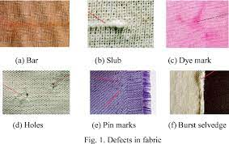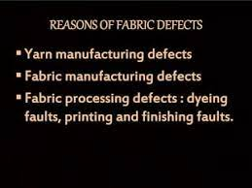
Fabric faults can be identified through visual inspection and tactile examination.

Process:
Visual Inspection:
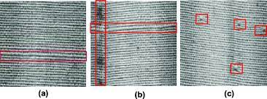
Look for irregularities, stains, or inconsistencies in the fabric's appearance.

Tactile Examination:
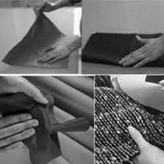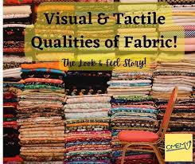
Feel the fabric to detect variations in texture or thickness.

Light Inspection:
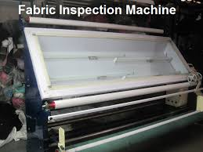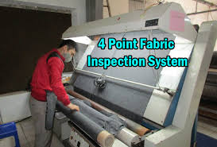
Use a light table to reveal flaws that might not be visible under normal lighting conditions.

Testing Procedures:
Shrinkage Test:
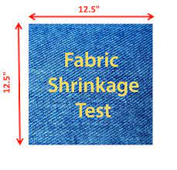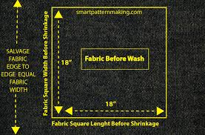
Shrinkage testing assesses how much a fabric or leather may shrink after exposure to moisture.

Procedure:
Pre-Wash Measurement:
Measure the fabric or leather before any exposure to water.

Wash and Dry:
Subject the material to standard washing and drying conditions.

Post-Wash Measurement:
Measure the material again after the washing and drying process.

Calculate Shrinkage:
Calculate the percentage of shrinkage based on the measurements.
Shrinkage testing ensures that materials maintain their dimensions and shape under normal usage conditions.

Colour Fastness Test:
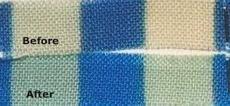
Colour fastness testing evaluates how well a material retains its colour when exposed to various conditions.

Procedure:
Rubbing Test:
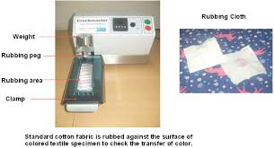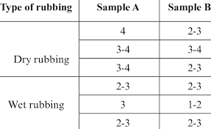
Rub the material against a standardized rubbing material to assess colour transfer.

Washing Test:
Subject the material to washing and evaluate colour retention.

Light Exposure Test:
Expose the material to light to test for colourfastness under sunlight or artificial light.
Colour fastness testing ensures that the fabric or leather retains its colour over time, even after exposure to wear, washing, and light.

KT0105 Fabric and leather quality (flaws and defects).
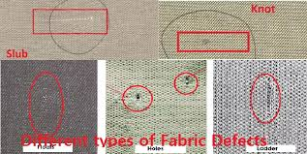
Upholstered masterpieces attain their peak when crafted from fabrics and leather of impeccable quality. This module scrutinises the intricacies of fabric and leather quality, identifying flaws and defects that can impact the overall aesthetic and durability of the final upholstered product. Learners will gain insights into recognising, assessing, and mitigating potential quality issues.

Types of Flaws and Damages
Shading:
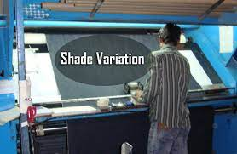
Shading refers to variations in colour intensity within a fabric or leather surface.

Effect on Quality:
Inconsistencies in shading can lead to an uneven appearance, affecting the overall aesthetic quality of upholstered furniture.

Batching:
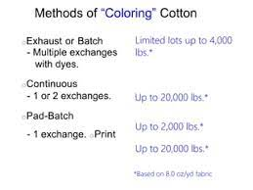
Batching occurs when materials from different dye lots are used, resulting in colour discrepancies.

Effect on Quality:
Batching can lead to visible colour variations between different sections of upholstery, impacting the cohesive look of the final product.

Analysing Quality
Considerations:
Consistency:
Evaluate the uniformity of colour, texture, and pattern across the material.

Integrity:
Assess the strength and structural integrity of the fabric or leather.

Finish:
Examine the surface finish for smoothness and evenness.

Problems and Faults Associated with Fabrics and Leather:
 | Fabric Problems | Leather Problems
 | Pilling | Cracking
Evaluation | Observe the formation of small balls of fibre on the fabric surface. | Inspect for visible cracks on the leather surface.
Solution | Use fabrics with higher resistance to pilling or incorporate protective finishes. | Apply leather conditioners to maintain moisture and flexibility.

 | Snags and Runs | Discoloration
Evaluation | Check for loose threads or runs in the fabric. | Note any changes in colour, especially in response to light exposure.
Solution | Repair snags promptly and avoid excessive handling to prevent runs. | Use UV-resistant finishes and keep leather away from direct sunlight.

Evaluation Methods and Solutions:
 | Fabric Evaluation | Leather Evaluation
 | Tensile Strength Test: | Flexibility Test
Evaluation | Assess the fabric's ability to withstand tension. | Evaluate the leather's flexibility and suppleness.
Solution | Choose fabrics with higher tensile strength for increased durability. | Use leather conditioners to maintain flexibility and prevent cracking.
 | Abrasion Resistance Test: | Colour Fastness Test:
Evaluation | Measure the fabric's resistance to wear and friction. | Assess how well the leather retains its colour under various conditions.
Solution | Select fabrics with higher abrasion resistance for upholstery in high-traffic areas. | Choose leather with high colour fastness to prevent discoloration.
KT0106 Labelling of the fabrics and leather.
The language of upholstery extends beyond fabrics and leather to the crucial realm of labelling. This module unfolds the art of tagging flaws and defects, the significance of labels reflecting information on meters, quality, cut numbers, and more. Understanding the importance of labelling is key to achieving traceability and maintaining the highest standards of quality in advanced upholstery.


Article:https://nancysnotions.com/labeling-and-documenting-fabric-rolls-a-systematic-approach/

Tagging of Flaws and Defects on Rolls of Cloth:
Tagging involves labelling or marking flaws and defects on rolls of fabric.
The allowed number of tags and rejection criteria are established to maintain quality standards.

Allowed Number of Tags
The industry often sets a specific limit on the number of allowable tags per roll.
Exceeding this limit may result in the rejection of the entire roll.

Rejection Criteria Examples
Excessive Flaws
Criteria:
If the number of identified flaws exceeds the specified limit.

Example:
A roll with more than five significant flaws may be rejected.

Critical Defects
Criteria:
Presence of critical defects impacting usability.

Example:
Rejecting rolls with tears or cuts compromising fabric integrity.

Labelling of Fabrics Reflecting Information
Information on Labels:
Labels on fabrics typically include details such as meters, quality, cut number, and cloth number.
These labels help identify and track each fabric roll.

Importance
Traceability:
Labels facilitate the tracking of fabric throughout the production process.

Quality Control:
Enables easy identification of fabric characteristics and quality parameters.

Traceability and Quality
Linked Importance
Labels provide a unique identifier for each roll, ensuring traceability from production to the finished product.
Quality control measures can be implemented more effectively with detailed information available on labels.

Example Scenario
Cut Number Identification
Importance:
Knowing the cut number helps match fabric pieces during upholstery assembly.

Traceability:
If an issue arises during production, identifying the cut number allows easy tracing of other rolls used in the same batch.

Cloth Number Reference
Importance:
Cloth number indicates the specific type or design of the fabric.

Quality Control:
If a defect is identified, referring to the cloth number ensures that other rolls of the same design are thoroughly inspected.

KT0107 Manual handling of fabric and leather.
Mastering the manual handling of fabrics and leather is a fundamental skill in advanced upholstery. This section explains correct methods and techniques, addressing considerations such as checks and stripes, distinguishing between wrong and right sides of materials, and understanding patterns. Upholstery craftsmanship is elevated when practitioners skilfully handle materials with precision and care.
Correct Methods/Techniques of Handling Fabric Manually
Rolling and Unrolling:
Technique:
Roll fabrics loosely to prevent creases and wrinkles.

Purpose:
Minimize the risk of damage and distortion during handling.

Lifting and Carrying:
Technique:
Lift and carry fabric rolls with care, distributing weight evenly.

Purpose:
Avoid tearing or straining the fabric, maintaining its structural integrity.

Folding:
Technique:
Fold fabrics carefully, aligning edges without causing permanent creases.

Purpose:
Preserve the fabric's appearance and prevent unnecessary wrinkles.

Checks and Stripes
Checks:
Identification:
Checks are patterns formed by intersecting lines, creating a grid-like design.

Handling Technique:
Align checks precisely during cutting to maintain pattern continuity.

Purpose:
Ensures uniformity in the final upholstery components.

Stripes:
Identification:
Stripes are long, narrow bands running parallel to each other.

Handling Technique:
Align stripes accurately to prevent distortion or misalignment in the final product.

Purpose:
Achieves a cohesive and visually pleasing appearance in the upholstery.

Distinguishing Between Wrong and Right Side of the Material
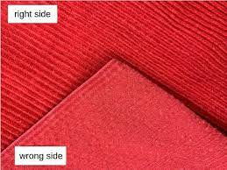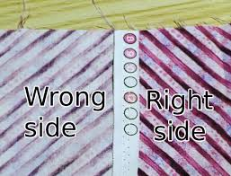
Technique:
Identify the right side (the surface meant to be visible) and the wrong side (the concealed surface) of the fabric.
Use subtle cues like texture, sheen, or pattern clarity to differentiate.

Purpose:
Ensures that the visible side of the fabric is consistently positioned in the upholstery, maintaining a consistent appearance.

Patterns and Repeat Patterns

Understanding Patterns:
Patterns refer to the design elements on the fabric surface, such as florals, geometrics, or motifs.
Repeat patterns involve the repetition of a specific design at regular intervals.

Handling Technique:
Align and match patterns accurately during cutting to maintain a seamless look in the final product.
Pay attention to the repeat interval to ensure continuity.

Purpose:
Achieves a harmonious and coordinated appearance in the upholstery, preventing disjointed patterns.

KT0108 Handling and storage of fabric and leather.
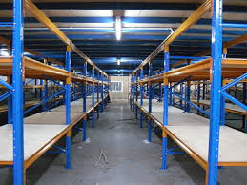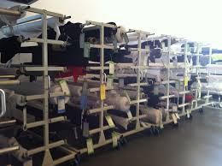
Ensuring the integrity and longevity of fabrics and leather necessitates a profound understanding of handling and storage practices. This module explores factors influencing handling, justifying correct storage methods, and providing practical tips on preserving materials. Upholstery artisans will navigate through the intricacies of storage orientation, humidity control, and temperature management to safeguard the raw materials that breathe life into their creations.

Factors Influencing Handling
Fabric Type:
Influence:
Delicate fabrics may require gentler handling to prevent damage.

Importance:
Protects the material from tears, snags, or deformation.

Weight of Rolls:
Influence:
Heavy rolls may require additional support during handling.

Importance:
Prevents strain on the fabric and ensures its structural integrity.

Environmental Conditions:
Influence:
Extreme temperatures or humidity can affect material properties.

Importance:
Maintains material stability and prevents adverse reactions.

Importance of Handling in Material Integrity
Preserving Quality:
Proper handling minimises the risk of damage, preserving the fabric's original quality.
Reduces the likelihood of flaws or defects that may compromise material integrity.

Justification for Correct Handling and Storage Practices
Preventing Deterioration:
Handling:
Avoids physical damage during transport and preparation.

Storage:
Shields materials from environmental factors that could lead to deterioration.

Practical Tips:
Handling:
Use clean, dry hands; avoid dragging; and provide adequate support during lifting.

Storage:
Utilise climate-controlled environments, keep materials off the floor, and use protective covers.

Justification for Correct Storage Methods
Storage Orientation:
Storing rolls upright prevents distortion and maintains fabric shape.

Humidity and Temperature:
Control humidity and temperature to prevent mould growth, degradation, and discoloration.

Light Intensity:
Protect fabrics from prolonged exposure to light to prevent fading and weakening of fibres.

Problems Related to Storage and Preventive Measures
Stock-Loss:
Preventive Measure:
Implement a tracking system to monitor inventory regularly.

Shrinkage:
Preventive Measure:
Store materials in a controlled environment to minimize temperature and humidity fluctuations.

Failures (e.g., Structural Damage):
Preventive Measure:
Ensure shelves and storage units are structurally sound and can support the weight of materials.

Waste:
Preventive Measure:
Rotate stock to use older materials first, reducing the risk of expiration or deterioration.
Safety Precautions Related to Storage
Organised Storage Environment reduces the risk of accidents, such as tripping or falling objects.
Proper storage minimizes the likelihood of material damage, contributing to the safety and quality of the final upholstered products.

KT0109 Advanced upholstery end-products.
Upholstery end-products span a broad spectrum of furniture pieces, ranging from traditional to contemporary designs. Common examples include sofas, chairs, ottomans, benches, headboards, and various decorative accents. The versatility of upholstered items allows for customisation to suit different preferences and interior styles.
Comfort and Functionality:
One of the primary objectives of upholstery is to enhance the comfort and functionality of furniture. Whether it is a plush sofa for relaxation or a well-padded dining chair for comfort during meals, upholstery end-products are crafted with the user's experience in mind. The selection of materials, padding, and design elements contributes to the overall comfort and usability of the furniture.

Aesthetic Appeal:
Upholstery is a significant factor in defining the visual appeal of furniture. The choice of fabrics, patterns, and colours allows for endless design possibilities. Upholstery end-products contribute to the overall aesthetics of a space, creating focal points and complementing the existing decor. From classic, timeless designs to modern, avant-garde styles, upholstery adds a layer of sophistication to furniture.

Quality Craftsmanship:
The creation of upholstery end-products requires skilled craftsmanship. Upholsterers meticulously apply their knowledge of fabrics, padding, and construction techniques to ensure the durability and longevity of the final pieces. Attention to detail in cutting, sewing, and finishing contributes to the overall quality and resilience of the upholstery.

Customisation and Personalisation:
Many upholstery end-products offer customization options, allowing customers to choose fabrics, colours, and design details to match their preferences. This level of personalization ensures that the furniture seamlessly integrates into the client's space, reflecting their individual style and taste.

Commercial and Residential Applications:
Upholstery end-products find application in both residential and commercial settings. In homes, upholstered furniture creates inviting and comfortable living spaces. In commercial environments, such as hotels, offices, and restaurants, upholstery plays a crucial role in establishing a welcoming atmosphere and contributing to the overall interior design concept.

Environmental Considerations:
As sustainability becomes increasingly important, there is a growing emphasis on eco-friendly materials and manufacturing processes in upholstery end-products. Upholsterers are exploring options such as recycled fabrics, environmentally friendly foams, and sustainable wood frames to align with broader environmental consciousness.

In summary, upholstery end-products represent the culmination of a meticulous process that transforms raw materials into functional, aesthetically pleasing, and comfortable furniture pieces. Whether for residential or commercial use, these items contribute significantly to the overall ambiance and functionality of a space, showcasing the artistry and craftsmanship of the upholstery industry.

Formative assessment

IAC0101 Visual and mechanical ways of identifying fabrics and leather (e.g. burn test, solubility testing) are described.
IAC0102 Various types of fabrics (natural and synthetics) used in advanced upholstery are identified.
IAC0103 The properties and characteristics of the various fabrics and materials and leather such as comfort, appearance, flame resistance, absorbency, fabric pile and grain lines, stretch, durability, creases and wrinkles, colours and shades, colour and colour variations are described.
IAC0104 Manufacturing processes of fabrics and leather (woven, knits, non-woven, cords, piping) are defined.
IAC0105 Fabric faults are identified and the effect thereof on the end-product is analysed.
IAC0106 Types of flaws and damages such as shading and batching and the effect of flaws and defects on fabric quality is reasoned.
IAC0107 The tagging of flaws and defects on roles of cloth is explained with reference to the allowed number of tags and rejects.
IAC0108 Factors determining the handling of fabrics, leather and materials are identified and explained.
IAC0109 Testing of fabrics and leather such as the shrinkage test and colour fastness test and why it is performed is explained.
IAC0110 The labelling of the fabrics reflecting information on meters, quality, cut number, cloth number and indicating the particular cut is justified.
IAC0111 The importance of fabric and leather quality in the manufacturing process is analysed.
IAC0112 Problems and faults associated with fabrics and leather are identified and possible ways to respond to it is evaluated.
IAC0113 The correct methods of manual handling of fabric with reference to checks and stripes, wrong and right side of the material, patterns and repeat patterns to ensure the quality of the cut upholstery components are described.
IAC0114 The correct handling and storage requirements and practices which will prevent deterioration is justified.
IAC0115 The correct storage methods (storage orientation, humidity, temperature, light intensity) of fabrics are justified.
IAC0116 Problems related to storage (stock-loss, shrinkage, failures, waste) are identified.
IAC0117 Safety precautionary measures related to storage are argued.
(Weight 15%)

SECTION 2: KM-06-KT02: Cutting lays (15%)

Learning Outcome
At the end of this section, learners should cover:

KT0201 Types.
KT0202 Cutting lays: to scale, full size.
KT0203 Cutting lay options: single lay; multi-lay.
KT0204 Cutting lay information: fabric width and length; cutting patterns and templates required; quantities; single lay; multi-lay; specific cutting details.
KT0205 Lay planning.
KT0206 Quality of the lay.

KT0201 Types.
Understanding the diverse methods of cutting lays is fundamental, encompassing both traditional manual approaches, where skilled operators play a crucial role, and advanced automated techniques utilizing cutting-edge machinery and technology.
Manual Cutting Lays:
Manual cutting lays involve the use of human operators to measure, mark, and cut materials. This traditional approach requires skilled labour and meticulous attention to detail.


Illustration above and list below are from: https://suitecitywoman.com/2017/07/26/30-diy-upholstery-tools-for-the-beginner-to-intermediate/
Staple remover or Tack lifter.
This trademarked tool by C.S. Osborne, resembles a screwdriver but has a forked head which makes it ideal for lifting tacks or staples from chairs without damaging the frame.
Heavy-duty stapler.
Used for uncomplicated, short term upholstery projects when fixing material to frames. Refer to manufacturer’s recommended staple sizes. Use a Pneumatic Air Staple Gun (see below in “Nice to Haves”) for more complex upholstery jobs or to reduce hand strain.
Hot-glue gun.
Used primarily for placing piping. The hot glue holds the piping in place before permanently securing it using staples. When purchasing hot glue sticks, buy the best quality you can find.
Side cutter.
Used to remove stubborn staples or tacks that your staple remover failed to lift completely. A good pair of general pliers may also do the trick and are a useful addition to your upholstery tool kit anyway.
Dust mask.
Use a dust mask to keep that dust out of your nose and mouth. Inexpensive ones can be purchased by the pack from dollar stores but look to hardware stores for heavier duty dust masks. Note: Use a respirator when using stain or paint strippers.
Shears.
Heavy duty scissors or shears carry extra weight in the blade which reduces hand fatigue and cramping in extended periods of use. The additional weight also imparts extra control and smoothness. Look for 9” or 12” tailor blades. Invest in a good set of shears and be prepared to sharpen the blades regularly which will become dull with repeated use.
Utility gloves.
Gloves will impair your dexterity for many upholstery tasks, but for stripping the old upholstery or moving bulkier pieces of furniture, they will go far in protecting your hands from splinters, cuts and even callouses.
Chalk.
One of a number of marking instruments that will come in handy in upholstery. Used to mark material prior to cutting. Sharpen to a point with a utility knife (see below in Have Already) for more precise marking. Tailor’s chalk, which has a waxy property and comes with honed edges, is also good to have on hand.
Flexible fabric tape measure.
Used for measuring chair parts, some of which may be curved and require precise measurements. Also used for measuring upholstery fabric, webbing, welting, etc.
Automated Cutting Lay

Automated cutting lays utilize machinery and technology to perform cutting tasks. Computer Numerical Control (CNC) machines, laser cutters, or other automated systems can increase precision and efficiency.

Examples below are taken from: https://www.omni-cnc.com/fabric-cutting/
Digital Cutting Machines: The All-Rounder for Multi-Layer Fabric Cutting
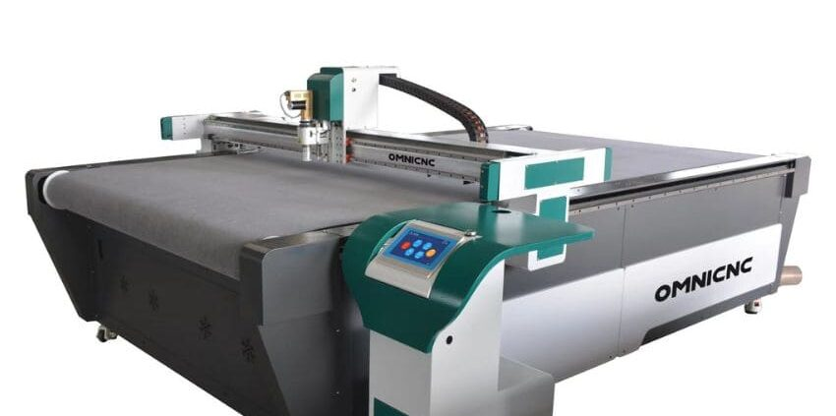
Auto-conveyer table could drag the fabric during work. Machine can cut to size, draw pattern, cut single and multi-layers. No need mould cost, no need waiting, draw in CAD software, download to controller and cut it on table at once.
Key Features of Digital Cutting Machines
Multi-layer cutting capability:
Efficiently cut through multiple layers of fabric, saving time and effort.

Precision cutting:
Achieve intricate and precise designs with high-quality edge finishes.

Variety of compatible materials:
Cut a wide range of fabrics, including cotton, silk, denim, and synthetic materials.

Versatility for various applications:
Suitable for apparel production, upholstery, home décor, and craft projects.

Laser Cutting Machines: Single-Layer Perfection for Delicate Fabrics

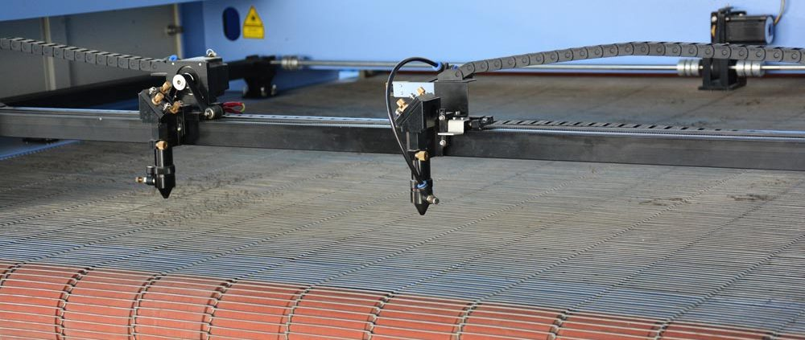
Laser cutting machine can cut fabric without pressure, therefore ensuring no rough edges or fraying during the process. Laser cut fabrics are typically found in luxury apparel that you may see in high end clothing stores, couture shops, and fashion runways.
Key Features of Laser Cutting Machines
Single-layer cutting:
Precisely cut single layers of fabric without causing fraying or distortion.

Heat-sealed edges:
Prevent fraying and maintain the integrity of delicate fabrics.

Intricate design capabilities:
Create intricate patterns and designs with high levels of detail.

Suitable for delicate fabrics:
Ideal for cutting silk, chiffon, lace, and other delicate materials.

KT0202 Cutting lays: to scale, full size.
The precision and accuracy of cutting lays hinge on the crucial decision of scaling, creating proportional representations, or opting for full-size cutting, directly impacting the replication of patterns onto materials and the overall quality of the end product.
Scaling and Full-Size Cutting:
Scaling involves creating a proportional representation of the cutting pattern, usually smaller or larger than the actual size.
Full-size cutting involves creating patterns at their intended size.

Importance and Practical Applications:
Scaling ensures accurate pattern replication, while full-size cutting allows for direct application of patterns onto materials.
This is crucial for maintaining design integrity, achieving accurate measurements, and minimizing errors in the final product.

KT0203 Cutting lay options: single lay; multi-lay.
Exploring the dichotomy of single and multi-lay options reveals distinct characteristics, advantages, and disadvantages, with considerations for cost-effectiveness in terms of fabric, time, and labour resources.
Single Lay
A single lay involves laying out one layer of fabric at a time before cutting. It's suitable for small-scale production or when precision is crucial.

Multi-Lay
Multi-lay involves stacking multiple layers of fabric for simultaneous cutting. This speeds up the process but requires careful alignment to maintain accuracy.

Advantages and Disadvantages

 | Advantages | Disadvantages
Single Lay | Precision, suitability for intricate designs. | Time-consuming for large-scale production.
Multi-Lay | Increased efficiency for large quantities. | Alignment challenges, potential for errors.

Cost-Effective Cutting Lay Options
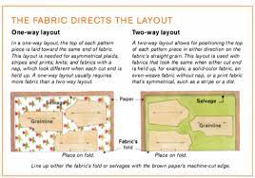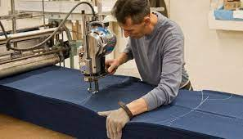
Consideration of resources such as fabric, time, and labour is vital. The choice between single and multi-lay depends on production scale, design complexity, and available resources.

Below are examples illustrating cost-effective cutting lay options, taking into consideration resources such as fabric, time, and labour:

Small-Scale Production with Complex Designs Scenario:
For a boutique producing limited quantities of intricate designer garments, opting for a single lay might be more cost-effective. The precision required for complex designs may outweigh the benefits of speed associated with multi-lay options.

Large-Scale Production of Basic Apparel Scenario:
In a mass-production setting where the focus is on producing a large volume of basic, uniform garments (e.g., t-shirts or work uniforms), a multi-lay approach can be cost-effective. The speed of cutting multiple layers simultaneously can significantly reduce labour and time costs.

Limited Fabric Availability Scenario:
If there is a shortage of a particular fabric, using a single lay might be more practical. It allows for precise placement of patterns to maximize the use of available material. In contrast, a multi-lay approach might result in more waste if the fabric is scarce.

Customized Production Runs Scenario:
When producing small batches of custom or personalized items, a single lay may be preferred. It allows for careful attention to detail, minimizing errors and ensuring that each item meets specific design requirements.
Quick Turnaround Requirements Scenario:
In a situation where quick turnaround is essential, a multi-lay approach could be cost-effective. While it might lead to slightly higher material waste, the time saved in the cutting process can be crucial for meeting tight deadlines.

Labour-Intensive Designs Scenario:
For garments that require intricate handwork or attention to detail during the sewing process, a single lay may be preferred. This ensures that each piece receives the necessary care, contributing to overall product quality.

Mixed Production Environment Scenario:
In a diversified production environment with a mix of simple and complex designs, a flexible approach is key. Combining single lay for intricate items and multi-lay for simpler designs can optimize both time and resources.

Automated Cutting for Standardized Products Scenario:
For products with standardized patterns (e.g., basic uniform components), an automated cutting lay using CNC machines may be a cost-effective choice. While the initial investment in technology is higher, the long-term efficiency gains can justify the cost.

These examples highlight the importance of evaluating various factors, including production scale, design complexity, and resource availability, to determine the most cost-effective cutting lay option for a given scenario.

KT0204 Cutting lay information: fabric width and length; cutting patterns and templates required; quantities; single lay; multi-lay; specific cutting details.
An integral aspect of effective cutting lays involves meticulous attention to details such as fabric width and length, cutting patterns, and quantities for single and multi-lay options, showcasing the importance of specific cutting details for various materials.
Necessary Cutting Lay Information
Fabric Width and Length Considerations:
Example:
If a fabric roll is 60 inches wide, it influences the layout to optimize material usage.

Cutting Patterns and Templates Required:
Example:
A dress pattern or template guides the cutting process for each garment piece.

Quantities for Single Lay and Multi-Lay:
Example:
Planning to cut 100 pieces may require a different strategy than cutting 10 pieces.

Specific Cutting Details for Different Materials:
Example:
Different materials may require varied cutting techniques to ensure quality and precision.

KT0205 Lay planning.
Unlocking the efficiency and precision in cutting lays relies on a strategic lay planning process, encompassing the use of markers, consideration of influencing factors, and the pursuit of optimisation for resource utilisation.
Lay Planning Process
Use of Markers
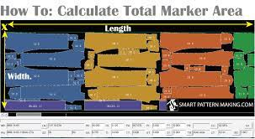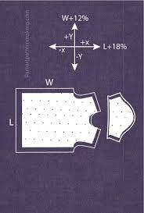
Markers are templates indicating the placement of patterns on fabric, optimising material usage.
Factors Influencing Lay Planning Decisions
Fabric properties,
Pattern complexity,
Production deadlines, and
Equipment capabilities.

Efficiency and Optimisation
Efficient lay planning minimises material waste, reduces production time, and ensures high-quality output.

Definitions:
Sample:
A representative piece used for testing and quality assurance.

Marker:
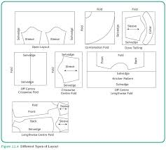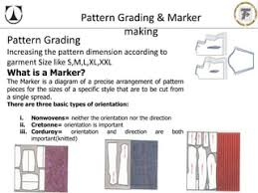
A template or layout guide indicating the arrangement of pattern pieces on fabric.

Work Instructions:
Detailed guidelines for performing specific tasks in the production process.

SOP (Standard Operating Procedures):
Established protocols for consistent and standardized operations.

Production Program:
A schedule outlining the sequence and timing of production tasks.
KT0206 Quality of the lay.
Ensuring the quality of cutting lays is a critical task that involves rigorous assessment and maintenance practices, identifying potential issues, and implementing proactive solutions to guarantee impeccable results in the production process.
Assessing and Maintaining Quality
Assessment:

Evaluate accuracy, alignment, and consistency of the cut pieces against the pattern.

Maintenance:
Ensure equipment calibration, proper blade sharpness, and adherence to quality control measures.

Identifying and Addressing Potential Issues
Common issues include:
Misalignment, fabric distortion, or defects in cutting patterns.

Solutions:
Regular equipment maintenance, operator training, and quality checks help prevent and address issues.

By understanding and implementing these concepts, individuals can contribute to effective cutting lays, optimizing resources and ensuring high-quality production outcomes.

Example of a Cutting Lay Specification

Objective | Ensure the effective implementation of cutting lays in the production process, emphasizing meticulous attention to details for optimized resource utilization and high-quality output.
Key Considerations
Fabric Width and Length | - Fabric rolls with varying widths and lengths must be accommodated.  - Meticulously measure and record the dimensions of available fabric to inform the lay planning process.
Cutting Patterns and Templates | - Utilise accurate cutting patterns and templates for each garment or product.  - Regularly update patterns to reflect design changes or improvements.
Quantities for Single and Multi-Lay | - Determine the appropriate cutting lay option based on production requirements.  - For single lay, assess the optimal placement of patterns for precision.  - For multi-lay, ensure careful alignment to maintain accuracy across layers.
Specific Cutting Details for Various Materials | - Consider the unique characteristics of different materials (e.g., textiles, leather) during the cutting process.  - Implement specific cutting details, such as recommended blade types or cutting techniques, for each material type.
Implementation Guidelines
Fabric Width and Length Assessment | - Conduct a thorough assessment of available fabric rolls, recording width and length specifications.  - Use this information to inform the lay planning process, maximising material utilisation.
Pattern and Template Management | - Maintain an organized system for cutting patterns and templates.  - Ensure that all patterns are labelled, updated, and easily accessible to production personnel.
Quantities Planning | - Assess production requirements to determine the most suitable cutting lay option (single or multi-lay).  - Document quantities for each lay, considering the balance between efficiency and precision.
Material-Specific Cutting Details | - Develop a comprehensive guide detailing cutting specifications for various materials used in production.  - Provide training to production staff on material-specific cutting techniques and considerations.
Quality Assurance Measures
Regular Quality Checks | - Implement regular checks during and after the cutting process to ensure accuracy and adherence to patterns.
Feedback Mechanism | - Establish a feedback loop where production personnel can report any challenges or improvements related to cutting details.
Continuous Improvement | - Encourage a culture of continuous improvement by regularly reviewing and updating cutting processes based on feedback and industry best practices.
Documentation
Fabric Specifications Record | - Maintain a record of fabric specifications, including width and length details.
Pattern and Template Catalogue | - Create a catalogue or database for easy reference to cutting patterns and templates.
Quantities and Lay Plans Documentation | - Document quantities for single and multi-lay options, including corresponding lay plans.
Material-Specific Cutting Guidelines | - Develop and distribute comprehensive guidelines for material-specific cutting details.
By adhering to these specifications, the cutting lay process will be streamlined, ensuring efficiency, resource optimization, and the production of high-quality goods.

Formative assessment

IAC0201 Understanding the sample, marker, work instructions, standard operating procedures and production programme, lay plan.
IAC0202 Cutting lay options and how to determine cost effective resources use.
(Weight 15%)

SECTION 3: KM-06-KT03: Laying up principles (15%)

Learning Outcome
At the end of this section, learners should cover:

KT0301 Inter-marking principles and fabric utilization.
KT0302 Principles of shrinkage, tension, crease free, ply movement.
KT0303 Styles, types, sizes and rating.
KT0304 Meeting lay plan requirements.
KT0305 Style specifications.
KT0306 Various types of lays.
KT0307 Fabric type and colour (identification using batch numbers).

KT0301 Inter-marking principles and fabric utilisation.
Inter-marking principles refer to the strategic placement of markers on fabric during the pattern layout process in the cutting phase of garment manufacturing. These principles are designed to optimise fabric utilisation, minimise waste, and enhance the efficiency of the cutting process.
Inter-marking involves arranging pattern pieces on fabric in a way that reduces empty spaces between them, thus maximising the use of available material. The goal is to achieve a balance between precision cutting, minimal material waste, and operational efficiency.

Key aspects of inter-marking principles include:

Pattern Nesting
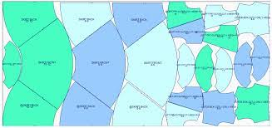
Explanation:
Optimizing pattern nesting is a key component of inter-marking principles, emphasising the arrangement of pattern pieces in a manner that minimises overlaps and gaps. This ensures efficient material usage and precise cutting.

Importance:
Proper pattern nesting is crucial for achieving the desired production output with minimal material waste. It requires careful consideration of pattern shapes, sizes, and orientations to enhance overall production efficiency.

Fabric Width Consideration
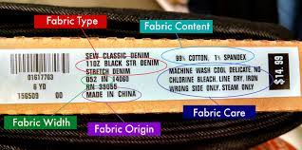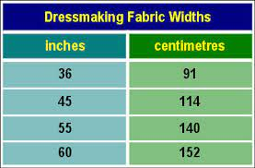
Explanation:
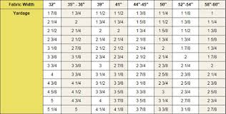
Inter marking principles involve considering the width of fabric rolls when planning the layout of pattern pieces. Understanding the dimensions of the fabric is crucial for optimising the arrangement of patterns, ensuring efficient material utilisation.

Importance:
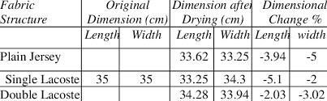

Factoring in fabric width helps prevent unnecessary waste and contributes to the cost-effective use of materials. It also influences the overall efficiency of the cutting process by determining the number and layout of pattern pieces that can fit on a fabric roll.

Marker Placement
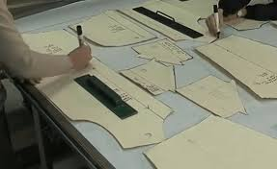
Explanation:
Marker placement is a key aspect of inter-marking principles, focusing on the strategic arrangement of markers on fabric to guide the cutting process accurately. Proper marker placement minimises fabric waste and contributes to the precision of pattern cutting.

Importance:
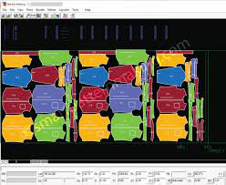
Well-placed markers are essential for achieving the desired shape and size of each pattern piece. Accurate marker placement directly influences the efficiency of the cutting process and the quality of the final product.

Efficient Material Utilisation:
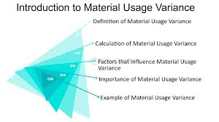
Explanation:

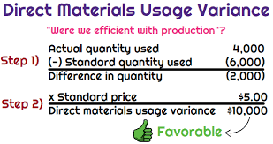

Inter-marking principles aim for efficient material utilisation, emphasising the need to maximise the use of available fabric and minimise waste. This involves careful planning and consideration of pattern layouts to achieve optimal results.

Importance:
Efficient material utilization is vital for reducing production costs and promoting sustainability. By minimizing waste, manufacturers contribute to environmentally responsible practices while maintaining economic viability.

Precision Cutting:
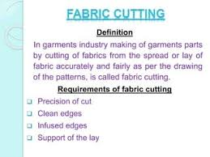
Explanation:
The ultimate goal of inter-marking principles is to achieve precision cutting. This involves accurately following the markers and layout to cut pattern pieces with the utmost accuracy, ensuring they match the intended design specifications.

Importance:
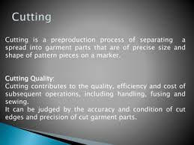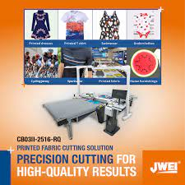
Precision cutting is critical for the overall quality of the finished product. It minimises errors, contributes to consistency in garment construction, and enhances the final aesthetic and functional aspects of the product.

Minimising Empty Spaces:
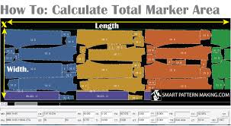
Explanation:
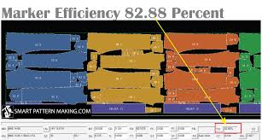
Inter-marking principles focus on minimizing empty spaces between pattern pieces on the fabric. This involves strategic nesting and arrangement to ensure that the fabric is utilised optimally, leaving minimal unused areas.

Importance:
Minimising empty spaces is essential for achieving maximum material utilization. It directly influences the efficiency of the cutting process by reducing waste and, subsequently, production costs.
By following inter-marking principles, manufacturers can achieve a more economical and environmentally friendly cutting process, ultimately contributing to the overall efficiency and sustainability of garment production.

KT0302 Principles of shrinkage, tension, crease free, ply movement.
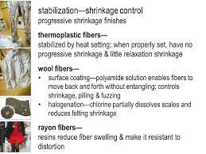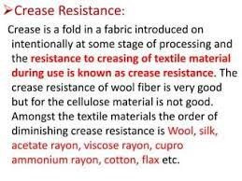
The principles of shrinkage, tension, crease resistance, and ply movement are critical considerations in the cutting phase of garment manufacturing. Each principle addresses specific challenges and characteristics of fabrics, influencing the accuracy and quality of the cutting process.
Shrinkage:
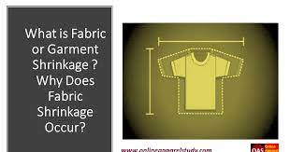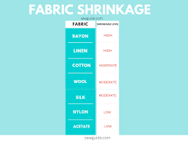
Explanation:
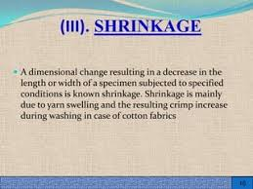
Shrinkage refers to the change in dimensions of a fabric due to moisture, heat, or other external factors. Fabrics can shrink during the cutting process or after garment construction.
Importance:
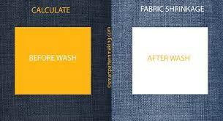
Understanding the potential for shrinkage is crucial for accurate pattern cutting. Pre-shrinking fabrics or adjusting patterns to account for potential shrinkage helps maintain the integrity of the final product.
Tension:
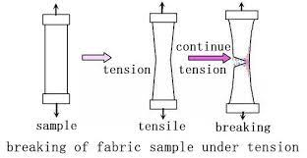
Explanation:
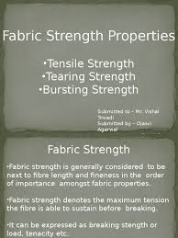
Tension in fabric occurs when the fibres are pulled or stretched. Tension can be caused by factors such as handling, machinery, or the fabric's inherent properties.
Importance:
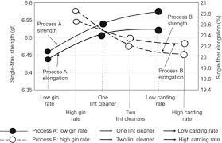
Fabric tension affects the accuracy of pattern cutting. Excessive tension can distort the fabric, leading to inaccuracies in the cut pieces. Managing tension is vital for achieving precision in pattern replication.
Crease Resistance:

Explanation:
Crease resistance refers to a fabric's ability to resist folding or wrinkling. Fabrics with good crease resistance maintain a smooth appearance even after folding or manipulation.
Importance:
Maintaining crease resistance is essential for achieving clean and accurate cuts. Fabrics that resist creasing are easier to handle during the cutting process, ensuring that pattern pieces maintain their intended shapes.
Ply Movement:
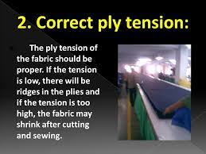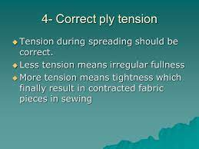
Explanation:
Ply movement refers to the shifting or movement of fabric layers (plies) during the cutting process. Layers may shift due to factors like fabric stretch, machinery movement, or manual handling.
Importance:
Understanding and managing ply movement is crucial for achieving precision in cutting. Movement between layers can result in misaligned pattern pieces, affecting the overall accuracy and quality of the final product.
Addressing these principles requires a combination of proper fabric handling, machinery adjustments, and, in some cases, the implementation of pre-treatment processes. Manufacturers must account for these factors in their cutting processes to ensure that patterns are replicated accurately, leading to high-quality and dimensionally stable finished products.

KT0303 Styles, types, sizes and rating.
Lay styles, types, sizes, and rating specifications play a pivotal role in determining the efficiency and quality of the cutting process. Different lay styles and types cater to specific production needs, while sizes and rating specifications ensure that the cutting process aligns with design requirements.

Understanding how each of these elements influences the cutting process is essential for achieving consistency, precision, and high-quality output. Proper consideration of lay styles, types, sizes, and ratings contributes to streamlined production processes and minimised errors.

Lay Styles
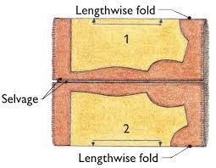
Definition:
Lay styles dictate the methodology employed in arranging and cutting fabric layers.

Examples:
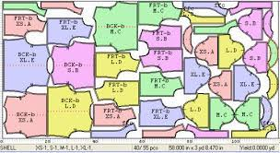
Marker lays involve strategic pattern placement, while spread lays evenly distribute fabric layers.

Importance:
Selection of an appropriate lay style hinges on production scale, material characteristics, and desired cutting efficiency.

Impact on Quality:
Properly chosen lay styles contribute to accurate pattern replication, minimising errors and ensuring consistent garment construction.

Impact on Efficiency:
The right lay style enhances cutting efficiency by minimising material waste and streamlining the cutting process.
Lay Types
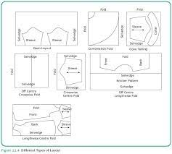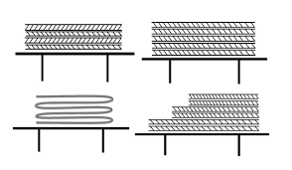
Definition:
Lay types encompass variations in the preparation and cutting of fabric layers.

Examples:
One-way lays ensure pattern alignment; zigzag lays optimize material usage through alternating piece directions.

Importance:
Tailoring the lay type to specific needs, such as pattern matching or efficient material usage, is crucial for effective cutting processes.

Impact on Quality:
Carefully chosen lay types contribute to pattern accuracy and fabric conservation, directly impacting the quality of the final product.

Impact on Efficiency:
Optimising lay types improves efficiency by accommodating specific design requirements and reducing material waste.

Sizes
Definition:
Sizes pertain to the dimensions and proportions of pattern pieces.

Considerations:
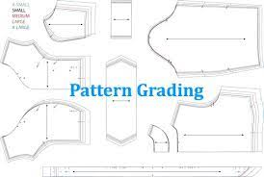
Scaling or grading patterns is essential for consistent sizing across different products.

Importance:
Proper handling of pattern sizes guarantees adherence to design specifications and ensures consistency in the final products.

Impact on Quality:
Accurate sizing, achieved through proper handling of pattern sizes, is critical for maintaining product consistency and meeting customer expectations.

Impact on Efficiency:
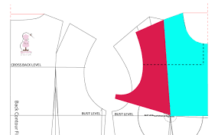
Efficient handling of pattern sizes streamlines the cutting process, reducing errors and ensuring uniformity in the final products.

Rating Specifications
Definition:
Rating specifications involve assigning grades or classifications to patterns based on their complexity or other attributes.

Examples:
Patterns may be rated for difficulty or efficiency based on design intricacy.

Importance:
Understanding and adhering to rating specifications contribute to streamlined production processes and minimized errors, fostering precision and consistency.

Impact on Quality:
Adhering to rating specifications ensures that patterns are handled appropriately, maintaining the quality of the final products.

Impact on Efficiency:
Efficiently managing patterns based on rating specifications improves production efficiency by aligning resources with the complexity of the design.

KT0304 Meeting lay plan requirements.
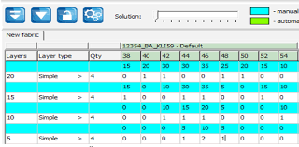
Meeting lay plan requirements is a crucial step in ensuring the seamless execution of cutting operations in garment manufacturing. A lay plan acts as a detailed blueprint, guiding the placement of patterns on fabric in a manner that considers various factors, including material properties, pattern intricacies, and production targets.

Definition:
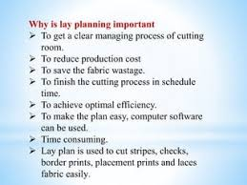
A lay plan is a visual representation of how pattern pieces are to be arranged on fabric for cutting. It accounts for the dimensions of the fabric rolls, pattern shapes, and the overall layout to optimize material usage.

Importance:
Guidance for Placement:
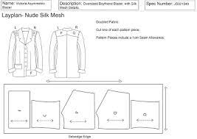
Lay plans provide clear guidance on where each pattern piece should be placed on the fabric, considering the intricacies of the design and ensuring an efficient cutting process.

Optimizing Material Utilization:
By adhering to the lay plan, manufacturers maximize the use of available fabric, minimizing waste and contributing to cost-effective production.

Precision and Accuracy:
Meeting lay plan requirements is instrumental in achieving accurate pattern replication, preventing errors that could compromise the quality of the final product.

Impact on Quality:
Consistency:
Following a well-designed lay plan ensures consistency in pattern placement, contributing to the uniformity of the final products.

Accuracy:
Adhering to lay plan requirements enhances the precision of pattern cutting, directly influencing the quality of the cut pieces.

Impact on Efficiency:
Streamlined Process:
Lay plans streamline the cutting process by providing a structured framework for organizing patterns on fabric. This minimizes guesswork and potential delays.

Resource Optimization:
Meeting lay plan requirements optimizes resource utilization, ensuring that the cutting process aligns with production goals and targets.

Challenges and Solutions:
Pattern Complexity:
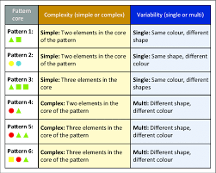
Lay plans must account for patterns with varying shapes and intricacies. This can be addressed through careful arrangement and consideration of the unique features of each pattern piece.
Batch Consistency:
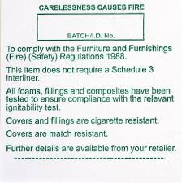
Maintaining consistency across production batches requires meticulous adherence to lay plan requirements. Regular reviews and adjustments may be necessary to accommodate design changes or improvements.
In summary, meeting lay plan requirements is an integral aspect of effective cutting operations. It not only provides a roadmap for pattern placement but also contributes to the overall efficiency, quality, and resource utilisation in garment manufacturing. Manufacturers must prioritise the accurate implementation of lay plans to achieve production goals while upholding high standards of quality.

KT0305 Style specifications
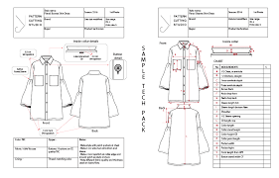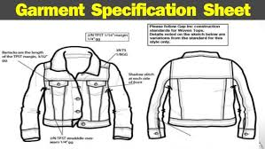
Style specifications are detailed instructions that guide the cutting process in garment manufacturing. They provide specific information on how each garment or product should be cut, ensuring accuracy and consistency in the creation of pattern pieces.
Importance:
Precision Cutting:
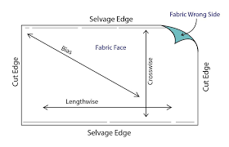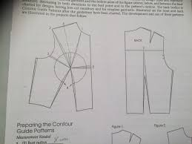
Style specifications play a crucial role in achieving precision during the cutting process. They provide clear guidelines on pattern placement, alignment, and dimensions, ensuring that each cut piece accurately reflects the intended design.

Quality Assurance:


Understanding and adhering to style specifications is fundamental for maintaining high-quality standards in the final product. It contributes to the uniformity and integrity of each garment or item, meeting or exceeding design expectations.

Consistency in Production:
Style specifications serve as a reference point for all cutting activities. By adhering to these specifications, manufacturers can minimize variations in the cutting process, ensuring that each piece is produced with the same level of accuracy and detail.

Key Aspects of Style Specifications:
Pattern Placement:
Description:
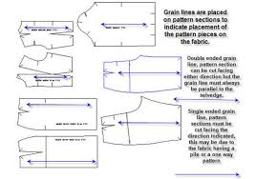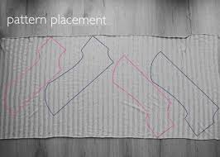
Style specifications dictate where each pattern piece should be placed on the fabric during the cutting process.

Importance:
Proper pattern placement is critical for achieving the desired aesthetic and fit of the final product. Style specifications ensure that each piece is positioned accurately.

Alignment and Grain Lines:
Description:
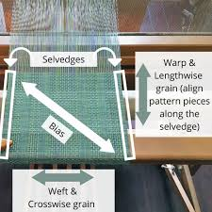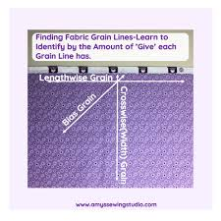
Style specifications provide instructions on aligning pattern pieces according to grain lines and other design elements.

Importance:
Proper alignment ensures that the fabric's natural grain is considered, contributing to the overall drape, appearance, and durability of the finished garment.

Dimensions and Sizing:
Description:
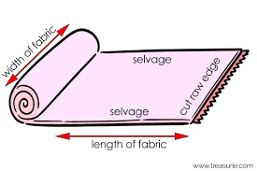
Style specifications include precise measurements for each pattern piece, ensuring accurate sizing and fit.

Importance:
Adherence to specified dimensions is crucial for consistency in sizing across different products and maintaining the integrity of the design.

Notches and Markings:
Description:
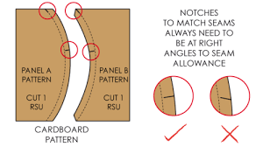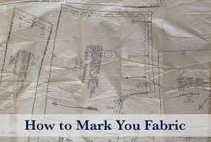
Style specifications may indicate the placement of notches, markings, or other indicators on pattern pieces for assembly and alignment during garment construction.

Importance:
Properly marked pattern pieces facilitate efficient assembly, reducing errors during the sewing and construction phases.

Cohesive Production Outcome:
Adherence to style specifications is not only about individual precision but also contributes to the overall cohesiveness of the production outcome. When every pattern piece is cut according to the same set of specifications, it ensures that the entire batch of products maintains a consistent level of quality and design integrity.

In summary, style specifications are a foundational element in the cutting process, providing a detailed roadmap for achieving precision, maintaining quality, and ensuring consistency throughout the production of garments or products. By following these specifications diligently, manufacturers can meet design standards, minimise variations, and produce a cohesive and high-quality final outcome.

KT0306 Various types of lays.
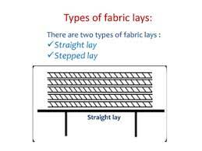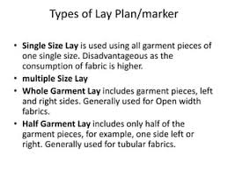
Exploring various types of lays is a crucial aspect of understanding the diverse methods employed in the cutting process within garment manufacturing. Different lay types, such as marker lays, spread lays, and cut lays, each serve specific purposes and come with unique characteristics. This exploration provides valuable insight into the intricacies of the cutting process and is instrumental in making informed decisions for efficient and effective production.

Key Types of Lays
Marker Lays:
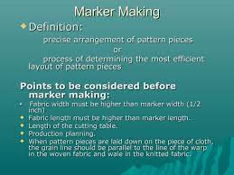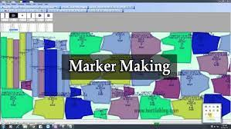
Description:
Marker lays involve arranging pattern pieces on a marker—a template that represents the cutting layout. The goal is to optimise material usage and minimise waste.

Purpose:
Marker lays are essential for maximising the efficiency of fabric utilisation, especially when working with limited quantities of expensive or specialty fabrics.

Spread Lays:
Description:
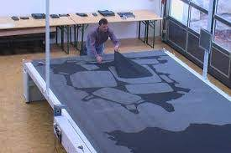 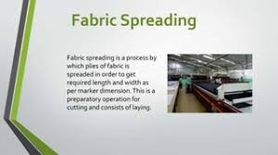s
Spread lays involve evenly spreading fabric layers before cutting. This method ensures uniformity and facilitates the cutting of multiple layers simultaneously.

Purpose:
Spread lays are particularly useful for large-scale production, allowing for efficient cutting of multiple identical pattern pieces with consistent quality.

Cut Lays:
Description:
Cut lays involve cutting individual layers of fabric one at a time. This method is often employed when precision and attention to detail are crucial.

Purpose:
Cut lays are suitable for scenarios where intricate patterns or special considerations require a more controlled and precise cutting approach.

Importance of Understanding Various Lay Types
Tailored Approach to Production:
Description:
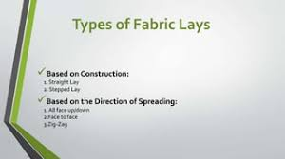
Different production scenarios may require different lay types. Understanding the characteristics of each type allows manufacturers to tailor their approach based on specific production requirements.

Significance:
This tailored approach contributes to the adaptability of production planning, ensuring that the chosen lay type aligns with the scale, complexity, and material characteristics of the production run.
Flexibility in Planning:
Description:
Knowledge of various lay types provides manufacturers with the flexibility to adapt their cutting processes to different situations and production scales.

Significance:
Flexibility in planning allows manufacturers to optimize resource utilisation, accommodate varying fabric types, and respond efficiently to changing production demands.

Optimal Efficiency:
Description:
By understanding the characteristics of each lay type, manufacturers can choose the most suitable approach to achieve optimal efficiency in the cutting process.

Significance:
Optimal efficiency results in minimised material waste, improved productivity, and streamlined production processes, ultimately contributing to cost-effectiveness.
In conclusion, exploring various types of lays is a fundamental aspect of mastering the intricacies of the cutting process in garment manufacturing. Each lay type serves a specific purpose, and a comprehensive understanding of their characteristics empowers manufacturers to make informed decisions, adapt to different production scenarios, and achieve optimal efficiency in the cutting phase. This knowledge is pivotal for maintaining high standards of quality, minimising waste, and ensuring the success of garment production endeavours.

KT0307 Fabric type and colour (identification using batch numbers).
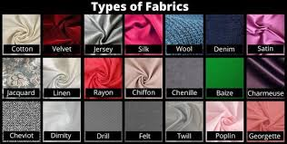
Analysing fabric type and colour is integral to the cutting process, as different materials may require specific handling techniques. Identification using batch numbers ensures consistency in colour and quality. Understanding how to analyse fabric types and colours allows manufacturers to offer tailored solutions, preventing errors in the cutting process and ensuring that finished products meet design specifications. Proper analysis contributes to the production of high-quality, visually consistent items, meeting customer expectations.

Importance of Analysing Fabric Type and Colour
Fabric Type Analysis
Description:

Analysing fabric type is a crucial step in the cutting process as different materials possess unique characteristics that impact how they should be handled during cutting.

Significance:
Understanding fabric types allows manufacturers to employ specific cutting techniques tailored to the material's properties, ensuring precision and maintaining the integrity of the fabric.
Colour Analysis
Description:

Evaluating the colour of the fabric is essential for maintaining visual consistency across the final products. Colour plays a significant role in the aesthetic appeal of garments or items.

Significance:
Accurate colour analysis ensures that the final products meet design specifications, creating a cohesive and visually pleasing collection.

Identification Using Batch Numbers
Description:
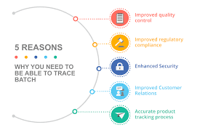
Assigning batch numbers to fabrics allows for systematic tracking and identification. Each batch number corresponds to specific fabric types and colours.

Significance:
Batch numbers serve as a reference point throughout the production process, ensuring that the same fabric types and colours are consistently used. This practice minimises variations, contributing to quality control and uniformity.

Consistency in Colour and Quality
Description:

Identification using batch numbers ensures consistency in both colour and quality across a production run. Fabrics from the same batch exhibit uniformity in appearance and characteristics.

Significance:
Consistency is vital for meeting customer expectations. Whether producing garments, upholstery, or other items, maintaining colour consistency enhances the overall visual appeal of the final products.

Tailored Solutions and Error Prevention
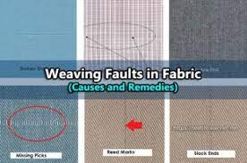
Description:
In-depth analysis of fabric types and colours enables manufacturers to offer tailored solutions based on the unique requirements of each material.

Significance:
Tailored solutions prevent errors in the cutting process by addressing specific considerations for each fabric type. This includes adjustments in cutting speed, blade selection, or handling techniques to optimise results.
Meeting Design Specifications
Description:
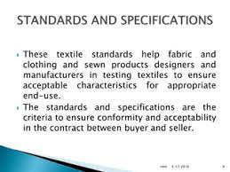
Proper analysis ensures that the finished products align with design specifications, including fabric type and colour requirements.

Significance:
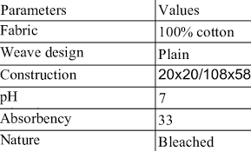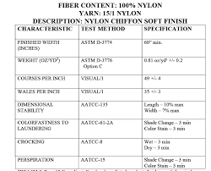
Meeting design specifications is critical for customer satisfaction. The ability to consistently produce items that match the intended design contributes to the reputation of the brand or manufacturer.

In conclusion, the thorough analysis of fabric type and colour, with the added layer of identification using batch numbers, is an integral part of the cutting process. It ensures that manufacturers have a deep understanding of the materials they are working with, allowing for tailored solutions, error prevention, and the production of high-quality, visually consistent items. By maintaining consistency in colour and quality, manufacturers enhance their ability to meet design specifications and customer expectations, ultimately contributing to the success of the production process.

Formative assessment

IAC0301 The application and importance of inter-marking principles are analysed with reference to the effect on production efficiency.
IAC0302 Principles of shrinkage, tension, crease free, ply movement are analysed in terms of lay efficiency and quality.
IAC0303 Aspects having an effect on the quality and efficiency of the lay such as types, sizes and styles specifications are analysed and described.
IAC0304 The effect of fabric type and colour on the lay is analysed and solutions are offered.
(Weight 15%)

SECTION: 4 KM-06-KT04: Lay planning (15%)

Learning Outcome
At the end of this section, learners should cover:

KT0401 Specifications and work ticket.
KT0402 Identification labels.
KT0403 Information on piece ticket.
KT0404 Lay plan or cut sheet.
KT0405 Understanding the sample, marker, work instructions, standard operating procedures and production programme, lay plan.

KT0401 Specifications and work ticket.
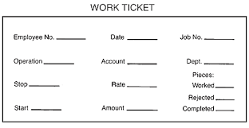
In lay planning, specifications and work tickets are the guiding documents that set the stage for precision. They provide detailed instructions and information vital for the accurate interpretation of the cutting process. Understanding these elements is paramount to aligning actions with job responsibilities and ensuring that the end product adheres to specified standards.
Accurate interpretation of the information on the work ticket or job card involves the following key components:
Fabric Specifications
Description:

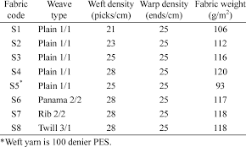

Details regarding the type of fabric to be used in the cutting process, including material composition, weight, texture, and any specific characteristics relevant to the production.

Importance:
Fabric specifications guide the selection and handling of materials, ensuring that the chosen fabric aligns with the intended design and performance requirements.

Pattern Requirements
Description:
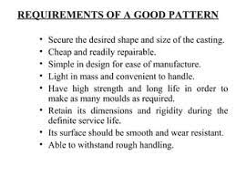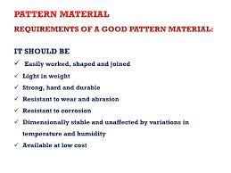
Information outlining the pattern pieces required for the production run, including the quantity, dimensions, and any specific details about pattern intricacies or variations.

Importance:
Clear understanding of pattern requirements ensures that the correct pieces are cut, contributing to the accurate assembly of the final product.

Specific Instructions
Description:
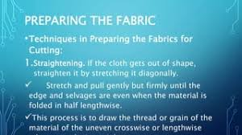
Any additional instructions or special considerations relevant to the cutting process. This may include details about pattern placement, handling specific fabrics, or adhering to unique design elements.

Importance:
Specific instructions provide additional context for the cutting process, ensuring that unique requirements are met and potential issues are addressed proactively.

Alignment with Job Responsibilities
Description:
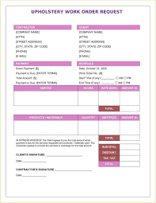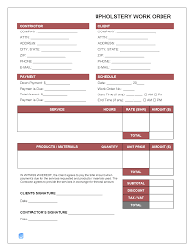
A clear linkage between the information on the work ticket or job card and the responsibilities outlined in the job role. This ensures that functions carried out during the cutting process align seamlessly with the defined job responsibilities.

Importance:
Alignment with job responsibilities is essential for maintaining efficiency and consistency, allowing each team member to contribute to the overall production goals effectively.

Target-Function Correlation
Description:
Establishing a direct correlation between production targets and individual functions by leveraging the information on specifications and work tickets. This ensures that each action contributes directly to achieving the production goals.

Importance:
The correlation between targets and functions ensures that the cutting process is not only accurate but also aligned with overarching production objectives, promoting efficiency and goal attainment.
Specifications and work tickets provide a comprehensive roadmap for the cutting process, encompassing fabric details, pattern requirements, specific instructions, alignment with job responsibilities, and a direct link between targets and functions. Accurate interpretation of these elements is crucial for orchestrating a successful and efficient cutting operation that meets design specifications and production goals.
KT0402 Identification labels.
Identification labels serve as pivotal components in the lay planning process, acting as tangible connectors between materials and their respective specifications. The ability to interpret and utilise these labels accurately is fundamental for maintaining order, precision, and efficiency throughout the cutting process.

Decoding Fabric Information
Description:
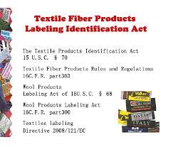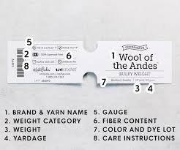
Identification labels contain essential information about the fabric, including its type, colour, and batch numbers. Decoding this information is the first step in understanding the characteristics and specifications of the material.

Importance:
Accurate decoding ensures that fabric properties align with the requirements of the lay planning process, preventing errors and facilitating seamless integration into the production workflow.

Seamless Material Integration
Description:
Accurate interpretation of identification labels facilitates the smooth integration of materials into the lay planning process. This involves matching the identified fabric with the corresponding specifications outlined in work tickets and other planning documents.

Importance:
Seamless integration ensures that the right materials are utilised in the right quantities, preventing mismatches and discrepancies that could lead to errors in the cutting process.

Fabric Type, Colour, and Batch Numbers
Description:
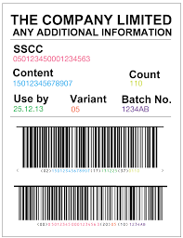
Identification labels typically include critical details such as fabric type (e.g., cotton, polyester), colour (e.g., red, blue), and batch numbers for traceability.

Importance:
Understanding fabric type guides handling techniques, colour information ensures visual consistency in the final product, and batch numbers allow for traceability and quality control. This comprehensive understanding is crucial for precise lay planning.

Linking Targets to Functions
Description:
Identification labels establish a direct link between production targets and individual functions in the lay planning process. This link ensures that the right materials are selected and used in accordance with the overall production goals.

Importance:
By linking targets to functions through identification labels, manufacturers align the cutting process with the broader production objectives. This alignment contributes to the overall efficiency and effectiveness of the cutting operation.

Contributing to Overall Efficiency
Description:
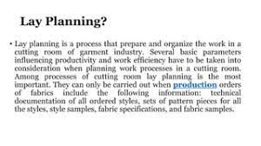
Utilising identification labels effectively streamlines the material selection process, reduces errors, and enhances overall efficiency in lay planning.

Importance:
Efficiency is critical for meeting production timelines and minimising waste. Accurate interpretation and use of identification labels contribute directly to the smooth functioning of the cutting operation, ensuring that resources are optimally utilised.

Identification labels serve as indispensable tools in the lay planning process, providing a tangible and informative link between materials and their specifications. Accurate interpretation of these labels is foundational for maintaining order, precision, and efficiency throughout the cutting process, contributing to the overall success of garment manufacturing.

KT0403 Information on piece ticket.

Piece tickets serve as indispensable guides in the intricate process of lay planning, acting as detailed companions to the actual fabric pieces. The accurate interpretation of information on piece tickets is fundamental for achieving precision in cutting and upholding stringent quality standards throughout the production process.

Critical Details on Piece Tickets
Description:
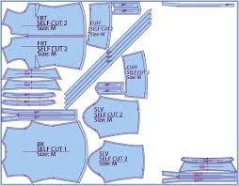
Piece tickets contain vital information crucial for the accurate execution of the cutting process. This information includes pattern names, dimensions, and any special considerations or instructions related to individual fabric pieces.

Importance:
Understanding these critical details is paramount for ensuring that each fabric piece is cut with precision and aligns with the specific requirements of the design and production standards.

Precision Cutting
Description:
Accurate interpretation of information on piece tickets directly contributes to precision cutting. This involves adhering to specified dimensions, pattern details, and any specific instructions that may influence the cutting technique.

Importance:
Precision cutting is essential for the assembly of garments or products, ensuring that each fabric piece fits seamlessly into the overall design and contributes to the desired final outcome.

Maintaining Quality Standards
Description:
Piece tickets play a crucial role in maintaining quality standards by providing detailed insights into each fabric piece's characteristics and requirements. This includes considerations for fabric type, colour, and any unique attributes.

Importance:
By adhering to the information on piece tickets, manufacturers uphold quality standards throughout the cutting process, contributing to the production of high-quality and consistent final products.

Aligning with Individual Responsibilities
Description:
The information on piece tickets establishes a direct connection between production targets and individual responsibilities. Each team member interprets and acts upon the details on the piece ticket in alignment with their assigned tasks.

Importance:
Aligning targets to functions through the information on piece tickets ensures that each team member understands their role in achieving production goals. This coordination fosters a collaborative and efficient cutting process.

Direct Connection to Production Goals
Description:
The linkage of targets to functions is established by aligning the information on piece tickets with individual responsibilities. This creates a direct connection between the details on the tickets and the overarching production goals.

Importance:
By understanding how their actions contribute to the overall production objectives, team members can work cohesively and efficiently, ensuring that each fabric piece is cut in accordance with the intended design and quality standards.

Piece tickets play a pivotal role in the lay planning process, providing detailed information essential for precision cutting and maintaining quality standards. Accurate interpretation of piece ticket details ensures that each fabric piece aligns with design specifications, contributing to the overall success of the lay planning and cutting operation.

KT0404 Lay plan or cut sheet.
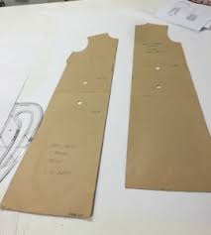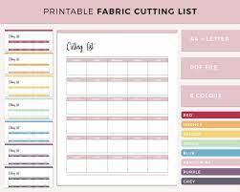
The lay plan or cut sheet stands as a visual blueprint for the arrangement of pattern pieces on fabric, representing a critical phase in the lay planning process. Accurate interpretation of the lay plan is instrumental in optimizing material usage and minimizing waste, key factors that significantly impact the efficiency of the cutting process.

Visual Representation of Pattern Arrangement
Description:
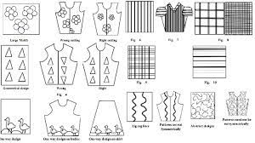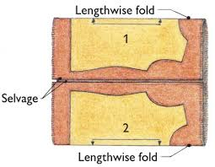
The lay plan or cut sheet serves as a graphical representation of how pattern pieces will be positioned on the fabric. It offers a visual guide to the layout, ensuring that each piece is strategically placed for efficient cutting.

Importance:
The visual representation aids in understanding the spatial relationship between pattern pieces, facilitating an organised and systematic approach to the cutting process.
Optimising Material Usage
Description:
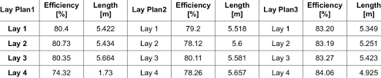
Accurate interpretation of the lay plan is crucial for optimising material usage. This involves strategically placing pattern pieces to minimise unused fabric areas and maximise the utilisation of available materials.

Importance:
Efficient material usage directly contributes to cost-effectiveness and sustainability. By minimising waste, manufacturers enhance their ability to produce more units with the same amount of fabric.

Minimising Waste
Description:
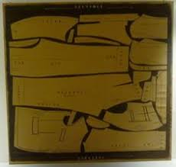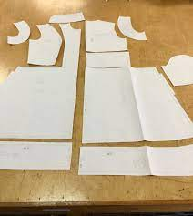
The lay plan or cut sheet guides the cutting process to minimise waste by determining the most efficient arrangement of pattern pieces. Accurate interpretation ensures that fabric remnants are kept to a minimum.

Importance:
Minimising waste not only supports environmental sustainability but also has economic implications, as it reduces the need for additional materials and contributes to overall cost savings.

Understanding Layout and Pattern Placement
Description:
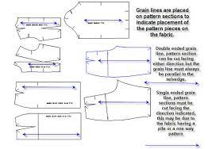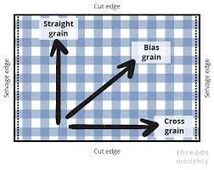
Accurate interpretation involves understanding the layout intricacies, such as the positioning of pattern pieces in relation to each other and the fabric. This includes considerations for grain lines, pattern repeats, and any specific instructions provided.

Importance:
Understanding layout and pattern placement is essential for ensuring that each piece is cut in the correct orientation and alignment, preventing errors and inconsistencies in the final product.

Aligning with Production Goals:
Description:
The cutting process must align with overarching production goals, and the lay plan serves as a crucial guide in achieving this alignment. Accurate interpretation ensures that the cutting operation is coordinated with the intended production targets.

Importance:
Aligning the cutting process with production goals fosters efficiency and consistency, allowing manufacturers to meet deadlines and fulfil orders in a timely manner.

Linking Targets to Functions:
Description:
By linking targets to functions through the lay plan, manufacturers establish a direct correlation between the visual representation and individual responsibilities. Each team member contributes to achieving production targets based on their role in the cutting process.

Importance:
This linkage ensures a collaborative and coordinated effort, where each team member understands their contribution to the overall efficiency of the cutting operation.

The lay plan or cut sheet is a pivotal tool in lay planning, offering a visual guide for pattern arrangement and material utilisation. Accurate interpretation is key to optimising resource usage, minimising waste, and aligning the cutting process with production goals, ultimately contributing to the overall efficiency and success of the manufacturing operation.

KT0405 Understanding the sample, marker, work instructions, standard operating procedures and production programme, lay plan.

To navigate the complexities of lay planning successfully, manufacturers must have a profound understanding of key elements such as samples, markers, work instructions, SOP, production programs, and lay plans. Accurate interpretation of these components is integral to ensuring that the cutting process aligns seamlessly with design specifications and overarching production goals.

Grasping Nuances of Samples for Design References
Description:
Samples serve as tangible representations of the final product, providing essential design references. Understanding the nuances of samples involves analysing details such as fabric drape, texture, and pattern intricacies.

Importance:
Grasping sample nuances is vital for aligning the cutting process with design specifications, ensuring that the fabric is handled and cut in a manner that preserves the intended aesthetic and structural characteristics.

Efficient Fabric Utilisation Through Markers
Description:
Markers are layouts that show how pattern pieces are arranged on fabric to optimise usage. Accurate interpretation of markers involves understanding the placement of pieces to minimise waste and maximise material utilisation.

Importance:
Efficient fabric utilisation contributes to cost-effectiveness and sustainability. Manufacturers can produce more units with the same amount of fabric, reducing overall production costs.

Precise Cutting with Work Instructions
Description:
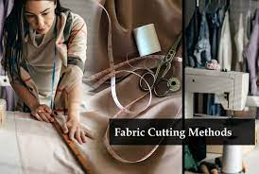
Work instructions provide detailed guidance on the cutting process, including specific techniques, tools, and considerations for handling different fabrics. Accurate interpretation ensures that each cut is executed precisely.

Importance:
Precise cutting is crucial for maintaining the integrity of the fabric and achieving consistency in the final product. Work instructions guide the cutting team in adopting standardised and effective techniques.
Adherence to Standard Operating Procedures (SOP)
Description:
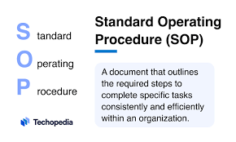
SOP outlines standardized procedures for the entire manufacturing process, including cutting. Accurate interpretation involves following established protocols for safety, quality control, and workflow consistency.

Importance:
Adherence to SOP ensures a standardised and regulated cutting process. This consistency minimises errors, enhances quality control, and contributes to a safe working environment.

Overarching Timelines with Production Programs
Description:
Production programs outline timelines for various phases of manufacturing, including cutting. Understanding production programs involves aligning the cutting schedule with broader production goals.

Importance:
Timely execution is critical in meeting production deadlines and fulfilling customer orders. Production programs provide a roadmap for efficient workflow management.

Visualising Layout Through Lay Plans:
Description:
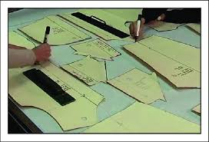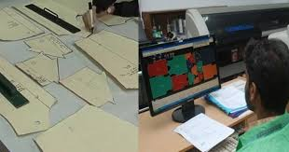
Lay plans visually represent the arrangement of pattern pieces on fabric. Accurate interpretation involves understanding the layout, pattern placement, and any specific instructions provided.

Importance:
Visualising the layout guides the cutting team in arranging pattern pieces strategically, minimising waste, and optimising material usage. It contributes to the overall efficiency of the cutting operation.

Linking Targets to Functions:
Description:
By comprehensively understanding these elements, manufacturers can link targets to functions. This involves ensuring that each team member understands their role in the cutting process and how it contributes to the overarching production goals.

Importance:
The linkage of targets to functions fosters a cohesive and well-coordinated approach to the cutting process. It enhances teamwork, efficiency, and the ability to meet production objectives.

Understanding samples, markers, work instructions, SOP, production programs, and lay plans is fundamental to successful lay planning. Accurate interpretation of these components ensures a cohesive and well-coordinated approach to the cutting process, aligning it with design specifications and overarching production goals. This comprehensive understanding contributes to efficiency, consistency, and the overall success of the manufacturing operation.

Importance of a Work Area Free from Hazards

Maintaining a work area free from hazards is not just a standard practice; it is a fundamental aspect that underpins the success of the lay planning process and ensures the overall safety of the manufacturing environment. Hazards, if present, have the potential to disrupt efficiency, compromise the quality of work, and pose serious risks to the well-being of workers. This emphasises the critical role of a hazard-free work area in facilitating a smooth and secure workflow.

Efficiency and Workflow Continuity
Description:

A work area free from hazards contributes to a seamless and uninterrupted workflow. Without the hindrance of safety concerns, team members can focus on their tasks with increased efficiency.

Importance:
Efficiency is essential in meeting production timelines and goals. A hazard-free environment minimises interruptions, ensuring that the lay planning process progresses smoothly and without unnecessary delays.

Accuracy and Error Reduction
Description:

Hazards in the work area can lead to distractions, affecting the accuracy of tasks performed. A hazard-free environment promotes concentration and attention to detail, reducing the likelihood of errors.

Importance:
In lay planning, precision is crucial. A hazard-free work area minimises the risk of mistakes in pattern placement, cutting, and other critical tasks, contributing to the overall quality of the final product.

Worker Well-being and Safety
Description:

The primary concern of a hazard-free work area is the well-being and safety of workers. Hazards, whether physical or environmental, can pose risks to the health and safety of personnel.
Importance:
Prioritising worker safety is a moral and legal responsibility. A safe work environment not only prevents accidents and injuries but also fosters a positive and secure atmosphere for employees to carry out their responsibilities.

Long-Term Productivity
Description:
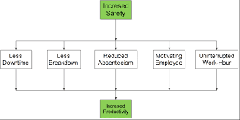
The importance of a hazard-free work area extends to long-term productivity. Continuous exposure to hazards can result in injuries, absenteeism, and decreased morale, negatively impacting the overall productivity of the manufacturing process.

Importance:
A safe and healthy work environment contributes to the sustained well-being and productivity of the workforce. It fosters a positive workplace culture, reducing turnover and enhancing overall employee satisfaction.

Employee Satisfaction
Description:
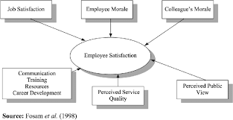
Providing a hazard-free work environment demonstrates an employer's commitment to the well-being and satisfaction of employees. It creates a positive workplace culture that values the health and safety of the workforce.

Importance:
Employee satisfaction is linked to morale, engagement, and retention. A safe work area contributes to a positive work environment, enhancing job satisfaction and promoting a sense of well-being among employees.

Overall Success of the Manufacturing Process
Description:
The success of the lay planning process is intricately tied to the overall success of the manufacturing process. A hazard-free work area ensures that each phase of production, including lay planning, is executed with precision and without compromising safety.

Importance:
A safe work environment is a cornerstone of overall success. It sets the foundation for quality production, on-time delivery, and the achievement of business objectives, contributing to the sustained success of the manufacturing process.

The importance of a work area free from hazards cannot be overstated. It is a critical factor in ensuring the success of the lay planning process, promoting efficiency, reducing errors, prioritising worker safety, and contributing to the long-term productivity and overall success of the manufacturing environment. A commitment to a hazard-free work area reflects a dedication to the well-being and satisfaction of the workforce, aligning with the principles of responsible and sustainable manufacturing.

Formative assessment

IAC0401 The information on the work ticket or job card is accurately interpreted and the functions described in line with the responsibilities of job role.
IAC0402 The sample, marker, work instructions, standard operating procedures and production programme, lay plan is accurately interpreted and the functions are described.
IAC0403 Work targets are identified and interpreted and any special instructions are identified.
IAC0404 The importance of a work area free from hazards are justified.
(Weight 15%)

SECTION: 6 KM-06-KT05: Process of building up the lay / lay-up methodology (25%)

Learning Outcome
At the end of this section, learners should cover:

KT0501 Preparing the table for the lay.
KT0502 Securing the lay.
KT0503 End cutting.
KT0504 Accurate placing of the patterns and templates.
KT0505 Splices and use of paper.
KT0506 Identification of fabric faults and defects.
KT0507 Identification of laying-up faults.
KT0508 Fabric laying procedure and stretching techniques.
KT0509 Considering the marker specifications.
KT0510 Moving and handling the lay.

Formative assessment

IAC0501 Important aspects to consider when preparing the table for the lay are identified and reasoned.
IAC0502 The importance of building an accurate and correct lay applying laying-up principles are argued and the effect on the quality on the end products is justified.
IAC0503 Methods of securing the lay are identified.
IAC0504 Important aspects to consider when securing the lay are reasoned.
IAC0505 End cutting methods are defined and described according to the reasons for use.
IAC0506 Fabric folding procedures are described with reference to implications for quality.
IAC0507 The correct terminology and definitions such as splicing, end-bits, off-cuts, bowing, etc. are given indicating the function of each.
IAC0508 Measuring units and metric system are understood and the application in the laying-up process is described.
(Weight 25%)

SECTION: 6 KM-06-KT06: Quality of the lay (15%)

Learning Outcome
At the end of this section, learners should cover:
KT0601 End-allowances.
KT0602 Edge alignment.
KT0603 Fabric tension.
KT0604 Direction of the fabric.
KT0605 Distortion of the lay.
KT0606 Alignment of checks and stripes.
KT0607 Fabric patterns and repeat patterns.

Formative assessment

IAC0601 Factors impacting on the quality of the lay such as end-allowances, edge alignment, fabric tension, direction, distortion and alignment of checks and stripes, patterns and repeat patterns are identified and correct procedures are described.
IAC0602 The importance of performing visual inspection procedures to ensure the fabric is free from basic fabric defects are justified.
IAC0603 Laying up allowance is defined and its significance is reasoned.
IAC0604 Application of specified length is described.
IAC0605 The importance of understanding the marker requirements is justified.
IAC0606 The significance of the shading is understood and identified in terms of the quality of the end product.
(Weight 15%)
Provider Programme Accreditation Criteria:
Physical Requirements:
The provider must have lesson plans and structured learning material or provide learners with access to structured learning material that addresses all the topics in all the knowledge modules.
Human Resource Requirements:
Lecturer/learner ratio of 1:20.
Qualifications of lecturers: 5 years relevant experience or NQF 2 58227 with 2 years of experience.
Legal Requirements:
OHS compliant.
Exemptions
No exemptions, but the module can be achieved in full through a normal RPL process.

