

FURNITURE UPHOLSTERER

KM08 ADVANCED COMPLEX COVERS FOR UPHOLSTERY

LEARNER GUIDE

Advanced Complex Covers for Upholstery

LEARNER GUIDE

Module # | KM-08
NQF Level | 3
Notional hours | 40
Credit(s) | 4
Curriculum Code | 683401000
SAQA QUAL ID | 103199
Qualification Title | Occupational Certificate: Furniture Upholsterer NQF Level 4, Credits 549

LEARNER CONTACT INFORMATION:

Name
Contact Address
Telephone (H)
Telephone (W)
Cellular

TABLE OF CONTENTS

PURPOSE OF THE QUALIFICATION 5
QUALIFICATION RULES 7
EXIT LEVEL OUTCOMES 9
ENTRY REQUIREMENTS: 10
ARTICULATION OPTIONS 11
ASSESSMENT REQUIREMENTS 12
PROVIDER ACCREDITATION REQUIREMENTS FOR THE MODULE: 13
SECTION 1: KM-01-KT01: Roles and responsibilities of the Occupational Health and safety representative as set out in the relevant legislation (Intermediate) (30%) 16
1.1 Explain the purpose of the Occupational health and Safety representative 16
1.2. Describe the process for appointing Occupational Health and safety representatives 28
1.3 Explain the functions of the occupational Health and safety Committees 30
SECTION 2: KM-01-KT02: Legislative requirements related to Occupational health and safety (Basic) (10%) 36
2.1 Explain the purpose and structure of the relevant legislation applicable to a specific workplace 36
2.2. Explain the difference between the various legislative instruments 48
SECTION 3: KM-01-KT03: Definitions of and difference between Occupational Health, Occupational Safety and Environmental management. (Basic) (10%) 56
3.1 Define and describe occupational health, safety and environmental control 56
SECTION 4: Concept of behavioural safety management (Basic) (10%) 60
4.1 Explain what is meant by behaviour and how the behaviour of people influences their health and safety 60
4.2. Describe the factors that influence the behaviour of people and give examples of this in a work environment 60
4.3 Identify and explain the role of behavioral modification in influencing the overall health and safety of employees 62
4.4. Explain what contribution leadership can make towards creating a culture where unacceptable behaviour regarding health and safety issues are not tolerated 63
SECTION 5: KM-01-KT05: Concepts and principles of emergency preparedness and response (Basic) (20%) 66
5.1 Explain the definition of an emergency and give examples of typical emergencies that could occur in the workplace 66
5.2. Explain the difference between preparedness and response and give examples of typical preparedness and response actions 68
5.3 Describe the roles of the various role players to ensure that an organisation is adequately prepared for emergencies 70
5.4. Describe the roles of the various role players when an emergency occur. 72
SECTION 6: KM-01-KT06: The principles of hazards identification and risks assessment (Basic) (5%) 79
6.1 Give practical examples to explain what a hazard is and how hazards relate to risks 79
6.2. Explain the concept of priority setting and relate it to the process of hazard and risk rating 83
SECTION 7: KM-01-KT07: Principles of safe working practices in and around the place of work (Intermediate) (5%) 93
7.1 Explain what is meant by a working practice using practical examples (NQF Level: 2) 93
7.2. Explain the concept of habits and how good and bad habits can be established with specific reference to occupational health and safety situations 97
SECTION 8: KM-01-KT08: Techniques of accident and incident investigation (5%) 101
8.1 Explain the difference between an accident and incident 101
8.2. Describe the generally accepted hierarchy of how incidents lead to accidents 101
8.3 Explain the basic process of accident and incident investigation 103
SECTION 9: KM-01-KT09: Roles and responsibilities of the various stakeholders in a workplace regarding Occupational Health and Safety (Intermediate) (5%) 116
9.1 List the key stakeholders that are involved in the prevention of accidents and 116
incidents in the workplace 116
9.2. Describe the role of each of the key stakeholders in preventing accidents and incidents 117
9.3 Explain the consequences when a stakeholder does not execute their duty in accident/incident prevention 123
9.4. Explain the role of the safety representative when one of the other stakeholders do not do what is expected of them 125

PURPOSE OF THE QUALIFICATION

Purpose:
The purpose of this qualification is to equip a learner with knowledge, skills and competencies to perform duties as a Furniture Upholsterer.

A Furniture Upholsterer manufactures an upholstered furnishing item by fitting suspension and padding and covering a frame to give it shape, comfort, and functionality for a range of domestic, commercial and decorative uses.

A qualified learner will be able to:
Read and interpret a design, drawing or sketch and take accurate measurements and calculate/estimate the number of fabrics, leather, man-made fabrics, padding and other raw material such as springs and webbing.
Make upholstery patterns and produce templates from sketches, customer descriptions or blueprints which match all quality standards.
Lay out, measure, cut and sew upholstery materials following patterns, templates, sketches, or design specifications.
Interpret specifications and prepare foundations for upholstered frames by attaching webbing, springs, foam and/or padding securely to the frame.
Fit slipcovers and loose material panels to cover frames with materials using staples, tacks and/or glue.
Manufacture upholstered furniture, upholstery prototypes and repair and re-upholster damaged furniture.

Rationale:
This qualification will equip learners with the necessary skills and competencies to operate as upholsterers by applying upholstery skills to fit springs, webbing, padding and covering a wide range of objects covered with fabric, leather, rexine or other upholstery material. After successful completion of this qualification, the learner will be skilled and capable of creating ergonomic and comfortable furniture using both traditional and modern techniques, materials and fabrics to produce aesthetically pleasing and fit for purpose consumer products.
Learners will find employment as frame preparers, cover fitters, patternmakers and furniture finishers, upholsterers or upholstery prototype makers and upholstery repairers. These skills will also open opportunities for self-employment.

Target groups identified include school leavers with a National Qualifications Framework (NQF) Level 2 qualification or persons who have been working in the furniture industry without formal qualifications and have the desire to formalise their skills and knowledge.

Employers will benefit from appointing qualified workers in terms of increased productivity and ability to be competitive in the international market and seek markets abroad supplying quality upholstered furniture and furnishings.

QUALIFICATION RULES

This qualification is made up of the following compulsory Knowledge, Practical Skill and Workplace Learning Modules:

Knowledge Modules:
683401000-KM-01, Basic Principles for Manufacturing of Upholstered Furniture, NQF Level 2, Credits 4
683401000-KM-02, Upholstered furniture frame preparation, NQF Level 2, Credits 8
683401000-KM-03, Upholstered Furniture Basic Cover Fitting, NQF Level 2, Credits 8
683401000-KM-04, Advanced Upholstery Furniture Technology, NQF Level 3, Credits 2
683401000-KM-05, Upholstery Pattern and Template Making Principles, Methods and Equipment, NQF Level 3, Credits 5
683401000-KM-06, Cutting Lay Requirements for Upholstery Fabrics and Materials, NQF Level 3, Credits 3
683401000-KM-07, Advanced Covering Techniques for Complex and Exposed Frames, NQF Level 3, Credits 4
683401000-KM-08, Advanced Complex Covers for Upholstery, NQF Level 3, Credits 4
683401000-KM-09, Complex Shaped Cushions and Padded Items, NQF Level 3, Credits 2
683401000-KM-10, Deep Buttoning of Upholstered Furniture, NQF Level 3, Credits 5
683401000-KM-11, Upholstered Furniture and Prototype Making Principles, NQF Level 4, Credits 13
683401000-KM-12, Raw Materials, Consumables, Tools and Equipment Used in Manufacturing of Upholstered Furniture Prototypes, NQF Level 4, Credits 8
683401000-KM-13, Manufacturing Principles and Processes for Upholstered Furniture Prototype Manufacturing and Reengineering, NQF Level 4, Credits 17
683401000-KM-14, Cutting and Sewing of Fabric and Material for Upholstered Furniture Prototypes, NQF Level 2, Credits 10
683401000-KM-15, Cover Making and Covering Methods for Upholstered Furniture Prototypes and Repairs, NQF Level 4, Credits 15
683401000-KM-16, Technical Specifications and Configuration of Upholstery Production Equipment for Manufacturing, NQF Level 4, Credits 10
683401000-KM-17, Communication and Interpersonal Relations in the Workplace, NQF Level 4, Credits 7
683401000-KM-18, Leadership and supervision in the upholstery departments, NQF Level 3, Credits 4
Total number of credits for Knowledge Modules: 129

Practical Skill Modules:
683401000-PM-01, Prepare Foundations for Upholstered Frames, NQF Level 2, Credits 20
683401000-PM-02, Cover Prepared Upholstered Frames with Fabric and Other Materials, NQF Level 2, Credits 20
683401000-PM-03, Perform Advanced Covering Operations for Complex and Exposed Frames, NQF Level 3, Credits 10
683401000-PM-04, Perform Deep Buttoning Procedures to Decorate Upholstered Furniture, NQF Level 3, Credits 10
683401000-PM-05, Produce Cutting Lay Requirements for Cutting of Upholstered Cover Components, NQF Level 3, Credits 4
683401000-PM-06, Produce upholstery patterns and templates for the upholstery frame preparation and cutting departments, NQF Level 3, Credits 16
683401000-PM-07, Lay Out, Measure, Cut and Sew Upholstery Materials According to Templates or Specifications and Optimising Material Usage, NQF Level 2, Credits 20
683401000-PM-08, Manufacture Upholstery Bespoke Furniture or Prototypes for Bulk Production, NQF Level 4, Credits 30
683401000-PM-09, Repair and Re-Upholster Upholstery Furniture, NQF Level 4, Credits 10
683401000-PM-10, Inspect Upholstery Furniture During Various Stages of the Manufacturing Process to Ensure Conformance to Quality Standards, NQF Level 4, Credits 15
683401000-PM-11, Reengineer Upholstery Furniture Products to Address Development or Manufacturing Defects, NQF Level 4, Credits 15
683401000-PM-12, Develop Technical Specifications and Line Setup Requirements for Manufacturing of Upholstery Furniture, NQF Level 4, Credits 15
683401000-PM-13, Guide Teams in the Upholstery Manufacturing Departments to Achieve Set Targets and Outputs, NQF Level 3, Credits 4
Total number of credits for Practical Skill Modules: 189

Work Experience Modules:
683401000-WM-01, Upholstery Furniture Frame Preparation Processes, NQF Level 2, Credits 24
683401000-WM-02, Upholstery Furniture Frame Cover Fitting Processes, NQF Level 2, Credits 24
683401000-WM-03, Upholstery Pattern and Template Making Processes, NQF Level 3, Credits 15
683401000-WM-04, Upholstery Cutting Lay Preparation, NQF Level 3, Credits 10
683401000-WM-05, Advanced Upholstery Covering Processes, NQF Level 3, Credits 25
683401000-WM-06, Material Cutting and Sewing Processes for Upholstery Prototypes or Bespoke Furniture, NQF Level 2, Credits 24
683401000-WM-07, Bespoke Upholstery Furniture and/or Upholstery Prototypes Manufacturing and Reparations, NQF Level 4, Credits 56
683401000-WM-08, Furniture Re-upholstery Department, NQF Level 4, Credits 17
683401000-WM-09, Upholstery Furniture Technical Specifications and Re-engineering, NQF Level 4, Credits 20
683401000-WM-10, Supervision in the Upholstery Department, NQF Level 4, Credits 16
Total number of credits for Work Experience Modules: 231

EXIT LEVEL OUTCOMES

Interpret drawings and product specifications and compile a list of materials and consumables for upholstery of furniture.
Prepare upholstery frame for final covering by hand-building the suspension of the frame applying safety procedures and conduct a quality inspection.
Fit and attach prepared covers and loose material panels onto prepared upholstery frames using staples, tacks and/or glue.
Produce a cutting lay for upholstery cover components by considering optimal use of material and cut and sew upholstery components to specifications.
Upholster furniture by fitting and attaching upholstery covers to complex and exposed prepared upholstery frames using hand and power tools.
Demonstrate an understanding and knowledge of the manufacturing of upholstery furniture.

Occupation Regulation
All trades are regulated by the Department of Higher Education and Training (DHET) through the National Artisan Moderation Body (NAMB). To become a qualified artisan you have to pass a trade test at a national trade test centre that is accredited by the Quality Council for Trades and Occupations (QCTO). All national trade test centres are quality assured and recommended for accreditation by the NAMB.

ENTRY REQUIREMENTS:

Recognition of Prior Learning (RPL):
RPL for access to the external integrated summative assessment:
Accredited providers and approved workplaces must apply the internal assessment criteria specified in the related curriculum document to establish and confirm prior learning. Accredited providers and workplaces must confirm prior learning by issuing a statement of result or certifying a work experience record.

RPL for access to the qualification:
Accredited providers and approved workplaces may recognise prior learning against the relevant access requirements.

Entry Requirements:
NQF Level 1 qualification with Mathematics.

ARTICULATION OPTIONS

Horizontal Articulation:
Further Education and Training Certificate: Craft Enterprise, Level 4.

Vertical Articulation:
National Certificate: N4 Textiles, Level 5.

ASSESSMENT REQUIREMENTS

Integrated Formative Assessment:
The skills development provider will use the curriculum to guide them on the stipulated internal assessment criteria and weighting. They will also apply the scope of practical skills and applied knowledge as stipulated by the internal assessment criteria. This formative assessment leads to entrance into the integrated external summative assessment.

Integrated Summative Assessment:
An external integrated summative assessment, conducted through the relevant QCTO Assessment Quality partner is required for the issuing of this qualification. The external integrated summative assessment will focus on the exit level outcomes and associated assessment criteria. The external assessment model requires that the external assessment will be conducted through a combination of a written assessment and practical task at an accredited trade test centre. The written examination will be concluded at an accredited trade test centre and marked by registered assessors. Practical tasks will also be assessed by registered assessors. The combination of the written and practical assessment will be conducted over a period of two working days.

Provider Programme Accreditation Criteria

Physical Requirements:
The provider must have lesson plans and structured learning material or provide learners with access to structured learning material that addresses all the topics in all the knowledge modules.

Human Resource Requirements:
Lecturer/learner ratio of 1:20.
Qualifications of lecturers: 5 years relevant experience or NQF 2 58227 with 2 years of experience

Legal Requirements:
OHS compliant

Exemptions:
No exemptions, but the module can be achieved in full through a normal RPL process

TOPIC ELEMENTS TO BE COVERED INCLUDE:

Purpose of the Knowledge Modules
The main focus of the learning in this knowledge module is to build an understanding of upholstery design, construction specifications, materials, equipment and production techniques associated with preparing an upholstered furniture frame for covering by hand building the suspension.

The learning will enable learners to demonstrate an understanding of:
KM-08-KT01: Advanced complex covers for complex upholstery (10%)
KM-08-KT02: Faults and problem solving related to advanced, complex covers (15%)
KM-08-KT03: Raw materials for advanced and complex covers (25%)
KM-08-KT04: Construction of advanced and complex covers (20%)
KM-08-KT05: Assembly and sewing process for advanced and complex covers (30%)

KM-08-KT01: Advanced complex covers for complex upholstery (10%)

Learning Outcome
At the end of this section, learners should cover:

KT0101 Types.
KT0102 Uses.
KT0103 Design requirements and technical specifications.
Mastering the creation of advanced complex covers is paramount. These covers, tailored to specific design requirements and technical specifications, go beyond mere functionality—they embody artistry and craftsmanship. In this section, we will delve into the intricacies of these covers, exploring types, uses, and the critical design and technical considerations that elevate them to a level of excellence.

KT0101 Types.
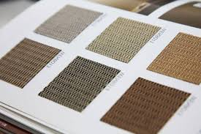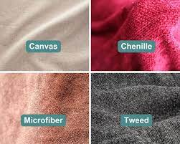
Understanding the diverse types of complex covers is essential for a furniture upholsterer to elevate their craft. Mastery of various cover types involves exploring different materials, styles, and structural nuances that contribute to both the aesthetic appeal and functionality of the final upholstered piece.

Let us break down some key types:

1 | Slipcovers | Slipcovers are versatile and popular for their ability to transform furniture easily. They are removable fabric covers that can be slipped over sofas, chairs, or cushions. This type allows for customization, making it practical for both protection and style.  For example, a tailored slipcover can give a classic sofa a modern update.
2 | Tufted Covers | Tufting involves creating patterns by pulling thread or twine through layers of fabric or leather, often securing with buttons or knots. Tufted covers add a touch of elegance and sophistication.  For instance, a tufted headboard cover can turn a simple bed into a luxurious focal point in a bedroom.
3 | Fitted Covers | Fitted covers are precisely tailored to the dimensions and contours of the furniture piece. This type provides a snug fit, enhancing both the appearance and comfort. A fitted cover for a contemporary armchair might involve intricate stitching to accentuate clean lines and modern design.
4 | Skirted Covers | Skirted covers feature fabric that extends to the floor, covering the furniture's legs. This type is often chosen for its traditional and timeless look. A skirted cover on a dining chair can give a sense of formality and grace to a dining room setting.
5 | Reversible Covers | Reversible covers are designed to be used on both sides, offering versatility and extending the lifespan of the upholstery. This type is practical for changing decor or addressing wear and tear.  An example could be a reversible cushion cover with different patterns or colours on each side.
6 | Sectional Covers | Sectional covers are tailored for furniture with multiple sections, such as L-shaped sofas. Precision in measurements and seam placement is crucial for a seamless appearance.  A sectional cover might include features like reinforced stitching to accommodate the various sections.
7 | Decorative Covers: | Decorative covers focus on aesthetics, incorporating embellishments like piping, fringes, or embroidery. These covers are often chosen for accent pieces or statement furniture.  An example might be a decorative cover for an accent chair, highlighting intricate patterns or detailing.
8 | Customised Covers | Customised covers are tailored to meet specific client preferences, considering unique design elements, fabric choices, and functionalities. This type requires collaboration between the upholsterer and the client to bring a personalized vision to life.  For instance, a customized cover for a chaise lounge may involve incorporating specific fabric patterns or colour schemes requested by the client.

Examples:
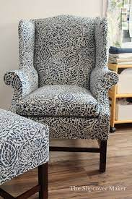
Traditional Wingback Chair Slipcover:
Type: Slipcover
Material: Durable and easily washable fabric
Style: Tailored fit with pleats for a classic look

Contemporary Sofa with Tufted Leather Cover:
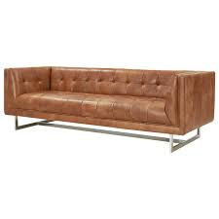
Type: Tufted Cover
Material: High-quality leather
Style: Diamond tufting for a luxurious and modern appearance

Fitted Cover for Mid-Century Armchair:
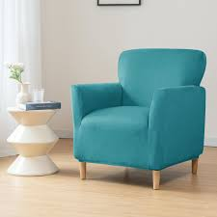
Type: Fitted Cover
Material: Mid-century-inspired fabric
Style: Clean lines and tailored fit to enhance the chair's original design

These examples illustrate how understanding and mastering different types of complex covers allow upholsterers to create unique and tailored pieces based on client preferences and design requirements.

KT0102 Uses.
Understanding the diverse uses of advanced complex covers is vital for furniture upholsterers to cater to the specific needs of various environments. Different settings demand covers that not only enhance aesthetics but also withstand specific challenges.

Here are some key uses and real-world scenarios:

Residential Settings | In a family home, where comfort and style are priorities, upholsterers might create advanced complex covers for sofas, chairs, and cushions. These covers could be tailored, tufted, or fitted, depending on the homeowner's preferences, contributing to a cohesive and inviting interior.
Commercial Spaces | In a bustling restaurant or hotel lobby, furniture experiences heavy use. Here, durable and easy-to-maintain covers are essential. Upholsterers may focus on slipcovers with stain-resistant fabrics or custom-fitted covers that can withstand frequent use without compromising on aesthetics.
Healthcare Environments | In a medical clinic or hospital waiting area, furniture must be both comfortable and hygienic. Upholsterers may create covers that are not only easy to clean but also resistant to the harsh cleaning agents used in healthcare settings. Slipcovers with antimicrobial fabrics could be a practical solution.
Office Spaces | In a corporate office, furniture in communal areas like lounges or collaborative spaces may require covers that balance professionalism with comfort. Fitted covers in durable fabrics can withstand daily use, maintaining a polished appearance even in a high-traffic environment.
Hospitality Industry | In a luxury hotel, where the aesthetics of furniture play a crucial role in creating a welcoming ambiance, upholsterers may focus on creating custom covers. These could feature decorative elements, such as embroidered patterns or high-quality fabrics, to elevate the overall guest experience.
Educational Institutions | In a school or university setting, furniture in common areas like libraries or student lounges needs to withstand constant use. Upholsterers may opt for sectional covers that are easily replaceable or machine-washable slipcovers, ensuring longevity and hygiene.
Outdoor Spaces | In a patio or garden setting, where furniture is exposed to the elements, outdoor covers are crucial. Upholsterers may specialise in creating covers using weather-resistant materials, employing techniques that protect against sun damage and water penetration.
Specialised Environments | In unique settings like recording studios or art galleries, where aesthetics and acoustics are crucial, specialised covers may be required. Upholsterers might use sound-absorbing materials or create covers that integrate seamlessly with the artistic theme of the space.

Benefits and Considerations:
Durability:
Covers for commercial and high-traffic areas should prioritise durability to withstand frequent use without compromising quality.

Maintenance:
Ease of maintenance is crucial, especially in settings where spills or stains are likely. Stain-resistant fabrics or washable covers can be practical solutions.

Aesthetics:
Balancing durability with aesthetics is key. Covers in commercial spaces should not only be functional but also contribute to the overall design scheme.

Functionality:
Understanding the specific needs of each environment ensures that the covers serve their purpose effectively, whether it is providing comfort, enhancing aesthetics, or meeting industry standards.

Example:
Consider a scenario in a trendy co-working space. The upholsterer might create custom sectional covers for modular seating, ensuring easy rearrangement. These covers could be made from a durable, stain-resistant fabric, aligning with the vibrant and dynamic atmosphere of the space.

This exploration of uses emphasises the adaptability and versatility that furniture upholsterers must possess to cater to diverse environments, each with its unique requirements and challenges.

KT0103 Design requirements and technical specifications.
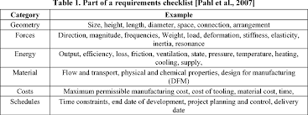
Meeting design requirements and adhering to technical specifications are crucial aspects of upholstery, demanding a meticulous and thoughtful approach. Upholsterers must not only comprehend the aesthetic desires of clients but also integrate essential technical elements seamlessly into their designs.

Here is an in-depth look, illustrated with a real-world scenario:
Imagine a client approaching an upholsterer with a specific vision for a modern and sleek custom couch. The client envisions a piece that seamlessly integrates into a contemporary living space, characterised by clean lines, minimalistic stitching, and a hidden fastening mechanism. Simultaneously, the upholsterer must ensure that the couch meets essential technical specifications, such as load-bearing capacity and the use of fire-resistant materials.

Clean Lines and Minimalistic Stitching | Design Requirements  The modern aesthetic calls for clean lines and minimalistic stitching.  The upholsterer must pay careful attention to the overall silhouette, avoiding ornate details or excessive embellishments.  The client may desire a streamlined look with straight lines and smooth surfaces.  Technical Specifications  Achieving clean lines involves precision in cutting and stitching.  Upholsterers may utilize advanced sewing techniques, such as flat seams or French seams, to maintain a seamless appearance.  Attention to detail is crucial to ensure that every stitch contributes to the overall modern aesthetic.
Hidden Fastening Mechanism | Design Requirements  A key design requirement is the incorporation of a hidden fastening mechanism.  The client desires a couch with a sleek appearance devoid of visible hardware or fasteners.  The challenge lies in seamlessly integrating functionality with aesthetics.  Technical Specifications:  Upholsterers may explore innovative solutions such as concealed zippers or Velcro attachments to achieve a hidden fastening mechanism.  This requires a deep understanding of both the functional aspects of fastening and the visual impact on the design.  Attention to the choice and placement of fastening elements is critical to meet the design objective.
Load-Bearing Capacity | Design Requirements:  While focusing on the sleek design, the couch must not compromise on comfort and durability.  The client expects a functional piece capable of accommodating seating requirements without sacrificing the visual appeal.  Technical Specifications:  Upholsterers must consider the internal frame and support system to ensure adequate load-bearing capacity.  This may involve using high-density foam, reinforced frames, and durable suspension systems.  The challenge is to balance the structural elements required for load-bearing with the desire for a visually lightweight and modern design.
Fire-Resistant Materials | Design Requirements:  Safety is paramount, and the client may request the use of fire-resistant materials for the couch.  This design requirement ensures compliance with safety standards and regulations while maintaining the desired aesthetics.  Technical Specifications:  Upholsterers must source materials that meet fire-resistant standards without compromising the design vision.  This may involve selecting flame-retardant fabrics and using fire-resistant padding or barriers within the couch structure.  Integrating these technical specifications discreetly ensures that safety measures do not detract from the overall design.

Benefits and Considerations:

Client Collaboration:
Effective communication with the client is essential to understand their aesthetic preferences and design vision. Regular consultations ensure that design requirements align with the client's expectations.

Material Selection:
Upholsterers must be knowledgeable about a variety of materials, selecting those that meet technical specifications while complementing the desired design. This includes choosing fire-resistant fabrics that maintain a modern aesthetic.

Structural Expertise:

Achieving a sleek and modern design while meeting load-bearing requirements demands expertise in furniture construction. Upholsterers must consider the internal framework, suspension systems, and foam density to ensure both comfort and durability.

Example:
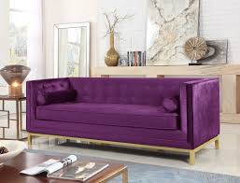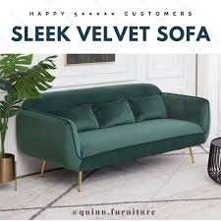

In the scenario described, the upholsterer successfully delivers a modern and sleek custom couch. The design incorporates clean lines achieved through precise stitching techniques, a hidden fastening mechanism using concealed zippers, and a structural composition that ensures optimal load-bearing capacity. Fire-resistant materials are seamlessly integrated into the upholstery, meeting safety standards without compromising the desired aesthetic.

This example illustrates how a balance between design requirements and technical specifications results in a customized piece that meets the client's vision while adhering to essential safety and functionality standards.

Recommendations for Images:
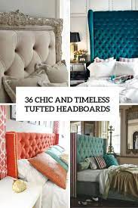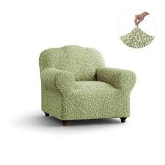
Include images showcasing a variety of advanced complex covers, from elegant button-tufting on a headboard to tailored slipcovers on different furniture pieces. Diagrams explaining the technical specifications and design considerations will enhance visual understanding.

Formative assessment

IAC0101 Various types of complex covers are identified and functions are explained in terms of design and technical requirements.
(Weight 10%)
SECTION 2: KM-08-KT02: Faults and problem solving related to advanced, complex covers (15%)

Learning Outcome
At the end of this section, learners should cover:

KT0201 Flaws, distortions and colour/pattern variations in the fabric.
KT0202 Inaccurate measurements.
KT0203 Misalignments.
KT0204 Slipping, fraying, inaccuracies, poor seam quality and equipment faults.
As with any intricate craft, upholstery is not without its challenges. This section focuses on identifying and resolving faults that may arise during the creation of advanced complex covers, ensuring a flawless end result. Upholsterers must not only create visually appealing pieces but also troubleshoot effectively to maintain high standards.

KT0201 Flaws, distortions and colour/pattern variations in the fabric.
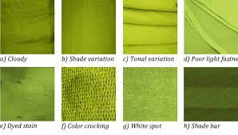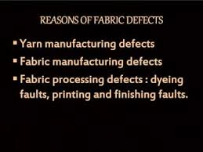
Consider a scenario where an upholsterer notices a flaw in the fabric intended for a high-end chair. It is crucial to address this early in the process to prevent a costly mistake. Understanding how different fabrics behave and implementing strategies to mitigate flaws becomes imperative for maintaining quality.
Scenario:
In the process of upholstering a high-end chair, the upholsterer notices a flaw in the fabric intended for the piece. This flaw could manifest as a defect in the weave, an irregularity in the pattern, or a colour discrepancy. Addressing such issues early in the process is crucial to maintain the quality and integrity of the final product.

Challenges:
Quality Control:
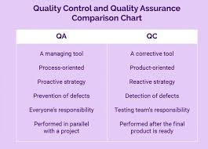
Identifying flaws requires a keen eye during the fabric inspection stage. Flaws may range from subtle imperfections to more noticeable distortions in the pattern or colour.

Material Variation:
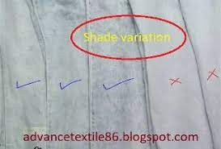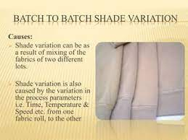
Different bolts of fabric, even from the same batch, may exhibit slight variations. Upholsterers must discern between intentional design elements and unintended flaws.

Strategies and Solutions:
Thorough Inspection:
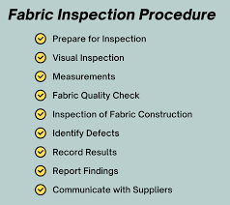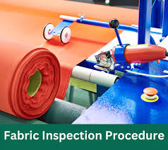
Implement a rigorous fabric inspection process before starting the upholstery. This involves examining each roll or bolt of fabric for flaws, distortions, or colour variations.

Communication with Suppliers:

Establish clear communication with fabric suppliers to understand potential variations and ensure the selection of high-quality materials.

Strategic Fabric Cutting:
If flaws are identified, strategic cutting techniques can be employed to minimise their impact. For example, placing flaws in inconspicuous areas or incorporating them into design elements.

KT0202 Inaccurate measurements.
Scenario:

Imagine an upholsterer working on a custom-fitted cover for a piece of furniture. Inaccurate measurements can lead to an ill-fitting cover, compromising both the visual aesthetics and comfort of the final product.

Challenges:
Precision Requirement:
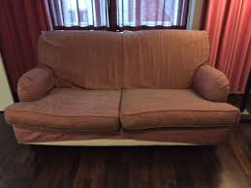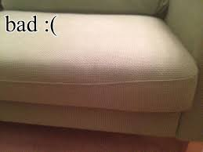
Crafting custom-fitted covers demands precise measurements to ensure a snug fit. Inaccuracies in measurements can result in misalignments and an unsightly appearance.

Impact on Comfort:
Ill-fitting covers may affect the overall comfort of the furniture, leading to sagging or uneven surfaces.

Strategies and Solutions:
Double-Checking Measurements:
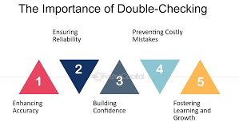
Upholsterers should adopt a practice of double-checking measurements at multiple stages of the process to catch any discrepancies early on.

Template Creation:

Creating templates for complex shapes or contours aids in achieving accuracy. Templates can be used as guides during cutting and sewing, minimising the risk of errors.

Client Verification:
Involving the client in the measurement verification process ensures that the upholsterer is aligned with the client's expectations for the final fit.

KT0203 Misalignments.
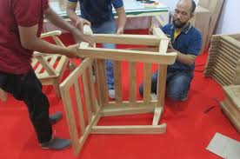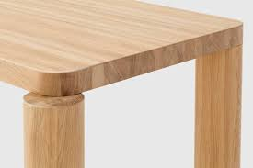
When there are misalignments during assembly, the overall aesthetic harmony of a piece can be disrupted. Upholsterers should be equipped with techniques to identify misalignments and implement corrective measures, ensuring a visually cohesive final product. This is particularly critical for furniture with multiple components or intricate design elements.

Challenges:
Visual Discrepancy:
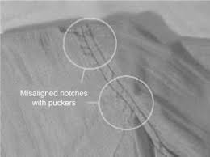
Misalignments can result in visible seams or uneven edges, detracting from the intended design.

Complex Assemblies:
Furniture with complex structures or multiple components increases the likelihood of misalignments.

Strategies and Solutions:
Use of Markers or Guides:
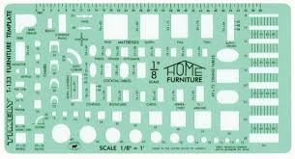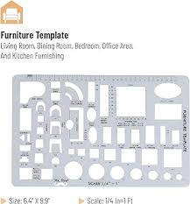
Employing markers, templates, or guides during assembly can help maintain alignment. These aids ensure that components are positioned correctly relative to each other.

Sequential Assembly:
Following a sequential assembly process, where each component is added systematically, reduces the risk of misalignments. This approach allows for adjustments before the final stages.

Typical Faults and Solutions
Pattern Alignment Issues
Cause:
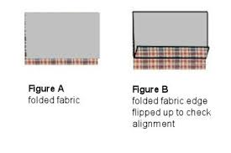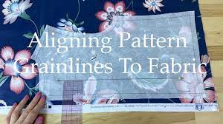
Incorrect pattern matching or alignment of fabric pieces.

Prevention and Rectification:
Ensure precise pattern matching when cutting fabric pieces by using templates or markers. Regularly check alignment during assembly and make adjustments as needed before finalising seams.
Uneven Seams or Edges
Cause:
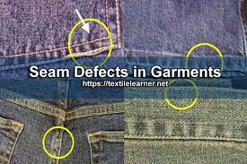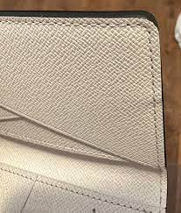
Unequal tension or stretching of fabric during assembly.

Prevention and Rectification:
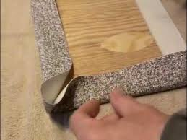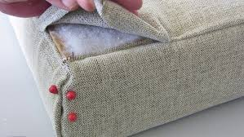
Maintain consistent tension while stretching fabric over the frame. Use guides or templates to ensure even distribution and avoid overstretching in certain areas.

Cause:
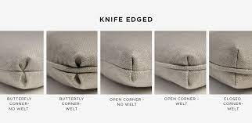
Improper wrapping or folding of fabric around corners or intricate design elements.

Prevention and Rectification:
Train upholsterers to handle complex folds or corners systematically. Use markers or guides to indicate precise folding points, ensuring uniformity across the piece.

Component Misalignment
Cause:
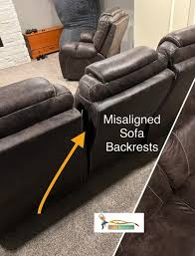
Incorrect positioning of various components during assembly.

Prevention and Rectification:
Follow a sequential assembly process, starting with the foundational components and gradually adding subsequent elements. Regularly check alignment at each step and make necessary adjustments before proceeding.

Pleating and Tucking Issues
Cause:
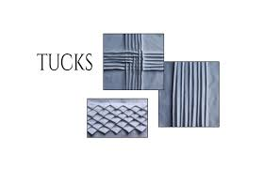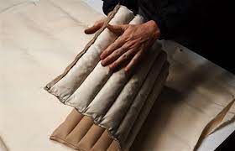
Inconsistent or improper pleating or tucking of fabric.

Prevention and Rectification:
Provide adequate training in pleating and tucking techniques. Use markers or guides to maintain uniformity and precision in these elements across the upholstery.

Stitching Irregularities
Cause:
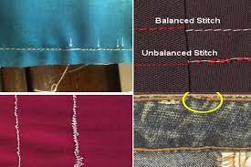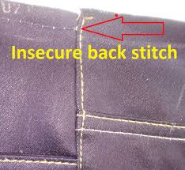
Uneven or inconsistent stitching along seams.

Prevention and Rectification:
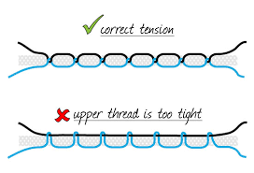
Ensure proper tension and alignment of the fabric while stitching. Regularly inspect and correct any stitching irregularities during the process.

KT0204 Slipping, fraying, inaccuracies, poor seam quality and equipment faults.
Imagine a situation where the fabric starts slipping during sewing or fraying at the edges. Upholsterers must possess the skills to address these issues promptly. For instance, understanding the tension settings on sewing machines and employing appropriate seam reinforcement techniques can prevent poor seam quality and related faults.
Challenges
Fabric Slippage:
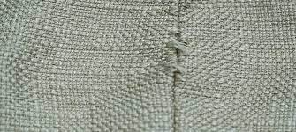
Slippery or delicate fabrics may slide or shift during the sewing process.

Fraying Edges:
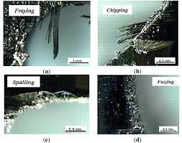
Fabrics with loose weaves or delicate fibres are prone to fraying at the edges.

Seam Quality:
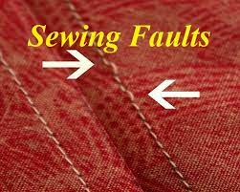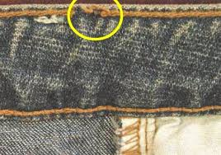
Poor seam quality, inaccuracies, or stitching irregularities can compromise the durability and aesthetics of the cover.
Equipment Issues:
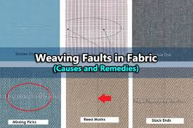
Faulty equipment, such as sewing machines with incorrect tension settings, can lead to sewing-related problems.

Strategies and Solutions
Fabric Stabilisation Techniques:
Using fabric stabilizers or temporary adhesive sprays can prevent slippage during sewing.

Edge Finishing:
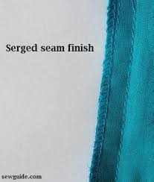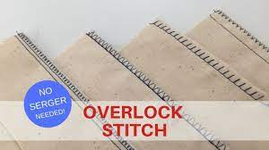
Employing edge-finishing techniques, such as serging or overlocking, prevents fraying and ensures a clean edge.

Quality Control Checks:
Regularly inspecting seams during and after sewing helps identify and rectify inaccuracies or stitching issues promptly.

Equipment Maintenance:
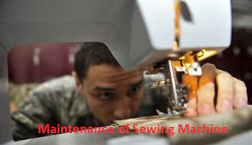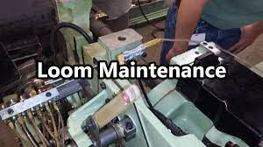
Upholsterers should conduct regular maintenance checks on sewing machines, ensuring correct tension settings and addressing any equipment faults promptly.

Typical Faults and Solutions
Fabric Slippage Issues
Cause:
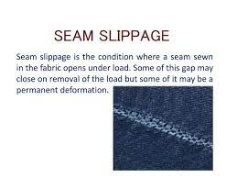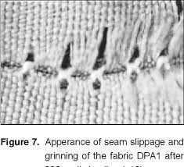
Slippery or delicate fabrics shifting during sewing.

Prevention and Rectification:
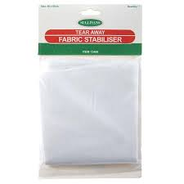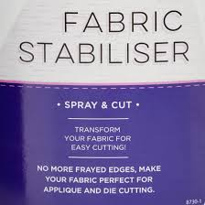
Employ fabric stabilisers or temporary adhesive sprays to stabilise the fabric during sewing, preventing slippage and ensuring accurate stitching.

Fraying Edge Problems
Cause:
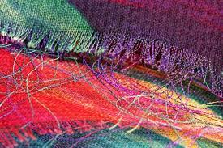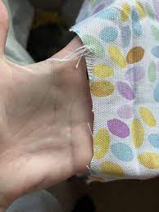
Fabrics with loose weaves or delicate fibres prone to fraying.

Prevention and Rectification:
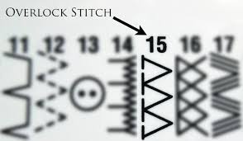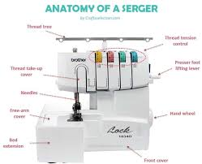
Use edge-finishing techniques like serging or overlocking to prevent fraying, ensuring a clean and durable edge finish.

Seam Quality and Inaccuracies
Cause:
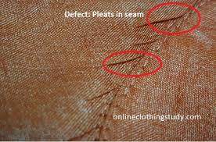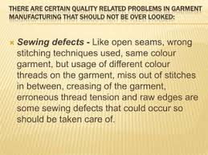
Poor seam quality, inaccuracies, or stitching irregularities compromising the upholstery.

Prevention and Rectification:
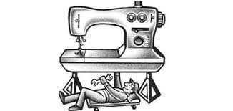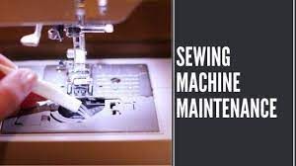

Conduct regular quality control checks during and after sewing to identify and rectify any inaccuracies or stitching issues promptly, maintaining high-quality seams.
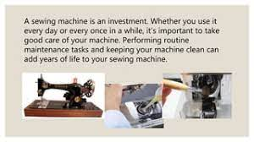

Equipment Faults
Cause:

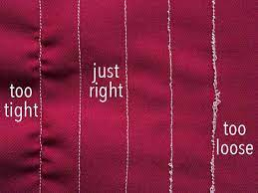
Faulty sewing machines with incorrect tension settings.

Prevention and Rectification:
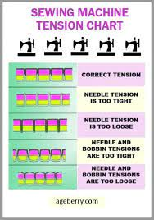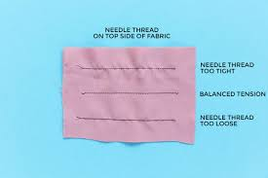
Regularly maintain sewing machines, ensuring correct tension settings and addressing any equipment faults promptly to prevent sewing-related problems.

These scenarios highlight the intricacies of addressing common challenges in upholstery, emphasising the importance of meticulous artistry, attention to detail, and strategic problem-solving techniques. Upholsterers who navigate these challenges effectively contribute to the production of high-quality, visually appealing, and durable upholstered pieces.

Formative assessment

IAC0201 Typical faults which may occur during the production of advanced complex covers are identified and prevention and rectification is discussed.
(Weight 15%)

KM-08-KT03: Raw materials for advanced and complex covers (25%)

Learning Outcome
At the end of this section, learners should cover:

KT0301 Leather.
KT0302 Patterned or striped fabric.
KT0303 Fabric pile direction.
KT0304 Other materials.
KT0305 Distortions and colour/pattern variations.
KT0306 Material characteristics and handling requirements.
Delving into the world of raw materials is fundamental for upholsterers crafting advanced complex covers. This section explores various elements, from the luxurious textures of leather to the intricate patterns of striped fabric. Understanding the characteristics, handling requirements, and potential challenges of these materials is crucial for creating covers that not only look stunning but also stand the test of time.

KT0301 Leather.
Leather Types and Characteristics
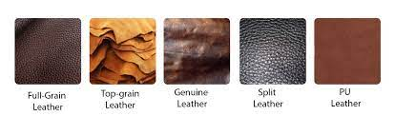
Full-grain leather is considered the highest quality and most desirable type of leather.

Here are some key attributes associated with full-grain leather:

Natural Appearance | Full-grain leather retains the natural grain pattern of the original hide, providing a unique and authentic appearance.  Imperfections like scars, wrinkles, and blemishes are often visible, enhancing the leather's character.
Durability | One of the most durable leather types available, full-grain leather tends to resist wear and tear over time.  It develops a desirable patina with age, adding to its aesthetic appeal and showcasing its durability.
Breathability | Full-grain leather is breathable, allowing air to pass through the material. This feature makes it comfortable to sit on, especially for furniture applications.
Aging Gracefully | With proper care, full-grain leather ages gracefully, developing a rich patina that adds to its charm.  Regular conditioning helps maintain its suppleness and prevents drying or cracking.
Luxurious Feel | Known for its soft and luxurious feel, full-grain leather enhances the tactile experience of furniture or products made from this material.
Suitability for Upholstery: | Full-grain leather is commonly used in high-end upholstery applications such as sofas, chairs, and luxury car interiors.  Its resilience makes it suitable for areas with frequent use.
Bonded Leather, while a more cost-effective option, has different characteristics and considerations:

Composition | Bonded leather is created by bonding together leather scraps using adhesives. It typically consists of a lower layer of leather fibres and a polyurethane or vinyl top layer.
Affordability | Bonded leather is often chosen for its affordability, making it a budget-friendly alternative to full-grain leather.  It allows consumers to achieve the look of leather at a lower price point.
Appearance | While it may mimic the look of genuine leather, bonded leather lacks the natural and unique characteristics found in full-grain leather.  The surface can appear uniform and may lack the distinctive patina that develops over time.
Durability Concerns | Bonded leather may not be as durable as full-grain leather. The bonding process and the presence of non-leather components can impact its longevity.  It may be more prone to peeling or flaking, especially in high-stress areas.
Limited Breathability | Compared to full-grain leather, bonded leather may have limited breathability due to the synthetic top layer.  This can affect comfort, especially in prolonged seating situations.
Application Considerations | Bonded leather is commonly used in applications where cost is a significant factor, such as entry-level furniture, accessories, or items with a shorter lifespan.

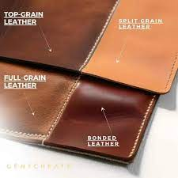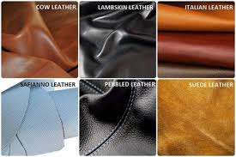
Understanding these distinctions between full-grain leather and bonded leather empowers upholsterers to make informed decisions based on client preferences, budget constraints, and the intended use of the finished product.

The characteristics of leather, including its durability, texture, and ability to age beautifully, are fundamental in advanced cover making. Leather finds applications in furniture upholstery due to its luxurious appearance, resilience, and adaptability to various styles. Constraints may include cost, environmental concerns regarding sourcing, and specific care requirements.

Analysing leather features involves assessing its grain type (full-grain, top-grain, etc.), thickness, finish, and colour-fastness. Opportunities lie in the diverse textures and finishes available, but constraints may arise from limited availability of specific types, variations in hide quality, and challenges in manipulating leather for complex designs.
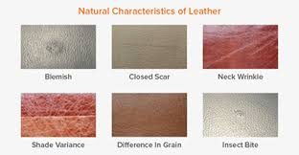

Factors impacting the quality of leather-based covers include hide selection, tanning techniques, and craftsmanship. The quality is influenced by factors like hide consistency, expertise in cutting, and stitching methods, ensuring uniformity in the final product.
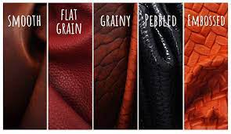
Identifying distortions or variations in leather colour and pattern requires keen observation. Corrective actions might involve careful positioning of pattern pieces to minimise flaws, selecting hides with uniform colouring, or utilising specific leather treatments to rectify minor variations.

KT0302 Patterned or striped fabric.
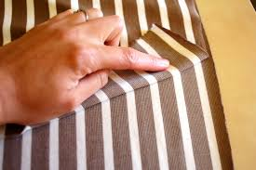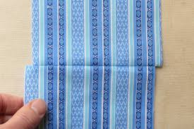
In scenarios where a client desires a bold pattern or stripe on their upholstery, upholsterers must understand how to align and match patterns seamlessly. Exploring the challenges and opportunities presented by patterned or striped fabric ensures that the final piece maintains visual harmony.

Pattern Matching Techniques
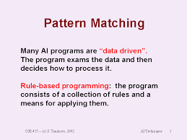

Strategies for Aligning Patterns
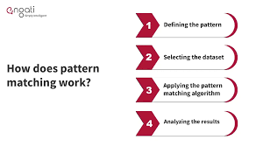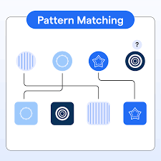
Techniques involve meticulous cutting and alignment to ensure the continuity of patterns across seams or different sections of furniture. This includes precise measuring, marking, and joining methods to seamlessly connect pattern repeats.

Dealing with Irregular Patterns or Complex Designs
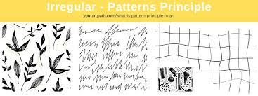
Irregular patterns or intricate designs demand advanced skills. Upholsterers may need to create templates, use trial placements, or adjust cutting angles to manage complex patterns effectively. Careful consideration of pattern repeats and variations is crucial for consistency.

Fabric Selection Criteria
Advising Clients on Suitability
Understanding client preferences and the intended use of the furniture helps in recommending suitable fabrics. For bold patterns or stripes, considerations include the scale of the design, durability of the fabric, and its compatibility with the furniture's purpose.

Considerations for Different Fabrics
Educating clients about the properties of various fabrics—like cotton, linen, or synthetics—helps them make informed choices. Highlighting factors such as durability, colour-fastness, and maintenance requirements ensures the selected fabric aligns with both aesthetic desires and practical needs.

In scenarios where bold patterns or stripes are desired, upholsterers' proficiency in aligning patterns seamlessly across seams and sections becomes pivotal. Additionally, advising clients on fabric suitability based on their preferences and furniture usage ensures a harmonious blend of design and functionality in the final upholstery.

Patterned or striped fabrics offer versatility and aesthetic appeal in complex cover making. They serve various purposes from accentuating design elements to providing a specific visual style. Constraints can arise from matching patterns, limited availability of certain patterns, and challenges in maintaining alignment during assembly.

Evaluating patterned or striped fabrics involves considering the scale, repeat, and alignment of patterns or stripes. Opportunities lie in creative design possibilities, but constraints can arise from fabric width limitations, pattern matching difficulties, and potential waste during cutting.

The quality of covers made from patterned or striped fabrics is influenced by precision in cutting, pattern matching skills, and attention to detail during assembly. Quality is maintained by ensuring consistent pattern alignment and minimising disruptions in the pattern flow.

Detecting distortions or colour/pattern variations in patterned or striped fabrics requires meticulous examination. Corrective actions may involve adjusting cutting techniques to accommodate pattern repeats, utilising specialised tools for pattern alignment, or selecting fabrics with minimal variations for high-quality outcomes.

KT0303 Fabric pile direction.
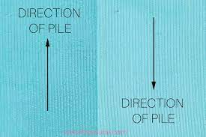
Imagine a scenario where an upholsterer neglects to consider fabric pile direction when working on a plush chair. The result might be a visually uneven surface. Upholsterers need to grasp the significance of fabric pile direction to achieve a cohesive and aesthetically pleasing appearance.

Importance of Fabric Pile Direction
Aesthetic and Tactile Impact
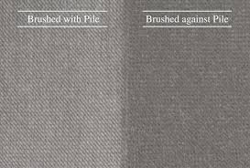
Fabric pile direction significantly influences the visual appearance and tactile feel of the upholstery. The way light reflects off or absorbs into the fabric can create visual variations, affecting the perceived texture and richness of the piece.

Consistency for a Cohesive Look
Consistent pile direction ensures a uniform appearance across the furniture. Neglecting to consider pile direction might result in a mismatched or uneven surface, especially noticeable on plush or velvety fabrics where the directionality of the pile is more evident.

Techniques for Consistent Pile Direction
Careful Cutting and Orientation
Upholsterers must meticulously cut fabric pieces and consistently orient them in the same direction across different sections of the furniture. This involves marking, aligning, and strategically positioning the fabric to maintain uniformity in pile direction.

Handling and Assembly Precision
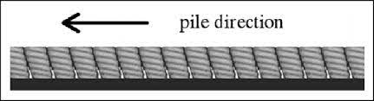
During assembly, attention to detail is crucial. Upholsterers need to maintain the identified pile direction while stretching, attaching, and securing the fabric to the furniture frame. Careful handling prevents accidental shifts in pile direction.
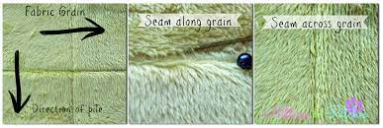
In scenarios where an upholsterer overlooks the importance of fabric pile direction, the resulting inconsistencies could detract from the overall visual appeal and tactile comfort of the upholstery. Therefore, understanding the impact of pile direction on the aesthetics and employing techniques for ensuring its uniformity across different sections are essential for achieving a cohesive and visually pleasing final product.
Understanding fabric pile direction is crucial for achieving desired textures and appearances in complex covers. Applications include creating tactile experiences and visual effects. Constraints may include limitations in directionality for certain designs and challenges in maintaining pile consistency.

Analysing fabric pile direction involves assessing how the texture changes concerning light and touch. Opportunities arise in creating depth and visual interest but constraints may include limitations in working with directional fabrics for intricate designs.

Quality in cover making involving fabric pile direction is influenced by consistent pile orientation, meticulous cutting techniques, and attention to detail in assembly. Upholsterers need to ensure uniformity in pile direction to achieve a seamless look.

Detecting distortions or variations in fabric pile direction requires careful examination under different lighting conditions. Corrective actions may involve adjusting cutting methods, aligning fabric pieces correctly, or using techniques to manage pile direction for a cohesive appearance.

KT0304 Other materials.
Beyond leather and fabric, various other materials contribute to the complexity of covers. Consider a scenario where an upholsterer is working on a piece that requires additional materials like decorative trims or embellishments. Knowledge of how to integrate these materials seamlessly enhances the overall design.

Integration of Decorative Elements

Incorporating Trims and Embellishments
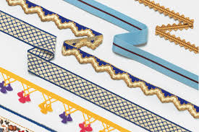
Techniques involve skilful placement and attachment of trims, buttons, or other decorative elements onto the upholstery. This may encompass sewing, gluing, or embedding these elements to enhance the aesthetic appeal of the piece.

Seamless Integration Techniques
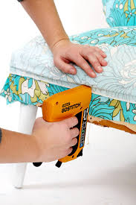
Upholsterers must integrate decorative elements in a manner that harmonizes with the overall design. Careful consideration of placement, spacing, and alignment ensures these elements complement the fabric or leather without overwhelming the visual balance.

Impact on Structural Integrity
Considerations for Durability and Functionality
Integrating additional materials should not compromise the cover's durability or functionality. Upholsterers need to assess the structural impact of these elements, ensuring they do not hinder the furniture's usability or longevity.

Maintaining Upholstery Integrity
Understanding how the added elements interact with the primary materials is crucial. Upholsterers should ensure that the integration of trims or embellishments does not weaken seams, alter the fabric's stretch-ability, or create discomfort in the final product.

In scenarios where upholsterers are working on pieces requiring additional decorative elements, their proficiency in seamlessly integrating these materials is crucial. Knowledge of techniques for incorporating trims and understanding the impact of these elements on structural integrity ensures a harmonious blend of aesthetics and functionality in the final upholstery.

Various materials like synthetic fabrics, blends, or specialty textiles offer diverse properties and purposes in complex cover making. Applications range from durability to specific aesthetic requirements. Constraints can include compatibility issues between different materials and challenges in blending textures.

Evaluating other materials involves assessing their unique properties, such as stretch, sheen, or breathability, for specific applications in cover making. Opportunities arise in combining materials for functional and visual purposes, but constraints can stem from material incompatibility or limitations in handling.

Quality in covers incorporating diverse materials is influenced by compatibility testing, appropriate joining techniques, and understanding how different materials behave during assembly. Maintaining consistency in material handling and application ensures high-quality outcomes.

Identifying distortions or colour/pattern variations in other materials requires a comprehensive examination of their unique characteristics. Corrective actions may involve adjusting stitching methods, combining materials strategically, or treating materials to minimize variations.

KT0305 Distortions and colour/pattern variations.
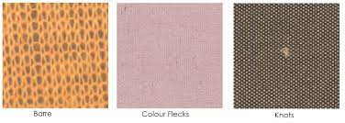
In the scenario of encountering distortions or colour/pattern variations in materials, upholsterers must be adept at identifying these issues and implementing corrective actions. This ensures that the final product meets the desired quality standards.

Recognising Production Issues
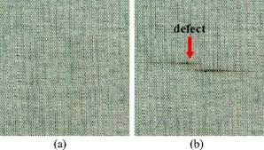
Identifying Distortions or Colour/Pattern Variations
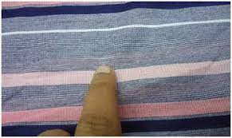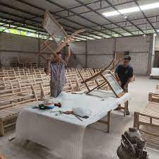
Upholsterers need a keen eye to spot distortions, inconsistencies in colour, or irregularities in patterns during various stages of production. This involves thorough inspection of materials under different lighting conditions to reveal subtle flaws.

Early Detection Techniques
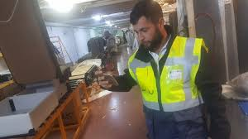


Early identification is crucial. Upholsterers must integrate inspection checkpoints throughout the production process. This allows for timely intervention and rectification before issues escalate, ensuring a higher standard of quality.

Implementing Corrective Actions
Adjusting Techniques or Materials
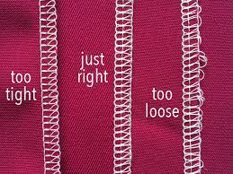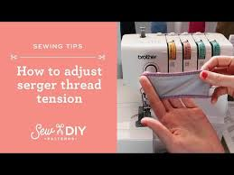
Corrective measures might involve fine-tuning machinery tension settings, altering stitching methods, or employing alternative materials to mitigate identified issues. For instance, adjusting sewing machine tension can prevent puckering or distortion in fabrics.

Selecting Alternative Approaches
In cases of irreparable flaws, upholsterers may need to switch to alternative materials or adjust the cutting layout to avoid using flawed sections. This adaptive approach ensures that imperfections are minimised in the final product.

In upholstery work, encountering distortions, colour mismatches, or pattern irregularities is not uncommon. Upholsterers must possess the skill to identify these issues promptly and have a repertoire of corrective measures to uphold quality standards. Effective identification and timely implementation of corrective actions ensure the final upholstery meets the desired quality benchmarks.
Understanding distortions and variations in textiles is vital for maintaining design integrity and aesthetics in cover making. Applications include ensuring uniformity and precision. Constraints arise from limitations in fabric production processes leading to potential flaws.

Evaluating distortions and colour/pattern variations involves assessing the impact on design continuity and visual appeal. Opportunities lie in creative adaptations, but constraints include challenges in matching or rectifying irregularities in complex designs.

Quality in cover making is influenced by meticulous inspection, precise cutting techniques, and strategic placement of fabric pieces to minimize distortions and variations. Upholsterers must have a keen eye for identifying irregularities.

Detecting distortions or colour/pattern variations requires careful scrutiny and understanding of fabric characteristics. Corrective actions may involve strategic placement of flawed areas, utilising complementary design elements, or employing specialized techniques to rectify minor variations.

KT0306 Material characteristics and handling requirements.
Imagine working with delicate materials like silk or highly textured fabrics. Upholsterers need to understand the characteristics and specific handling requirements of each material to prevent damage during the production process. This knowledge contributes to the overall durability and longevity of the finished piece.

Handling Delicate Materials
Techniques for Preventing Damage
Gentle Handling Techniques
Upholsterers must employ gentle handling methods, including cautious manipulation, precise cutting, and controlled stretching to prevent tears, snags, or distortions in delicate materials like silk or highly textured fabrics.

Specialised Tools and Equipment
Utilising appropriate tools, such as fine needles, sharp scissors, or specialized sewing machine feet, aids in handling delicate materials more effectively, minimizing the risk of damage during the upholstery process.

Storage and Transportation Considerations
Proper Storage Conditions
Delicate fabrics require specific storage conditions to prevent damage. Upholsterers should store these materials in a clean, dry, and well-ventilated environment away from direct sunlight or moisture, ensuring their integrity before use.

Careful Transportation Practices
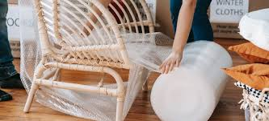
When transporting delicate materials, upholsterers must use protective coverings or packaging to shield them from potential damage caused by friction, creasing, or exposure to external elements.
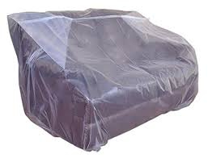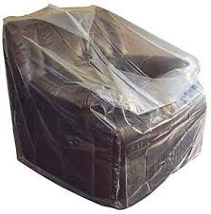

In scenarios where upholsterers are working with delicate materials such as silk or highly textured fabrics, understanding the characteristics and handling requirements of each material becomes paramount. Employing gentle handling techniques, coupled with appropriate storage and transportation practices, contributes significantly to preserving the integrity and longevity of these materials throughout the upholstery production process.

Understanding material characteristics is essential for selecting appropriate textiles and leather in cover making. Applications include ensuring durability, comfort, and aesthetic appeal. Constraints may arise from specific handling requirements that demand specialized expertise.
Analysing material characteristics involves assessing properties like durability, texture, and maintenance needs. Opportunities arise in selecting materials for specific functionalities but constraints can include limitations in working with delicate or high-maintenance materials.

Quality in cover making is influenced by adherence to material handling guidelines, proper storage, and careful manipulation during assembly. Upholsterers need to understand material behaviour to achieve desired outcomes.

Identifying distortions or variations in material characteristics requires understanding material properties and potential flaws. Corrective actions may involve adjusting handling techniques, using suitable treatments, or selecting alternative materials to overcome limitations.
Formative assessment

IAC0301 The types, characteristics and properties of textiles and leather are outlined and discussed in term of their purposes, applications and constraints placed on advanced and complex cover making.
IAC0302 A range of textiles and leather features are analysed and evaluated in terms of opportunities and constraints pertaining to advanced and complex cover making.
IAC0303 Aspects which can influence the quality of advanced and complex cover making is evaluated.
IAC0304 The identification of distortions and colour/pattern variations and corrective actions are explained.
(Weight 25%)

KM-08-KT04: Construction of advanced and complex covers (20%)

Learning Outcome
At the end of this section, learners should cover:

KT0401 Components.
KT0402 Number, size and shape of components.
KT0403 Dimensions and measurements.
KT0404 Use of markers, patterns or templates.
KT0405 Trims and finishings.
The construction phase is where the vision of a designer comes to life. This section delves into the key elements of constructing advanced and complex covers, from identifying components to analysing principles that ensure efficiency and quality.

KT0401 Components. Please complete with your ChatGPT input.

KT0402 Number, Size, and Shape of Components:
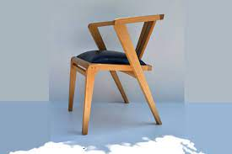

In the scenario of crafting a bespoke chair with unique design elements, the upholsterer must carefully consider the number, size, and shape of each component. This involves analysing the design specifications to ensure that the proportions are harmonious and functional.

Understanding Components
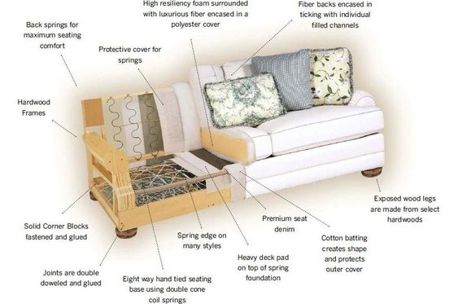

Identification of Different Components
In designing a custom sectional sofa, upholsterers need to comprehend and identify various components such as arms, backrests, seat cushions, and decorative elements. Each component plays a crucial role in the functionality, comfort, and overall aesthetics of the furniture piece.

Contribution to Design and Functionality:
The arms, back, cushions, and other elements contribute differently to the overall comfort and visual appeal of the sofa. Understanding how each component integrates into the design ensures a cohesive and functional outcome.

Construction Steps and Sequence
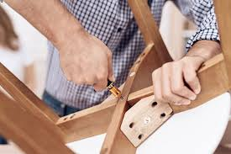

Identifying Steps in Construction
Sequential Construction Process
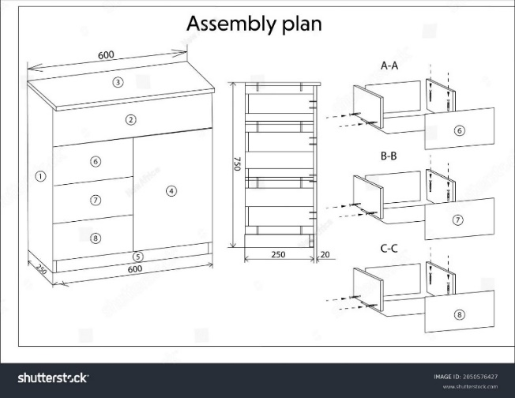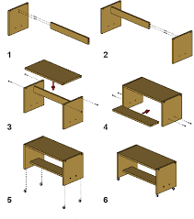

The construction process involves a series of steps, starting from framing to adding layers like padding, fabric, and final finishing touches. Each step needs a sequential approach, ensuring that the assembly progresses logically and efficiently.

Analysing Efficiency in Construction

Efficiency lies in the logical arrangement of steps. Analysing and refining the sequence of tasks to minimize redundancies and optimize workflow is crucial. This ensures a streamlined construction process, saving time and resources.

Principles for Quality
Identifying Quality Principles
Craftsmanship Standards
Quality principles encompass precision in measurements, attention to detail in stitching, and consistency in component assembly. Upholsterers must adhere to high craftsmanship standards to ensure a superior final product.

Material and Technique Selection
Quality is influenced by the selection of materials and the application of appropriate techniques. Upholsterers must choose materials that meet durability standards and employ techniques that enhance longevity and aesthetics.

Inspection and Quality Control
Principles involve regular inspection checkpoints throughout the construction process. Upholsterers need to ensure that each step meets quality benchmarks before proceeding, ensuring a high-quality finished product.

In the construction of advanced and complex covers, understanding components like arms, backrests, and cushions is pivotal. Analysing the steps and sequence of construction, along with adhering to principles for efficiency and quality, ensures a systematic and high-quality production process for complex furniture pieces like custom sectional sofas.

KT0403 Dimensions and measurements.
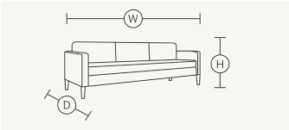
Consider a scenario where an upholsterer is tasked with creating a custom sectional sofa. Understanding the different components, such as the arms, back, and cushions, is essential for crafting a cohesive and functional design. Each component contributes to the overall comfort and aesthetics of the piece.

Understanding Sofa Components:
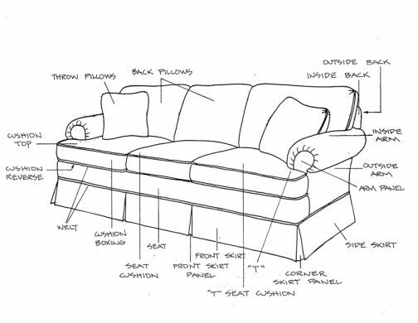
Identification of Key Components:
Constructing a custom sectional sofa involves recognizing and comprehending various essential components such as arms, backrests, seat cushions, and legs. Each component serves a distinct purpose and contributes to the overall functionality and aesthetics of the sofa.

Role in Design and Comfort:
The arms, back, cushions, and other elements play significant roles in determining the overall comfort and visual appeal of the sofa. Understanding how each component integrates into the design ensures a cohesive and functional outcome.

Contributions to Design and Functionality
Design Harmony and Cohesion:
Each component contributes to the sofa's design language and overall style. Upholsterers need to ensure that these components harmonize visually, complementing each other to create a cohesive and aesthetically pleasing design.

Functional Importance
Beyond aesthetics, components also serve functional purposes. For instance, the arms provide armrests, the backrest offers support, and cushions determine seating comfort. Understanding these roles helps in creating a sofa that is both comfortable and visually appealing.

In the creation of a custom sectional sofa, comprehending and integrating various components such as arms, backrests, and cushions are fundamental. Each component plays a unique role in contributing to the overall design, functionality, comfort, and visual harmony of the finished piece.

KT0404 Use of markers, patterns or templates.
Imagine the challenges of creating a perfectly fitting cover for an irregularly shaped piece of furniture. Upholsterers must excel in achieving precise dimensions and measurements to ensure a snug fit that enhances the overall visual appeal of the finished piece.
Achieving Precise Dimensions
Challenges of Irregular Shapes
Creating covers for irregularly shaped furniture demands meticulous attention to detail. Upholsterers face challenges in obtaining accurate measurements due to the varying contours and asymmetry of the piece.

Precision in Measurement Techniques
Upholsterers must employ precise measuring tools and techniques to capture the irregular dimensions accurately. This involves using flexible measuring tapes, contour gauges, or templates to trace and record the unique shape and size of the furniture.

Ensuring Snug Fit and Visual Appeal
Tailoring for a Snug Fit
Achieving a snug fit requires translating the obtained measurements precisely onto the fabric. Upholsterers meticulously transfer these dimensions, ensuring the cover hugs the irregular contours of the furniture snugly.

Enhancing Visual Appeal
Accurate dimensions and measurements contribute significantly to the visual appeal of the finished piece. A well-fitted cover not only enhances aesthetics but also showcases craftsmanship and attention to detail.

Construction Steps and Sequence
Identifying Steps in Construction
Sequential Construction for Custom Fit
The construction process for irregularly shaped covers involves a series of steps, starting from pattern creation to final adjustments. Analysing and organizing these steps ensure a systematic approach to achieve a custom fit.

Efficiency in Workflow:
Optimising the sequence of construction steps minimizes errors and ensures efficiency. Upholsterers need to strategize the workflow to accommodate the unique challenges posed by irregular shapes, ensuring precise construction.

Principles for Quality
Quality Principles in Custom Fit Covers
Precision and Accuracy
Quality principles revolve around achieving precision in measurements. Upholsterers must maintain accuracy in every step, from measuring irregular shapes to transferring these measurements onto fabric.

Material Adaptation for Fit
Selecting and manipulating materials to adapt to irregular shapes is crucial. Upholsterers must consider fabric stretch, pliability, and structural integrity to ensure a seamless and durable fit.

Quality Checks for Fit
Upholsterers need to conduct meticulous quality checks during and after construction to ensure that the cover fits the irregular furniture shape seamlessly. Thorough inspection guarantees a high-quality, custom-fit cover.

Designing covers for irregularly shaped furniture demands expertise in precise dimensions and measurements. Upholsterers' proficiency in capturing accurate measurements and implementing efficient construction steps, adhering to quality principles, ensures snug-fitting covers that enhance the visual appeal of the finished piece.

KT0405 Trims and finishings.
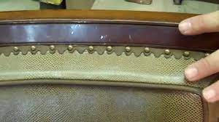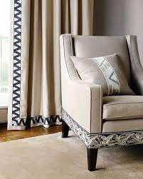
In a scenario where a client desires a luxurious finish for their upholstered piece, the choice of trims and finishings becomes crucial. Upholsterers must be adept at selecting appropriate trims that complement the design while ensuring durability and longevity.

Selecting Appropriate Trims
Complementing Design Aesthetics
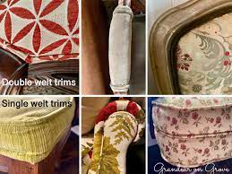
Trims and finishings contribute significantly to the overall aesthetics of an upholstered piece. Upholsterers must select trims that complement the design, adding a touch of elegance or enhancing specific design elements without overpowering the overall look.

Durability and Longevity
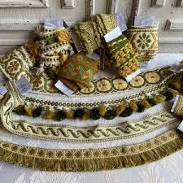
Beyond aesthetics, the choice of trims and finishings should prioritize durability. Upholsterers need to select materials and trims that withstand wear and tear while maintaining their aesthetic appeal over time, ensuring longevity for the upholstered piece.
In scenarios requiring the creation of identical pieces like dining chairs, the use of markers, patterns, or templates proves invaluable in ensuring consistency and uniformity. Meanwhile, when considering trims and finishings for an upholstered piece, the selection process must balance aesthetic enhancement with durability and longevity to meet the client's desires effectively.

Formative assessment

IAC0401 The construction of advanced and complex covers are identified, described according to steps and sequence and analysed for efficiency.
IAC0402 Principles for advanced and complex covers are identified, described analysed in terms of quality.
(Weight 20%)

KM-08-KT05: Assembly and sewing process for advanced and complex covers (30%)

Learning Outcome
At the end of this section, learners should cover:

KT0501 Sequence of attaching cover components.
KT0502 Material cutting tolerances and accuracy.
KT0503 Shaping tolerances and accuracy.
KT0504 Component marking tolerances and accuracy.
KT0505 Hand sewing techniques such as slip stitch, ladder stitch and hemming stitch.
KT0506 Machine sewing techniques such as flat, /French and flat fell seams.
KT0507 Gluing, tacking and stapling.
KT0508 Closing methods.
In a scenario where a client desires a luxurious finish for their upholstered piece, the choice of trims and finishings becomes crucial. Upholsterers must be adept at selecting appropriate trims that complement the design while ensuring durability and longevity.

KT0501 Sequence of attaching cover components.
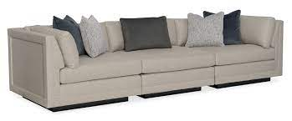
Imagine assembling a multi-piece sectional sofa where the sequence of attaching components is critical. Upholsterers must follow a logical order to ensure that each element is seamlessly integrated. This involves a strategic approach to guarantee efficiency and precision in the final assembly.

Sequencing for Multi-Piece Assembly
In crafting a multi-piece sectional sofa, the sequence of attaching components is critical. Upholsterers must follow a logical order, typically starting with foundational elements like the frame and gradually adding cushions, arms, backrests, and finishing details. This systematic approach ensures a seamless integration of each component, contributing to the efficiency and precision of the final assembly.

Process
Identifying Assembly Steps
Understanding the sequence of attaching cover components involves identifying and describing each step in the assembly process. This includes framing, cushioning, attaching arms, backrests, and other elements systematically.

Example:
In constructing a sectional sofa, the initial step might involve verifying the alignment of the frame joints and reinforcing areas prone to stress. Following this step, adding high-density foam or padding becomes the subsequent logical step to provide comfort and shape to the piece.

Efficiency Analysis
Analysing the efficiency in the assembly process involves assessing the logical order and identifying opportunities for optimization. Streamlining the sequence ensures smoother and more precise assembly, minimising errors and enhancing overall efficiency.

Example:
An optimisation in the assembly process might involve attaching the backrests before the arms to ensure a more secure fit and easier access for attaching the arms without compromising the alignment of the backrest.

KT0502 Material cutting tolerances and accuracy.
In scenarios where an upholsterer is constructing a tailored slipcover, cutting tolerances and accuracy are paramount. A slight deviation in cutting can lead to an ill-fitting cover. Upholsterers must master the art of precise cutting, understanding the impact on the overall quality of the finished piece.

Precision in Tailored Slipcovers
Crafting tailored slipcovers demands meticulous attention to cutting tolerances and accuracy. Upholsterers must ensure precise measurements and cutting to prevent even slight deviations that might result in an ill-fitting cover.

Quality Analysis
In terms of quality, the accuracy in material cutting significantly impacts the overall fit and appearance of the finished piece. Upholsterers must maintain strict tolerances to uphold quality standards in tailored slipcover construction.

Advanced Covering Principles
Identifying Cutting Techniques
Detailing cutting techniques and their impact on slipcover construction is crucial. Accurate cutting influences the overall quality and aesthetics of the finished piece, aligning with advanced covering principles.

Example:
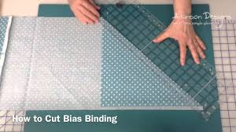
Utilising a bias cut for slipcovers crafted from fabrics with patterns or motifs ensures seamless alignment across the piece, enhancing the visual appeal and demonstrating adherence to advanced covering principles.

Analysing Quality Impact:
Assessing the cutting tolerances and their impact on the final product involves examining how precision in cutting directly affects the quality and fit of tailored slipcovers.

Example:
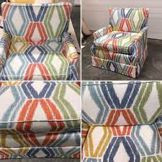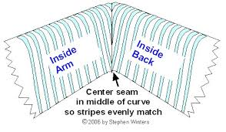
A millimetre deviation in cutting might result in misalignment of patterns or a slightly loose fit in the slipcover, impacting the overall aesthetics and quality of the finished piece.

KT0503 Shaping tolerances and accuracy.
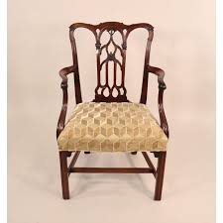
Consider the challenges of shaping intricate curves on a modern armchair. Upholsterers must adhere to specific tolerances and accuracy to achieve the desired contours. This involves a keen understanding of the shaping process and the impact on the visual aesthetics of the final piece.

Challenges in Shaping Curves
Upholsterers face challenges in shaping intricate curves, especially in modern furniture designs. Adhering to specific tolerances and accuracy is essential to achieve desired contours and ensure visual aesthetics.

Constructing modern armchairs often involves intricate curves, posing a significant challenge for upholsterers. Achieving these complex shapes requires a meticulous approach and adherence to specific tolerances and accuracy in shaping.

Example:
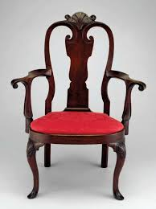
Consider the contours of a mid-century modern armchair with intricate curves in its armrests. Shaping these curves demands precision to maintain the chair's design integrity and functionality.

Impact on Final Aesthetics
Shaping tolerances and accuracy significantly affect the visual aesthetics of the final piece. Upholsterers must understand the shaping process to maintain quality standards in achieving intricate curves.

The tolerances and accuracy maintained in shaping play a pivotal role in the visual aesthetics of the final piece. Upholsterers' precision in shaping not only ensures the desired contours but also affects the overall appeal and perceived quality of the furniture.

Example:
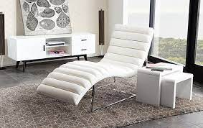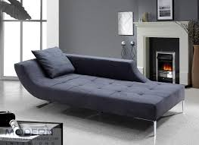
In a contemporary chaise lounge, the sleek and fluid lines define its elegance. Upholsterers' attention to detail in shaping these lines dictates the visual harmony and attractiveness of the final product.

Advanced Covering Principles
Understanding Shaping Techniques
Detailing various shaping techniques and their application in achieving specific contours aligns with advanced covering principles. Upholsterers need to understand how different materials respond to shaping techniques and their impact on achieving desired shapes.

Example:
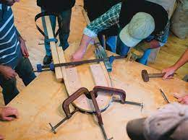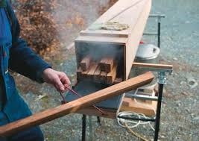
Utilising steam bending or sculpting techniques for wooden frames in furniture crafting exemplifies advanced covering principles. Upholsterers' mastery of these techniques ensures precise curves and maintains design integrity.

Analysing Quality Impact
Assessing the impact of shaping tolerances on the final product involves examining how precision in shaping influences not only the aesthetics but also the functionality and comfort of the furniture.

Example:
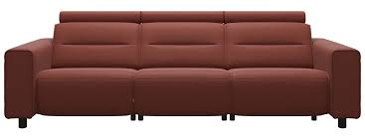
A precisely contoured modern sofa's armrests ensure both a visually appealing design and ergonomic comfort, demonstrating the correlation between shaping accuracy and quality upholstery.

KT0504 Component marking tolerances and accuracy.
In scenarios where upholsterers are working on a set of identical dining chairs, component marking tolerances become critical. Consistency in marking ensures that each piece aligns perfectly with the design specifications, contributing to a cohesive and visually appealing set.

Criticality of Component Marking
In crafting identical dining chairs, precise component marking tolerances are crucial for consistency across pieces. Accurate marking ensures alignment with design specifications and contributes to a cohesive set.

Example:
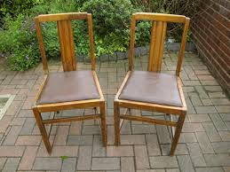
When upholstering dining chairs, accurate marking of the fabric pattern placement on each chair's seat ensures uniformity in the pattern's alignment across the set, contributing to an aesthetically pleasing ensemble.

Impact on Uniformity
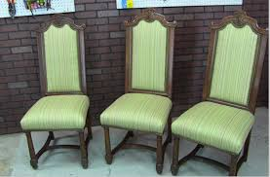
Consistency in component marking directly impacts the uniformity of multiple pieces. Upholsterers must maintain precise marking to achieve visual harmony and meet quality standards for a set of identical chairs.

Example:
Consistent marking of armrest placements on dining chairs guarantees that the chairs are identical in design, contributing to a cohesive dining set where each piece complements the others seamlessly.

Assembly and Sewing Process
Identifying Marking Steps
In the assembly process, detailing the steps involving component marking is crucial. Upholsterers need to describe how marking is integrated into the sequence of assembly, ensuring alignment with design specifications.

Example:
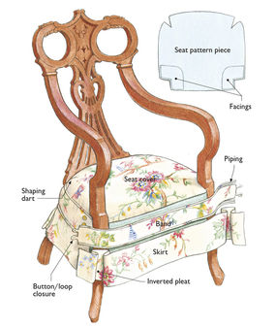
Describing the process of marking seam allowances or button placements on dining chair upholstery fabric to ensure uniformity and precision in assembly across multiple chairs.

Efficiency in Marking Techniques
Analysing the efficiency in component marking involves assessing the accuracy and precision of marking techniques. Efficient marking practices contribute to uniformity across pieces, enhancing the overall assembly efficiency.

KT0505 Hand sewing techniques such as slip stitch, ladder stitch and hemming stitch.
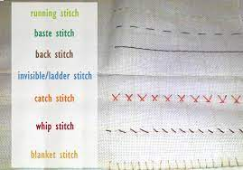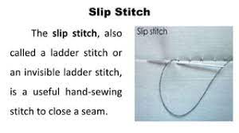
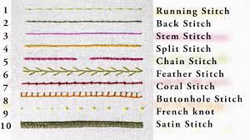
Hand sewing techniques add a personal touch to upholstery. In scenarios where intricate detailing is required, such as creating a hand-stitched diamond tufting pattern, upholsterers must master techniques like slip stitch, ladder stitch, and hemming stitch. These skills elevate the craftsmanship of the final piece.
Artistry in Hand Sewing
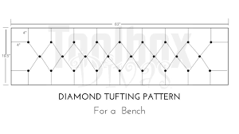
Hand sewing adds a unique touch, especially in intricate detailing like diamond tufting. Mastery of techniques such as slip stitch, ladder stitch, and hemming stitch elevates craftsmanship, adding finesse to the final piece.

Example:
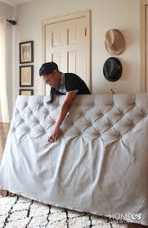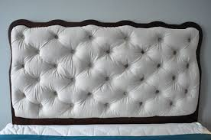
A hand-sewn button-tufted headboard displays the artistry of diamond tufting, where meticulous slip stitching on the fabric's underside ensures a clean and seamless tufted appearance on the front, enhancing the visual appeal.

Craftsmanship and Detailing
Hand sewing techniques exemplify artisanship and attention to detail. Upholsterers must understand and apply these techniques to achieve desired patterns or detailing, ensuring a high-quality finish.

Example:
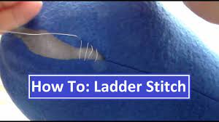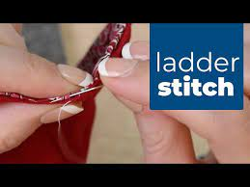
The application of a ladder stitch to invisibly close seams in upholstery not only reinforces durability but also maintains a polished and professional appearance, reflecting the upholsterer's mastery of hand sewing techniques.

Advanced Covering Principles
Detailing Hand Sewing Methods
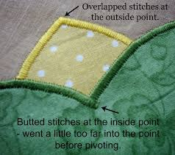
Advanced covering principles encompass detailing various hand sewing techniques and their applications in achieving specific designs. Upholsterers need to understand the impact of hand sewing on the overall quality and aesthetics of the upholstery.

Example:
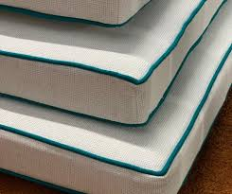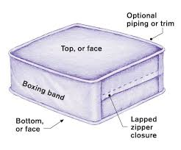
Detailing the application of a slip stitch in attaching intricate piping along the edges of a sofa cushion, demonstrating how this technique ensures a neat and durable finish while adhering to advanced covering principles.

KT0507 Gluing, tacking and stapling.
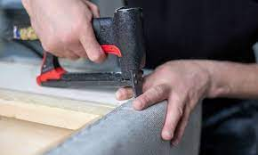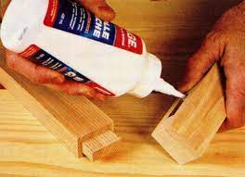
In scenarios where fabric needs to be secured to a frame, understanding the appropriate use of gluing, tacking, and stapling is crucial. For instance, gluing may be suitable for delicate fabrics, while stapling is ideal for securing heavy-duty materials. Upholsterers must employ these techniques judiciously to ensure a secure and durable construction.

Appropriate Use of Attachment Techniques
Upholsterers must understand when to use gluing, tacking, or stapling based on fabric types and furniture frames. Each technique serves a specific purpose, with gluing being suitable for delicate fabrics and stapling for heavy-duty materials.

Impact on Structural Integrity
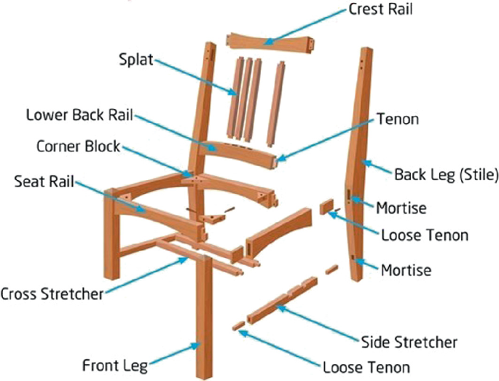
The appropriate use of attachment techniques affects the structural integrity and durability of the upholstery. Upholsterers must employ these techniques judiciously to ensure a secure and long-lasting construction.

Assembly and Sewing Process
Detailing Attachment Methods
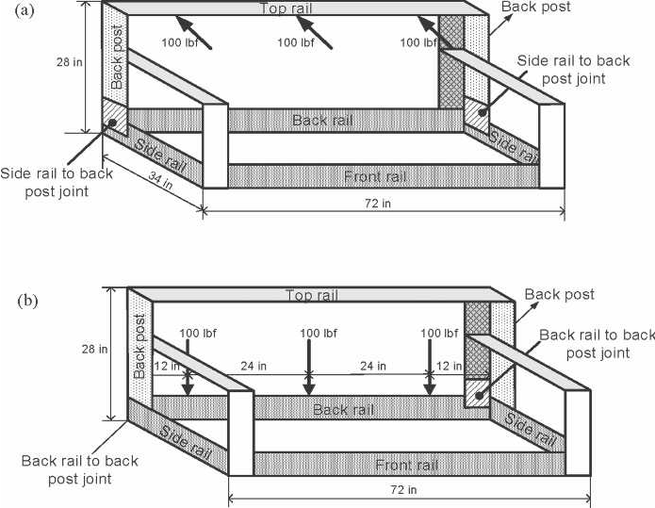
Describing the integration of attachment techniques within the assembly process is crucial. Upholsterers need to explain when and how gluing, tacking, or stapling is incorporated, highlighting their significance in the assembly sequence.

Efficiency in Attachment
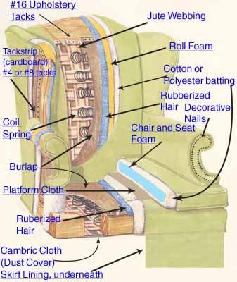
Analysing the efficiency of attachment techniques involves assessing their impact on the overall assembly efficiency. Upholsterers must evaluate how these techniques streamline the process while ensuring structural integrity.

KT0508 Closing methods.
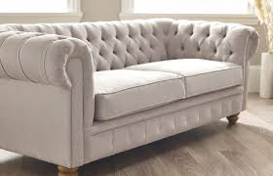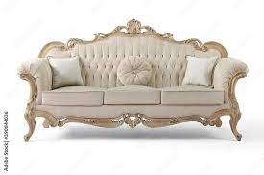
Consider the final touches on a luxurious sofa where closing methods play a pivotal role. Whether using hidden stitches or decorative trims, upholsterers must choose closing methods that enhance the overall aesthetic while ensuring a polished and refined appearance.
Final Touches for Aesthetic Appeal
Closing methods like hidden stitches or decorative trims contribute to the final aesthetic of a luxurious sofa. Upholsterers must choose methods that not only enhance the overall appearance but also ensure a refined and polished finish.

Impact on Overall Presentation
The choice of closing methods significantly influences the overall presentation of the upholstered piece. Upholsterers must analyse how different methods contribute to the final aesthetic appeal and quality of the upholstery.

Advanced Covering Principles
Defining Closing Techniques
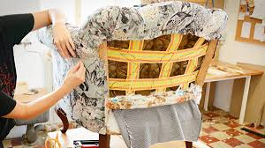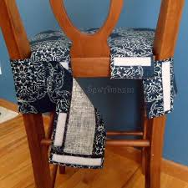
Advanced covering principles involve defining various closing methods and their application in achieving specific design aesthetics. Upholsterers need to understand how different closing methods align with quality standards and elevate the upholstery's overall appeal.

Each of these aspects plays a crucial role in the construction and finishing of advanced and complex covers. Integrating these techniques into the assembly process and adhering to precise cutting, shaping, marking, sewing, attachment, and closing methods significantly impacts the overall quality, efficiency, and aesthetic appeal of the finished upholstered piece.

Formative assessment

IAC0501 Assembly and sewing process for advanced and complex covers are identified, described according to steps and sequence and analysed for efficiency.
IAC0502 Advanced covering principles for advanced and complex covers are identified, described analysed in terms of quality.

(Weight 30%)

Provider Programme Accreditation Criteria:

Physical Requirements:
The provider must have lesson plans and structured learning material or provide learners with access to structured learning material that addresses all the topics in all the knowledge modules.
Human Resource Requirements:
Lecturer/learner ratio of 1:20.
Qualifications of lecturers: 5 years relevant experience or NQF 2 58227 with 2 years of experience.
Legal Requirements:
OHS compliant.
Exemptions:
No exemptions, but the module can be achieved in full through a normal RPL process.

