

FURNITURE UPHOLSTERER

KM09 COMPLEX SHAPED CUSHIONS AND PADDED ITEMS

LEARNER GUIDE

Complex Shaped Cushions and Padded Items

LEARNER GUIDE

Module # | KM09
NQF Level | 3
Notional hours | 20
Credit(s) | 2
Curriculum Code | 683401000
SAQA QUAL ID | 103199
Qualification Title | Occupational Certificate: Furniture Upholsterer NQF Level 4, Credits 549

LEARNER CONTACT INFORMATION:

Name
Contact Address
Telephone (H)
Telephone (W)
Cellular

TABLE OF CONTENTS

PURPOSE OF THE QUALIFICATION 5
QUALIFICATION RULES 7
EXIT LEVEL OUTCOMES 9
ENTRY REQUIREMENTS: 10
ARTICULATION OPTIONS 11
ASSESSMENT REQUIREMENTS 12
PROVIDER ACCREDITATION REQUIREMENTS FOR THE MODULE: 13
SECTION 1: KM01KT01: Roles and responsibilities of the Occupational Health and safety representative as set out in the relevant legislation (Intermediate) (30%) 16
1.1 Explain the purpose of the Occupational health and Safety representative 16
1.2. Describe the process for appointing Occupational Health and safety representatives 28
1.3 Explain the functions of the occupational Health and safety Committees 30
SECTION 2: KM01KT02: Legislative requirements related to Occupational health and safety (Basic) (10%) 36
2.1 Explain the purpose and structure of the relevant legislation applicable to a specific workplace 36
2.2. Explain the difference between the various legislative instruments 48
SECTION 3: KM01KT03: Definitions of and difference between Occupational Health, Occupational Safety and Environmental management. (Basic) (10%) 56
3.1 Define and describe occupational health, safety and environmental control 56
SECTION 4: Concept of behavioural safety management (Basic) (10%) 60
4.1 Explain what is meant by behaviour and how the behaviour of people influences their health and safety 60
4.2. Describe the factors that influence the behaviour of people and give examples of this in a work environment 60
4.3 Identify and explain the role of behavioral modification in influencing the overall health and safety of employees 62
4.4. Explain what contribution leadership can make towards creating a culture where unacceptable behaviour regarding health and safety issues are not tolerated 63
SECTION 5: KM01KT05: Concepts and principles of emergency preparedness and response (Basic) (20%) 66
5.1 Explain the definition of an emergency and give examples of typical emergencies that could occur in the workplace 66
5.2. Explain the difference between preparedness and response and give examples of typical preparedness and response actions 68
5.3 Describe the roles of the various role players to ensure that an organisation is adequately prepared for emergencies 70
5.4. Describe the roles of the various role players when an emergency occur. 72
SECTION 6: KM01KT06: The principles of hazards identification and risks assessment (Basic) (5%) 79
6.1 Give practical examples to explain what a hazard is and how hazards relate to risks 79
6.2. Explain the concept of priority setting and relate it to the process of hazard and risk rating 83
SECTION 7: KM01KT07: Principles of safe working practices in and around the place of work (Intermediate) (5%) 93
7.1 Explain what is meant by a working practice using practical examples (NQF Level: 2) 93
7.2. Explain the concept of habits and how good and bad habits can be established with specific reference to occupational health and safety situations 97
SECTION 8: KM01KT08: Techniques of accident and incident investigation (5%) 101
8.1 Explain the difference between an accident and incident 101
8.2. Describe the generally accepted hierarchy of how incidents lead to accidents 101
8.3 Explain the basic process of accident and incident investigation 103
SECTION 9: KM01KT09: Roles and responsibilities of the various stakeholders in a workplace regarding Occupational Health and Safety (Intermediate) (5%) 116
9.1 List the key stakeholders that are involved in the prevention of accidents and 116
incidents in the workplace 116
9.2. Describe the role of each of the key stakeholders in preventing accidents and incidents 117
9.3 Explain the consequences when a stakeholder does not execute their duty in accident/incident prevention 123
9.4. Explain the role of the safety representative when one of the other stakeholders do not do what is expected of them 125

PURPOSE OF THE QUALIFICATION

Purpose:
The purpose of this qualification is to equip a learner with knowledge, skills and competencies to perform duties as a Furniture Upholsterer.

A Furniture Upholsterer manufactures an upholstered furnishing item by fitting suspension and padding and covering a frame to give it shape, comfort, and functionality for a range of domestic, commercial and decorative uses.

A qualified learner will be able to:
- Read and interpret a design, drawing or sketch and take accurate measurements and calculate/estimate the number of fabrics, leather, manmade fabrics, padding and other raw material such as springs and webbing.
- Make upholstery patterns and produce templates from sketches, customer descriptions or blueprints which match all quality standards.
- Lay out, measure, cut and sew upholstery materials following patterns, templates, sketches, or design specifications.
- Interpret specifications and prepare foundations for upholstered frames by attaching webbing, springs, foam and/or padding securely to the frame.
- Fit slipcovers and loose material panels to cover frames with materials using staples, tacks and/or glue.
- Manufacture upholstered furniture, upholstery prototypes and repair and reupholster damaged furniture.

Rationale:

This qualification will equip learners with the necessary skills and competencies to operate as upholsterers by applying upholstery skills to fit springs, webbing, padding and covering a wide range of objects covered with fabric, leather, rexine or other upholstery material. After successful completion of this qualification, the learner will be skilled and capable of creating ergonomic and comfortable furniture using both traditional and modern techniques, materials and fabrics to produce aesthetically pleasing and fit for purpose consumer products.

Learners will find employment as frame preparers, cover fitters, patternmakers and furniture finishers, upholsterers or upholstery prototype makers and upholstery repairers. These skills will also open opportunities for selfemployment.

Target groups identified include school leavers with a National Qualifications Framework (NQF) Level 2 qualification or persons who have been working in the furniture industry without formal qualifications and have the desire to formalise their skills and knowledge.

Employers will benefit from appointing qualified workers in terms of increased productivity and ability to be competitive in the international market and seek markets abroad supplying quality upholstered furniture and furnishings.

QUALIFICATION RULES

This qualification is made up of the following compulsory Knowledge, Practical Skill and Workplace Learning Modules:

Knowledge Modules:
- 683401000KM01, Basic Principles for Manufacturing of Upholstered Furniture, NQF Level 2, Credits 4
- 683401000KM02, Upholstered furniture frame preparation, NQF Level 2, Credits 8
- 683401000KM03, Upholstered Furniture Basic Cover Fitting, NQF Level 2, Credits 8
- 683401000KM04, Advanced Upholstery Furniture Technology, NQF Level 3, Credits 2
- 683401000KM05, Upholstery Pattern and Template Making Principles, Methods and Equipment, NQF Level 3, Credits 5
- 683401000KM06, Cutting Lay Requirements for Upholstery Fabrics and Materials, NQF Level 3, Credits 3
- 683401000KM07, Advanced Covering Techniques for Complex and Exposed Frames, NQF Level 3, Credits 4
- 683401000KM08, Advanced Complex Covers for Upholstery, NQF Level 3, Credits 4
- 683401000KM09, Complex Shaped Cushions and Padded Items, NQF Level 3, Credits 2
- 683401000KM10, Deep Buttoning of Upholstered Furniture, NQF Level 3, Credits 5
- 683401000KM11, Upholstered Furniture and Prototype Making Principles, NQF Level 4, Credits 13
- 683401000KM12, Raw Materials, Consumables, Tools and Equipment Used in Manufacturing of Upholstered Furniture Prototypes, NQF Level 4, Credits 8
- 683401000KM13, Manufacturing Principles and Processes for Upholstered Furniture Prototype Manufacturing and Reengineering, NQF Level 4, Credits 17
- 683401000KM14, Cutting and Sewing of Fabric and Material for Upholstered Furniture Prototypes, NQF Level 2, Credits 10
- 683401000KM15, Cover Making and Covering Methods for Upholstered Furniture Prototypes and Repairs, NQF Level 4, Credits 15
- 683401000KM16, Technical Specifications and Configuration of Upholstery Production Equipment for Manufacturing, NQF Level 4, Credits 10
- 683401000KM17, Communication and Interpersonal Relations in the Workplace, NQF Level 4, Credits 7
- 683401000KM18, Leadership and supervision in the upholstery departments, NQF Level 3, Credits 4
Total number of credits for Knowledge Modules: 129

Practical Skill Modules:
- 683401000PM01, Prepare Foundations for Upholstered Frames, NQF Level 2, Credits 20
- 683401000PM02, Cover Prepared Upholstered Frames with Fabric and Other Materials, NQF Level 2, Credits 20
- 683401000PM03, Perform Advanced Covering Operations for Complex and Exposed Frames, NQF Level 3, Credits 10
- 683401000PM04, Perform Deep Buttoning Procedures to Decorate Upholstered Furniture, NQF Level 3, Credits 10
- 683401000PM05, Produce Cutting Lay Requirements for Cutting of Upholstered Cover Components, NQF Level 3, Credits 4
- 683401000PM06, Produce upholstery patterns and templates for the upholstery frame preparation and cutting departments, NQF Level 3, Credits 16
- 683401000PM07, Lay Out, Measure, Cut and Sew Upholstery Materials According to Templates or Specifications and Optimising Material Usage, NQF Level 2, Credits 20
- 683401000PM08, Manufacture Upholstery Bespoke Furniture or Prototypes for Bulk Production, NQF Level 4, Credits 30
- 683401000PM09, Repair and ReUpholster Upholstery Furniture, NQF Level 4, Credits 10
- 683401000PM10, Inspect Upholstery Furniture During Various Stages of the Manufacturing Process to Ensure Conformance to Quality Standards, NQF Level 4, Credits 15
- 683401000PM11, Reengineer Upholstery Furniture Products to Address Development or Manufacturing Defects, NQF Level 4, Credits 15
- 683401000PM12, Develop Technical Specifications and Line Setup Requirements for Manufacturing of Upholstery Furniture, NQF Level 4, Credits 15
- 683401000PM13, Guide Teams in the Upholstery Manufacturing Departments to Achieve Set Targets and Outputs, NQF Level 3, Credits 4
Total number of credits for Practical Skill Modules: 189

Work Experience Modules:
- 683401000WM01, Upholstery Furniture Frame Preparation Processes, NQF Level 2, Credits 24
- 683401000WM02, Upholstery Furniture Frame Cover Fitting Processes, NQF Level 2, Credits 24
- 683401000WM03, Upholstery Pattern and Template Making Processes, NQF Level 3, Credits 15
- 683401000WM04, Upholstery Cutting Lay Preparation, NQF Level 3, Credits 10
- 683401000WM05, Advanced Upholstery Covering Processes, NQF Level 3, Credits 25
- 683401000WM06, Material Cutting and Sewing Processes for Upholstery Prototypes or Bespoke Furniture, NQF Level 2, Credits 24
- 683401000WM07, Bespoke Upholstery Furniture and/or Upholstery Prototypes Manufacturing and Reparations, NQF Level 4, Credits 56
- 683401000WM08, Furniture Reupholstery Department, NQF Level 4, Credits 17
- 683401000WM09, Upholstery Furniture Technical Specifications and Reengineering, NQF Level 4, Credits 20
- 683401000WM10, Supervision in the Upholstery Department, NQF Level 4, Credits 16
Total number of credits for Work Experience Modules: 231

EXIT LEVEL OUTCOMES

- Interpret drawings and product specifications and compile a list of materials and consumables for upholstery of furniture.
- Prepare upholstery frame for final covering by handbuilding the suspension of the frame applying safety procedures and conduct a quality inspection.
- Fit and attach prepared covers and loose material panels onto prepared upholstery frames using staples, tacks and/or glue.
- Produce a cutting lay for upholstery cover components by considering optimal use of material and cut and sew upholstery components to specifications.
- Upholster furniture by fitting and attaching upholstery covers to complex and exposed prepared upholstery frames using hand and power tools.
- Demonstrate an understanding and knowledge of the manufacturing of upholstery furniture.

Occupation Regulation
All trades are regulated by the Department of Higher Education and Training (DHET) through the National Artisan Moderation Body (NAMB). To become a qualified artisan you have to pass a trade test at a national trade test centre that is accredited by the Quality Council for Trades and Occupations (QCTO). All national trade test centres are quality assured and recommended for accreditation by the NAMB.

ENTRY REQUIREMENTS:

Recognition of Prior Learning (RPL):
RPL for access to the external integrated summative assessment:
Accredited providers and approved workplaces must apply the internal assessment criteria specified in the related curriculum document to establish and confirm prior learning. Accredited providers and workplaces must confirm prior learning by issuing a statement of result or certifying a work experience record.

RPL for access to the qualification:
Accredited providers and approved workplaces may recognise prior learning against the relevant access requirements.

Entry Requirements:
NQF Level 1 qualification with Mathematics.

ARTICULATION OPTIONS

Horizontal Articulation:
Further Education and Training Certificate: Craft Enterprise, Level 4.

Vertical Articulation:
National Certificate: N4 Textiles, Level 5.

ASSESSMENT REQUIREMENTS

Integrated Formative Assessment:
The skills development provider will use the curriculum to guide them on the stipulated internal assessment criteria and weighting. They will also apply the scope of practical skills and applied knowledge as stipulated by the internal assessment criteria. This formative assessment leads to entrance into the integrated external summative assessment.

Integrated Summative Assessment:
An external integrated summative assessment, conducted through the relevant QCTO Assessment Quality partner is required for the issuing of this qualification. The external integrated summative assessment will focus on the exit level outcomes and associated assessment criteria. The external assessment model requires that the external assessment will be conducted through a combination of a written assessment and practical task at an accredited trade test centre. The written examination will be concluded at an accredited trade test centre and marked by registered assessors. Practical tasks will also be assessed by registered assessors. The combination of the written and practical assessment will be conducted over a period of two working days.

Provider Programme Accreditation Criteria

Physical Requirements:

- The provider must have lesson plans and structured learning material or provide learners with access to structured learning material that addresses all the topics in all the knowledge modules.

Human Resource Requirements:
- Lecturer/learner ratio of 1:20.
- Qualifications of lecturers: 5 years relevant experience or NQF 2 58227 with 2 years of experience

Legal Requirements:
- OHS compliant

Exemptions
- No exemptions, but the module can be achieved in full through a normal RPL process

TOPIC ELEMENTS TO BE COVERED INCLUDE:

Purpose of the Knowledge Modules

The main focus of the learning in this knowledge module is to build an understanding of upholstery design, construction specifications, materials, equipment and production techniques associated with preparing an upholstered furniture frame for covering by hand building the suspension.

The learning will enable learners to demonstrate an understanding of:

- KM09KT01: Complex shaped cushions and padded items (10%)
- KM09KT02: Faults and problem solving related to complex shaped cushions and padded items (20%)
- KM09KT03: Raw materials for complex shaped cushions and padded items (20%)
- KM09KT04: Construction of complex shaped cushions and padded items (20%)
- KM09KT05: Cutting, assembly and sewing processes for complex shaped cushions and padded items (30%)

INTRODUCTION

This module is meticulously designed to provide comprehensive insights into the various aspects of designing, creating, and problemsolving in the realm of complex shaped cushions and padded items.

In the dynamic world of textile and upholstery, the creation of complex shaped cushions and padded items stands as a testament to both artistic creativity and technical prowess. This Knowledge Module, encompassing five key topics, is crafted to impart a holistic understanding and practical competence in this specialized field.

KM09KT01: Complex Shaped Cushions and Padded Items (10%)
This introductory topic lays the foundation for the module, highlighting the significance, diversity, and application of complex shaped cushions and padded items in various contexts. It aims to provide an overview of the aesthetic and functional aspects that make these items unique and soughtafter in the realms of home decor, ergonomics, and bespoke furniture.

KM09KT02: Faults and Problem Solving Related to Complex Shaped Cushions and Padded Items (20%)
Practical expertise is not just about creation but also about effective problemsolving. This topic delves into the common faults that may arise during the production of complex shaped cushions and padded items. It explores diagnostic techniques and corrective measures, enabling learners to enhance the quality and durability of their creations through proficient troubleshooting.

KM09KT03: Raw Materials for Complex Shaped Cushions and Padded Items (20%)
The choice of raw materials is pivotal in shaping the final product's quality, comfort, and appeal. This section of the module focuses on the various fabrics, fillings, and supportive materials used in the production of complex shaped cushions and padded items. It discusses the properties, selection criteria, and sustainability aspects of these materials, equipping learners with the knowledge to make informed choices.

KM09KT04: Construction of Complex Shaped Cushions and Padded Items (20%)
Construction techniques form the core of this topic. It addresses the methods and skills required to bring complex designs to life, from conceptualization to final product realization. It covers the intricacies of pattern making, structural considerations, and the interplay of form and function in creating items that are both aesthetically pleasing and ergonomically sound.

KM09KT05: Cutting, Assembly, and Sewing Processes for Complex Shaped Cushions and Padded Items (30%)
This comprehensive topic is the culmination of the module, focusing on the practical aspects of creating complex shaped cushions and padded items. It encompasses detailed instruction on cutting techniques, assembly methods, and sewing processes. This section is designed to refine the handson skills of learners, enabling them to execute complex designs with precision and finesse.

In summary, this Knowledge Module is structured to provide an indepth understanding and handson experience in the field of complex shaped cushions and padded items. From the initial selection of materials to the final touches in construction, each topic is tailored to build both theoretical knowledge and practical expertise, ensuring that learners are wellequipped to excel in this specialised domain.

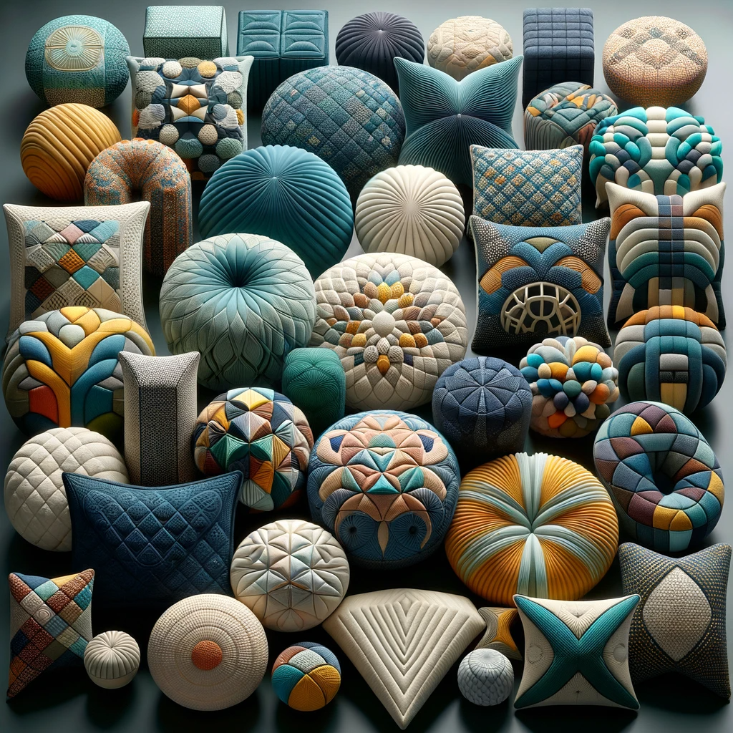

A collection of complex shaped cushions and padded items designed for upholstered furniture. The image should showcase a variety of cushions in unique shapes, such as circular, triangular, and abstract forms. Each cushion features intricate patterns and textures, possibly including quilted designs, floral prints, and modern geometric patterns. The colours are vibrant and varied, ranging from deep blues and greens to bright yellows and pinks. The cushions are displayed in a way that highlights their unique shapes and designs, some stacked or arranged artistically, creating a visually appealing and diverse collection.

KM09KT01: Complex shaped cushions and padded items (10%)

Learning Outcome

At the end of this section, learners should cover:

- KT0101 Types.
- KT0102 Uses.
- KT0103 Design requirements and technical specifications.

INTRODUCTION
In the realm of interior design, upholstery, and functional aesthetics, complex shaped cushions and padded items represent a unique intersection of creativity and technical skill. This module topic, KM09KT01, is meticulously crafted to explore the depth and breadth of these bespoke items, focusing on their types, uses, and the intricacies involved in their design and production.

KT0101: Types
This segment delves into the myriad types of complex shaped cushions and padded items available in the market and used in various settings. It aims to provide a comprehensive overview of the different styles, shapes, and forms these items can take, ranging from simple geometric variations to intricate and customdesigned patterns. This part of the module will not only acquaint learners with the existing types but also inspire innovation and creativity in their designs.

KT0102: Uses
Complex shaped cushions and padded items are not just aesthetic additions; they serve multiple functional purposes. In this section, we explore the diverse uses of these items in different environments – from residential to commercial, from decorative to ergonomic applications. Understanding the multifaceted utility of these items will enable learners to appreciate the practical impact of their work and the role these items play in enhancing comfort, style, and functionality in various spaces.

KT0103: Design Requirements and Technical Specifications
The cornerstone of creating exceptional complex shaped cushions and padded items lies in understanding their design requirements and technical specifications. This crucial segment covers the essential aspects of design, including ergonomic considerations, aesthetic appeal, material selection, durability factors, and compliance with industry standards. It provides an indepth look at how technical specifications and design requirements converge to produce items that are not only visually stunning but also meet the highest standards of quality and functionality.

Through this Knowledge Module Topic, learners will gain a thorough understanding of the various aspects of complex shaped cushions and padded items. From recognizing different types to understanding their practical applications, and from conceptualizing designs to adhering to technical specifications, this module provides a comprehensive foundation for mastering this specialized field.

KT0101 Types

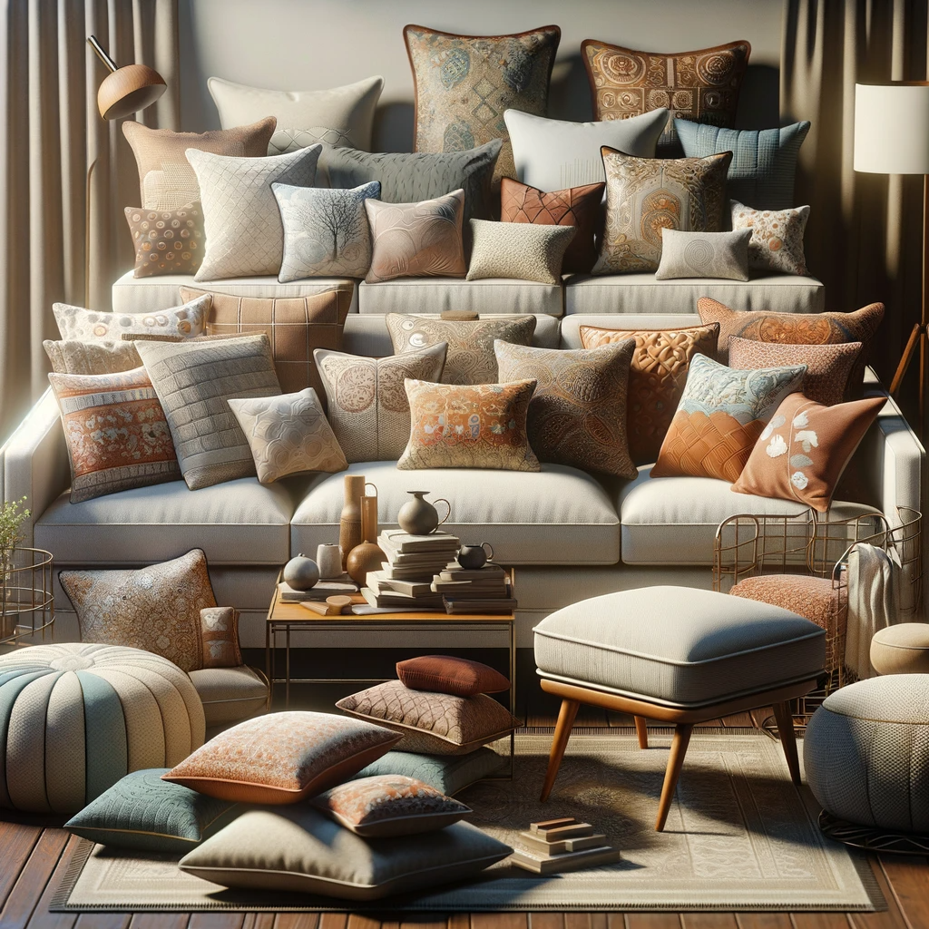

An image depicting various uses of different pillows in furniture upholstery. The scene includes several pieces of furniture, such as a sofa, armchair, and ottoman, each adorned with different types of pillows. The pillows vary in shape, size, and colour, showcasing a wide range of designs like square, round, bolster, and lumbar pillows. Some pillows have decorative patterns, while others are solid colours. The furniture pieces are styled in a cosy, inviting setting, possibly with a warm, soft lighting to enhance the comfort and aesthetic appeal of the upholstery. The image should convey a sense of elegance and creativity in home decor.

KT0101: Types of Pillows with Different Coverings and Fabrics

In the field of furniture upholstery, the types of pillows used can significantly influence both the aesthetic appeal and the comfort level of a piece of furniture. This section explores the diverse range of pillows, focusing on their coverings and fabrics, which are integral to the functionality and style of upholstered furniture.

1. Fiberfill or Synthetic Pillows

Description: Fiberfill pillows are commonly made from polyester fibres. These are lightweight, hypoallergenic, and offer a costeffective alternative to natural fillings.
Fabric Choices: Typically covered with tightly woven fabrics to prevent fibre escape. Microfiber and synthetic blends are popular choices for their durability and ease of cleaning.

2. Foam Pillows
Description: Foam pillows provide firm support and retain their shape well. They are often used in seat cushions and can be made from various densities of foam to achieve desired firmness.
Fabric Choices: Stretchable fabrics like spandex blends or heavyweight cotton are suitable, as they accommodate the firmness and shape of foam pillows without sagging.

3. Down or Feather Pillows
Description: These pillows offer a luxurious feel, made from the soft feathers and down of ducks or geese. They are known for their softness, warmth, and adaptability.
Fabric Choices: Highthreadcount cotton or downproof fabrics are essential to prevent feather leakage and ensure a smooth, comfortable surface.

4. Memory Foam Pillows
Description: Memory foam is heatsensitive and conforms to the body, providing excellent support. These pillows are popular in ergonomic designs.
Fabric Choices: Breathable, moisturewicking fabrics like bamboo blends or perforated weaves are recommended for comfort and to offset memory foam's heatretaining properties.

5. Latex Pillows
Description: Latex pillows are durable, naturally hypoallergenic, and resistant to mould and dust mites. They offer a balance of support and comfort.
Fabric Choices: Cotton or natural fibre covers are preferred for their breathability, complementing the natural properties of latex.

6. Wool or Cotton Pillows
Description: Natural fillings like wool or cotton are breathable, durable, and naturally resistant to dust mites and mould. They provide a firmer feel compared to down.
Fabric Choices: Organic cotton, linen, or hemp fabrics are often used for their natural feel and ecofriendly qualities.

7. Specialty Pillows
Description: These include cervical, lumbar, or contour pillows designed for specific support needs. They can be made from a combination of materials.
Fabric Choices: The choice of fabric often depends on the specific application, with emphasis on support, comfort, and hypoallergenic properties.

8. Decorative Pillows
Description: Used more for aesthetics than support, decorative pillows come in various shapes and sizes. They can feature intricate designs, textures, and embellishments.
Fabric Choices: A wide range, including silk, velvet, brocade, and heavyduty upholstery fabrics, are used based on the desired style and theme of the room.

Understanding and Selection Criteria
When selecting the appropriate type of pillow for a furniture upholstery project, several factors need to be considered:

Purpose and Placement: Determine whether the pillow is for decorative purposes, ergonomic support, or general comfort. The location of the pillow on the furniture also impacts the choice, as seat cushions require more durable and firmer materials compared to back cushions or decorative accents.

Client Preferences and Needs: Understand the client's preferences regarding comfort, maintenance, hypoallergenic properties, and aesthetic appeal.

Durability and Maintenance: Consider the expected usage and maintenance requirements. Some materials may be more suitable for highuse areas, while others might be preferred for their ease of cleaning.

Environmental and Health Considerations: The choice of natural versus synthetic materials can be influenced by environmental concerns and health considerations, such as allergies.

Cost: Factor in the cost of materials and fillings, as it can vary significantly between different types of pillows and fabrics.

In summary, the choice of pillows and their coverings in furniture upholstery is a crucial aspect that combines functionality, comfort, and design. Understanding the diverse types of pillows and their suitable fabric coverings is essential for any furniture upholsterer, enabling them to meet client needs effectively while enhancing the overall appeal and longevity of the upholstered furniture.

KT0102 Uses

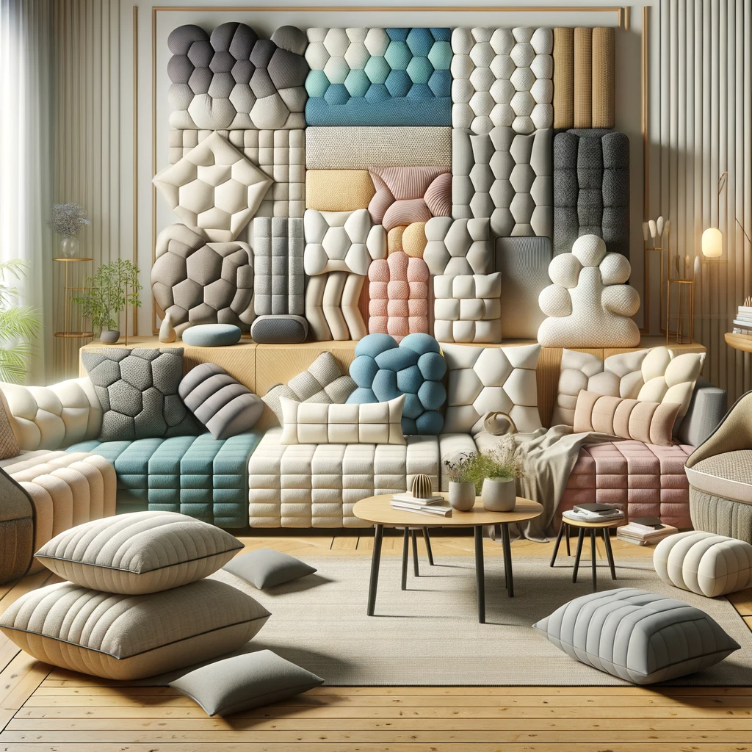
An image depicting the various uses of complex shaped cushions and padded items in interior design. The scene includes a living room setting with a variety of furniture pieces such as a modern sofa, armchairs, and a window seat. Each piece of furniture is adorned with uniquely shaped cushions and padded items, showcasing their versatility and aesthetic appeal. The cushions include various shapes like hexagonal, waveshaped, and asymmetrical designs. The padded items could be used as backrests, seat pads, or decorative elements, each with distinct textures and colours, ranging from pastel shades to vibrant hues. The overall ambiance is stylish and contemporary, demonstrating how these complex cushions can enhance the decor of a space.

KT0102: Uses of Complex Shaped Cushions and Padded Items

The application of complex shaped cushions and padded items is vast and varied, extending across multiple domains, from enhancing comfort and aesthetics in living spaces to providing functional and ergonomic solutions in various settings. This section explores the multifaceted uses of these items.

1. Home Furnishings
Comfort and Aesthetics: In residential settings, complex shaped cushions and padded items are primarily used for comfort and decorative purposes. They add visual interest and a touch of personal style to sofas, chairs, and beds.
Theme and Design Alignment: These items can be tailored to align with specific interior design themes, whether contemporary, traditional, eclectic, or minimalist, aiding in creating a cohesive and harmonious decor.

2. Commercial Spaces
Brand Identity and Aesthetic Appeal: In commercial settings such as hotels, restaurants, and offices, these items are used to enhance the brand identity and aesthetic appeal of the space. They provide a comfortable and visually appealing environment for customers and employees.
Customization for Space Utilization: Customshaped cushions and padding are often used to optimize space, fitting into unique or unconventional areas, like window seats or custombuilt furniture.

3. Healthcare and Ergonomics
Support and Pressure Relief: In healthcare settings, specially designed cushions and pads are used to provide support, alleviate pressure points, and prevent bedsores for patients, particularly in longterm care facilities.
Ergonomic Solutions: Ergonomically designed cushions and pads are used in office chairs, car seats, and other environments to improve posture and provide support, reducing strain and discomfort.

4. Outdoor and Recreational Use
Durability and Comfort for Outdoor Furniture: For outdoor furniture, such as patio chairs and loungers, these items are designed to be durable and weatherresistant, while providing comfort and style.
Recreational Gear: In recreational gear like camping equipment, boat seats, and sporting goods, complex shaped cushions and pads offer comfort and protection.

5. Children’s Furniture and Accessories
Safety and Comfort: In children’s furniture, such as cribs, high chairs, and play areas, these items are used to provide safety and comfort. They are often designed with bright colours and engaging textures to be visually stimulating for children.

6. Custom and Specialty Applications
Bespoke Furniture and Artistic Pieces: For customdesigned furniture and artistic installations, complex shaped cushions and pads can be integral components, contributing to the uniqueness and functional aspects of the pieces.
Specialty Equipment Padding: In specialty equipment like musical instruments, camera gear, or delicate machinery, custom padding provides protection and cushioning.

7. Vehicle Interiors
Comfort and Aesthetics in Automotive Upholstery: In automotive interiors, these items are used for both comfort and aesthetic enhancement, providing cushioning and support in car seats, headrests, and armrests.

8. Pet Furniture
Comfort for Pets: In pet furniture like beds and play structures, cushions and pads are used to provide comfort and support for pets, designed to be durable and easy to clean.
Understanding the diverse applications of complex shaped cushions and padded items is crucial for furniture upholsterers. It enables them to cater to various needs and preferences, ensuring that their creations are not only aesthetically pleasing but also functionally apt for their intended use.

KT0103 Design requirements and technical specifications

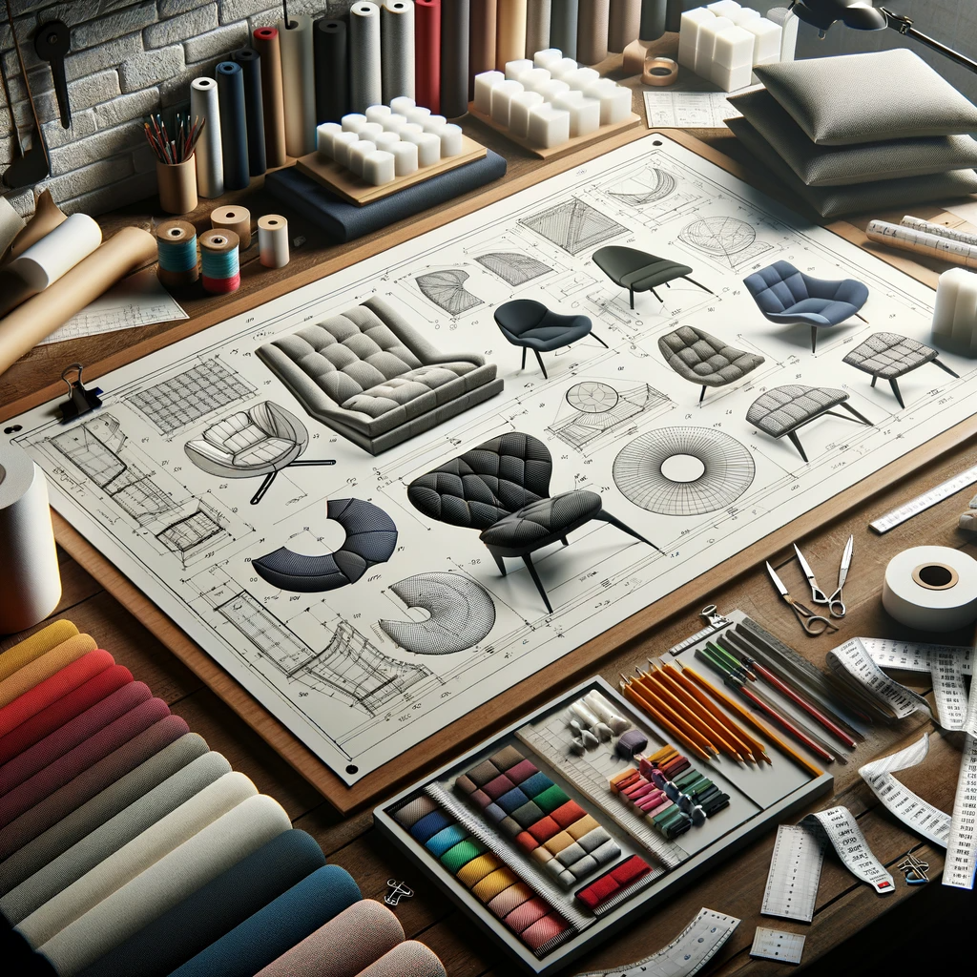

An image representing the design requirements and technical specifications for complex shaped cushions and padded items for furniture upholstery qualification. The scene should include a drafting table with detailed technical drawings and specifications of various complex shaped cushions and padded items. These drawings should show different angles, dimensions, and material specifications, highlighting the precision and detail involved in the design process. Around the drafting table, there are samples of fabrics, foam densities, and color swatches, along with tools like measuring tapes, rulers, and pencils, emphasizing the technical aspects of upholstery design. The overall setting conveys a professional environment focused on quality and precision in furniture design.
Dear Judith,

Certainly, I am pleased to provide the theoretical learning content for Knowledge Topic Element KT0103: Design Requirements and Technical Specifications for Complex Shaped Cushions and Padded Items, as part of the furniture upholstery qualification.

KT0103: Design Requirements and Technical Specifications for Complex Shaped Cushions and Padded Items

Designing complex shaped cushions and padded items involves a blend of artistry and engineering. This section outlines the critical design requirements and technical specifications necessary to ensure both aesthetic appeal and functionality in these items.

1. Ergonomic Considerations
Comfort and Support: Designs must prioritize ergonomic factors to provide adequate support and comfort. This involves understanding human anatomy and the intended use of the cushion or padded item, ensuring that it conforms and responds to body contours effectively.
Height, Depth, and Angle: For seating cushions, key ergonomic considerations include the height, depth, and angle of the cushion, which should accommodate a range of body types while promoting proper posture.

2. Aesthetic Design
Visual Appeal: The visual design should complement the furniture style and interior décor. This includes considerations of shape, color, texture, and pattern.
Symmetry and Proportion: Proportions should be balanced, and symmetry should be considered, especially in pairs or sets of cushions and padded items, to create a harmonious look.

3. Material Selection
Fabric Type: Choice of fabric should align with the item’s use, considering factors such as durability, ease of cleaning, and resistance to fading. Fabrics range from natural fibers like cotton and linen to synthetics like polyester and acrylic.
Filling Material: The choice of filling impacts comfort and shape retention. Options include foam, down, polyester fiberfill, and specialized materials like memory foam or latex.

4. Durability and Quality
Wear and Tear: Highquality materials and construction techniques should be used to ensure that the items withstand regular use and maintain their shape over time.
Seam Strength: For complex shapes, seam strength is vital. Reinforced seams and appropriate stitching techniques should be employed to prevent tearing and ensure longevity.

5. Safety and Compliance
Fire Safety Standards: Materials should meet fire safety standards, especially for items used in public spaces or commercial settings.
Nontoxic Materials: In environments like children’s rooms or healthcare settings, materials should be nontoxic and hypoallergenic.

6. Sustainability and Environmental Impact
Ecofriendly Materials: Where possible, ecofriendly materials and sustainable practices should be employed, such as using organic fabrics or recycled filling materials.
Life Cycle Considerations: Design for longevity and ease of maintenance, reducing the environmental impact over the item's life cycle.

7. Technical Specifications
Measurements and Templates: Precise measurements and templates are crucial for ensuring that the final product fits the intended space or furniture piece accurately.
Pattern Making and Cutting Techniques: Advanced pattern making and cutting techniques may be required for complex shapes, ensuring accuracy and efficiency in the production process.

8. Customization and Client Specifications
Client Requirements: Understanding and integrating clientspecific requirements, such as custom dimensions, preferred materials, or unique design elements, is essential in bespoke projects.

In summary, the design and creation of complex shaped cushions and padded items demand a thorough understanding of ergonomic principles, aesthetic design, material selection, and technical specifications. Mastery in these areas ensures that furniture upholsterers can produce items that are not only visually appealing but also functional, durable, and tailored to specific needs and environments.

I trust this content will be insightful and beneficial for the learners pursuing the furniture upholsterer qualification.

Internal Assessment Criteria

- IAC0101 Various types of complex covers are identified and functions are explained in terms of design and technical requirements.
(Weight 10%)

KM09KT02: Faults and problem solving

related to complex shaped cushions and

padded items (20%)

Learning Outcome
At the end of this section, learners should cover:

- KT0201 Flaws, distortions and colour/pattern variations in the fabric.
- KT0202 Inaccurate measurements.
- KT0203 Misalignments.
- KT0204 Slipping, fraying, inaccuracies, poor seam quality and equipment faults.
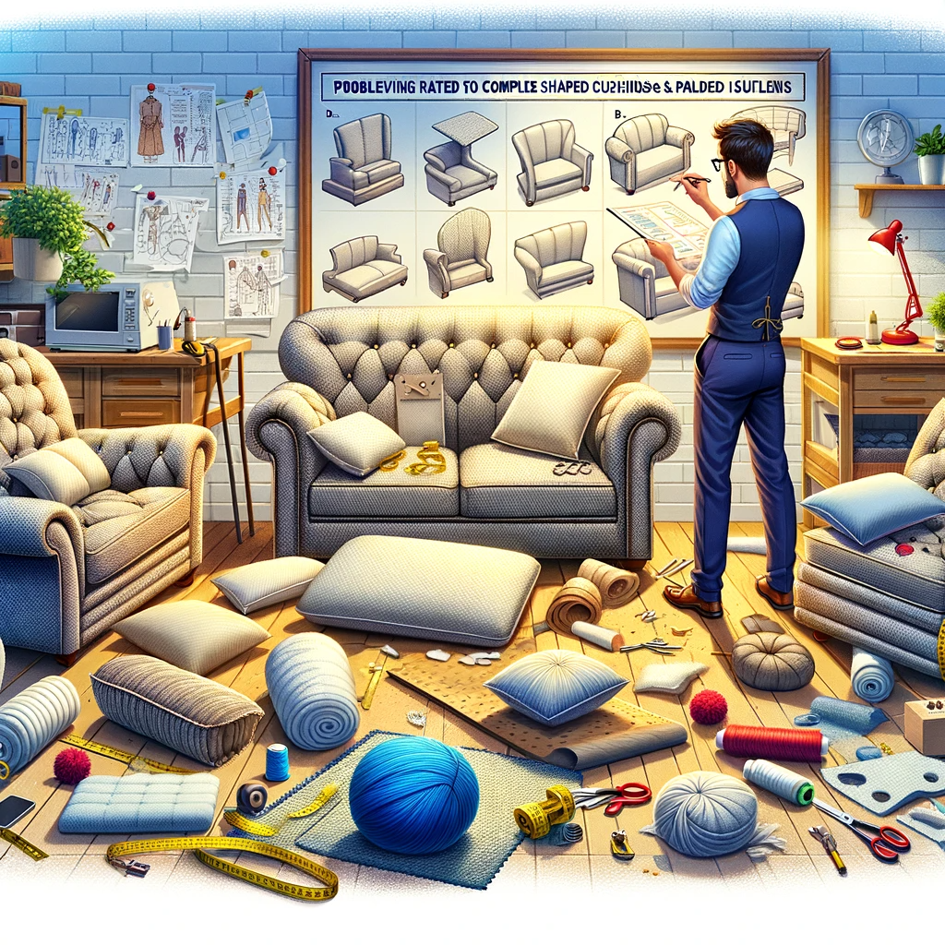
An image illustrating faults and problemsolving related to complex shaped cushions and padded items for furniture upholstery qualification. The scene should depict a workshop setting with a few pieces of furniture, like sofas and chairs, each displaying different common faults in upholstery, such as uneven stuffing, misaligned patterns, and improper fitting of complex shapes. In the foreground, there is a professional upholsterer examining these faults, with tools like seam rippers, stuffing materials, and measuring tapes at hand, suggesting active problemsolving. Additionally, there should be a bulletin board or a digital screen in the background showing diagrams and notes on common upholstery problems and their solutions, emphasising the educational and troubleshooting aspect of the upholstery qualification.
INTRODUCTION

This module will encompass critical aspects and solutions regarding various faults and challenges encountered in the upholstery process.

Introduction to Knowledge Module KM09KT02: Faults and Problem Solving Related to Complex Shaped Cushions and Padded Items

The realm of furniture upholstery, particularly when dealing with complex shaped cushions and padded items, is both intricate and challenging. This module, KM09KT02, is devoted to exploring the common faults that may arise in the process and the effective strategies for problemsolving. Mastery in recognizing and rectifying these issues is essential for maintaining high standards of quality and craftsmanship in the upholstery industry.

KT0201: Flaws, Distortions, and Colour/Pattern Variations in the Fabric
This section addresses the challenges posed by fabric flaws, distortions, and colour or pattern inconsistencies. Understanding how to identify these issues and the methods to mitigate their impact is crucial. This includes techniques for working with patterned fabrics to ensure alignment and continuity, as well as strategies for dealing with fabric flaws and distortions to maintain the aesthetic integrity of the upholstered item.

KT0202: Inaccurate Measurements
Inaccurate measurements can lead to significant issues in the upholstery of complex shaped cushions and padded items. This topic explores the importance of precision in measuring and the repercussions of inaccuracies. It covers practical tips for accurate measurement taking and adjustments that may be required during the upholstery process to compensate for initial measurement errors.

KT0203: Misalignments
Misalignments in upholstery work can compromise both the functionality and the visual appeal of the finished product. This segment delves into the common causes of misalignments, such as improper pattern placement or assembly errors. It provides insight into preventive measures and corrective techniques to ensure alignment and symmetry in complex upholstery projects.

KT0204: Slipping, Fraying, Inaccuracies, Poor Seam Quality, and Equipment Faults
The final section of this module focuses on a range of issues including fabric slipping, material fraying, and inaccuracies in cutting or assembling, poor seam quality, and faults arising from equipment use. Each of these challenges is addressed in detail, offering solutions and best practices to overcome them. This includes selecting the right tools and materials, employing effective sewing techniques, and maintaining equipment to ensure highquality outcomes.

In conclusion, KM09KT02 is an essential module that provides comprehensive insights into the potential faults in upholstery of complex shaped cushions and padded items, and equips learners with the skills and knowledge to effectively address and solve these issues. The aim is to enhance the proficiency of furniture upholsterers, enabling them to produce work of exceptional quality, and to maintain the standards expected in the furniture upholstery industry.

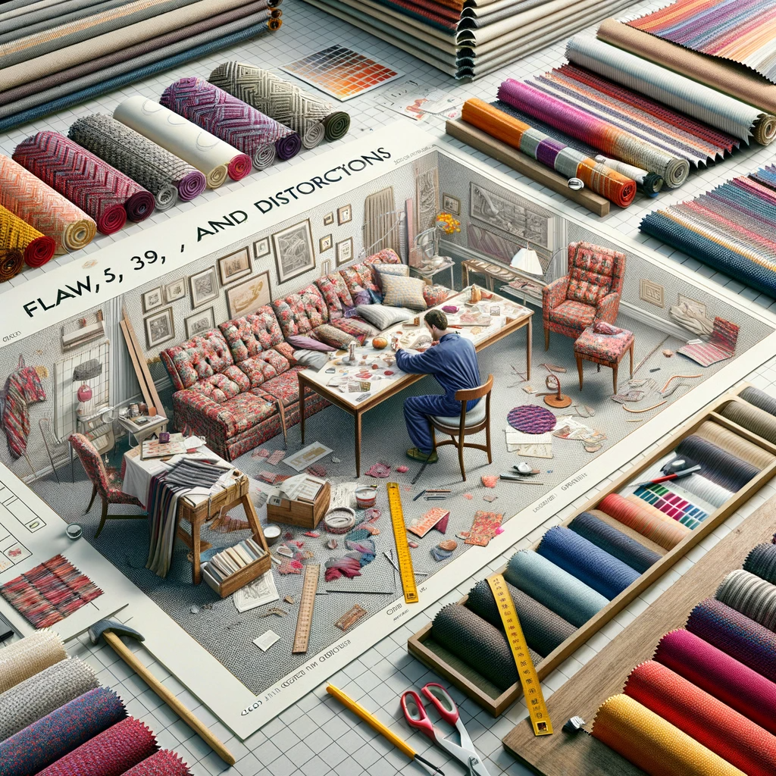

An image depicting 'KT0201: Flaws, Distortions, and Colour/Pattern Variations in the Fabric'. The scene shows a workspace with various fabric samples displaying common issues such as flaws, distortions, and colour or pattern inconsistencies. One area of the workspace highlights patterned fabrics with misalignments and breaks in continuity, while another section showcases fabrics with visible flaws and distortions. Tools and techniques used to address these issues are prominently displayed, such as alignment grids, colour matching guides, and fabric stretching tools. An upholsterer is actively working on a piece of furniture, demonstrating the application of these techniques to ensure the aesthetic integrity of the upholstered item, emphasising the importance of attention to detail and problemsolving in upholstery work.

KT0201 Flaws, distortions and colour/pattern variations in the fabric

*KT0201: Flaws, Distortions, and Colour/Pattern Variations in the Fabric

This section of the module delves deeply into the complexities of working with various fabrics, focusing on identifying and addressing flaws, distortions, and colour or pattern variations, which are common challenges in upholstery work. Mastery in handling these aspects is pivotal in ensuring the aesthetic and structural integrity of upholstered furniture.

Identifying Fabric Flaws and Distortions
Visual Inspection: Before using any fabric, a thorough visual inspection is essential. Look for tears, holes, uneven weaves, or any other irregularities that might compromise the quality of the finished product.
Feeling the Fabric: Running hands over the fabric can help identify hidden flaws like snags, rough patches, or variations in thickness.

Dealing with Fabric Flaws
Cutting around Flaws: When possible, plan the cutting layout to avoid incorporating flawed areas into the final product.
Using Interfacing: In cases where flaws are small and unavoidable, using interfacing can reinforce the area without affecting the overall design.

Handling Distortions in Fabric
PreShrinking: Some fabrics, particularly natural fibres, are prone to shrinkage. Preshrinking the fabric before cutting and sewing can prevent distortions in the final product.
Fabric Relaxation: Allowing the fabric to rest and relax, especially after it has been on a roll, can reduce inherent distortions. This is crucial for ensuring accurate measurements and alignments.

Working with Colour/Pattern Variations
Colour Consistency: In situations where fabric rolls are from different dye lots, ensure that all pieces for a single item come from the same roll to maintain colour consistency.
Pattern Matching: For patterned fabrics, careful planning is needed to ensure that patterns match at seams and junctions. This includes aligning motifs and ensuring continuity across different pieces of fabric.

Techniques for Patterned Fabrics
Pattern Repeats and Symmetry: Understand the repeat pattern of the fabric to ensure symmetry and alignment. This is particularly important for geometric or floral patterns that need to align at seams.
Strategic Cutting: Cut patterned fabrics in a single layer to ensure precise alignment, especially for complex shapes or where the pattern needs to match at specific points on the furniture.

Mitigating the Impact of Flaws and Variations
Creative Use of Trim and Accents: In some cases, trims, borders, or complementary fabrics can be used to disguise minor flaws or breaks in the pattern.
Client Communication: When flaws are inherent in the fabric or unavoidable, communicate with the client to manage expectations and discuss possible solutions or alternatives.

In summary, KT0201 provides an indepth exploration of the challenges posed by fabric flaws, distortions, and colour/pattern variations, along with practical strategies and techniques to address these issues. By mastering these skills, upholsterers can ensure that their work not only meets but exceeds quality standards, resulting in furniture that is both structurally sound and aesthetically pleasing.

KT0202 Inaccurate measurements

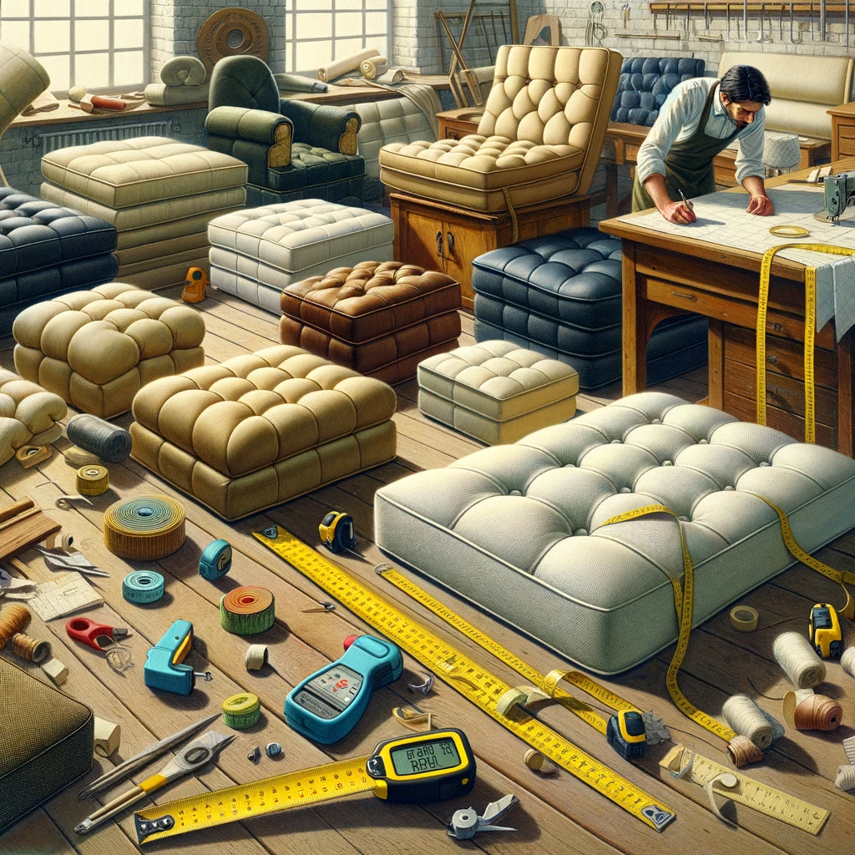

An image depicting 'KM09KT02: Faults and Problem Solving Related to Complex Shaped Cushions and Padded Items', focusing on the issue of inaccurate measurements. The scene is set in an upholstery workshop, showing a few complex shaped cushions and padded items with visible flaws due to incorrect measurements. These flaws include uneven edges, misaligned seams, and disproportionate shapes. Tools commonly used for precise measurements, like measuring tapes, rulers, and digital callipers, are displayed, some of them showing the incorrect measurements that led to the faults. An upholsterer is seen examining the items, highlighting the process of identifying and solving these measurementrelated problems. The overall image should convey the importance of accuracy in measurements to avoid faults in complex upholstery work.

KT0202: Inaccurate Measurements

In the upholstery of complex shaped cushions and padded items, precise measurements are foundational to the success of the final product. Inaccurate measurements can lead to a multitude of problems, affecting the fit, appearance, and functionality of upholstered items. This section addresses the causes, consequences, and solutions for inaccurate measurements in upholstery projects.

Causes of Inaccurate Measurements
Improper Use of Measuring Tools: Utilizing inappropriate measuring tools or using them incorrectly can lead to measurement errors. For instance, using a flexible tape measure for straight dimensions can result in inaccuracies.
Human Error: Misreading measurements, incorrect calculations, or failure to account for seam allowances can cause inaccuracies.
Material Movement: Fabrics, especially stretchable or slippery materials, can move or shift during measurement, leading to errors.
Inconsistent Measurement Units: Mixing measurement units (e.g., centimeters and inches) can cause confusion and inaccuracies.

Consequences of Inaccurate Measurements
Illfitting Covers: Inaccurate measurements can result in covers that are either too tight, causing strain on seams and fabric, or too loose, leading to a sloppy appearance.
Wastage of Material: Overestimating measurements can lead to unnecessary wastage of fabric, while underestimating can result in a shortage, potentially requiring additional material purchases.
Functional Issues: For items requiring precise dimensions for functionality (e.g., cushion inserts fitting into existing frames), inaccurate measurements can render the item unusable.

Strategies to Ensure Accurate Measurements
Standardized Measuring Tools: Use standardized, wellcalibrated tools such as rigid rulers for straight lines and soft measuring tapes for curved or irregular surfaces.
DoubleCheck Measurements: Always doublecheck measurements, especially before cutting the fabric. It's a practice to measure twice and cut once.
Account for Seam Allowances: Include appropriate seam allowances in measurements and be consistent in their application.
Stabilize Fabric During Measuring: Use weights or pins to stabilize fabrics, particularly those prone to movement, to ensure accurate measurements.
Record Keeping: Maintain clear, wellorganized records of measurements, including notes on any special considerations or adjustments made.

Correcting Measurement Errors
Adjustments in Cutting: If discrepancies are caught before cutting, adjustments can be made to the cutting plan to accommodate the correct measurements.
Use of Insets or Panels: For minor errors, additional fabric panels or insets can be used to adjust the size without compromising the overall design.
Client Communication: In cases where errors significantly affect the project, transparent communication with the client is crucial to discuss potential solutions or alterations.

In summary, KT0202 highlights the critical importance of accurate measurements in upholstery. By understanding common pitfalls and adopting best practices for measurement, upholsterers can significantly reduce the likelihood of errors, ensuring that their projects meet both aesthetic and functional standards.

KT0203 Misalignments

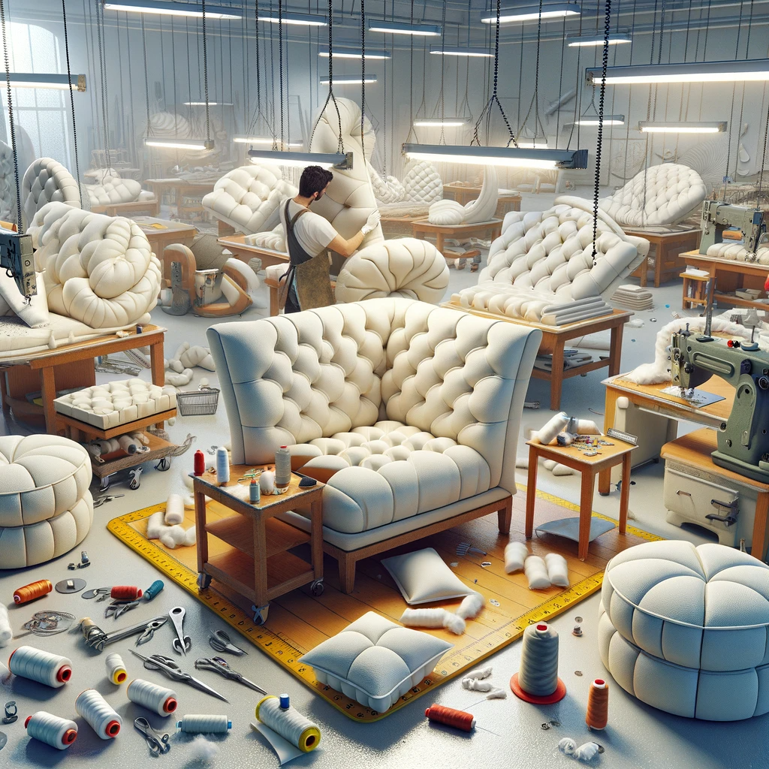

An image illustrating 'KM09KT02: Faults and Problem Solving Related to Complex Shaped Cushions and Padded Items', focusing specifically on misalignments. The scene features an upholstery workshop with several complex shaped cushions and padded items displaying clear misalignments. These misalignments could be in the form of mismatched seams, uneven stuffing distribution, or asymmetrical shapes. Various tools and techniques for correcting these issues are visible, such as alignment guides, fabric clamps, and sewing machines set up to rectify the alignment errors. An upholsterer is actively working to correct these misalignments, demonstrating the meticulous attention to detail and problemsolving skills required in highquality upholstery work. The image should emphasize the importance of precision and care in creating perfectly aligned and aesthetically pleasing upholstered items.

KT0203: Misalignments

Misalignments in upholstery, particularly with complex shaped cushions and padded items, can significantly detract from the aesthetic and functional integrity of the finished product. This section explores the causes, impacts, and resolution strategies for misalignments in upholstery projects.

Causes of Misalignments
Inaccurate Cutting: Misalignments often originate from inaccurate cutting of fabric or filling materials, where pieces do not align correctly during assembly.
Improper Sewing Techniques: Errors in sewing, such as uneven seam allowances or misaligned stitching, can lead to misshapen and misaligned final products.
Fabric Stretch or Distortion: Certain fabrics, especially those with stretch or bias, can distort during sewing, leading to misalignment.
Incorrect Pattern Use: Failure to properly align patterns, particularly for patterned fabrics, can result in visual misalignments that disrupt the design continuity.

Impacts of Misalignments
Aesthetic Disruption: Misalignments can break the visual flow of patterns and shapes, resulting in a product that looks unprofessional and poorly crafted.
Functional Compromise: In some cases, misalignments can affect the functional aspects of the item, such as cushion fit, comfort, or durability.
Client Dissatisfaction: Misalignments can lead to client dissatisfaction, particularly in custom upholstery work where precision and attention to detail are expected.

Strategies to Prevent and Address Misalignments
Accurate Template and Pattern Use: Ensure all templates and patterns are accurately designed and used, particularly for complex shapes and patterned fabrics.
Consistent Seam Allowances: Maintain consistent seam allowances throughout the sewing process. Using sewing guides or markers can help achieve this.
Proper Fabric Handling: Understand the properties of different fabrics and adjust handling and sewing techniques accordingly to prevent stretch or distortion.
Regular Checks During Sewing: Periodically align and check the pieces during the sewing process to catch and correct any misalignments early.
Skill Development in Sewing Techniques: Upholsterers should continually refine their sewing skills, focusing on techniques that promote accuracy and precision.

Correcting Misalignments
Seam Adjustment: If misalignment is detected early, seams can often be ripped and resewn correctly.
Adding or Reducing Fabric: In cases where misalignment is due to fabric shortage or excess, strategically adding insets or trimming excess material can help realign the pieces.
Client Communication: If misalignment significantly affects the project outcome, it's crucial to communicate with the client to discuss possible remedial actions or alterations.

In conclusion, KT0203 addresses the critical aspect of avoiding and correcting misalignments in upholstery. Mastery in this area is vital for upholsterers, as it directly impacts the quality and satisfaction associated with their finished products.

KT0204 Slipping, fraying, inaccuracies, poor seam quality and equipment faults.

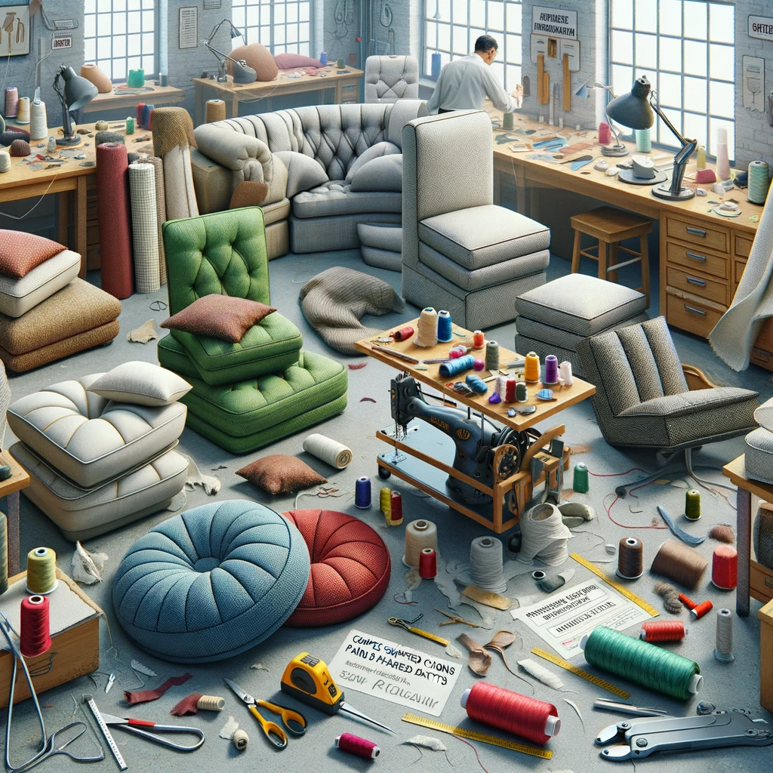

An image depicting 'KM09KT02: Faults and Problem Solving Related to Complex Shaped Cushions and Padded Items', focusing on slipping, fraying, inaccuracies, poor seam quality, and equipment faults. The scene shows an upholstery workshop with various complex shaped cushions and padded items exhibiting these specific faults. Slipping fabrics, frayed edges, inaccurate cuts, and poorly stitched seams are clearly visible on different items. Also, malfunctioning upholstery equipment like a faulty sewing machine or an inaccurate cutting tool is displayed, contributing to these issues. An upholsterer is seen inspecting and addressing these faults, using tools like seam rippers, fabric adhesives, and precision cutting tools. The environment emphasizes the challenges in upholstery work and the importance of proper techniques and equipment maintenance to ensure highquality results.

KT0204: Slipping, Fraying, Inaccuracies, Poor Seam Quality, and Equipment Faults

This section of the module delves into some of the more technical aspects of upholstery, specifically focusing on issues such as fabric slipping, fraying, general inaccuracies, poor seam quality, and equipment faults. These challenges, if not properly managed, can compromise the integrity and appearance of the finished upholstery products.

Slipping
Causes: Slipping primarily occurs with smooth or silky fabrics that move against each other or the work surface.
Prevention: Use of nonslip surfaces or temporary adhesives can help stabilize the fabric during cutting and sewing. Pinning or basting the fabric can also be effective.

Fraying
Causes: Fraying happens when the weave of the fabric unravels, often at the edges. It's common in loosely woven or rawedged fabrics.
Prevention: Sealing edges with a fraycheck solution, serging, or using a zigzag stitch can prevent fraying. Choosing tightly woven fabrics and proper handling also minimizes this issue.

Inaccuracies
Causes: Inaccuracies in cutting, measuring, or sewing can lead to misshapen or poorly fitting upholstery.
Prevention: Accurate measuring and careful cutting are essential. Using sharp, appropriate tools and following patterns or templates precisely can reduce inaccuracies.

Poor Seam Quality
Causes: This can result from incorrect tension settings, using the wrong type of thread or needle, or lack of skill in sewing.
Prevention: Regularly maintaining and correctly setting up sewing equipment is crucial. Using the appropriate thread, needle, and stitch type for the fabric and project will enhance seam quality. Practice and skill development in sewing is also key.

Equipment Faults
Causes: These can range from mechanical issues in sewing machines to dull cutting tools.
Prevention: Regular maintenance of equipment, including cleaning, oiling, and servicing sewing machines, and sharpening cutting tools, is essential. Being familiar with the equipment and understanding its proper use can prevent many faults.

Problem Solving Strategies
For Slipping: Increase surface tension or use stabilizing materials like tissue paper or temporary adhesives.
For Fraying: Apply edge finishing techniques as soon as the fabric is cut, and handle the fabric carefully.
For Inaccuracies: Doublecheck measurements and patterns before cutting. Use marking tools for precision.
For Poor Seam Quality: Adjust tension and choose appropriate thread and needle size. Practice sewing on scrap fabric to test settings.
For Equipment Faults: Develop a routine for equipment maintenance. Learn basic troubleshooting and when to seek professional servicing.

In summary, KT0204 provides an indepth analysis of common issues like slipping, fraying, inaccuracies, poor seam quality, and equipment faults in upholstery work. Understanding these challenges and implementing the strategies outlined above will greatly enhance the quality and durability of upholstered furniture.

Internal Assessment Criteria

- IAC0201 Typical faults which may occur during the production of complex shaped cushions and padded items are identified and prevention and rectification is discussed.
(Weight 20%)

KM09KT03: Raw materials for complex shaped cushions and padded items (20%)

Learning Outcome
At the end of this section, learners should cover:

- KT0301 Patterned or striped fabric.
- KT0302 Fabric pile direction.
- KT0303 Distortions and colour/pattern variations.
- KT0304 Material characteristics and handling requirements.
- KT0305 Linings and fillings.
INTRODUCTION
Dear Judith,

I am pleased to provide the introduction for Knowledge Module KM09KT03, titled "Raw Materials for Complex Shaped Cushions and Padded Items", which is a vital component of the furniture upholstery qualification.

Introduction to Knowledge Module KM09KT03: Raw Materials for Complex Shaped Cushions and Padded Items

In the specialized field of creating complex shaped cushions and padded items, the selection and handling of raw materials are fundamental to achieving both aesthetic excellence and functional integrity. This module, KM09KT03, offers a comprehensive exploration of various raw materials used in upholstery, focusing on their properties, challenges, and best practices for handling. It is designed to equip learners with the knowledge necessary to make informed decisions about material selection and use, which is crucial in the upholstery of complex items.

KT0301: Patterned or Striped Fabric
This section delves into the specifics of working with patterned or striped fabrics. Learners will explore the techniques for aligning patterns and stripes, ensuring continuity, and avoiding common pitfalls such as pattern mismatches. The module will also cover the visual impact of patterned fabrics on the final product and how to maximize their aesthetic potential.

KT0302: Fabric Pile Direction
Understanding and working with fabric pile direction is critical, especially in materials like velvet or corduroy. This topic covers how pile direction affects the look and feel of the finished item, including the importance of consistent pile orientation for color uniformity and texture consistency.

KT0303: Distortions and Colour/Pattern Variations
This segment addresses challenges related to fabric distortions and colour or pattern variations. Learners will gain insights into identifying and correcting distortions, managing colour consistency, and dealing with pattern variations, especially in largescale or repeat pattern fabrics.

KT0304: Material Characteristics and Handling Requirements
Different materials come with their unique characteristics and handling requirements. This part of the module provides an indepth look at various upholstery materials, discussing their properties, such as stretch, durability, and ease of care, and how these characteristics dictate handling techniques during the upholstery process.

KT0305: Linings and Fillings
Finally, the module will explore the world of linings and fillings, which play a crucial role in the comfort and structure of upholstered items. It will cover the range of options available, from traditional natural fillings to modern synthetic alternatives, and discuss their suitability for different types of cushions and padded items.

In conclusion, KM09KT03 is an essential module for anyone involved in furniture upholstery, providing a detailed understanding of the raw materials involved in the creation of complex shaped cushions and padded items. Mastery of this module will enable learners to make informed choices about materials, leading to higher quality and more durable finished products.

KT0301 Patterned or striped fabric

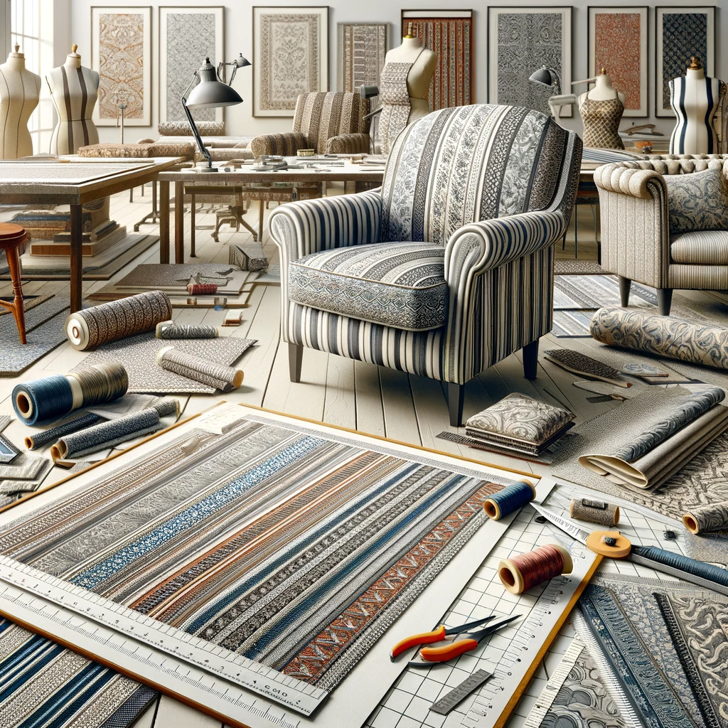

An image for 'KT0301: Patterned or Striped Fabric', focusing on the specifics of working with these types of fabrics. The scene includes a design studio with various pieces of furniture upholstered in patterned and striped fabrics. The furniture pieces illustrate successful alignment of patterns and stripes, showcasing continuity and avoiding mismatches. Closeup views of fabric sections highlight the precision in aligning patterns at seams and corners. Additionally, there are design tools like rulers, fabric markers, and pattern layout diagrams displayed, emphasizing the techniques used for pattern alignment. The overall setting showcases the visual impact of these fabrics on furniture, demonstrating how wellexecuted pattern and stripe alignment can enhance the aesthetic appeal of the final product.

KT0301: Patterned or Striped Fabric

Working with patterned or striped fabrics in the furniture upholstery industry requires a keen eye for detail and a deep understanding of how fabric patterns interact with furniture shapes. This section covers the key aspects of selecting, matching, and utilizing patterned or striped fabrics in upholstery projects.

Understanding Patterned and Striped Fabrics
Fabric Patterns: Patterns can range from simple stripes to intricate designs. The scale and repeat of a pattern are crucial in determining its suitability for a particular piece of furniture.
Striped Fabrics: Stripes can be vertical, horizontal, or diagonal. The width and colour contrast of stripes can have a significant impact on the visual appearance of the upholstered item.

Selecting Fabrics
Scale of the Pattern: Choose a pattern scale that complements the size of the furniture piece. Large patterns may be overwhelming on small items, while small patterns may get lost on large pieces.
Colour Scheme: The colour of the pattern should harmonize with the room’s decor and other furniture.

Matching Patterns and Stripes
Pattern Repeat: Understand the repeat of the pattern to plan the layout. This ensures that the pattern aligns correctly at seams and edges.
Stripe Alignment: For striped fabrics, ensure that stripes align at seams, particularly at corners or where different pieces meet.
Continuity: Patterns should flow seamlessly over the furniture, creating a continuous look. This is especially important for items with multiple cushions or sections.

Cutting Techniques
Straight Grain: Ensure that the fabric is cut on the straight grain to prevent distortion, which is crucial for maintaining the integrity of the pattern.
Pattern Placement: Plan the cutting layout to make the best use of the fabric's design, considering the focal points and symmetry of the pattern.

Sewing and Assembly
Precision Sewing: Accuracy in sewing is paramount to ensure that patterns or stripes match up at the seams.
Tension and Stretch: Be mindful of the tension and stretch of the fabric during sewing to avoid misaligning the pattern.

Challenges and Solutions
Matching Complex Shapes: With complex shapes, it may be challenging to match patterns or stripes perfectly. Creative solutions like using complementary solid colours or fabric panels can help navigate these challenges.
Wastage: Pattern matching can lead to increased fabric wastage. Efficient layout planning is essential to minimize this.

Usage Considerations
Wear and Tear: Consider the orientation of patterns or stripes in relation to the wear and tear of the furniture piece.
Visual Impact: The direction and scale of patterns or stripes can affect the perceived size and shape of the furniture. Vertical stripes might make a piece appear taller, while horizontal stripes can make it seem wider.

In summary, KT0301 provides a comprehensive understanding of working with patterned or striped fabrics in the furniture upholstery industry. Mastery of these concepts is essential for creating visually appealing and professionally finished upholstered furniture. Understanding how to select, match, and handle these fabrics effectively is crucial for achieving the desired aesthetic and ensuring the longevity and quality of the upholstered pieces.

KT0302 Fabric pile direction
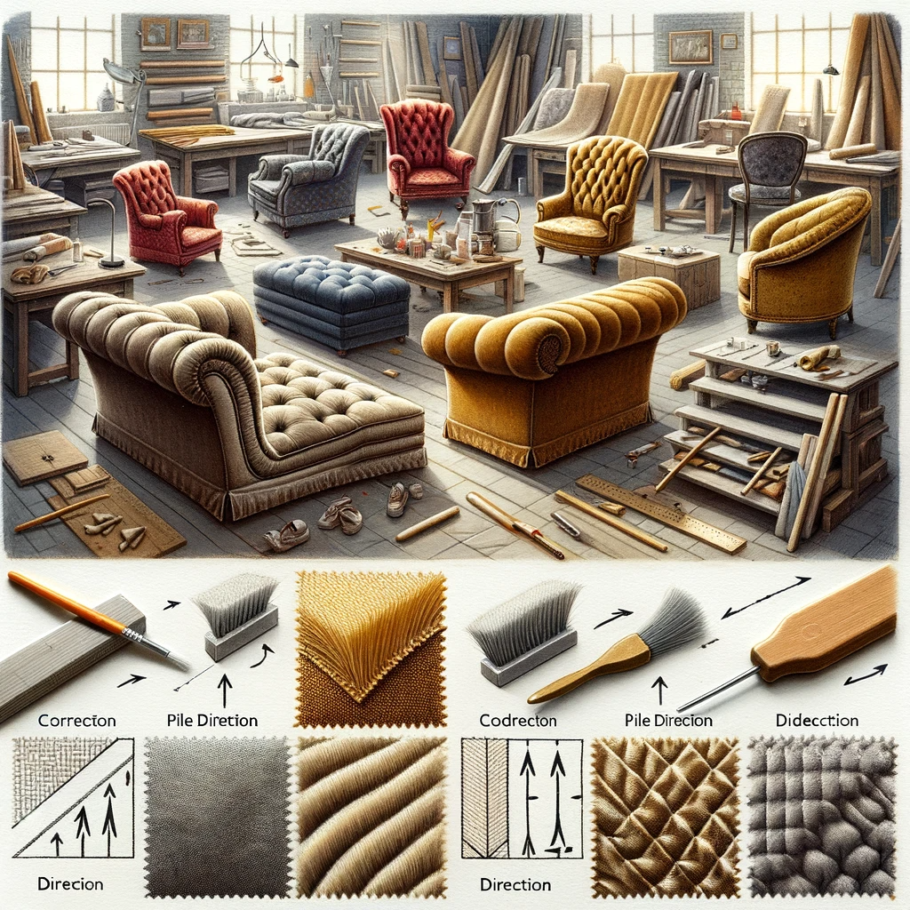

An image for 'KT0302: Fabric Pile Direction', illustrating the importance of fabric pile direction in upholstery. The scene shows a workshop with various pieces of furniture upholstered with fabric that has a noticeable pile, like velvet or corduroy. Some furniture pieces are correctly upholstered with the fabric pile running uniformly in one direction, while others show incorrect application with inconsistent pile direction. The difference in appearance and texture due to pile direction is evident. Closeup views of the fabric highlight the pile alignment, with arrows indicating the correct and incorrect directions. Tools such as fabric brushes and pile direction guides are visible, emphasizing the techniques used for maintaining consistent pile direction. The overall image educates on the impact of pile direction on the look and feel of upholstered furniture.

KT0302: Fabric Pile Direction

In the upholstery industry, understanding and working with fabric pile direction is essential, especially when dealing with fabrics like velvet, corduroy, or any other piled fabric. This section provides a comprehensive overview of the importance of fabric pile direction and how it affects the upholstery process and the finished product.

Understanding Pile and Pile Direction
Pile Definition: The pile of a fabric refers

to the raised surface or nap created by upright threads or fibres. The direction in which these fibres lie is known as the pile direction.
Types of Pile Fabrics: Common piled fabrics include velvet, corduroy, chenille, and some types of carpets and rugs. Each has its unique texture and pile behaviour.

Importance of Pile Direction
Visual Appearance: The pile direction can significantly affect the colour and sheen of the fabric. Light reflects differently on the pile, depending on its direction, which can cause variations in colour perception.
Texture and Feel: The direction of the pile also influences the texture and feel of the fabric. Running a hand against the pile feels different from running it with the pile.

Working with Pile Fabrics
Consistent Pile Orientation: When cutting and sewing piled fabric, it's crucial to maintain a consistent pile direction throughout the piece. This ensures uniformity in colour and texture.
Planning and Cutting: Layout planning before cutting is vital. All pieces should be cut in the same pile direction, typically with the pile running downward for a natural flow.

Challenges and Solutions
Shading Issues: Different pile directions can create shading variations, making fabric pieces appear mismatched. To prevent this, use a consistent direction for all parts of the furniture.
Handling Marks: Pile fabrics can show marks and impressions more readily. Handling them carefully and using proper cleaning techniques can minimize this issue.

Pile Direction in Upholstery Design
Aesthetic Effect: The pile direction can be used creatively to produce different aesthetic effects. For example, alternating the pile direction in sections can create a unique look.
Comfort Consideration: For seating, it’s generally preferable for the pile to run towards the front of the piece, enhancing the comfort and ease of sitting down and getting up.

Maintenance and Care
Cleaning and Brushing: Piled fabrics require regular brushing to maintain their appearance and texture. Cleaning methods should be chosen based on the fabric type and pile nature.
Wear and Durability: Consider the direction of the pile in relation to wear and tear. For instance, on a seat cushion, the pile should ideally run towards the front to resist flattening and matting.

In summary, KT0302 provides an indepth exploration of fabric pile direction, highlighting its significance in the upholstery process. Understanding how to work with and utilize the pile direction effectively is crucial for achieving desired aesthetic and tactile qualities in upholstered furniture, ensuring both visual appeal and durability.

KT0303 Distortions and colour/pattern variations

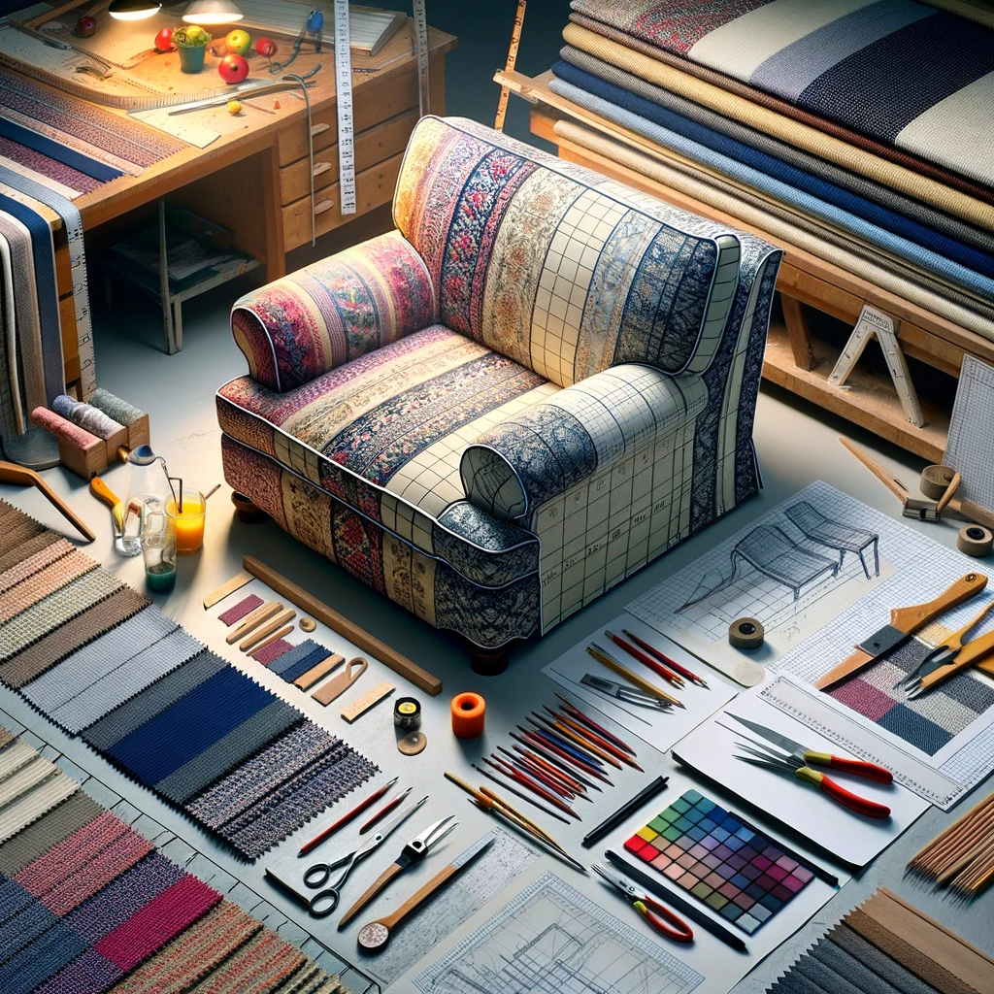

An image for 'KT0303: Distortions and Colour/Pattern Variations', focusing on the challenges of working with fabrics that have distortions and varying patterns or colours. The scene displays a workshop with different upholstered items, each showing an example of distortion or colour/pattern variation. One item may have a skewed pattern due to fabric distortion, another might show colour fading, and a third could have a misaligned pattern join. Tools for measuring, cutting, and aligning fabric, such as alignment grids and colour matching guides, are visible, highlighting the methods used to minimize these issues. The image should also include closeup views of fabric sections where these distortions and variations are prominent, emphasizing the need for careful attention and skill in handling such fabric challenges in upholstery.

KT0303: Distortions and Colour/Pattern Variations

This section addresses the challenges posed by distortions and colour or pattern variations in fabrics used for upholstery. Understanding these issues is crucial for upholsterers to ensure quality and consistency in their finished products.

Understanding Distortions in Fabric
Causes of Distortions: Distortions in fabric can occur due to improper storage, handling, or inherent fabric qualities. Stretchable fabrics are particularly prone to distortion.
Identifying Distortions: Distortions are often visible as warps or inconsistent alignment in the fabric weave or pattern. They can also manifest as skewing or stretching in specific areas.

Preventing and Correcting Distortions
Proper Storage and Handling: Store fabrics rolled rather than folded to minimize creases and distortions. Handle fabrics gently and avoid unnecessary stretching or pulling.
PreShrinking: Some fabrics, particularly natural fibers, can be preshrunk to minimize distortions that might occur during washing or use.
Alignment and Smoothing Techniques: When laying out fabric for cutting, ensure it is properly aligned. Use smoothing techniques to even out any distortions before cutting or sewing.

Colour and Pattern Variations in Fabrics
Colour Variations: Variations in colour can occur due to different dye lots, fading, or fabric quality. This can be a significant issue when matching fabrics for a single upholstery project.
Pattern Variations: Pattern variations can arise from misprints, irregular pattern repeats, or inconsistencies in the printing process.

Managing Colour and Pattern Variations
Consistent Dye Lots: When purchasing fabric, ensure all material comes from the same dye lot to minimize colour variations.
Inspecting Fabrics before Use: Carefully inspect the fabric for any colour or pattern inconsistencies before starting the upholstery process.
Strategic Cutting and Placement: Plan cutting and placement of fabric to minimize the visibility of any variations or to use them creatively as part of the design.

Addressing Issues with Colour Fastness and Bleeding
Testing for Colour Fastness: Conduct a colour fastness test on a small, inconspicuous area of the fabric to check if the dye bleeds or fades.
PreTreatment: Some fabrics may require pretreatment to set the colour and reduce the risk of bleeding.

In summary, KT0303 offers essential insights into managing distortions and colour/pattern variations in upholstery fabrics. By understanding these challenges and implementing effective strategies, upholsterers can enhance the overall quality and aesthetic appeal of their finished products, ensuring satisfaction in both their craftsmanship and the final outcome.

KT0304 Material characteristics and handling requirements

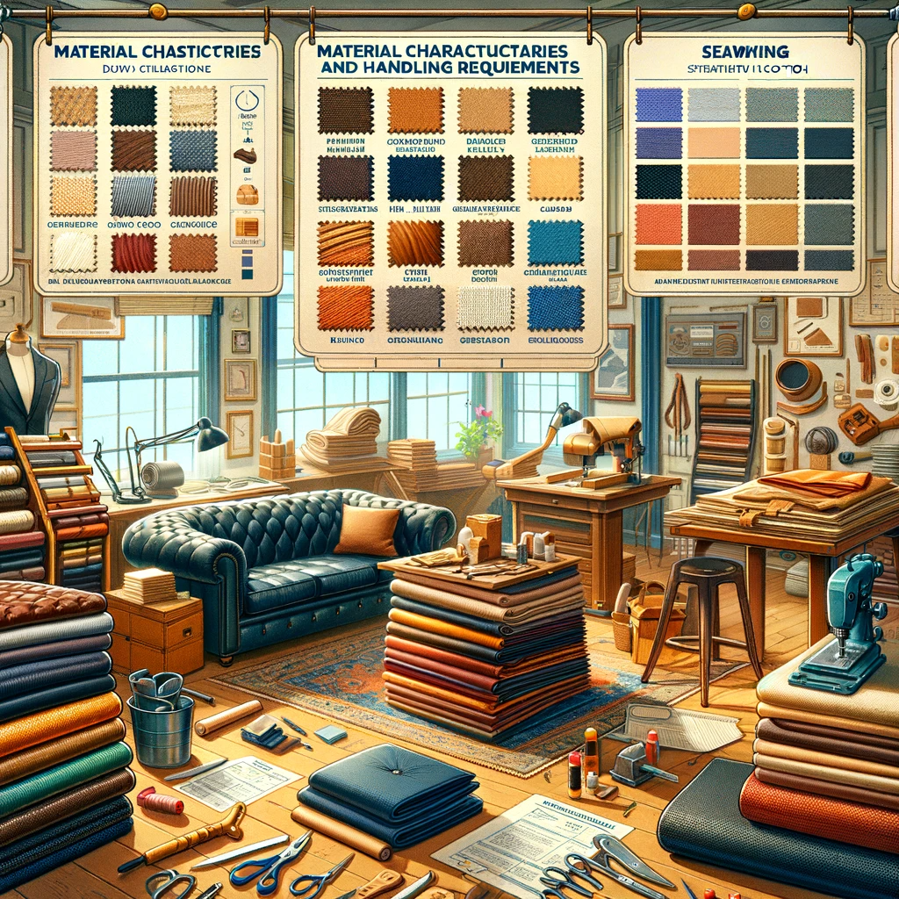

An image for 'KT0304: Material Characteristics and Handling Requirements', illustrating the diverse characteristics of upholstery fabrics and their specific handling requirements. The scene shows an upholstery workshop with a range of fabric types such as leather, velvet, heavy cotton, and synthetic blends, each labelled with their key characteristics like durability, stretchability, and sensitivity to heat or moisture. The workshop also displays the appropriate tools and techniques for handling these materials, like leather working tools, fabric steamers, and delicate sewing needles. Additionally, there are informational posters or screens describing best practices for fabric care, cutting, and sewing, tailored to the unique properties of each material type. The image should convey the importance of understanding material characteristics for proper handling and care in upholstery work.

KT0304: Material Characteristics and Handling Requirements

This section of the module focuses on the diverse range of materials used in upholstery, emphasizing their unique characteristics and the specific handling requirements they entail. An understanding of these aspects is crucial for achieving both functional and aesthetic excellence in upholstery work.

Understanding Different Upholstery Materials
Natural Fabrics: Including cotton, linen, silk, and wool. These materials are known for their comfort and breathability but may require special care, such as dry cleaning or careful washing to prevent shrinkage.
Synthetic Fabrics: Such as polyester, nylon, acrylic, and olefin. These are typically more durable, stainresistant, and easier to clean than natural fabrics, but they may not offer the same level of comfort and breathability.
Blended Fabrics: Combining natural and synthetic fibre to offer a balance of comfort, durability, and ease of maintenance.

Handling Requirements Based on Material Characteristics
Durability and Wear Resistance: For hightraffic or heavyuse areas, choose materials that are durable and wearresistant, such as heavyduty synthetics or tightly woven natural fabrics.
Stain Resistance and Cleanability: Consider the ease of cleaning, especially for items prone to spills or stains. Synthetic fabrics or treated natural fabrics can offer better stain resistance.
Colour Fastness and Fade Resistance: Some materials, especially natural fibers, may fade over time when exposed to sunlight. Synthetic materials or specially treated fabrics can be more faderesistant.

Special Considerations for Different Fabrics
Stretch and Recovery: Fabrics like spandex or certain knits have high stretch and recovery, requiring careful handling during cutting and sewing to avoid distortion.
Heat Sensitivity: Synthetic fabrics can be sensitive to heat, necessitating caution when ironing or exposing them to high temperatures.
Moisture Absorption: Natural fibres typically absorb more moisture than synthetics, which can be a consideration in humid environments or for outdoor furniture.

Fabric Pile and Texture
Pile Direction: For fabrics with a pile, like velvet or corduroy, it’s important to consider the pile direction for colour consistency and texture.
Texture Impact: The texture of a fabric can impact both the look and feel of the upholstered item, affecting choices for specific applications (e.g., smooth textures for a sleek look or rough textures for a rustic feel).

Handling Specialty Fabrics
Leather and Faux Leather: Require specific cutting techniques and sewing needles. They are durable but need regular conditioning to prevent cracking.
Microfiber: Known for its softness and durability, microfiber needs regular cleaning with appropriate methods to maintain its appearance.

In conclusion, KT0304 provides a comprehensive overview of the various materials used in upholstery, highlighting their characteristics and the handling requirements they necessitate. Mastery of this knowledge enables upholsterers to select the right materials for specific projects and handle them appropriately, resulting in highquality, durable, and aesthetically pleasing upholstered items.

KT0305 Linings and fillings



An image for 'KT0305: Linings and Fillings for the Furniture Upholstery Industry Relating to Cushions and Pillows'. The scene illustrates a workshop setting with various types of cushions and pillows, each cut open to show the different types of linings and fillings used in upholstery. These include foam, feather, down, polyester fibre, and memory foam, all visibly labelled. The workshop also displays tools and materials used for inserting and securing these fillings, like stuffing rods, fabric adhesives, and sewing kits. Alongside, there are charts or guides explaining the properties of each lining and filling type, such as firmness, durability, and comfort levels, highlighting their suitability for different upholstery applications. The image emphasizes the diversity and importance of choosing the right linings and fillings for cushions and pillows in the furniture upholstery industry.

KT0305: Linings and Fillings

In the upholstery of complex shaped cushions and padded items, linings and fillings play a crucial role in determining the comfort, shape, and durability of the finished product. This section explores the various types of linings and fillings, their properties, and their appropriate applications in upholstery.

Understanding Linings in Upholstery
Purpose of Linings: Linings are used to protect the outer fabric and filling, provide structure, and enhance the overall finish of the upholstered item. They can also help in maintaining the shape and extending the life of the item.
Types of Linings: Common lining materials include cotton, polyester, muslin, and nonwoven fabrics. The choice of lining depends on the type of furniture, the fabric used, and the desired final appearance.

Selection and Application of Linings
Durability and Weight: Choose a lining that complements the durability and weight of the outer fabric. Heavier fabrics may require sturdier linings.
Colour and Texture Considerations: The colour of the lining should generally not show through the outer fabric. The texture should be compatible with the outer fabric to prevent slippage or friction.
Sewing and Fitting Linings: Linings should be cut and sewn precisely to fit the shape of the item. They are typically attached to the inside of the outer fabric or directly to the padding.

Exploring Different Types of Fillings
Foam: Available in various densities and thicknesses, foam is a popular choice for its durability and support. It’s ideal for seat cushions and structured items.
Down and Feathers: Offering a luxurious feel, down and feathers are used for soft, plush cushions. They require regular fluffing to maintain their shape.
Polyester Fibrefill: A synthetic option that is hypoallergenic, lightweight, and relatively inexpensive. It’s commonly used for decorative cushions and less structured items.
Memory Foam: Known for its contouring properties, memory foam provides excellent support and is often used in ergonomic cushions.
Batting: Layers of cotton, wool, or polyester batting can be used to add softness and volume, or to wrap foam cushions for a smoother appearance.

Considerations for Filling Selection
Comfort and Support: The choice of filling should align with the desired level of comfort and support. For instance, seat cushions typically require firmer support than back cushions.
Resilience and Durability: Consider the resilience and longevity of the filling material, especially for items that will be used frequently.
Maintenance and Care: Some fillings, like down, require more maintenance (such as fluffing and professional cleaning) compared to synthetic options.
Allergies and Sensitivities: For environments where users may have allergies, synthetic fillings like polyester fibrefill or hypoallergenic foam are preferable.

In summary, KT0305 provides a detailed exploration of the various linings and fillings used in upholstery, highlighting their unique properties and applications. Understanding how to select and work with these materials is essential for upholsterers to create comfortable, durable, and aesthetically pleasing cushions and padded items.

Internal Assessment Criteria

- IAC0301 The types, characteristics and properties of textiles and leather are outlined and discussed in term of their purposes, applications and constraints placed on complex shaped cushions and padded items.
- IAC0302 A range of textiles and leather features are analysed and evaluated in terms of opportunities and constraints pertaining to complex shaped cushions and padded items.
- IAC0303 Aspects which can influence the quality of complex shaped cushions and padded items is evaluated.
- IAC0304 The identification of distortions and colour/pattern variations and corrective actions are explained.
(Weight 20%)

KM09KT04: Construction of complex shaped

cushions and padded items (20%)

Learning Outcome
At the end of this section, learners should cover:

- KT0401 Components.
- KT0402 Number, size and shape of components.
- KT0403 Dimensions and measurements.
- KT0404 Use of markers, patterns or templates.
- KT0405 Trims and finishings.

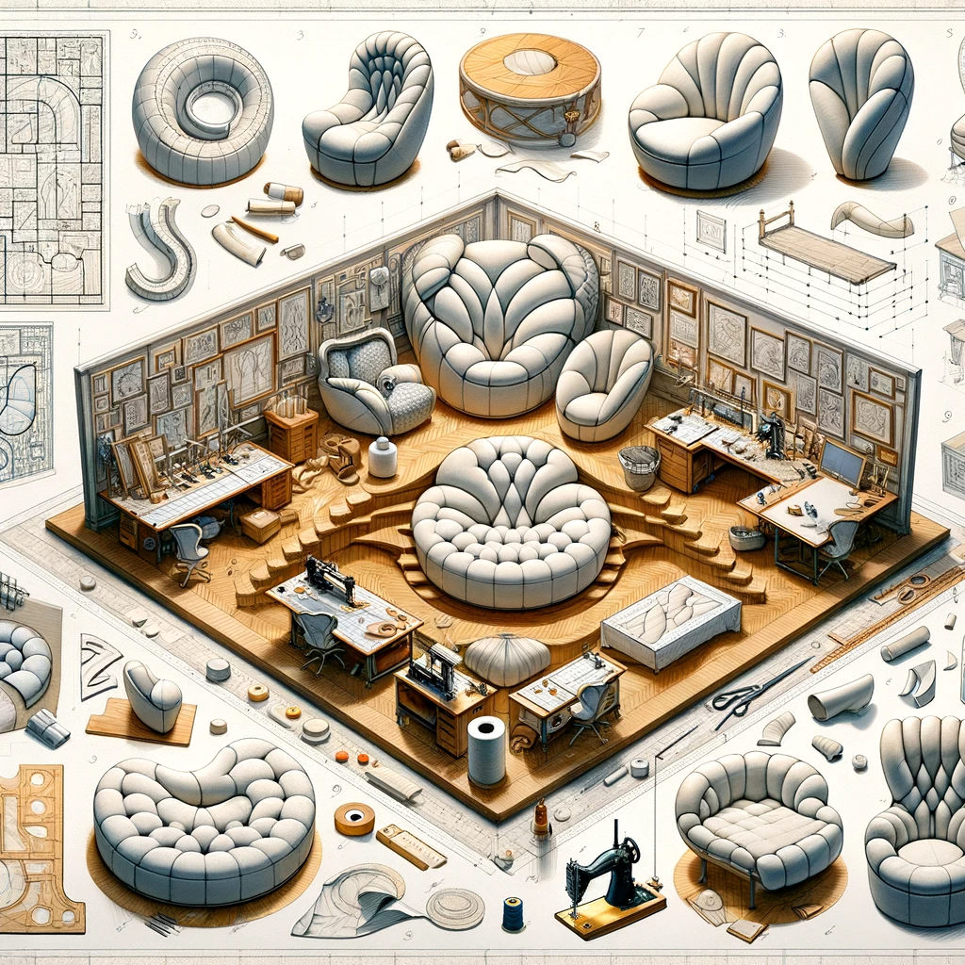

An image depicting the construction of complex shaped cushions and padded items. The scene shows a furniture workshop with several workstations, each focusing on a different stage in the construction process of complex cushions. The first station displays the initial design and patternmaking, with intricate templates and sketches of unique shapes. The next station shows the cutting of fabric and foam, highlighting the precision required for complex forms. Another area is dedicated to sewing and assembling the pieces, with a variety of sewing machines and tools visible. The final section showcases the completed complex cushions and padded items, displaying a range of shapes like oval, angular, and contoured designs. The entire scene emphasizes the skill and attention to detail needed in the construction of these unique and customshaped upholstery items.

INTRODUCTION

KT0401 Components

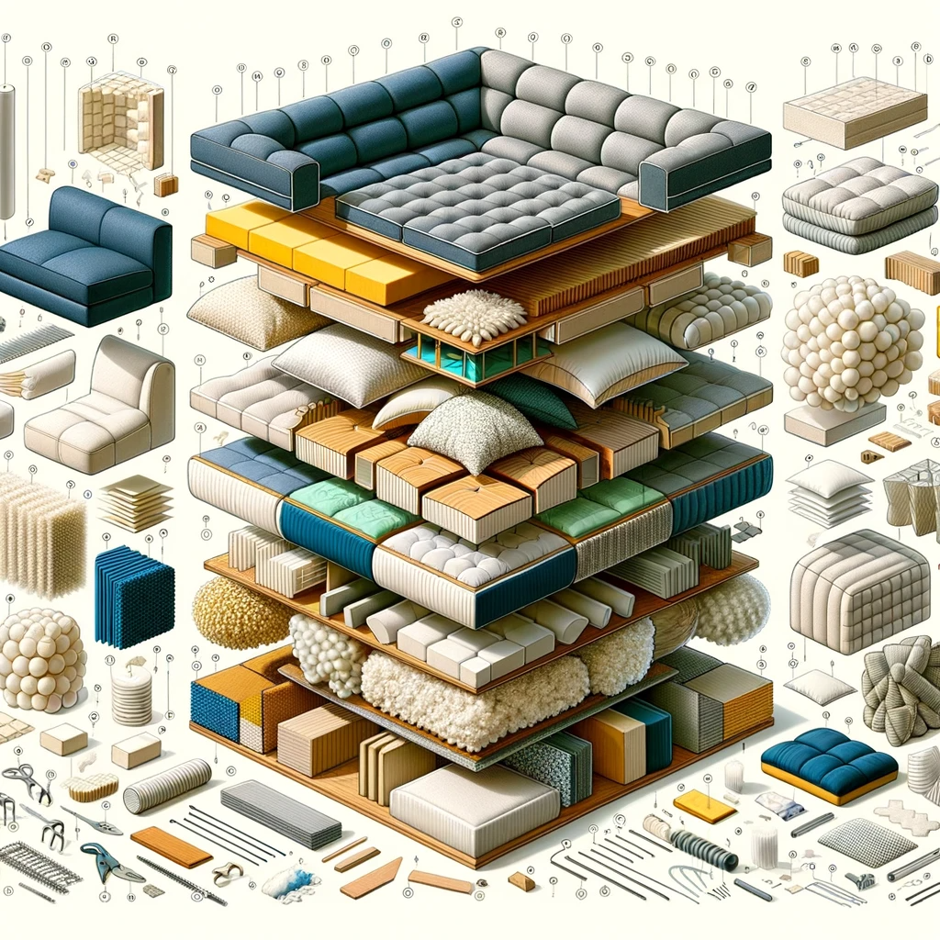

An image depicting the components of complex shaped cushions and padded items. The scene shows a deconstructed view of several complex cushions and padded items, with each component separately displayed and labelled. These components include various types of foam, different fabrics, structural supports like frames or wires, and specialized fastenings. Some cushions might show memory foam layers, others could have feather or fibrefill padding, and some might include rigid inserts for shape maintenance. The fabrics range from heavyduty upholstery fabric to delicate silks or linens, each chosen for specific cushion types. The layout of the image provides a clear and educational view of how these diverse components come together to form complex shaped cushions and padded items, highlighting the intricacy and engineering behind upholstery design.

Introduction to Knowledge Module KM09KT04: Construction of Complex Shaped Cushions and Padded Items

In the meticulous craft of upholstery, the construction of complex shaped cushions and padded items demands both technical skill and creative insight. This module, KM09KT04, is designed to guide learners through the intricate process of constructing these items, emphasizing the importance of precision, aesthetics, and functionality. The module breaks down the construction process into its fundamental components, ensuring a comprehensive understanding of each step and its significance.

KT0401: Components
This segment introduces the various components that make up complex shaped cushions and padded items. It covers the essential elements, such as fabric, lining, fillings, and support materials, and discusses how they interact to form the final product. Understanding these components is the foundation for successful construction.

KT0402: Number, Size, and Shape of Components
The focus here is on determining the appropriate number, size, and shape of components required for different projects. This part of the module teaches learners how to analyse design requirements and translate them into practical construction plans, considering the specificities of each item.

KT0403: Dimensions and Measurements
Accurate dimensions and measurements are critical in upholstery, especially for complex shapes. This section delves into techniques for measuring and calculating dimensions accurately, emphasizing the importance of precision for ensuring that all components fit together perfectly.

KT0404: Use of Markers, Patterns, or Templates
Patterns and templates are invaluable tools in the construction of complex shapes. This topic explores how to create and use these aids effectively, ensuring consistency and accuracy in replication. It also covers the use of markers for fabric cutting and assembly, which is crucial for maintaining alignment and symmetry.

KT0405: Trims and Finishings
The final touches in upholstery construction can significantly enhance the aesthetic appeal and functionality of the item. This section discusses various types of trims and finishings, such as piping, buttons, zippers, and decorative stitching. It guides learners on how to select and apply these elements to add both style and durability to the finished product.

In summary, KM09KT04 offers a detailed exploration of the construction process of complex shaped cushions and padded items. Through this module, learners will acquire the skills and knowledge necessary to transform design concepts into tangible, highquality upholstered items, mastering the art and science of upholstery construction.

KT0402 Number, size and shape of components.
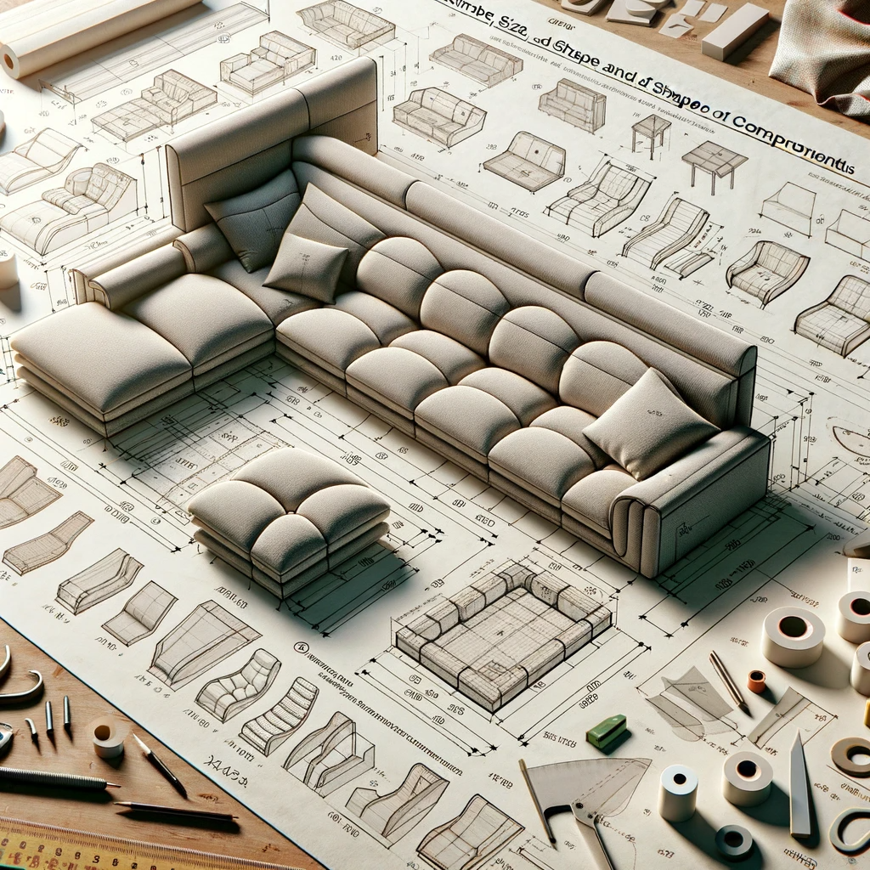

An image depicting 'KT0402: Number, Size, and Shape of Components Based on a Hypothetical Upholstered Item'. The scene shows a drafting table with a design layout for a hypothetical upholstered item, such as a modern, complexshaped sofa. The layout includes detailed drawings of each component of the sofa, with dimensions and shapes clearly marked. Components like armrests, backrests, seat cushions, and supporting frames are shown, each with their specific number, size, and shape. There are also notes on fabric requirements, foam densities, and other materials needed for each part. The image conveys the detailed planning and precision required in designing upholstered furniture, highlighting the complexity of determining the number, size, and shape of components for a custom piece.
- KT0403 Dimensions and measurements.

- KT0404 Use of markers, patterns or templates.

- KT0405 Trims and finishings.

Formative assessment

- IAC0401 The construction of complex shaped cushions and padded items are identified, described according to steps and sequence and analysed for efficiency.
- IAC0402 Principles for complex shaped cushions and padded items are identified, described analysed in terms of quality.
(Weight 20%)

SECTION 5: KM09KT05: Cutting, assembly and sewing processes for complex shaped cushions and padded items (30%)

Learning Outcome
At the end of this section, learners should cover:

- KT0501 Sequence of attaching cover components.
- KT0502 Material cutting tolerances and accuracy.
- KT0503 Placing and alignment for material cutting.
- KT0504 Marking of components.
- KT0505 Shaping tolerances and accuracy.
- KT0506 Component marking tolerances and accuracy.
- KT0507 Sewing methods.
- KT0508 Application of trims and decorative finishes.
- KT0509 Closing methods â types and uses.

- KT0501 Sequence of attaching cover components.

- KT0502 Material cutting tolerances and accuracy.

- KT0503 Placing and alignment for material cutting.

- KT0504 Marking of components.

- KT0505 Shaping tolerances and accuracy.

- KT0506 Component marking tolerances and accuracy.

- KT0507 Sewing methods.

- KT0508 Application of trims and decorative finishes.

- KT0509 Closing methods â types and uses.

Formative assessment

- IAC0501 Assembly and sewing process for complex shaped cushions and padded items are identified, described according to steps and sequence and analysed for efficiency.
- IAC0502 Advanced covering principles for complex shaped cushions and padded items are identified, described analysed in terms of quality.
(Weight 30%)

Provider Programme Accreditation Criteria
Physical Requirements:
- The provider must have lesson plans and structured learning material or provide learners with access to structured learning material that addresses all the topics in all the knowledge modules.
Human Resource Requirements:
- Lecturer/learner ratio of 1:20.
- Qualifications of lecturers: 5 years relevant experience or NQF 2 58227 with 2 years of experience.
Legal Requirements:
- OHS compliant.
Exemptions
- No exemptions, but the module can be achieved in full through a normal RPL process.

