

FURNITURE UPHOLSTERER

KM10 DEEP BUTTONING OF UPHOLSTERED FURNITURE

LEARNER GUIDE

Deep Buttoning of Upholstered Furniture

LEARNER GUIDE

Module # | KM-10
NQF Level | 3
Notional hours | 50
Credit(s) | 5
Curriculum Code | 683401000
SAQA QUAL ID | 103199
Qualification Title | Occupational Certificate: Furniture Upholsterer NQF Level 4, Credits 549

LEARNER CONTACT INFORMATION:

Name
Contact Address
Telephone (H)
Telephone (W)
Cellular

TABLE OF CONTENTS

PURPOSE OF THE QUALIFICATION 5
QUALIFICATION RULES 7
EXIT LEVEL OUTCOMES 9
ENTRY REQUIREMENTS: 10
ARTICULATION OPTIONS 11
ASSESSMENT REQUIREMENTS 12
PROVIDER ACCREDITATION REQUIREMENTS FOR THE MODULE: 13
SECTION 1: KM-01-KT01: Roles and responsibilities of the Occupational Health and safety representative as set out in the relevant legislation (Intermediate) (30%) 16
1.1 Explain the purpose of the Occupational health and Safety representative 16
1.2. Describe the process for appointing Occupational Health and safety representatives 28
1.3 Explain the functions of the occupational Health and safety Committees 30
SECTION 2: KM-01-KT02: Legislative requirements related to Occupational health and safety (Basic) (10%) 36
2.1 Explain the purpose and structure of the relevant legislation applicable to a specific workplace 36
2.2. Explain the difference between the various legislative instruments 48
SECTION 3: KM-01-KT03: Definitions of and difference between Occupational Health, Occupational Safety and Environmental management. (Basic) (10%) 56
3.1 Define and describe occupational health, safety and environmental control 56
SECTION 4: Concept of behavioural safety management (Basic) (10%) 60
4.1 Explain what is meant by behaviour and how the behaviour of people influences their health and safety 60
4.2. Describe the factors that influence the behaviour of people and give examples of this in a work environment 60
4.3 Identify and explain the role of behavioral modification in influencing the overall health and safety of employees 62
4.4. Explain what contribution leadership can make towards creating a culture where unacceptable behaviour regarding health and safety issues are not tolerated 63
SECTION 5: KM-01-KT05: Concepts and principles of emergency preparedness and response (Basic) (20%) 66
5.1 Explain the definition of an emergency and give examples of typical emergencies that could occur in the workplace 66
5.2. Explain the difference between preparedness and response and give examples of typical preparedness and response actions 68
5.3 Describe the roles of the various role players to ensure that an organisation is adequately prepared for emergencies 70
5.4. Describe the roles of the various role players when an emergency occur. 72
SECTION 6: KM-01-KT06: The principles of hazards identification and risks assessment (Basic) (5%) 79
6.1 Give practical examples to explain what a hazard is and how hazards relate to risks 79
6.2. Explain the concept of priority setting and relate it to the process of hazard and risk rating 83
SECTION 7: KM-01-KT07: Principles of safe working practices in and around the place of work (Intermediate) (5%) 93
7.1 Explain what is meant by a working practice using practical examples (NQF Level: 2) 93
7.2. Explain the concept of habits and how good and bad habits can be established with specific reference to occupational health and safety situations 97
SECTION 8: KM-01-KT08: Techniques of accident and incident investigation (5%) 101
8.1 Explain the difference between an accident and incident 101
8.2. Describe the generally accepted hierarchy of how incidents lead to accidents 101
8.3 Explain the basic process of accident and incident investigation 103
SECTION 9: KM-01-KT09: Roles and responsibilities of the various stakeholders in a workplace regarding Occupational Health and Safety (Intermediate) (5%) 116
9.1 List the key stakeholders that are involved in the prevention of accidents and 116
incidents in the workplace 116
9.2. Describe the role of each of the key stakeholders in preventing accidents and incidents 117
9.3 Explain the consequences when a stakeholder does not execute their duty in accident/incident prevention 123
9.4. Explain the role of the safety representative when one of the other stakeholders do not do what is expected of them 125

PURPOSE OF THE QUALIFICATION

Purpose:
The purpose of this qualification is to equip a learner with knowledge, skills and competencies to perform duties as a Furniture Upholsterer.

A Furniture Upholsterer manufactures an upholstered furnishing item by fitting suspension and padding and covering a frame to give it shape, comfort, and functionality for a range of domestic, commercial and decorative uses.

A qualified learner will be able to:
Read and interpret a design, drawing or sketch and take accurate measurements and calculate/estimate the number of fabrics, leather, man-made fabrics, padding and other raw material such as springs and webbing.
Make upholstery patterns and produce templates from sketches, customer descriptions or blueprints which match all quality standards.
Lay out, measure, cut and sew upholstery materials following patterns, templates, sketches, or design specifications.
Interpret specifications and prepare foundations for upholstered frames by attaching webbing, springs, foam and/or padding securely to the frame.
Fit slipcovers and loose material panels to cover frames with materials using staples, tacks and/or glue.
Manufacture upholstered furniture, upholstery prototypes and repair and re-upholster damaged furniture.

Rationale:
This qualification will equip learners with the necessary skills and competencies to operate as upholsterers by applying upholstery skills to fit springs, webbing, padding and covering a wide range of objects covered with fabric, leather, rexine or other upholstery material. After successful completion of this qualification, the learner will be skilled and capable of creating ergonomic and comfortable furniture using both traditional and modern techniques, materials and fabrics to produce aesthetically pleasing and fit for purpose consumer products.
Learners will find employment as frame preparers, cover fitters, patternmakers and furniture finishers, upholsterers or upholstery prototype makers and upholstery repairers. These skills will also open opportunities for self-employment.

Target groups identified include school leavers with a National Qualifications Framework (NQF) Level 2 qualification or persons who have been working in the furniture industry without formal qualifications and have the desire to formalise their skills and knowledge.

Employers will benefit from appointing qualified workers in terms of increased productivity and ability to be competitive in the international market and seek markets abroad supplying quality upholstered furniture and furnishings.

QUALIFICATION RULES

This qualification is made up of the following compulsory Knowledge, Practical Skill and Workplace Learning Modules:

Knowledge Modules:
683401000-KM-01, Basic Principles for Manufacturing of Upholstered Furniture, NQF Level 2, Credits 4
683401000-KM-02, Upholstered furniture frame preparation, NQF Level 2, Credits 8
683401000-KM-03, Upholstered Furniture Basic Cover Fitting, NQF Level 2, Credits 8
683401000-KM-04, Advanced Upholstery Furniture Technology, NQF Level 3, Credits 2
683401000-KM-05, Upholstery Pattern and Template Making Principles, Methods and Equipment, NQF Level 3, Credits 5
683401000-KM-06, Cutting Lay Requirements for Upholstery Fabrics and Materials, NQF Level 3, Credits 3
683401000-KM-07, Advanced Covering Techniques for Complex and Exposed Frames, NQF Level 3, Credits 4
683401000-KM-08, Advanced Complex Covers for Upholstery, NQF Level 3, Credits 4
683401000-KM-09, Complex Shaped Cushions and Padded Items, NQF Level 3, Credits 2
683401000-KM-10, Deep Buttoning of Upholstered Furniture, NQF Level 3, Credits 5
683401000-KM-11, Upholstered Furniture and Prototype Making Principles, NQF Level 4, Credits 13
683401000-KM-12, Raw Materials, Consumables, Tools and Equipment Used in Manufacturing of Upholstered Furniture Prototypes, NQF Level 4, Credits 8
683401000-KM-13, Manufacturing Principles and Processes for Upholstered Furniture Prototype Manufacturing and Reengineering, NQF Level 4, Credits 17
683401000-KM-14, Cutting and Sewing of Fabric and Material for Upholstered Furniture Prototypes, NQF Level 2, Credits 10
683401000-KM-15, Cover Making and Covering Methods for Upholstered Furniture Prototypes and Repairs, NQF Level 4, Credits 15
683401000-KM-16, Technical Specifications and Configuration of Upholstery Production Equipment for Manufacturing, NQF Level 4, Credits 10
683401000-KM-17, Communication and Interpersonal Relations in the Workplace, NQF Level 4, Credits 7
683401000-KM-18, Leadership and supervision in the upholstery departments, NQF Level 3, Credits 4
Total number of credits for Knowledge Modules: 129

Practical Skill Modules:
683401000-PM-01, Prepare Foundations for Upholstered Frames, NQF Level 2, Credits 20
683401000-PM-02, Cover Prepared Upholstered Frames with Fabric and Other Materials, NQF Level 2, Credits 20
683401000-PM-03, Perform Advanced Covering Operations for Complex and Exposed Frames, NQF Level 3, Credits 10
683401000-PM-04, Perform Deep Buttoning Procedures to Decorate Upholstered Furniture, NQF Level 3, Credits 10
683401000-PM-05, Produce Cutting Lay Requirements for Cutting of Upholstered Cover Components, NQF Level 3, Credits 4
683401000-PM-06, Produce upholstery patterns and templates for the upholstery frame preparation and cutting departments, NQF Level 3, Credits 16
683401000-PM-07, Lay Out, Measure, Cut and Sew Upholstery Materials According to Templates or Specifications and Optimising Material Usage, NQF Level 2, Credits 20
683401000-PM-08, Manufacture Upholstery Bespoke Furniture or Prototypes for Bulk Production, NQF Level 4, Credits 30
683401000-PM-09, Repair and Re-Upholster Upholstery Furniture, NQF Level 4, Credits 10
683401000-PM-10, Inspect Upholstery Furniture During Various Stages of the Manufacturing Process to Ensure Conformance to Quality Standards, NQF Level 4, Credits 15
683401000-PM-11, Reengineer Upholstery Furniture Products to Address Development or Manufacturing Defects, NQF Level 4, Credits 15
683401000-PM-12, Develop Technical Specifications and Line Setup Requirements for Manufacturing of Upholstery Furniture, NQF Level 4, Credits 15
683401000-PM-13, Guide Teams in the Upholstery Manufacturing Departments to Achieve Set Targets and Outputs, NQF Level 3, Credits 4
Total number of credits for Practical Skill Modules: 189

Work Experience Modules:
683401000-WM-01, Upholstery Furniture Frame Preparation Processes, NQF Level 2, Credits 24
683401000-WM-02, Upholstery Furniture Frame Cover Fitting Processes, NQF Level 2, Credits 24
683401000-WM-03, Upholstery Pattern and Template Making Processes, NQF Level 3, Credits 15
683401000-WM-04, Upholstery Cutting Lay Preparation, NQF Level 3, Credits 10
683401000-WM-05, Advanced Upholstery Covering Processes, NQF Level 3, Credits 25
683401000-WM-06, Material Cutting and Sewing Processes for Upholstery Prototypes or Bespoke Furniture, NQF Level 2, Credits 24
683401000-WM-07, Bespoke Upholstery Furniture and/or Upholstery Prototypes Manufacturing and Reparations, NQF Level 4, Credits 56
683401000-WM-08, Furniture Re-upholstery Department, NQF Level 4, Credits 17
683401000-WM-09, Upholstery Furniture Technical Specifications and Re-engineering, NQF Level 4, Credits 20
683401000-WM-10, Supervision in the Upholstery Department, NQF Level 4, Credits 16
Total number of credits for Work Experience Modules: 231

EXIT LEVEL OUTCOMES

Interpret drawings and product specifications and compile a list of materials and consumables for upholstery of furniture.
Prepare upholstery frame for final covering by hand-building the suspension of the frame applying safety procedures and conduct a quality inspection.
Fit and attach prepared covers and loose material panels onto prepared upholstery frames using staples, tacks and/or glue.
Produce a cutting lay for upholstery cover components by considering optimal use of material and cut and sew upholstery components to specifications.
Upholster furniture by fitting and attaching upholstery covers to complex and exposed prepared upholstery frames using hand and power tools.
Demonstrate an understanding and knowledge of the manufacturing of upholstery furniture.

Occupation Regulation
All trades are regulated by the Department of Higher Education and Training (DHET) through the National Artisan Moderation Body (NAMB). To become a qualified artisan you have to pass a trade test at a national trade test centre that is accredited by the Quality Council for Trades and Occupations (QCTO). All national trade test centres are quality assured and recommended for accreditation by the NAMB.

ENTRY REQUIREMENTS:

Recognition of Prior Learning (RPL):
RPL for access to the external integrated summative assessment:
Accredited providers and approved workplaces must apply the internal assessment criteria specified in the related curriculum document to establish and confirm prior learning. Accredited providers and workplaces must confirm prior learning by issuing a statement of result or certifying a work experience record.

RPL for access to the qualification:
Accredited providers and approved workplaces may recognise prior learning against the relevant access requirements.

Entry Requirements:
NQF Level 1 qualification with Mathematics.

ARTICULATION OPTIONS

Horizontal Articulation:
Further Education and Training Certificate: Craft Enterprise, Level 4.

Vertical Articulation:
National Certificate: N4 Textiles, Level 5.

ASSESSMENT REQUIREMENTS

Integrated Formative Assessment:
The skills development provider will use the curriculum to guide them on the stipulated internal assessment criteria and weighting. They will also apply the scope of practical skills and applied knowledge as stipulated by the internal assessment criteria. This formative assessment leads to entrance into the integrated external summative assessment.

Integrated Summative Assessment:
An external integrated summative assessment, conducted through the relevant QCTO Assessment Quality partner is required for the issuing of this qualification. The external integrated summative assessment will focus on the exit level outcomes and associated assessment criteria. The external assessment model requires that the external assessment will be conducted through a combination of a written assessment and practical task at an accredited trade test centre. The written examination will be concluded at an accredited trade test centre and marked by registered assessors. Practical tasks will also be assessed by registered assessors. The combination of the written and practical assessment will be conducted over a period of two working days.

Provider Programme Accreditation Criteria

Physical Requirements:
The provider must have lesson plans and structured learning material or provide learners with access to structured learning material that addresses all the topics in all the knowledge modules.

Human Resource Requirements:
Lecturer/learner ratio of 1:20.
Qualifications of lecturers: 5 years relevant experience or NQF 2 58227 with 2 years of experience

Legal Requirements:
OHS compliant

Exemptions
No exemptions, but the module can be achieved in full through a normal RPL process

TOPIC ELEMENTS TO BE COVERED INCLUDE:
Purpose of the Knowledge Modules

The main focus of the learning in this knowledge module is to build an understanding of upholstery design, construction specifications, materials, equipment and production techniques associated with preparing an upholstered furniture frame for covering by hand building the suspension.

The learning will enable learners to demonstrate an understanding of:

KM-10-KT01: Deep buttoning and diamond buttoning (15%)
KM-10-KT02: Preparation for buttoning and deep buttoning processes (10%)
KM-10-KT03: Buttoning and deep buttoning principles and methods (35%)
KM-10-KT04: Raw materials and equipment used in various types of buttoning (25%)
KM-10-KT05: Buttoning and deep buttoning quality (15%)

SECTION 1: KM-10-KT01: Deep buttoning and diamond buttoning (15%)

Learning Outcome
At the end of this section, learners should cover:

KT0101 Definition and terminology.
KT0102 Define the terminology used when producing upholstered furniture components with buttoning or tufting.
KT0103 Types and application of buttoning.
KT0104 Specification requirements.
The techniques of deep buttoning and diamond buttoning stand as timeless craftsmanship, adding a touch of elegance and sophistication to upholstered pieces. This section delves into the artistry of these techniques, exploring their nuanced applications, distinctive characteristics, and the terminology that defines them. Aspiring upholsterers and seasoned craftsmen alike will find this exploration essential in mastering the intricacies of creating buttoned surfaces that not only captivate the eye but also offer unparalleled comfort.

Deep Buttoning, a technique that transcends mere functionality, involves creating captivating depressions or 'tufts' by securing buttons at regular intervals into the upholstery fabric. The result is a distinctive, cushioned appearance that not only elevates the tactile experience but also adds a luxurious aesthetic to various furniture pieces

Diamond Buttoning, a refined subset of deep buttoning, takes the artistry further by arranging buttons in a diamond-shaped pattern. This meticulous arrangement not only imparts a sense of structure and symmetry but also introduces a visual rhythm to the upholstered surface. Diamond buttoning stands as a testament to the artisan's attention to detail, creating a bespoke and refined look.
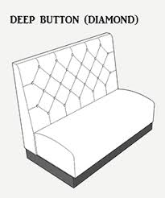

Throughout this section, we will explore the terminology, techniques, and applications that define deep buttoning and diamond buttoning. From the precise arrangement of buttons to the selection of materials, upholsterers will gain insights into the art and science behind these techniques, empowering them to craft buttoned surfaces that are not only visually captivating but also embody the essence of timeless craftsmanship.

KT0101 Definition and terminology.
Deep buttoning and diamond buttoning are intricate upholstery techniques that add both style and comfort to furniture pieces. These methods involve strategically placing buttons on upholstery fabric to create distinctive patterns and textures. In the realm of furniture design, these techniques have long been celebrated for their ability to enhance the aesthetics of pieces like sofas, chairs, and headboards.
Let us delve into the detailed definitions and terminologies associated with deep buttoning and diamond buttoning.
Deep Buttoning:
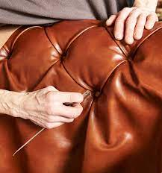
Deep buttoning is a sophisticated upholstery technique that transforms a flat surface into an elegant, textured masterpiece. This method involves the strategic placement of buttons at regular intervals on upholstery fabric, creating tufts or depressions. The buttons are secured through the layers of padding and fabric, resulting in a cushioned appearance that not only adds visual interest but also provides a luxurious feel to the furniture.

Various terms are associated with deep buttoning, contributing to a comprehensive understanding of this technique:

Tufting:
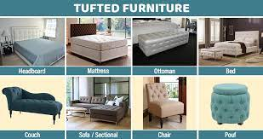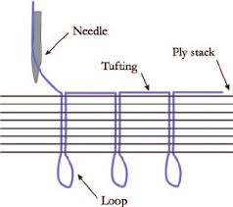
The process of securing buttons to create depressions or tufts in the upholstery fabric.

Button Molds:
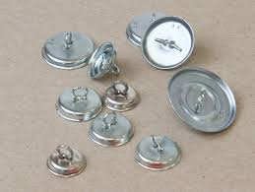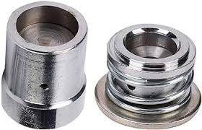
Wooden or metal structures used to anchor buttons securely in place within the upholstery.

Bridle Ties:
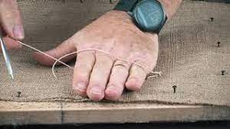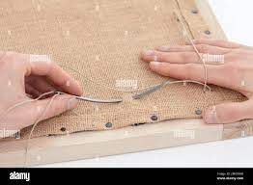
Straps or threads that run through the button molds and anchor the buttons to the frame, ensuring a tight and secure fit.

Pleats:
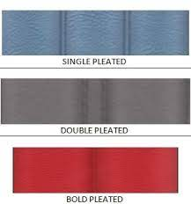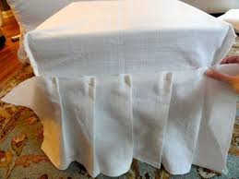
Folds in the fabric that accompany the tufting, adding a tailored and polished look to the upholstered piece.

Gores:
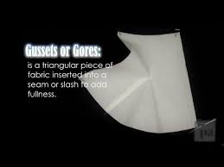
Fabric segments that radiate from the buttons, contributing to the overall shape and structure of the tufts.

Diamond Buttoning
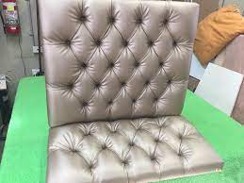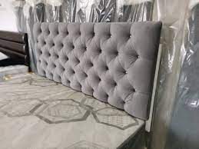
Diamond buttoning is a specific variation of deep buttoning, characterized by the arrangement of buttons in a diamond-shaped pattern. This method imparts a sense of symmetry and structure to the upholstered piece, elevating its visual appeal.

Understanding the terms associated with diamond buttoning provides insight into the nuances of this particular style:

Diamond Pattern:
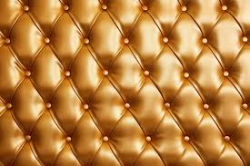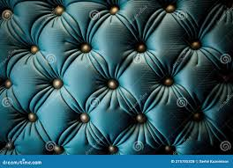
The specific arrangement of buttons in a diamond shape, usually formed by intersecting lines of buttons.

Button Grid:
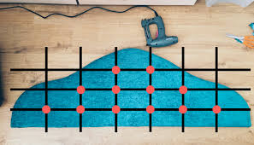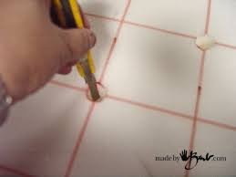
The overall layout or arrangement of buttons across the upholstery fabric, defining the spacing and symmetry.

Button Intersection:
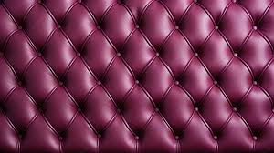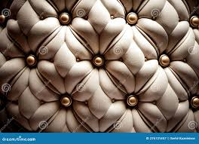
The point where the lines of buttons in a diamond pattern meet, creating a focal point within the design.

Button Centres:
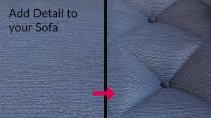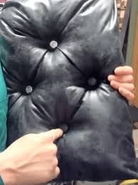
The exact placement of buttons within the diamond pattern, influencing the overall balance and aesthetics.
These definitions and terminologies provides understanding of the intricacies involved in deep buttoning and diamond buttoning, laying the foundation for mastery in these upholstery techniques.

 | Deep Buttoning | Diamond Buttoning
Button Arrangement | In deep buttoning, buttons are typically arranged in a grid pattern with regular intervals. The buttons are evenly spaced across the upholstered surface, creating a symmetrical and organized appearance. The result is a series of tufted depressions that give the upholstery a classic, cushioned look. | Diamond buttoning, on the other hand, involves arranging buttons in a diamond-shaped pattern. This arrangement creates a sense of structure and symmetry on the upholstered surface. Instead of a regular grid, the buttons are strategically placed in a diamond grid, adding a more tailored and intricate visual appeal.
Visual Aesthetics | The visual effect of deep buttoning is often associated with traditional and luxurious aesthetics. The regular grid pattern creates a timeless and elegant look, making it a popular choice for classic furniture pieces. | Diamond buttoning introduces a level of refinement and sophistication to the upholstery. The diamond-shaped arrangement adds a touch of intricacy and modernity to the overall design, making it suitable for both traditional and contemporary settings.
Symmetry | Symmetry is a key feature of deep buttoning. The evenly spaced buttons create a balanced and harmonious appearance, contributing to a sense of order and formality. | While still maintaining a sense of symmetry, diamond buttoning introduces a more dynamic visual element. The diamond pattern disrupts the traditional grid, adding interest and complexity to the design.
Versatility | Deep buttoning is versatile and can be applied to various furniture pieces, including sofas, chairs, and headboards. It is particularly well-suited for pieces where a classic and plush look is desired. | Diamond buttoning, with its more contemporary aesthetic, is also versatile and can be applied to a range of furniture. It is often chosen for those seeking a modern twist on traditional buttoning techniques.

KT0103 Types and application of buttoning.
The application of buttoning techniques in upholstery is diverse, offering unique characteristics and functions tailored to various furniture types:

Armchairs and Settees
Deep Buttoning:
Characteristics:
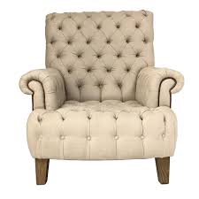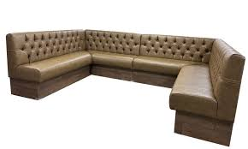
Deep buttoning in armchairs and settees adds a sense of opulence and comfort, creating a plush and inviting seating arrangement.

Features:
Tufted buttons, often secured with bridle ties, create a cushioned appearance, enhancing both the visual and tactile aspects of the furniture.

Functions:
Deep buttoning in armchairs and settees not only contributes to a luxurious aesthetic but also provides added comfort, making these pieces ideal for relaxing and lounging.

Headboards
Deep Buttoning:
Characteristics:
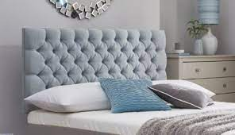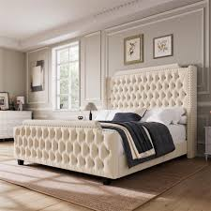
Deep buttoning in headboards offers a luxurious and tailored aesthetic to beds, often accentuating the room's decor.

Features:
Tufted buttons arranged in various patterns, such as diamond or grid designs, create a focal point in the bedroom, elevating the overall ambiance.

Functions:
Beyond its decorative appeal, deep buttoning in headboards provides a comfortable backing for individuals sitting up in bed, adding functionality to its aesthetic charm.

Box Pouffes
Diamond Buttoning:
Characteristics:
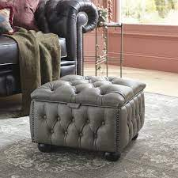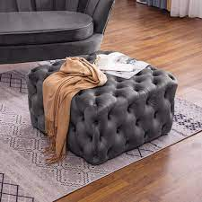
Box pouffes receive a touch of sophistication with diamond buttoning, transforming into chic and versatile seating or footrests.

Features:
The diamond pattern adds structure and symmetry to the pouffe, enhancing its visual appeal and making it a stylish accent piece in living spaces.

Functions:
Diamond buttoning in box pouffes not only contributes to their aesthetics but also provides a comfortable surface, making them suitable for additional seating or as a decorative element in a room.

Office or Reception Seating
Deep Buttoning:
Characteristics:
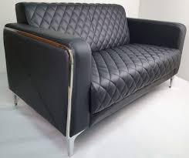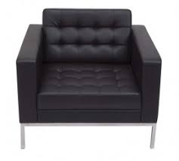
Upholstered furniture in professional settings benefits from deep buttoning, exuding professionalism and elegance.

Features:
Deep buttoning on office or reception seating often follows a more restrained and tailored design, conveying a sense of sophistication suitable for formal environments.

Functions:
The deep buttoning in office or reception seating not only enhances the visual appeal of the furniture but also contributes to a comfortable and inviting atmosphere for clients and guests.

The various types and applications of buttoning techniques allows furniture designers and craftsmen to tailor their approach based on the specific requirements and aesthetics of each piece, ensuring both form and function are seamlessly integrated.

KT0104 Specification requirements.
For successful implementation of deep buttoning and diamond buttoning, specific parameters and details play a crucial role in achieving the desired results.

These specification requirements encompass various aspects of the upholstery process:

Specification | Definition | Importance
Sample Interpretation | Understanding and replicating the desired buttoning pattern from a provided sample. | Sample interpretation serves as a visual guide, allowing upholsterers to grasp the intended buttoning pattern accurately. It ensures consistency and fidelity to the original design, whether it be a specific tufting arrangement or a unique button placement.
Material Type | Selection of appropriate fabric and padding conducive to the buttoning technique. | The choice of materials significantly influences the outcome of deep buttoning and diamond buttoning. Upholsterers must select fabrics that not only align with the design vision but also possess the durability and flexibility necessary for successful buttoning. Similarly, the padding chosen affects the depth and resilience of the tufted areas.
Button Type and Size | Choosing buttons that complement the design and ensuring their size aligns with the envisioned aesthetic. | Buttons are integral to the visual impact of buttoning techniques. The selection of button type, whether traditional or modern, and size is critical in achieving the desired look. Larger buttons may create a more pronounced effect, while smaller buttons can contribute to a more delicate and intricate appearance. The choice should harmonize with the overall design theme.
Button Attachment Method | Determining the method of attaching buttons, whether using bridle ties, button molds, or other anchoring techniques. | The method of attaching buttons is a crucial aspect of specification. Bridle ties, for example, provide flexibility and a secure fit, while button molds offer a more structured attachment. The choice depends on the desired level of detailing, functionality, and the specific requirements of the furniture piece.
Buttoning Layout and Spacing | Planning the layout and spacing of buttons to achieve the desired pattern and density. | The arrangement and spacing of buttons contribute to the overall aesthetics of the upholstered piece. Upholsterers must consider the design intent, whether it is a diamond pattern, grid layout, or other configurations. Careful planning ensures a balanced and visually appealing result.

Mastering these specification requirements is imperative for upholsterers and designers, as they form the foundation for accurate interpretation and execution of deep buttoning and diamond buttoning techniques in real-life upholstering scenarios. Attention to detail in material selection, button choice, and overall pattern planning ensures the successful realization of the envisioned design.

Formative assessment

IAC0101 Deep buttoning and diamond buttoning specification is correctly interpreted in terms of sample; material type; button type; button size.
IAC0102 Functions and applications of deep buttoning such as armchair or settees, headboards, box pouffes, office or reception seating are discussed.
(Weight 15%)

SECTION 2: KM-10-KT02: Preparation for buttoning and deep buttoning processes (10%)

Learning Outcome
At the end of this section, learners should cover:

KT0201 Principles of constructing templates for box, square and deep diamond buttoned seat backs, arms and seats.
KT0202 Concepts and principles of drawing up cutting and lay plans for square, diamond and box patterns and button covers and base covers.
KT0203 Types of templates that need to be constructed for box, square and deep diamond buttoned seat backs, arms and seats.

KT0201 Principles of constructing templates for box, square and deep diamond buttoned seat backs, arms and seats.
Constructing templates for box, square, and deep diamond buttoned upholstery requires a meticulous approach, considering the specific design elements and functional requirements of each furniture piece.

Here are detailed principles along with examples and advice on visual aids that can complement the content:

Understanding Furniture Dimensions
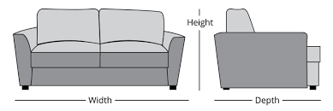
Principle:
Begin by understanding the dimensions of the furniture piece, including seat backs, arms, and seats. Accurate measurements form the foundation for constructing templates.

Example:
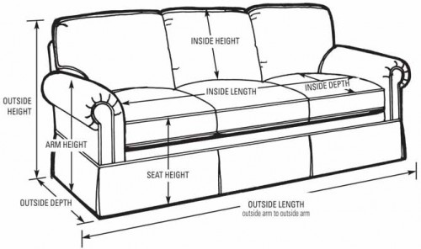
For a deep diamond buttoned seat back on a sofa, measure the height, width, and depth to ensure the template fits seamlessly.

Template Material and Flexibility
Principle:
Choose a template material that is flexible yet durable, allowing for easy manipulation to conform to the contours of the furniture.

Example:
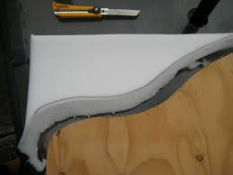
Use a sturdy yet pliable cardboard or foam board that can be easily shaped to match the curves and angles of the seat back or arms.

Box and Square Buttoning Layout
Principle:
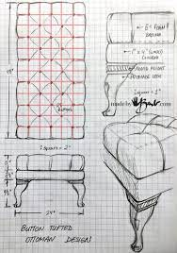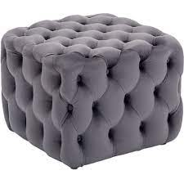
For box and square buttoning, create a grid layout on the template, marking the positions where buttons will be placed. Ensure the grid is symmetrical and aligned with the furniture piece.

Example:
Divide the template into equal sections both horizontally and vertically for a box or square pattern.

Deep Diamond Buttoning Configuration
Principle:
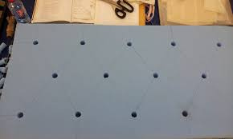
For deep diamond buttoning, determine the desired diamond pattern and establish the button layout accordingly. The configuration should be consistent and visually appealing.

Example:
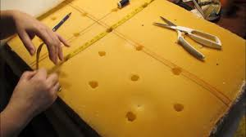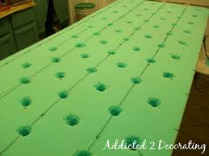
Plan a diamond pattern with intersecting lines on the template, indicating where buttons will be placed.

Mock-up and Adjustment
Principle:
Before finalising the template, create a mock-up using inexpensive material to check the accuracy of the design. Make adjustments as needed to ensure a perfect fit.

Example:
Use muslin fabric to create a preliminary version of the upholstery and assess how the buttons align with the template.

Labelling and Marking
Principle:
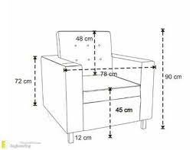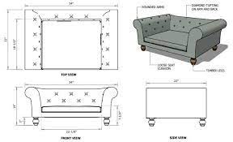
Clearly label the template with information such as dimensions, button positions, and any specific instructions for upholstery.

Example:
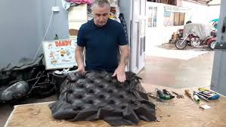

Use markers or labels to indicate where buttons should be placed and any specific details about the buttoning process.

By following these principles upholsterers can construct templates with precision and confidence, ensuring the successful implementation of box, square, and deep diamond buttoning techniques on various furniture components.

KT0202 Concepts and principles of drawing up cutting and lay plans for square, diamond and box patterns and button covers and base covers.
Creating cutting and lay plans for upholstery involves strategic planning to optimise fabric usage and ensure precision in crafting square, diamond, and box patterns, as well as button and base covers. Below are detailed principles along with examples and advice on visual aids that can enhance the understanding of the content:
Interpreting Specifications
Principle:
Start by thoroughly interpreting the specifications provided for the upholstery project, including dimensions, pattern requirements, and any specific instructions.

Example:
If the project involves a diamond-patterned seat, understand the desired dimensions and the number of diamonds required.

Calculating Allowances
Principle:
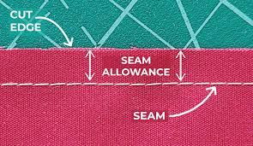
Calculate fabric allowances for seams, pattern matching, and any additional considerations to prevent shortages during the upholstery process.

Example:
If a square pattern requires matching at seams, calculate the extra fabric needed for pattern alignment.

Drawing Up Cutting Plans
Principle:
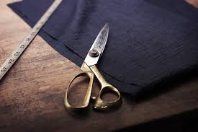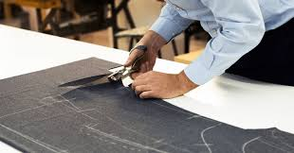
Develop cutting plans that maximize fabric utilization while adhering to the specified patterns. Consider the layout for square, diamond, and box patterns separately.
Example:
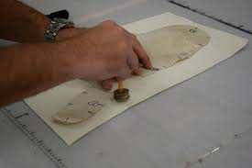
Plan the layout of square patterns to minimize fabric waste and ensure efficient cutting.

Lay Plans for Diamond Patterns
Principle:
Lay plans for diamond patterns should account for the angular placement of pieces to create the desired diamond configuration.

Example:
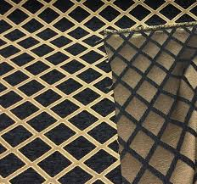
Arrange fabric pieces in a way that aligns with the specified diamond pattern, optimizing fabric usage.

Button and Base Cover Lay Plans:
Principle:
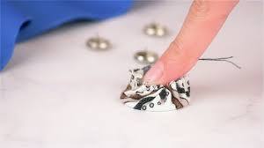
Develop lay plans for button covers and base covers that consider the size and quantity of covers needed, optimizing the use of fabric.

Example:
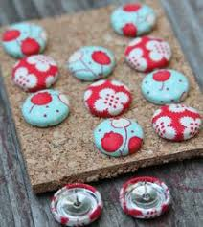
Plan the layout for button covers, ensuring the efficient use of fabric with minimal waste.

Fabric Pattern Matching
Principle:
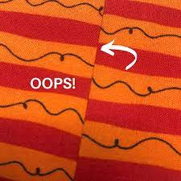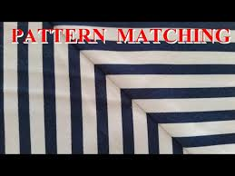
When working with patterned fabrics, incorporate fabric pattern matching into the cutting and lay plans to maintain continuity in the design.

Example:
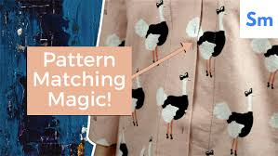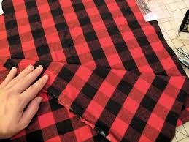
Align fabric pieces in a way that preserves the pattern flow, especially in square or box patterns where continuity is crucial.

Labelling and Documentation
Principle:
Clearly label each piece on the cutting and lay plans, documenting the type of pattern, dimensions, and any specific instructions.

Example:
Label fabric pieces for a diamond-patterned seat with corresponding dimensions and positions.

By following these concepts and principles, upholsterers can efficiently draw up cutting and lay plans for various patterns and covers, ensuring a seamless and resource-effective upholstery process.

KT0203 Types of templates that need to be constructed for box, square and deep diamond buttoned seat backs, arms and seats.
Constructing templates for box, square, and deep diamond buttoned upholstery involves a thoughtful process, and understanding the sequence for transferring diamond dimensions to foam and preparing the foam is essential.
Here are detailed descriptions of the types of templates needed and the procedures involved:

Types of Templates | Description
Box Pattern Templates | Rectangular templates with a grid layout, indicating the placement of buttons for a box pattern. These templates ensure uniformity and precision in button positioning.
Square Pattern Templates | Templates resembling the shape of the seating area with a grid or square layout. These templates guide the placement of buttons for a symmetrical square buttoning pattern.
Deep Diamond Buttoning Templates | Templates designed with intersecting lines forming diamond shapes. These templates are crucial for achieving a balanced and visually appealing deep diamond buttoning pattern.

Transferring Diamond Dimensions to Foam

Determining Diamond Dimensions | Understand the specified dimensions for the deep diamond buttoning pattern from the template.
Marking Foam | Transfer the diamond dimensions onto the foam using a marking tool. Place reference points at the intersections of the diamond pattern.
Connecting Reference Points | Use a straight edge or ruler to connect the reference points, creating the diamond pattern on the foam.
Frame Allowance | Add the correct allowance around the frame by extending the diamond pattern beyond the actual dimensions. This ensures a snug fit around the frame during upholstery.
Labelling | Clearly label the foam pieces with information such as dimensions, diamond pattern orientation, and any specific instructions for ease of identification during the upholstery process.
Preparing Foam for Diamond Buttoning

Cutting Foam to Size | Cut the foam pieces according to the marked diamond dimensions, ensuring precision in size.
Shaping Foam | Contour the foam to match the shape of the furniture piece, especially for seat backs and arms. This ensures a seamless and tailored appearance.
Foam Attachment Method | Choose an appropriate method for attaching the foam to the furniture frame, whether through adhesives, ties, or other secure means.
Button Attachment Points | Identify and mark the locations on the foam where buttons will be attached. This aligns with the diamond pattern on the template.
Foam Reinforcement | Consider adding additional foam layers or reinforcement at key points to provide extra support for the buttons, ensuring durability.

These template types and procedures for transferring dimensions and preparing foam is critical for achieving accurate and visually appealing box, square, and deep diamond buttoning in upholstery.

Formative assessment

IAC0201 Interpret specifications, calculate allowances and draw up cutting and lay plans for square, diamond and box patterns and button covers and base covers.
IAC0202 Describe the types of templates that need to be constructed for box, square and deep diamond buttoned seat backs, arms and seats.
IAC0203 Explain the sequence in which the diamond dimension of the template is transferred to the foam, and the correct allowance around the frame.
IAC0204 Describe the various ways in which the foam can be prepared for diamond buttoning.
(Weight 10%)
SECTION 3: KM-10-KT03: Buttoning and deep buttoning principles and methods (35%)

Learning Outcome
At the end of this section, learners should cover:

KT0301 Range of buttoning processes, methods and techniques.
KT0302 Button preparation methods and attaching techniques.
KT0303 Principles of diamond, square, box, and deep diamond buttoning and tufting.
KT0304 Types of knots used when deep buttoning.
KT0305 Concepts and principles of buttoning plans for square, diamond and box patterns.
KT0306 Principles of the sequence in which the diamond dimension of the template is transferred to the foam, and the correct allowance around the frame.
KT0307 Principles and concepts of diamond, square, box and deep diamond buttoning.
Buttoning and deep buttoning represent intricate upholstery techniques that involve the strategic placement of buttons to create unique patterns and textures on upholstered furniture. These methods, integral to the world of upholstery, not only enhance the aesthetic appeal of furniture pieces but also contribute to their comfort and durability. In this comprehensive exploration of buttoning and deep buttoning principles and methods, we will delve into various aspects of these techniques, covering a wide range of processes, methods, and principles.

KT0301 Range of buttoning processes, methods and techniques.
Buttoning processes are diverse, encompassing various methods and techniques that contribute to the overall visual and tactile appeal of upholstered furniture. From diamond and square buttoning to box and deep diamond buttoning, each process brings its own set of unique characteristics and applications.
Diamond Buttoning:
Characteristics
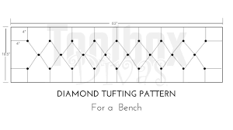

Symmetrical Arrangement | Diamond buttoning is characterised by a symmetrical arrangement of buttons, creating diamond-shaped patterns on the upholstery fabric.
Focal Points | Intersection points of the diamonds serve as focal points, adding visual interest and depth to the upholstered piece.
Versatility | Suitable for various furniture styles, diamond buttoning adapts well to both traditional and contemporary designs.
Applications | Chairs and Sofas: Commonly used for seating surfaces in chairs and sofas, providing a sophisticated and visually appealing texture.

Square Buttoning:
Characteristics:
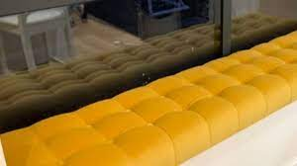

Geometric Precision | Square buttoning emphasizes geometric precision, arranging buttons in a grid pattern with straight lines and right angles.
Clean and Orderly Appearance | The grid layout creates a clean and orderly appearance, suitable for contemporary and minimalist designs.
Defined Lines | Straight lines formed by the grid contribute to a defined and tailored look in square buttoning.
Applications | Headboards: Square buttoning is often used in headboards, providing a structured and stylish backdrop for beds.

Box Buttoning:
Characteristics:

Combination of Diamond and Square Elements | Box buttoning combines elements of both diamond and square patterns, resulting in a structured and elegant appearance.
Texture Play | Alternating diamond and square shapes create an interesting texture, adding depth to the upholstery.
Harmony Between Elements | Achieving harmony between the diamond and square elements is crucial for a seamless box buttoning design.
Applications | Ottomans and Pouffes: Box buttoning adds a touch of sophistication to ottomans and pouffes, transforming them into chic and versatile seating or footrests.

Deep Diamond Buttoning
Characteristics

Luxurious Texture | Deep diamond buttoning involves creating pronounced depressions, resulting in a luxurious and textured appearance.
Vintage Charm | Often associated with vintage or classic charm, making it a popular choice for traditional or antique-inspired furniture.
Plush Comfort | The depth of the buttoning provides an extra layer of cushioning, contributing to a plush and comfortable seating experience.
Applications | Antique-style Furniture: Deep diamond buttoning is frequently used in antique-style furniture, lending a timeless and opulent feel.

Tufting
Characteristics
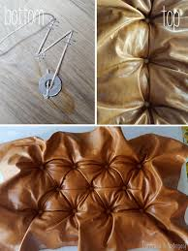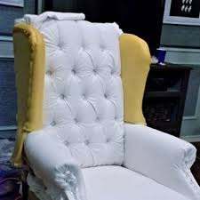

Adjustability | Tufting allows for adjustability in achieving the desired depth, offering flexibility in creating the desired aesthetic.
Consistent Spacing | Consistent spacing between tufts is crucial for a balanced and visually appealing tufted design.
Secure Attachment | Tufting threads or buttons must be securely attached to the furniture frame, ensuring stability and longevity.
Applications | Upholstered Beds: Tufting is commonly used in upholstered beds, creating a luxurious and inviting look for bedroom furniture.
Considerations for Buttoning Processes
Considerations

Furniture Style | The choice of buttoning process depends on the overall style of the furniture, whether it is traditional, contemporary, or a blend of both.
Intended Use | Consider the intended use of the furniture piece. Different buttoning processes may be suitable for seating surfaces, headboards, or decorative elements.
Fabric and Material Selection | The characteristics of the chosen fabric and button materials influence the overall texture and feel of the buttoning process.
Aesthetic Preferences | Aesthetic preferences play a significant role in selecting a buttoning process. Upholsterers often choose processes that align with the desired visual appeal.
Functionality Requirements | Consider the functionality requirements of the furniture. Buttoning processes in high-stress areas may require techniques that provide enhanced durability and stability.
Skill and Expertise | The skill level of the upholsterer influences the choice of buttoning processes. Some techniques may require more intricate skills and attention to detail.

The diverse range of buttoning processes, methods, and techniques provides upholsterers with a palette of options to enhance the aesthetics and functionality of upholstered furniture. Understanding the characteristics and applications of each process allows for informed decisions based on the specific requirements of different furniture pieces.

KT0302 Button preparation methods and attaching techniques.
Before buttons are attached to upholstery, meticulous preparation is required. This section will detail the methods of button preparation, including selecting appropriate materials, covering techniques, and securing buttons to the upholstery fabric through various attaching techniques.
Button Preparation Methods
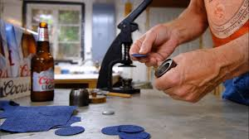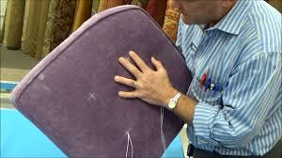

Selection of Button Materials | Choosing appropriate button materials is essential. Upholsterers must consider factors such as size, shape, and colour, ensuring the selected buttons align with the overall design aesthetic and functionality.
Fabric Covering | Fabric covering involves wrapping the selected button with upholstery fabric. This method allows upholsterers to coordinate the button with the furniture's overall upholstery, creating a seamless and integrated look.
Padding Application | Adding padding beneath the fabric covering provides depth and enhances the visual appeal of the button. It also contributes to a softer feel when pressed, adding a layer of comfort to the upholstery.
Button Mold Creation | Creating a button mold involves shaping the fabric-covered button and its padding to achieve a rounded or domed appearance. This step ensures a polished and professional finish.
Thread Attachment Points | Identifying and marking attachment points on the back of the button is crucial. These points determine where the button will be secured to the upholstery fabric, guiding the attachment process.
Attaching Techniques

Shank Attachment | The shank attachment technique involves threading a needle through the shank or stem of the button, securing it to the upholstery fabric. This method provides stability and prevents the button from shifting.
Wire Attachment | For buttons without a shank, a wire attachment technique can be used. A wire is threaded through the button and secured to the fabric, providing a stable anchor point.
Tufting Twine Attachment | Tufting twine, a strong and durable material, can be used to attach buttons. The twine is threaded through the button and securely tied to the upholstery fabric, ensuring a tight and long-lasting connection.
Knot Techniques | Various knot techniques, such as slip knots or square knots, can be employed to secure buttons. The choice of knot depends on factors like adjustability, stability, and the overall aesthetic preference of the upholsterer.
Attachment Grid | Establishing an attachment grid involves marking predetermined points on the upholstery fabric where buttons will be attached. This grid ensures uniform spacing and precise placement, contributing to an organised and visually appealing result.
Blind Buttoning | Blind buttoning is a technique where buttons are affixed without visible stitching. A specialised needle is used to secure the button from the front while concealing the attachment point, creating a seamless appearance.

Considerations for Button Preparation and Attaching

Fabric Compatibility | Upholsterers must consider the compatibility of the fabric with the button material. Some fabrics may work better with certain button materials, ensuring a secure and lasting bond.
Button Size and Proportion | The size and proportion of the button should align with the furniture piece's scale and design. Buttons that are too large or too small can disrupt the overall visual balance.
Strength and Durability | Consider the strength and durability requirements of the upholstery. High-stress areas, such as seating surfaces, may require stronger attachment techniques and materials to withstand frequent use.
Aesthetic Considerations | The aesthetic preferences of the upholsterer and the overall design concept of the furniture should guide button preparation and attaching techniques. A cohesive and intentional approach enhances the visual appeal.
Functionality | Buttons play a dual role in upholstery, serving both aesthetic and functional purposes. Consider the intended use of the furniture piece and ensure that the chosen button preparation and attaching techniques meet functional requirements.
Consistency in Attachment | Maintaining consistency in attachment techniques and spacing contributes to a polished and professional appearance. A systematic approach ensures uniformity across the entire upholstery.

Understanding the intricacies of button preparation methods and attaching techniques is pivotal for achieving a successful and visually appealing upholstery outcome. Upholsterers must carefully select materials, consider attachment techniques, and align their choices with both aesthetic and functional considerations to achieve a harmonious and durable result.

KT0303 Principles of diamond, square, box, and deep diamond buttoning and tufting.
Understanding the principles behind different buttoning and tufting techniques is fundamental to achieving precision and elegance in upholstery. This section will explore the principles governing diamond, square, box, and deep diamond buttoning, as well as tufting, shedding light on the nuances that make each technique distinct.
Diamond Buttoning

Symmetry and Alignment | Achieving symmetry in the arrangement of diamond patterns is fundamental. Buttons should be aligned precisely at intersection points to maintain visual balance and harmony.
Consistent Spacing | Consistency in the spacing between buttons is crucial. Even spacing contributes to the overall aesthetic appeal and ensures a uniform appearance of the diamond pattern.
Pattern Continuity | Maintaining continuity in the diamond pattern, especially at seams or transitions, is essential for a seamless and polished look. A break in pattern continuity can be visually distracting.
Material Selection | The choice of materials, including fabric and buttons, impacts the overall texture and feel of the diamond buttoning. Coordinating these materials enhances the elegance and aesthetic of the upholstery.
Precision in Button Placement | Precise placement of buttons at calculated intervals is crucial for achieving a defined and visually appealing diamond pattern. Inconsistencies in placement can disrupt the intended design.

Square Buttoning

Geometric Precision | Square buttoning emphasizes geometric precision. Buttons are arranged in a grid pattern with uniform spacing, creating a clean and orderly appearance.
Even Distribution | Achieving an even distribution of buttons across the entire square pattern is essential. This principle ensures that the visual weight is balanced, contributing to a polished design.
Straight Lines and Right Angles | The grid layout of square buttoning requires straight lines and right angles. Upholsterers must pay attention to maintaining these geometric elements for a well-defined and structured look.
Material Consistency | Consistency in material choices, such as using the same fabric and button types, reinforces the uniformity of the square buttoning pattern.
Seamless Transitions | Seamless transitions between different sections of square buttoning, especially at seams, contribute to an overall cohesive appearance. Irregular transitions can disrupt the continuity of the design.

Box Buttoning

Harmony Between Elements | Achieving harmony between the diamond and square elements is a key principle in box buttoning. The alternating arrangement should create a unified and balanced visual appeal.
Proportional Scaling | Proportional scaling ensures that the size and spacing of both diamonds and squares are consistent. This principle contributes to a well-proportioned design.
Continuous Flow | Maintaining a continuous flow of the pattern across different sections of the furniture piece is crucial. This principle ensures that the box pattern appears unified and continuous.
Texture Play | The combination of diamond and square shapes in box buttoning allows for texture play. Upholsterers can use this principle to add depth and visual interest to the overall design.

Deep Diamond Buttoning

Plush Comfort | Deep diamond buttoning aims to create a plush and comfortable seating experience. The depth of the buttoning adds an extra layer of cushioning for enhanced comfort.
Strategic Button Placement | Buttons should be strategically placed to create balanced diamonds. Achieving uniformity in the size and spacing of diamonds enhances the overall aesthetic.
Durability Through Even Distribution | Even distribution of buttons ensures durability by preventing uneven stress on specific areas. This principle contributes to the longevity of deep diamond buttoning.
Visual Texture | The pronounced depressions in deep diamond buttoning provide visual texture. Upholsterers can use this texture to create a luxurious and visually interesting appearance.

Tufting

Tufting Depth and Adjustability | Tufting principles involve determining the desired tufting depth and ensuring adjustability during the tufting process. Upholsterers must consider the overall aesthetic and comfort requirements.
Consistent Spacing | Like buttoning, tufting requires consistent spacing between tufts for a balanced and visually appealing look. Irregular spacing can create visual disturbances.
Secure Attachment | Tufting threads or buttons must be securely attached to the furniture frame to withstand tension and maintain the desired tufting depth. A secure attachment ensures the longevity of tufted upholstery.
Material Harmony | Harmonising materials, such as choosing tufting buttons that complement the overall fabric, contributes to a cohesive and polished tufted appearance.

Understanding these principles for diamond, square, box, deep diamond buttoning, and tufting is crucial for upholsterers. It provides a foundation for achieving precision, elegance, and functionality in upholstery, ensuring that each technique is applied with careful consideration of both aesthetic and practical factors.

KT0304 Types of knots used when deep buttoning.
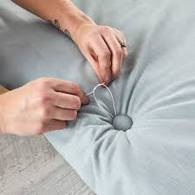
Deep buttoning involves securing buttons with knots, and the choice of knots significantly influences the overall appearance and durability of the upholstery. This section will identify various types of knots used in deep buttoning and explain the reasons behind selecting specific knots for different applications.
Button Attachment Knots
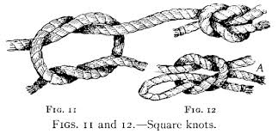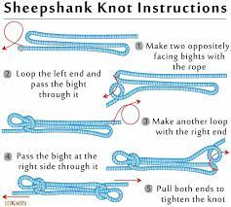

Type | Description | Application
Shank Knot | A shank knot involves tying a knot on the shank or stem of the button. It is a secure knot that helps maintain tension and prevents the button from loosening over time. | Suitable for deep buttoning where a tight and durable attachment is required, particularly in high-stress areas such as seating surfaces.
Lock Stitch | The lock stitch involves creating a loop around the button's shank and securing it with multiple wraps. This knot adds extra stability and prevents the button from shifting. | Ideal for deep buttoning on cushions or areas where there might be frequent pressure and movement.
Cross Stitch | The cross stitch is formed by creating an "X" pattern with the thread across the button's shank. This knot provides a decorative touch while ensuring a secure attachment. | Suited for deep buttoning in visible areas where aesthetics are a priority, such as on the front of upholstered furniture.

Tufting Thread Knots
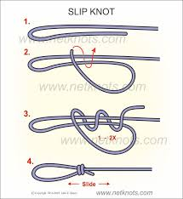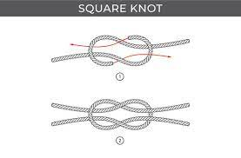

Types | Description | Application
Slip Knot | A slip knot is easily adjustable and allows for precise tightening. It involves creating a loop that tightens around the button when pulled. | Suitable for tufting thread where adjustability is required, allowing upholsterers to achieve the desired tufting depth.
Square Knot | The square knot involves two overhand knots tied in opposite directions. It is a secure and stable knot commonly used in various applications, including tufting. | Effective for tufting thread where a stable and straightforward knot is needed.
Surgeon's Knot | The surgeon's knot is an extension of the square knot, providing additional security. It involves wrapping the thread around the shank before tying the knot. | Particularly useful in situations where the tufting thread needs extra reinforcement to withstand tension.

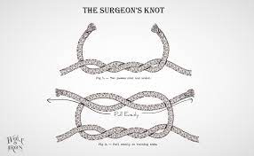

Knot Selection Considerations
Reasons Behind Choosing Specific Knots

Reason | Explanation
Durability | For areas of high stress and frequent use, such as seating surfaces, knots like the shank knot or lock stitch are chosen for their durability and ability to withstand tension.
Aesthetics | In visible areas where aesthetics play a crucial role, decorative knots like the cross stitch may be preferred to enhance the visual appeal of the deep buttoning.
Adjustability | Knots like the slip knot are chosen when adjustability is essential, allowing upholsterers to fine-tune the tufting depth according to the desired aesthetic and comfort.
Stability | Stability is a key consideration in deep buttoning, and knots like the square knot and surgeon's knot provide a stable and secure attachment, ensuring buttons stay in place over time.
Thread Type | The type of thread used can influence knot selection. For thicker threads or those with less elasticity, knots that provide a secure grip, such as the square knot, may be preferred.

Understanding the characteristics and applications of different knots is essential in deep buttoning, as the choice of knots directly impacts the longevity, stability, and visual appeal of the upholstery. Upholsterers must consider both functional and aesthetic factors when selecting the appropriate knot for each deep buttoning application.

KT0305 Concepts and principles of buttoning plans for square, diamond and box patterns.
Creating effective buttoning plans is crucial for achieving a harmonious and visually appealing design. This section will delve into the concepts and principles guiding the development of buttoning plans for square, diamond, and box patterns, considering factors like symmetry, spacing, and pattern continuity.

Square Pattern Buttoning Plans

Concepts | Explanation
Symmetry and Order | Square buttoning plans revolve around achieving a symmetrical and orderly layout. The arrangement of buttons follows a grid pattern, emphasising neatness and precision.
Geometric Precision | The concept involves maintaining geometric precision in the buttoning plan. Each button is positioned equidistant from its neighbouring buttons, contributing to a clean and structured appearance.
Material Consistency | Consistency in material selection, such as uniform fabric and button styles, ensures a cohesive look. Material consistency plays a vital role in reinforcing the geometric design.
Even Spacing | Achieving even spacing between buttons is fundamental for a balanced and visually appealing square pattern. Deviations in spacing can disrupt the clean lines of the design.
Grid Alignment | The grid alignment should be consistent across the entire furniture piece, ensuring that the square pattern remains coherent from one section to another.
Pattern Continuity | Maintaining pattern continuity, especially at seams or transitions between different sections, is crucial for a seamless and polished appearance.

Diamond Pattern Buttoning Plans:

Concepts | Explanation
Symmetry and Focal Points | Diamond buttoning plans emphasize creating a symmetrical arrangement of diamonds. Intersection points in the pattern serve as focal points, adding visual interest.
Versatility | The concept of versatility involves adapting the diamond pattern to various furniture styles, ensuring that it complements both traditional and contemporary designs.
Texture and Depth | Creating texture and depth in the buttoning plan is essential for achieving a luxurious and visually interesting appearance. The diamonds contribute to a tactile and opulent feel.
Balanced Placement | Buttons should be strategically placed to create balanced diamonds. Achieving uniformity in the size and spacing of diamonds enhances the overall aesthetic.
Intersection Precision | Precise alignment of buttons at intersection points is critical. Any misalignment can disrupt the diamond pattern and compromise the overall visual impact.
Material Harmony | Harmonising materials, including fabric and button choices, is vital for reinforcing the cohesive and elegant look of the diamond pattern.
Box Pattern Buttoning Plans:

Concepts | Explanation
Structural Elegance | Box buttoning plans aim to achieve structural elegance by combining elements of both square and diamond patterns. The alternating arrangement creates visual interest and complexity.
Texture Play | The concept of texture play involves using the alternating diamond and square shapes to add texture and depth to the overall buttoning plan.
Harmonious Fusion | Achieving harmony between the diamond and square elements is a key principle. The fusion should be seamless, with each element complementing the other.
Proportional Scaling | Proportional scaling ensures that the size and spacing of both diamonds and squares are consistent and balanced. This principle contributes to a well-proportioned design.
Continuous Flow | Maintaining a continuous flow of the pattern across different sections of the furniture piece is crucial. This principle ensures that the box pattern appears unified and continuous.

Creating effective buttoning plans for square, diamond, and box patterns involves a careful consideration of these concepts and principles. Upholsterers must balance symmetry, spacing, and pattern continuity to achieve a harmonious and visually appealing design that complements the overall aesthetic of the furniture piece.

KT0306 Principles of the sequence in which the diamond dimension of the template is transferred to the foam, and the correct allowance around the frame.
This section will provide detailed insights into the sequence for transferring the diamond dimension from templates to foam, emphasizing precision and the correct allowance around the furniture frame. Understanding this sequence is vital for achieving a seamless and well-fitted upholstery.

Sequence for Transferring Diamond Dimension to Foam

Template Analysis | Begin by thoroughly analysing the diamond buttoning template. Understand the specific dimensions, pattern layout, and the placement of intersection points.
Foam Preparation | Ensure the foam is cut to the desired size based on the template analysis. The foam should match the overall shape of the furniture piece, including curves and contours.
Marking Reference Points | Mark the reference points on the foam where the intersections of the diamond pattern occur. Use a pencil or marking tool for accuracy.
Connecting Reference Points | Utilise a straight edge or ruler to connect the marked reference points on the foam, forming the diamond pattern. Pay close attention to maintaining straight lines and proper angles.
Check Alignment | Verify the alignment of the diamond pattern on the foam with the template. This step ensures precision and helps identify any discrepancies early in the process.
Frame Allowance Marking | Mark the areas on the foam where allowance is required around the furniture frame. This step involves extending the diamond pattern slightly beyond the actual dimensions to accommodate the frame.
Double-Check Measurements | Double-check all measurements, ensuring that the diamond pattern is accurately transferred, and the allowance around the frame is consistent.
Labelling | Clearly label the foam pieces with information such as dimensions, diamond pattern orientation, and allowances. Proper labelling streamlines the upholstery process and avoids confusion during assembly.

Correct Allowance Around the Frame

Understanding Frame Structure | Analyse the frame structure of the furniture piece. Identify areas where the foam needs to snugly fit against the frame to create a seamless and well-fitted appearance.
Determining Allowance | Consider the depth of the diamond pattern and the thickness of the upholstery material when determining the allowance. The allowance ensures that the foam fits securely around the frame without gaps or unevenness.
Consistent Allowance Application | Apply the allowance consistently around the entire frame, maintaining uniformity. Inconsistencies in allowance can result in an uneven appearance or discomfort in the finished upholstery.
Securing the Foam | Implement appropriate methods to secure the foam to the frame, whether through adhesives, ties, or other fastening techniques. The secure attachment ensures that the foam maintains its position and shape over time.
Testing Fit | Conduct a fit test by placing the foam on the frame and ensuring that it sits snugly without gaps. This step is crucial for identifying any adjustments needed before proceeding with the final upholstery.
Final Inspection | Perform a final inspection, checking the overall fit, alignment of the diamond pattern, and the uniformity of the allowance. Address any discrepancies before moving forward with additional upholstery layers.

Understanding the precise sequence for transferring the diamond dimension to foam and applying the correct allowance around the frame is foundational to achieving a seamless and well-fitted upholstery. These principles ensure that the final result not only meets aesthetic expectations but also aligns with functional requirements, contributing to the overall quality and longevity of the upholstered furniture.

KT0307 Principles and concepts of diamond, square, box and deep diamond buttoning.
Exploring the overarching principles and concepts that govern diamond, square, box, and deep diamond buttoning will provide a comprehensive understanding of these techniques. This section will cover the visual aesthetics, functional considerations, and design principles inherent in each buttoning style.

Diamond Buttoning
Visual Aesthetics

Symmetry and Elegance | Diamond buttoning is characterized by a symmetrical arrangement of buttons forming diamond shapes on the upholstery. The visual aesthetics emphasise symmetry, contributing to an elegant and refined appearance.
Focal Points | The intersection points of the diamonds often serve as focal points, drawing attention and adding visual interest to the furniture piece.
Versatility | Diamond buttoning is versatile, suitable for both traditional and contemporary designs. It adapts well to various furniture styles, from classic to modern.

Functional Considerations

Comfortable Seating | The tufted diamonds create depressions that enhance the cushioning effect, providing a comfortable and inviting seating experience.
Durability | The strategic placement of buttons, when done correctly, ensures even distribution of pressure, contributing to the durability of the upholstery.

Design Principles

Pattern Continuity | Maintaining consistency in the diamond pattern across the entire piece is crucial for a polished and cohesive design.
Material Selection | The choice of fabric and button material influences the texture and overall feel of the diamond buttoning, aligning with the intended design aesthetic.
Square Buttoning
Visual Aesthetics

Geometric Precision | Square buttoning is defined by a grid of buttons arranged in a symmetrical pattern. The emphasis is on geometric precision, creating a clean and orderly appearance.
Contemporary Appeal | The structured and orderly nature of square buttoning often lends itself well to contemporary and minimalist designs.

Functional Considerations

Supportive Backing | Square buttoning provides a supportive backing, making it particularly suitable for furniture pieces where a more rigid structure is desired.
Defined Lines | The straight lines formed by the grid pattern contribute to a defined and tailored look.

Design Principles

Even Spacing | Maintaining even spacing between buttons is essential for achieving a balanced and visually appealing square pattern.
Material Contrast | Playing with material contrast, such as using buttons in a contrasting colour or texture, can accentuate the square pattern.

Box Buttoning
Visual Aesthetics

Structural Elegance | Box buttoning combines the elements of both diamond and square patterns, resulting in a structured and elegant appearance.
Texture Play | The alternating diamond and square shapes create an interesting texture, adding depth to the upholstery.

Functional Considerations

Balanced Comfort | Box buttoning provides a balanced mix of comfort and structure, making it suitable for various furniture types.
Visual Interest | The combination of diamond and square elements adds visual interest, making box buttoning suitable for both classic and contemporary designs.

Design Principles

Pattern Harmony | Achieving harmony between the diamond and square elements is essential for a seamless box buttoning design.
Scale Consideration | The scale of the boxes and diamonds should be proportionate to the size of the furniture piece, ensuring a balanced composition.

Deep Diamond Buttoning
Visual Aesthetics

Luxurious Texture | Deep diamond buttoning involves creating pronounced depressions, resulting in a luxurious and textured appearance.
Vintage Charm | This style often exudes a vintage or classic charm, making it a popular choice for traditional or antique-inspired furniture.

Functional Considerations

Plush Comfort | The depth of the buttoning provides an extra layer of cushioning, contributing to a plush and comfortable seating experience.
Classic Elegance | Deep diamond buttoning is often associated with classic and timeless furniture designs.

Design Principles:

Button Placement | The spacing and placement of buttons are critical for achieving the desired deep diamond pattern and ensuring an even and balanced appearance.
Material Selection | Choosing rich and textured fabrics enhances the vintage appeal of deep diamond buttoning.

In summary, the principles and concepts of diamond, square, box, and deep diamond buttoning are deeply rooted in both aesthetics and functionality. Each style brings its own set of visual characteristics, functional considerations, and design principles, allowing upholstery professionals to choose the most suitable technique based on the desired outcome and the specific requirements of the furniture piece.

Formative assessment

IAC0301 Identify and explain the difference between diamond, square, box, and deep diamond buttoning and tufting.
IAC0302 Identify the types of knots used when deep buttoning, and explain the reasons for using different knots.
(Weight 35%)

SECTION 4: KM-10-KT04: Raw materials and equipment used in various types of buttoning (25%)

Learning Outcome
At the end of this section, learners should cover:

KT0401 Raw materials and equipment, including needles, twine, foam, drill, and different types of buttons and their component parts.
KT0402 Identify the hand tools and their functions.
KT0403 The parts of the button press.
KT0404 Tools and equipment used for a variety of buttoning processes.
KT0405 Buttoning material types and their uses.
KT0406 Concepts and principles of plans to determine the amount of fabric and allowances required for the base cover and for the button covers.
Understanding the raw materials and equipment used in buttoning processes is essential for upholsterers seeking to master the craft. From needles and twine to foam and different types of buttons, each component plays a crucial role in achieving the desired aesthetic and functional outcome. This section will delve into the diverse array of materials and tools employed in buttoning, empowering learners to identify, select, and utilise them effectively.

KT0401 Raw materials and equipment, including needles, twine, foam, drill, and different types of buttons and their component parts.
Needles
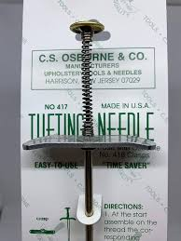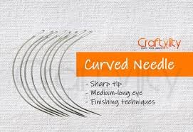
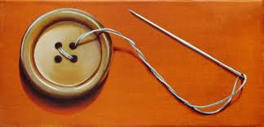

Tufting Needle | The tufting needle stands as a cornerstone tool in buttoning processes, specifically tailored for threading buttons through layers of fabric and padding in tufting techniques.  With its elongated and sturdy design, this needle ensures a secure attachment, creating distinctive tufted patterns that enhance the overall aesthetics of upholstered furniture.
Curved Upholstery Needle | Designed for precision in securing buttons, the curved upholstery needle shines in its ability to navigate hard-to-reach areas.  Its unique curvature provides flexibility, making it an invaluable tool for upholsterers seeking versatility in buttoning applications, especially in intricate designs or areas with spatial constraints.
Button Thread Needle | The specialised button thread needle plays a vital role in securely attaching buttons to upholstery.  Often used in conjunction with tufting twine, this needle ensures a stable connection between the button and fabric, contributing to the longevity and durability of the buttoning application.

Twine
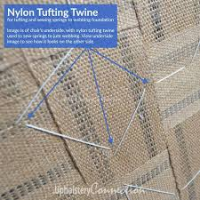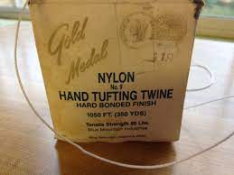

Tufting Twine | Renowned for its strength and durability, tufting twine takes centre stage in tufting processes. This robust material secures buttons firmly to the furniture frame, providing the necessary tension for creating tufted patterns that define the visual appeal of upholstered surfaces.
Button Thread | Specially crafted for attaching buttons securely, button thread serves as the linchpin in establishing a stable and enduring connection between the button and fabric. Its reliable properties contribute to the overall integrity of various buttoning applications.

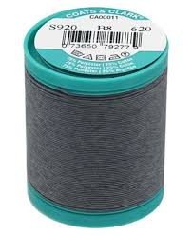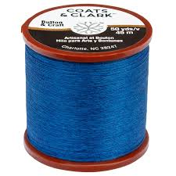

Foam
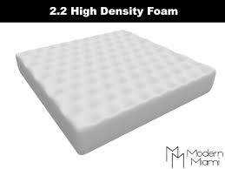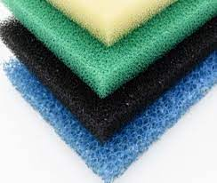
Polyester Foam
High-Density Foam | In the realm of deep buttoning processes, high-density foam emerges as a key material.  Its application extends to creating button molds that result in rounded and plush buttoned surfaces.  This foam variety ensures a structured and visually appealing outcome, especially in antique-inspired or classic furniture designs.
Polyester Foam | Commonly employed for padding beneath fabric-covered buttons, polyester foam adds a layer of comfort and softness to upholstery.  This versatile material strikes a balance between support and plushness, enhancing the tactile experience of seated or reclined surfaces adorned with buttoned details.

Drill
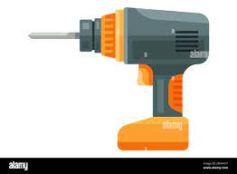

Buttonhole Drill | The buttonhole drill plays a pivotal role in buttoning processes by enabling the creation of precise holes in upholstery fabric.  This specialised tool facilitates the attachment of buttons in various buttoning techniques, ensuring accuracy and uniformity in the placement of buttons across upholstered surfaces.

Buttons and Their Component Parts
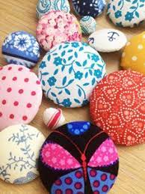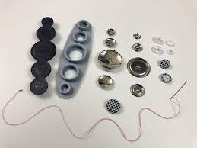

Covered Buttons | With components comprising a button shell, fabric cover, and button back, covered buttons achieve a cohesive appearance.  The fabric cover is meticulously secured over the button shell, resulting in a seamless and integrated design that elevates the visual aesthetics of upholstered furniture.
Shank Buttons | Characterised by a button face, shank, and button back, shank buttons offer a secure attachment to fabric without causing pulling or stretching.  This button variety is favoured for its stability and is often chosen for applications where durability is paramount.
Snap Buttons | Composed of a button cap, socket, and stud, snap buttons provide a quick and secure fastening solution.  Widely utilised in upholstered cushions, snap buttons offer convenience and ease of use, making them a popular choice for functional and decorative purposes.

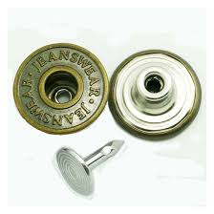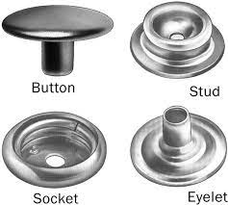
SHANK BUTTON SNAP BUTTON

Understanding the nuances of these raw materials and tools is essential for upholsterers, as they form the foundation for executing various buttoning techniques. Mastery of these components empowers craftsmen to create upholstery that not only meets aesthetic expectations but also stands the test of time in terms of durability and functionality.

KT0402 Identify the hand tools and their functions.
Hand tools are the unsung heroes in the realm of buttoning, playing a pivotal role in executing precision and efficiency in various techniques. Upholsterers rely on these tools to shape, cut, and secure components, contributing to the overall quality of the finished upholstery. This section will explore essential hand tools and their specific functions, providing a comprehensive understanding for those engaging in the buttoning craft.
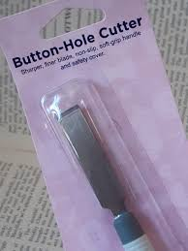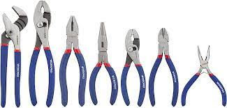
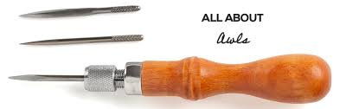

Hand Tools | Functions
Buttonhole Cutter | The buttonhole cutter takes the spotlight for its role in enabling precise cutting of holes in upholstery fabric.  Tailored for accommodating buttons in buttoning processes, this tool ensures accuracy and consistency in creating openings for buttons.  Its sharp and controlled cutting action allows upholsterers to achieve clean and well-defined buttonholes.
Pliers | Pliers emerge as versatile companions in buttoning applications, serving multiple functions.  From gripping and pulling to securing components such as buttons, pliers provide the necessary leverage for a range of tasks.  Their robust design and gripping capabilities make them indispensable for tasks that require strength and precision, contributing to the secure attachment of buttons in various buttoning techniques.
Awl | The awl takes centre stage as an essential tool for marking and creating small holes in fabric.  Its fine, pointed tip aids in the alignment and attachment of buttons by establishing reference points.  Upholsterers rely on the awl for its ability to create small punctures without causing damage to the fabric, ensuring accuracy in the placement of buttons and facilitating a seamless buttoning process.
Scissors | Scissors, with their cutting prowess, play a fundamental role in shaping fabric, thread, and twine with precision.  The neat and clean edges achieved through scissors contribute to the overall aesthetics of buttoning projects.  Whether cutting fabric covers, trimming excess thread, or shaping twine, scissors are indispensable for achieving a polished and refined finish in buttoned upholstery.

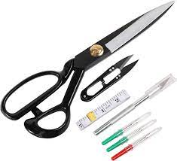
Understanding the functions of these hand tools is vital for upholsterers seeking mastery in the buttoning craft. Each tool plays a specific role in contributing to the precision, efficiency, and overall quality of buttoned upholstery. As craftsmen become adept at leveraging these tools, they enhance their ability to execute diverse buttoning techniques with finesse and achieve impeccable results.

KT0403 The parts of the button press.
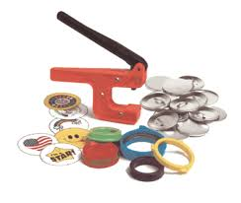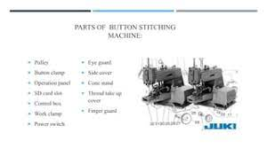
The button press stands as a specialized apparatus, a linchpin in the efficiency and precision of the button-covering process. Upholsterers heavily rely on this tool to seamlessly assemble button components, contributing to the overall aesthetics of upholstered surfaces. Understanding the key components and their functions within the button press is paramount for those engaging in button production.

Button Press parts | Function
Die Set | The die set serves as the foundation for the button-covering process, holding button components in place.  Its design ensures proper alignment, allowing upholsterers to achieve uniform and visually appealing button covers.  The die set is instrumental in creating a cohesive and seamless appearance by securely positioning each component during the covering process.
Ram or Plunger | The ram, also known as the plunger, plays a crucial role in the button press by applying pressure to the die set.  This pressure is essential for facilitating the secure assembly of button components.  The controlled force exerted by the ram ensures that all elements, including the fabric cover and button shell, come together seamlessly, resulting in a well-covered button that enhances the overall aesthetics of the upholstery.
Base Plate | Providing a stable foundation to the entire button press, the base plate serves as a platform for the die set and ram.  Stability is paramount during the covering process, and the base plate ensures that the button press remains steady and secure.  This component contributes to the overall accuracy and consistency in button production, ensuring that each button is covered with precision.
Handle or Lever | The handle or lever is the interface through which the operator exerts pressure on the ram, activating the covering process.  This ergonomic component allows for controlled and consistent application of force, ensuring uniform button assembly.  The handle or lever is a critical element in the hands-on operation of the button press, providing the operator with the means to execute precise and efficient button covering.

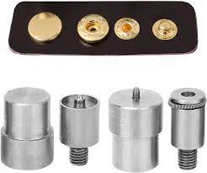
Understanding the synergy among these components in the button press is paramount for upholsterers seeking to streamline the button-covering process. The precision afforded by the die set, ram, base plate, and handle or lever collectively contributes to the creation of meticulously covered buttons, elevating the visual appeal of upholstered furniture.

KT0404 Tools and equipment used for a variety of buttoning processes.
The versatility of buttoning processes relies significantly on the tools and equipment employed by upholsterers. From automated machines that enhance efficiency in mass production to handheld kits offering flexibility in small-scale projects, each tool plays a distinct role in achieving precision and desired outcomes. This section explores the essential tools and equipment used in a range of buttoning applications.

Tools and Equipment for Buttoning Processes
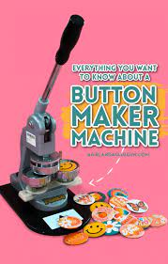

Button-Making Machine | The button-making machine stands as a powerhouse in automating the button-covering process, significantly enhancing efficiency in mass production.  This versatile equipment streamlines the covering of buttons, allowing upholsterers to produce a large quantity with uniform quality.  It is an invaluable tool for projects where speed and consistency are paramount.
Handheld Button-Covering Kits | Compact and versatile, handheld button-covering kits are equipped with interchangeable dies for covering buttons manually.  These kits offer flexibility, making them ideal for small-scale projects or situations where precision and hands-on control are required.  Upholsterers can easily switch between dies, catering to various button sizes and designs.
Button Tufting Machine | Specifically designed to streamline the tufting process, the button tufting machine provides consistent and efficient button attachment for tufted upholstery.  This specialized equipment ensures uniform button placement and depth, contributing to the overall aesthetic appeal of tufted furniture.  It is a time-saving tool that enhances the precision of tufting techniques.
Electric or Pneumatic Staple Gun | The electric or pneumatic staple gun is a versatile tool employed to secure fabric and buttons to the furniture frame rapidly and securely.  Its quick and efficient operation makes it an essential tool in various buttoning processes.  Whether attaching fabric or securing buttons, the staple gun provides a reliable and robust solution, streamlining the upholstery process.

Understanding the distinct uses of these tools and equipment is crucial for upholsterers aiming to achieve efficiency and precision in different buttoning processes. From automating mass production to offering hands-on control in small-scale projects, each tool contributes to the diverse toolkit of an upholsterer, enabling them to bring various buttoning techniques to life with finesse and accuracy.

KT0405 Buttoning material types and their uses.
The selection of buttoning materials plays a pivotal role in shaping the visual and tactile qualities of upholstered furniture. Each material serves a specific purpose in contributing to the overall design, stability, and comfort of buttoned surfaces. This section delves into different types of buttoning materials and their distinct applications in the upholstery craft.

Buttoning Material | Uses
Fabric Covers | Fabric covers are a cornerstone in buttoning applications, wrapping around buttons to seamlessly integrate them with the upholstery.  The choice of fabric cover significantly influences the visual aesthetics of the buttoned surface, allowing upholsterers to match patterns, textures, and colours for a cohesive and harmonious design.  Fabric covers are instrumental in creating a polished and integrated appearance in various buttoning techniques.
Button Backs | Button backs play a crucial role in providing a secure attachment point for buttons.  Ensuring stability and longevity in buttoning applications, these components are often made of metal or plastic and are discreetly positioned beneath the fabric.  The button back, combined with other buttoning materials, contributes to the overall structural integrity of the button, preventing shifting or loosening over time.
Padding Material | Placed beneath fabric-covered buttons, padding materials serve a dual purpose. They enhance the comfort of buttoned surfaces, providing a soft and inviting feel. Additionally, padding contributes to the button's rounded appearance, especially in deep buttoning processes. The choice of padding material influences the tactile experience and visual aesthetics of the upholstered piece.
Thread and Twine | Thread and twine are essential elements for securing buttons to the fabric or furniture frame.  Their primary function is to provide stability in various buttoning processes.  Whether used in tufting, deep buttoning, or other techniques, the quality and strength of thread and twine are critical for ensuring that buttons are securely attached, contributing to the durability of the upholstery.

Understanding the characteristics and applications of these buttoning materials empowers upholsterers to make informed choices in their craft. The synergy between fabric covers, button backs, padding materials, thread, and twine is instrumental in achieving both aesthetic excellence and functional longevity in buttoned upholstery.
KT0406 Concepts and principles of plans to determine the amount of fabric and allowances required for the base cover and for the button covers.
Creating comprehensive plans for fabric and allowances is a foundational step in successful buttoning projects. This section will delve into the key concepts and principles guiding the development of these plans.

Concepts of Fabric and Allowance Plans

Symmetry and Pattern Continuity | Ensuring symmetry in fabric cutting and accounting for pattern continuity ensures a harmonious appearance in buttoned upholstery.
Fabric Grain Direction | Understanding the grain direction of the fabric is crucial for aligning patterns and achieving a cohesive look in button covers and base covers.
Allowances for Seams | Including allowances for seams ensures that fabric pieces can be securely stitched together, preventing distortion in the final upholstered piece.
Button Placement Planning | Strategically planning button placement involves considering both aesthetic preferences and functional requirements, ensuring an even distribution for a balanced design.
Calculating Fabric Yardage | Precise calculation of fabric yardage involves accounting for all components, patterns, and allowances, preventing material shortages and minimising waste.
Consideration of Fabric Width | Factoring in the width of the chosen fabric is essential for optimising material usage and minimizing seams in the upholstery.
Material Compatibility | Ensuring compatibility between the fabric type and buttoning materials contributes to a cohesive appearance and influences the overall durability of the upholstery.
Mock-Up and Prototyping | Creating a mock-up or prototype allows upholsterers to visualize the final product, identify potential challenges, and make adjustments to the fabric and allowance plans before starting the actual buttoning process.

By grasping these concepts and principles, upholsterers can develop meticulous plans that serve as a roadmap for efficient fabric cutting and buttoning. This attention to detail not only enhances the visual appeal of the final upholstery but also contributes to the overall durability and functionality of the finished piece.

Formative assessment

IAC0401 Identify the raw materials and equipment, including needles, twine, foam, drill, and different types of buttons and their component parts.
IAC0402 Identify the parts and explain the relationship between the parts of the button press.
(Weight 25%)

SECTION 5: KM-10-KT05: Buttoning and deep buttoning quality (15%)

Learning Outcome
At the end of this section, learners should cover:

KT0501 Buttoning faults and rectification.
KT0502 Quality issues and problems.
KT0503 Quality faults and operational issues that can be identified during the buttoning process.
KT0504 Deep buttoning faults and rectification.
Achieving impeccable quality in buttoning and deep buttoning is paramount for upholstered furniture that stands the test of time both aesthetically and functionally. This chapter delves into the intricate details of quality standards, covering a spectrum of potential faults and issues that may arise during the buttoning process. Upholsterers, upon completing this chapter, will gain the skills to identify, rectify, and elevate the overall quality of their buttoned upholstery.

KT0501 Buttoning faults and rectification.
Understanding the nuances of buttoning faults is crucial for upholsterers aiming to deliver flawless results. This section explores common issues that may arise during buttoning processes and provides insights into effective rectification methods, ensuring a seamless and visually appealing outcome.
Mastering Buttoning Excellence: Overcoming Common Challenges
Misalignment of Buttons
Issue | Buttons positioned unevenly or crooked.
Rectification | Achieving harmony in button placement is paramount.  Begin by systematically realigning buttons, ensuring consistent spacing and positioning.  Precision is key, so take the time to measure and adjust, creating a visually balanced and symmetrical appearance.

Fabric Wrinkling
Issue | Wrinkles or folds in the fabric around buttons.
Rectification | Fabric wrinkles detract from the overall aesthetic.  To address this, meticulously adjust tension during the buttoning process.  Ensure the fabric is adequately stretched and smoothed, resulting in a taut and flawless finish that accentuates the button design.

Uneven Button Depth
Issue | Buttons not uniformly set to the same depth.
Rectification | Consistency is the cornerstone of buttoning excellence.  Employ a steady and even pressure during the buttoning process to ensure uniform button depth.  Take the time to calibrate equipment and techniques, guaranteeing a polished and professional outcome.

Loose Buttons
Issue | Buttons that are not securely attached.
Rectification | A secure attachment is non-negotiable.  Strengthen the bond between fabric and button by tightening button backs.  Additionally, consider adjusting your buttoning technique to enhance the overall attachment.  A firm and secure button not only contributes to the visual appeal but also ensures durability over time.

By addressing these common buttoning faults with precision and care, upholsterers can elevate their craft and deliver impeccable results. Remember, the key lies in meticulous attention to detail and a commitment to mastering the art of buttoning.

KT0502 Quality issues and problems.
Exploring quality issues in buttoning involves a comprehensive examination of potential problems stemming from resource, raw material, and design challenges. Upholsterers will gain insights into pre-emptive measures to mitigate these issues, fostering a culture of craftsmanship excellence.

Inadequate Resource Planning
Insufficient resources for the intended buttoning project.

Mitigation
Resource planning is the backbone of successful buttoning projects.
Upholsterers need to conduct a thorough assessment before starting any project.
This includes ensuring an adequate supply of fabric, buttons, twine, and any other materials or tools required. By forecasting the needs of the project, upholsterers can prevent delays and interruptions, leading to a smoother workflow and ultimately enhancing the overall quality of the final product.
Consideration should also be given to the workspace, ensuring it is equipped with the necessary tools and equipment.
A well-prepared workspace contributes to efficiency and precision during the buttoning process.

Poor-Quality Raw Materials
Subpar fabric, buttons, or twine impacting overall quality.

Mitigation
The quality of the end product is directly tied to the quality of the raw materials.
Upholsterers should prioritize sourcing materials known for their durability, resilience, and aesthetic appeal.
Thorough quality checks should be conducted before using any raw materials to identify and rectify any defects or inconsistencies.
Building relationships with reliable suppliers who provide high-quality materials is essential.
Regularly updating knowledge on the latest materials available in the market ensures that upholsterers stay ahead in utilizing the best resources for their projects.

Mismatched Design
Design elements that clash or create visual dissonance.

Mitigation
Design plays a pivotal role in the success of a buttoning project.
Upholsterers should invest time in the planning and visualisation stages to ensure a cohesive and visually pleasing design.
This involves careful consideration of the pattern, colour palette, and the placement of buttons.
Prototyping or creating design mock-ups can be valuable in visualising the final outcome and making necessary adjustments before the actual buttoning process begins.
Collaboration with designers or clients can provide additional perspectives and ensure that the final design aligns with the intended aesthetic.

Insufficient Padding
Inadequate or uneven padding beneath the buttons.

Mitigation
Insufficient padding can lead to uneven buttoning and discomfort in the finished piece.
Upholsterers should ensure that padding is evenly distributed and appropriately thick.
Regularly inspect and adjust padding during the buttoning process to maintain a consistent feel and appearance.

Uneven Stitching
Irregular or uneven stitching around buttons.

Mitigation
Inconsistent stitching can detract from the overall quality of the buttoning.
Upholsterers should pay meticulous attention to the stitching process, ensuring it is uniform in tension and spacing.
Regularly check and adjust sewing machines to avoid uneven stitching, and consider using templates or guides for precision.

Colour Fading
Fabric colours fading or changing over time.

Mitigation
The longevity of the buttoned upholstery depends on the colour-fastness of the fabric.
Upholsterers should choose fabrics with high colour-fastness ratings and inform clients about proper care instructions.
Recommending the use of UV-resistant fabrics and advising against prolonged exposure to direct sunlight can help prevent colour fading.

Inadequate Finishing
Poor finishing touches affecting the overall appearance.

Mitigation
A polished and professional finish is crucial for a buttoned piece to shine.
Upholsterers should pay attention to the final details, such as trimming excess fabric, ensuring clean edges, and securing buttons with precision.
Implementing a thorough quality control process at the end of each project helps catch and rectify any finishing issues before delivery.

Insufficient Testing
Overlooking stress testing for durability.

Mitigation
A buttoned piece should withstand regular use without compromising its integrity.
Upholsterers should conduct stress tests, simulating typical wear and tear, to ensure the durability of the buttons, fabric, and overall construction.
This proactive approach helps identify weaknesses and allows for necessary adjustments before the final product reaches the client.
Addressing these additional quality issues demonstrates a comprehensive commitment to excellence in buttoning craftsmanship.
Upholsterers who consistently implement thorough checks and proactive measures are better positioned to deliver enduring and aesthetically pleasing buttoned pieces.

KT0503 Quality faults and operational issues that can be identified during the buttoning process.
Maintaining the highest standards of quality in buttoning processes is essential for upholstered furniture to stand the test of time in both aesthetics and functionality. This section illuminates the potential quality faults and operational challenges that may arise during the buttoning process. Upholsterers will not only gain insights into identifying these issues but also acquire strategies to address them in real-time, ensuring a seamless and error-free workflow.

Machine Malfunctions

Issue | Technical glitches in buttoning machinery.
Resolution | Regular maintenance and troubleshooting protocols to address machinery issues promptly.

Machine malfunctions can disrupt the efficiency of buttoning processes, leading to delays and subpar outcomes. Regular maintenance is crucial to prevent technical glitches. This includes routine checks on buttoning machines, lubrication of moving parts, and timely replacement of worn components. Additionally, establishing a robust troubleshooting protocol enables operators to identify and address issues promptly, minimizing downtime and ensuring a smooth workflow. Investing in advanced machinery with built-in diagnostic features can also enhance the ability to address potential malfunctions in real-time.

Inadequate Training

Issue | Insufficiently trained personnel leading to errors.
Resolution | Invest in comprehensive training programs for the buttoning team to enhance skill sets.

The proficiency of the buttoning team significantly impacts the quality of the final product. Inadequate training can result in errors, affecting the precision and aesthetics of buttoning. Upholsterers must invest in comprehensive training programs that cover the entire buttoning process, from understanding machinery to mastering various buttoning techniques. This includes hands-on training sessions, workshops, and continuous skill development programs. A well-trained team not only reduces errors but also contributes to a more efficient and harmonious workflow.

Lack of Quality Control Measures

Issue | Absence of systematic quality checks during and after buttoning.
Resolution | Implement stringent quality control processes to catch and rectify issues early in the production pipeline.

Quality control is paramount in ensuring that every buttoned piece meets the desired standards. Establishing systematic quality checks at various stages of the buttoning process is essential. This includes inspecting fabric quality, verifying button placement, and assessing overall aesthetics. Implementing a comprehensive checklist for quality control can help catch and rectify issues early in the production pipeline, preventing defective products from reaching the final stages. Regular audits and feedback loops can further refine the quality control process over time.

Fabric Distortion

Issue | Distortion or stretching of fabric during the buttoning process.
Resolution | Fabric distortion can compromise the visual appeal and structural integrity of the buttoned piece. Upholsterers should pay careful attention to the tension applied during the buttoning process. Implementing controlled and even pressure, along with securing the fabric in place, helps prevent distortion. Additionally, using appropriate fabric types that are resilient to stretching and employing techniques such as strategic padding can contribute to minimizing distortion.

Inadequate Workstation Ergonomics

Issue | Uncomfortable or inefficient workstations affecting the buttoning process.
Resolution | Ensuring a comfortable and ergonomic workspace is crucial for the well-being of the buttoning team and the precision of the work. Upholsterers should invest in ergonomic seating, adjustable work surfaces, and adequate lighting. An ergonomic workstation minimizes the risk of repetitive strain injuries, enhances focus, and contributes to a more efficient buttoning process. Regular assessments and adjustments to workstation ergonomics based on feedback from the team can lead to a healthier and more productive work environment.

Material Compatibility Issues

Issue | Compatibility issues between different materials used in buttoning.
Resolution | Using a combination of materials in buttoning, such as fabric, buttons, and twine, requires careful consideration of compatibility. Upholsterers should choose materials that work harmoniously together, both aesthetically and functionally. Conducting compatibility tests before starting a project helps identify potential issues early on. For example, testing how a specific fabric interacts with the chosen buttons or ensuring that the twine used complements the overall design. This proactive approach prevents unexpected issues during the buttoning process.

Addressing these additional challenges ensures a more comprehensive approach to maintaining quality standards and operational efficiency during the buttoning process. Upholsterers who are attuned to these potential issues and implement proactive strategies are better equipped to deliver buttoned pieces that stand out in both aesthetics and functionality.

KT0504 Deep Buttoning Faults and Rectification:
Deep buttoning introduces its unique set of challenges. This section focuses on identifying faults specific to deep buttoning processes and provides effective rectification strategies to maintain the integrity of the design.

Uneven Button Distribution

Issue | Buttons concentrated in specific areas, creating an uneven appearance.
Resolution | Plan button placement strategically, ensuring even distribution across the upholstered surface.

Uneven button distribution can compromise the visual appeal of deep buttoning. Planning the button placement strategically is crucial. This involves creating a well-thought-out template that guides the placement of buttons across the upholstered surface. Upholsterers should consider factors such as furniture design, fabric patterns, and user comfort when planning button distribution. Regularly reviewing and adjusting the template based on these considerations ensures an even and aesthetically pleasing distribution of buttons.
Insufficient Padding:

Issue | Lack of padding resulting in a flat or distorted buttoned appearance.
Resolution | Adequately pad beneath fabric-covered buttons to achieve a rounded and plush outcome.

Insufficient padding can diminish the tactile and visual appeal of deep buttoning. Adequate padding is essential for achieving a rounded and plush appearance in fabric-covered buttons. Upholsterers should carefully select and layer padding materials beneath the fabric to ensure uniform and comfortable buttoned surfaces. Conducting tactile assessments during the buttoning process and adjusting the padding as needed contributes to achieving the desired outcome.

Fabric Puckering

Issue | Fabric gathering or puckering around buttons.
Resolution | Adjust tension and fabric positioning during the deep buttoning process to eliminate puckering.

Fabric puckering can detract from the polished look of deep buttoning. Adjusting tension and fabric positioning is a nuanced approach to eliminate puckering. Upholsterers should ensure that the fabric is taut and evenly distributed before securing the buttons. Fine-tuning the tension on the buttoning machine and maintaining consistent fabric positioning throughout the process are key aspects of rectifying and preventing puckering issues.

This section serves as a guide, equipping upholsterers with the knowledge and skills needed to uphold the highest standards of quality in buttoning and deep buttoning. By systematically addressing potential faults and operational challenges, craftsmen can ensure that their buttoned upholstery not only meets but exceeds expectations in terms of durability, aesthetics, and overall excellence.

Formative assessment

IAC0501 Describe quality faults that can be identified during the process, including problems with resources, raw materials and design.
IAC0502 Identification and rectification of deep buttoning faults and how to correct these.
(Weight 15%)

Provider Programme Accreditation Criteria
Physical Requirements:
The provider must have lesson plans and structured learning material or provide learners with access to structured learning material that addresses all the topics in all the knowledge modules.
Human Resource Requirements:
Lecturer/learner ratio of 1:20.
Qualifications of lecturers: 5 years relevant experience or NQF 2 58227 with 2 years of experience.
Legal Requirements:
OHS compliant.
Exemptions
No exemptions, but the module can be achieved in full through a normal RPL process.

