

FURNITURE UPHOLSTERER

KM11 UPHOLSTERED FURNITURE AND PROTOTYPE MAKING PRINCIPLES

LEARNER GUIDE

Upholstered Furniture and Prototype Making Principles

LEARNER GUIDE

Module | KM-11
NQF Level | 4
Notional hours | 130
Credit(s) | 13
Curriculum Code | 683401000
SAQA QUAL ID | 103199
Qualification Title | Occupational Certificate: Furniture Upholsterer NQF Level 4, Credits 549

LEARNER CONTACT INFORMATION:

Name
Contact Address
Telephone (H)
Telephone (W)
Cellular

TABLE OF CONTENTS

PURPOSE OF THE QUALIFICATION 5
QUALIFICATION RULES 7
EXIT LEVEL OUTCOMES 10
ENTRY REQUIREMENTS: 12
ARTICULATION OPTIONS 13
ASSESSMENT REQUIREMENTS 14
INTRODUCTION 16
KM-11-KT01: Furniture and upholstered furniture (20%) 19
KT0101 Origin of furniture 21
KT0102 Furniture types and styles 24
KT0103 Uses and functionality 31
KT0104 Major factors that influenced change in furniture design and manufacturing processes 33
KT0105 Traditional and modern upholstered furniture materials and technologies 39
Internal Assessment Criteria 44
KM-11-KT02: Upholstered furniture manufacturing processes (30%) 45
INTRODUCTION 45
KT0201 Principles and concepts of the upholstered furniture value chain. 47
KT0202 General principles (i.e. product viability and sustainability) 50
KT0204 Definitions and terminology used in the process 54
KT0205 Upholstered furniture manufacturing process and production flow 64
KT0206 Process flow charts 66
KT0207 Manufacturing process problems, constraints and their implications 70
Internal Assessment Criteria 72
KM-11-KT03: Standards, quality and science 73
(50%) 73
INTRODUCTION 73
KT0301: Principles and Concepts of Science and Standards Associated with Health, Safety, and Ergonomics 74
KT0301 Principles and concepts of science and standards associated with health, safety and ergonomics 75
KT0302 International and national standard setting bodies 78
KT0303 Principles and concepts of scientific testing 80
KT0304 Concepts of tolerances and making allowances when pattern making 82
KT0305 Principles of standard dimensions 84
KT0306 Principles of industry and workplace quality specifications 89
Internal Assessment Criteria 94
Formative Assessment 95

PURPOSE OF THE QUALIFICATION

Purpose:
The purpose of this qualification is to equip a learner with knowledge, skills and competencies to perform duties as a Furniture Upholsterer.

A Furniture Upholsterer manufactures an upholstered furnishing item by fitting suspension and padding and covering a frame to give it shape, comfort, and functionality for a range of domestic, commercial and decorative uses.

A qualified learner will be able to:
- Read and interpret a design, drawing or sketch and take accurate measurements and calculate/estimate the number of fabrics, leather, man-made fabrics, padding and other raw material such as springs and webbing.
- Make upholstery patterns and produce templates from sketches, customer descriptions or blueprints which match all quality standards.
- Lay out, measure, cut and sew upholstery materials following patterns, templates, sketches, or design specifications.
- Interpret specifications and prepare foundations for upholstered frames by attaching webbing, springs, foam and/or padding securely to the frame.
- Fit slipcovers and loose material panels to cover frames with materials using staples, tacks and/or glue.
- Manufacture upholstered furniture, upholstery prototypes and repair and re-upholster damaged furniture.

Rationale:

This qualification will equip learners with the necessary skills and competencies to operate as upholsterers by applying upholstery skills to fit springs, webbing, padding and covering a wide range of objects covered with fabric, leather, rexine or other upholstery material. After successful completion of this qualification, the learner will be skilled and capable of creating ergonomic and comfortable furniture using both traditional and modern techniques, materials and fabrics to produce aesthetically pleasing and fit for purpose consumer products.

Learners will find employment as frame preparers, cover fitters, patternmakers and furniture finishers, upholsterers or upholstery prototype makers and upholstery repairers. These skills will also open opportunities for self-employment.

Target groups identified include school leavers with a National Qualifications Framework (NQF) Level 2 qualification or persons who have been working in the furniture industry without formal qualifications and have the desire to formalise their skills and knowledge.

Employers will benefit from appointing qualified workers in terms of increased productivity and ability to be competitive in the international market and seek markets abroad supplying quality upholstered furniture and furnishings.

QUALIFICATION RULES

This qualification is made up of the following compulsory Knowledge, Practical Skill and Workplace Learning Modules:

Knowledge Modules:
- 683401000-KM-01, Basic Principles for Manufacturing of Upholstered Furniture, NQF Level 2, Credits 4
- 683401000-KM-02, Upholstered furniture frame preparation, NQF Level 2, Credits 8
- 683401000-KM-03, Upholstered Furniture Basic Cover Fitting, NQF Level 2, Credits 8
- 683401000-KM-04, Advanced Upholstery Furniture Technology, NQF Level 3, Credits 2
- 683401000-KM-05, Upholstery Pattern and Template Making Principles, Methods and Equipment, NQF Level 3, Credits 5
- 683401000-KM-06, Cutting Lay Requirements for Upholstery Fabrics and Materials, NQF Level 3, Credits 3
- 683401000-KM-07, Advanced Covering Techniques for Complex and Exposed Frames, NQF Level 3, Credits 4
- 683401000-KM-08, Advanced Complex Covers for Upholstery, NQF Level 3, Credits 4
- 683401000-KM-09, Complex Shaped Cushions and Padded Items, NQF Level 3, Credits 2
- 683401000-KM-10, Deep Buttoning of Upholstered Furniture, NQF Level 3, Credits 5
- 683401000-KM-11, Upholstered Furniture and Prototype Making Principles, NQF Level 4, Credits 13
- 683401000-KM-12, Raw Materials, Consumables, Tools and Equipment Used in Manufacturing of Upholstered Furniture Prototypes, NQF Level 4, Credits 8
- 683401000-KM-13, Manufacturing Principles and Processes for Upholstered Furniture Prototype Manufacturing and Reengineering, NQF Level 4, Credits 17
- 683401000-KM-14, Cutting and Sewing of Fabric and Material for Upholstered Furniture Prototypes, NQF Level 2, Credits 10
- 683401000-KM-15, Cover Making and Covering Methods for Upholstered Furniture Prototypes and Repairs, NQF Level 4, Credits 15
- 683401000-KM-16, Technical Specifications and Configuration of Upholstery Production Equipment for Manufacturing, NQF Level 4, Credits 10
- 683401000-KM-17, Communication and Interpersonal Relations in the Workplace, NQF Level 4, Credits 7
- 683401000-KM-18, Leadership and supervision in the upholstery departments, NQF Level 3, Credits 4
Total number of credits for Knowledge Modules: 129

Practical Skill Modules:
- 683401000-PM-01, Prepare Foundations for Upholstered Frames, NQF Level 2, Credits 20
- 683401000-PM-02, Cover Prepared Upholstered Frames with Fabric and Other Materials, NQF Level 2, Credits 20
- 683401000-PM-03, Perform Advanced Covering Operations for Complex and Exposed Frames, NQF Level 3, Credits 10
- 683401000-PM-04, Perform Deep Buttoning Procedures to Decorate Upholstered Furniture, NQF Level 3, Credits 10
- 683401000-PM-05, Produce Cutting Lay Requirements for Cutting of Upholstered Cover Components, NQF Level 3, Credits 4
- 683401000-PM-06, Produce upholstery patterns and templates for the upholstery frame preparation and cutting departments, NQF Level 3, Credits 16
- 683401000-PM-07, Lay Out, Measure, Cut and Sew Upholstery Materials According to Templates or Specifications and Optimising Material Usage, NQF Level 2, Credits 20
- 683401000-PM-08, Manufacture Upholstery Bespoke Furniture or Prototypes for Bulk Production, NQF Level 4, Credits 30
- 683401000-PM-09, Repair and Re-Upholster Upholstery Furniture, NQF Level 4, Credits 10
- 683401000-PM-10, Inspect Upholstery Furniture During Various Stages of the Manufacturing Process to Ensure Conformance to Quality Standards, NQF Level 4, Credits 15
- 683401000-PM-11, Reengineer Upholstery Furniture Products to Address Development or Manufacturing Defects, NQF Level 4, Credits 15
- 683401000-PM-12, Develop Technical Specifications and Line Setup Requirements for Manufacturing of Upholstery Furniture, NQF Level 4, Credits 15
- 683401000-PM-13, Guide Teams in the Upholstery Manufacturing Departments to Achieve Set Targets and Outputs, NQF Level 3, Credits 4
Total number of credits for Practical Skill Modules: 189

Work Experience Modules:
- 683401000-WM-01, Upholstery Furniture Frame Preparation Processes, NQF Level 2, Credits 24
- 683401000-WM-02, Upholstery Furniture Frame Cover Fitting Processes, NQF Level 2, Credits 24
- 683401000-WM-03, Upholstery Pattern and Template Making Processes, NQF Level 3, Credits 15
- 683401000-WM-04, Upholstery Cutting Lay Preparation, NQF Level 3, Credits 10
- 683401000-WM-05, Advanced Upholstery Covering Processes, NQF Level 3, Credits 25
- 683401000-WM-06, Material Cutting and Sewing Processes for Upholstery Prototypes or Bespoke Furniture, NQF Level 2, Credits 24
- 683401000-WM-07, Bespoke Upholstery Furniture and/or Upholstery Prototypes Manufacturing and Reparations, NQF Level 4, Credits 56
- 683401000-WM-08, Furniture Re-upholstery Department, NQF Level 4, Credits 17
- 683401000-WM-09, Upholstery Furniture Technical Specifications and Re-engineering, NQF Level 4, Credits 20
- 683401000-WM-10, Supervision in the Upholstery Department, NQF Level 4, Credits 16
Total number of credits for Work Experience Modules: 231

EXIT LEVEL OUTCOMES

- Interpret drawings and product specifications and compile a list of materials and consumables for upholstery of furniture.
- Prepare upholstery frame for final covering by hand-building the suspension of the frame applying safety procedures and conduct a quality inspection.
- Fit and attach prepared covers and loose material panels onto prepared upholstery frames using staples, tacks and/or glue.
- Produce a cutting lay for upholstery cover components by considering optimal use of material and cut and sew upholstery components to specifications.
- Upholster furniture by fitting and attaching upholstery covers to complex and exposed prepared upholstery frames using hand and power tools.
- Demonstrate an understanding and knowledge of the manufacturing of upholstery furniture.

Occupation Regulation
All trades are regulated by the Department of Higher Education and Training (DHET) through the National Artisan Moderation Body (NAMB). To become a qualified artisan you have to pass a trade test at a national trade test centre that is accredited by the Quality Council for Trades and Occupations (QCTO). All national trade test centres are quality assured and recommended for accreditation by the NAMB.

ENTRY REQUIREMENTS:

Recognition of Prior Learning (RPL):
RPL for access to the external integrated summative assessment:
Accredited providers and approved workplaces must apply the internal assessment criteria specified in the related curriculum document to establish and confirm prior learning. Accredited providers and workplaces must confirm prior learning by issuing a statement of result or certifying a work experience record.

RPL for access to the qualification:
Accredited providers and approved workplaces may recognise prior learning against the relevant access requirements.

Entry Requirements:
NQF Level 1 qualification with Mathematics.

ARTICULATION OPTIONS

Horizontal Articulation:
Further Education and Training Certificate: Craft Enterprise, Level 4.

Vertical Articulation:
National Certificate: N4 Textiles, Level 5.

ASSESSMENT REQUIREMENTS

Integrated Formative Assessment:
The skills development provider will use the curriculum to guide them on the stipulated internal assessment criteria and weighting. They will also apply the scope of practical skills and applied knowledge as stipulated by the internal assessment criteria. This formative assessment leads to entrance into the integrated external summative assessment.

Integrated Summative Assessment:
An external integrated summative assessment, conducted through the relevant QCTO Assessment Quality partner is required for the issuing of this qualification. The external integrated summative assessment will focus on the exit level outcomes and associated assessment criteria. The external assessment model requires that the external assessment will be conducted through a combination of a written assessment and practical task at an accredited trade test centre. The written examination will be concluded at an accredited trade test centre and marked by registered assessors. Practical tasks will also be assessed by registered assessors. The combination of the written and practical assessment will be conducted over a period of two working days.

Provider Programme Accreditation Criteria

Physical Requirements:

- The provider must have lesson plans and structured learning material or provide learners with access to structured learning material that addresses all the topics in all the knowledge modules.

Human Resource Requirements:
- Lecturer/learner ratio of 1:20.
- Qualifications of lecturers: 5 years relevant experience or NQF 2 58227 with 2 years of experience

Legal Requirements:
- OHS compliant

Exemptions
- No exemptions, but the module can be achieved in full through a normal RPL process

TOPIC ELEMENTS TO BE COVERED INCLUDE:

Purpose of the Knowledge Modules

The main focus of the learning in this knowledge module is to build an understanding of upholstery design, construction specifications, materials, equipment and production techniques associated with preparing an upholstered furniture frame for covering by hand building the suspension.

The learning will enable learners to demonstrate an understanding of:

- KM-11-KT01: Furniture and upholstered furniture (20%)
- KM-11-KT02: Upholstered furniture manufacturing processes (30%)
- KM-11-KT03: Standards, quality and science (50%)

INTRODUCTION
Introduction to Knowledge Module KM-11: Upholstered Furniture and Prototype Making Principles
Welcome to Knowledge Module KM-11, an essential component of your learning journey, focused on the intricate world of Upholstered Furniture and Prototype Making Principles. This module is meticulously designed to provide a comprehensive understanding of not just the art and science behind upholstered furniture but also the manufacturing processes and quality standards that define this sector.

KM-11-KT01: Furniture and Upholstered Furniture (20%)
The first topic delves into the realm of furniture, with a specific emphasis on upholstered varieties. It aims to explore the historical evolution, design philosophies, and the diversity of materials used in upholstered furniture. This segment serves as an introduction to the broader context of furniture making, setting a foundation for understanding how upholstered furniture stands apart in terms of design, comfort, and functionality.

KM-11-KT02: Upholstered Furniture Manufacturing Processes (30%)
In this section, we will navigate through the detailed processes involved in manufacturing upholstered furniture. From initial design concepts to the final product, this topic covers various stages such as frame construction, padding, and fabric selection. A key aspect of this topic is understanding the interplay between craftsmanship and technology in modern manufacturing, including emerging trends and sustainability practices in the industry.

KM-11-KT03: Standards, Quality, and Science (50%)
The final topic, which forms the crux of this module, emphasises the standards, quality control, and scientific principles underpinning upholstered furniture production. It will guide you through international standards and regulations that govern this sector, ensuring safety, durability, and consumer satisfaction. This segment also delves into the scientific aspects of material properties, ergonomics, and environmental considerations, providing a holistic view of the product lifecycle and its impact.

Throughout KM-11, we will employ a variety of learning methods, including case studies, practical workshops, and interactive sessions, ensuring that theoretical knowledge is complemented with real-world applications. This approach is in line with our commitment to cater to diverse learning styles and to foster a deeper understanding of the subject matter.

As we embark on this journey through KM-11, we encourage you to actively engage with the content, challenge assumptions, and bring your unique perspectives to the discussions. This module is not just about acquiring knowledge; it's about shaping your ability to innovate and think critically in the field of upholstered furniture and prototype making.

We look forward to a fruitful learning experience together.

KM-11-KT01: Furniture and upholstered furniture (20%)

Learning Outcome

At the end of this section, learners should cover:

- KT0101 Origin of furniture.
- KT0102 Furniture types and styles.
- KT0103 Uses and functionality.
- KT0104 Major factors that influenced change in furniture design and manufacturing processes.
- KT0105 Traditional and modern upholstered furniture materials and technologies.

INTRODUCTION

Welcome to the first segment of our Knowledge Module KM-11, titled "Furniture and Upholstered Furniture." This topic is thoughtfully crafted to deepen your understanding of the rich history, diverse styles, and evolving functionalities of both general and upholstered furniture. It is designed to provide a comprehensive overview, covering the essential elements that have shaped the furniture industry from its inception to the present day.

KT0101: Origin of Furniture

We embark on our journey with a historical exploration into the origin of furniture. This element will transport you back in time to understand how early human civilisations first began to create furniture, tracing its evolution through various historical periods. You'll discover how cultural, social, and technological developments have influenced furniture design, providing context for today’s trends and practices.

KT0102: Furniture Types and Styles

In this section, we delve into the myriad of furniture types and styles that have emerged over the centuries. From the opulent designs of the Renaissance to the minimalistic trends of modern times, this element provides a panoramic view of the aesthetic and functional aspects that define different furniture styles. It is an invitation to appreciate the diversity and artistry embedded in furniture design.

KT0103: Uses and Functionality

The third element focuses on the uses and functionality of furniture, emphasising its role beyond mere aesthetic appeal. We explore how furniture meets various human needs – from comfort to utility – and how its design is influenced by these requirements. This segment underscores the importance of ergonomics, space optimisation, and adaptability in contemporary furniture design.

KT0104: Major Factors that Influenced Change in Furniture Design and Manufacturing Processes

Here, we examine the key factors that have driven change in furniture design and manufacturing processes over time. This includes technological advancements, changes in consumer tastes, economic factors, and environmental concerns. Understanding these dynamics is crucial for grasping how current practices in furniture design and production have been shaped.

KT0105: Traditional and Modern Upholstered Furniture Materials and Technologies

The final element of this topic is a comprehensive overview of the materials and technologies used in traditional and modern upholstered furniture. From classic materials like wood and metal to innovative, sustainable options, this section offers insight into how material choices impact the aesthetics, comfort, and durability of upholstered furniture. It also covers the technological advancements that have revolutionised upholstery techniques.

Throughout KM-11-KT01, we encourage you to engage with the content critically, drawing connections between past and present, and considering future implications in the world of furniture and upholstery. This journey is not just about learning facts; it's about developing a nuanced understanding of how furniture, as an integral part of our lives, reflects and shapes our society.

We look forward to exploring this fascinating topic with you.

KT0101 Origin of furniture

The origin of furniture is as ancient as human civilisation itself, intertwined with the evolution of societies, cultures, and technologies. This element aims to provide a comprehensive understanding of how furniture has evolved from rudimentary objects to sophisticated designs, reflecting the sociocultural and technological advancements of different eras.

Early Beginnings

- Prehistoric Period: The earliest forms of furniture can be traced back to the Neolithic Period (10,000 – 2,000 BC), where excavations have revealed stone furniture such as beds, cupboards, and seats.

- Ancient Civilisations: The Egyptians (3100 – 332 BC) are known for their advancements in furniture making. They used wood, a scarce resource in Egypt, to craft elaborate pieces, signifying wealth and status. Examples include stools, beds raised off the ground, and chests.

Classical Antiquity

- Greek and Roman Influences: The Greeks (8th Century – 146 BC) introduced a variety of furniture forms, including the klismos chair and the kline (a type of daybed). The Romans (753 BC – 476 AD) further developed these designs, incorporating luxury materials and detailed ornamentation, reflecting their wealth and love for opulence.

The Middle Ages

- Medieval Furniture: During the Middle Ages (5th – 15th Century), furniture was primarily functional, with a focus on large, heavy, and dark pieces. Craftsmanship was robust, with a lesser emphasis on comfort or aesthetics. This period saw the development of joinery as a key technique in furniture construction.

Renaissance and Beyond

- Renaissance (14th – 17th Century): Marked a return to classical influences, featuring ornate designs and an emphasis on artistry. Furniture became a symbol of status and wealth.

- Baroque (17th Century): Characterised by dramatic, intricate, and ornamental designs, reflecting the grandeur of the period.

- Rococo (18th Century): A move towards lighter, more graceful furniture with asymmetrical designs, pastel colours, and intricate inlays.

Industrial Revolution to Modern Day

- 19th Century: The Industrial Revolution brought about mass production of furniture, making it more accessible. There was a shift from handcrafted to machine-made furniture.

- 20th Century and Beyond: Marked by diversity in styles, including Art Nouveau, Art Deco, Modernism, and Postmodernism. Designers began experimenting with new materials like plastic, metal, and glass, paving the way for contemporary furniture design.

The history of furniture is a reflection of human ingenuity and creativity. From the stone beds of the Neolithic era to the sleek, functional designs of the 21st century, furniture has continually evolved to meet the changing needs and tastes of society. Understanding this rich history not only provides insight into past lifestyles and cultures but also offers valuable lessons for contemporary and future furniture design. It highlights the importance of materials, craftsmanship, functionality, and aesthetics, elements that remain crucial in furniture design today.

As we move forward, it is essential to appreciate how past innovations and cultural shifts continue to influence modern furniture design. By examining the origin and evolution of furniture, we gain a deeper understanding of our relationship with the objects that populate our living spaces, shaping our daily lives and reflecting the ever-changing tapestry of human civilisation.

This exploration into the origin of furniture sets the stage for a more detailed examination of specific types, styles, and functionalities as we progress through the subsequent elements of this Knowledge Module. It is an invitation to view furniture not merely as utilitarian objects but as a rich tapestry woven through the fabric of human history, art, and culture.

We hope this journey through the origin of furniture will inspire you to view these everyday objects with a renewed sense of appreciation and curiosity.

KT0102 Furniture types and styles

This element of the Knowledge Module KM-11 offers an in-depth exploration of the various types and styles of furniture that have emerged over the centuries. Understanding these distinct styles not only enhances our appreciation of furniture design but also provides valuable insights into the cultural and historical contexts in which these styles evolved.

Influential Furniture Designers and Trends

The evolution of furniture design has been significantly influenced by various designers and trends across the globe. Each has contributed unique styles and innovations, reflecting cultural, historical, and aesthetic values. This section explores some of the most influential furniture designers and trends from different regions, highlighting their respective impacts and contributions to the field.

British Furniture Design

- Tudor Style: Characterised by heavy, ornate, and dark wood furniture. Influenced by Gothic and medieval styles, Tudor furniture is known for its robust and carved designs, often made from oak.

- Thomas Chippendale: An 18th-century designer, Chippendale is renowned for his distinct style that blends Rococo, Gothic, and Chinese influences. His work is synonymous with elegance and fine craftsmanship.

- Art Nouveau in Britain: British Art Nouveau furniture, part of a broader artistic movement, featured flowing lines and organic forms, often inspired by natural elements.

French Furniture Design

- Louis XIV Style: Symbolising absolute power, the Louis XIV style is lavish and grand, with extensive use of gilding, marquetry, and classical motifs.

- Art Deco: Originating in France, Art Deco furniture featured bold geometric shapes, rich colours, and luxurious materials, reflecting the opulence of the era.

- Le Corbusier: A pioneer of modern architecture, Le Corbusier's furniture designs were functional, simple, and emphasised comfort and practicality.

- Thonet: Michael Thonet, known for his bentwood furniture, revolutionised furniture manufacturing with his techniques, particularly the iconic café chairs.

Italian Furniture Design

- Gio Ponti: An influential mid-20th-century designer, Ponti's work is characterised by its lightness, use of vibrant colours, and innovative forms. His designs bridged tradition and modernity.

Scandinavian Furniture Design

- Gustavian Style: Originating in Sweden, this style is known for its simplicity, light colours, and neoclassical influences. It reflects a blend of elegance and functionality.

German Furniture Design

- Bauhaus: The Bauhaus school in Germany emphasised the unity of art, craft, and technology. Bauhaus furniture is famous for its functionality, clean lines, and the use of industrial materials like steel and glass.

American Furniture Design

- Campaign Furniture: Developed for military campaigns, this furniture was portable and collapsible, combining functionality with elegance.

- Charles and Ray Eames: Among the most famous American designers of the 20th century, their work is noted for its innovative use of materials like plywood and fibreglass.

- Quaker Furniture: Known for its simplicity, utility, and fine craftsmanship, reflective of the Quaker values of modesty and functionality.

African Furniture Design

- African furniture design is diverse, reflecting the continent's rich cultural heritage. It often features intricate carvings, bold geometric patterns, and the use of indigenous materials. While less documented in mainstream design history, African furniture has influenced contemporary design with its focus on sustainable materials and artisanal craftsmanship.

African furniture design is a rich and diverse field, deeply rooted in the continent's vast cultural and artistic heritage. Unlike the more documented Western furniture design history, African furniture often reflects a blend of functionality, cultural symbolism, and artisanal craftsmanship. It is a realm where furniture is not just a utilitarian object but a canvas for expressing cultural identity, social status, and artistic values.

Historical and Cultural Context

- African furniture design varies significantly across different regions, each with its own unique styles, materials, and techniques. These variations are influenced by local cultures, histories, and available resources.

- Historically, furniture in many African societies was associated with royalty and the elite. For example, in West Africa, intricately carved stools and chairs were often symbols of power and were used in ceremonial contexts.

- The design often incorporates motifs and symbolism that are significant in local cultures. These can represent beliefs, myths, or social values.

Materials and Techniques

- Traditional African furniture is characterised by the use of natural and locally sourced materials such as wood, bamboo, reeds, animal hides, and various fibres.

- Woodworking and carving are significant aspects of African furniture design. Artisans often use hand tools to create intricate patterns and detailed carvings.

- In many African cultures, the process of making furniture is not just a craft but also an art form, where each piece tells a story or conveys a message.

Contemporary African Furniture Design

- Contemporary African designers are blending traditional techniques with modern aesthetics, creating pieces that appeal to a global market while retaining a distinctly African identity.

- There is a growing focus on sustainability and eco-friendly practices in African furniture design. Designers are increasingly using recycled materials and focusing on environmentally sustainable methods.

- The global exposure of African design is increasing, with designers and pieces being featured in international exhibitions and design shows.

Influential African Designers and Trends

- Designers like Hamed Ouattara from Burkina Faso and Cheick Diallo from Mali are known for their innovative use of materials and modern interpretations of traditional forms.

- South African designers often incorporate vibrant colours and patterns, reflecting the country's diverse cultural landscape. Pieces often feature geometric patterns, beadwork, and bold colour palettes.

- The use of metalwork in furniture, a tradition in parts of North Africa, continues to influence modern designs, with designers creating pieces that combine metal with other materials like wood and glass.

African furniture design is a testament to the continent's rich artistic and cultural heritage. It stands out for its use of natural materials, craftsmanship, and meaningful designs that go beyond aesthetics. As the world becomes increasingly globalised, African furniture design continues to gain recognition for its unique blend of tradition and innovation, sustainability, and expressive storytelling through design.

Understanding and appreciating this design ethos provides a broader perspective on the diversity and depth of global furniture design.

These designers and trends have each contributed uniquely to the evolution of furniture design. From the opulence of Louis XIV to the minimalist functionality of Bauhaus, and from Chippendale's elegance to the innovative use of materials by the Eames, each has left an indelible mark on the world of furniture. Understanding their influences helps in appreciating the diversity and richness of furniture design and its ongoing evolution.

Types of Furniture

- Seating: Includes chairs, stools, sofas, benches, and ottomans. Each has evolved in design, form, and comfort to cater to various needs, from formal seating like dining chairs to more relaxed forms like armchairs and chaises.

- Surfaces: Encompasses tables, desks, and counters. These vary greatly in sise, shape, and purpose, from functional dining tables to decorative coffee tables.

- Storage: Includes cabinets, wardrobes, dressers, and shelves. These pieces are designed to organise and store items, evolving in style and functionality to suit different spaces and needs.

Styles of Furniture

- Classical Styles:

- Ancient Egyptian Style: Characterised by sturdy construction with a focus on luxury materials like gold, ivory, and ebony.
- Greek and Roman Styles: Known for their emphasis on symmetry, proportion, and the use of columns and motifs like acanthus leaves.

- Medieval Style: Functional and robust, with minimal decoration. Common materials were oak and iron.

- Renaissance: Marked a return to classical ideals with more ornate and symmetrical designs. It featured intricate carvings and rich materials.

Baroque and Rococo:

- Baroque Style: Characterised by dramatic, bold, and opulent designs, often with elaborate carvings and gilding.
- Rococo Style: More playful and ornate, with asymmetrical designs, pastel colours, and an emphasis on lightness and grace.

- Neoclassical Style: A revival of classical motifs, emphasising elegance and simplicity, with straight lines and minimal ornamentation.

19th Century Styles:

- Victorian Style: Known for its excessive ornamentation, heavy proportions, and dark woods.
- Arts and Crafts Movement: Reacted against industrial mass production, emphasising handcrafted pieces and natural materials.

Modern and Contemporary Styles:

- Art Nouveau and Art Deco: Art Nouveau featured organic, flowing lines, while Art Deco was known for its bold geometric patterns and lavish ornamentation.

- Mid-Century Modern: Characterised by clean lines, organic forms, and minimal ornamentation, focusing on functionality and simplicity.

- Contemporary Style: Reflects current trends, often featuring a blend of styles with an emphasis on form, colour, and texture.

Each furniture style reflects the cultural, social, and technological contexts of its time. From the opulent designs of the Baroque period to the minimalist trends of contemporary design, furniture styles not only fulfil functional needs but also serve as expressions of artistic movements and societal changes.

As we delve deeper into these styles, it is important to consider how historical trends influence contemporary design and how modern innovations might shape the future of furniture design. This exploration into furniture types and styles is not just an academic exercise; it is a journey through the history of human creativity and ingenuity, manifested in the everyday objects that surround us.

We look forward to your engagement with this rich and diverse topic.

KT0103 Uses and functionality

Knowledge Topic Element KT0103: Uses and Functionality in Furniture Upholstery

In this segment of the Knowledge Module KM-11, we explore the diverse uses and functionality of upholstered furniture, a critical aspect of understanding its design and production. This topic is designed to provide a holistic view of how the practical application and functionality of upholstered furniture play a vital role in both residential and commercial settings.

Understanding the Purpose of Upholstered Furniture

- Comfort and Ergonomics: The primary function of upholstered furniture is to provide comfort. This involves ergonomic design to support the body correctly, reducing strain and enhancing relaxation.

- Aesthetic Appeal: Upholstery contributes significantly to the aesthetic value of furniture. It allows for a range of design choices through textures, colours, and patterns, enabling furniture to complement or enhance interior design schemes.

Types and Their Functionalities

- Sofas and Couches: Designed for seating multiple people, they are central to living areas and reception spaces. Variations like sectional sofas and loveseats cater to different space sizes and user needs.

- Armchairs and Recliners: Provide individual seating with a focus on comfort. Recliners add an extra level of functionality with adjustable positions.

- Ottomans and Poufs: Often used as footrests or additional seating, they also serve as decorative elements and, in some cases, storage solutions.

- Dining Chairs: Combine comfort with durability, designed to be used for extended periods during meals and gatherings.

- Office Chairs: Focus heavily on ergonomics and adjustability to accommodate long hours of use in work environments.

- Beds and Headboards: Upholstered beds and headboards offer both comfort and an aesthetic focal point in bedrooms.

Specialised Uses

- Commercial Furniture: In commercial spaces like hotels and offices, upholstery must meet specific standards for durability and fire safety, besides providing comfort and style.

- Outdoor Furniture: Requires weather-resistant upholstery, balancing comfort with resilience to environmental elements.

- Healthcare and Institutional Furniture: In these settings, upholstery must meet stringent hygiene and durability standards, often utilising specialised materials.

Technological Advancements and Sustainability

- Innovations: Advances in materials and manufacturing processes have expanded functionality. Memory foam, for instance, offers enhanced comfort and support.

- Sustainable Practices: There's a growing emphasis on using eco-friendly materials and sustainable production methods in upholstery, aligning with environmental consciousness.

The uses and functionality of upholstered furniture are as varied as they are essential. This element of the course provides a comprehensive understanding of how different types of upholstered furniture cater to specific needs, environments, and aesthetic preferences. It highlights the importance of considering various factors like ergonomics, material choice, and the intended use environment in the design and production of upholstered furniture.

Through this exploration, we aim to deepen your appreciation and understanding of the practical aspects of upholstered furniture, equipping you with the knowledge to make informed decisions in both design and manufacturing processes.

We look forward to further exploring these aspects with you.

KT0104 Major factors that influenced change in furniture design and manufacturing processes

Knowledge Topic Element KT0104: Major Factors that Influenced Change in Furniture Design and Manufacturing Processes

In this critical section of our Knowledge Module KM-11, we delve into the major factors that have influenced change in furniture design and manufacturing processes. Understanding these factors is vital to comprehend how the furniture industry has evolved, adapting to technological advancements, cultural shifts, and consumer preferences.

Socio-Economic Developments and Their Influence on Furniture Design (1800 - 1941)

The 19th and early 20th centuries were periods of profound change and innovation in furniture design, influenced by major socio-economic developments. This era was marked by the growth of the middle class, significant artistic movements, and technological advancements that collectively transformed the world of furniture design and manufacturing.

Growth of the Middle Classes in Europe and America

- During the 19th century, the rapid expansion of the middle class in Europe and America led to an increased demand for furniture. This emerging class sought pieces that were both stylish and affordable.

- The middle class's desire for accessibility and practicality in furniture design encouraged the production of simpler, less expensive, and more functional pieces, moving away from the ornate styles favoured by the aristocracy.

Arts and Crafts Movement

- Originating in Britain during the late 19th century, the Arts and Crafts Movement was a response to the perceived decline in standards resulting from industrial mass production. It advocated for a return to handcrafted artisanship.

- This movement emphasised the inherent beauty of natural materials and the importance of craftsmanship. Furniture designs from this period were characterised by their simplicity, utility, and honesty in construction.

Impact of the Victorian Era

- The Victorian Era (1837 - 1901) was a time of ornate and elaborate designs. Furniture was often heavy, intricately carved, and made from dark woods.

- This era also saw a proliferation of new styles and designs, catering to the eclectic tastes of the Victorian middle class, such as Gothic Revival and Rococo Revival.

The Industrial Revolution

- The Industrial Revolution had a transformative impact on furniture making. Mass production techniques developed during this period allowed for the creation of furniture at a scale and affordability previously unattainable.

- This period also witnessed the introduction of new materials and methods, such as bentwood and the use of cast iron in furniture.

Art Nouveau, Bauhaus, and Art Deco Movements

- Art Nouveau (1890 - 1910): This movement was known for its organic, flowing lines inspired by natural forms. Furniture designs were characterised by elegant, curved lines and often incorporated motifs from nature.

- Bauhaus (1919 - 1933): Emerging in Germany, the Bauhaus movement emphasised functionality and simplicity, with a focus on rationality and the integration of art, craft, and technology.

- Art Deco (1920s - 1940s): This style was famous for its luxury and glamour, featuring geometric shapes, symmetry, and bold colours. Furniture pieces were often made of expensive materials like ebony, marble, and ivory.

Technological Advancements

- The period between the world wars saw significant technological advancements in furniture manufacturing. The introduction of dowels, fibreboard, and plywood, along with standardised board sizes, revolutionised the industry.



- These materials allowed for greater flexibility in design and more efficient production methods. Plywood, for instance, was used extensively in the creation of curved and moulded forms, which were popular in modern furniture design.

The period from 1800 to 1941 was a time of dynamic change in furniture design, reflecting broader socio-economic trends. The growth of the middle class, coupled with artistic movements and technological innovations, significantly influenced the aesthetics, materials, and production methods of furniture, laying the groundwork for modern furniture design. Understanding these developments provides a comprehensive backdrop against which the evolution of furniture design can be appreciated.

Cultural and Social Influences

- Artistic Movements: Artistic movements such as Art Nouveau, Art Deco, and Modernism have significantly influenced furniture design, introducing new aesthetics and forms.

- Social Changes: Shifts in societal norms and lifestyles, like the rise in urban living and smaller living spaces, have led to changes in furniture design, emphasising functionality and space efficiency.

Technological Advancements

- Industrial Revolution: The advent of the Industrial Revolution was a turning point, introducing mass production techniques. This allowed for the production of furniture at a scale and cost that made it accessible to a broader segment of society.

- Material Innovations: The development of new materials like plastics, engineered wood, and advanced textiles has expanded the possibilities in furniture design, offering durability, affordability, and versatility.

Economic Factors

- Globalisation: The globalisation of markets has had a profound impact on furniture manufacturing, with increased competition leading to innovations in design and production efficiency.

- Consumer Demand: Economic trends influence consumer purchasing power and demand, leading to shifts in furniture styles and manufacturing practices to meet changing consumer preferences.

Environmental Awareness

- Sustainability: Growing awareness of environmental issues has led to a focus on sustainable and eco-friendly materials and production processes in furniture design.

- Recycling and Upcycling: The trends of recycling and upcycling have influenced furniture design, encouraging the use of reclaimed materials and the repurposing of existing furniture.

Ergonomics and Human-Centred Design

- Ergonomic Research: Advances in understanding human ergonomics have influenced furniture design, focusing on user comfort and health.

- Inclusive Design: There is an increasing emphasis on creating furniture that is accessible and usable by people of all abilities, reflecting a shift towards inclusive design.

Technological Integration

- Smart Furniture: The integration of technology into furniture, such as built-in charging ports or smart home compatibility, reflects the ongoing fusion of technology and furniture design.



The factors influencing change in furniture design and manufacturing are diverse and interlinked, reflecting broader trends in technology, society, culture, and the environment. By examining these influences, we gain a comprehensive understanding of the dynamic nature of the furniture industry and its continuous evolution.

This exploration equips you with a deeper appreciation of the context behind contemporary furniture design and manufacturing, encouraging a forward-thinking approach in your future endeavours in this field.

We look forward to further discussing these fascinating developments with you.

KT0105 Traditional and modern upholstered furniture materials and technologies

Knowledge Topic Element KT0105: Traditional and Modern Upholstered Furniture Materials and Technologies

In this segment of the Knowledge Module KM-11, we will explore the materials and technologies that have been integral to the evolution of traditional and modern upholstered furniture. This component is crucial for understanding how the choice of materials and the adoption of new technologies have shaped the aesthetics, functionality, and sustainability of upholstered furniture over time.

The Age of Modernism (1942 - Present Day) and Technological Innovations in Furniture Design

The Age of Modernism, spanning from 1942 to the present day, represents a significant shift in furniture design, influenced by changing socio-economic conditions and advancements in technology. This era is marked by a focus on functionality, simplicity, and the use of new materials and production techniques. Central to this transformation has been the role of technological innovations like Computer-Aided Design (CAD), Computer-Aided Manufacturing (CAM), and Computer Numerically Controlled (CNC) machines, which have reshaped how furniture is designed, manufactured, and consumed.

Socio-Economic Changes and Psycho-Physical Needs

- Post-World War II, there was a significant demand for affordable and functional furniture due to the economic constraints and the need for efficient housing solutions. This period also saw a shift in consumer preferences towards minimalist and practical designs.

- The psycho-physical needs of consumers began receiving more attention, with an emphasis on ergonomic design to improve comfort and prevent health issues related to furniture use.

- Additionally, the well-being of factory workers became a priority, with a focus on creating safer work environments and reducing the physical strain associated with furniture production.

Impact of CAD and CAM

- Computer-Aided Design (CAD): CAD technology revolutionised the furniture design process. It allowed designers to create precise and detailed models of furniture pieces, experiment with different materials and styles, and visualise the final product before the manufacturing process began.

- Computer-Aided Manufacturing (CAM): CAM systems facilitated the efficient translation of CAD designs into manufacturing instructions. This integration streamlined production processes, ensuring consistency and precision in the manufacturing of furniture.

Advancements with CNC Machines

- CNC Machines in Furniture Manufacturing: CNC technology brought a high level of precision and automation to furniture production. These machines could quickly and accurately cut, carve, and shape materials, allowing for complex designs that were difficult to achieve manually.

- Speed and Efficiency: CNC machines significantly sped up the production process, enabling manufacturers to meet the increasing demand for furniture more efficiently.

- Standardisation and Quality Control: The use of CNC technology standardised the quality of furniture pieces, ensuring each item met specific design and quality standards.

- Reducing Repetitive Strain for Workers: By automating repetitive tasks, CNC machines reduced the physical strain on factory workers. This not only improved worker safety and health but also increased productivity and job satisfaction.

Modern Material Use and Sustainability

- The Modernism era also saw the introduction of new, more sustainable materials in furniture manufacturing, aligning with growing environmental concerns.

- Innovations in materials and production processes have allowed for the creation of furniture that is both environmentally friendly and durable, meeting the needs of a more eco-conscious consumer base.

The rise of the Age of Modernism in furniture design is a testament to the profound impact of socio-economic changes and technological advancements. The integration of CAD, CAM, and CNC technologies has revolutionised the way furniture is designed, produced, and experienced. These innovations have not only catered to the evolving needs of consumers and workers but have also paved the way for more sustainable practices in the furniture industry. Understanding these developments provides valuable insights into the future trajectory of furniture design and manufacturing in the modern era.

Traditional Upholstered Furniture Materials

- Natural Fabrics: Traditional upholstery often utilised natural fabrics like cotton, linen, wool, and silk. These materials offered comfort, durability, and a classic aesthetic.

- Leather: Leather has been a staple in upholstery for its durability, ease of cleaning, and the luxury it imparts.

- Horsehair and Cotton Padding: Historically, horsehair was a common filling for upholstered furniture, known for its resilience. Cotton batting later became popular for its softness and comfort.

- Spring Systems: Traditional furniture often used coiled springs for support, which were hand-tied to the furniture frame for stability and comfort.

Modern Upholstered Furniture Materials

- Synthetic Fabrics: The advent of synthetic fabrics like polyester, nylon, and microfiber brought about a revolution in upholstery. These materials offer enhanced durability, stain resistance, and a vast range of textures and colours.

- Faux Leather and Vegan Alternatives: With rising ethical and environmental concerns, faux leather and other vegan materials have become popular, offering the look and feel of leather without using animal products.

- Foam and Memory Foam: Polyurethane foam and memory foam are now widely used for cushioning due to their flexibility, comfort, and ability to retain shape.

- Webbing and Elastic Belts: Modern upholstered furniture often uses webbing or elastic belts for support, which are easier to install and maintain compared to traditional spring systems.

Technological Advancements in Upholstery

- Computer-Aided Design (CAD): CAD technology has revolutionised furniture design, allowing for precise modelling, visualisation, and modification of furniture designs before production.



- CNC Machinery: Computer Numerical Control (CNC) machinery has improved the precision and efficiency of cutting and shaping furniture frames.

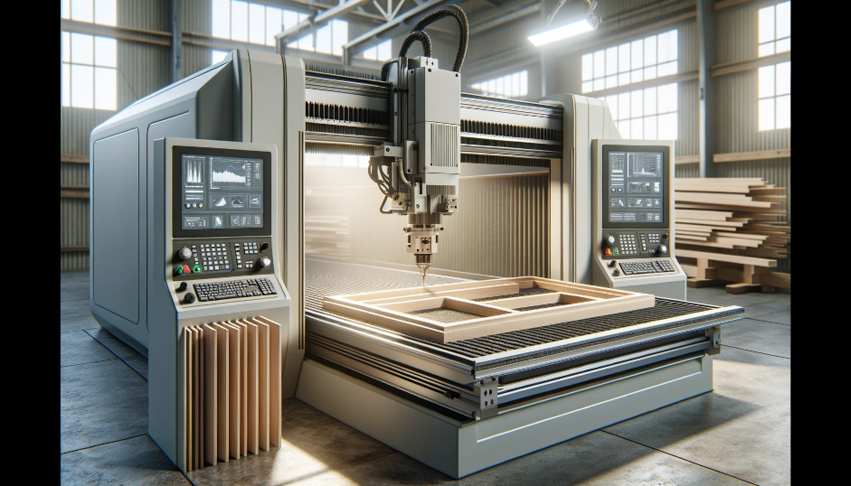

- 3D Printing: Emerging technologies like 3D printing are beginning to find applications in creating customised furniture components and accessories.

- Sustainable Technologies: There is an increasing focus on developing sustainable manufacturing processes and materials, including recycled fabrics and eco-friendly foam alternatives.

The journey from traditional to modern upholstered furniture is marked by a constant interplay between material innovation and technological advancement. This evolution reflects not only changes in aesthetic preferences and functional requirements but also a growing consciousness about environmental impact and sustainability.

Understanding these materials and technologies provides a comprehensive backdrop against which modern upholstery can be appreciated and further innovated. It highlights the importance of material selection and technology in creating furniture that is not only comfortable and beautiful but also sustainable and responsive to the needs of contemporary life.

We look forward to delving deeper into these materials and technologies with you, enhancing your knowledge and skills in the field of furniture upholstery.

Internal Assessment Criteria

- IAC0101 Types of furniture are described with reference to their function and the main materials they are constructed from, including examples of solid wood furniture, furniture made from composite board products, joinery products, domestic, and office, commercial and outdoor furniture.
- IAC0102 The major socio-economic developments that influenced furniture design in the 19th and mid-20th centuries (1800 - 1941), with reference to the growth of the middle classes in Europe and America, Arts and Crafts Movement, impact of the Victorian Era and the Industrial Revolution on the furniture designer-maker, the period before World War I and the Art Nouveau, Bauhaus, and Art Deco movements, and new technologies like dowels, fibreboard and plywood and standard board sises introduced between the world wars (1918 -1938) are listed and described.
- IAC0103 The rise of the Age of Modernism (1942 - present day) and explain how socio-economic and psycho-physical needs of consumers and factory workers are met by technological innovations such as computer aided design (CAD), and computer aided manufacturing (CAM) with computer numerically controlled (CNC) machines to speed up production, standardise quality, and remove repetitive movements that cause harm to workers is described.
- IAC0104 Identify influential furniture designers and trends, including but not limited to: British (Tudor, Thomas Chippendale, Art Nouveau), French (Louis XIV, Art Deco, Le Corbusier, Thonet), Italian (Gio Ponti), Scandinavian (Gustavian), German (Bauhaus), American (Campaign furniture, Charles and Ray Eames, Quaker), African are listed and their respective influences are compared.
- IAC0105 Traditional and modern raw materials used to construct upholstered furniture foundations (coir, hessian webbing, straw, horse hair, helical springs, no-sag / sig sag springs, foam, riempie), and covers (natural, synthetic) are compared.
(Weight 20%)

KM-11-KT02: Upholstered furniture manufacturing processes (30%)

Learning Outcome
At the end of this section, learners should cover:

- KT0201 Principles and concepts of the upholstered furniture value chain.
- KT0202 General principles (i.e. product viability and sustainability).
- KT0203 Concepts of upholstered furniture design construction design and components.
- KT0204 Definitions and terminology used in the process.
- KT0205 Upholstered furniture manufacturing process and production flow.
- KT0206 Process flow charts.
- KT0207 Manufacturing process problems, constraints and their implications.

INTRODUCTION
Introduction to Knowledge Module Topic KT02: Upholstered Furniture Manufacturing Processes

Welcome to Knowledge Module Topic KT02, an integral part of your learning journey that delves into the fascinating world of upholstered furniture manufacturing processes. This module has been thoughtfully designed to provide a comprehensive understanding of the entire lifecycle of upholstered furniture production, from conceptualisation to the final product. It aims to equip you with the knowledge and skills necessary to navigate and innovate within this dynamic field.

KT0201: Principles and Concepts of the Upholstered Furniture Value Chain
We begin by exploring the upholstered furniture value chain, which encompasses the entire journey of a piece of furniture from the initial design concept through to its manufacture and eventual delivery to the consumer. This element will provide you with an understanding of how each stage in the value chain adds to the final product's quality, functionality, and aesthetic appeal.

KT0202: General Principles (Product Viability and Sustainability)
Here, we will delve into the general principles guiding upholstered furniture manufacturing, focusing on product viability and sustainability. This includes considerations of material choices, production techniques, and the lifecycle of products, ensuring that they not only meet market demands but do so in an environmentally responsible and sustainable manner.

KT0203: Concepts of Upholstered Furniture Design, Construction Design, and Components
In this section, we will dissect the concepts behind the design and construction of upholstered furniture. It covers everything from the basic components like frames, springs, padding, and fabric, to more complex considerations in design and construction that determine the furniture's final look, feel, and durability.

KT0204: Definitions and Terminology Used in the Process
A clear understanding of the specific definitions and terminology used in the upholstered furniture manufacturing process is crucial. This element of the module will provide you with a comprehensive glossary of terms, ensuring that you are well-versed in the language of the industry.

KT0205: Upholstered Furniture Manufacturing Process and Production Flow
This part of the module delves into the heart of the manufacturing process, outlining each step in the production flow of upholstered furniture. It provides an in-depth look at how different elements of design and construction come together in a cohesive manufacturing process.

KT0206: Process Flow Charts
Visual representations in the form of process flow charts will be utilised to illustrate the steps involved in the production of upholstered furniture. These charts will help in visualising the sequence of operations and the interdependencies among different stages of the manufacturing process.

KT0207: Manufacturing Process Problems, Constraints, and their Implications
Finally, we will address the potential problems and constraints that can arise during the manufacturing process, along with their implications. This includes common challenges such as material shortages, quality control issues, and production bottlenecks. Understanding these challenges is essential for troubleshooting and ensuring the smooth operation of the manufacturing process.

As we embark on this journey through KT02, we encourage you to engage actively with the content, question the established norms, and think creatively about how you can contribute to the evolution of upholstered furniture manufacturing. This module is not only about understanding the current processes but also about envisioning and shaping the future of upholstered furniture production.

KT0201 Principles and concepts of the upholstered furniture value chain.

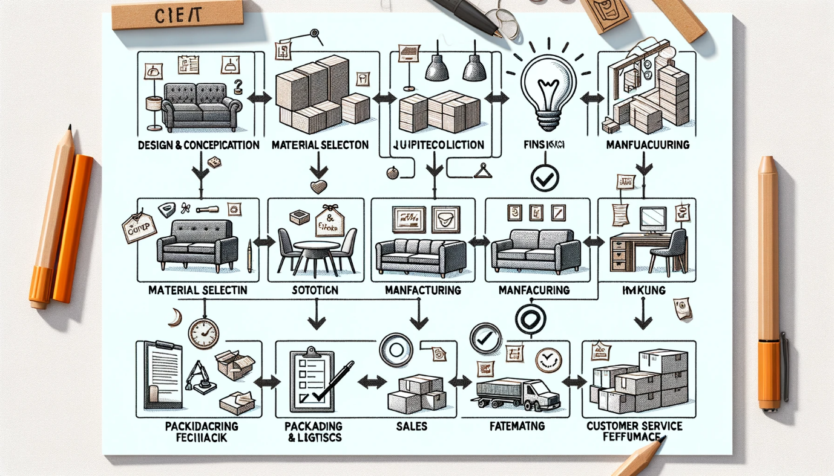

The upholstered furniture value chain encompasses a series of steps from the initial concept of a furniture piece to its final delivery to the consumer. Understanding this value chain is crucial for appreciating the complexity and intricacy involved in creating upholstered furniture. Here we outline and sketch the primary stages of this value chain, highlighting key principles and concepts at each stage.

1. Design and Conceptualisation

- Stage Description: This initial stage involves ideation, where designers conceptualise the furniture's style, function, and ergonomics. Factors such as market trends, customer needs, and design innovation are considered.
- Key Concepts: Creativity, market research, functionality, aesthetics.
- Sketch Element: Idea generation, sketches of designs, mood boards.

2. Material Selection

- Stage Description: Selecting the right materials is crucial for durability, comfort, and appearance. This includes choosing woods for frames, types of springs, foam, fabrics, and other upholstery materials.
- Key Concepts: Sustainability, quality, cost-effectiveness, material properties.
- Sketch Element: Samples of materials, charts comparing material properties.

3. Prototyping and Testing

- Stage Description: Prototypes are created based on the initial designs. These prototypes undergo various tests to assess comfort, durability, and aesthetics.
- Key Concepts: Prototyping, testing for durability and comfort, design refinement.
- Sketch Element: Prototype models, testing processes.

4. Manufacturing

- Stage Description: This is the production phase where the furniture is assembled and upholstered. It involves cutting and joining the frame, installing springs, adding padding and upholstery.
- Key Concepts: Manufacturing processes, quality control, craftsmanship.
- Sketch Element: Assembly line, craftsmen at work.

5. Quality Assurance

- Stage Description: Each piece of furniture undergoes quality checks to ensure it meets the set standards and specifications.
- Key Concepts: Quality control, compliance with standards, defect identification.
- Sketch Element: Inspection checklists, quality control in progress.

6. Packaging and Logistics

- Stage Description: Once approved, the furniture is packaged and prepared for shipping. Logistics involves planning the delivery to retailers or directly to customers.
- Key Concepts: Packaging for safety, logistics planning, transportation.
- Sketch Element: Packaged products, logistics flow charts.

7. Sales and Marketing

- Stage Description: This involves the marketing and selling of the final product to retailers or consumers. Strategies include advertising, showroom display, and e-commerce platforms.
- Key Concepts: Marketing strategies, sales channels, customer engagement.
- Sketch Element: Marketing campaign material, sales distribution channels.

8. Customer Service and Feedback

- Stage Description: Post-sale, customer service plays a vital role in addressing any issues and gathering feedback for future improvements.
- Key Concepts: Customer support, feedback collection, continuous improvement.
- Sketch Element: Customer service interactions, feedback loop diagrams.

Conclusion

The upholstered furniture value chain is a complex and multifaceted process, involving a range of activities from creative design to customer satisfaction. Each stage is interdependent, contributing to the overall quality and appeal of the final product. Understanding this value chain is essential for anyone involved in the upholstered furniture industry, as it provides insights into the various factors that contribute to creating a successful furniture piece. This knowledge is not just about production efficiency but also about meeting customer expectations and adapting to evolving market trends.

KT0202 General principles (i.e. product viability and sustainability)

In the realm of upholstered furniture manufacturing, the concepts of product viability and sustainability are paramount. This section of the Knowledge Module not only explores these principles but also lists and defines key industry-accepted terms related to these concepts.

Product Viability in Upholstered Furniture

Product viability refers to the capability of upholstered furniture to be successfully produced, marketed, and sold in a competitive market while meeting customer needs and expectations.

Key Components of Product Viability:

1. Market Demand Analysis: Understanding customer preferences, trends, and market gaps.

2. Design Feasibility: Ensuring that the design is practical, aesthetically pleasing, and meets ergonomic standards.

3. Cost-Effectiveness: Balancing quality and cost in materials and manufacturing to ensure the product is affordable to the target market.

4. Quality Assurance: Implementing rigorous quality checks to ensure durability and customer satisfaction.

5. Compliance: Adhering to industry standards and regulations related to furniture manufacturing.

Sustainability in Upholstered Furniture

Sustainability in upholstered furniture manufacturing is about minimising the environmental impact through eco-friendly practices and promoting social responsibility throughout the production process.

Key Aspects of Sustainability:

1. Material Sourcing: Using sustainable or recycled materials like eco-friendly fabrics and sustainably sourced wood.

2. Manufacturing Processes: Implementing energy-efficient manufacturing processes and reducing waste.

3. Product Lifecycle: Designing furniture for durability, repairability, and eventual recyclability.

4. Carbon Footprint: Measures to reduce the carbon footprint of manufacturing and distribution processes.

5. Social Responsibility: Ensuring fair labour practices and contributing positively to the communities involved in the manufacturing process.

Industry Accepted Terms and Definitions

1. Life Cycle Assessment (LCA): A technique to assess environmental impacts associated with all stages of a product's life from raw material extraction through materials processing, manufacture, distribution, use, repair and maintenance, and disposal or recycling.
2. Ergonomics: The study of people's efficiency in their working environment, especially applied to the design of products to optimise human well-being and overall system performance.

3. Carbon Footprint: The total amount of greenhouse gases produced to directly and indirectly support human activities, usually expressed in equivalent tons of carbon dioxide (CO2).

4. Cradle-to-Cradle Design: A biomimetic approach to the design of products and systems that models human industry on nature's processes, where materials are viewed as nutrients circulating in healthy, safe metabolisms.

5. Green Manufacturing: A method of manufacturing that minimises waste and pollution achieved through product and process design.

6. Fair Trade: A trading partnership, based on dialogue, transparency, and respect, that seeks greater equity in international trade. It contributes to sustainable development by offering better trading conditions to, and securing the rights of, marginalised producers and workers.

Understanding the general principles of product viability and sustainability is crucial in upholstered furniture manufacturing. It is not only about creating a product that meets market demands but also about doing so in a way that is sustainable and responsible. The industry terms provided are fundamental to grasping these concepts and applying them effectively in the furniture manufacturing process. This knowledge serves as a basis for developing practices that are not only economically viable but also environmentally and socially responsible, ensuring the long-term sustainability of the upholstered furniture industry.
KT0203 Concepts of upholstered furniture design construction design and components

This segment of the Knowledge Module focuses on the key concepts, design elements, and components involved in the construction of upholstered furniture. Understanding these elements is crucial for anyone involved in the design, manufacturing, or retailing of upholstered furniture.

Upholstered Furniture Frames

1. Simple Frame: Refers to basic furniture frames, typically consisting of four legs and a straightforward structural design. These are often found in standard chairs and sofas without complex contours or shapes.

2. Complex Frame: Involves intricate designs, often with curves, carvings, or additional structural elements. These frames require advanced woodworking skills and are typically used in high-end furniture pieces.

3. Motion Furniture Frame: Specifically designed for furniture that incorporates movement, such as recliners or sofa beds. These frames include mechanisms that allow parts of the furniture to move or adjust.

Foundations

1. Spring System: Integral to the support and comfort of upholstered furniture. Types include:
- Coil Springs: Traditional spring system known for durability and support.
- Sinuous Springs (No-sag Springs): S-shaped springs commonly used in modern furniture for a balance of support and comfort.

2. Webbing: A system of woven strips (often made of jute, nylon, or rubber) used to provide support in the seating area. It's a more cost-effective alternative to spring systems.

3. Foam Padding: Various densities and types of foam are used to provide comfort and shape to the furniture. High-density foam is often used for its durability and comfort.

Covers

1. Natural Fabrics: Include cotton, linen, wool, and silk. These fabrics offer comfort and a classic aesthetic but can vary in durability and maintenance requirements.

2. Synthetic Fabrics: Such as polyester, nylon, and microfiber, are popular for their durability and ease of maintenance.

3. Leather: A premium covering material known for its durability, ease of cleaning, and luxury appeal.

Additional Components

1. Show Wood: Exposed wood parts of the furniture, such as legs, arms, or decorative trim. These parts are often crafted with attention to detail and finished to enhance the overall aesthetic of the piece.

2. Fully Upholstered: Furniture where all visible parts, including the frame, are covered with upholstery material. This style offers a cohesive and often more contemporary look.

Definitions and Abbreviations

- Frame (Fr): The structural skeleton of the furniture piece.
- Spring System (SS): The component within the furniture that provides support and comfort.
- Webbing (Web): Alternative to spring systems, used for support in seating.
- Foam Padding (FP): Used for cushioning and shaping upholstered furniture.
- Natural Fabric (NF): Coverings made from organic fibres.
- Synthetic Fabric (SF): Man-made fabric coverings.
- Leather (Lthr): A high-quality, durable covering material.

Understanding these components and their abbreviations is essential in upholstered furniture design and construction. Each element plays a crucial role in the overall functionality, comfort, and aesthetic of the furniture piece. Knowledge of these terms and concepts is vital for effective communication and collaboration among designers, manufacturers, and retailers in the upholstered furniture industry.

KT0204 Definitions and terminology used in the process

In the realm of furniture manufacturing, it is crucial to understand the various processes involved in crafting different types of furniture. These processes are often distinguished by their unique characteristics, materials, and methods. In this module, we will delve into the definitions and terminology used to identify and differentiate the manufacturing processes for various types of furniture, including show wood, simple frame, fully upholstered, complex frame, and motion furniture. We will also utilise flow diagrams to provide a visual representation of these processes.

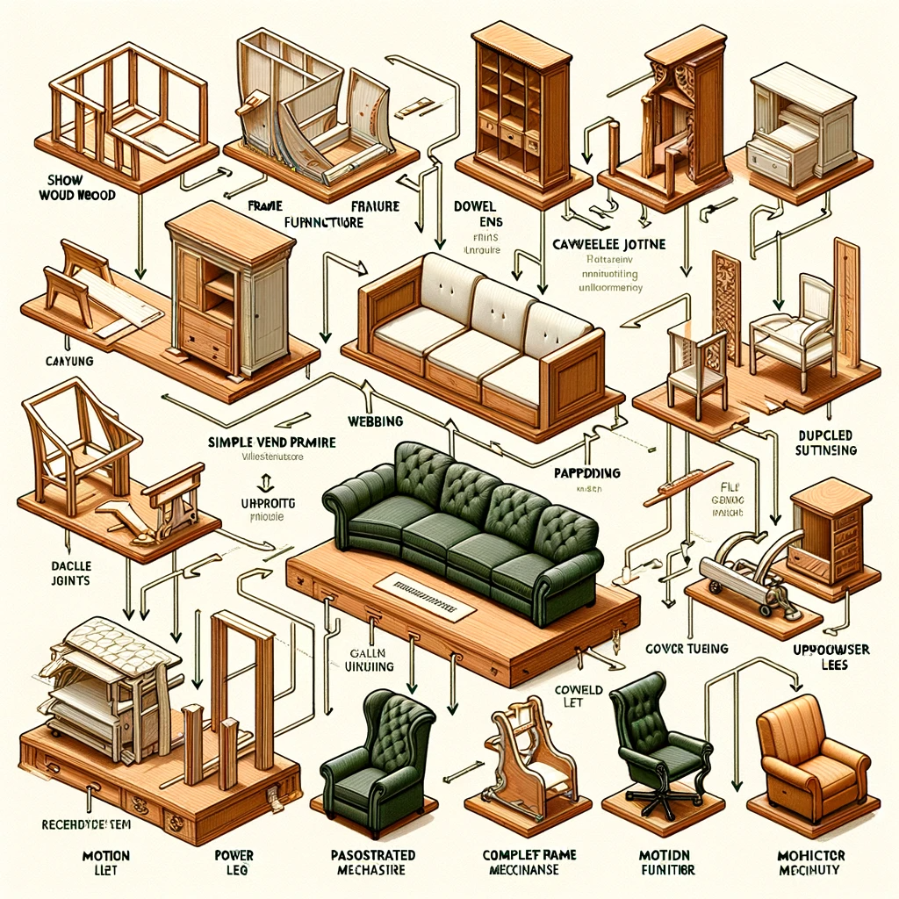

1. Show Wood Furniture:

Definition: Show wood furniture is characterised by its prominent wooden elements that are exposed and visible in the final product. These wooden components are often intricately designed and serve both decorative and structural purposes.

Terminology:
- Frame: The wooden framework that provides the structural support for the piece.
- Veneer: Thin slices of wood used to cover surfaces for aesthetic appeal.
- Finish: The final coating or treatment applied to protect and enhance the wood's appearance.

2. Simple Frame Furniture:

Definition: Simple frame furniture relies on a basic wooden frame as its core structure. The focus is on functionality and simplicity, with minimal decorative elements.

Terminology:
- Dowel Joints: Wooden pegs used to join frame components securely.
- Upholstery: The process of covering the frame with fabric or padding materials.
- Webbing: Straps or webbed material used to provide support under cushions.

3. Fully Upholstered Furniture:

Definition: Fully upholstered furniture is characterised by its complete covering with fabric or leather, concealing the frame entirely. Comfort and aesthetics play a significant role in this type of furniture.

Terminology:
- Padding: Soft materials such as foam or batting used to provide cushioning.
- Welt: A cord or fabric strip that conceals seams and adds a decorative element.
- Tufting: A decorative technique that creates patterns of depressions or buttons on the upholstery.

4. Complex Frame Furniture:

Definition: Complex frame furniture incorporates intricate wooden structures in its design, often featuring detailed carvings and ornate elements.

Terminology:
- Cabriole Leg: A curved leg with an upper convex and lower concave curve.
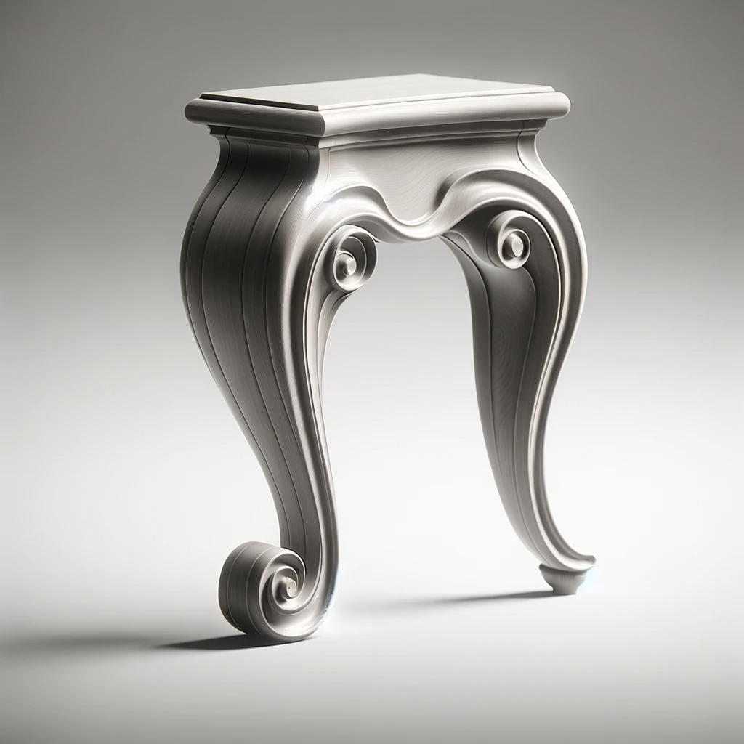

- Marquetry: The art of inlaying wood with decorative patterns or designs.

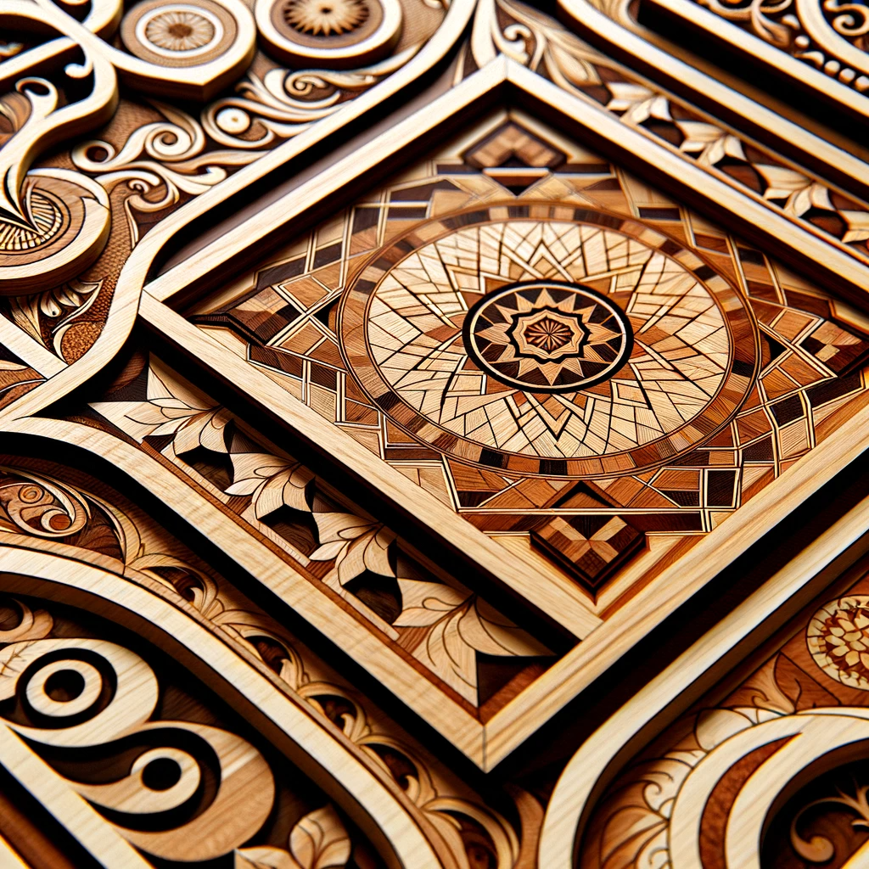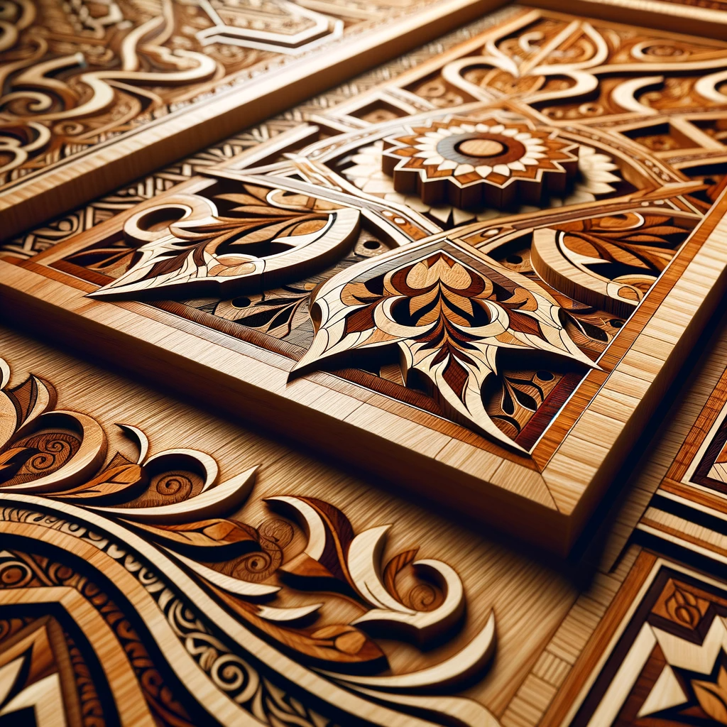

- Scrollwork: Elaborate, scrolling decorative motifs often found on arms and backs.

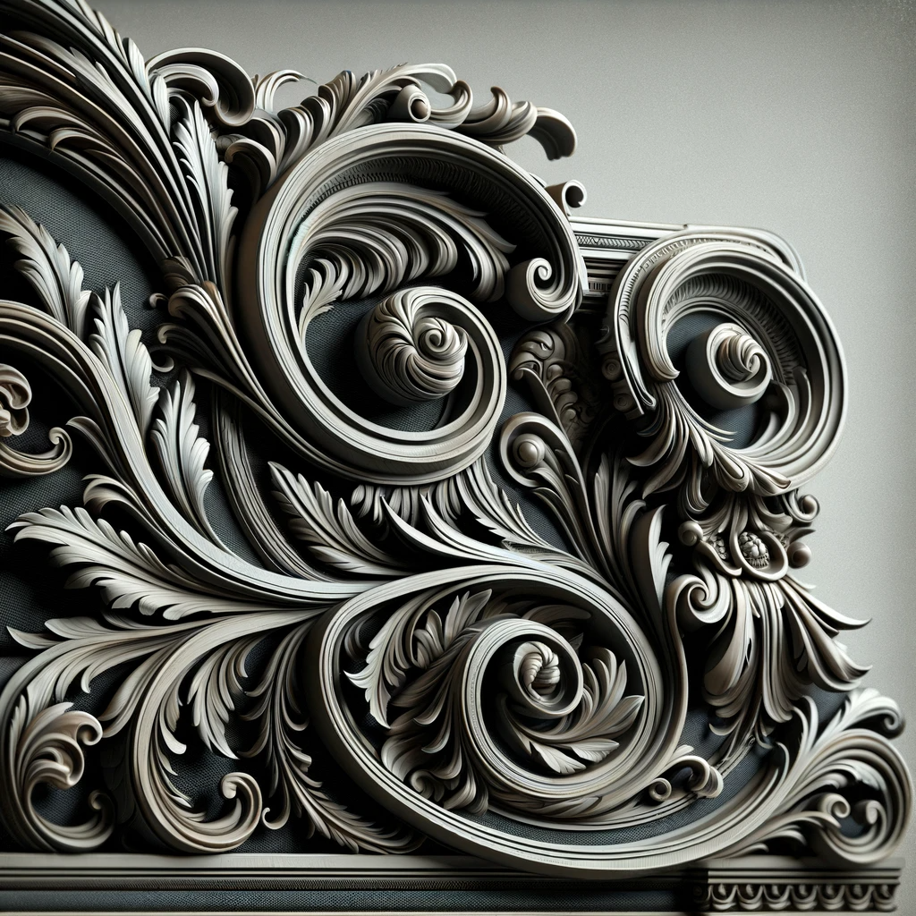
5. Motion Furniture:

Definition: Motion furniture includes pieces that have adjustable or reclining features for added comfort and functionality.

Terminology:
- Recliner Mechanism: The system that allows the furniture to recline.
- Power Lift: A motorised system that helps users stand up from the seated position.
- Glider: Furniture that moves back and forth in a controlled manner.

Flow Diagram:

To visually distinguish these manufacturing processes, consider the following flow diagram:

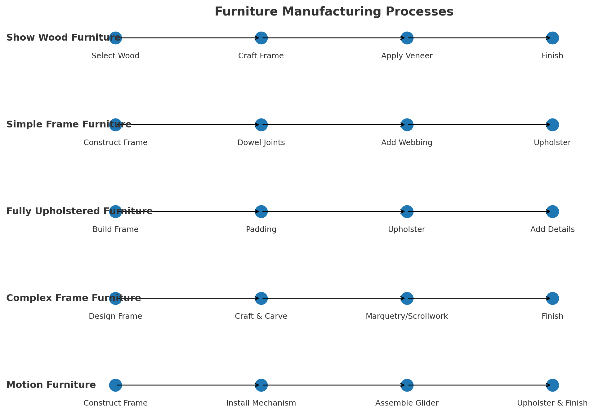

In conclusion, understanding the definitions and terminology related to different furniture manufacturing processes is essential for anyone involved in the industry. Whether you are a designer, manufacturer, or consumer, this knowledge enables you to appreciate the craftsmanship and functionality of furniture while making informed choices.

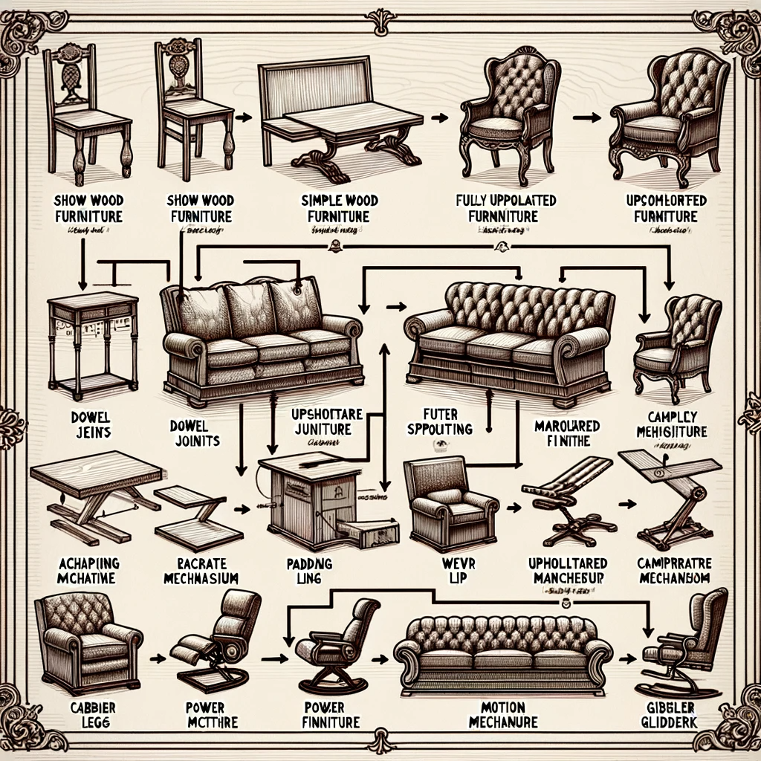

KT0205 Upholstered furniture manufacturing process and production flow

Upholstered furniture manufacturing is a complex and versatile industry that encompasses various processes to create comfortable and visually appealing pieces. In this module, we will explore the intricacies of the upholstered furniture manufacturing process while highlighting the key differences between batch manufacturing, mass manufacturing, and customised one-off manufacturing approaches.

Upholstered Furniture Manufacturing Process:

The manufacturing process of upholstered furniture typically follows a series of sequential steps to transform raw materials into finished products. These steps include:

1. Frame Construction:
- The creation of the wooden or metal framework that forms the foundation of the piece.
- Joinery techniques such as mortise and tenon, dowel joints, or metal welding may be used.

2. Upholstery Preparation:
- Cutting and shaping the padding materials (foam, batting) to fit the frame.
- Fabric selection and cutting to size.

3. Assembly:
- Combining the frame and upholstery materials.
- Securing the fabric to the frame using staples, glue, or stitching.

4. Detailing and Decoration:
- Adding decorative elements such as tufting, piping, or nailhead trim.
- Applying finishing touches like buttons or embroidery.

5. Quality Control:
- Inspection for defects, ensuring structural integrity and visual appeal.
- Any necessary adjustments or repairs are made at this stage.

6. Finishing:
- Applying a final finish or treatment to the exposed wood or metal components for protection and aesthetics.
- Quality control is repeated to ensure the piece meets standards.

Comparison of Manufacturing Approaches:

1. Batch Manufacturing:

- Definition: Batch manufacturing involves producing a limited quantity of identical or similar furniture pieces at once.
- Advantages:
- Cost-effective for producing multiple pieces with consistent designs.
- Efficient use of resources and labour.
- Challenges:
- Limited customisation options.
- May not accommodate unique customer preferences.

2. Mass Manufacturing:

- Definition: Mass manufacturing is characterised by producing large quantities of identical furniture items using assembly line techniques.
- Advantages:
- High production efficiency and reduced production costs.
- Consistency in design and quality.
- Challenges:
- Limited flexibility for customisation.
- May not cater to niche or specialised markets.

3. Customised One-off Manufacturing:

- Definition: Customised one-off manufacturing focuses on creating unique, made-to-order furniture pieces tailored to individual customer specifications.
- Advantages:
- High degree of personalisation and flexibility.
- Appeals to customers seeking unique designs.
- Challenges:
- Longer production times and potentially higher costs.
- Requires close collaboration with customers to meet their specific requirements.

In the world of upholstered furniture manufacturing, the choice of production approach—whether batch, mass, or customised one-off—depends on various factors such as market demand, customer preferences, and production capacity. Understanding these manufacturing processes and their distinctions is crucial for professionals in the industry, as it enables them to make informed decisions and meet the diverse needs of their clientele.

KT0206 Process flow charts

Process flow charts are invaluable tools for visualising and optimising manufacturing processes. In this module, we will guide you through the process of creating flow charts and demonstrate how to identify and assess problems and constraints within the value chain of furniture upholstery manufacturing.

Creating Process Flow Charts:

Process flow charts, also known as process flow diagrams or workflow diagrams, are graphical representations that outline the sequential steps of a process. Here is a step-by-step guide on how to create them:

1. Define the Process:

- Clearly identify the specific process you want to document. In this case, it is the upholstery manufacturing process for furniture.

2. Identify Key Steps:

- List the critical steps involved in the manufacturing process. Start from the beginning and proceed in a sequential order.

3. Determine the Sequence:

- Arrange the steps in the order in which they occur. Use arrows or connecting lines to show the flow between each step.

4. Add Symbols and Shapes:

- Use standard symbols and shapes to represent various elements in the process. For example, rectangles for processes, diamonds for decision points, and arrows for flow direction.

5. Include Inputs and Outputs:

- Clearly label the inputs (materials, information, etc.) required at each step and the outputs (finished components, data, etc.) generated.

6. Document Details:

- Provide detailed information about each step, including who is responsible, tools or equipment used, and any quality checkpoints.

7. Review and Revise:

- Continuously review the flow chart for accuracy and clarity. Make necessary revisions to improve its comprehensibility.

Identifying Value Chain Problems and Constraints:

In the furniture upholstery value chain, various problems and constraints can impact the manufacturing process. Here are some types of issues you might encounter and their potential impacts:

1. Supply Chain Delays:

- Impact: Delays in receiving raw materials can disrupt production schedules, leading to missed deadlines and increased costs due to rush orders.

2. Quality Control Issues:

- Impact: Poor quality materials or workmanship can result in defective products, leading to increased rework costs, customer dissatisfaction, and potential recalls.

3. Labour Shortages:

- Impact: Insufficient skilled labour can slow down production, delay deliveries, and increase labour costs if overtime is necessary.

4. Equipment Breakdowns:

- Impact: Machinery breakdowns can halt production, resulting in missed deadlines and potential repair or replacement costs.

5. Design Changes:

- Impact: Frequent design changes can lead to confusion, rework, and wasted materials.

6. Market Demand Fluctuations:

- Impact: Rapid shifts in market demand can lead to overproduction or underproduction, impacting inventory management and revenue.

7. Environmental Regulations:

- Impact: Non-compliance with environmental regulations can lead to fines, legal issues, and damage to the company's reputation.

By identifying and assessing these problems and constraints within the value chain, furniture upholstery manufacturers can proactively address and mitigate issues, ensuring smoother operations, cost-efficiency, and higher customer satisfaction.

Creating process flow charts and analysing the value chain for problems and constraints are essential steps in optimising furniture upholstery manufacturing. These practices enhance efficiency, reduce costs, and ensure the delivery of high-quality products to customers.

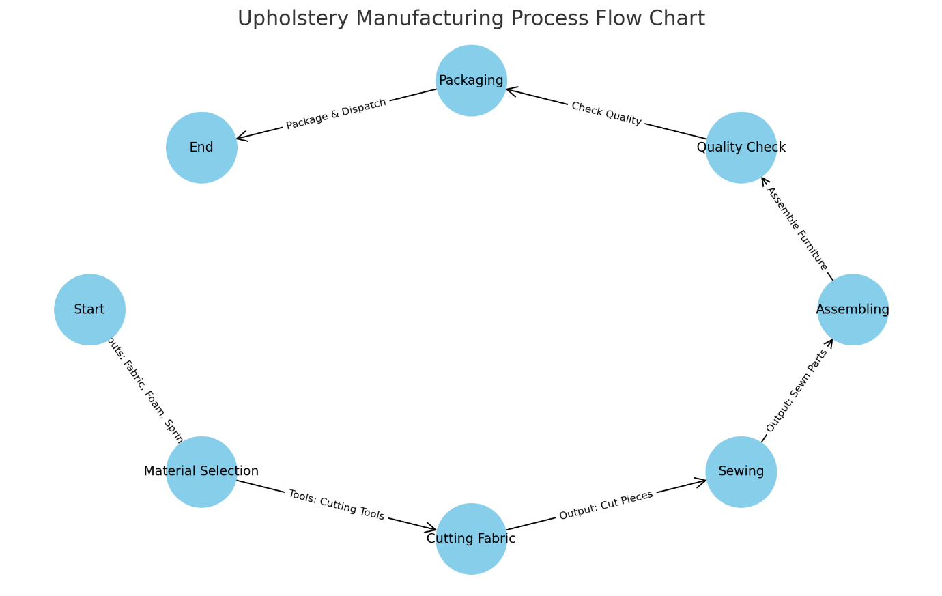

Here is an example flow chart for the upholstery manufacturing process for furniture:

- Start: The process begins.
- Material Selection: Selecting fabric, foam, springs and trims if required
- Cutting Fabric: Using cutting tools to cut the materials into desired shapes.
- Sewing: Sewing the cut pieces of fabric.
- Assembling: Assembling the sewn parts into furniture.
- Quality Check: Checking the quality of the assembled furniture.
- Packaging: Packaging the finished furniture for dispatch.
- End: The process concludes.

Each step is connected in sequence, demonstrating the flow from start to end. Inputs like materials and tools and outputs like cut pieces and sewn parts are labelled on the connecting arrows. This flow chart visually represents the sequential steps involved in upholstery manufacturing, ensuring clarity and efficiency in the process.

🌐 Sources

- [lucidchart.com - How to Make a Process Map](https://www.lucidchart.com/pages/process-mapping/how-to-make-a-process-map)
- [smartdraw.com - Flowchart - Process Flow Charts, Templates, How To, and ...](https://www.smartdraw.com/flowchart/)
- [visme.co - How to Make a Flowchart: Beginner's Guide (& Free ...](https://visme.co/blog/how-to-make-a-flowchart/)
- [heflo.com - Business process flow diagram: How to make one in 6 ...](https://www.heflo.com/blog/workflow/business-process-flow-diagram/)
- [microsoft.com - Create a basic flowchart in

Visio](https://support.microsoft.com/en-au/office/create-a-basic-flowchart-in-visio-e207d975-4a51-4bfa-a356-eeec314bd276)
- [smartdraw.com - How to Make a Flowchart](https://www.smartdraw.com/flowchart/how-to-make-a-flowchart.htm)

KT0207 Manufacturing process problems, constraints and their implications

In the furniture upholstery industry, the manufacturing process is a complex interplay of materials, labour, machinery, and time. While striving for efficiency and quality, several problems and constraints can arise, each with its implications. This document will explore common issues, limitations, and their potential impact on production, cost, and final product quality.

1. Material Constraints

a. Quality Variability: The quality of fabrics, leathers, foams, and other materials can vary significantly, leading to inconsistencies in the finished products. This variability can affect durability, appearance, and customer satisfaction.

b. Availability: Certain materials may be subject to availability constraints due to seasonal variations, supplier issues, or geopolitical factors. This can lead to delays and increased costs.

c. Sustainability Concerns: With a growing emphasis on environmentally friendly practices, sourcing sustainable materials that meet regulatory and customer expectations can be challenging.

2. Labour Constraints

a. Skill Level: The craftsmanship required for high-quality upholstery is significant. A shortage of skilled labour can lead to production bottlenecks and quality issues.

b. Training and Retention: Continuous training is essential to keep up with new techniques and materials. High turnover rates can affect the consistency of the product.

c. Health and Safety: Upholstery manufacturing can involve exposure to chemicals, repetitive motions, and other health hazards. Ensuring worker safety is paramount but can add to operational costs and complexity.

3. Equipment and Technological Constraints

a. Machinery Maintenance: Upholstery manufacturing relies heavily on machinery, which requires regular maintenance. Breakdowns can cause significant delays.

b. Technological Upgradation: Keeping up with the latest technology for efficiency and quality can be expensive and requires additional training for staff.

c. Precision and Consistency: Achieving precision in cuts, stitches, and assembly is crucial. Limitations in equipment can affect the uniformity and quality of the final product.

4. Financial Constraints

a. Cost Management: Balancing material, labour, and operational costs while maintaining product quality is a constant challenge.

b. Investment in Innovation: Investing in new technologies, training, and sustainable practices requires substantial capital, which may not be readily available.

c. Market Fluctuations: Changes in market demand can lead to fluctuations in pricing, affecting profitability and planning.

5. Regulatory and Compliance Constraints

a. Safety Standards: Complying with safety and fire regulations for upholstery is essential but can add to the complexity and cost.

b. Environmental Regulations: Adhering to environmental laws regarding material sourcing, waste management, and manufacturing processes is crucial.

c. International Trade Laws: For manufacturers operating globally, navigating different trade laws and tariffs can be challenging.

Conclusion

In the furniture upholstery industry, understanding and managing these constraints is crucial for successful operation. Manufacturers must adopt a proactive approach, continuously adapting to changing circumstances and investing in their workforce, technology, and processes. This adaptive capability not only ensures the resilience of the industry but also its ability to deliver high-quality, sustainable products that meet evolving market demands and regulatory standards.

Internal Assessment Criteria

- IAC0201 The upholstered furniture value chain is described and sketched.
- IAC0202 Industry accepted terms used in upholstered furniture manufacturing are listed and defined.
- IAC0203 Names and abbreviations of parts and components of upholstered furniture frames, foundations and covers are identified and defined, including show wood, fully upholstered, simple frame, complex frame and motion furniture.
- IAC0204 The manufacturing processes for at least one example each of show wood, simple frame, fully upholstered, complex frame and motion furniture are distinguished by means of a flow diagram.
- IAC0205 Batch manufacturing, mass manufacturing and customised one-off manufacturing processes are compared.
- IAC0206 Types of problems and constraints in the value chain are identified, and the impact each will have on the manufacturing process is assessed.
(Weight 30%)

KM-11-KT03: Standards, quality and science

(50%)

Learning Outcome

At the end of this section, learners should cover:

- KT0301 Principles and concepts of science and standards associated with health, safety and ergonomics.
- KT0302 International and national standard setting bodies.
- KT0303 Principles and concepts of scientific testing.
- KT0304 Concepts of tolerances and making allowances when pattern making.
- KT0305 Principles of standard dimensions.
- KT0306 Principles of industry and workplace quality specifications.
- KT0307 Process of controlling and assuring quality specifications.

INTRODUCTION

Introduction to Knowledge Module KM-11-KT03: Standards, Quality, and Science

Welcome to Knowledge Module KM-11-KT03: Standards, Quality, and Science. This comprehensive module is designed to provide learners with an in-depth understanding of the intricate relationship between scientific principles, standards, and quality, particularly in the context of health, safety, ergonomics, and industrial practices. The module is structured into seven key knowledge topics (KT), each focusing on specific areas that are critical for developing a robust understanding of the standards and quality in various professional settings.

KT0301: Principles and Concepts of Science and Standards Associated with Health, Safety, and Ergonomics

This topic serves as the foundational stone of the module, introducing learners to the basic principles and concepts of science that underpin standards related to health, safety, and ergonomics. Here, you will explore how scientific methods and reasoning contribute to the development of these standards, ensuring safe and ergonomic work environments.

KT0302: International and National Standard Setting Bodies

In this section, the focus shifts to the various international and national bodies responsible for setting standards. You will learn about organisations such as the International Organisation for Standardisation (ISO) and the South African Bureau of Standards (SABS), understanding their roles, processes, and the impact of their work on global and local scales.

KT0303: Principles and Concepts of Scientific Testing

Delving into the realm of scientific testing, KT0303 provides insights into the methodologies and protocols that govern scientific experiments and tests. This knowledge is crucial for comprehending how standards are empirically validated and how they ensure consistency and reliability in various fields.

KT0304: Concepts of Tolerances and Making Allowances When Pattern Making

A vital aspect of industrial and manufacturing processes, this topic addresses the concept of tolerances and allowances in pattern making. Learners will gain an understanding of how precise measurements and allowances are integral to quality control and how they impact the final product.

KT0305: Principles of Standard Dimensions

Here, you will explore the principles behind standard dimensions, which are essential for interoperability, compatibility, and efficiency in manufacturing and construction. This topic provides an understanding of how standard dimensions facilitate uniformity and predictability in various industries.

KT0306: Principles of Industry and Workplace Quality Specifications

This section deals with the specific principles that guide the development of industry and workplace quality specifications. It covers how these specifications are crafted to meet the needs of different sectors, ensuring quality and consistency in professional practices.

KT0307: Process of Controlling and Assuring Quality Specifications

Finally, KT0307 addresses the processes involved in controlling and assuring quality specifications. This includes methods of quality assurance, quality control, and the various techniques used to monitor and maintain standards in different industries.

Throughout this module, you will engage with these topics through a blend of theoretical knowledge and practical applications, preparing you to understand and implement standards, quality, and scientific principles in your professional journey. Your learning will be supported by a variety of resources, including case studies, real-world examples, and interactive discussions, ensuring a comprehensive and engaging educational experience.

We look forward to guiding you through this exciting and informative journey into the world of standards, quality, and science.

KT0301 Principles and concepts of science and standards associated with health, safety and ergonomics

In this segment of Knowledge Topic KT0301, we will delve into the principles and concepts of science and standards as they pertain to health, safety, and ergonomics, particularly focusing on upholstered furniture. This knowledge is crucial for understanding how scientific research informs the creation of laws, standards, and guidelines to ensure the safety, comfort, and wellbeing of users.

1. Understanding the Science behind Upholstered Furniture

To appreciate the standards and guidelines for upholstered furniture, it is essential to first understand the basic scientific principles that govern its design and manufacturing. This includes:

- Materials Science: Understanding the properties of various materials used in upholstered furniture, such as fabrics, foams, and frames. This involves studying their durability, comfort, and safety characteristics.

- Human Ergonomics: The study of designing furniture that conforms to the human body, minimising strain and maximising comfort. This includes considerations of shape, size, and contouring.

- Chemistry and Toxicology: Evaluating the chemical components of materials used in upholstered furniture, particularly focusing on potential toxicity and off-gassing issues that could impact health.

2. Setting Laws and Standards Based on Scientific Research

Scientific research plays a pivotal role in setting laws and standards for upholstered furniture. This process typically involves:

- Risk Assessment: Identifying potential hazards associated with materials and designs, such as flammability, structural integrity, and chemical emissions.

- Ergonomic Design Standards: Developing guidelines based on ergonomic research to ensure that furniture supports the user’s body adequately, reducing the risk of musculoskeletal disorders.

- Material Safety Standards: Establishing safety standards for materials, ensuring they are non-toxic and do not pose health risks to users.

3. Guidelines Associated with Health and Safety

The health and safety guidelines for upholstered furniture are based on scientific research and are designed to protect users. These guidelines often include:

- Flammability Standards: Regulations to ensure materials used are flame retardant and can resist ignition.

- Structural Safety: Ensuring furniture can withstand everyday use without collapsing or causing injury.

- Chemical Emissions Standards: Guidelines to limit the emission of harmful chemicals from materials used in upholstered furniture.

4. Ergonomic Standards

Ergonomic standards in upholstered furniture design are crucial for user comfort and health. These standards are informed by:

- Anthropometric Data: Utilising data on human body measurements to design furniture that accommodates various body sizes and shapes.

- User-Centred Design Principles: Principles that focus on designing furniture that meets the specific needs and preferences of users, including posture support and ease of use.

5. The Role of Regulatory Bodies

Various national and international bodies are responsible for setting and enforcing these standards. In South Africa, for example, the South African Bureau of Standards (SABS) plays a significant role in this regard. Internationally, organisations like the International Organisation for Standardisation (ISO) set global benchmarks.

In conclusion, the principles and concepts of science in setting standards for upholstered furniture are integral to ensuring the health, safety, and ergonomics of users. Through a meticulous process of scientific research and risk assessment, standards and guidelines are developed to regulate the design, materials, and manufacturing of upholstered furniture, ultimately contributing to safer and healthier living and working environments.

KT0302 International and national standard setting bodies

In this section of Knowledge Topic KT0302, we will explore the role of international and national standard-setting bodies and the application of their standards in the workplace. Understanding these bodies and the standards they set is crucial for ensuring compliance and maintaining high levels of quality, safety, and efficiency in various industries, including the specific contexts of workplaces.

1. Overview of Standard Setting Bodies

Standard setting bodies are organisations responsible for developing, coordinating, and promulgating technical standards. The scope of these bodies varies, with some having international reach, while others operate at the national level. Key international bodies include:

- International Organisation for Standardisation (ISO): Develops and publishes a wide range of proprietary, industrial, and commercial standards globally.
- International Electrotechnical Commission (IEC): Specialises in standards for electrical, electronic, and related technologies.

Nationally, each country may have its own standard-setting body, such as the South African Bureau of Standards (SABS) in South Africa, which works on national standards often in alignment with international norms.

2. Application of International and National Standards in the Workplace

The application of these standards in the workplace serves multiple purposes:

- Ensuring Quality: Standards help maintain a consistent level of quality in products and services.

- Enhancing Safety: Adherence to safety standards minimises risks and ensures the wellbeing of employees and customers.

- Facilitating Trade: Compliance with international standards can facilitate trade by ensuring compatibility and interoperability of products and services.

3. Industry-Specific Standards

Apart from general standards, there are industry-specific standards designed to address the unique requirements of specific sectors. For example:

- Food and Beverage Industry: Standards like ISO 22000 for food safety management.

- Information Technology: Standards like ISO/IEC 27001 for information security management.

These standards are tailored to address the technical and regulatory requirements of each industry, ensuring that businesses operating in these sectors meet specific quality and safety benchmarks.

4. Workplace-Specific Standards

Within individual workplaces, there may be a set of standards that are specific to the operational, safety, and quality requirements of that particular environment. These could include:

- Internal Quality Standards: Specific processes and criteria developed by a workplace to ensure consistency and excellence in its operations.

- Health and Safety Protocols: Customised safety guidelines to address the unique risks associated with a particular workplace.

5. Implementation and Compliance

The implementation of these standards involves:

- Training and Awareness: Ensuring that all staff are aware of the applicable standards and understand how to comply with them.

- Monitoring and Auditing: Regularly reviewing practices and procedures to ensure ongoing compliance with the standards.

- Continuous Improvement: Using standards as a benchmark for continuous improvement in quality, safety, and efficiency.

In conclusion, international and national standard-setting bodies play a pivotal role in establishing the benchmarks for quality, safety, and efficiency in various industries. Understanding and applying these standards in the workplace is essential for compliance, risk management, and maintaining a competitive edge. Industry-specific and workplace-specific standards further tailor these general guidelines to meet the unique needs of each sector and individual workplace, ensuring that standards are not just met, but are a driving force for continual improvement and excellence.

KT0303 Principles and concepts of scientific testing

In this section of Knowledge Topic KT0303, we will focus on the principles and concepts of scientific testing as they apply to various components and tools used in upholstery manufacturing. Understanding these tests is crucial for ensuring the quality, durability, and safety of the finished products. We will identify and discuss a minimum of two scientific tests for each of the following: upholstery webbing, springs, foam, adhesives, power tools and their consumables, synthetic fabric, hardware, and finished products.

1. Upholstery Webbing

- Tensile Strength Test: This test measures the force required to break the webbing. It ensures that the webbing can support weight and maintain its integrity over time.

- Elongation Test: Determines how much the webbing can stretch before breaking, indicating its flexibility and resilience under stress.

2. Springs

- Compression Test: Measures the ability of a spring to withstand compressive forces, which is crucial for maintaining comfort and durability in upholstered furniture.

- Fatigue Test: Assesses how the springs perform under repeated compressive loads, simulating long-term use.

3. Foam

- Density Test: Determines the mass per unit volume of the foam, which affects comfort and longevity.
- Indentation Force Deflection (IFD) Test: Measures the firmness of the foam by assessing the force required to compress it to a certain level.

4. Adhesives

- Shear Strength Test: Evaluates the ability of the adhesive to withstand shear forces, ensuring that it can hold materials together effectively.

- Peel Test: Assesses the adhesive’s strength by measuring the force required to peel it away from the surfaces it binds.

5. Power Tools and Their Consumables

- Durability Test: Checks how long the tools and consumables last under normal usage conditions, ensuring they are reliable and safe.

- Performance Test: Assesses the efficiency and effectiveness of the tools in performing their intended tasks.

6. Synthetic Fabric

- Abrasion Resistance Test: Measures the fabric’s ability to withstand wear and tear, ensuring its longevity and appearance retention.

- Flammability Test: Assesses the fabric’s resistance to catching fire, which is crucial for safety.

7. Hardware (e.g., Screws, Hinges)

- Corrosion Resistance Test: Evaluates the hardware’s ability to resist rust and corrosion, which affects durability and strength.

- Load Test: Determines the maximum weight or force the hardware can support, ensuring it can hold up the furniture structure securely.

8. Finished Products

- Stability Test: Ensures the finished product is stable and does not tip over easily, which is crucial for safety.

- Load Capacity Test: Assesses the maximum weight the finished product can support, confirming its strength and durability.

In conclusion, the application of these scientific tests in the upholstery manufacturing process is essential for ensuring that each component meets the required standards of quality and safety. These tests not only help in maintaining the integrity and longevity of the final product but also ensure the comfort and satisfaction of the end-users.

KT0304 Concepts of tolerances and making allowances when pattern making

In this segment of Knowledge Topic KT0304, we will discuss the concepts of tolerances and allowances in the context of pattern making, with a specific focus on raw materials. Understanding these concepts is fundamental for setting quality standards for new products, ensuring that they meet both design specifications and functional requirements.

1. Understanding Tolerances in Raw Materials

Tolerance in raw materials refers to the permissible limit or variation in a physical dimension, a measured value or physical property of the material. These tolerances are crucial because they account for:

- Inherent Variabilities: Natural variations in the raw materials due to their source, processing methods, or environmental factors.

- Manufacturing Limitations: Minor deviations that occur during the manufacturing process.

Examples of tolerances in raw materials may include:

- Thickness Variance in sheets of metal or wood.
- Weight Tolerance in textile fabrics or foam materials.
- Colour Variation in dyed materials.

2. The Importance of Tolerances in Pattern Making

In pattern making, tolerances are vital for:

- Ensuring Fit and Functionality: Tolerances ensure that parts fit together correctly and function as intended.

- Quality Control: Maintaining tolerances within acceptable limits is crucial for quality assurance.

- Cost-Effectiveness: Managing tolerances can reduce waste and improve cost-efficiency in production.

3. Setting Quality Standards Considering Tolerances

When setting quality standards for new products, it is essential to consider the tolerances of raw materials:

- Defining Acceptable Limits: Establish what variations are acceptable for each raw material and how these affect the final product.

- Adjusting Designs Accordingly: Design patterns must account for material tolerances to ensure that the final product aligns with quality standards.

- Testing and Validation: Conduct tests to ensure that the product meets quality standards even with variations in raw materials.

4. Making Allowances in Pattern Design

Allowances in pattern design are adjustments made to account for:

- Material Behaviour: Such as shrinkage, stretching, or warping.

- Assembly and Construction Techniques: Considering how different materials and parts will be joined together.

- End-User Requirements: Including ease of assembly, maintenance, and usability.

For example, in textile pattern making, allowances are made for fabric stretch or shrinkage. In woodworking, allowances might be made for the expansion or contraction of wood.

5. Applying Tolerances and Allowances in Practice

In practice, applying tolerances and allowances involves:

- Detailed Material Analysis: Understanding the characteristics and variability of each material.

- Collaboration with Suppliers: Working closely with material suppliers to understand and manage tolerances.

- Iterative Prototyping and Testing: Making prototypes to test how tolerances and allowances play out in the actual product.

In conclusion, the concepts of tolerances and allowances are integral to pattern making, especially when dealing with varying raw materials. By effectively managing these factors, designers and manufacturers can ensure that their products meet the desired quality standards, perform as expected, and satisfy customer needs.

KT0305 Principles of standard dimensions

In this segment of Knowledge Topic KT0304, we will discuss the concepts of tolerances and allowances in the context of pattern making, with a specific focus on raw materials. Understanding these concepts is fundamental for setting quality standards for new products, ensuring that they meet both design specifications and functional requirements.

1. Understanding Tolerances in Raw Materials

Tolerance in raw materials refers to the permissible limit or variation in a physical dimension, a measured value or physical property of the material. These tolerances are crucial because they account for:

- Inherent Variabilities: Natural variations in the raw materials due to their source, processing methods, or environmental factors.

- Manufacturing Limitations: Minor deviations that occur during the manufacturing process.

Examples of tolerances in raw materials may include:

  - Thickness Variance in sheets of metal or wood.
  - Weight Tolerance in textile fabrics or foam materials.
  - Colour Variation in dyed materials.

2. The Importance of Tolerances in Pattern Making

In pattern making, tolerances are vital for:

- Ensuring Fit and Functionality: Tolerances ensure that parts fit together correctly and function as intended.
- Quality Control: Maintaining tolerances within acceptable limits is crucial for quality assurance.
- Cost-Effectiveness: Managing tolerances can reduce waste and improve cost-efficiency in production.

3. Setting Quality Standards Considering Tolerances

When setting quality standards for new products, it is essential to consider the tolerances of raw materials:

- Defining Acceptable Limits: Establish what variations are acceptable for each raw material and how these affect the final product.

- Adjusting Designs Accordingly: Design patterns must account for material tolerances to ensure that the final product aligns with quality standards.

- Testing and Validation: Conduct tests to ensure that the product meets quality standards even with variations in raw materials.

4. Making Allowances in Pattern Design

Allowances in pattern design are adjustments made to account for:

- Material Behaviour: Such as shrinkage, stretching, or warping.

- Assembly and Construction Techniques: Considering how different materials and parts will be joined together.

- End-User Requirements: Including ease of assembly, maintenance, and usability.

For example, in textile pattern making, allowances are made for fabric stretch or shrinkage. In woodworking, allowances might be made for the expansion or contraction of wood.

5. Applying Tolerances and Allowances in Practice

In practice, applying tolerances and allowances involves:

- Detailed Material Analysis: Understanding the characteristics and variability of each material.

- Collaboration with Suppliers: Working closely with material suppliers to understand and manage tolerances.

- Iterative Prototyping and Testing: Making prototypes to test how tolerances and allowances play out in the actual product.

In conclusion, the concepts of tolerances and allowances are integral to pattern making, especially when dealing with varying raw materials. By effectively managing these factors, designers and manufacturers can ensure that their products meet the desired quality standards, perform as expected, and satisfy customer needs.

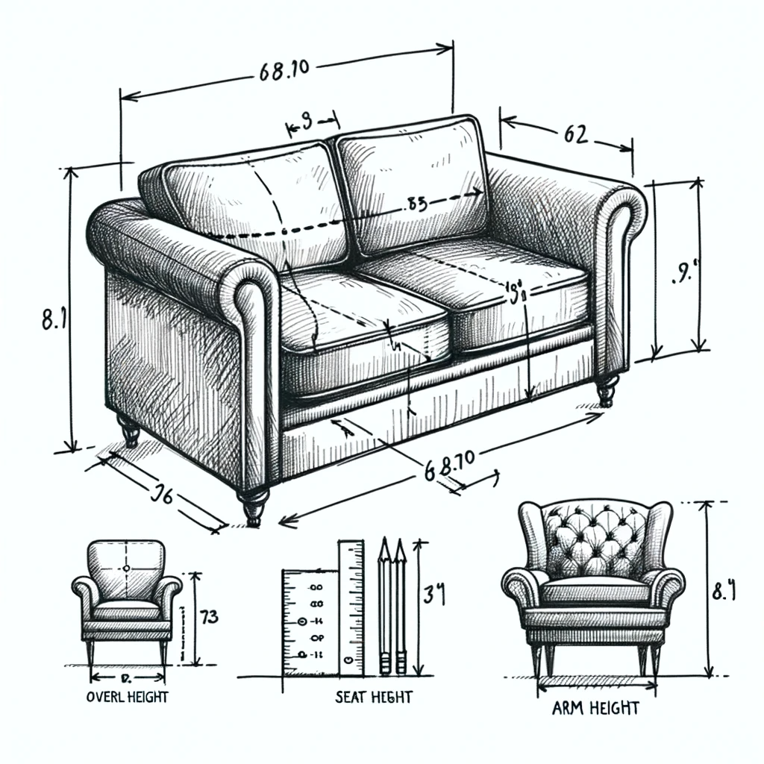

Sketch illustrating standard dimensions for a piece of upholstered furniture, such as a sofa or an armchair. Include metric measurements for overall height, width, depth, seat height, arm height, and back height. The style should be simple and clear, suitable for an educational context.

Knowledge Topic KT0305: Principles of Standard Dimensions for Furniture and Upholstered Furniture

In this segment of Knowledge Topic KT0305, we will discuss the principles of standard dimensions for furniture, particularly focusing on upholstered furniture such as sofas and armchairs. Understanding these standard dimensions is crucial for designing comfortable, functional, and ergonomically sound furniture. The dimensions are provided in metric measurements, which are commonly used in the furniture industry for consistency and precision.

1. Overview of Standard Dimensions in Furniture Design

Standard dimensions in furniture design are guided by ergonomics, functionality, and aesthetic proportions. These dimensions ensure that the furniture caters to the average user's size, providing comfort and accessibility.

2. Key Dimensions for Upholstered Furniture

The standard dimensions for upholstered furniture typically include:

- Overall Height: This is the total height of the furniture from the floor to the highest point, usually the top of the backrest.

- Width: The horizontal measurement across the furniture, indicating how much space it occupies and how many people it can accommodate.

- Depth: The front-to-back measurement, impacting the seating comfort and space utilisation.

- Seat Height: The height of the seat from the floor, crucial for comfort and ergonomic seating.

- Arm Height: Height of the arms from the floor, important for arm support and comfort.

- Back Height: The vertical measurement from the seat to the top of the backrest, influencing lumbar support and overall comfort.

3. Importance of Standard Dimensions

- Ergonomics: Proper dimensions ensure ergonomic support, reducing discomfort and the risk of musculoskeletal issues.

- Aesthetics: Standard dimensions contribute to the visual balance and appeal of the furniture.

- Functionality: Correct dimensions ensure that the furniture serves its intended purpose effectively.

4. Variability and Customisation

While standard dimensions provide a guideline, there is room for variability and customisation based on specific needs, target audiences, or design styles. Designers often adjust these dimensions to create unique pieces or cater to specific ergonomic needs.

5. Application in Design and Manufacturing

In practice, these standard dimensions are used as a starting point in the design and manufacturing process. They guide the creation of patterns, cutting of materials, and overall construction of the furniture.

Enclosed is a sketch illustrating the standard dimensions for a piece of upholstered furniture. This sketch serves as a visual guide to understanding the key measurements and their application in furniture design.

In conclusion, the principles of standard dimensions are integral to the design and production of furniture and upholstered furniture. They ensure that the furniture is not only aesthetically pleasing but also comfortable, functional, and ergonomically sound.

KT0306 Principles of industry and workplace quality specifications

Knowledge Topic Element KT0306: Principles of Industry and Workplace Quality Specifications

In this segment of Knowledge Topic KT0306, we will delve into the principles of industry and workplace quality specifications, specifically focusing on the distinctions between quality specifications, quality control, and quality assurance. These concepts are foundational to understanding how quality is maintained and managed in industrial and workplace settings.

1. Quality Specifications

Quality specifications refer to the detailed description of the criteria a product or service must meet. These are typically set by industry standards or by individual organisations based on their specific requirements. Key aspects of quality specifications include:

- Technical Specifications: Detailed descriptions of the technical aspects of a product or service, such as material types, dimensions, tolerances, and performance criteria.

- Compliance Requirements: Regulations and standards that the product or service must comply with, often set by industry standards or legal requirements.

- Customer Expectations: Specifications may also include criteria based on customer needs and expectations.

2. Quality Control (QC)

Quality Control is a product-oriented process that focuses on detecting defects in the final product or service. It is typically implemented as a series of inspections and tests that occur throughout the production process. Key elements of QC include:

- Inspection and Testing: Regular checks at various stages of the production process to ensure that the product meets the defined specifications.

- Defect Identification: Identifying and addressing any deviations from the quality specifications.

- Corrective Actions: Implementing procedures to correct any identified quality issues.

3. Quality Assurance (QA)

Quality Assurance is a process-oriented approach that focuses on preventing defects by ensuring the quality of the production process itself. It is more about managing and improving the processes that create the product or service. Key aspects of QA include:

- Process Standardisation: Developing standardised processes to ensure consistency in quality.

- Continuous Improvement: Regularly reviewing and improving production processes to enhance quality.

- Training and Development: Ensuring that staff are adequately trained in quality management practices.

4. Differences between Quality Specifications, QC, and QA

While interconnected, these concepts differ fundamentally in their focus and implementation:

- Quality Specifications provide the benchmark or target for quality. They define what quality means for a particular product or service.

- Quality Control is about inspection and detection; it is a reactive process that identifies and addresses defects after they have occurred.

- Quality Assurance is about prevention and process improvement; it is a proactive process focused on preventing defects by ensuring the quality of the processes involved in production.

5. Application in Industry and Workplace

In practical terms, these principles are applied as follows:

- Setting Quality Specifications: Defining clear and achievable quality targets for products or services.

- Implementing QC Measures: Conducting regular inspections and tests to ensure products or services meet the specified quality standards.

- Establishing QA Processes: Developing and maintaining standardised processes, and continuously improving these to prevent defects and enhance quality.

In conclusion, understanding the differences between quality specifications, quality control, and quality assurance is essential for effective quality management in any industry or workplace. These principles are not mutually exclusive but are complementary components of a comprehensive approach to ensuring and maintaining quality.

KT0307 Process of controlling and assuring quality specifications.

In this part of Knowledge Topic KT0307, we will explore the processes involved in controlling and assuring quality specifications in the workplace. This includes identifying factors such as health, safety, and environmental conditions that can negatively impact the production process and the quality of materials and final products. Additionally, we will analyse the implications of poor quality processes with reference to internal and external customers.

1. Identifying Negative Influences on Quality

In any production environment, several factors can detrimentally affect the quality of materials and the final product. Key areas of concern include:

- Workplace Health and Safety Conditions: Poor health and safety conditions can lead to accidents, reduced workforce efficiency, and compromised production quality.
- Environmental Conditions: Factors like humidity, temperature, dust, and contamination can affect both the material quality and the precision of the manufacturing process.
- Equipment Maintenance: Inadequate maintenance of machinery and tools can result in defects and inconsistencies in the final product.

2. Quality Control Processes

The process of controlling quality involves several critical steps:

- Regular Inspection and Testing: Routine checks of materials and products at different stages of production to identify defects or deviations from quality specifications.

- Monitoring Environmental Conditions: Ensuring that the production environment is maintained within acceptable parameters that do not compromise material quality or production processes.

- Preventive Maintenance: Regular servicing and maintenance of equipment to ensure they function optimally and consistently produce quality outputs.

3. Quality Assurance Practices

Quality assurance focuses on the overall process to prevent defects and maintain quality:

- Standard Operating Procedures (SOPs): Implementing and adhering to SOPs ensures consistency in the production process.

- Employee Training: Regular training of employees to enhance their skills and awareness of quality standards.

- Continuous Process Improvement: Implementing methodologies like Six Sigma or Lean Manufacturing to improve efficiency and quality.

4. Implications of Poor Quality Processes

Poor quality processes can have far-reaching implications:

- Internal Customers and Processes: Defects in quality can lead to increased waste, rework, and delays in production. This inefficiency can strain internal resources and disrupt workflow, ultimately affecting the morale and productivity of the workforce.

- External Customers: For the end consumer, poor quality can result in dissatisfaction, loss of trust, and damage to the company's reputation. This can lead to decreased sales, loss of market share, and negative brand perception.

- Legal and Compliance Risks: In some industries, failing to meet quality standards can lead to legal repercussions and non-compliance with regulatory standards.

5. Addressing Quality Issues

To address quality issues effectively:

- Root Cause Analysis: Identifying the underlying causes of quality issues is crucial for developing effective solutions.

- Feedback Loops: Establishing mechanisms for both internal and external feedback can provide insights into quality issues and areas for improvement.

- Investing in Quality Management: Allocating resources to quality control and assurance processes is essential for long-term success and customer satisfaction.

In conclusion, controlling and assuring quality specifications in the workplace is a comprehensive process that involves identifying and mitigating negative influences on production, implementing robust quality control and assurance practices, and understanding the implications of poor quality. By focusing on these areas, businesses can ensure that they not only meet but exceed the expectations of both their internal and external customers, thereby securing their position in the market.

Internal Assessment Criteria

- IAC0301 Principles and concepts of using scientific research to set laws, standards and guidelines associated with health, safety and ergonomics for upholstered furniture are described.
- IAC0302 The application of international, national, industry-specific and workplace-specific standards in the work place is explained.
- IAC0303 A minimum of two scientific tests each for upholstery webbing, springs, foam, adhesives, power tools and their consumables, synthetic fabric, hardware and finished products are identified and discussed.
- IAC0304 Tolerances for raw materials are identified and how to allow for it when setting quality standards for new products is explained.
- IAC0305 Principles of standard dimensions for furniture and upholstered furniture are explained and illustrated with sketches.
- IAC0306 Differences between quality specifications, quality control and quality assurance are differentiated.
- IAC0307 Work place health, safety and environmental conditions that can negatively affect the production process and the quality of materials and the final product are identified.
- IAC0308 Implications of poor quality processes in the workplace with reference to internal customers and processes, and external customers are analysed.
(Weight 50%)

Formative Assessment

- IAC0301 Principles and concepts of using scientific research to set laws, standards and guidelines associated with health, safety and ergonomics for upholstered furniture are described.
- IAC0302 The application of international, national, industry-specific and workplace-specific standards in the work place is explained.
- IAC0303 A minimum of two scientific tests each for upholstery webbing, springs, foam, adhesives, power tools and their consumables, synthetic fabric, hardware and finished products are identified and discussed.
- IAC0304 Tolerances for raw materials are identified and how to allow for it when setting quality standards for new products is explained.
- IAC0305 Principles of standard dimensions for furniture and upholstered furniture are explained and illustrated with sketches.
- IAC0306 Differences between quality specifications, quality control and quality assurance are differentiated.
- IAC0307 Work place health, safety and environmental conditions that can negatively affect the production process and the quality of materials and the final product are identified.
- IAC0308 Implications of poor quality processes in the workplace with reference to internal customers and processes, and external customers are analysed.
(Weight 50%)

Provider Programme Accreditation Criteria
Physical Requirements:
- The provider must have lesson plans and structured learning material or provide learners with access to structured learning material that addresses all the topics in all the knowledge modules.
Human Resource Requirements:
- Lecturer/learner ratio of 1:20.
- Qualifications of lecturers: 5 years relevant experience.
Legal Requirements:
- OHS compliant.
Exemptions
- No exemptions, but the module can be achieved in full through a normal RPL process.

